ODESSA NATIONAL MEDICAL UNIVERSITY
DEPARTMENT OF ROBOTIC AND ENDOSCOPIC SURGERY

METHODICAL instructive elaboration

of the practical class for the discipline
"Surgical diseases with child's surgery and oncology» for students of the 6-th course of the medical faculty

Topic № 28: “Interpretation of lower limb pain in differential diagnostics of vascular, neurologic, endocrine diseases and diseases of musculoskeletal system”.

Discussed and approved at
methodical board of Department
of Robotic and Endoscopic surgery
"28" August 2019
Protocol № 1
Head of the Department
Ass. prof. __________ Malinovsky A.V.

Odessa - 2019

Topic of practical class: “Interpretation of lower limb pain in differential diagnostics of vascular, neurologic, endocrine diseases and diseases of musculoskeletal system”
1. Significance of topic

According to the literature, complaints of pain in the limbs are made by at least 40% of people over 40 and over 50% older than 50 years. With age, the percentage of people with pain syndrome in the limbs increases to 80%. The presence of such complaints significantly worsens the quality of life of patients and limits their physical activity. Pain syndrome in the limbs is a complex complex of symptoms, which includes vascular, nervous and quick-tempered components. Incorrect assessment of the dominant component leads to inadequate treatment and, according to treats, worsens the patient's condition. Underestimation or improper treatment of occlusal lesions of the limbs can even lead to the loss of the affected limb to patients.
2. Aims of the class

2.1. Training aims (a student must learn and master):

Level I – To acquaint students and create an idea about the symptoms, etiology and pathogenesis of occlusive diseases of the limbs, venous diseases, nerve injury of the limbs and diseases of the musculoskeletal system. It is necessary to give students the opportunity to study and assimilate the classification and clinic of diseases of the arteries and veins of the extremities.

Level II – The student should know and understand the symptomatology of pain syndrome in the limbs, the methods of physical examination and instrumental studies necessary for differential diagnosis. The student should know and be able to evaluate and interpret the results of laboratory and instrumental research. Also, the student must learn the principles of treatment and determine the individual algorithm of examination and treatment in a specific clinical situation.

Level III – To give students the opportunity to master the skills and techniques of performing a physical examination of the patient, analyzing the results of laboratory and instrumental research.

Level IV – To provide students with the ability to study theoretically, clinically, experimentally patients with pain syndrome in extremities of different etiology.
2.2. Educational aims:

1. Formation of professional personality of doctor.
2. Formation of medical deontology and ethics, professional responsibility.

3. Interdisciplinary integration

№ | Disciplines | To know | To master
Previous disciplines (basic disciplines)
1 | Normal anatomy. | Structure of extremities, features of innervation and circulation
2 | Normal physiology. | The function of the limbs, the principles of their interaction with other systems and organs
3 | Pathological physiology. | Pathogenesis of the development of inflammatory processes
4 | Topographic anatomy and surgical surgery. | Interrelations between limb organ structures
Following disciplines (clinical disciplines)
1 | Propaedeutics of internal diseases. | Methods of physical examination of the patient, the main clinical syndromes. Instrumental and laboratory methods of examination.
2 | Pharmacology. | The mechanism of action and dosage of drugs of various groups, which are used in the treatment of pain syndrome in the limbs
3 | Neurology. | Etiology, pathogenesis, classification, clinic, diagnosis and treatment of diseases of the nerves of the extremities
4 | Oncology. | Etiology, pathogenesis, classification, clinic, diagnosis and treatment of tumorous diseases of the extremities

4. Contents of the topic

Pain in the extremities is observed in various diseases. And this pain can come from any part of the limb. However, in some cases, the cause of pain in the limbs are diseases of the internal organs with the irradiation of pain in the hands and feet, as, for example, with myocardial infarction, acute cholecystitis, an attack of renal colic, etc.
The main causes of pain in the limbs are:
Irradiating pain in diseases of internal organs.
Spinal cord injury.
Neuro-vascular syndrome with diseases of the shoulder girdle.
Pain in the extremities with diseases of the spinal cord.
Pain in the extremities of vascular disease.
Diseases of the arteries.
Diseases of veins.
Diseases of lymphatic vessels.
Diseases of capillaries.
Pain in the extremities in diseases of peripheral nerves.
Pain in the limbs with joint diseases.
Pain in the extremities with diseases of the periarticular tissues and subcutaneous tissue.
Pain in limbs with bone disease.
Pain in the extremities due to muscle damage.

The most common causes of pain in the extremities are:
- Diseases of the lower extremities are a group of diseases that include arterial pathology (acute thrombosis and embolism of the main arteries, obliterating atherosclerosis, obliterating thromboangiitis, nonspecific aortoarteritis, Raynaud's disease) and veins (acute venous thrombosis, syndrome Pjet-Shreter, varicose veins, post-thrombophlebitic syndrome, congenital arteriovenous dysplasia) of the upper and lower extremities. These diseases are different in etiology and pathogenesis. However, the common for them is one of the clinical manifestations - pain in the limbs. It should be noted that vascular disease of the extremities is a very common pathology, which is often encountered by family and district doctors, as well as emergency and emergency doctors.

- Myofascial pain syndrome.

This is a common pathology that practically every person encounters during life. The appearance of pain in it is caused by the appearance in the muscle of foci of an increased pain reaction. Pain in the extremities also occurs with myositis of various etiologies, as well as due to injury. The reasons contributing to the development of myofascial pain in the limbs, may be abnormal development of bone and muscle skeletal (short leg, flat feet), over-voltage and overload untrained muscles, stretching the muscles followed by their spasm (for example, when an unfortunate turn, throwing), prolonged immobilization of muscles (With dislocations and fractures), direct compression and hypothermia of the muscles. Under the influence of the above factors is exposed muscle micro-traumas, local ischemia, disrupted neurotrophic control, resulting in muscle appears trigger point, and the presence of which determines the entire picture of the disease. The causes of pain in the limbs are infectious when myositis, respiratory diseases, connective tissue diseases. The nature of muscle pain in the limbs with myofascial syndrome is very variable. The pain can be weak and very intense. The pain is accompanied by weakness of the muscle, with no signs of atrophy ("slimming"). There is a limitation of the volume of those movements for which the given muscle is responsible. The key phenomenon is the presence of skeletal muscle region of enhanced sensitivity with a diameter less than 1 cm ². At this point painful to palpation, and pressing it causes pain at this point remote from the body portion (reflected pain). Reflected pain is blunt and prolonged, it is felt in the depths of tissues. Binding feature is the presence of a disease and spastic muscles on palpation, the presence of this muscle areas more painful muscle seal, wherein the elevated region and located painful sensitivity.
With acute purulent myositis, the pain in the limbs is quite strong. Affected muscles are swollen, their strength is reduced. There is a chill, an increase in body temperature, weakness, malaise, changes in blood, characteristic of inflammatory processes. With infectious inflammation of the myositis, the weakness of the affected muscles is less pronounced. Sometimes the only symptom is pain. In myositis caused by autoimmune diseases, moderate pain syndrome and progressive weakness of the limb muscles are revealed. A special form is myositis, in which muscle weakness and progressive muscle atrophy are combined with the deposition of calcium compounds in the connective tissue. Develops after a muscle injury (stroke, rupture, etc.) ..

3. Phantom pain in the limbs are characterized by 4 main properties:
- Pain continues after healing of damaged tissues. In some patients pains are transitory, while others persist for years and decades, even if the primary damage completely heals. Sometimes the pain is similar to that which preceded amputation. So, for example, patients with an amputated leg feel at her pain from ulcers that existed in the real leg before her operative removal. Within two years after the amputation, 45% of the patients experience pain in one particular localization, and 35% of the patients experience the same pain as before the amputation.
- Trigger zones can extend to healthy areas of the same or opposite side of the body. A light touch to the other limb or to the head can trigger an attack of terrible pain in the phantom limb. Obviously, the pain in a place remote from the stump can cause phantom pain. For example, angina pectoris, which developed over 25 years after amputation, can provoke severe pain in the phantom limb for each attack.
- Long-term relief of pain can be achieved by reducing somatic impulses. This is the basis of such treatment methods as local injection of anesthetics into sensitive areas or nerves of the stump. These blockades can stop the pain for hours, days, weeks, even forever, but are usually effective only for a few hours ..
- In addition, prolonged pain relief may be due to increased sensory impulses. Injections of a hypertonic solution into the appropriate areas cause pain that irradiates into a phantom limb, which lasts about ten minutes, followed by a dramatic partial or complete disappearance of the pain for hours, weeks, or forever. Vibration stimulation, electrostimulation of the stump muscles can also bring relief. Surgical electrodes can also be placed on the spinal cord.
4. Pain in the extremities is also observed with traumatic injuries (dislocations, fractures, ligament ruptures).

Criteria for diagnosis: In the diagnosis of pain in the limbs, the localization of pain and their nature are important. Diagnosis is established on the basis of physical and instrumental research.
The list of the main diagnostic measures:
1) Visual inspection of the limb;
2) palpation of tissues to determine the presence of edema and the rate of their growth, the presence of tumor formations in the limb;
3) check the pulsation of arteries at the points of projection of the main vessels;
4) auscultation of arteries for revealing regurgitation, characteristic for stenosing lesions;
5) performing ultrasound dopplerography of the arteries and veins of the limb;
6) in case of questionable Doppler study - performing an invasive study - angiography or phlebography
7) checking neurological symptoms and determining the sensitivity of the limb.
In surgical practice, the doctor is more often faced with the treatment of vascular diseases. With the pathology of the veins, varicose disease of the lower extremities and postthrombophlebitis syndrome are more common. Both pathologies, depending on the stage of the disease, are treated conservatively or surgically. With the pathology of the arteries, obliterating aorto-arteritis and atherosclerosis are more common. In this case, performing hagiographic research is mandatory. Depending on the results of angiography, the question of further treatment of the patient is solved. For conservative treatment, a drug is used that improves capillary blood flow (vasaprostan, alprostan, ilomedine) and peripheral vasodilators. Surgical treatment often involves the shunting (allo or autoprosthesis) of affected areas of the vessel.
5. Plan and structure of the class

No. | Basic stages of the class | Training aims according to the levels of mastering | Means of training and control | Materials for methodological maintainance of  the class, visibility, and control of knowledges | Terms (in minutes or per cent)
1 | Initial | 1) Giving the training aims of level I (see chapter 2.1)  2) Control testing of initial level of knowledge, readiness of the students for perception of the material | Krok-2 type tests of initial level of knowledge, including software version (see chapter 6.1) | Krok-2 type tests of initial level of knowledge, including software version (see chapter 6.1) | 15 %
2 | Basic | 1) Giving the training aims of levels II – IV (see chapter 2.1)  2) Observation of patients, disucussion of algorithms of diagnostics and management of patients with lower limb pain | Observation of patients at the department of robotic and endoscopic surgery | 1) Schemes, tables (including PowerPoint presentations) of algorithms of diagnostics and management  2) Diagnostic images  3) Illustrations and videos of surgical procedures | 70 %
3 | Conclusive | 1) Control testing of theoretical knowledges and practical skills  2) Conclusions  3) Giving the home task | 1) Krok-2 type tests of final level of knowledge, including software version (see chapter 6.3)  2) List of literature for the next class | Krok-2 type tests of final level of knowledge, including software version (see chapter 6.3) | 15 %

6. Materials for methodological maintainance of the class

6.1. Materials for initial stage of the class

A 47-year-old female patient complains of leg heaviness, fatigue when standing and walking. This feeling
disappears when she takes a horizontal position. Objectively: dilatation of the superficial veins of the left shin
and thigh with pigmentation and trophic skin disorders. What functional test should the examination be started
with?
Pratt test 2
Perthes test
Pratt test 1
Sheinis test
Trendelenburgs test

Two hours ago a 38-year-old patient got pain in his right shin. He was diagnosed with popliteal artery
embolism, acute arterial insufficiency of grade I. What is the most appropriate therapeutic tactics?
Destruction of the embolus by the catheter
Embolectomy
Bypass grafting
Amputation at the middle of shin
Resection of the popliteal artery

After a car accident a 37-year-old patient has an acute pain and bleeding in the middle third of his right thigh.
Objectively: there is a wound on the anterior surface of the right thigh with massive bleeding, abnormal mobility
at the level of the middle third of the thigh. The first aid is to be started with:
Venipuncture and intravenous infusion of polyglycine
Tourniquet application
Immobilization of the extremity with a transportation splint
Digital occlusion of the femoral artery
Injection of pain-killers
•••••
A 52 year old patient complains about headache, weakness of his upper left extremity. Neurological
symptoms become more intense during physical stress of the left extremity. Pulsation on the arteries of the left
extremity is sharply dampened but it remains unchanged on the carotid arteries. What is the most probable
diagnosis?
Takayasus disease
Occlusion of the left subclavicular artery, steal syndrome
Raynauds syndrome
Occlusion of brachiocephalic trunk
Thoracal outlet syndrome

6.2. Materials for basic stage of the class

Site of arterial occlusion and corresponding site of associated limb ischemia
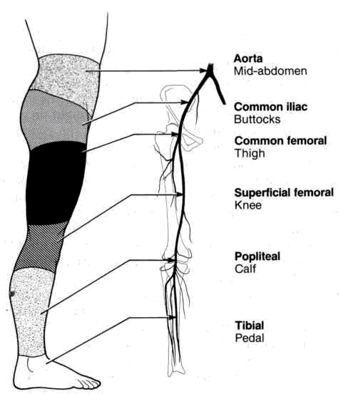
From: Basic surgery/ed., H.C. Polk, Jr., et al. – 5th ed.

Management options for acute lower limb ischemia
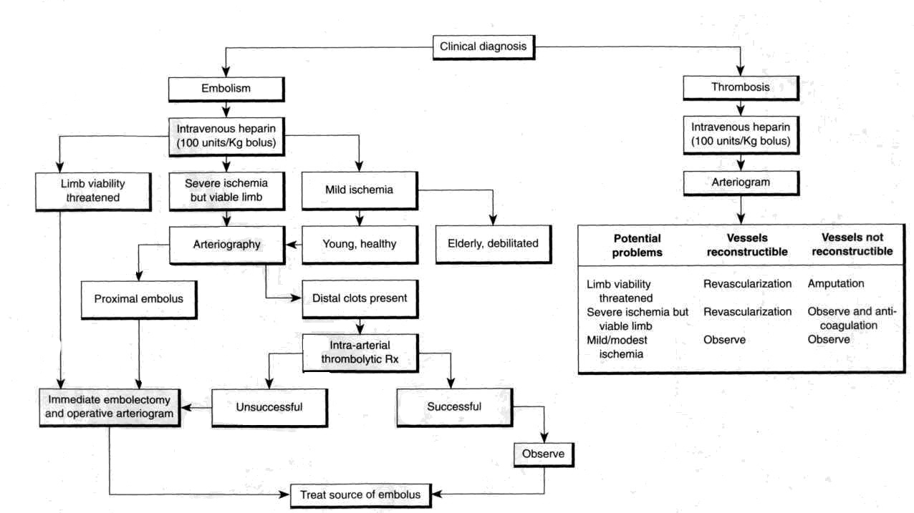

From: Basic surgery/ed., H.C. Polk, Jr., et al. – 5th ed.

7. Literature for students

8.1. Basic literature

- General Surgery: textbook / S.D. Khimich, M.D. Zheliba, V.P. Andryushchenko et al. — К., 2019. — 536 p., hardcover

- Essential surgery. Editor prof V.V.Grubnik, O.L.Kovalchuk, A.V.Malinovsky. Ternopil, TSM, 2010, 543 p.

- Surgery: a textbook is intended for English-speaking students of higher medical educational institutions of III-IVth levels of accreditation, interns / K. M. Amosova, Ya. S. Bereznyts’kyy, A. O. Burka [et al.]; ed. by Ya. S. Bereznyts’kyy [et al.], 2016. - 711 p.

- Surgery Editor. Bereznyts'ky Y.S., Zarharash M.P, Mishalov V.G. Vinnytsia, 2016, 711p.

8.2. Additional literature

- Surgery: a textbook is intended for English-speaking students of higher medical educational institutions of III-IVth levels of accreditation, interns / K. M. Amosova, Ya. S. Bereznyts’kyy, A. O. Burka [et al.]; ed. by Ya. S. Bereznyts’kyy [et al.], 2018. - 711 p.

- Essential surgery [Text] : навч. посіб. для студ. вищ. мед. навч. закл. IV рівня акредитації, які опановують навч. дисципліну англ. мовою (протокол № 4 від 01.10.2010 р.) / V. V. Grubnik, O. L. Kovalchuk, A. V. Malynovskyy, O. V. Grubnik. - Ternopil : TSMU "Ukrmedknyha", 2010. - 544 p. : fig., tab. - Текст англ. - Бібліогр.: с. 529-531. - 500 прим. - ISBN 978-966-673-147-3

- Sabiston textbook of surgery: the biological basis of modern surgical practic / [edited by] Courtney M. Townsend, Jr, R. Daniel Beauchamp. B. Mark Evers, Kenneth L. Mattox.—20th edition.

9. Topic of the next class

Thromboses and embolisms of arteries of lower limbs. Venous diseases. Syndrome of superior vena cava

Elaboration composed by: ass. Chernov Nikolai

