ODESSA NATIONAL MEDICAL UNIVERSITY
DEPARTMENT OF ROBOTIC AND ENDOSCOPIC SURGERY

METHODICAL instructive elaboration

of the practical class for the discipline
"Surgical diseases with child's surgery and oncology» for students of the 6-th course of the medical faculty

Topic № 29: “Thromboses and embolisms of arteries of lower limbs.”.

Discussed and approved at
methodical board of Department
of Robotic and Endoscopic surgery
"28" August 2019
Protocol № 1
Head of the Department
Ass. prof. __________ Malinovsky A.V.

Odessa - 2019

Topic of practical class: “Thromboses and embolisms of arteries of lower limbs.”
1. Significance of topic

The significance of the topic is due to the gradual increase in the number of patients with multifocal atherosclerosis, one of the complications of which is thromboembolic events. Considering the fact that when there is thrombosis and embolism of the peripheral blood channel, the main factor of the positive result for the patients is the time factor from the moment of occlusion of the vessel to the provision of specialized medical care, it becomes clear the need for knowledge of the clinical picture and diagnosis of these diseases by physicians of all specialties. Correct orientation in the evaluation of early diagnosis of thrombosis and embolism and timely referral of patients to the angio-surgical department will allow to achieve better treatment results and prevent unsatisfactory disabling (and sometimes lethal) end results.
2. Aims of the class

2.1. Training aims (a student must learn and master):

Level I – to acquaint students with the frequency of thromboembolic events in the world and Ukraine, the causes of the disease, the pathogenesis of development and the classification of the pathological process.

Level II – The student must know the anatomy of the vessels, their morphological structure, pathophysiological changes in the case of a disturbance of the coagulation system.
Level III – Give students the opportunity to master the technique of determining the pulse at typical points, the technique of performing functional clinical trials.

2.2. Educational aims:

1. Formation of professional personality of doctor.
2. Formation of medical deontology and ethics, professional responsibility.

3. Interdisciplinary integration

№ | Disciplines | To know | To master
Previous disciplines (basic disciplines)
1 | Anatomy. | The exact typical position of the magistral vessels. | Clearly indicate the location of the projection of superficial arteries to determine their pulsation. Find the projection of venation sites.
2 | Biochemistry. | Mechanisms of the blood coagulation system, clotting factors, their indicators and norms. | To treat the deviation of all indicators of the surrogate system and their significance in the emergence of thromboembolic diseases.
3 | Histology. | Histological structure of thrombus in different phases of its origin. Differences in the histological structure of the thrombus and embolus. | Determine the time since the onset of thromboembolism. Distinguish the histologic thrombus from the embolus.

4. Contents of the topic

Overview

- Atherosclerosis is a disease process that involves both large and small arteries. Arterial lesions tend to occur at certain locations, such as the proximal internal carotid artery, the infrarenal aorta, and the superficial femoral artery.
- Collateral circulation develops when occlusive disease occurs over a period of time. The ability to develop collateral circulation can keep even the total occlusion of a major artery from becoming symptomatic, at least at rest. For example, the internal iliac, cross pelvic, and lumbar arteries, as well as the internal mammary artery via the superior and inferior epigastric arteries, can form a collateral bed to help supply the leg with aortic and iliac disease.
- Risk factors for peripheral vascular disease are essentially the same as those for coronary artery disease: smoking, diabetes mellitus, hypertension, lipid abnormalities, and a strong family history.
- Preoperative cardiac stress testing is frequently performed in an effort to assess risk and decrease perioperative complications.

Clinical presentation

- A thorough history and physical examination can confirm the diagnosis of peripheral vascular disease and can suggest the anatomic location of specific occlusive lesions.

Claudication

- Claudication is one of the most characteristic symptoms of peripheral vascular disease. Patients complain of profound fatigue, aching, or crampy pain in the extremity, usually the leg. The two key features of claudication are its consistent reproducible occurrence at a constant distance, and its prompt relief by rest (within minutes). It is always caused by exertion, never by standing or sitting for prolonged periods.
- Symptoms appear distal to the site of vascular occlusion (see Scheme 1): in iliac occlusion, the discomfort is in the thigh or buttock; in superficial femoral artery occlusion, the symptoms are found in the calf.
- Pulses are usually absent or diminished distal to the lesion. Pulses that are palpable at rest may disappear after exercise.
- At rest, the patient has no discomfort, indicating that limb-threatening ischemia is not present.

Scheme 1. Site of arterial occlusion and corresponding site of associated limb ischemia
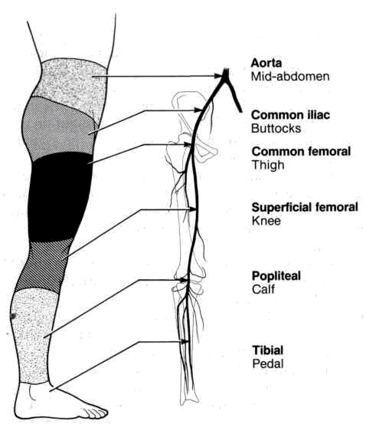
From: Basic surgery/ed., H.C. Polk, Jr., et al. – 5th ed.

Medical treatment

- Most claudication can be managed without surgery. In most patients, a routine exercise program and cessation of smoking will result in a noticeable improvement in walking distance. Control of other atherosclerosis risk factors also should be attempted.
- Pentoxifylline is currently the only agent approved for the treatment of intermittent claudication. It reduces whole blood viscosity by decreasing plasma fibrinogen and platelet aggregation.
- Anticoagulants (such as aspirine) are also effective.

Prognosis

- Claudication is an indication that systemic vascular disease is present.
- The prognosis of the affected limb is relatively good, with only 10% of patients progressing to severe ischemia or limb loss in 10 years.
- The long-term survival of these patients is more guarded, being 73% at 5 years and 38% at 10 years.
- The most common cause of death is atherosclerotic heart disease.

Ischemic rest pain

- Ischemic rest pain results from severe compromise of arterial flow.
- Patients describe intense pain, burning, or tingling, usually across the distal foot and arch, which is exacerbated by elevating the foot (e.g., while trying to sleep in bed). It may be relieved by keeping the foot in a dependent position or by walking slowly.
- Serious consideration should be given to revascularization in these patients because the disability and discomfort are severe and the degree of ischemia is critical.

Gangrene

- Gangrene (tissue necrosis) occurs when blood flow is inadequate to maintain tissue viability. Ischemic ulcers usually occur at the distal calf, or at the toes (see Fig. 1).
- Gangrene may result from chronic progressive arterial disease or may result from embolization of cholesterol or an organized thrombus from a proximal source.
- Occasionally, gangrene of the toes may occur without significant proximal arterial disease. This form represents occlusion of small blood vessels owing to intrinsic obliterative disease and is seen most commonly in patients with diabetes and end-stage renal disease.
- Treatment is local debridement or amputation or nonviable tissue and revascularization or removal of the source of emboli to protect the remaining tissue at risk.

A 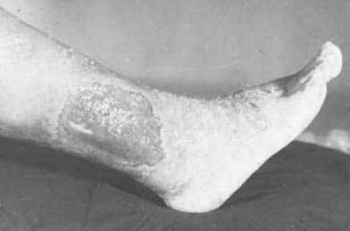 B 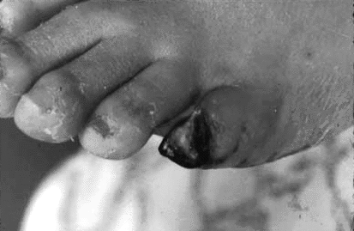

Fig. 1. Ischemic ulcer (A) and gangrene of a toe (B)

Diagnosis

Duplex scanning

- The basic non-invasive test is duplex scanning of arteries.
- It could show the speed and direction of the blood flow, thus confirming the diagnosis and demonstrating the site of occlusion (see Fig. 19-1).

Arteriography

- Arteriography (see Fig. 4) is the current standard invasive method for evaluating vascular diseases. Contrast material is injected into the artery of interest, usually by way of a femoral artery puncture, and sequential x-ray exposures are made. As the contrast material moves distally, the filling of the arteries is recorded during the filming sequence.
- Advantage is that arteriography provides large films that clearly reveal the area under investigation. Unfortunately, this procedure is associated with several serious complications.
- Acute renal failure can result from the nephrotoxicity of the dye, and acute dehydration can result from the brisk diuresis induced by the hyperosmotic contrast dye. Both complications can be minimized by adequate pre- and postangiographic hydration and by limits on the total amount of dye injected.
- An additional complication can be an allergic reaction to the dye.
- Acute arterial occlusion occasionally follows angiography. Ischemia is most apt to be related to technical problems, including simple thrombosis of the artery at the site of needle insertion, distal embolization into the lower leg from a thrombus forming on the angiogram catheter or from a dislodged plaque, or subintimal dissection of an atherosclerotic plaque during catheter manipulation. Clinical symptoms of acute arterial occlusion following angiography include absent pulses, especially those present prior to the examination; severe and constant pain, numbness, or paresthesia in the extremity examined; and pallor of the skin and coolness to touch in the involved extremity. Treatment of acute arterial occlusion during angiography depends on the underlying cause and should be initiated promptly. If flow is reestablished within 2-6 hours, the results are excellent. For example, acute thrombosis can be treated with lytic therapy, using urokinase or streptokinase. Intimal dissection that causes thrombosis requires thrombectomy and direct arterial repair or bypass. Embolization of an atherosclerotic plaque may require operative embolectomy. Although arterial vasospasm can explain this acute ischemic episode, it occurs in less than 3% of cases.
- Pseudoaneurysms may develop following removal of the angiographic catheter. This complication usually results from an inability to apply adequate pressure at the arterial puncture site and is more likely to occur in patients with high blood pressure. Pseudoaneurysms present as swelling following removal of the catheter. An ultrasound of the area should be obtained to distinguish a pseudoaneurysm from a simple hematoma. If pulsatile flow is seen outside the lumen of the artery, a pseudoaneurysm is present. Pseudoaneurysm should be repaired promptly in the operating room.

Brachial artery catheterization

- This study is performed frequently for cardiac catheterization or for angiography when the lower extremity vessels are unsuitable.
- Thrombosis of the brachial artery does not usually result in acute hand ischemia but it can cause hand claudication. Surgical repair is indicated.

Axillary artery catheterization

- This study is performed occasionally when the femoral vessels are not adequate for angiography.
- A periarterial hematoma may follow this study and compress the brachial plexus causing arm disability if it is not promptly decompressed. This complication is considered a surgical emergency.

Magnetic resonance angiography

- Magnetic resonance angiography is rapidly becoming a more accurate and common method of assessing the arterial circulation (see Fig. 2).
- Although holding great promise for the future, most magnets and software packages do not currently produce information that is reliable enough to replace the information provided by conventional arteriography.

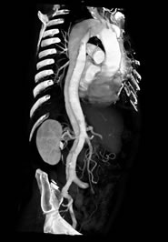

Fig. 2. Magnetic resonance angiography of aorta

Nonoperative procedures to improve arterial flow

Percutaneous transluminal angioplasty (PTA)

- An inflatable balloon attached to an angiographic catheter is fluoroscopically guided to the stenotic area. The balloon is then inflated to 4-8 atm to fracture the plaque.
- A clinically significant embolism or thrombosis may follow this procedure in approximately 3% of cases.
- Patency varies with anatomic location of the stenosis and with the character of the disease. Focal, isolated areas of stenosis tend to show more durable results than diffusely diseased arteries. More proximal arteries, especially common iliac arteries, with a focal stenosis have the best results. Arteries with lower flow rates, such as the superficial femoral artery, and more distal arteries, tend not to have as high a patency rate.

Stents

- Stents are expandable metal mesh tubes that are inserted over a balloon catheter. The balloon is inflated to expand the stent, then deflated and withdrawn .The expanded stent is thought to help prevent the elastic artery from restenosing, and “tacking down”, the intimal flaps keeps the artery from dissecting.

Lasers and atherectomy catheters

- Lasers can be used to open occluded arteries so that a balloon angioplasty catheter can be inserted. They have not been shown to increase patency rates above those of PTA alone.
- The advent of newer guide wires has enabled short segment occlusions to be passed without the added cost of laser-equipped devices.
- Atherectomy catheters actually remove atherosclerotic plaque from the arterial wall either by cutting and extracting small slivers via the catheter/introducer system (e.g., Simpson atherectomy device) or by using a rapidly rotating tip that disintegrates the plaque (see Fig. 16-4) (e.g., Auth rotoblater).

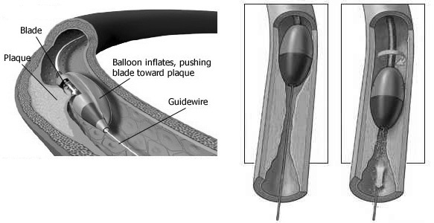

Scheme of percutaneous atherectomy

Pitfalls in percutaneous interventional techniques

- Intimal hyperplasia leading to restenosis at the site of intervention is the pitfall with all of these methods. Balloon angioplasty, the simplest and least expensive procedure, has proven to be the most durable, with the possible exception of angioplasty in combination with stents at the common iliac artery level.
- Thrombosis, as well as early intimal hyperplasia, has proven to be a concern, especially with lower flow vessels (e.g., infrainguinal). This pitfall may be managed by anticoagulation with heparin and warfarin, although there may be a higher complication rate from bleeding.

AORTOILIAC OCCLUSIVE DISEASE

Overview

- Aortoiliac occlusive disease is usually caused by atherosclerosis.
- Other less common entities that can occlude the aorta include Takayasu's arteritis and aortic coarctation.

Clinical characteristic

- Patients may be asymptomatic or may present with buttock or thigh claudication.
- LeRiche syndrome consists of diminished femoral pulses, buttock and thigh claudication, and impotence (due to different variants of occlusion of iliac arteries).
- Angiography is helpful for anatomical diagnosis (see Fig. 4).
- Severe ischemia, leading to gangrene or limb loss, is rare with isolated aortoiliaс disease.

A 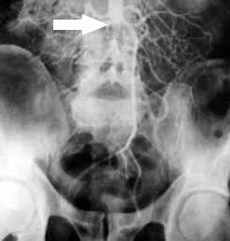 B 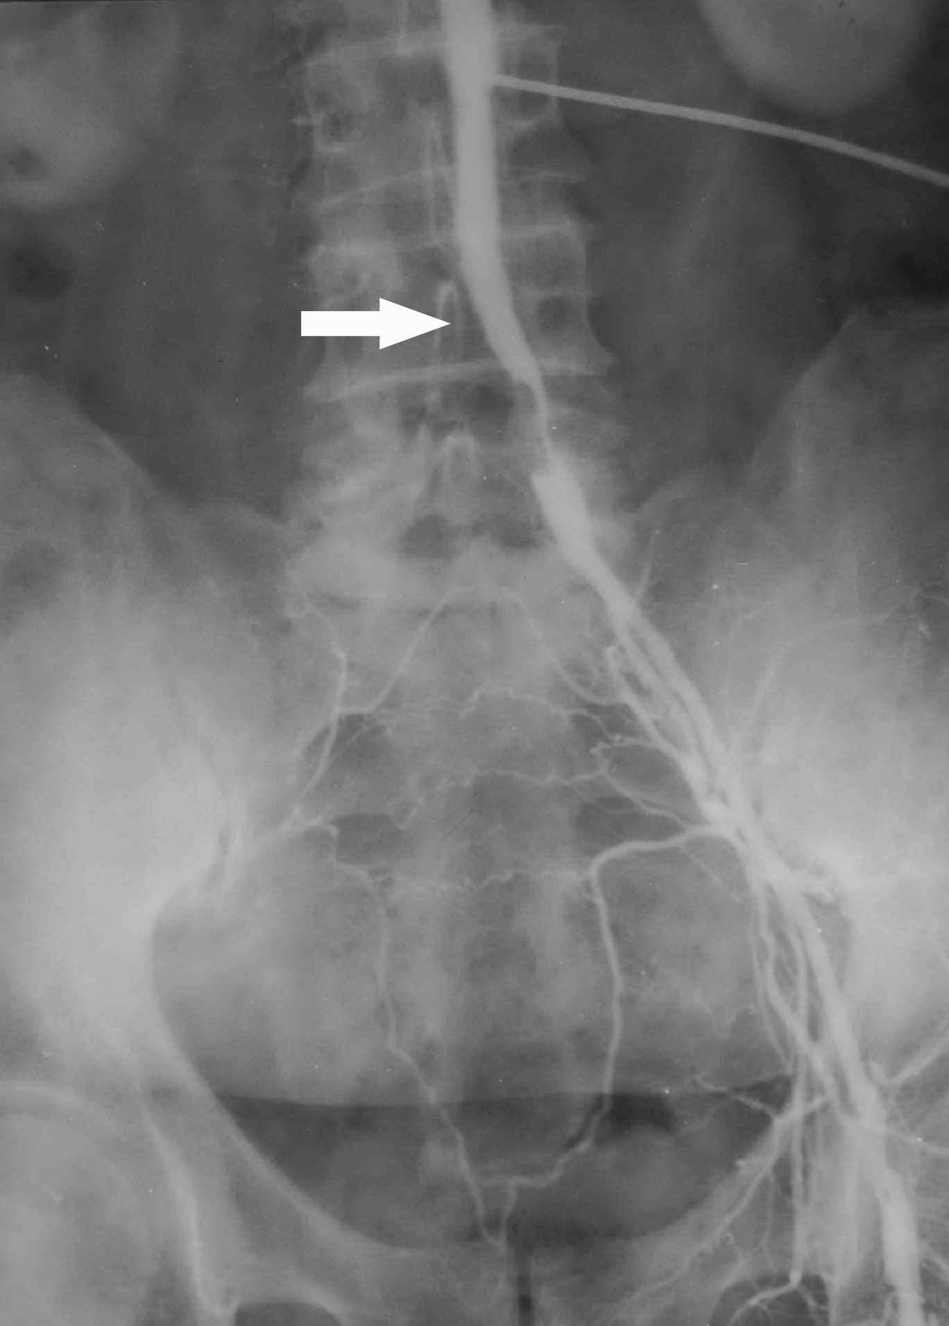 C 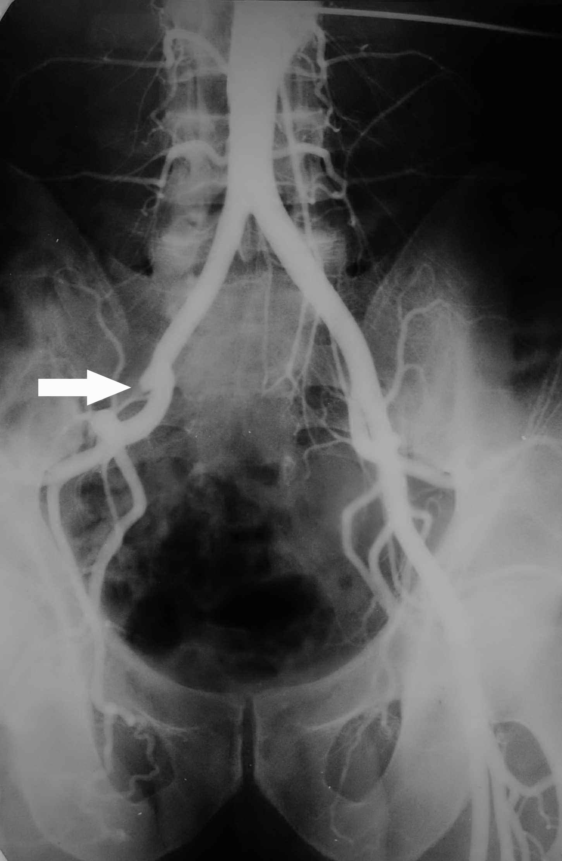

Fig. 4. Arteriographic pictures of atherosclerotic occlusion of bifurcation of aorta (A), right common iliac artery (B), and right external iliac artery (C)

Surgical treatment

Indications for surgery

- Indications for surgery for aortoiliac occlusive diseases include:
- Severe claudication or rest pain.
- Tissue loss.
- Peripheral arterial emboli (caused by occlusion of distal vessels in the skin or digits the lower extremity by small plaques or platelet-fibrin clots, while the patient presents with a painful cyanotic digit (''blue toe" syndrome) or multiple small skin infarctions).
- Impotence in men (when other organic or psychogenic causes have been ruled out and when a hemodynamically significant vascular lesion is present).

Endarterectomy

- Endarterectomy consists of opening the artery and removing the portion of the intima and media containing the plaque (see Fig. 5 ).
- Currently, this technique is used only for short lesions of the distal aorta or common iliac arteries.

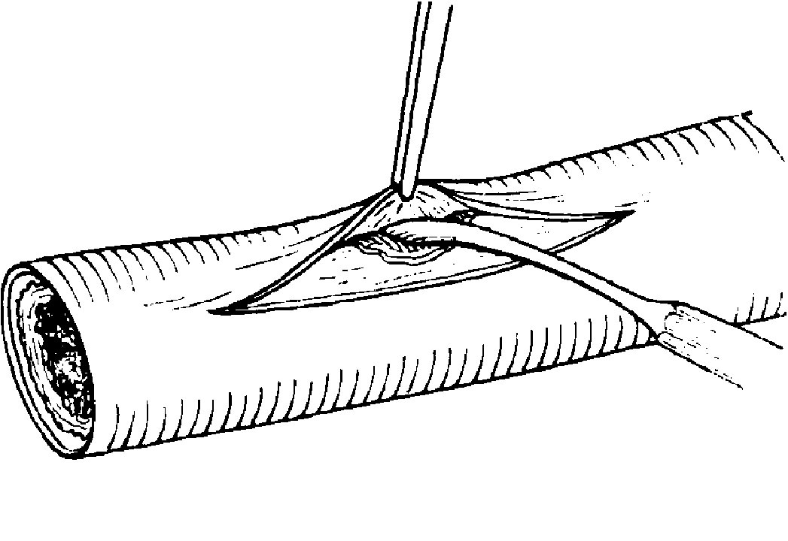

Fig. 16-5. Scheme of open endarterectomy

Aortobifemoral bypass

- Aortobifemoral bypass is the most commonly performed procedure (see Fig. 6).
- Grafts are either woven or knitted dacron, or expanded polytetrafluoroethylene (ePTFE).
- The distal anastomosis is usually performed on the common femoral artery; this procedure will bypass any infrarenal aortic, iliac, and common femoral disease.
- The proximal anastomosis is usually done in the infrarenal aorta.
- Operative mortality is 1%-5%. The major cause of death is myocardial infarction.

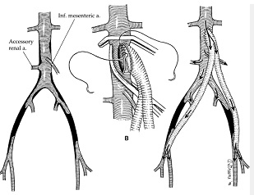

Fig. 6. Scheme of aortobifemoral bypass

Femoral-femoral extra-anatomic bypass

- Femoral-femoral extra-anatomic bypass (see Fig. 7) may be used in patients with unilateral iliac disease if the remaining iliac artery does not have significant obstructive disease.
- In well-selected cases with minimal disease in the iliac artery providing inflow and good runoff in the symptomatic leg, this procedure provides acceptable results with 70% - 75% long-term patency rates.

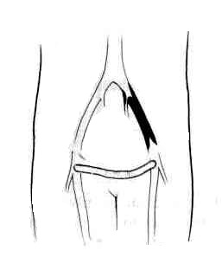
Fig. 7. Scheme of femoral-femoral extra-anatomic bypass

Axillobifemoral extra-anatomic bypass

- Axillobifemoral extra-anatomic bypass (see Fig. 8) is used for poor-risk patients who require revascularization but cannot tolerate direct aortofemoral bypass or when aortobifemoral bypass couldn’t be applied (technically difficult access to abdominal aorta, re-stenosis of aortobifemoral graft, ect.).
- This procedure is associated with a low mortality rate, but the long-term patency (60% - 70%) is lower than for aortofemoral bypass. The grafts frequently require thrombectomy to achieve long-term patency.

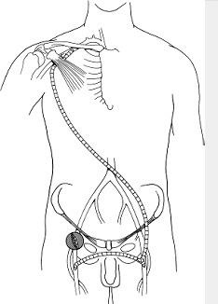

Fig. 8. Scheme of axillobifemoral extra-anatomic bypass

LOWER EXTREMITY OCCLUSIVE DISEASE

Overview

- Lower extremity occlusive disease includes occlusive disease of the common femoral, superficial, deep femoral, popliteal, and tibial arteries.
- The most common cause of lower extremity disease is atherosclerosis, although other less common conditions can also cause occlusive disease.
- The superficial femoral artery is the artery most frequently involved. Disease usually occurs distally where the artery passes through the adductor hiatus. The most common symptom is claudication, which may not be severe if good collateral vessels are present.
- The profunda femoris artery supplies blood to the thigh and collateral flow to the popliteal artery. The origin or this vessel frequently is stenotic, but the distal vessel is usually spared by atherosclerosis.
- The popliteal artery may be diseased because of atherosclerosis, entrapment by the gastrocnemius or popliteus muscle, or cysts in the adventitia of the artery. The latter two conditions should be considered if a young patient presents with claudication.
- The tibial arteries may be diseased by atherosclerosis or embolization. Patients with diabetes frequently have disease of these vessels. Approximately 75% of femoral-tibial bypasses are in diabetic patients.

Clinical characteristic

- Patients with lower extremity arterial disease may be asymptomatic or may present with claudication (most common), rest pain, or tissue necrosis. If the arterial insufficiency is severe, tissue necrosis may produce non-healing ulcers.
- Other physical findings include loss of hair, nail changes, pallor on elevation, and dependent rubor.
- Angiography is used to determine the site of occlusion (see Fig. 9).

A 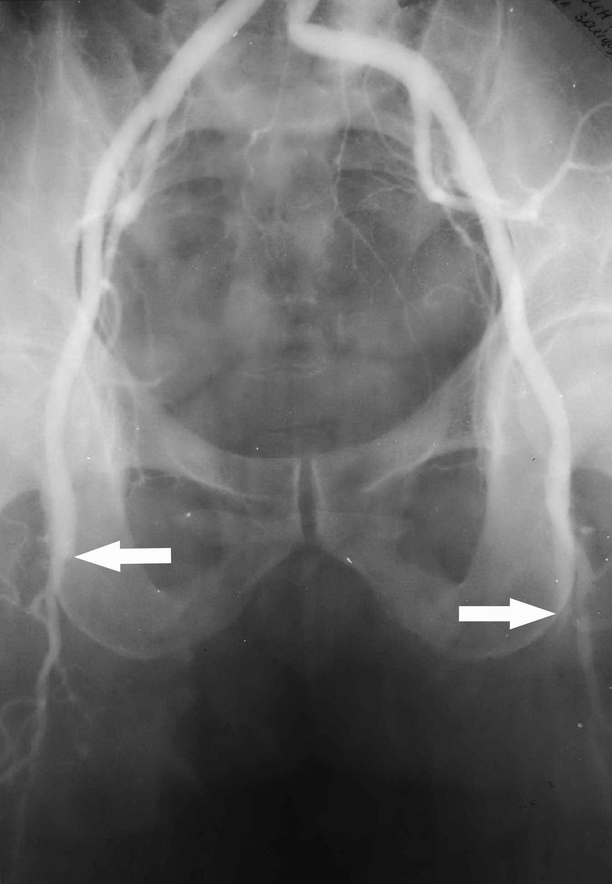 B 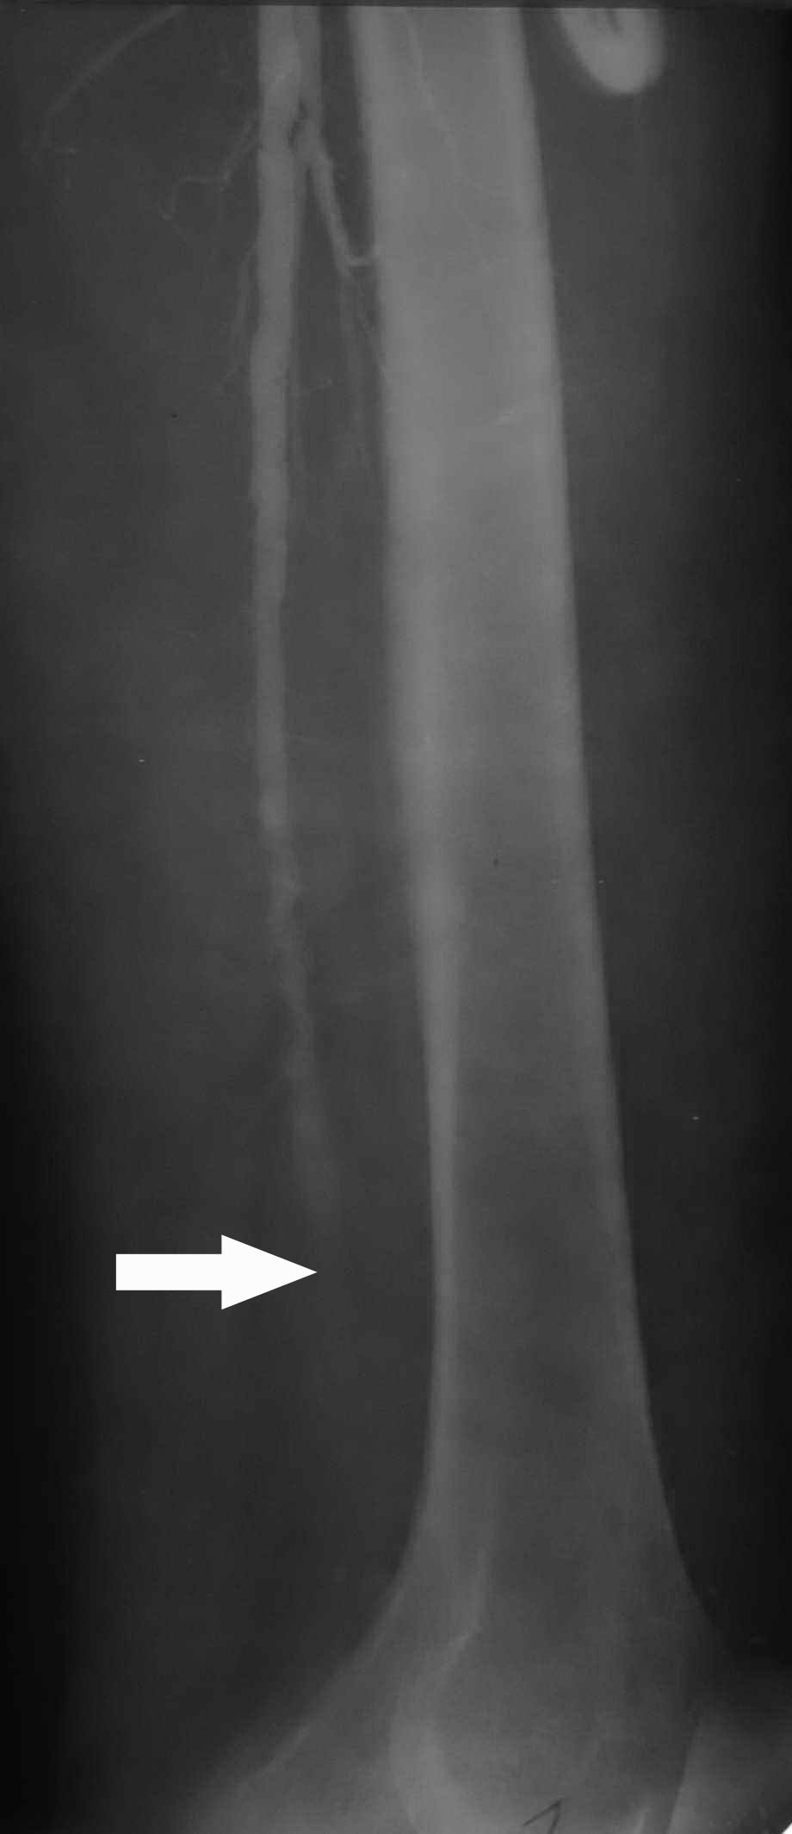 C 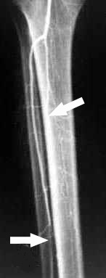

Fig. 9. Arteriographic pictures of atherosclerotic occlusion of both common femoral arteries (A), popliteal artery (B), and tibial arteries (C)

Surgical treatment

Indications tor surgery

- Indications for surgery include the following:
- Tissue necrosis of the leg or foot is an urgent reason to proceed with surgery.
- Rest pain.
- Claudication is a relative indication for intervention: if the symptoms interfere with a patient’s ability to work or if they interfere severely with the patient's lifestyle, surgery may be offered.

Femoropopliteal bypass

- Femoropopliteal bypass, using autogenous saphenous vein, is the basic operation (see Fig. 10).
- If a vein is not available or is not suitable for bypass, an artificial prosthetic graft may be used. Although early results with prosthetic grafts are acceptable, these grafts are not as curable as veins, and every reasonable attempt should be made to use autogenous material.
- The 5-year patency of vein bypasses is 65% - 80%, and the limb salvage rate is 90%.
- Mortality from the operation is primarily from myocardial infarction, and these patients should be evaluated for occult coronary artery disease.

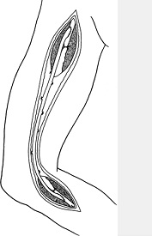

Fig. 10. Scheme of femoropopliteal bypass

Femorotibial bypass

- Femorotibial artery bypass is required in patients with occlusive disease in the popliteal and tibial vessels (see Fig. 11).
- One technique uses a reversed saphenous vein.
- The other technique leaves the saphenous vein in its bed but renders its valves incompetent (in situ technique).
- Both of these techniques give acceptable results: at 5 years the patency rate is approximately 70%; limb salvage rates are approximately 80%.
- If the greater saphenous vein is not usable, either lesser saphenous, cephalic, or brachial veins may be used. Patency rates are not usually as favorable (50% at 5 years) with these grafts.
- PTFE, dacron, and human umbilical vein have been used for bypasses to tibial vessels. The patency rates of these are approximately 20% at 1 year and are generally used only if autogenous vein is not available, or if the patient is a very poor risk and will not tolerate a long operation.

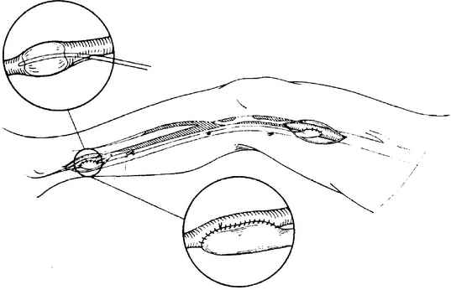

Fig. 11. Scheme of femorotibial bypass

Profundaplasty

- Profundaplasty (repair of the origin of the profunda femoris artery) as an isolated procedure may result in relief of rest pain and healing of ulcers if applied properly.
- This procedure is used in poor-risk patients with occlusion of the superficial femoral arteries and severe stenosis of the origin of the profunda femoris artery.
- It can often be carried out under local anesthesia.

Lumbar sympathectomy

- Lumbar sympathectomy is rarely useful in patients who have severe lower extremity arterial disease. It is an uncommon operation since the introduction of the femorotibial bypass.
- Good results may be obtained in patients with mild rest pain or small areas of superficial skin ulceration.
- This-procedure is rarely indicated in diabetics because many of these patients have an "autosympathectomy” as a result of their underlying disease.
- The L2, L3, and L4 ganglion are removed via a retroperitoneal approach.
- Lumbar sympathectomy is more frequently used for refractory cases of obliterating endarteritis, the disease affecting distal arteries (popliteal, tibial) due to edema and hyperplasia of vascular intima (see Fig. 16-12). Obliterating endarteritis commonly is a disease of young men who are poor smokers.

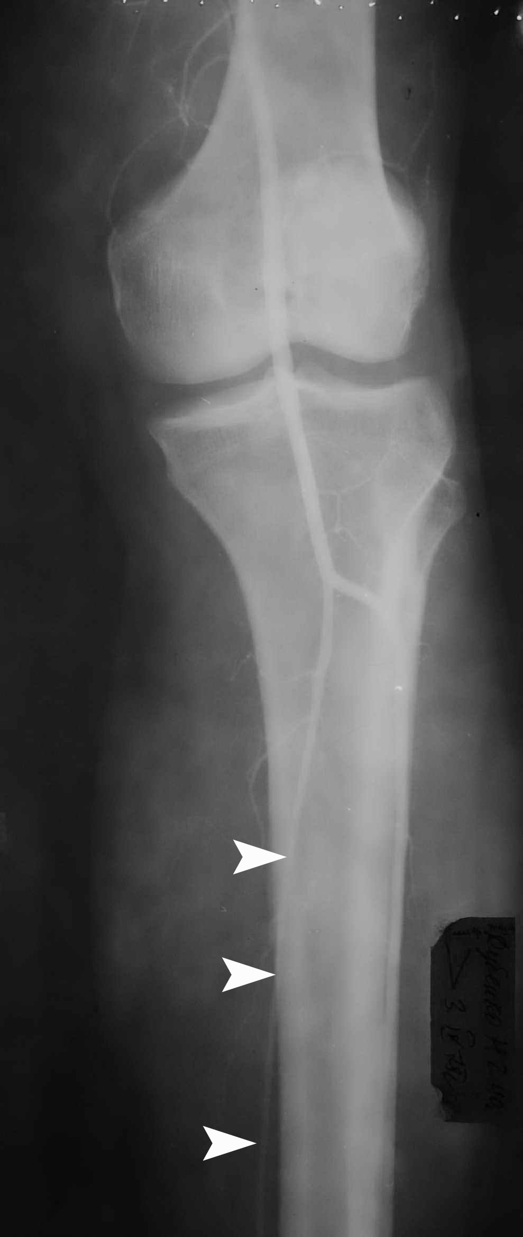

Fig. 16-12. Arteriographic picture of obliterating endarteritis

Amputation

- If reconstruction cannot be accomplished or if a patient is not a rehabilitation candidate, amputation (see Fig. 13) may be not only lifesaving but also expeditious in promoting the total rehabilitation or the patient. Occasionally, the result is better than that of an extensive vascular procedure.
- Indications for amputation include: systemic sepsis, particularly when caused by gas-forming organisms; a patient who has no potential for ambulation even after successful revascullarization; unreconstructable vascular disease.
- The level of amputation should be below the knee if possible. This choice allows the greatest chance of rehabilitation. An absolute method for predicting amputation healing is not available. The healing failure rate is up to 20% for below-the-knee amputations.
- Operative mortality rate is about 13%, with 50% of deaths occurring secondary to cardiac problems and 25% secondarily to respiratory problems. The long-term mortality rate following amputation is 50% at 3 years and 70% at 5 years when the amputation is performed for vascular disease.

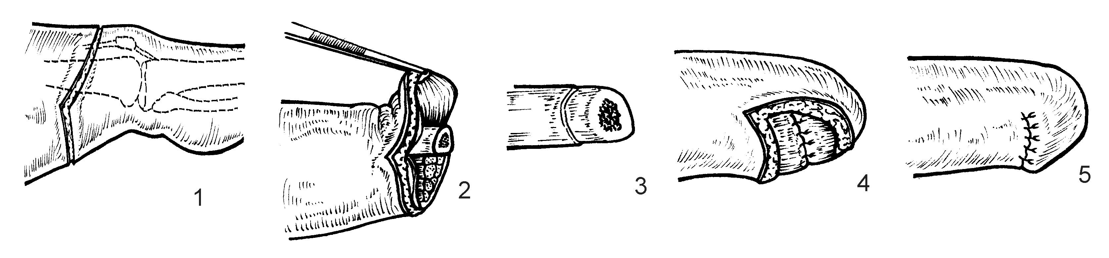

Fig. 13. Technique of lower limb amputation

ACUTE ARTERIAL INSUFFICIENCY OF THE LOWER EXTREMITY

Overview

- Acute arterial insufficiency of the lower extremity may occur because of embolization or thrombosis.
- Severe, acute ischemia may be followed by limb loss from nerve and muscle damage within a few hours if rapid diagnosis and prompt treatment do not occur.

Embolism

- The most common site of an arterial embolism is at a bifurcation, where the arterial lumen tends to narrow. The bifurcation of the common femoral artery into the superficial and deep femoral arteries is the most common site, followed by the iliac, popliteal, and mesenteric arteries (see Scheme 2).
- Heart disease is thought to be the source of emboli in 60% of cases (see Scheme 16-2).
- Atrial fibrillation is present in 50%-80% of patients who produce emboli.
- Mural thrombus, post-myocardial infarction or from a ventricular aneurysm may produce emboli.
- A patent foramen ovale may allow a paradoxical embolism to travel from the venous circulation into the arterial circulation.
- Rheumatic valvular heart disease is the source of emboli in 21% of patients.
- Arterial-arterial emboli may occur from aortic ulcerated plaques in 1%-2% of patients. This small but significant group of patients may present with digital emboli resulting in painful, cyanotic toes ("blue toe" syndrome). This syndrome may occur as a complication of arterial catheterization or angiography.

Scheme 16-2. Incidence of different sources of embolism (A) and embolised arteries (B)

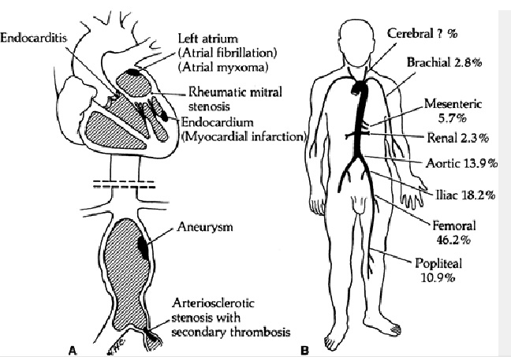

Thrombosis (acute occlusion)

- Acute occlusion of a chronically diseased artery may cause acute ischemia.
- Usually, these patients have a history of claudication, have a known lack of pulses, or have a number of risk factors for arterial occlusive disease, such as cigarette smoking, diabetes, and advanced age.

Clinical features and visualization data of acute arterial insufficiency of the lower extremity

- The clinical presentation from a lower extremity embolus results from acute ischemia to the affected muscle groups. The 5 P's (pain, paralysis, paresthesia, pallor, pulseless) are a convenient way to remember features of the ischemic limb.
- Pain is present in 80% of patients with an acute arterial occlusion, and it heralds the beginning of ischemia. If pain is absent, it may be because of the immediate onset of anesthesia or paresthesia or, in some patients, a well-developed collateral circulation.
- Paralysis and paresthesia (or anesthesia) develops because of the sensitivity of peripheral nerves to anoxia. Muscle is nearly as sensitive as nerve; therefore, motor or sensory deficits are accurate predictors of impending gangrene and limb loss.
- Pallor signals varying degrees of reduced circulation and is usually associated with coolness of the extremity.
- Absence of pulses helps localize the area of occlusion. Frequently, in older patients and in those with a history of claudication, pulses may chronically be absent or diminished. The presence of neurologic signs is the most accurate determining factor when deciding the urgency of the situation.
- Preoperative angiography should be obtained if the level of occlusion is uncertain, especially if a chronic disease is suspected. Angiography is frequently not necessary, and should not delay definitive therapy in a threatened limb. Intraoperative angiograms are often a useful method of obtaining needed information with minimal delay.

Treatment

- Management of acute arterial occlusion includes rapid diagnosis and expeditious surgical correction of the occlusion.
- Patients should be heparinized immediately when the clinical diagnosis is made.
- Patients should be given adequate hydration to maintain a high urine output (preferably 100 ml/hr). Alkalinization of the urine and osmotic diuresis (mannitol) are used to protect the kidney from damage due to myoglobinuria in patients with prolonged severe ischemia.
- Revascularization should be performed within 6 hours of the onset of symptoms for minimal morbidity from muscle and nerve damage.
- In the case of embolism, an embolectomy (see Fig. 15) is performed by exposing the artery and passing a balloon-tipped catheter through the embolus and thrombus, then inflating the balloon and withdrawing the catheter, extracting the thrombus. Limb salvage is possible approximately 75% of the time; the mortality in these patients approaches 20%.
- In a patient with an acute occlusion and chronic disease, an angiogram defines the anatomy and patent distal vessel. A bypass (see above) is usually the preferred therapy in these patients.
- The role of lytic therapy for an acute ischemic episode is still unclear. In patients with no motor or sensory deficits, lytic therapy may dissolve the embolus and thrombus, thereby avoiding an operation. In patients with motor or sensory deficits, lytic therapy is usually not the first choice because it can be time-consuming and may not be successful.
- Patients who have suffered an embolic event should have a complete cardiac evaluation (including an echocardiogram and Holter monitor) to search for an embolic source. These patients should be anticoagulated to reduce the chance of recurrence.
- See also Scheme 3.

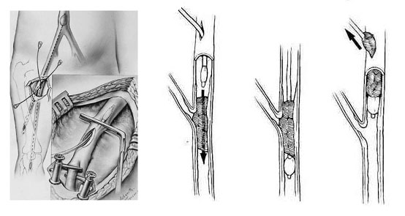

Fig. 15. Technique of embolectomy using balloon extractor

aneurysms

Abdominal aortic aneurisms

Overview

- An aneurysm is an abnormal dilatation of the wall of an artery. Generally, an aneurysm is considered significant if its diameter is twice that of the normal artery.
- An aneurysm of the aorta may rupture and cause death and should be repaired when detected.
- The cause of abdominal aortic aneurysms is multifactorial. Age, smoking, hypertension, and family history are all predisposing factors toward aneurysm formation.
- Aneurysms are more common in males (4:1).

Clinical features and visualization data

- Abdominal aortic aneurysms most often occur below the level of the renal arteries and are usually discovered on physical examination or during evaluation of an unrelated abdominal condition in which the patient has a CT scan, ultrasound examination, or abdominal x-rays.
- X-ray reveals calcification of part of the abdominal aorta seen on posterior-anterior or lateral abdominal films in 60% of patients.
- Ultrasonography and CT scan of the abdomen demonstrate the dilated aorta and are the most accurate tests for aneurysm size. CT is especially useful since it gives details about the relationship of the aneurysm to the renal and visceral vessels and demonstrates venous anomalies, which may be present (see Fig. 16, A,B).
- Angiography (see Fig. 16, C) is useful for patients with hypertension due to associated renal artery stenosis, distal arterial occlusive symptoms or suspected mesenteric ischemia.

A 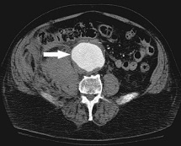 B 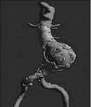 C 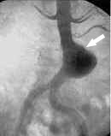

Fig. 16. Aneurysm of abdominal aorta: contrast-enhanced CT (A), 3D-reconstruction (B), and angiographic picture (C)

Treatment

- Aneurysms are repaired by replacing the diseased segments of the aorta with prosthetic grafts (see Fig. 17).
- All patients undergoing elective repair should have careful preoperative medical screening, including a cardiac evaluation. Patients with severe or unstable coronary artery disease should undergo CABG preoperatively.
- Intraoperative patients should be very carefully controlled. A Swan-Ganz catheter is used to monitor cardiac filling pressure and cardiac output before, during, and after aortic clamping. Mannitol is given to stimulate brisk diuresis. Aortic clamp time is kept to a minimum. Clamps are removed slowly, and fluid, acid-base and electrolyte status is adjusted.
- The novel technique with lesser morbidity and mortality is aortic stenting (see Fig. 18). But studies evaluating the long-term patency of the stents are still ongoing. Except re-occlusion, potential complication of stents is dislocation.

A 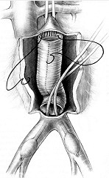 B 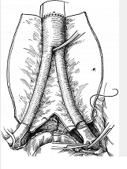

Fig. 17. Scheme of repair of aneurism of infrarenal segment (A) and bifurcation (B) of aorta
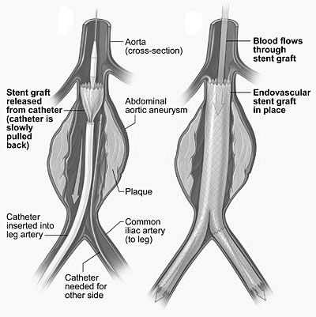

Fig. 18. Scheme of repair of aneurism of infrarenal segment of aorta using Z-stent

Atypical aneurysms of the abdominal aorta

Inflammatory aneurysms

- Inflammatory aneurysms are characterized by a dense fibrotic reaction, involving primarily the anterior and lateral walls of the aneurysm and the surrounding tissues.
- The duodenum is frequently densely adherent to the aneurysm wall and can be severely injured if attempts are made to mobilize the aneurysm. The aneurysm is repaired by dissecting the neck above the area of inflammation for proximal control, frequently above the duodenum near the renal vein. Control of the iliac vessels is frequently obtained after the aneurysm has been opened using balloons to occlude the lumens from within.
- The inflammatory reaction frequently recedes after the aneurysm is repaired.

Mycotic aneurysms

- Mycotic abdominal aortic aneurysms are caused by bacterial inflammation of the arterial wall. In the infrarenal aorta, the most common organism found is Salmonella.
- Mycotic aneurysms usually are saccular, occur in atypical locations, and lack calcification of the wall.
- Patients present with fever, elevated white blood cell counts, and positive blood cultures. Evidence of septic embolization may also be present.
- Treatment begins with culture and sensitivity-directed antibiotics. The patients are then surgically explored.
- If there is no periaortic purulence and Cram stain of the proximal and distal artery is negative, the aneurysm is repaired with an interposition graft.
- If gross purulence is present, the aneurysm and surrounding tissue are resected, the aorta is closed, and an extra-anatomic bypass (i.e., axillobifemoral bypass (see above)) is constructed.
- Long-term antibiotic therapy is indicated in these patients.

Ruptured abdominal aortic aneurysms

Overview

- The risk of rupture is related to the size of the aneurysm.
- Approximate rates of rupture in 5 years are: if less than 4.5 cm in diameter, 9%, if 4.5 - 7 cm in diameter, 35%, if more than 7 cm in diameter, 75%.
- The expansion rate of an aneurysm is 0.4 cm in diameter per year. More rapid expansion suggests an unstable aneurysm and is an indication for repair.

Clinical features and visualization data

- Severe central abdominal or back pain, occasionally localized to the lower abdomen, groin, or testes.
- A pulsatile, usually tender abdominal mass is present.
- Patients presenting with the sudden onset of abdominal pain and a pulsatile abdominal mass should be taken directly to surgery without any further diagnostic tests. Any delay in surgical repair could prove lethal.
- Some patients with a small, contained rupture may have a stable blood pressure. They are at risk of catastrophic decompensation and should be treated urgently.
- If there is significant doubt about the diagnosis (e.g., obese patients may not have palpable aneurysms; and some patients may have other coexisting medical problems or a history of chronic back pain confounding the diagnosis), an immediate CI scan can help establish the presence of an abdominal aortic aneurysm, and sometimes establish whether it is leaking.

Treatment

- Surgical repair of a ruptured aortic aneurysm must be performed as soon as the diagnosis is made.
- The operative mortality rates range from 50% to 60%. Death is usually secondary to massive intraoperative hemorrhage and cardiac complications.

Postoperative complications

Postoperative renal failure

- Postoperative renal failure occurs in 21% of cases of ruptured aneurysms and in less than 2% of aneurysms treated by elective surgery.
- If hemodialysis is required, the risk of mortality rises to approximately 50%.

Ischemic colitis

- Ischemic colitis results from ligation of the inferior mesenteric artery. It occurs to some degree in 6% of elective cases, but it results in full-thickness injury with necrosis in only 1%-2% of cases.
- Ischemic colitis should be suspected in any patient with postoperative diarrhea, especially when the stools are heme-positive. It can usually be diagnosed with sigmoidoscopy. The mortality rate can reach 50% if diagnosis and treatment are delayed.
- Treatment consists of resection of the dead colon, proximal colostomy, and closure of the distal colon (Hartmann's procedure).

Acute leg ischemia

- Acute leg ischemia should be suspected if pulses that were present previously are absent. It is caused by clamp injury or embolization.
- Treatment is repair of the injury or embolectomy.

Spinal cord ischemia

- Spinal cord ischemia is a rare complication (0.25% of cases) of aortic aneurysm surgery and is most common in cases of ruptured aneurysm. Spinal cord ischemia results from diminished flow through the artery of Adamkiewicz (which supplies the spinal cord and arises from the left side of the abdominal aorta, usually at Th₈ to L₁ but occasionally as low as L₄), due to systemic hypotension or clamping of the aorta.
- Spinal cord ischemia produces a classic anterior spinal artery syndrome: paraplegia; rectal and urinary incontinence; and loss of pain and temperature sensation but preservation of vibratory and proprioceptive sensation.

Aortic graft infection

- Aortic graft infection may result from bacterial seeding either at the time of graft implantation or at a later date as a result of bacteremia. The most common infecting organism is Staphylococcus aureus, but Staphylococcus epidermidis is not infrequently found. The lumen of all currently used grafts is covered with a pseudointima rather than endothelium and have a decreased resistance to infection compared to the native vessel.
- The incidence of infection is 1% - 4%. It may be decreased significantly by the perioperative use of antibiotics. Cephalosporins are the drugs of choice.
- If the graft goes to the femoral arteries, the most common presenting sign is an inflammatory mass or draining sinus in the groin. Grafts that are totally in the abdomen may present only with fever and occasionally abdominal discomfort. Multiple skin petechiae may be seen in the lower extremities due to small emboli from the infected graft.
- The graft anastomosis may erode into the gastrointestinal tract, a condition called an aortoenteric fistula. Endoscopy and aortogram may demonstrate the condition.
- Treatment depends on the location of the infection. Local groin infection of an aortofemoral bypass can be treated by unilateral graft limb excision and, if necessary, extra-anatomic reconstruction of the involved leg. Infection of an intra-abdominal graft mandates bilateral extra-anatomic reconstruction followed by removal of the graft. Graft infection is a serious problem, which carries a 35% - 50% mortality and a 20% - 40% chance of major amputation.

Sexual dysfunction

- The sympathetic nerves controlling ejaculation cross the left common iliac artery near the aortic bifurcation. If injured, retrograde ejaculation will occur.
- Disturbance of pelvic blood flow during aortic reconstruction may result in impotence. Perfusion of at least one hypogastric artery should be maintained in planning the method of graft placement.

Other arterial aneurysms

Iliac artery aneurysms

- Iliac artery aneurysms usually are extensions of aortic aneurysms. They rarely occur as isolated aneurysms.
- They may be diagnosed as pulsatile masses that are palpable on rectal examination; occasionally, they rupture into the sigmoid colon or another part of the gastrointestinal tract and present with gastrointestinal bleeding.

Splenic artery aneurysms

- Splenic artery aneurysms are the second most common intra-abdominal aneurysm after aortic. Causes include fibrous dysplasia, portal hypertension, multiparity, and inflammation (secondary to pancreatitis).
- Rate of rupture of bland splenic aneurysms in nonpregnant women is 2%, in a pregnant woman - 90%. The mortality of rupture is 25%.
- Diagnosis is frequently incidental and is made when a plain film of the abdomen shows a left upper quadrant ring-shaped calcification or ultrasound shows round-shaped lesion with visible blood flow.
- Indications for repair include rupture, symptoms (pain in left upper quadrant), and the presence of an aneurysm in a woman of childbearing age.

Peripheral arterial aneurysms

- The popliteal artery is the most common location for peripheral aneurysms. The usual cause is atherosclerosis.
- Approximately 50% are bilateral. Of these, 25% have associated abdominal aortic aneurysms.
- Rupture is rare, but embolization and thrombosis are common. Thus, these aneurysm should be repaired when discovered.
- Physical examination detects prominent popliteal pulses, and the aneurysm can be seen on ultrasound. An arteriogram (see Fig. 16-19) guides reconstruction.
- Most popliteal aneurysms are treated by ligation and bypass. Attempts to completely remove the aneurysm are dangerous because of injury to adjacent nerves.

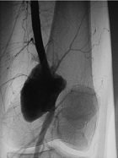

Fig. 16-19. Arteriographic picture of aneurysm of popliteal artery

VASOSPASTIC DISEASES

Overview

- Vasospastic diseases chiefly affect the upper extremities and involve episodic vasoconstriction, usually of the small palmar and digital arteries and arterioles.
- Common symptoms include pain, numbness, coldness, and, occasionally, skin ulcers.
- Vasospasm may be caused by occupations in which the hands suffer repeated trauma, such as a jackhammer operator; collagen vascular disease; atherosclerosis; emboli from peripheral arterial lesions; hematological disorders (cryoglobulinemia or cold hemagglutinins, thrombocytosis, macroglobulinemia); myxedema; nerve compression syndromes (such as the carpal tunnel syndrome); arterial compression syndromes (such as the thoracic outlet syndrome); or may be without an identifiable causative factor.
- Doppler examination is used to measure arm and wrist blood pressure.
- The presence of a cervical or an axillary bruit suggests arterial occlusive disease. Arteriography may be necessary to eliminate this possibility totally. During arteriography, avasodilator may be injected intra-arterialiy and the dye injection repeated. Demonstration of increased blood flow and vasodilation is strong support for the presence of vasospastic disease.

Raynaud's phenomenon

Overview

- Raynaud's phenomenon is episodic vasoconstriction, most commonly of the fingers occasionally of the feet. It is usually initiated by cold exposure or emotional stimuli occurred mainly in women.
- Although scleroderma is most commonly associated with Raynaud's phenomenon, it may develop in anyone with a collagen vascular disease.

Clinical features

- The affected digits may go through a classic sequence of color changes: pallor, cyanosis, and rubor due to the reactive hyperemia.
- Symptoms range from numb discomfort, which is usually localized in the fingers, to ulceration or gangrene.

Treatment

- Cold should be avoided. Hands should be protected by gloves or hand warming in extremely cold weather.
- Tobacco should be avoided because it stimulates vasoconstriction.
- Emotional problems should be controlled.
- Calcium channel blockers, such as nifedipine, are the drugs of choice.
- Sympathectomy is rarely recommended.

Raynaud's disease

- Raynaud's disease is similar to Raynaud's phenomenon; however, the condition shows no association with a systemic disease.
- The process rarely progresses to necrosis.
- Seventy percent of patients are young women, in whom the occurrence is usually bilateral and symmetrical.
- Treatment is similar to that of Raynaud's phenomenon, and nonoperative management controls at least 80% of patients.

5. Plan and structure of the class

No. | Basic stages of the class | Training aims according to the levels of mastering | Means of training and control | Materials for methodological maintainance of  the class, visibility, and control of knowledges | Terms (in minutes or per cent)
1 | Initial | 1) Giving the training aims of level I (see chapter 2.1)  2) Control testing of initial level of knowledge, readiness of the students for perception of the material | Krok-2 type tests of initial level of knowledge, including software version (see chapter 6.1) | Krok-2 type tests of initial level of knowledge, including software version (see chapter 6.1) | 15 %
2 | Basic | 1) Giving the training aims of levels II – IV (see chapter 2.1)  2) Observation of patients, disucussion of algorithms of diagnostics and management of patients with Thromboses and embolisms of arteries of lower limb | Observation of patients at the department of robotic and endoscopic surgery | 1) Schemes, tables (including PowerPoint presentations) of algorithms of diagnostics and management  2) Diagnostic images  3) Illustrations and videos of surgical procedures | 70 %
3 | Conclusive | 1) Control testing of theoretical knowledges and practical skills  2) Conclusions  3) Giving the home task | 1) Krok-2 type tests of final level of knowledge, including software version (see chapter 6.3)  2) List of literature for the next class | Krok-2 type tests of final level of knowledge, including software version (see chapter 6.3) | 15 %

6. Materials for methodological maintainance of the class

6.1. Materials for initial stage of the class

A 43 year old patient had right-sided deep vein thrombosis of iliofemoral segment 3 years ago. Now he is
suffering from the sense of heaviness, edema of the lower right extremity. Objectively: moderate edema of shin,
brown induration of skin in the lower third of shin, varix dilatation of superficial shin veins are present. What is
the most probable diagnosis?
Lymphedema of lower right extremity
Postthrombophlebitic syndrome, varicose form
Acute thrombosis of right veins
Parkes-Weber syndrome
Acute thrombophlebitis of superficial veins
•••••
A patient with frostbite of both feet was delivered to the admission ward. What actions should be taken?
To apply an alcohol compress
To put feet into hot water
To apply a bandage, to introduce vasodilating medications
To administer cardiac medications
To rub feet with snow
•••••

A 98 y.o. male patient complains of pain in the left lower limb which intensifies on walking, feeling of cold and
numbness in both feet. He has been ill for 6 years. On examination: pale dry skin, hyperkeratosis. Hairy covering
is poorly developed on the left shin. "Furrow symptom " is positive on the left. Pulse on foot arteries and popliteal
artery isnt palpated, on the femoral artery its weak. On the right limb the artery pulsation is reserved. What is
the most probable diagnosis?
Raynaulds disease
Obliterating endarteritis
Buergers disease (thromboangiitis obliterans)
Hemoral arthery thombosis
Arteriosclerosis obliterans

A 62-year-old male patient complains of intense pain in the left leg that suddenly arose three hours before, leg
numbness and coldness. During the year there has been pain in the leg while walking, hypersensitivity to
cooling. Objectively: the left foot and shin have marbled skin, subcutaneous veins are collapsed. The foot is cold,
active movements of the foot and toes are preserved. Pulse is present only on the femoral artery. There is rough
systolic murmur above the artery. Make a provisional diagnosis:
Stenosis of the left popliteal artery
Occlusive disease
Acute occlusion of the left femoral artery
Acute arterial thrombosis ileofemoralny
Acute thrombophlebitis

A 50-year-old patient complains of bursting pain in the left lower limb that is getting worse on exertion,
swelling in the region of shin and foot. Objectively: left shin and foot are doughy, skin of the lower shin is
indurated and has a bronze tint, subcutaneous veins are dilated, there is an ulcer with necrotic masses. What is
the most likely diagnosis?
Gangrene of the lower extremity
Chronic arterial insufficiency
Acute arterial thrombosis
Postthrombophlebitic syndrome
Deep vein thrombosis of the lower limbs

6.2. Materials for basic stage of the class

Scheme 1. Site of arterial occlusion and corresponding site of associated limb ischemia
From: Basic surgery/ed., H.C. Polk, Jr., et al. – 5th ed.

Scheme 2. Incidence of different sources of embolism (A) and embolised arteries (B)

Scheme 16-3. Management options for acute lower limb ischemia
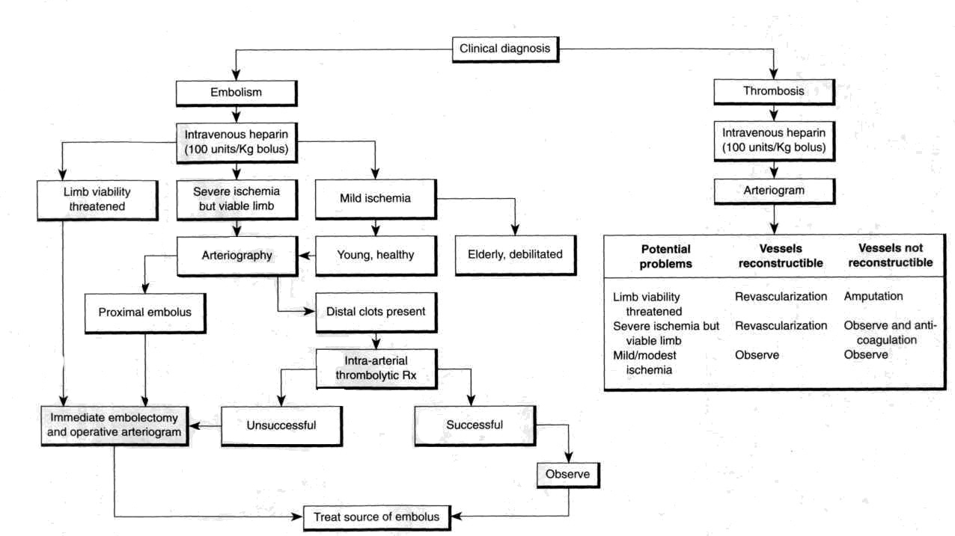

From: Basic surgery/ed., H.C. Polk, Jr., et al. – 5th ed.

Table 1. Operations for treatment of chronic lower extremity ischemia

Site of disease | Procedure options
Aortic and/or bilateral iliac artery | Aorto-bilateral-femoral bypass  Axillo-bilateral-femoral bypass
Unilateral iliac artery stenosis | Percutaneous transluminal angioplasty (РТА)  Iliac thromboendarterectomy  Femorofemoral bypass  Aortofemoral bypass
Profunda femoris artery | Thromboendarterectomy
Superficial femoral or popliteal artery | Femoropopliteal bypass with saphenous vein  Femorotibial bypass with saphenous vein
From: Basic surgery/ed., H.C. Polk, Jr., et al. – 5th ed.

Table 2. Factors suggesting embolism versus thrombosis

Factor | Embolism | Thrombosis
Identifiable source or risk  factor for embolus | Usual, particularly atrial fibrillation  or prior history of embolism | Unusual
History of claudication | Rare | Common
Physical findings suggestive  of occlusive disease | Few; proximal and contralateral  limb pulses normal | Often present; proximal or contralateral limb pulses diminished or absent

7. Literature for teachers

- General Surgery: textbook / S.D. Khimich, M.D. Zheliba, V.P. Andryushchenko et al. — К., 2019. — 536 p., hardcover

- Essential surgery. Editor prof V.V.Grubnik, O.L.Kovalchuk, A.V.Malinovsky. Ternopil, TSM, 2010, 543 p.

- Surgery: a textbook is intended for English-speaking students of higher medical educational institutions of III-IVth levels of accreditation, interns / K. M. Amosova, Ya. S. Bereznyts’kyy, A. O. Burka [et al.]; ed. by Ya. S. Bereznyts’kyy [et al.], 2016. - 711 p.

- Surgery: a textbook is intended for English-speaking students of higher medical educational institutions of III-IVth levels of accreditation, interns / K. M. Amosova, Ya. S. Bereznyts’kyy, A. O. Burka [et al.]; ed. by Ya. S. Bereznyts’kyy [et al.], 2018. - 711 p.

- Essential surgery [Text] : навч. посіб. для студ. вищ. мед. навч. закл. IV рівня акредитації, які опановують навч. дисципліну англ. мовою (протокол № 4 від 01.10.2010 р.) / V. V. Grubnik, O. L. Kovalchuk, A. V. Malynovskyy, O. V. Grubnik. - Ternopil : TSMU "Ukrmedknyha", 2010. - 544 p. : fig., tab. - Текст англ. - Бібліогр.: с. 529-531. - 500 прим. - ISBN 978-966-673-147-3

- Sabiston textbook of surgery: the biological basis of modern surgical practic / [edited by] Courtney M. Townsend, Jr, R. Daniel Beauchamp. B. Mark Evers, Kenneth L. Mattox.—20th edition.
- Surgery Editor. Bereznyts'ky Y.S., Zarharash M.P, Mishalov V.G. Vinnytsia, 2016, 711p.

8. Literature for students

8.1. Basic literature

- General Surgery: textbook / S.D. Khimich, M.D. Zheliba, V.P. Andryushchenko et al. — К., 2019. — 536 p., hardcover

- Essential surgery. Editor prof V.V.Grubnik, O.L.Kovalchuk, A.V.Malinovsky. Ternopil, TSM, 2010, 543 p.

- Surgery: a textbook is intended for English-speaking students of higher medical educational institutions of III-IVth levels of accreditation, interns / K. M. Amosova, Ya. S. Bereznyts’kyy, A. O. Burka [et al.]; ed. by Ya. S. Bereznyts’kyy [et al.], 2016. - 711 p.

- Surgery Editor. Bereznyts'ky Y.S., Zarharash M.P, Mishalov V.G. Vinnytsia, 2016, 711p.

8.2. Additional literature

- Surgery: a textbook is intended for English-speaking students of higher medical educational institutions of III-IVth levels of accreditation, interns / K. M. Amosova, Ya. S. Bereznyts’kyy, A. O. Burka [et al.]; ed. by Ya. S. Bereznyts’kyy [et al.], 2018. - 711 p.

- Essential surgery [Text] : навч. посіб. для студ. вищ. мед. навч. закл. IV рівня акредитації, які опановують навч. дисципліну англ. мовою (протокол № 4 від 01.10.2010 р.) / V. V. Grubnik, O. L. Kovalchuk, A. V. Malynovskyy, O. V. Grubnik. - Ternopil : TSMU "Ukrmedknyha", 2010. - 544 p. : fig., tab. - Текст англ. - Бібліогр.: с. 529-531. - 500 прим. - ISBN 978-966-673-147-3

- Sabiston textbook of surgery: the biological basis of modern surgical practic / [edited by] Courtney M. Townsend, Jr, R. Daniel Beauchamp. B. Mark Evers, Kenneth L. Mattox.—20th edition.

9. Topics for student’s research

(3-4 topics)

10. Topic of the next class

Preparation for exam.

Elaboration composed by: ass. Chernov Nikolai

