ODESSA NATIONAL MEDICAL UNIVERSITY
DEPARTMENT OF ROBOTIC AND ENDOSCOPIC SURGERY

METHODICAL instructive elaboration

of the practical class for the discipline
"Surgical diseases with child's surgery and oncology» for students of the 6-th course of the medical faculty

Topic № 7: “Purulent diseases of fingers and hand”.

Discussed and approved at
methodical board of Department
of Robotic and Endoscopic surgery
"28" August 2019
Protocol № 1
Head of the Department
Ass. prof. __________ Malinovsky A.V.

Odessa - 2019

Topic of practical class:Purulent diseases of fingers and hand

1. Significance of topic

Purulent diseases of the hand and fingers are most often caused by minor injuries, cuts, pricks, which are the entrance gates for the microflora. In conditions of intensive industrial and agricultural production, this occurs in the most active part of the population. It is known that about 20% of all outpatient surgical patients are being treated for panaritium. This disease causes a loss of ability to work for a considerable period of time. Phlegmon and abscesses of the hand also often lead to disability of patients, which predetermines the need for early diagnosis and proper treatment of patients in this category.
2. Aims of the class

2.1. Training aims (a student must learn and master):

Level I – to teach students the method of examination of patients with purulent diseases of the hand

Level II – diagnose various diseases of the hand

Level III – to know the evidence for conservative and prompt intervention, - know the technique of surgical interventions

Level IV – treatment of a patient in the postoperative period

2.2. Educational aims:

1. Formation of professional personality of doctor.
2. Formation of medical deontology and ethics, professional responsibility.

3. Interdisciplinary integration

№ | Disciplines | To know | To master
Previous disciplines (basic disciplines)
1 | Anatomy | Differentiate the anatomical structures of the fingers and brush, show the projection of the vessels and nerves on the brush, depict the areas of inertia of the skin of the fingers and hands. | Identify the focus of inflammation; Operational access according to anatomical features
2 | Pharmacology | Classify the main antimicrobial substances according to the mechanism of action on pathogens of infection, be able to calculate the doses of chemotherapeutic substances, be able to prescribe recipes for basic chemical antiseptics. | Prescribe conservative treatment, preoperative preparation, treatment in the postoperative period.
3 | Microbiology | Classify pathogens of infectious diseases. | To possess methods of bacteriological research of a material and to identify pathogens of infectious diseases

4. Contents of the topic
Felon is a collective name for all acute inflammatory processes of different structures of fingers, mainly hands (their palmar surface). Clinical manifestation of pannification in the hands largely depends on the anatomical and functional features of the fingers. Skin of the palmar and back surfaces of the fingers is different. In the skin of the palmar surface there is no pigment apparatus, hair and sebaceous glands, which excludes the possibility of boils and carbuncles, but many sweat glands.
The skin of the palmar surface of the fingers is well innervated, which is the reason for the expressed tactile sensitivity and severe pain in the case of the fingers of the inflammatory process. The skin of the back of the fingers is soft, elastic, movable. It has hair and sebaceous glands (with the exception of the end phalanx). Therefore, boils and carbuncles can develop only on the main and middle phalanges. On the palmar surface of the fatty base is more than on the back. There is no subcutaneous fascia, and directly from the papillary layer, almost perpendicularly, are dense connective tissue strands, which are woven on the periosteum on the end phalanx, and on the middle and main phalanges - in the wall of the tendonous vagina, densely interlaced with connective tissue fibers, which, arranged parallel to the surface Skin, forming in a subcutaneous basis numerous cells. Due to this structure, it is limited to the movement of the skin and makes it difficult to spread the edema, the growth of which quickly leads to compression of blood vessels, damage to the blood supply of fatty lobes and a sharp increase in pain due to increased intracutaneous pressure. The vertical walls of the cells do not allow the spread of the inflammatory process on the plane, but contribute to the penetration of the infection towards the bone. On the back surface of the fingers, the connective tissue fibers are arranged parallel to the surface of the body and do not prevent the spread of edema.
The rear surface of the end phalanx is protected by a nail. The nail plate has a quadrangular shape. Proximal and lateral edges deepen into the nail bed. Above the proximal edge of the plate (matrix) the skin folds-eponymy, or nail roller, hangs. From the inner surface of the nail plate to the gut phalanges are connective tissue bundles that fix the nail to the bone, which promotes the spread of suppurative process on the nail phalanx. Regeneration of the nail after its removal lasts 4-6 months.
On the palatine surface, two tendons go to each finger, except for the big one: the superficial and deep flexor. The thumb has one bending tendon (the long flexor and finger).
Tenderness vagina I and V fingers longer than others. They pass through the space of Pirogov to the distal part of the forearm with the formation in it and on the forearm of the common synovial lake. Tendon vagina II-IV fingers are shorter and end already at the level of the phytic-phalangeal joints. This has great practical value in the clinic of the disease. Due to the long abdomen I and V of the tendon of the fingers and the fusion of them in the wrist area, the inflammatory processes of the tendon vagina of these fingers are more severe and complicated by deep phlegmons in the brush. Inflammation of the tendons of II-IV fingers is limited to these fingers. II-V fingers have 3 phalanges, the first - 2 phalanxes. Phalanxes are interconnected by means of block joints.
Each finger is blood-drawn with 4 arteries: 2 palm and 2 rear ones. Blood supply of the nail phalanx has its own peculiarities. While the middle and the main phalanx have a separate feeding artery, the nail phalange is supplied by the blood vessels of the spreading type. In this case, the blood supply to the proximal and distal epiphyses is better than the other parts of the phalanx, because they have separate arterial branches of different caliber, which penetrate into the bone mainly from the palmar surface. It plays an important role in the pathogenesis of bone panaritis of the end phalanx.
The innervation of fingers is carried out by sensory and motor branches of 3 nerves: elbow, radial and medial, which, disintegrating on the final branches, innervate the corresponding areas. The finest phalanges are best innervated, which explains severe pain in the event of a pathological process in them.
The lymph from the fingers flows out by superficial and deep lymphatic vessels. The pronounced lymphatic network is present on the back surface of the nail phalanx, palmar surface of the fingers, palms. Hence, the lymphatic vessels follow the lateral surfaces of the fingers in the inter-fringe-fold folds and through the latter penetrate the rear of the brush. In this regard, in the event of an inflammatory process on the palmar surface, swelling of the brush is expressed more strongly on the reverse side.
Etiology. Purulent inflammation of fingers is observed in 20-25% of patients of surgical clinics. In its occurrence an important role is played by different kinds of microtraumas. Most often it is broken wounds and rollers. In this connection, panaritium is mostly in people whose occupation is associated with the possibility of injury to the fingers (fish industry workers, butchers, cooks, medical workers, especially surgeons and midwives, etc.).
More injuries rarely cause panaritias, because they pay more attention. The most common cause of panaritis is streptococci and staphylococci. There is an inflammatory process on the fingers more often when their skin is dry, weakened. In most patients, panaritis is localized on the right hand - due to increased functional load. Most often the ultimate phalanx is affected.
Classification. Depending on the depth of penetration of microbes and the development of infection, the following types of felon are distinguished:
- superficial - skin (panaritium cutaneum); Subcutaneous (panaritium subcutaneum), nail (whiten or paronychia - felon parunquale s.paronychia); Sublingual (panaritium subunquale);
- deep-tendon (panaritium tendinosum s.tendovaginitis purulenta); Bone marrow (panaritium osseum); Articular joint (panaritium articulare).
If the pathological process captures all the tissues of the finger, develops pandactilitis (pandactilitis). A profound panaritium is usually a consequence of untimely and inferior surface treatment.
Clinics and surgical tactics in different forms of panaritium have their own peculiarities.
Skin felon occurs in the case of a shallow penetration of the infection. The inflammatory process thus develops under the epidermis. The latter exfoliate and forms a blister filled with pus. More often, this kind of pannariation is localized on the palmar surface of the finger. The appearance of the bladder is accompanied by a slight pain, which gradually increases. The puff may reach such dimensions, which sometimes captures the entire phalanx. On the back surface of the brush and forearm there are signs of lymphangiitis, which is accompanied by an increase in body temperature. The general condition of the patient with this kind of panaritium is usually not disturbed.
The treatment of skin felon operative: after treating the surgical field, the knifes on the edges cut off the blister. The manure is removed, the necrotized epidermis is removed. After this, it is necessary to make sure that the subcutaneous panaritis is not associated with deep tissues. To do this, click on the affected area with your finger. In the case of penetration of infection under the skin from the depths will be manure. In such cases, using one or the other method of anesthetizing, the subcutaneous stern is cut off. The operation ends with an overlay of a band-filled antiseptic. If skin panaritis is complicated by lymphangitis, immobilization of the finger and brush is carried out.
On the back surface of the skin panaritium is less common and localized more often in the middle phalanx. The average duration of skin panaritium is 4-5 days.
Subcutaneous felon is most common. The reason for penetration of the infection into the subcutaneous basis is crushed microtrauma. In 80-90% of cases, it is localized on the palmar surface of the I-III fingers of the right hand. In women, subcutaneous panaritis is more common than that of men (needles). Subcutaneous panaritium is accompanied by the appearance of severe pain in the fingers, which prevents the patient from sleeping. Sometimes the pain has a twitching character that is synchronous with the pulse. It is connected with the fact that the connective tissue membranes, which go vertically from the skin to the periosteum, do not allow the spread of edema, therefore its pressure in the tissues rises, compression of the nerve receptors.
The finger swells, especially its back surface. When the process is localized only on the subcutaneous basis, redness of the skin may not first be present. In the case of severe edema, the skin becomes even pale as a result of compression of the blood vessels.
Pressing the probe on the affected area reveals the maximum pain zone. The patient spares his finger and holds him slightly bent. With subcutaneous panaritis, the general condition of the patient is almost not violated. In the course of connective tissue fibers, the process can go to the bone, in the tendon vagina, joint, lymphatic and blood vessels
Patients with subcutaneous panarticism at first rarely seek help from a doctor. Usually they do this after the first sleepless night, which is a gross mistake, because at this time in most cases, deep destructive, necrotic processes occur in the finger tissue. In the first 2-3 days (in a serous or serosinfiltrative stage), under the control of a physician, conservative therapy may be performed. Immobilize the brush, apply local and general antibiotic therapy, prescribe sulfanilamide preparations.
At the amazed finger, an alcohol dampening band is applied, which is changed 2-3 times a day, makes for a finger warm baths (alcoholic or with antiseptic) for 40-60 minutes 2 times a day.
In the absence of the effect of conservative therapy for 1-2 days, operative treatment is shown. The latter should be carried out under reliable anesthesia. This may be local novocaine anesthesia (with subcutaneous panaritis of the nail and middle phalanges) or intravenous anesthesia. Local anesthesia is carried out according to the method proposed by Oberst-Lu-Kashevich. With subcutaneous panaritization of the nail phalanx, it is expedient to carry out the so-called hook-shaped incision. By ensuring good outflow of manure, it does not very deform the finger, does not violate its tactile sensitivity and function.
In the event of localization of the inflammatory process on the primary and middle phalanges, cuts are made along the side surfaces of the finger of the phalanx. You can also apply longitudinal sections through the point of greatest pain. After the opening of the inflammation cell and the creation of conditions for evacuation of manure cut necrotic tissue. The wound is drained with rubber strips. It is not recommended to use gauze tampons, because they dry up quickly and inhibit the outflow of manure.
Paronychia is an inflammation of the nail roller. More often, the causes of paronychia are the microtubule of the rear surface of the end phalanx, near the nail, the tuck. Characterized by paronychia with painful swelling of the rhinitis roller and hyperemia of adjacent tissues. The damaged roller hangs over the nail plate. Palpation of the end of the finger, especially at the base of the nail, is extremely painful. Sometimes manure can penetrate under the nail plate, and then there is a sublingual panaritium. During pressing from under the skin roller manure is isolated. The general condition of patients is almost unchanged. By localization of manure distinguish surface (subepidermalnaya) and deep paronychia. In the case of the latter, the manure is collected in the thickness of the nail roller.
Treatment of paronychia begins with the application of conservative measures. Several times a day make warm baths from a solution of sodium bicarbonate. Carry out physiotherapy procedures. To ensure the outflow of manure, tweezers or knifes, you can slightly pull up the nail roller. When it does not help, operative treatment is shown. Make two cuts of the nail roller (0.5 cm each) as an extension of the two edges of the nail plate. Separate the flap of the nail roller. Cut the proximal end of the nail plate and cut it at a distance of 0.5 cm in a place where it is opaque from the bed. It is important to well reject the nail plate, carefully remove the manure, without damaging the nail bed and nail roller at the same time. Otherwise, the nail and nail roller that will grow will be deformed and split. After the manipulations described above, the nail roll rollers are put in place, impose an aseptic band (a Canvell operation).
Uneven paranorrhea is a consequence of injury and infection of the distal edge of the nail (subcutaneous bed). The reason for it are various bumps, injections, minor injuries. Uneven paranorrhea may be primary (usually the process begins with the submandibular panaritium) and secondary (infection under the nail gets in the presence of paronychia). The clinical picture is characterized by the appearance of pulsating pain in the finger. Palpation of the nail is very painful. Appears swelling of the back surface of the nail phalanx. The general reaction is manifested in the form of fever and fever. A cluster of pus is visible through the nail.
Treatment of the underlying pannary operative. At the free edge of the nail and in its distal part, if the nail root is not drawn into the process, the distal affected part is sharpened. In the case of localization of the process at the base of the nail without detaching the rest of its part carry out the operation Kanvela. If the underlying panaritium captures the entire nail bed and separates the nail, it shows complete removal. After surgery, apply ointment bandages, bandages with a biological film or placental membrane, etc.
Tendonous felon (tendovaginitis) occurs in the case of the transition of the inflammatory process from the subcutaneous basis or the direct damage to the tendon vagina. Of all the inflammatory processes, this species is the most dangerous, because with the defeat of the I and V fingers can spread to the palm and forearms, which subsequently leads to a disruption of the function of not only fingers, but also brushes. The inflammation of the tendon arises easily, because it is relatively poorly supplied to the bloodstream, and the closed cavity, which is the vagina, creates sryati-likvi conditions for the reproduction of microbes. The back of the brush tendons are more resistant to infection and, as a rule, are not drawn into the inflammatory process.
The adverse course of the disease is often due to late recognition and inadequate treatment. The clinical picture and the course of the tendernous felon II, III, IV fingers and I and V are different, which is explained by their structure. With tendinous panaritium II, III, IV fingers they are bent. In this position, the tendency of the tendons decreases. The soft tissues are very swollen, the slightest movements, especially the extension, are accompanied by severe pain. Sharp pain also occurs in the case of touching the probe to the skin in the projection of the tendons. Attempts to bend a finger are accompanied by a very strong pain, which is the main symptom of the tendernous panaritium. The general condition of the patient also violates: the body temperature rises to 39-40 ° C, there is weakness, chills, headache, and later edema of the back of the brush develops. With tendovaginitis I, V fingers, all local phenomena spread rapidly to the palm, even on the forearm. The disease is accompanied by lymphangitis and lymphadenitis.
Treatment of tendon felon operative. The sooner the operation was performed, the better the consequences. The fact is that the exudate, which is accumulated in the tendonous vagina, compresses the blood vessels of the tendons, which leads to the rapid death of the latter.
The operation is carried out under different types of anesthesia. Many cuts for access to the tendons are proposed. Most commonly used are two parallel cuts at the level of middle phalanges, which are carried out on the palmar-lateral surfaces of the finger. In addition, one incision is made in the palm for the opening of the blind sac of the tendonous vagina. Manure is produced, the vaginal cavity is washed with antibiotics, the area over the tendon is drained with a rubber strip. The finger and brush are immobilized with plaster bandage. When the tendon has a dim yellow color, it indicates its death. In this case, it is inappropriate to store it, it must be removed and a tendoectomy performed.
Tendonous felon often leads to a persistent violation of the function of the finger due to numbness of the tendon. There are isolated cases of death from complications of sepsis.
Articular felon - a purulent inflammation of the interphalangeal and metacarpophalangeal joints. It may be primary and secondary. Primary is a consequence of joint injury (puncture, injury), more often on the back side. In the case of secondary infection joint panaritium enters the joint from the surrounding tissue (subcutaneous, tendon, bone panaritiums).
Clinical articular felon is manifested by the presence of severe pain in the affected joint, the movements of which become impossible. The joint becomes spindle-shaped, the rear interphalange furrows are smoothed out. There is a local temperature increase. Swelling and hyperemia of the skin are expressed most to the back of the finger. When pushed at the end of the finger, the patient experiences pain in the affected joint area. The finger is slightly bent for maximum relaxation of the articular bag. The inflammatory process can destroy the lateral ligaments, and then in the joint there are nonphysiological movements. In the case of destruction of inter-articular cartilage in the joint, a crunch is felt. Diagnosis is confirmed by X-ray examination and joint puncture, in which a small amount of turbid liquid can be obtained from its cavity.
Treatment of articular felon in the stage of serous exudation may be conservative: joint puncture, suction of pus, washing of the cavity with antiseptic, introduction of antibiotics in it, immobilization of the finger and brush with gypsum longate, administration of antibiotics. The surgical treatment of articular panaritis consists of holding two parallel sections on the reciprocally-lateral surface of the finger. Extend the joint, cut granulations and affected areas of the capsule, washed the articular cavity and drained. It is desirable to maintain lateral connections when opening the joint. When the pathological process is affected by articular cartilage, conducts an economical resection of the joint. Immobilization of the finger and brush is required for 2 weeks.
Bone felon (osteomyelitis of bone phalanges) is purulent inflammation of the finger with involvement in the process of bone tissue. Like previous forms of felon, bone felon may be primary (more often as a result of direct injury), secondary (in the case of transition of the inflammatory process from the soft tissues of the finger to the periosteum and bone) and hematogenous. The latter species is rare. Primary bony felon often affects the end phalanx. On the primary and secondary phalanges, secondary osteomyelitis develops. Among other forms of inflammatory processes of fingers, bone felon account for 5 to 6.3%. The ultimate phalanx is often affected, which is associated with anatomical and physiological features. In addition, on the extremity phalanx more often there is subcutaneous panaritis with the transition of infection to the bone. Depending on the changes occurring in the bone, in the course of bone panaritium there are three stages: the first is characterized by osteoporosis phalanges, the second - periosteal reaction, and the third - the destruction of the bone, the death of its area and the formation of a sequestration. X-ray distinguish three types of sequestration: regional, subtotal and total, that is, complete necrosis of the phalanx with involvement in the joint process. At the first stages of the development of bone panaritium in the course of the course, it reminds the subcutaneous panaritium. The patient complains of severe pain in the phalanx, swelling, reddening of the skin. Characteristic local temperature rise. Depending on the defeat, the phalanx becomes mace or spindle. Her palpation is accompanied by a sharp pain, movements in her fingers are limited. With a secondary felon, when the inflammation passes to the soft tissue bone, the general condition of the patient sharply worsens, local and general clinical signs increase. In the first days during the x-ray examination of the bone, no pathological changes are detected. They appear not earlier than 10-12 days. At this time, the radiograph is already noticeable destruction of the bone. Sequence boxes at bone panaritium are not observed.
Treatment of bone felon is operative, and the sooner it is carried out, then the best consequence. The operation is performed under anesthesia. Cuts - as with subcutaneous panaritis. Cut soft tissue to the bone. It should be careful not to damage the joint. If the bone phalanx is changed, there are sequester in it, it is shown removal of it together with dead bodies. When the sequester is at least slightly connected to the periosteum, it must be preserved. In the postoperative period, antibiotics are administered: intramuscularly, intravenously, in the surrounding soft tissues, directly into the bone.
Pandactylit is a common form of felon, in which all the tissues of the finger, skin, subcutaneous basis, joints, tendons, and bones are involved in the pathological process. As a primary disease, pandactylitis is rare. More often, it is a consequence of the spread of other types of felon on the tissue of the finger. Pandactylit runs over the type of wet necrosis with rosublimation of tissues and only when bony panaritium of the end phalanx - in the form of dry necrosis
In pandaktylit affected finger sharply increased in volume, leather-hipe remiyovana with cyanotic-purple hue. Swelling extends to the back of the brush. There is a lot of pain in the finger. On the skin, there may be noticeable wounds from performed surgical interventions or fistulous strokes after the breakthrough of the subcutaneous, articular or tendon scars. From wounds stands a dense manure. Clinical course is characterized by the expressed phenomena of intoxication (headache, high body temperature, tachycardia). The disease is complicated by cubital-axis and axillary lymphadenitis.
Treatment of pandaktylit should be complex. The operation is performed under anesthesia (intravenous or inhaled mask). On the side surfaces of the finger, parallel cuts of all soft tissues to the bone are carried out. Sometimes they capture all three phalanxes. Expand the affected joint and tendon vagina. Particular attention during the operation deserves the behavior of a surgeon with bone fragments. Only clearly necrotized areas of the bone that have lost contact with the periosteum are removed. Cut necrotic tissue and granulation. After that, the wound is washed with antiseptic agent (antibiotic) and drained. The finger and brush are immobilized with plaster bandage. In the postoperative period, general and local (intravenous, intradermal) administration of antibiotics are performed

5. Plan and structure of the class

No. | Basic stages of the class | Training aims according to the levels of mastering | Means of training and control | Materials for methodological maintainance of  the class, visibility, and control of knowledges | Terms (in minutes or per cent)
1 | Initial | 1) Giving the training aims of level I (see chapter 2.1)  2) Control testing of initial level of knowledge, readiness of the students for perception of the material | Krok-2 type tests of initial level of knowledge, including software version (see chapter 6.1) | Krok-2 type tests of initial level of knowledge, including software version (see chapter 6.1) | 15 %
2 | Basic | 1) Giving the training aims of levels II – IV (see chapter 2.1)  2) Observation of patients, disucussion of algorithms of diagnostics and management of patients with purulent diseases of fingers and hand | Observation of patients at the department of robotic and endoscopic surgery | 1) Schemes, tables (including PowerPoint presentations) of algorithms of diagnostics and management  2) Diagnostic images  3) Illustrations and videos of surgical procedures | 70 %
3 | Conclusive | 1) Control testing of theoretical knowledges and practical skills  2) Conclusions  3) Giving the home task | 1) Krok-2 type tests of final level of knowledge, including software version (see chapter 6.3)  2) List of literature for the next class | Krok-2 type tests of final level of knowledge, including software version (see chapter 6.3) | 15 %

6. Materials for methodological maintainance of the class

6.1. Materials for initial stage of the class

(5-7 Krok-2 type tests)

6.2. Materials for basic stage of the class

Types of felons

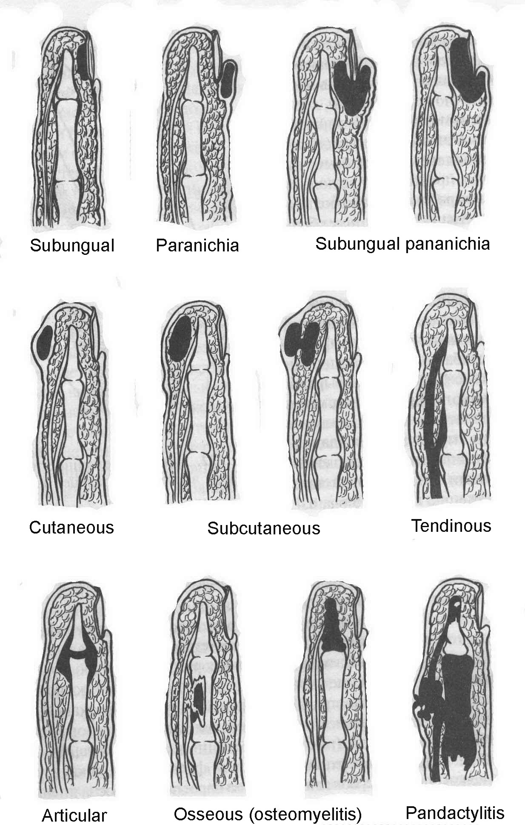

Technique of conduction ahaesthesia for surgery on digits

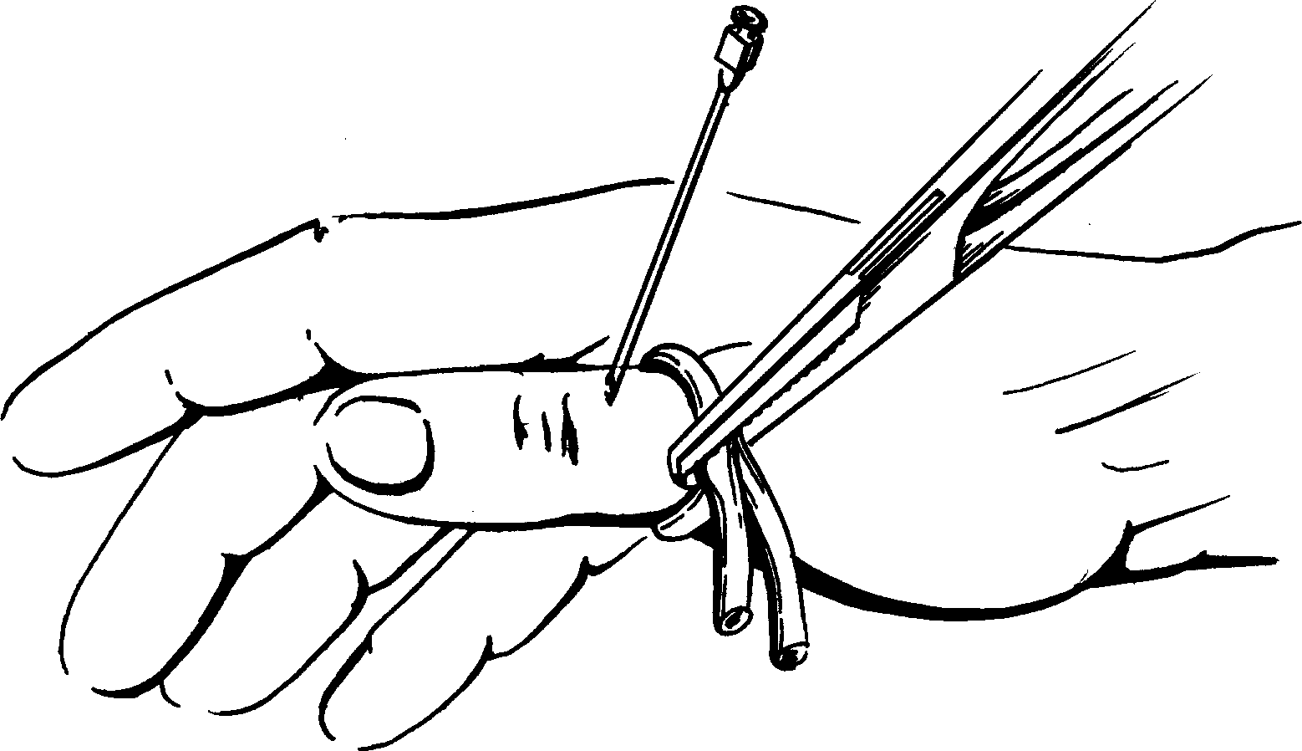

Skin incisions of drainage of felons and phlegmones of hand

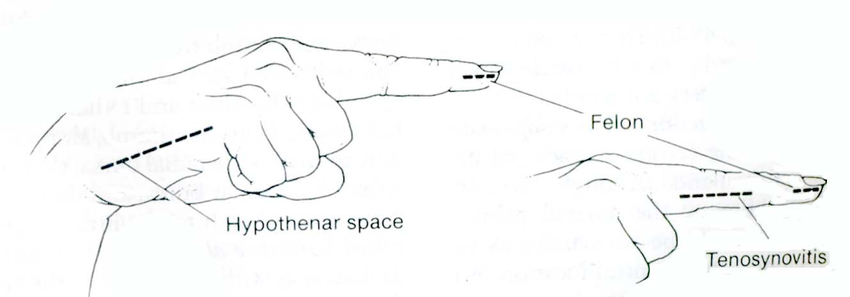
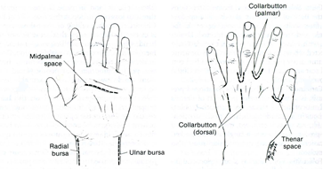

6.3. Materials for final stage of the class

(7-10 Krok-2 type tests)

7. Literature for teachers

- General Surgery: textbook / S.D. Khimich, M.D. Zheliba, V.P. Andryushchenko et al. — К., 2019. — 536 p., hardcover

- Essential surgery. Editor prof V.V.Grubnik, O.L.Kovalchuk, A.V.Malinovsky. Ternopil, TSM, 2010, 543 p.

- Surgery: a textbook is intended for English-speaking students of higher medical educational institutions of III-IVth levels of accreditation, interns / K. M. Amosova, Ya. S. Bereznyts’kyy, A. O. Burka [et al.]; ed. by Ya. S. Bereznyts’kyy [et al.], 2016. - 711 p.

- Surgery: a textbook is intended for English-speaking students of higher medical educational institutions of III-IVth levels of accreditation, interns / K. M. Amosova, Ya. S. Bereznyts’kyy, A. O. Burka [et al.]; ed. by Ya. S. Bereznyts’kyy [et al.], 2018. - 711 p.

- Essential surgery [Text] : навч. посіб. для студ. вищ. мед. навч. закл. IV рівня акредитації, які опановують навч. дисципліну англ. мовою (протокол № 4 від 01.10.2010 р.) / V. V. Grubnik, O. L. Kovalchuk, A. V. Malynovskyy, O. V. Grubnik. - Ternopil : TSMU "Ukrmedknyha", 2010. - 544 p. : fig., tab. - Текст англ. - Бібліогр.: с. 529-531. - 500 прим. - ISBN 978-966-673-147-3

- Sabiston textbook of surgery: the biological basis of modern surgical practic / [edited by] Courtney M. Townsend, Jr, R. Daniel Beauchamp. B. Mark Evers, Kenneth L. Mattox.—20th edition.
- Surgery Editor. Bereznyts'ky Y.S., Zarharash M.P, Mishalov V.G. Vinnytsia, 2016, 711p.

8. Literature for students

8.1. Basic literature

- General Surgery: textbook / S.D. Khimich, M.D. Zheliba, V.P. Andryushchenko et al. — К., 2019. — 536 p., hardcover

- Essential surgery. Editor prof V.V.Grubnik, O.L.Kovalchuk, A.V.Malinovsky. Ternopil, TSM, 2010, 543 p.

- Surgery: a textbook is intended for English-speaking students of higher medical educational institutions of III-IVth levels of accreditation, interns / K. M. Amosova, Ya. S. Bereznyts’kyy, A. O. Burka [et al.]; ed. by Ya. S. Bereznyts’kyy [et al.], 2016. - 711 p.

- Surgery Editor. Bereznyts'ky Y.S., Zarharash M.P, Mishalov V.G. Vinnytsia, 2016, 711p.

8.2. Additional literature

- Surgery: a textbook is intended for English-speaking students of higher medical educational institutions of III-IVth levels of accreditation, interns / K. M. Amosova, Ya. S. Bereznyts’kyy, A. O. Burka [et al.]; ed. by Ya. S. Bereznyts’kyy [et al.], 2018. - 711 p.

- Essential surgery [Text] : навч. посіб. для студ. вищ. мед. навч. закл. IV рівня акредитації, які опановують навч. дисципліну англ. мовою (протокол № 4 від 01.10.2010 р.) / V. V. Grubnik, O. L. Kovalchuk, A. V. Malynovskyy, O. V. Grubnik. - Ternopil : TSMU "Ukrmedknyha", 2010. - 544 p. : fig., tab. - Текст англ. - Бібліогр.: с. 529-531. - 500 прим. - ISBN 978-966-673-147-3

- Sabiston textbook of surgery: the biological basis of modern surgical practic / [edited by] Courtney M. Townsend, Jr, R. Daniel Beauchamp. B. Mark Evers, Kenneth L. Mattox.—20th edition.

9. Topics for student’s research

(3-4 topics)

10. Topic of the next class

(name of the topic according to the current shedule)

Elaboration composed by: ass. ….

