ODESSA NATIONAL MEDICAL UNIVERSITY
DEPARTMENT OF ROBOTIC AND ENDOSCOPIC SURGERY

METHODICAL instructive elaboration

of the practical class for the discipline
"Surgical diseases with child's surgery and oncology» for students of the 6-th course of the medical faculty

Topic № 9:" Abdominal pain, considering of features of abdominal pain in differential diagnostics ".

Discussed and approved at
methodical board of Department
of Robotic and Endoscopic surgery
"28" August 2019
Protocol № 1
Head of the Department
Ass. prof. __________ Malinovsky A.V.

Odessa - 2019

Topic of practical class: « Abdominal pain, considering of features of abdominal pain in differential diagnostics » – 7.5 hours

1. Significance of topic

Actuality of the topic: This topic is actual in terms of forming clinical thinking among specialists of different specialties. Assessment of the characteristics of pain syndrome plays an important role in the differential diagnosis of diseases of the abdominal organs, which further determines the tactics of treatment in each specific case. The pain syndrome carries a variety of varieties and forms that to a certain extent allow a preliminary diagnosis and start treatment without polyprogram with further pre-examination. Similarly, the knowledge of the various forms of pain syndrome in the pathology of the abdominal cavity allows you to determine the severity of the inflammatory process and choose the right treatment tactics.

2. Aims of the class

2.1. Training aims (a student must learn and master):

Level I - to familiarize students with the concept of pain and its characteristics
Level II – the student must know, to master the pathogenesis of pain.
Level III – to give students the opportunity to master the skills of palpation, percussion and auscultation of the abdominal cavity.
Level III - be able to conduct differential diagnosis of abdominal pain.

2.2. Educational aims:
1. To form the deontological representation when working with patients with abdominal pain.
2. The materials of the research topic develop a sense of responsibility for the timeliness and correctness of professional actions.
3. To form an imagination about the basis of the psychotherapeutic approach to patients with abdominal pain in surgical patients.
4. Master the ability to establish a psychological contact with the patient and his relatives.

3. Interdisciplinary integration
№ | Disciplines | To know | To master
Previous disciplines (basic disciplines)
1 | Anatomy, histology,  pathomorfology | To know the anatomical structure of the abdominal cavity, the morphological changes under conditions that relate to the topic under study. | Apply the data in preparation for the lesson.
2 | Physiology and pathophysiology | To know the normal function of organs and systems of abdominal cavity, hemodynamic changes, changes in metabolic processes, in systems and organs that relate to the topic under study, changes in the second organs and systems, changes in the organism, the main mechanisms of etiology and pathogenesis of abdominal pain. | Apply the data in preparation for the lesson.
3 | Propaedeutics of internal medicine | Methods of physical examination in patients with abdominal pain | Carry out a systemic study of the body of patient with abdominal pain. Interpret laboratory and instrumental research data.
4 | General surgery, modules | Methods of physical examination in patients with abdominal pain | Carry out a systemic study of the body of patient with abdominal pain. Interpret laboratory and instrumental research data.
5 | Propaedeutics of pediatrics | Methods of physical examination in patients with abdominal pain | Carry out a systemic study of the body of patient with abdominal pain. Interpret laboratory and instrumental research data.
Following disciplines (clinical disciplines)
1 | Obstetrics and Gynecology | Methods of physical examination in patients with abdominal pain | Carry out a systemic study of the body of patient with abdominal pain. Interpret laboratory and instrumental research data.
2 | Urology | Methods of physical examination in patients with abdominal pain | Carry out a systemic study of the body of patient with abdominal pain. Interpret laboratory and instrumental research data.
3
Inside the discipline (other topics)
1 | Diaphragm.  Methods of research.  Diaphragm damage.  Diaphragmatic hernia. | Know the methods of research and diagnosis of diseases of the abdominal cavity | Be able to conduct differential diagnosis between various diseases of the abdominal cavity, accompanied by pain syndrome
2 | Sharp abdomen.  Injuries to the abdomen.  External abdominal hernia.  Inside the hernia of the abdomen. | Know the methods of research and diagnosis of diseases of the abdominal cavity | Be able to conduct differential diagnosis between various diseases of the abdominal cavity, accompanied by pain syndrome
3 | Chemical burns and scar stricture of the stomach.  Damage to the stomach and duodenum.  Ulcer disease of the stomach and duodenum and its complications.  Stomach cancer. | Know the methods of research and diagnosis of diseases of the abdominal cavity | Be able to conduct differential diagnosis between various diseases of the abdominal cavity, accompanied by pain syndrome
4 | Liver injury.  Abscesses of the liver.  Non-parasitic liver disease.  Cholelithiasis.  Mechanical jaundice.  Post-cholystic syndrome.  Tumors of the liver. | Know the methods of research and diagnosis of diseases of the abdominal cavity | Be able to conduct differential diagnosis between various diseases of the abdominal cavity, accompanied by pain syndrome
5  6 | Acute pancreatitis.  Pancreas cancer.  Pancreatic injury. | Know the methods of research and diagnosis of diseases of the abdominal cavity | Be able to conduct differential diagnosis between various diseases of the abdominal cavity, accompanied by pain syndrome
5  6 | Damage to the spleen.  Disease of the spleen. | Know the methods of research and diagnosis of diseases of the abdominal cavity | Be able to conduct differential diagnosis between various diseases of the abdominal cavity, accompanied by pain syndrome
4. Contents of the topic

CHAPTER 1. ACUTE ABDOMEN: GENERAL CONSIDERATIONS
- The acute abdomen is the term used for an episode of severe abdominal pain that lasts for several hours or longer and requires medical attention.
Table 1-1. Gastrointestinal and intraperitoneal causes of abdominal pain
Inflammation/Infection  Peritoneum  Chemical and nonbacterial peritonitis  Perforated peptic ulcer  Perforated gallbladder  Ruptured ovarian cyst  Mittelschmerz  Bacterial peritonitis  Primary peritonitis  Pneumococcal  Streptococcal  Tuberculous  Perforated hollow viscus  Stomach  Intestine  Biliary tract  Hollow intestinal organs  Appendicitis  Cholecystitis  Peptic ulceration  Gastroenteritis  Regional enteritis (Crohn’s disease)  Meckel's diverticulitis  Colitis  Ulcerative  Bacterial  Amebic  Diverticulitis  Solid viscera  Pancreatitis  Hepatitis  Hepatic abscess  Splenic abscess  Mesentery  Lymphadenitis  Pelvic organs  Pelvic inflammatory disease  Tuboovarian abscess  Endometritis | Mechanical (obstruction, acute distention)  Hollow intestinal organs  Intestinal obstruction  Adhesions  Hernia  Tumor  Volvulus  Intussusception  Biliary obstruction  Calculi  Tumor  Choledochal cyst  Hematobilia  Solid viscera  Acute splenomegaly  Acute hepatomegaly  Cardiac failure  Budd-Chiari syndrome  Mesentery  Omental torsion  Pelvic organs  Ovarian cyst  Torsion or degeneration of fibroid  Ectopic pregnancy  Vascular  Intraperitoneal bleeding  Ruptured liver  Ruptured spleen  Ruptured mesentery  Ruptured ectopic pregnancy  Ruptured aortic, splenic, or hepatic aneurysm  Ischemia  Mesenteric thrombosis  Hepatic infarction  Toxemia  Purpura  Splenic infarction  Omental ischemia  Miscellaneous  Endometriosis
From: Principles of surgery/ed., S.I. Schwartz, et al. – 7th ed. (modified)

Symptoms
Pain
- Gradual periumbilical pain indicates visceral peritoneal irritation (e.g. appendicitis, diverticulitis).
- Severe, explosive pain indicates a process that immediately soils the parietal peritoneum (e.g. perforation of a hollow viscus). The pain may be either localized or generalized.
- Progressive, severe pain suggests a worsening intra-abdominal condition.
- Localized pain that recurs as a generalized pain suggests that the inflamed organ has perforated.
- Crampy pain indicates an obstruction in the gastrointestinal tract. If crampy pain develops into constant severe pain, it suggests that the involved bowel segment is now ischemic or gangrenous.
Table 1-2. Diagnosis related to the mode of onset of abdominal pain
Sudden onset  Perforated viscus  Volvulus  Passage of stone (kidney or gallbladder)  High intestinal obstruction  Mesenteric embolism/arterial thrombosis  Ruptured aortic aneurysm  Ruptured ectopic pregnancy  Ovarian torsion/ruptured cyst  Sickle cell crisis  Myocardial ischemia/infarction  Mittelschmerz  Porphyria  Abdominal wall intramuscular hematoma  Intraperitoneal bleeding  Intussusception | Gradual onset  Appendicitis  Diverticulitis  Cholecystitis  Lower intestinal obstruction  Mesenteric ischemia/insufficiency  Leaking aortic aneurysm  Ectopic pregnancy  Gastroenteritis  Endometritis  Gastritis/peptic ulcer disease  Pancreatitis  Salpingitis  Endometriosis  Regional enteritis/ulcerative colitis  Pyelonephritis  Pneumonia  Splenic vein thrombosis  Hepatitis  Diabetic acidosis  Addisonian crisis  Herpes zoster | Intermittent pain  Peptic ulceration  Reflux esophagitis  Cholelithiasis  Crohn's disease  Diverticulitis  Endometriosis  Chronic mesenteric ischemia  Pelvic inflammatory disease  Chronic pancreatitis  Constant pain with  acute exacerbation  Pancreatitis  Alkaline reflux gastritis
From: Principles of surgery/ed., S.I. Schwartz, et al. – 7th ed.

Scheme 1-1. Scheme illustrating how the sequencing of events in the history and physical examination can suggest the right diagnosis
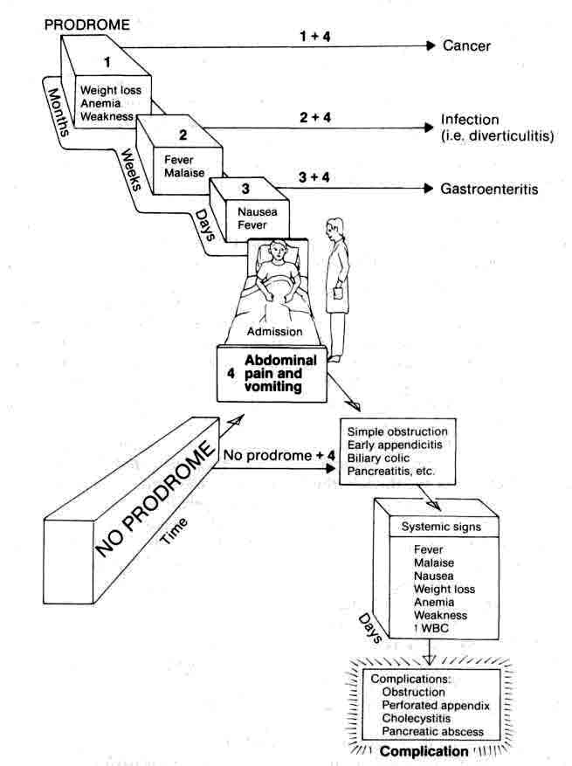
From: Basic surgery/ed., H.C. Polk, Jr., et al. – 5th ed.

Scheme 1-2. Characteristic location of abdominal pain associated with various diseases
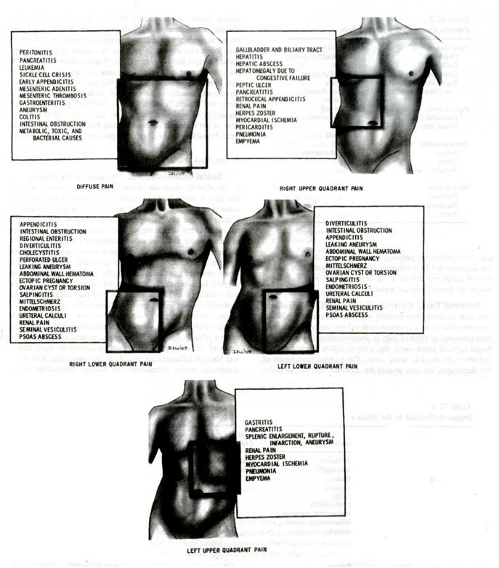
From: Principles of surgery/ed., S.I. Schwartz, et al. – 7th ed.
Anorexia, nausea and vomiting
- Anorexia, nausea, and vomiting are common accompanying symptoms in acute inflammatory abdominal processes.
- Vomiting is very frequent in obstruction of gastrointestinal tract.
- These symptoms also accompany nonsurgical diseases, in which case they often precede the pain (e.g. gastroenteritis).

Changes in bowel habits
- Changes in bowel habits are so common that they are seldom helpful unless very specific changes occur.
- Watery diarrhea suggests gastroenteritis of various origin.
- Bloody diarrhea suggests ulcerative colitis, Salmonella infestation, or colonic ischemia.
- Patients with intestinal obstruction usually pass no flatus or bowel movement for 1-2 days prior to seeking medical attention.

Symptoms of sepsis
- Symptoms of sepsis, such as chills and fever, may be nonspecific, although certain patterns are typical of certain diseases.
Specific symptoms

Previous surgery
Adhesions may have formed within the peritoneal cavity, leading to intestinal obstruction.
- If the surgery was for malignant disease, the malignancy may have recurred, causing different complications.
- Previous removal of any organ eliminates it from consideration.
- Previous surgery may point to a specific problem (e.g. suppurative cholangitis in a patient with previous choledocholithiasis and retained common duct stone).

Previous episodes of similar pain
Characteristic maneuvers
- A patient with acute peritonitis lie very still; any movement results in excruciating pain.
- A patient with a common duct stone or a kidney stone will pace the floor, unable to find a comfortable position.
- The pain of an acute peptic ulcer may be relieved by food or antacids, whereas pain from acute cholecystitis or pancreatitis may be exacerbated by food.
- A patient with hemoperitoneum will not stay in some position for a long time (“tilting doll” sign).

Comorbidities
- Comorbidities and their signs (some of them are listed below) should be noticed as they may produce acute abdomen.
- Urinary tract: dysuria, hematuria, changes in urinary habits.
- Reproductive tract in the female: past or present vaginal discharge, dysmenorrhea, a history of pelvic inflammatory disease, time of last menstrual period.
- Cardiovascular system: atrial fibrillation, ischemiс heart disease.
- Diabetes mellitus: poorly controlled blood sugars.

Physical examination
Complete physical examination
Changes in vital signs, particularly fever, tachypnea, hypotension or cardiac rhythm irregularities, should be noticed.
- Inspection should be done for jaundice, dehydration, feculent breath, pneumonia or mental disorientation.
- Examination of the extremities for loss of pulses is also necessary.

Abdominal examination
Overall inspection
- A distended abdomen with visible peristalsis suggests small bowel obstruction.
- Prominent muscle guarding or rigidity (signs of peritonitis) may be visible in a thin and muscular patient.
- A scaphoid abdomen may suggest herniation of the abdominal contents through the diaphragm into the thoracic cavity, particularly after blunt abdominal trauma.
- Hernias are frequently visible, particularly when the patient is standing.

Palpation of abdomen
The inguinal area should be examined for hernias or inflammatory conditions.
- The abdomen should be examined to determine the points of maximum tenderness or the presence of referred tenderness.
- Rebound tenderness (Schetkin-Blumberg’s sign) is tenderness that occurs when the examining hand is quickly removed from the abdominal wall. It is indicative of acute peritoneal irritation.
- Muscle spasm (another sign of peritoneal irritation) is determined by gently depressing the abdominal wall muscles.
- Palpation for abdominal masses should be done systematically. A mass in a particular abdominal quadrant suggests a specific diagnosis (see Scheme 1-3). Further work-up is necessary when finding the abdominal mass.

Scheme 1-3. Location of abdominal masses according to their organ of origin

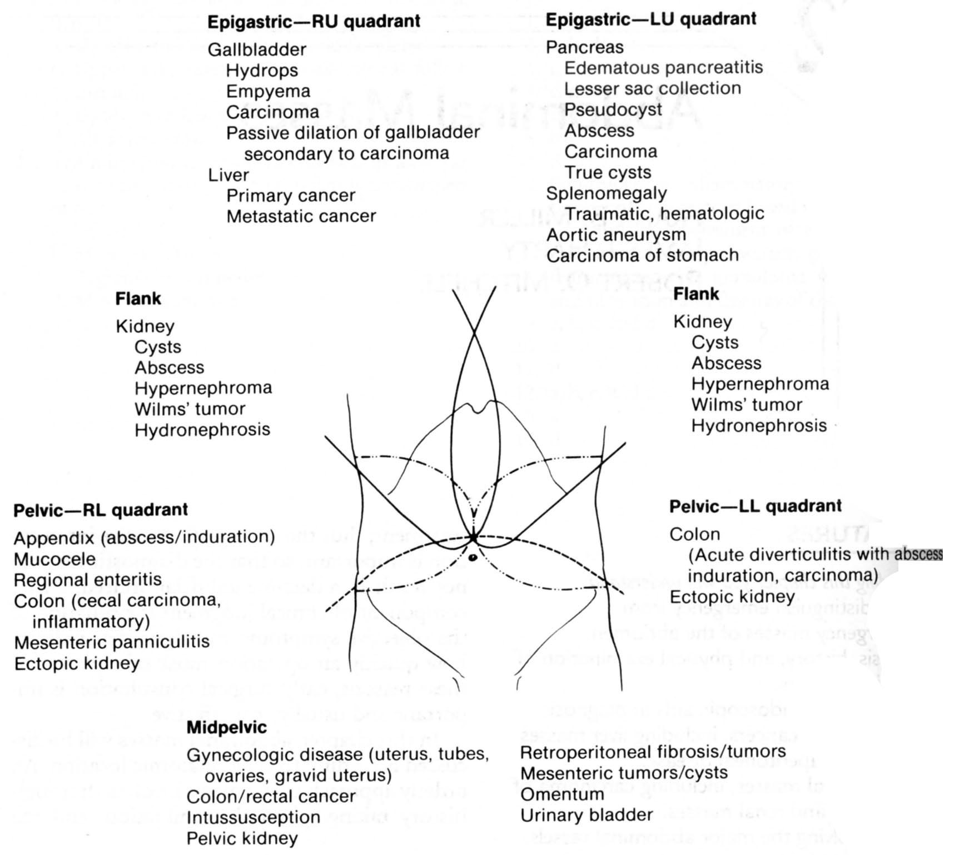
From: Basic surgery/ed., H.C. Polk, Jr., et al. – 5th ed.

Scheme 1-4. Algorithm of management of patient with abdominal mass
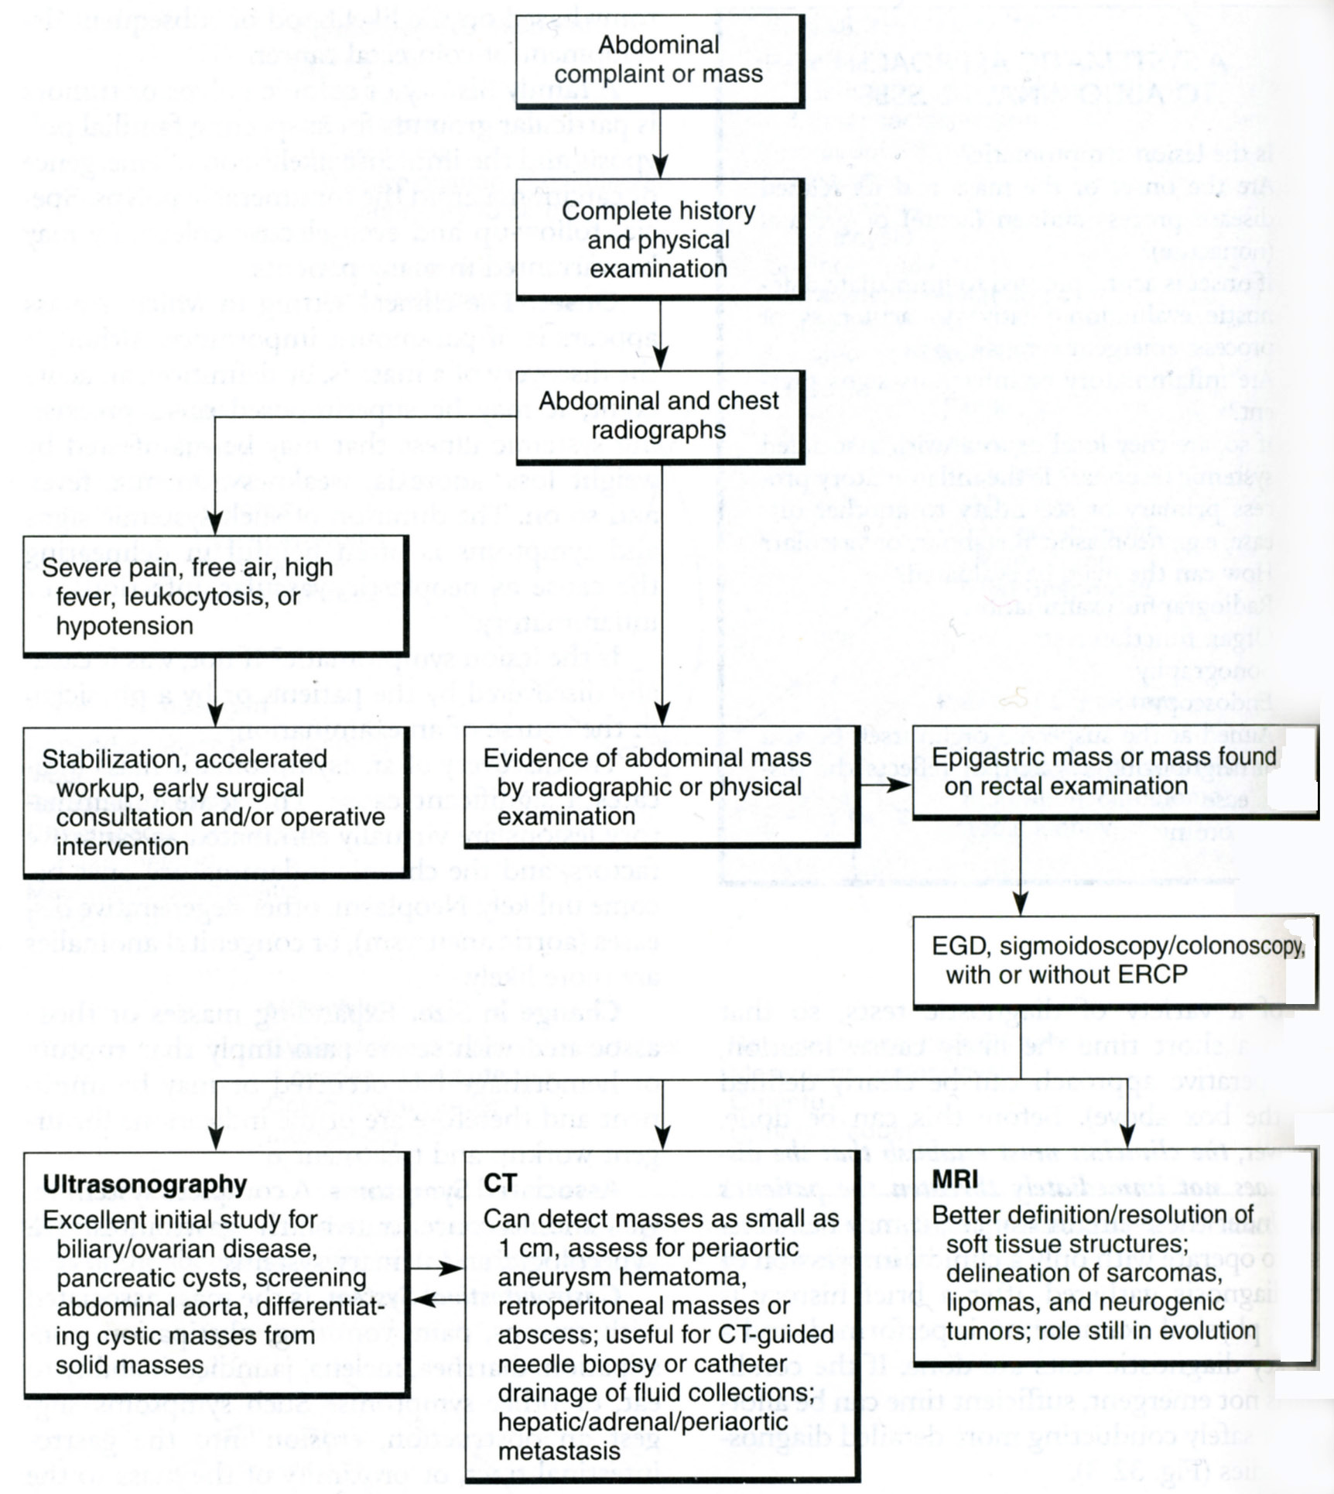
From: Basic surgery/ed., H.C. Polk, Jr., et al. – 5th ed.

Percussion of abdomen
- Percussion confirms areas of tenderness.
- The hollow sound of tympany indicates free intraperitoneal air, but it usually is present because of air in the intestine.
- Absence of hepatic dullness sugests free intra-abdominal air due to perforation of hollow organ.

Auscultation of abdomen
- Intermittent peristaltic rushes that have a crescendo followed by silence suggest an intestinal obstruction. This sign is particularly useful when the peristaltic rush coincides with the onset of episodic abdominal pain. Certain nonsurgical inflammatory conditions, such as gastroenteritis, produce high-pitched intermittent peristaltic rushes. In these cases, the pain pattern is usually not synchronous with the rushes.
- A silent abdomen indicates the absence of peristalsis, suggesting diffuse peritonitis, which occurs with major abdominal sepsis, intestinal ischemia or gangrene, prolonged (longer than 3 days) mechanical obstruction or dynamic bowel obstruction.

Rectal examination
- Rectal and gynecologic examination must be performed in any case of acute abdomen.
- A mass palpable on rectal examination may be a pelvic abscess, a sign of pelvic inflammatory disease or a malignancy.
- The presence of blood in the stools suggests either a malignancy, hemorrhoids, or an acute inflammatory gastrointestinal process, such as an ulcer or colitis.
- The colour of stool helps to determine the site of gastrointestinal bleeding (melena is produced by upper gastrointestinal tract and bloody stools is produced by lower one).
- Rectal examination also reveals pathology of prostate gland.

Gynecologic examination
- Cervical or parauterine tenderness suggests pelvic inflammatory disease.
- A uterine, ovarian, or pelvic mass suggests intrauterine pregnancy, ectopic pregnancy with rupture and hemorrhage, pelvic, ovarian, or tubal inflammatory disease with or without abscess formation, ovarian cysts, and pelvic or gynecologic malignancy.
- Cervical discharges should be examined microscopically for gonococci and other flora.

Examination of genitalia
- It should be performed in all men and boys for the torsion of the testicle.

Special signs
- Special signs are useful in diagnosing different acute abdominal pathologies (e.g. Murphy's sign for acute cholecystitis, Rovsing’s sign for acute appendicitis, Gray-Turner’s sign for necrotizing pancreatitis, ect.).

Medical illnesses that can cause acute abdomen
- Life-threatening medical illnesses, such us acute myocardial infarction, lower lobe pneumonias, diabetic ketoacidosis, should be particularly sought (see also Tables 1-3, 1-4).
- Musculoskeletal problems, particularly vertebral compression of abdominal wall nerves, usually mimic acute surgical conditions.

Table 1-3. Extraperitoneal causes of abdominal pain

Cardiopulmonary  Pneumonia  Empyema  Myocardial ischemia  Active rheumatic heart disease  Blood  Leukemia  Sickle cell crisis  Neurogenic  Spinal cord tumors  Osteomyelitis of spine  Tabes dorsalis  Herpes zoster  Abdominal epilepsy  Genitourinary  Nephritis  Pyelitis  Perinephric abscesses  Ureteral obstruction  Calculi  Tumors  Prostatitis  Seminal vesiculitis  Epidydimitis | Vascular  Aortic aneurysm (dissection, rupture or expansion)  Periarteritis  Metabolic  Uremia  Diabetic acidosis  Porphyria  Addisonian crisis  Toxins  Bacterial (tetanus)  Insect bites  Venoms  Drugs  Lead poisoning  Abdominal wall  Intramuscular hematoma  Psychogenic
From: Principles of surgery/ed., S.I. Schwartz, et al. – 7th ed.

Table 1-4. Surgical masqueraders
Cause | History | Physical examination | Special tests
Abdominal wall
Trauma, hematoma, tumor, infection | Trauma, anticoagulant use, enlarging mass, fever | Location of tenderness, mass, presence of fever, cellulitis | Biopsy if solid mass is present
Viral myositis, toxins | Viral prodrome of malaise, fever, anorexia, spider bite, snake bite | Fang marks
Trigger point, myofascial syndrome, nerve entrapment | Previous operation, parasthesias, no visceral symptoms (e.g., vomiting) | Pain exacerbated with rectus muscle tightening; single finger pressure causes pain. Fascial or muscular cord | Responds to local anesthesia
Thorax
Pneumothorax, pleural effusion | Tuberculosis, cancer, trauma | Hyperresonance to percussion with pneumothorax, flat percussion note, breath sounds ↓↓, egophony over fluid | Chest radiographs, decubitus film of chest, CT scan
Pneumonia, pulmonary infarction | Exposure, known tuberculosis, preexisting thrombophlebitis, pelvic inflammatory disease, ingestion of drugs, hemoptysis | Breath sounds ↓↓, rales, dull percussion note, friction rub | Chest radiographs, lung scan, pulmonary angiogram
Constrictive pericarditis, myocardial infarction, embolization | Symptoms of heart failure, anginal prodrome | BP ↓↓, thready pulse, pulse pressure ↓↓, venous pressure ↑↑ | ECG, chest radiographs, echocardiography
Central nervous system
Cord or nerve root compression or inflammation | Exacerbated by cough or straining, hyperesthesia, causalgia, etc. | Duplication of pain by pressure on spine; abdominal wall rigidity, guarding, or rebound  tenderness | Radiograph of spine, myelogram, MRI, or CT scan
Brain, psychogenic, abdominal migraine | Occasional vomiting, abdominal discomfort, cranial nerve symptoms, previous known psychiatric disorder, epilepsy, or migraine headaches | Muscular tenderness, abdominal guarding, etc.; neurologic abnormalities | Skull radiographs, brain scan, EEG, spinal fluid analysis, CT or MRI scan
Genitourinary
Kidney, ureter, bladder | Previous stone or infection, symptoms of infection, back pain, suprapubic pain, pain radiating to thigh or testicle | Suprapubic or costovertebral angle tenderness, fever | Urine analysis, leukocytosis, IVP or CT scan with IV contrast, cystoscopy, arteriography
Ovary, tubes, uterus | Previous infection, exposure to VD, menstrual irregularity, vaginal discharge | Pelvic tenderness, mass, vaginal discharge | Smear of discharge, culposcopy, laparoscopy, sonography
Metabolic (exogenous)
Heavy metal poisoning | Ingestion or close contact with lead, mercury, arsenicals | Lack of peritoneal signs | Smear of peripheral blood, blood or urine levels of offending agent ↑
Food poisoning | Ingestion of contaminated food, epidemic, associated  diarrhea common | Fever, lack of signs of peritoneal irritation | Stool culture, blood agglutinins
Metabolic (endogenous)
Diabetes, uremia, porphyria, collagen disease, Mediterranean fever, hemolytic diseases, lactose intolerance | Known disease, arthralgias, nerve deficits, anemia, relation to food | Lack of signs of peritonitis (unless ischemic bowel necrosis present) | Depending on underlying conditions: blood sugar ↑, blood urea nitrogen ↑, hemoglobin ↑, urine porphyrins ↑, sickled red cells, antinuclear antibody ↑, ESR ↑ , CRP ↑, LE prep +, hydrogen breath test +
From: Basic surgery/ed., H.C. Polk, Jr., et al. – 5th ed.

Immunocompromised patients
- A high index of suspicion is necessary for acute abdominal emergencies in immunosuppressed patients (HIV, transplant or steroid-dependent patients) whose symptoms and findings may be minimal (see also Table 1-5).

Table 1-5. Acute abdominal pain in the immunocompromised patient

Cytomegalovirus infection  Interstitial pneumonitis  Mononucleosis  Pancreatitis  Hepatitis  Cholecystitis  Gastrointestinal ulceration  Neutropenic enterocolitis  Pancreatitis  Pentamidine  Steroid  Azathioprine  CMV  Heptatitis  А, В, С  CMV  Epstein-Barr virus  Cholecystitis  CMV  Acalculous  Campylobacter  Hepatosplenic abscess  Fungal  Mycobacterial  Protozoal  Splenic rupture | Bowel perforation  Lymphoma, leukemia (especially after chemotherapy)  CMV  Colon ulcers  Mycobacterial  Pseudomembranous colitis  Kaposi's sarcoma  Iatrogenic  Acute graft vs. host disease  Pseudoacute abdomen  Fecal impaction  Standard abdominal processes  Appendicitis  Cholecystitis  Diverticulitis  Bowel obstruction  Ulcer disease  Pelvic inflammatory disease  Perirectal abscess  Urinary tract infection  Lymphadenitis
From: Principles of surgery/ed., S.I. Schwartz, et al. – 7th ed.

Acute abdomen in children
Table 1-6. Differential diagnoses of acute abdominal conditions in the pediatric population
Infants  Viral enteritis  Intussusception  Pyelonephritis  Gastroesophageal reflux  Bacterial enterocolitis  Appendicitis  Pneumonitis  Pyloric stenosis  Testicular torsion  Mesenteric cysts  Ruptured tumors  Pancreatitis  Meckel's diverticulitis  Hirschsprung's disease  Strangulated hernia  Poisoning  Trauma (child abuse) | Children  Meckel's diverticulitis  Cystitis  Crohn's disease  Appendicitis  Viral enteritis  Pneumonitis  Bacterial enterocolitis  Pancreatitis  Ruptured tumors  Poisoning  Trauma (child abuse)  Pyelonephritis | Adolescents  Pelvic inflammatory disease  Appendicitis  Mittelschmerz  Crohn's disease  Pancreatitis  Pneumonia  Hematocolpos  Psychosomatic  Viral enteritis  Peptic ulcer  Poisoning  Trauma  Ectopic pregnancy  Pregnancy  Cholelithiasis  Bacterial enterocolitis
From: Principles of surgery/ed., S.I. Schwartz, et al. – 7th ed.
Laboratory tests
Complete blood count
- A red cell count may reveal anemia or suggest hemoconcentration secondary to dehydration.
- Leukocytosis in the 20,000-40,000 range suggests a major septic process in need of rapid surgical intervention.
- A normal white cell count in an elderly or diabetic patient may accompany a major septic episode.
- Profound leukopenia, particularly with a lymphocytic predominance, suggests a viral illness.
- Leukemia may also be diagnosed from the complete blood count.

Urine examination
- Urine examination generally rules out urinary tract infection or kidney stone disease.
- Pelvic inflammatory processes in contact with the ureter or bladder may produce a few white cells and red cells in the urine. If there is a doubt, intravenous pyelography should be performed prior to surgery.

Blood biochemistry
- Serum amylase is usually increased in acute pancreatitis, although other surgical illnesses, such as mesenteric thrombosis and perforated ulcer, should not be overlooked.
- Bilirubin level and alkaline phosphatase are increased in jaundice of any origin and require further differential diagnostics.

Arterial blood gases
- Arterial blood gases may be very helpful in identifying a profound metabolic acidosis which suggests either septic shock, or severely ischemic or necrotic tissue.

Other laboratory tests
- Serum electrolytes, serum creatinine, coagulation profile and liver function tests are other studies that are often essential.

Radiographic studies
Upright chest radiograph
- Upright chest radiograph and flat and upright abdominal radiograph should be obtained in most cases of acute abdominal pain.
- A chest radiograph is essential to rule out other diseases, such as pneumonia, that can mimic conditions associated with an acute abdomen.

Upright (flat) abdominal radiograph
Bony structure abnormalities
- Bony structure abnormalities, such as fractures or metastatic lesions, may provide important diagnostic information in trauma or malignant disease.

Gastrointestinal gas pattern
- Paralytic ileus. Air that is evenly distributed throughout the small and large intestine usually signifies paralysis of the bowel (see Fig. 1-1). Ileus may be localized to a specific area, such as the duodenal "sentinel" loop or distension of transverse colon in acute pancreatitis.
- Acute gastric dilation is indicated by a markedly dilated gastric bubble.
- Mechanical obstruction of the intestine is revealed by the presence of distended air- and fluid-filled loops of bowel (Kloiber’s cups) proximal to the obstruction and decompressed intestine distally (see Fig. 5-18).
- Specific causes of mechanical obstruction may be diagnosed by the intestinal gas pattern (hernias may result in intestinal air located in a nonanatomic location; volvulus may appear as an isolated distended loop of bowel with tapered ("bird’s beak") margins).

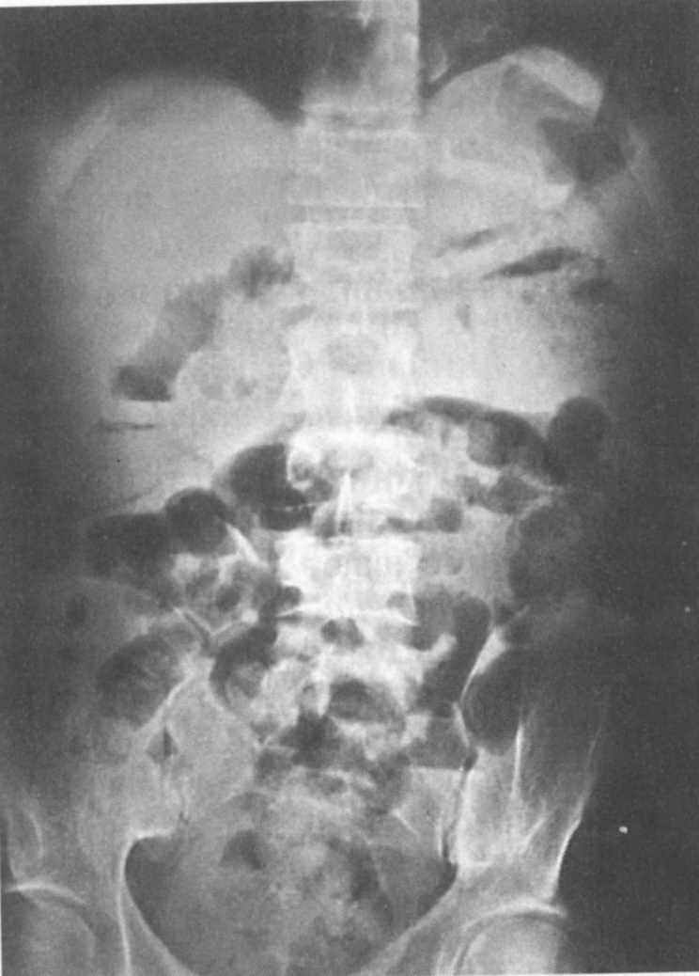
Fig. 1-1. Increased gastrointestinal gas pattern

Abnormal air collections outside the intestinal lumen
- Free air within the peritoneal cavity (most commonly, under the diaphragm in upright position of a patient) signals a perforation of a hollow viscus (see Fig. 4-25). It is present in about 80% of gastroduodenal perforations but in fewer than 25% of colonic perforations. However, it may be present in patients with open drains and for up to 1 week following a laparotomy or laparoscopy.
- Air collections within the wall of the colon, a condition termed pneumatosis cystoides intestinalis, generally indicate an isolated, walled-off intestinal perforation.
- Air stippling within soft tissue structures may indicate the dissection of air into the tissues from a thoracic source, such as a pneumothorax. It may, however, be due to a rapidly progressive, catastrophic gas-forming infection.
- Air-fluid level outside the intestinal tract is associated with a subphrenic or subhepatic abscess (see Fig. 1-2).
- Air within the biliary tree indicates biliary-digestive fistula, cholangitis or provided by biliary drainage (see Fig. 5-19).
- Air within the portal vein is seen in pylephlebitis.
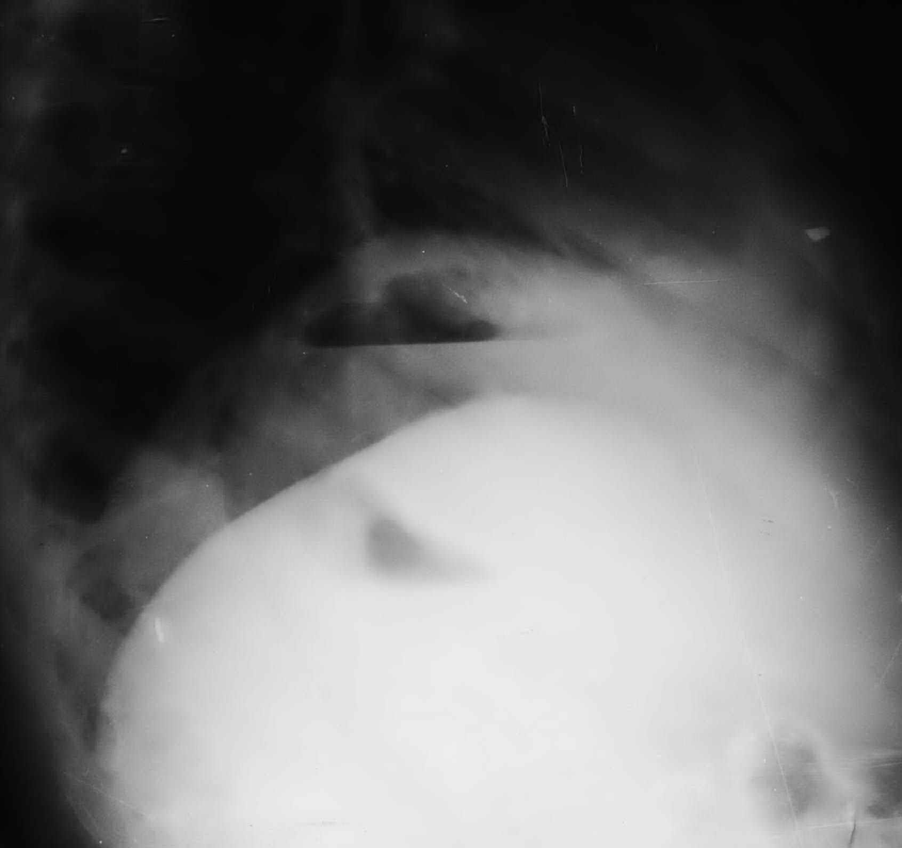
Fig. 1-2. Radilogical picture of subphrenic abscess

Abnormal calcifications
- Renal stones are calcified in up to 85% of cases and appear along the path of theureter.
- Fecaliths are strong evidence for acute appendicitis in patients with abdominal pain.
- Pancreatic calcification suggests chronic pancreatitis.
- Gallstones are calcified in 15% of cases.
- Heavily calcified vessels may be present in mesenteric ischemia.
- Masses, such as teratomas or malignant neoplasms, may calcify.

Soft tissue shadows
- Peritoneal fat lines and psoas muscle shadows may be lost in rapidly spreading infections, hematomas or abscesses.
- Margins of solid organs (liver, kidney, or spleen) may be displaced from their normal locations by an abnormal mass.
- A distended bladder may be visible and may be responsible for marked abdominal pain.

Contrast radiograph
- Intravenous pyelogram should be obtained if a renal or ureteral stone, acute pyelonephritis or perinephric abscess or renal infarction is suspected. When a patient suspected of having appendicitis has microscopic hematuria, the intravenous pyelogram is particularly useful to verify that the hematuria is due to the periappendiceal inflammation rather than to a renal stone.
- Barium swallow is helpful if rupture of esophagus (Boerhaave's syndrome) suspected.
- Upper gastrointestinal series should be performed if an ulcer disease of stomach or duodenum (including perforated) or gastric cancer is suspected but cannot be proven by endoscopy.
- Placing contrast materials into the colon and rectum should be done very cautiously when an inflammatory condition or a perforation is suspected, because even a small increase in pressure could easily convert into a frank perforation.
- Small bowel follow-through contrast study is useful in identifying a point of small bowel obstruction when either history, physical examination, or plain x-ray fail to verify the diagnosis of small bowel obstruction.

Abdominal ultrasonography
- Abdominal ultrasonography is usually of little diagnostic value in the patient with abdominal distention and severe pain, but it can be helpful when acute cholecystitis, cholelithiasis, biliary obstruction, pancreatitis, intra-abdominal abscess or renal disease is suspected.

Computed tomography (CT) and magnetic resonance imaging (MRI)
- CT and MRI may also be helpful but is generally reserved for the patient whose condition remains undiagnosed after other studies have been exhausted.

General principles of approach to a patient with acute abdominal pain
- Careful and systematic evaluation of the patient should be routinely followed.
- Statistically speaking, certain diagnoses are very common.
- When the diagnosis is not initially clear, continued observation and repeated visualization and laboratory studies are needed. Although this practice might be desirable in a patient with gastroenteritis, delay can be catastrophic in acute appendicitis, acute mesenteric ischemia, strangulated small bowel obstruction, volvulus, or incarcerated hernia.
- If the diagnosis is not certain, but the patient may have a potentially lethal condition that could be cured by an early operation, then an early operation should be performed.
- Analgesics, particularly narcotics, should be withheld from the patient until the diagnsis is established or until the decision to proceed to surgery has been made.
- Antibiotics should also be withheld until a diagnosis has been made and the antibiotiс therapy is needed.
- Fluid deficits and electrolyte imbalances should be corrected before surgery.
- Nasogastric tube should be placed before the induction of anesthesia to empty the stomach, thus minimizing the risk of pulmonary aspiration.

CHAPTER 2. DIFFUSE ABDOMINAL PAIN
- Diffuse abdominal pain most commonly is caused by diffuse peritonitis, acute pancreatitis (more frequently it may produce epigastric or paraumbilical pain), different variants of bowel obstruction (See Chapters 5, 6), first phase of acute appendicitis (See Chapter 3), acute mesenteric ischemia, gastroenteritis, and other diseases listed above (see Table 1-1).

PERITONITIS
Overview
Table 2-1. Classification of intraabdominal infections
Primary peritonitis  Spontaneous peritonitis in children  Spontaneous peritonitis in adults  Peritonitis in patients with CAPD  Tuberculous and other granulomatous peritonitis  Secondary peritonitis  Acute perforation peritonitis (acute suppurative peritonitis)  Gastrointestinal or biliary tract perforation  Bowel wall necrosis (intestinal ischemia)  Pelvic peritonitis (due to pelvic inflammatory  diseases)  Other forms  Postoperative peritonitis  Anastomotic leak  Leak of a simple suture  Blind loop leak  Other iatrogenic leaks  Posttraumatic peritonitis  Peritonitis after blunt abdominal trauma  Peritonitis after penetrating abdominal trauma | Tertiary peritonitis  Peritonitis without evidence for pathogens  Peritonitis with fungi  Peritonitis with low-grade pathogenic bacteria  Other forms of peritonitis  Biliary peritonitis  Enzimatic (panreatogenic) peritonitis  Urinary peritonitis  Uremic peritonitis  Granulomatous peritonitis  Drag-related peritonitis  Periodic peritonitis  Lead peritonitis  Hyperlipidemic peritonitis  Porphyric peritonitis  Foreign-body peritonitis  Talc peritonitis  Intraabdominal abscess  Associated with primary peritonitis  Associated with secondary peritonitis
From: Principles of surgery/ed., S.I. Schwartz, et al. – 7th ed.

- Most cases of peritonitis are due to an invasion of the peritoneal cavity by bacteria.
- Bacterial peritonitis is usually polymicrobial, both aerobic (Escherichia coli, Enterobacter, Staphylococci) and anaerobic organisms (Streptococci, Bacteroides, Clostridium welchii) from gastrointestinal tract being present.
- The exception is primary peritonitis (spontaneous peritonitis) in which a pure infection with Gonococcus, Streptococcs, Pneumococcs, Chlamydia or Haemophilus bacteria occurs.

Scheme 2-1. Classification of peritonitis by location
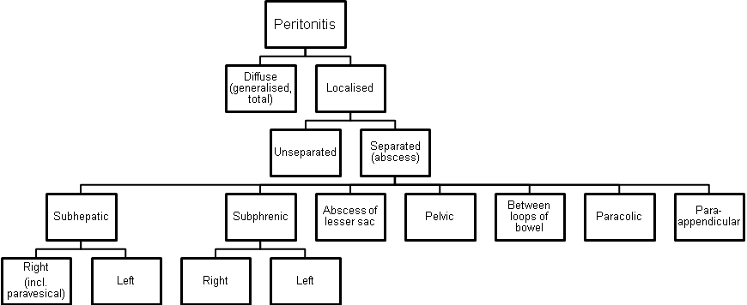

Clinical features
Localised peritonitis
- Localised peritonitis is bound up intimately with the causative condition and the initial symptoms and signs are those of that condition.
- The temperature, and especially the pulse rate, rise.
- Abdominal pain increases.
- The most important sign is local muscle guarding and rigidity of the abdominal wall with a rebound tenderness (Shetkin-Blumberg’s sign).
- If inflammation arises under the diaphragm shoulder tip pain may be felt (de Mussy sign).
- In cases of pelvic peritonitis arising from an inflamed appendix in the pelvic position or from salpingitis, the abdominal signs are often slight, deep tenderness of one or both lower quadrants alone being present, but a rectal or vaginal examination reveals marked tenderness of the pelvic peritoneum.
- A large collection of bile localised to the subhepatic space can remain dangerously “silent” until a late stage.

Diffuse peritonitis
Scheme 2-2. Phases of clinical course of diffuse peritonitis


Reactive phase
- Abdominal pain is severe and made worse by moving or breathing. The patient usually lies still.
- Vomiting may occur.
- Tenderness and rigidity on palpation along with rebound tenderness are typically found.
- Infrequent bowel sounds may still be heard for a few hours but they cease with the onset of paralytic ileus.
- The pulse rises progressively, but if the peritoneum is deluged with irritant fluid, there is a sudden rise.
- The temperature changes are variable and can be subnormal.

Toxic and terminal phase
- Abdominal pain still remains.
- Infrequent bowel sounds may still be heard for a few hours but they cease with the onset of paralytic ileus. The abdomen remains silent and increasingly distends.
- Circulatory failure ensues, with cold, clammy extremities, sunken eyes, dry tongue, thready (irregular) pulse, and drawn and anxious face (Hippocratic facies).
- Diuresis is decreasing.
- The patient finally lapses into unconsciousness.

Table 2-2. Signs of loss of extracellular fluid volume
Tachycardia
Increased respiratory rate
Dry, cool skin
Poor capillary filling of extremities
Decreased pulse volume
Decreased skin turgor
Decreased urinary output
Hemoconcentration
Increased specific gravity of urine
Hypotension
Orthostatic - early
Frank - late
From: Basic surgery/ed., H.C. Polk, Jr., et al. – 5th ed.

Laboratory studies
- A leucocytosis is usually seen in peritonitis but is often delayed for many hours.
- Serum amylase estimation may uphold the diagnosis of acute pancreatitis.

Diagnostic peritoneal lavage
- Peritoneal diagnostic aspiration (under local anesthesia, usually at the umbilical area) may be very helpful.
- Bile-stained fluid indicates perforated peptic ulcer or gallbladder; the presence of pus indicates bacterial peritonitis; blood is aspirated in a high proportion of patients with intraperitoneal bleeding.
- When aspiration fails, the introduction of a small quantity of sterile physiological saline, followed after a few minutes by peritoneal aspiration may produce fluid of diagnostic value.
- Microscopy of the fluid may show neutrophils, bacteria, and amylase level of the fluid could be determined for suspected pancreatogenic peritonitis.

Visualization data
- An upright abdomen radiography may confirm the presence of dilated gas-filled loops of bowel (consistent with a paralytic ileus) or show free gas. If the patient is too ill for an erect film to demonstrate free air under the diaphragm, a lateral decubitus film is just as useful showing gas beneath the abdominal wall.
- Ultrasound and CT, when available, may also he helpful in some patients by identifying a cause of peritonitis (e.g. perforated appendicitis, acute pancreatitis). Such knowledge may influence operative approach or contraindicate operation.

Treatment
- In any case of doubt, early surgical intervention is preferred to a “wait and see” policy. This rule is particularly true for postoperative peritonitis.

General care of the patient
Correction of circulating volume and electrolyte imbalance (see also Chapter 22)
- The plasma volume must be restored and the plasma electrolyte concentrations corrected using central venous catheterisation, pressure and diuresis monitoring.
- A fluid balance chart must be started so that daily output by gastric aspiration and urine is known.
- Additional losses are estimated. Throughout recovery, the haematocrit and serum electrolytes and urea must be checked regularly.
- If the patient’s recovery is delayed for more than 7 - 10 days, intravenous feeding (hyperalimentation or total parenteral nutrition, TPN) is required.

Gastrointestinal decompression
- A nasogastric tube aspiration is maintained until the paralytic ileus resulting from peritonitis has recovered.
- Measured volumes of water are allowed by mouth when only small amounts are being aspirated.
- If the abdomen is soft and not tender, bowel sounds return, and flatus and stools passage resumed, and oral feeding may be progressively introduced. It is important not to prolong the ileus by missing this stage.

Antibiotic therapy
- Initially parenteral broad-spectrum antibiotics active against aerobic and anaerobic bacteria should be given.

Analgesia
- Freedom from pain allows early mobilisation and adequate physiotherapy in the postoperative period which help to prevent basal pulmonary collapse, deep-vein thrombosis and pulmonary embolism.
- The patient should be nursed in the sitting-up position and must be relieved of pain before and after operation.
- Once the diagnosis has been made drug analgesics may be given.
- If appropriate expertise is available, epidural infusion may provide excellent analgesia.

Vital system support
- Administration of oxygen postoperatively can help to prevent and mitigate the effects of septic shock, especially adult respiratory distress syndrome (ARDS) which may require a period of mechanical ventilation.
- If oliguria persists despite adequate fluid replacement, both diuretics and inotropic agents (dopamine) may be needed.

Specific treatment of the cause
- If the cause of peritonitis is amenable to surgery, such as in perforated appendicitis, diverticulitis, peptic ulcer, gangrenous cholecystitis or in rare cases of perforation of the small bowel, operation must be carried out as soon as the patient is fit for anaesthesia.
- In peritonitis due to pancreatitis or salpingitis, or in cases of primary peritonitis of streptococcal or pneumococcal origin, nonoperative treatment is preferred.

Scheme 2-3. General algorithm of management of secondary diffuse peritonitis (excluding enzymatic)
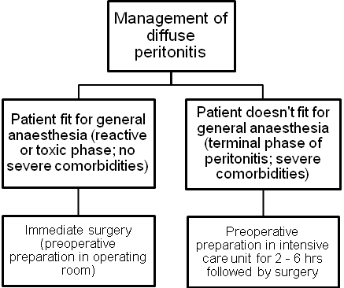

Peritoneal lavage and drainage
- In operations for general peritonitis it is essential that after the cause has been dealt with the whole penitoneal cavity should be explored with the sucker until all exudate is removed.
- The use of a large volume of saline (1 - 2 litres), which may contain dissolved antibiotic or antiseptic, is very effective.
- Wide drainage by tubes of large diameter of the site of origin of peritonitis, subphrenic, subhepatic spaces, flanks and pelvic space is essential (see Fig. 2-1).
- Postoperative lavage of these sites by antibiotic or antiseptic solutions is beneficial.

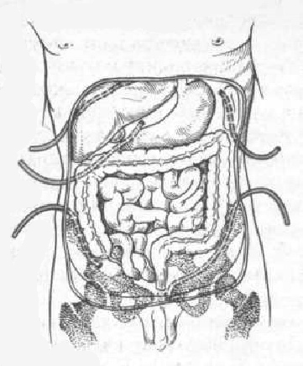
Fig. 2-1. Drainage of peritoneal cavity for diffuse peritonitis

Complications of peritonitis
Acute intestinal obstruction due to peritoneal adhesions
- This usually gives central colicky abdominal pain with evidence of small bowel gas and fluid levels sometimes confined to the proximal intestine on X-ray (see Fig. 5-18).
- Bowel sounds are increased. It is more common with localised peritonitis. It is essential to distinguish this from paralytic ileus.

Paralytic ileus
- There is usually little pain and gas-filled loops with fluid levels are seen distributed throughout the small and large intestines on abdominal X-ray.
- In paralytic ileus, bowel sounds are reduced or absent.

Abscesses
- Abscess is localized form of peritonitis. It is separated collection of infected fluid of variuos location within the abdominal cavity.
- Abscesse may be due to separation of distinct primary inflammatory process (e.g. appendicular abscess) or may be a sequela of diffuse peritonitis.

Clinical features and laboratory data
- Fever, local pain, tachycardia and leukocytosis and other signs of SIRS are present.
- The patient may have tenderness or an abdominal mass, particularly with a pelvic abscess, but often no physical findings are present.
- When there is a delay in seeking medical attention patients may present with generalized sepsis with hypotension.
- The most characteristic symptoms of a pelvic abscess are diarrhea and the passage of mucus in the stools. Rectal examination reveals a bulging of the anterior rectal wall.
- Postoperative abscesses usually produce fever during the second postoperative week.
- In the majority of cases with the aid of antibiotic treatment, small abscesses become smaller and smaller, and finally are undetectable.

Visualization data
- Computed tomography (CT) scan and ultrasound show separated fluid collection (see Fig. 2-2).
- Plain adbominal radiograph may show round-shaped cavity with horizontal fluid level (“basket” sign).

A 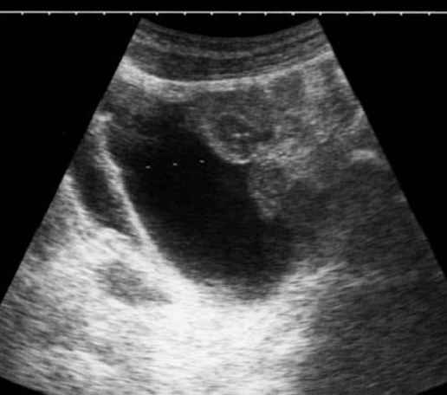 B 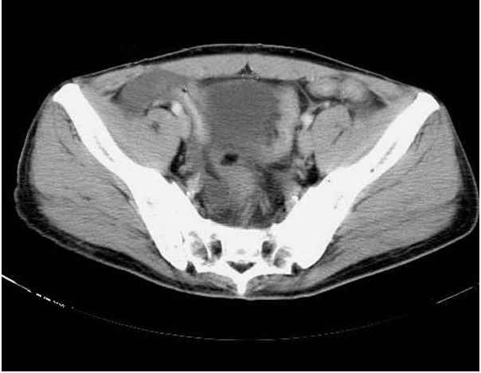
Fig. 2-2. US- and CT- pictures of pelvic abscess

Treatment
Scheme 2-4. Algorithm of surgical management of intra-abdominal abscesses

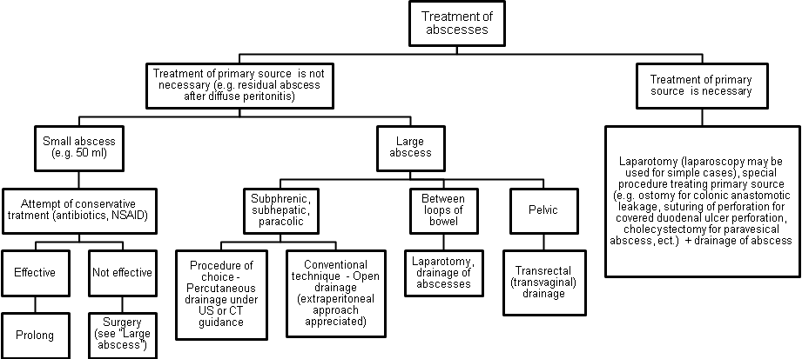

A 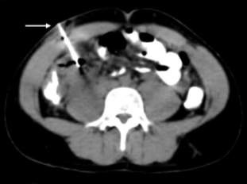 B 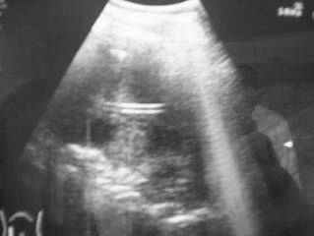
Fig. 2-3. CT- and US-guided percutaneous drainage of intra-abdominal abscess

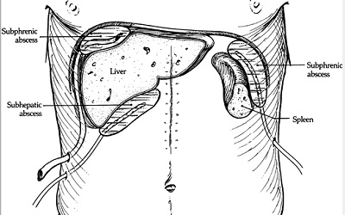
Fig. 2-4. Open drainage of subphrenic and subhepatic intra-abdominal abscesses

1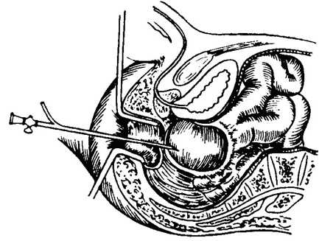 2 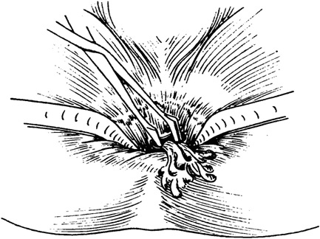
Fig. 2-5. Transrectal drainage of pelvic abscess

5. Plan and structure of the class
No. | Basic stages of the class | Training aims according to the levels of mastering | Means of training and control | Materials for methodological maintainance of  the class, visibility, and control of knowledges | Terms (in minutes or per cent)
1 | Initial | 1) Giving the training aims of level II (see chapter 2.1)  2) Control testing of initial level of knowledge, readiness of the students for perception of the material | Krok-2 type tests of initial level of knowledge, including software version (see chapter 6.1) | Krok-2 type tests of initial level of knowledge, including software version (see chapter 6.1) | 15 %
2 | Basic | 1) Giving the training aims of levels II – IV (see chapter 2.1)  2) Conduct curation of a patient with the abdominal pain  3) Take part in the clinical analysis of the intensive care unit patient with the abdominal pain  4) Perform dressing for a patient in the postoperative period | Observation of patients at the department of robotic and endoscopic surgery  Analysis of specific case histories with the formation of a diagnostic and treatment program to address the need for modern methods. | 1) Schemes, tables (including PowerPoint presentations) of algorithms of diagnostics and management  2) Diagnostic images  3) Illustrations and videos of surgical procedures  4) Equipment  Radiographs  Disease history  5) Untypical tasks in the form of: patient, medical history, test situation assignments, business games, dressing | 70 %
3 | Conclusive | 1) Control testing of theoretical knowledges and practical skills  2) Conclusions  3) Giving the home task | 1) Krok-2 type tests of final level of knowledge, including software version (see chapter 6.3)  2) List of literature for the next class | Krok-2 type tests of final level of knowledge, including software version (see chapter 6.3) | 15 %

6. Materials for methodological maintainance of the class

6.1. Materials for initial stage of the class

A 75-years-old man was admitted to ER with complaints of intense diffuse abdominal pain, multiple vomiting and abdominal distension. He is ill for 4 days. Arterial pressure is 80/40 mmHg, pulse is weak, 120 beats per minute, central arterial pressure is negative, last 24 hours urine output is 300 ml. Physical examination of abdomen reveals muscle quarding, severe tenderness, and rebound tenderness at all the sites. What’s the most appropriate tactics of managing the patient?

A. Immediate surgery - laparotomy
B. Immediate surgery – diagnostic peritoneal lavage
C. Delayed surgery – laparotomy – after preoperative preparation for 2 days
D. Delayed surgery – laparotomy – after preoperative preparation for 2-4 hours +
E. Delayed surgery – laparotomy – after preoperative preparation for 20-24 hours

A 48-years-old woman was admitted to ER 2 weeks after appendectomy for gangrenous appendicitis, with complaints of moderate pain at hypogastric region of abdomen irradiating into the rectum and febrile temperature. The symptoms appeared 3 days ago. Physical examination of abdomen reveals slight muscle spasm at hypogastric region, no tenderness. Postoperative scar is free of inflammation. Ultrasound reveals a fluid collection 7 сm in diameter. What’s the most appropriate tactics of managing the patient?

A. Conservative treatment with antibiotics
B. Percutaneous drainage of the collection
C. Transrectal drainage of the collection +
D. Conservative treatment with physiotherapy
E. Lower midline laparotomy and open drainage of the collection

A 28-years-old man who had a history of ulcer disease was admitted to ER with complaints of intense (knife-stab) pain at upper part of abdomen and multiple vomiting. The pain appeared 30 minutes ago. Physical examination of abdomen reveals wooden-like muscle spasm, severe diffuse tenderness, and rebound tenderness at all the sites. What’s the most possible sign found at the imaging studies?

A. Abdominal ultrasonography shows fluid in right flank
B. Small bowel follow-through contrast study shows slow passage of contrast medium
C. CT of abdominal cavity shows fluid in right flank
D. Upright abdominal radiography shows free air under the right dome of diaphragm +
E. Chest radiography shows high position of right dome of the diaphragm

A 68-years-old woman was admitted to ER with complaints of intense pain at right upper quadrant of abdomen and multiple vomiting. The pain appeared 3 days ago after ingestion of fatty food. Physical examination of abdomen reveals slight muscle spasm and severe local tenderness at right upper quadrant. What’s the most valuable method of further investigation to make the diagnosis and chose proper tactics?

A. Gastroduodenal endoscopy
B. Upright abdominal radiography
C. Upper gastrointestinal series
D. Barium enema
E. Abdominal ultrasonography +

A 40-years-old woman was admitted to ER with complaints of a cramping pain at right lower quadrant of abdomen irradiating to perineum, fever of 38 °C and single vomiting. There is no diarrhea and constipation. Physical examination of abdomen reveals moderate tenderness in right iliac region and right flank, no rebound tenderness and muscle guarding. Give your presumable diagnosis:

A. Acute appendicitis
B. Acute gastroenteritis
C. Renal colic +
D. Acute salpingitis
E. Bowel obstruction

A 27-years-old woman was admitted to ER with complaints of a constant pain at right lower quadrant of abdomen without irradiation, subfebrile fever and small amount of muddy vaginal discharges. There is no diarrhea and constipation. Physical examination of abdomen reveals moderate tenderness in right iliac region and pubic region, slight rebound tenderness and no muscle guarding. Menstruation was 20 days ago. Give your presumable diagnosis:

A. Acute appendicitis
B. Ruptured ectopic pregnancy
C. Salpingitis +
D. Cancer of cervix of uterus
E. Pelvic appendicular abscess

6.2. Materials for basic stage of the class

A 55-years-old man was operated 2 years ago for cancer of sigmoid colon pT₂N₁M₀: the sigmoidectomy was performed. During regular examination, a hyperechogenic node of 3,5 cm was found in the 4th segment of liver. Contrast-enhanced MRI show increased uptake of the medium by the node, and doesn’t reveal any other nodes, lymphadenopathy and local recurrence of the tumor. US-guided biopsy shows cells of moderately-differentiated adenocarcinoma. The examination of abdomen showed no pathological changes. The patient has no concomitant pathology. What’s the most appropriate tactics of managing the patient?

A. Percutaneous radiofrequency ablation of the node
B. Laparoscopic radiofrequency ablation of the node
C. Open liver segmentectomy +
D. Open left hemihepatectomy
E. Open criogenic destruction of the node

A 35 -years-old man, a sheepman, was admitted to surgical department with complaints of a moderate periodical pain at right subcostal region which appeared 2 weeks ago. While physical examination of abdomen, there is slight tenderness at the right subcostal region, no hepatomegaly. There is no history of jaundice. Blood and urine analyses are normal. Ultrasound reveals unechogenic lesion with regular boards measuring 8 cm in diameter, located deeply in liver parenchima in the 6th and 7th segments. The patient has no concomitant pathology. What’s the most appropriate tactics of managing the patient?

A. Percutaneous drainage of the lesion +
B. Laparoscopic drainage of the lesion
C. Open drainage of the lesion
D. Open right hemihepatectomy
E. Conservative treatment

A 50-years-old man was admitted to ER 1 week after discharge from a hospital: he underwent laparoscopic cholecystectomy for gangrenous cholecystitis. Currently he complains of moderate pain at right subcostal region of abdomen irradiating into the right shoulder, hiccups and febrile temperature. The symptoms appeared 4 days ago. Physical examination of abdomen reveals slight muscle spasm, moderate tenderness, and no rebound tenderness at right subcostal region. Ultrasound revealed a fluid collection under the right dome of the diaphragm. What’s the most appropriate tactics of managing the patient?

A. Upper midline laparotomy and open drainage of the collection
B. Percutaneous drainage of the collection +
C. Laparoscopic drainage of the collection
D. Laparotomy by oblique subcostal incision and open drainage of the collection
E. Conservative treatment with antibiotics
A 40-years-old man was admitted to ER with complaints of an intense constant pain at epigastric region irradiating to the back, and multiple vomiting. The symptoms appeared the last morning, after a party the day before. Physical examination of abdomen reveals intense tenderness in both upper quadrants, no rebound tenderness, and slight muscle guarding at the epigastric region. Serum amylase is elevated threefold than normal. Upright abdominal radiography shows increased bowel gas pattern. What’s the most appropriate tactics of managing the patient?

A. Upper midline laparotomy, exploration of lesser sac, drainage of lesser sac
B. Percutaneous drainage of the lesser sac
C. Laparoscopic exploration of lesser sac, drainage of lesser sac
D. Conservative treatment with steroids and non-steroidal anti-inflammatory drugs
E. Conservative treatment with antispasmodics, antagonists of somatostatine and proton pump inhibitors +

A 70-years-old man was admitted to ER with complaints of a cramping pain at all the sites of abdomen and multiple vomiting. The last bowel movement was 2 days prior to admission. While physical examination of abdomen, there is marked distention, moderate diffuse tenderness, no rebound tenderness and muscle guarding. Digital examination reveals absence of feces in the rectum. What’s the most valuable method of further investigation to make the diagnosis and chose proper tactics?

A. Abdominal ultrasonography
B. Upright abdominal radiography +
C. Upper gastrointestinal series
D. Small bowel follow-through contrast study
E. Gastroduodenal endoscopy

A 40-years-old woman was admitted to ER with complaints of a cramping pain at right lower quadrant of abdomen irradiating to perineum, fever of 38 °C and single vomiting. There is no diarrhea and constipation. Physical examination of abdomen reveals moderate tenderness in right iliac region and right flank, no rebound tenderness and muscle guarding. Urine analysis shows increased amount of WBC and RBC. What’s the most appropriate sequence of methods of further investigation?

A. Upright abdominal radiography, ultrasonography of abdomen and kidneys, intravenous pyelography +
B. Upright abdominal radiography, barium enema, CT of retroperitoneal space
C. Upright abdominal radiography, gastroduodenal endoscopy, CT of retroperitoneal space
D. Upper gastrointestinal series, small bowel follow-through contrast study, intravenous pyelography
E. MRI of retroperitoneal space, ultrasonography of kidneys, upright abdominal radiography

A 20-years-old man was admitted to ER with complaints of slight constant pain at right iliac region for the last 5 days. 7 days ago he had severe pain at right lower quadrant of abdomen which had diminished with time. Currently while physical examination, the smooth, slightly tender mass is palpated in right iliac region. Patient’s body temperature is subfebrile. There is no diarrhea and constipation. Ultrasound reveals a mass without cavity in the right iliac fossa that measures 7 cm in diameter. What’s the most appropriate tactics of managing the patient?

A. Lower midline laparotomy, appendectomy
B. Laparotomy by McBurney’s incision, appendectomy
C. Laparoscopic appendectomy
D. Case monitoring
E. Conservative treatment with antibiotics and non-steriodal anti-inflammatory drugs +

4. A 20-years-old man was admitted to ER with complaints of moderate constant pain at right iliac region for the last 5 days, fatigue and fever of 38 °C. 7 days ago he had severe pain at right lower quadrant of abdomen which had deminished with time. Currently, the hard tender mass and moderate rebound tenderness in right iliac region is determined. There is no diarrhea and constipation. Ultrasound reveals a mass with a cavity (fluid collection) measuring 10 сm in diameter. What’s the most appropriate tactics of managing the patient?

- Conservative treatment by antibiotics
- Conservative treatment by physiotherapy
- Surgical treatment – drainage +
- Case monitoring
- Conservative treatment with antibiotics and anti-inflammatory drugs
6.3. Materials for final stage of the class

3 hours ago a 65-year-old female patient felt sharp abdominal pain irradiating to the right scapula, there was a single vomiting. She has a history of rheumatoid arthritis. Objectively: pale skin, AP- 100/60 mm Hg, Ps- 60/min. Abdomen is significantly painful and tense in the epigastrium and right subcostal areat, there are positive symptoms of parietal peritoneum irritation over the right costal arch, that is tympanitis. What is the tactics of an emergency doctor?
- To take the patient to the rheumatological department
- To perform gastric lavage
- To take the patient to the surgical hospital
- To inject spasmolytics
- To inject pain-killers and watch the dynamics

A patient complains of an extremely intense pain in epigastrium. He has peptic ulcer disease of duodenum for 10 years. The patient is in the forced position being on the right side with legs abducted to stomach. Abdomen has acute tenderness in the epigastrium. Guarding contraction of the abdominal wall muscles is observed. What is the preliminary diagnosis?
- Thrombosis of mesenteric vessels
- Perforation of ulcer
- Acute condition of peptic ulcer disease
- Acute pancreatitis
- Penetration of ulcer into pancreas

A 29 y.o. patient was admitted to the hospital with acute girdle pain in epigastric area, vomiting in 1 hour after the meal. On examination: pale, acrocyanosis. Breathing is frequent, shallow. Abdominal muscles are tensed, positive Schotkin-Blumbergs symptom. What is the maximal term to make a diagnosis?
- In 2 hours
- In 3 hours
- In 1 hour
- In 6 hours
- In 0,5 hours

A patient suffers from suddenly arising crampy pain in the right loin area. 2 hours after the pain had started, hematuria took place. Loin X-ray: no pathological shadows. Ultrasound: pyelocaliectasis on the right, the left part is normal. What is the most probable diagnosis?
- Stone of the right kidney, renal colic
- Intestine invagination
- Tumour of the right kidney pelvis
- Twist of the right ovary cyst
- Acute appendicitis

A 20 y.o. patient suddely felt ill 12 hours ago. There was pain in epigactric area, nausea, sporadic vomiting.
He had taken alcohol before. In few hours the pain localized in the right iliac area. On examination: positive rebound tenderness symptoms. WBC- 12,2&times;10<sup>9</sup>/L. What is the most probable diagnosis?
- Acute appendicitis
- Acute cholecystitis
- Rightside kidney colic
- Perforated ulcer
- Acute pancreatitis

A female patient has been suffering from pain in the right subcostal area, bitter taste in the mouth, periodical bile vomiting for a month. The patient put off 12 kg. Body temperature in the evening is 37,6oC. Sonography revealed that bile bladder was 5,5?2,7 cm large, its wall - 0,4 cm, choledochus - 0,8 cm in diameter. Anterior liver segment contains a roundish hypoechoic formation up to 5 cm in diameter and another two up to 1,5 cm each, walls of these formations are up to 0,3 cm thick. What is the most likely diagnosis?
- Cystous liver cancer
- Alveolar echinococcus of liver
- Liver abscess
- Paravesical liver abscesses
- Liver cancer
A patient, aged 25, suffering from stomach ulcer. Had a course of treatment in the gastroenterological unit. 2 weeks later developed constant pain, increasing and resistant to medication. The abdomen is painful in epigastric area, moderate defence in pyloroduodenal area. Which complication development aggravated the patients state?
- Stenosis
- Penetration
- Malignisation
- Haemorrhage
- Perforation

A 38 y.o. woman was hospitalized to the surgical unit with vomiting and acute abdominal pain irradiating to the spine. On laparocentesis hemmorhagic fluid is obtained. What disease should be suspected?
- Perforated gastric ulcer
- Renal colic
- Acute enterocolitis
- Acute appendicitis
- Acute pancreatitis

A 38 year old man, previously in good health, suddenly develops severe abdominal pain radiating from the left loin to groin and accompanied by nausea, perspiration and the need for frequent urination. He is restless, tossing in bed but has no abnormal findings. The most likely diagnosis is:
- Sigmoid diverticulitis
- Retroperitoneal haemorrhage
- Torsion of the left testicle
- Leftsided renal colic
- Herpes zoster

A 45-year-old woman, mother of four children, comes to the emergency room complaining of a sudden onset of the epigastric and right upper quadrant pain, radiating to the back, accompanied by vomiting. On examination, tenderness is elicited in the right upper quadrant, bowel sounds are decreased, and laboratory data shows leukocytosis, normal serum levels of amylase, lipase, and bilirubin. The most likely diagnosis is:
- Perforated peptic ulcer disease
- Sigmoid diverticulitis
- Acute pancreatitis
- Acute cholecystitis
- Myocardial infarction

A 50-year-old man comes to the emergency room with a history of vomiting of 3 days duration. His past history examination reveals that for about 20 years he has been suffering from epigasric pain lasting for 2 to 3 weeks, during early spring and autumn. He remembers getting relief from pain by taking milk and antacids. Physical examination showed a fullness in the epigastric area with visible peristalsis, absence of tenderness, and normal active bowel sounds. The most likely diagnosis is:
- Gastric outlet obstruction
- Incarcerated umbilical hernia
- Cholecystitis
- Small bowel obstruction
- Volvulus of the colon

7. Literature for teachers

- General Surgery: textbook / S.D. Khimich, M.D. Zheliba, V.P. Andryushchenko et al. — К., 2019. — 536 p., hardcover

- Essential surgery. Editor prof V.V.Grubnik, O.L.Kovalchuk, A.V.Malinovsky. Ternopil, TSM, 2010, 543 p.

- Surgery: a textbook is intended for English-speaking students of higher medical educational institutions of III-IVth levels of accreditation, interns / K. M. Amosova, Ya. S. Bereznyts’kyy, A. O. Burka [et al.]; ed. by Ya. S. Bereznyts’kyy [et al.], 2016. - 711 p.

- Surgery: a textbook is intended for English-speaking students of higher medical educational institutions of III-IVth levels of accreditation, interns / K. M. Amosova, Ya. S. Bereznyts’kyy, A. O. Burka [et al.]; ed. by Ya. S. Bereznyts’kyy [et al.], 2018. - 711 p.

- Essential surgery [Text] : навч. посіб. для студ. вищ. мед. навч. закл. IV рівня акредитації, які опановують навч. дисципліну англ. мовою (протокол № 4 від 01.10.2010 р.) / V. V. Grubnik, O. L. Kovalchuk, A. V. Malynovskyy, O. V. Grubnik. - Ternopil : TSMU "Ukrmedknyha", 2010. - 544 p. : fig., tab. - Текст англ. - Бібліогр.: с. 529-531. - 500 прим. - ISBN 978-966-673-147-3

- Sabiston textbook of surgery: the biological basis of modern surgical practic / [edited by] Courtney M. Townsend, Jr, R. Daniel Beauchamp. B. Mark Evers, Kenneth L. Mattox.—20th edition.
- Surgery Editor. Bereznyts'ky Y.S., Zarharash M.P, Mishalov V.G. Vinnytsia, 2016, 711p.

8. Literature for students

8.1. Basic literature

- General Surgery: textbook / S.D. Khimich, M.D. Zheliba, V.P. Andryushchenko et al. — К., 2019. — 536 p., hardcover

- Essential surgery. Editor prof V.V.Grubnik, O.L.Kovalchuk, A.V.Malinovsky. Ternopil, TSM, 2010, 543 p.

- Surgery: a textbook is intended for English-speaking students of higher medical educational institutions of III-IVth levels of accreditation, interns / K. M. Amosova, Ya. S. Bereznyts’kyy, A. O. Burka [et al.]; ed. by Ya. S. Bereznyts’kyy [et al.], 2016. - 711 p.

- Surgery Editor. Bereznyts'ky Y.S., Zarharash M.P, Mishalov V.G. Vinnytsia, 2016, 711p.

8.2. Additional literature

- Surgery: a textbook is intended for English-speaking students of higher medical educational institutions of III-IVth levels of accreditation, interns / K. M. Amosova, Ya. S. Bereznyts’kyy, A. O. Burka [et al.]; ed. by Ya. S. Bereznyts’kyy [et al.], 2018. - 711 p.

- Essential surgery [Text] : навч. посіб. для студ. вищ. мед. навч. закл. IV рівня акредитації, які опановують навч. дисципліну англ. мовою (протокол № 4 від 01.10.2010 р.) / V. V. Grubnik, O. L. Kovalchuk, A. V. Malynovskyy, O. V. Grubnik. - Ternopil : TSMU "Ukrmedknyha", 2010. - 544 p. : fig., tab. - Текст англ. - Бібліогр.: с. 529-531. - 500 прим. - ISBN 978-966-673-147-3

- Sabiston textbook of surgery: the biological basis of modern surgical practic / [edited by] Courtney M. Townsend, Jr, R. Daniel Beauchamp. B. Mark Evers, Kenneth L. Mattox.—20th edition.

9. Topics for student’s research:
Theme: "Prevention of infection complications in the postoperative period in surgical patients"
1. A task for UDRS: participation of students in production of illustrative material (tables, slides, presentations).
2. A task for NDRS: preparation of papers, reports at a meeting of scientific student's organization
10. Topic of the next class

Topic 10. Syndrome of acute bowel obstruction

Elaboration composed by: ass. Chystiakov R S

