ODESSA NATIONAL MEDICAL UNIVERSITY
DEPARTMENT OF ROBOTIC AND ENDOSCOPIC SURGERY

METHODICAL instructive elaboration

of the practical class for the discipline
"Surgical diseases with child's surgery and oncology» for students of the 6-th course of the medical faculty

Topic № 12" Syndrome of acute abdomen: diagnostics, differential diagnostics, management ".

Discussed and approved at
methodical board of Department
of Robotic and Endoscopic surgery
"28" August 2019
Protocol № 1
Head of the Department
Ass. prof. __________ Malinovsky A.V.

Odessa - 2019

Topic of practical class: « Syndrome of acute abdomen: diagnostics, differential diagnostics, management » – 7.5 hours

1. Significance of topic

Acute surgical pathology of the abdominal cavity refers to the group of diseases that need urgent urgent measures aimed at saving the life of the patient. This is due to the clinical course of surgical diseases and is characterized by the fact that at every moment since the onset of the disease there is a real threat to the life of patients in the event of untimely assistance.
Acute abdomen is a generalizing concept that includes a number of surgical diseases of the abdominal cavity organs, as well as related pathologies (urology, gynecology, therapy, cardiology), etc.

2. Aims of the class

2.1. Training aims (a student must learn and master):

Level I - Nosological forms of acute surgical pathology of the abdominal cavity organs, which are included in the concept of "acute abdomen";
Level II – The main provisions of emergency care for urgent surgical patients, the timing of hospitalization, the timing of the implementation of surgical interventions from the moment of the disease and hospitalization in surgical hospitals;
Level III – Principles of emergency care: conservative therapy, urgent surgical interventions, volume of operational benefit for different nosological forms;
Level III - Rules for the preparation of medical documentation for "acute abdomen";

2.2. Educational aims:
1. 1. Education of students in clinical thinking.
2. On specific examples, educate students about the responsibility for their own business, the principles of medical ethics and deontology in surgery, the observance of medical secrecy, adherence to production discipline and professional subordination.

3. Interdisciplinary integration
№ | Disciplines | To know | To master
Previous disciplines (basic disciplines)
1 | Anatomy, histology,  pathomorfology | Surgical anatomy of the abdominal cavity. | To be able to show on the abdominal wall the projection of the organs of the abdominal cavity.
2 | Physiology and pathophysiology | Features of functioning and interrelation of organs of the abdominal cavity. Pathological impact of the abdominal organs on each other.  Biochemical changes in the organs of the abdominal cavity and throughout the body during inflammatory and other diseases of the abdominal cavity | To be able to interpret changes in the organs of the abdominal cavity during diseases of other organs.
3 | Propaedeutics of internal medicine | Methods of physical examination in patients with syndrome of acute abdomen | Carry out a systemic study of the body of patient with syndrome of acute abdomen. Interpret laboratory and instrumental research data.
4 | Pharmacology | Effects of pharmacological drugs on the abdominal organs | Determine the indications and contraindications to the appointment of pharmacological drugs in patients with "acute abdomen"
5 | General surgery, modules | Methods of physical examination in patients with syndrome of acute abdomen | Carry out a systemic study of the body of patient with syndrome of acute abdomen. Interpret laboratory and instrumental research data.
6 | Emergency medical care | Features of emergency medical care for patients with "acute abdomen" | To be able to construct a scheme for the provision of medical care, including surgical care, for patients with "acute abdomen"
Following disciplines (clinical disciplines)
1 | Obstetrics and Gynecology | Methods of physical examination in patients with abdominal pain | Carry out a systemic study of the body of patient with abdominal pain. Interpret laboratory and instrumental research data.
2 | Urology | Methods of physical examination in patients with abdominal pain | Carry out a systemic study of the body of patient with abdominal pain. Interpret laboratory and instrumental research data.
3
Inside the discipline (other topics)
1 | Anatomical and physiological features of the abdominal cavity organs | Topographic-anatomical interrelations of the abdominal cavity organs | Know the projection of the abdominal organs on the anterior abdominal wall and their relationship and location in relation to the peritoneum
2 | Modern views on the etiology and pathogenesis of acute surgical pathology of the abdominal cavity; | To know modern views on the etiology of diseases that make up the concept of "acute stomach" | To know the etiology, pathogenesis and course of the main acute diseases of the abdominal cavity organs
3 | Classification of acute surgical pathology of the abdominal cavity; | Know the classification of acute surgical pathology of the abdominal cavity organs | The main features in which the diseases of the abdominal cavity are similar to each other and differ from each other
4 | Clinical features of the course of acute surgical pathology of the abdominal cavity; | To know the clinical features of the course of acute surgical pathology of the abdominal cavity organs | Be able to determine the prognosis of the course of pathology, which refers to the "acute stomach"
5 | Additional survey methods, laboratory duties, auxiliary (X-ray, ultrasound, etc.), which are used in doubtful cases; | To know additional examination methods, laboratory duties, auxiliary (X-ray, ultrasound, etc.), which are used in doubtful cases | To analyze the results of laboratory and instrumental research
6  7 | Differential diagnosis of acute surgical pathology of the abdominal cavity; | To know the differential diagnosis of acute surgical pathology of the abdominal organs | Be able to conduct differential diagnosis of diseases that are related to the "acute stomach". The concept of a "false acute abdomen"
6  7 | Principles of providing emergency care for acute surgical pathology of the abdominal organs | Know the basic principles of providing emergency care for acute surgical pathology of the abdominal organs | Be able to develop tactics for examining and treating a patient with an "acute abdomen"

4. Contents of the topic

ACUTE PANCREATITIS
Overview
- Scheme 2-5 shows the classification of different forms of pancreatitis which differs in english and russian literature (except names of complications of acute pancreatitis).

Scheme 2-5. Classification of forms of pancreatitis

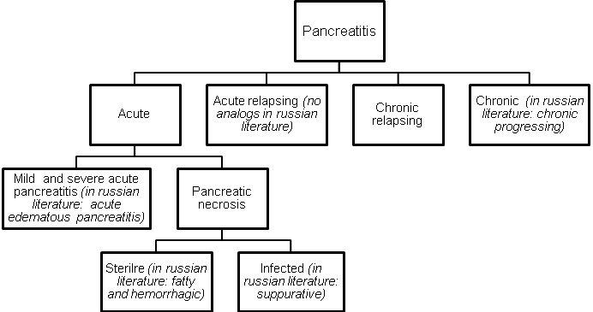

- Approximately 75% of pancreatitis cases can be explained by biliary tract disease or alcohol abuse, although the exact mechanism of pancreatitis remains theoretical.

Table 2-3. Etiological classification acute pancreatitis
Biliary

Acute cholecystitis (reactive)
Choledocholythiasis
Stenosis of sphincter of Oddi
Cholangitis

Alcoholic

Postoperative

Traumatic

Infectious

Mumps
Other

Other

Drugs (e.g. contrast medium)
Hyperparathyroidism
Malnutrition
Hyperlypidemia
Pancreas divisum
Duodenal obstruction
Ishemia
Scorpion venom

Scheme 2-6. Phases of clinical course of mild and severe acute pancreatitis
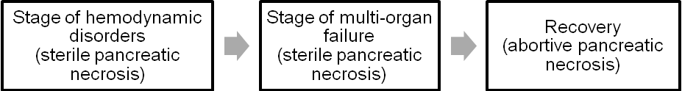

Scheme 2-7. Phases of clinical course of pancreatiс necrosis
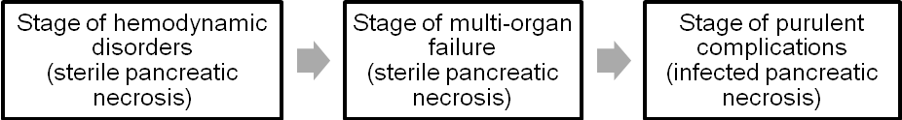

Clinical features and laboratory data
- Clinical presentation of acute pancreatitis may vary from mild abdominal discomfort to profound pain with hypotension and hypoxemia. Often the patient mentions recent consumption of a heavy meal, many times with large quantities of alcoholic beverages.
- Usually the patient presents with epigastric pain that is radiated to the back and is associated with nausea and vomiting. In severe cases, a rigid abdomen with epigastric guarding, rebound tenderness and marked abdominal pain may be present.
- Severe pancreatic inflammation and necrosis may cause retroperitoneal hemorrhage, which can lead to large third-space fluid losses, hypovolemia, hypotension, tachycardia, hypoxemia and even losing consciousness (pancreatogenic shock).
- When blood dissection extends to the flank tissues, resulting in periumbilical and flank ecchymoses, it is known as Cullen's and Turner's signs.
- Serum amylase level is elevated in 95% of patients.

Visualization data
Plain abdominal radiograph
- Calcification in the area of the lesser sac and pancreas may indicate chronic pancreatitis, which is most often seen in association with alcoholism (see Fig. 2-6).
- A gas collection in the lesser sac suggests abscess formation in or around the pancreas.
- Soft tissue shadows and gas-containing viscera may be visibly displaced by collections and edema in the lesser sac and structures adjacent to the pancreas.
- An area of colonic spasm adjacent to an inflamed pancreas causes the gas in the transverse colon to end abruptly (the "cutoff" sign).
- Focal duodenal and jejunal ileus in the area of the pancreas can cause the “reversed 3” sign.

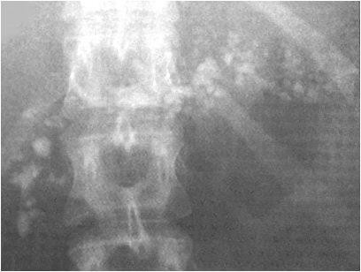

Fig. 2-6. Calcification in the area of pancreas indicating chronic pancreatitis

Upper GI series
- The duodenal C-loop may be widened by pancreatic edema.
- Hypotonic duodenography may demonstrate the "pad" sign, a smoothing out or obliteration of the duodenal mucosal folds by the edematous pancreas and the inflammatory response on the medial aspect of the C-loop.

Ultrasound examination
- Acute pancreatitis is suggested by swelling that is greater than the normal anteroposterior thickness and loss of tissue planes between the pancreas and the splenic vein (see Fig. 2-7-a).
- Lesser sac and retroperitoneal collections (acute pseudcyst and abscesses of pancreaes and lesser sac, retroperitoneal phlegmone) are easily diagnosed (see Fig. 2-8-a) as well as destruction of tissue of pancreas in infected pancreatic necrosis (see Fig. 2-9-a).
- Ultrasound may also demonstrate the presence of gallbladder pathology, such as cholecystitis, cholelithiasis or a dilated common bile duct (see Chapters 4, 10).

A 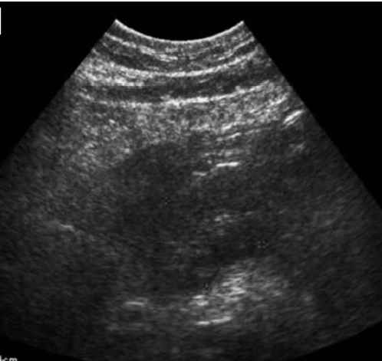 B 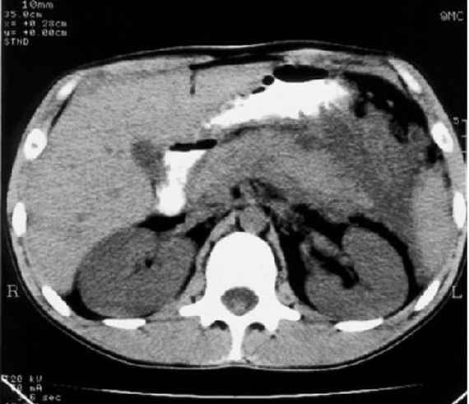
Fig. 2-7. US- and CT- pictures of acute edematous pancreatitis

A 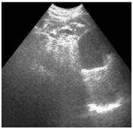 B 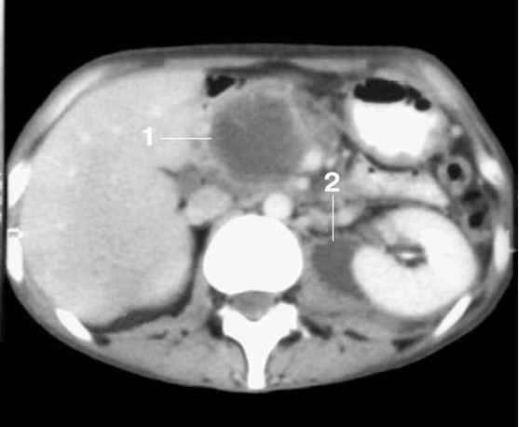
Fig. 2-8. US- and MRI- pictures of lesser sac and retroperitoneal collections

A 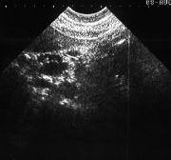 B 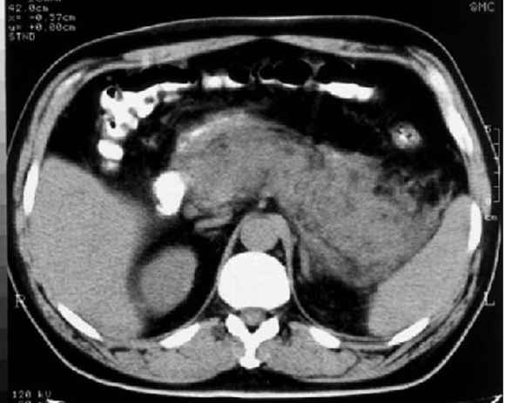
Fig. 2-9. US- and CT- pictures of infected pancreatic necrosis

CT and MRI
- CT scan of the pancreas may also be helpful. It provides higher resolution than ultrasonography, and it is not limited by the masking effect of intestinal gas (see Fig. 2-7-b, 2-8-b, 2-9-b).
- The criteria for CT findings are similar to those described for ultrasound.
- Magnetic resonance pancreatograms and cholangiograms are very useful for delineating anatomy before surgery. They can provide excellent detail of the pancreatic tissue and bile ducts, including stones in СВD that may produce biliary pancreatitis (see Chaper 10).

ERCP
- The use of endoscopic retrograde cholangiopancreatography (ERCP) in the first 5 days of severe acute pancreatitis is dangerous and is associated with an increased mortality rate.
- In early period of acute pancreatitis ERCP is indicated if biliary pancreatitis associated with CBD stone and mechanical jaundice with progressive course is present (e.g. impacted stone in papilla of Vateri) (see Chaper 10). Endoscopic sphincterotomy for extraction of stones may be performed then.

Table 2-4. Ranson's prognostic criteria for acute pancreatitis (morbidity and mortality rates correlate with the number of criteria present: 0-2 = 2% mortality; 3-4 = 15% mortality; 5-6 = 40% mortality; 7-8 = 100% mortality)
Present on admission

Age > 55 years
White blood cell count > 16,000/μL
Blood glucose > 200 mg/dL
Serum lactate dehydrogenase > 350 I.U./L
SGOT (AST) > 250 I.U./dL

Developing during first 48 hours

Hematocrit fall > 10%
Blood urea nitrogen increase > 8 mg/dL
Serum Ca²⁺ < 8 mg/dL
Arterial PO₂ < 60 mmHg
Base deficit < 4 mEq/L
Estimated fluid sequestration > 600 mL

From: Principles of surgery/ed., S.I. Schwartz, et al. – 7th ed.

Treatment of acute pancreatitis and its early complications
- The goal of surgical treatment of pancreatic necrosis is to allow the sequestration of pancreatic tissue to occur as completely as possible in order to remove more sequesters while laparotomy. Thus, if no early life-threatening complications are present (such as suppurative peritonitis, large abscess of lesser sac, large acute pseudocyst with further complications, and retroperitoneal phlegmone), there is no evidence for biliary pancreatitis and this diagnosis is quite certain, the sequestrectomy (see Fig. 2-10) should be delayed to 2 – 4 weeks from the onset of a disease.

Scheme 2-8. Algorithm of management of mild and severe acute pancreatitis
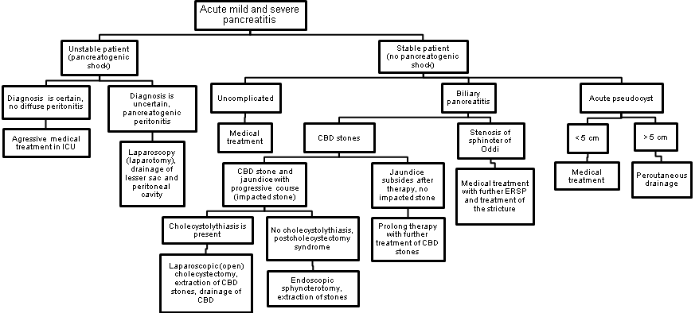
Scheme 2-9. Algorithm of management of pancreatic necrosis and its early complications

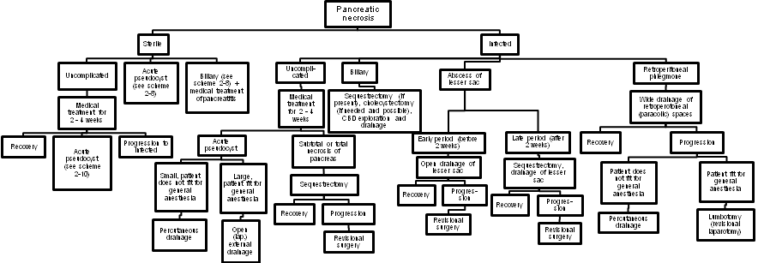

1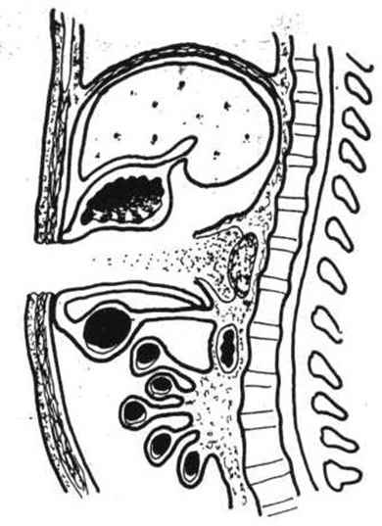 2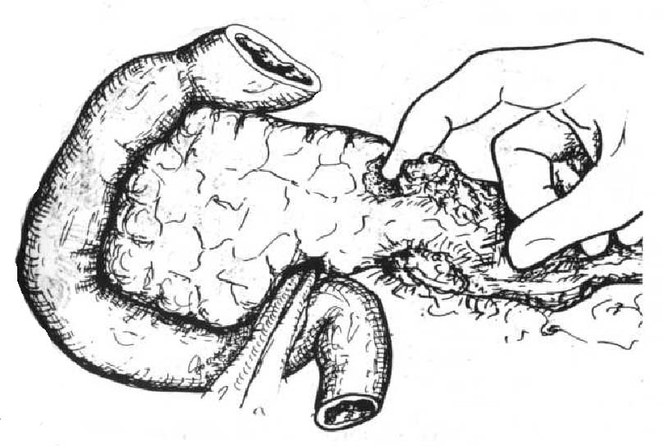 3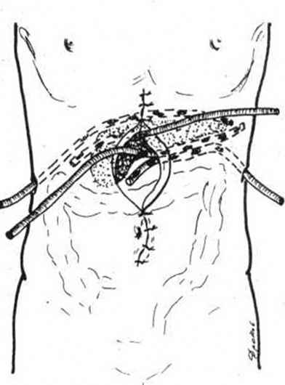
Fig. 2-10. Sequestrectomy, drainage of lesser sac and retroperitoneal space and laparostomy

Medical treatment of pancreatitis
- Nasogastric suction is used to control nausea and vomiting, decrease pancreatic stimulation, and decrease gastrointestinal distention from an ileus.
- Withhold oral feedings until laboratory test results return to normal, and pain is gone for 48 hours. In severe cases total parenteral nutrition (TPN) or enteral feeding via jejunostomy (endoscopiс percutaneous jejunostomy) may be benficial.
- Intravenous fluids are used to replace the third-space fluid loss. Crystalloid solutions are usually adequate.
- Antagonists of somatostatine and inhibitors of proteases are highly effective in early stages of pancreatitis.
- Broad-spectrum antibiotics are used in severe cases of sterile pancreatic necrosis, in infected pancreatic necrosis and in biliary pancreatitis. The early use of antibiotics is thought to promote the maturation of peripancreatic fluid collections into pseudocysts rather than abscesses.
- Blockers of H₂-hystamine receptors and proton pump inhibitors (PPIs) are also beneficial.

Late complications of pancreatic necrosis
Table 2-5. Complications of pancreatic necrosis
Early (within first 2-4 weeks)

Pancreatogenic shock
Acute renal failure
Adult respiratory distress syndrome
Miocardial depression
Pancreatogenic peritonitis
Acute pseudocyst
Abscess of pancreas
Abscess of lesser sac
Retroperitoneal phlegmone
Dynamic ileus
Acute hemorrhagic gastritis
Cholangitis

Late (within 1 – 3 months)

Intra-abdominal abscesses
Diffuse suppurative peritonitis
Pleuritis, empyema, pneumonia
Pseudocyst
Uncomplicated
Compression of CBD with jaundice
Compression of stomach or duodenum
with obstruction
Infected (with suppuration)
Bleeding
Ruptured
Arrosive bleeding
Fistula formation
Biliary
Duodenal
Colonic
Sepsis
Splenic vein thrombosis, splenic infarction
Acute acalculous (enzymatic) cholecystitis

Distant

Diabetes mellitus (III type)
Pancreatic fistula
Pancreatic insufficiency
Abdominal adhesions
Stenosis of sphincter of Oddi
Pancreatogenic ascites
Chronic sepsis

Pancreatic pseudocyst
- The pseudocyst begins as a lesser sac collection and is not lined by epithelium and consists only of the inflammatory response of the neighboring organs (stomach, duodenum, colon, and transverse mesocolon). Maturation of the pseudocyst takes 4-8 weeks.
- During the maturation phase, the patient recovers from a bout of pancreatitis but develops a persistent elevation of amylase, a low-grade fever, a minimally elevated white blood cell count, and chronic pain.
- Pseudocysts are usually diagnosed by ultrasound or CT scan.
- The goal is to allow the maturation phase to continue until the walls of the pseudocyst have matured. External drainage (see Fig. 2-11) is used if the pseudocyst is not found to be mature and if suturing of the pseudocyst wall is not safe. The external drainage results in a pancreatic fistula. Thus, if a pseudocyst is matured it’s better to drain in internally: cystojejunostomy (see Fig. 2-12) is a procedure of choise but cystogastrostomy or cystoduodenostomy may also be used if technical convenient.
- Novel approach, although currently without distinct indications, is endoscopic cystogastrostomy (see Fig. 2-13). Probably, it is indicated for small mature pseudocysts and in high risk of common anaesthesia.
- Small pseudocysts may resolve with medical treatment (see Scheme 2-10).

Scheme 2-10. Algorithm of management of pancreatic pseudocyst
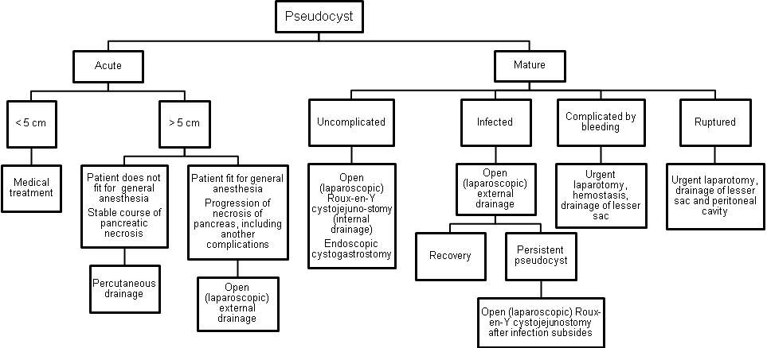
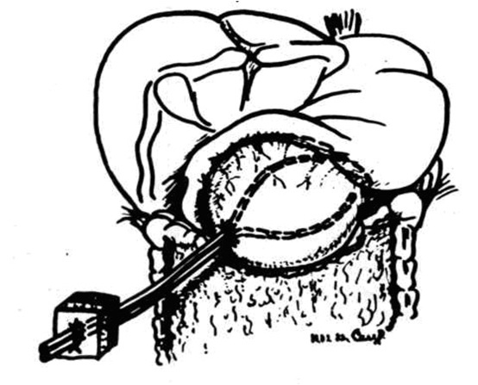
Fig. 2-11. External drainage of pseudocyst
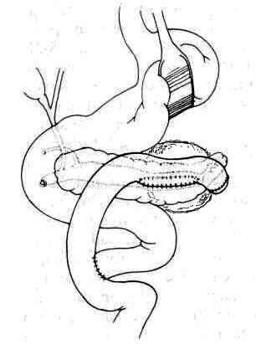

Fig. 2-12. Roux-en-Y cystojejunostomy (internal drainage of pseudocyst)
1 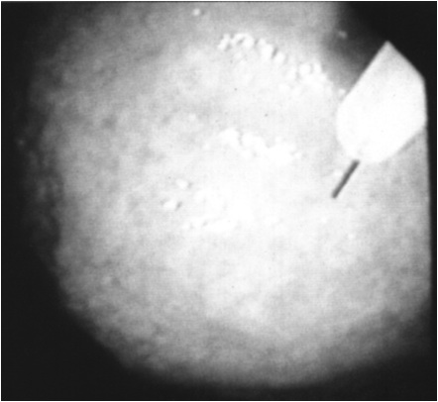 2 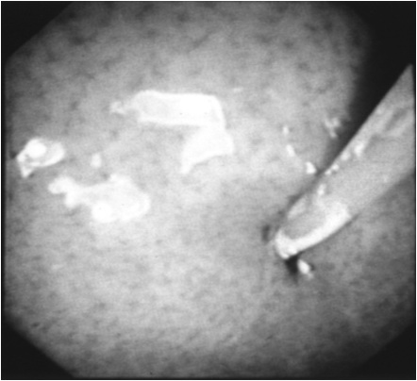
Fig. 2-13. Endoscopic cystogastrostomy

Scheme 2-11. Potential progression of lesser sac collections and surgical treatment

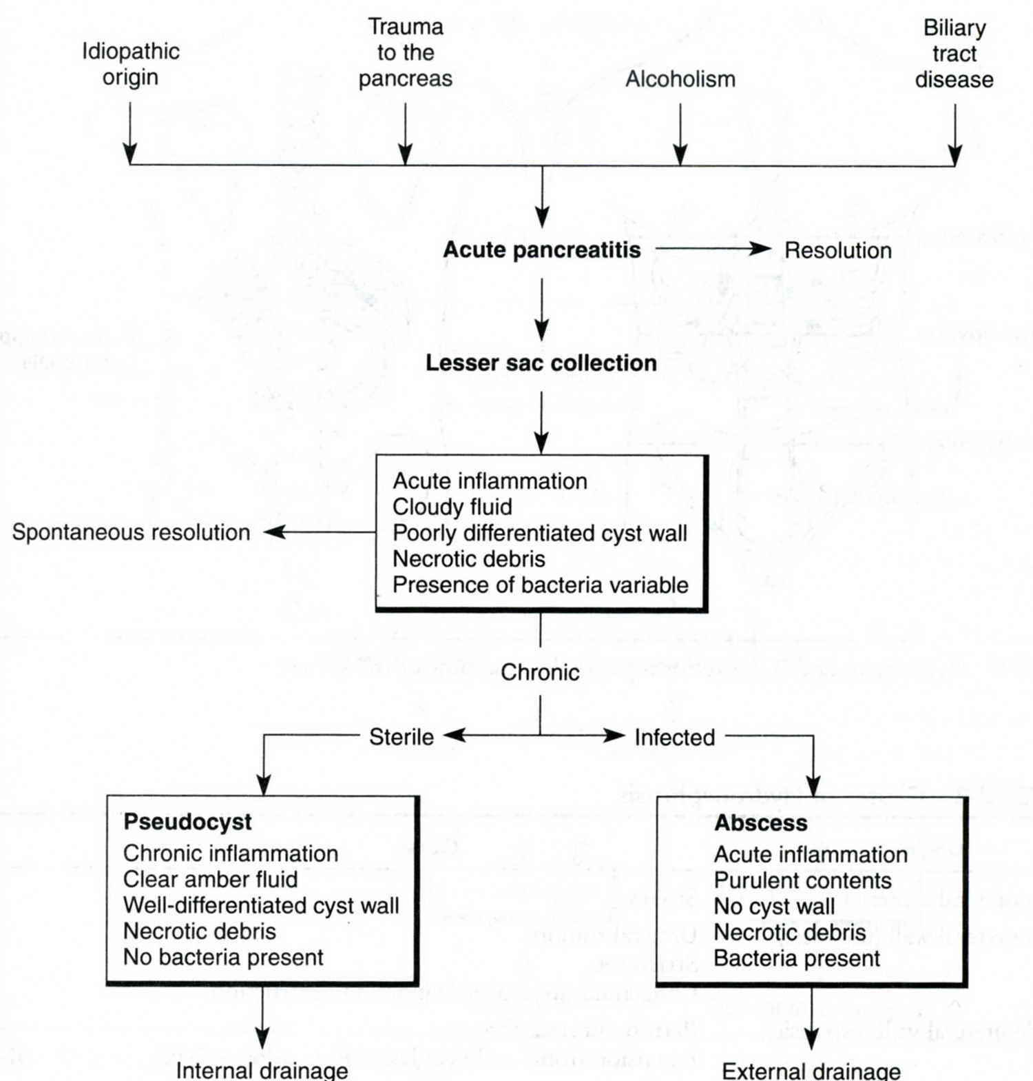
From: Basic surgery/ed., H.C. Polk, Jr., et al. – 5th ed.

Arrosive bleeding
- Arrosive bleeding usually occurs from splenic and pancreatoduodenal artery and their branches and may be massive and frequently fatal.
- Passage of fresh blood out of drains and features of acute blood loss are characteristic clinical presentation.
- In this circumstances previously performed laparostomy allowes to tamponade lesser sac and control bleeding. If there is no laparostomy, urgent relaparotomy with ligation of bleeding vessel is indicated.

Fistulas
- Fistula formation due to enzymatic lysis of tissues of CBD, duodenum and transverse colon along with its mesenterix may lead to biliary, duodenal and colonic fistulas respectively.
- Small fistulas, particularly colonic, heal spontaneously.
- Surgery for large fistulas commonly performed when the necrotic process in pancreatic tissue subsides. Large biliary fistulas require CBD drainage by T-tube or recontructive biliary-digestive anastomosis. Large duodenal fistulas may require antrumectomy. Large colonic fistulas are treated by proximal end colostomy.

Pancreatic fistulas
- Pancreatic fistulas are common sequella of external drainage of pseudocyst or abscess of lesser sac.
- If fistula doesn’t heal spontaneously after 6 months, it requires surgical treatment – an anastomosis between fistula and stomach.
- Spontaneous healing of pancreatic fistula may be accelerated by using high dosages of octreotide and topical application of ethylic alcohol.

MESENTERIC THROMBOSIS
- Mesenteric vascular disease may present as an acute life-threatening emergency or as a chronic debilitating problem.

Acute mesenteric ischemia
- Acute mesenteric ischemia is a surgical emergency with 80% mortality rate.
- Etiology includes embolization (usually to the superior mesenteric artery), thrombosis of visceral arteries (sudden occlusion of preexisting atherosclerotic lesions), and nonocclusive mesenteric ischemia (cardiogenic shock, patients following cardiopulmonary bypass and, high doses of intravenous vasoconstrictors and inotropes).

Clinical features
- The classic presentation of acute mesenteric ischemia is a sudden onset of acute abdominal pain in an elderly patient with a history of cardiac disease, such as atrial fibrillation and congestive heart failure (heart is a common source and emboli).
- These patients usually present with severe diffuse abdominal pain out of proportion to the physical findings and a history of gut emptying, usually a massive bowel movement with or without vomiting.
- Patients with mesenteric thrombosis have preexisting symptoms of weight loss and pain with eating.
- Signs of partial bowel obstruction and bloody stools are frequently present.

Diagnosis
- Salvage of these patients depends on a high index of suspicion and prompt diagnosis and treatment.
- An angiogram can be both diagnostic and therapeutic.

Treatment
- If an embolus is found, the treatment is prompt surgical embolectomy.
- If mesenteric thrombosis is found, the treatment is vascular reconstruction, which usually is a bypass to the superior mesenteric artery.
- The angiographic catheter may be left in place for direct intra-arterial infusion of a vasodilator.
- Following embolectomy or reconstruction, the bowel is assessed for viability. Overtly necrotic bowel is resected.
- A "second look" operation should be done in 24 hours to ensure viability of the residual bowel.
- If the original angiogram reveals nonocclusive mesenteric ischemia, treatment is directed toward improving cardiac function. Hydration and, if necessary, inotropic therapy are begun. The angiographic catheter is left in place, and vasodilating drugs can be infused into the mesenteric circulation after hydration has been accomplished. A repeat angiogram is done in 24 hours to assess the success of treatment. These patients may require laparotomy if peritoneal signs are present.

Scheme 2-12. Algorithm of management of acute mesenteric ischemia
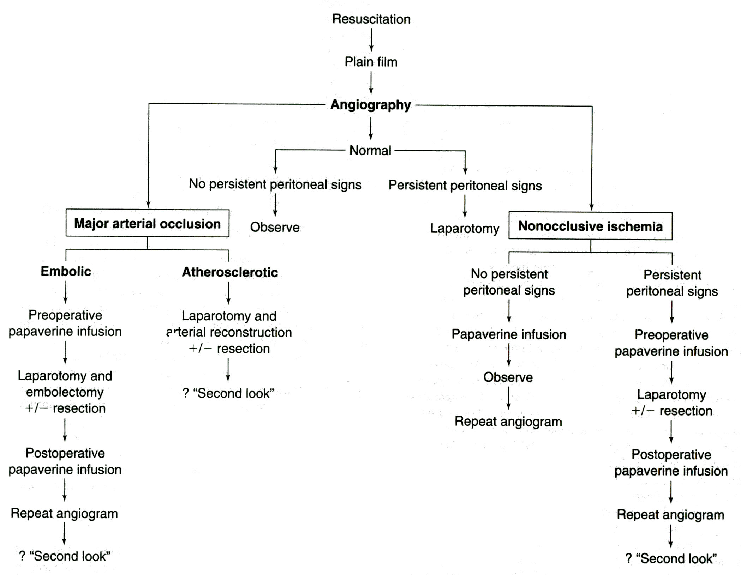
From: Principles of surgery/ed., S.I. Schwartz, et al. – 7th ed.

Chronic mesenteric ischemia
- Chronic mesenteric ischemia results from slowly progressive stenosis or occlusion of the visceral vessels (i.e., celiac, superior mesenteric artery, and inferior mesenteric artery).

Clinical features
- Abdominal pain following a meal, leading to "food fear" and weight loss.
- Slight diffuse abdominal tenderness may be present.
- An epigastric bruit may be audible.

Diagnosis
- Duplex scanning of the visceral vessels has been used to screen patients
with suspected chronic mesenteric ischemia.
- Arteriography is the most useful diagnostic study.

Treatment
- If appropriate lesions are found, operation is recommended.
- Bypass from a healthy aorta to the visceral vessels (see Fig. 2-14) or endarterectomy (see Chapter 16) of the involved visceral vessels is the preferred treatment.
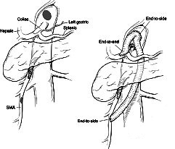

Fig. 2-14. Scheme of aorto-mesenteric bypass

CHAPTER 3. PAIN IN RIGHT LOWER QUADRANT OF ABDOMEN
- Pain in right lower quadrant of abdomen most commonly is caused by acute appendicitis, gastroenteritis, mesenteric adenitis, Meckel’s diverticulitis, various gynecologic conditions, some forms of bowel obstruction and other diseases listed above (see Chapter 1).

ACUTE APPENDICITIS
Overview
- Incidence of acute appendicitis is approximately 50 cases of 100000 persons.
- It is one of the most common surgical abdominal pathology and one of the most difficult diagnosis (up to 16 % patients have normal appendix in exploration (68 % of these - females) and only 55 % patients have typical clinical presentation).
- Mortality in complicated cases (by diffuse peritonitis) may spread up to 50 %.

Table 3-1. Classification of acute appendicitis
Morphological stages

Catarrhal
Phlegmonous
Gangrenous
Perforated

Complications

Periappendicular mass
Appendicular abscess
In right iliac fossa
Pelvic
Subhepatic
Abscesses between loops of intestine
Peritonitis
Pylephlebitis
Sepsis
Fecal fistula
Wound infection

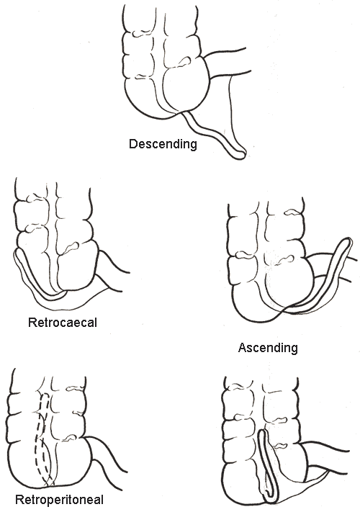
Fig. 3-1. Positions of vermiform appendix

Uncomplicated appendicitis
Clinical features and laboratory data
Anorexia followed by diffuse (epigastric or paraumbilical) pain with further pain shift to right lower quadrant (Kocher’s sign) is the most characteristic complaint.
- Nausea, single or repeated vomiting is possible.
- In retrocaecal or retroperitoneal position of vermiform appendix: dysuria and flank pain may be present.
- Fever most commonly is subfebrile.
- Local tenderness with rebound tenderness and muscle guarding is the most characteristic sign.
- Special signs are: Razdolskyy’s – percussion tenderness in right iliac region, Sytkovskyy’s – increase of pain while lying on left side, Bartomue-Mechelson’s – palpation in right iliac region is more tender while lying on left side than lying supine, Obraztzov’s – deep palpation in right iliac region is tender while rising straight right leg, Rovsing’s – pain in right iliac region while powerful pushing the left iliac region, Voskresenskyy’s – increased skin sensitivity in right iliac region.
- Moderate leukocytosis (not mandatory in 10 – 30 % patients) and left shift of leukogram is present.
- In retrocaecal and pelvic appendix position: leukocyteuria and microhematuria are possible.

Visualization data
- Plane film may reveal fecaliths (indirect feature) and intestinal pneumatosis (nonspecific).
- Ultrasound may reveal enlargement (diameter > 6 mm) and incompressability of appendix, and pericaecal fluid or mass.
- Laparoscopy is the most accurate method which may be curative.

During pregnancy
- Local pain and tenderness are located laterally and superiorly.
- Rebound tenderness and muscle guarding may be absent or weak.
- Leukocytosis is above normal pregnancy count (15000 – 20000 / ml).

Differential diagnosis
Table 3-2. List of diseases to be differentiated with acute appendicitis
More likely in infants and children of both genders  Acute mesenteric adenitis  Viral gastroenteritis  Intussusception  More likely in girls  Primary pneumococcal peritonitis  More likely in boys  Torsion of testis (torsion of spermatic cord)  More likely in adults females  Pelvic inflammatory diseases: salpingitis (adnexitis), tubal or tuboovarian abscess  Endometritis  Ruptured Graafian follicle (mittelschmertz, ovarian apoplexy)  Ovarian cyst (uncomplicated, twisted, ruptured, with hemorrhage)  Endometriosis  Ruptured ectopic pregnancy  Ovarian tumor (uncomplicated, twisted, with hemorrhage)  Myomatous nodus with necrosis  More likely in adults males  Acute orchitis  Acute epidydimitis  Acute seminal vesiculitis  More likely in adults of both genders  Intestinal pathology:  Acute nonspecific gastroenteritis  Salmonella gastroenteritis  Acute regional enteritis  Fecal impaction  Bowel obstruction (volvulus, adhesive obstruction)  Diverticulitis or perforation of diverticula (Meckel’s, colonic diverticula)  Caecal carcinoma (uncomplicated and perforated), carcinoid of appendix  Epiploic appendagitis  Yersiniosis (incl. pseudotuberculosis)  Typhoid fever | Upper GI and biliary tract pathology:  Perforated peptic ulcer  Acute cholecystitis  Acute pancreatitis  Urinary tract pathology:  Acute pyelonephritis  Paranephritis  Renal or ureteric colic  Vascular abdominal pathology:  Mesenteric vascular occlusion (ischemia, thrombosis/embolism)  Dissecting aneurism of abdominal aorta  Pulmonary pathology:  Basilar pneumonia  Pleuritis  Metabolic/endocrine disorders:  Diabetes mellitus  Abdominal porphyria  Uremia  Addisonian crisis  Tuberculosis:  Tuberculous peritonitis  TB osteomyelitis of spine with psoas abscess  Distal ileum tuberculosis  Blood pathology:  Leukemia  Thrombocytopenic purpura  Sickle cell crisis  Rheumatic pathology:  Henoch-Schönlein purpura  Neurologic/spine pathology:  Spinal neuralgia (osteochondrosis, metastatic)  Herpes Zoster  Other pathology:  Intramuscular haematoma of abdominal wall  Lead poisoning

Surgical treatment
Scheme 3-1. Surgical tactics in acute appendicitis
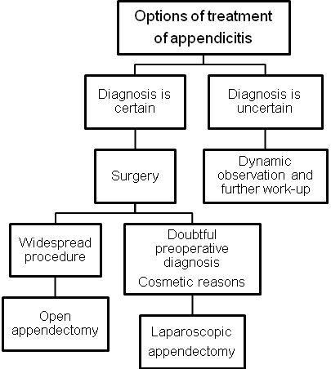
- Figures 3-1, 3-2 show the scheme of open and laparoscopic appendectomy.
- Drainage after appendectomy: for catarrhal is not required; for phlegmonous – tubular drain via the stab wound into right iliac fossa; for gangrenous and perforated – Penrose drain via laparotomy wound into right iliac fossa, and tubular drain via the stab wound into pelvic space.

1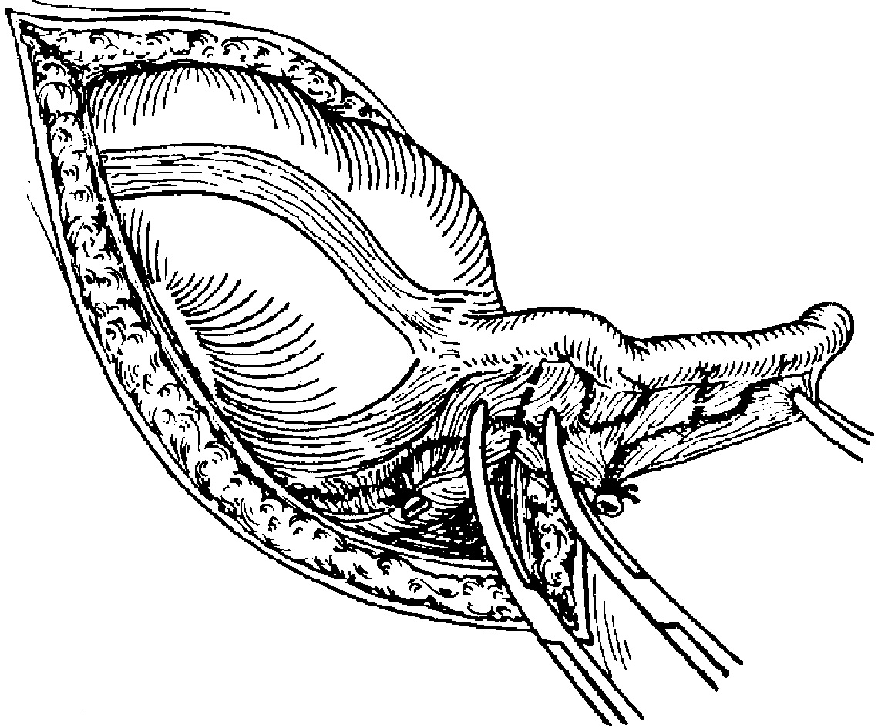 2 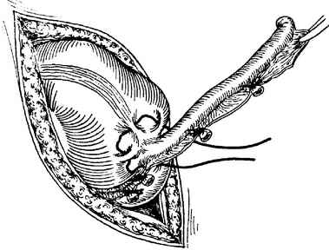 3 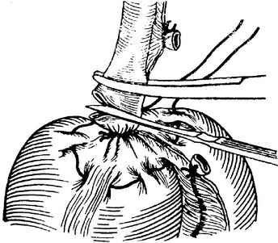

4 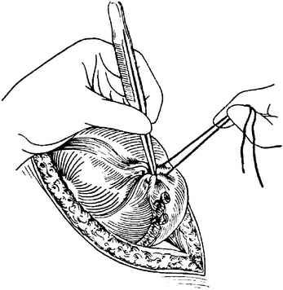 5 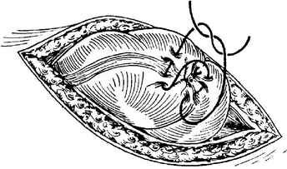
Fig. 3-2. Technique of open appendectomy

Appendicular abscess
Clinical features and laboratory data
- Pain in right lower quadrant (or other region depending on abscess location) is characteristic.
- Chills, fatigue, febrile or hyperpyrexic fever, tachycardia and hypotension are always present.
- Flatulence, constipation or signs of complete intestinal obstruction may be present.
- In pelvic location: perineal pain, painful dejection, and tenesmus are possible.
- Subhepatic abscess may be complicated by right pleuritis.
- Palpable mass (excl. pelvic or multiple intraperitoneal abscesses) with local tenderness, possible rebound tenderness and muscle guarding.
- In pelvic location: digital rectal examination reveals painful bulging.
- Marked leukocytosis or hyperleukocytosis and left shift of leukogram is detected.

Visualization data
- Plane film may reveal fecaliths, “basket” sign, and intestinal pneumatosis.
- Ultrasound and CT scan show signs of abscess: rounded or irregular-shaped lesion with thick capsule and cavity filled by the heterogenous fluid (see Fig. 2-2).

Surgical treatment
Scheme 3-2. Surgical tactics in appendicular abscess

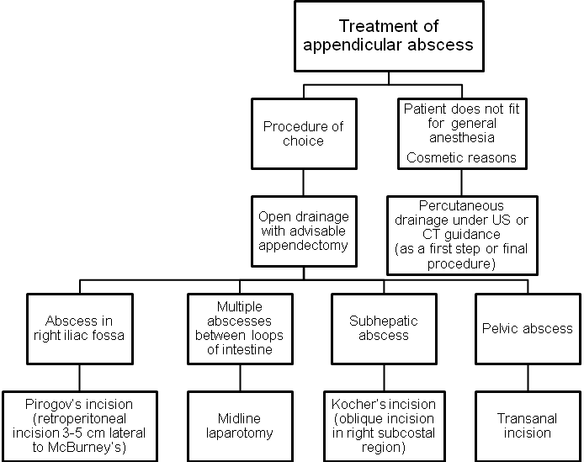

Appendicular mass

Clinical features and laboratory data

- Pain in right lower quadrant (or other regions depending on mass location) is characteristic.
- Flatulence, constipation or signs of complete intestinal obstruction may be present.
- Patients have subfebrile fever or normal body temperature.
- A mass is palpated (excluding pelvic mass). Local tenderness, and rebound tenderness may be detected.
- Moderate leukocytosis and left shift of leukogram is present.
Visualization data
- Ultrasound and CT scan show irregular-shaped dense mass without cavity.
- Appendicular mass should be differentiated with carcinoma of caecum, especially in elder patients if other signs of malignancy are present (using CT, colonoscopy and barium enema).

Treatment
Scheme 3-3. Surgical tactics in appendicular mass
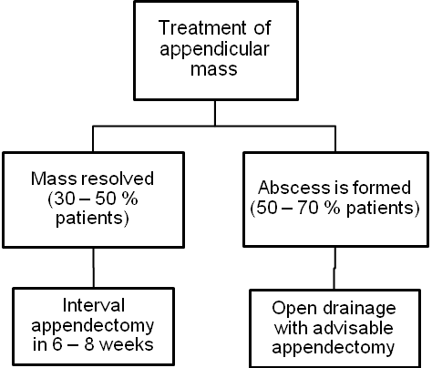
Conservative therapy regimen
- In-patient treatment.
- Antibiotics (double-therapy): cefalosporins of III generation or semisynthetic penicillins + metronidazole.
- Nonsteriodal anti-inflammatory drugs.
- The therapy continues till the mass resolves (approximately 7 – 10 days).

CHAPTER 4. PAIN IN RIGHT UPPER QUADRANT OF ABDOMEN
- Pain in right lower quadrant of abdomen most commonly is caused by acute cholecystitis and other complications of gallstone disease, tumors, abscesses and cysts of liver, peptic ulcer of duodenum including perforation, hepatomegaly of various origin, right renal colic, tumors of head of pancreas, and other diseases listed above (see Chapter 1).

CHOLELITHIASIS (GALLSTONE DISEASE)
Overview
- Gallstones form as a result of biliary solids precipitating out of the solution.
- Most stones (70%) are made up of cholesterol, bilirubin, and calcium with cholesterol as the major component.

Table 4-1. Classification of gallstone disease
Cholecystolithiasis (gallbladder stones)

Asymptomatic gallbladder stones
Biliary colic
Chronic colecystitis
Uncomplicated
Complicated
Biliary-digestive fistula
Gallstone ileus
Porcelain gallbladder
Acute cholecystitis
Catarrhal
Phlegmonous
Gangrenous
Perforated
Complicated:
Acute biliary pancreatitis
Paravesical mass
Paravesical abscess
Peritonitis
Cholangitis
Compression of CBD with
mechanical jaundice
Biliary-digestive fistula

Choledocholithiasis (CBD stones)

Uncomplicated
Complicated
Acute biliary pancreatitis
Mechanical jaundice
Cholangitis
Chronic
Acute
Serous
Purulent
Cholangiolithiasis
(intrahepatic biliary ducts stones)

Scheme 4-1. Main complications of gallstone disease
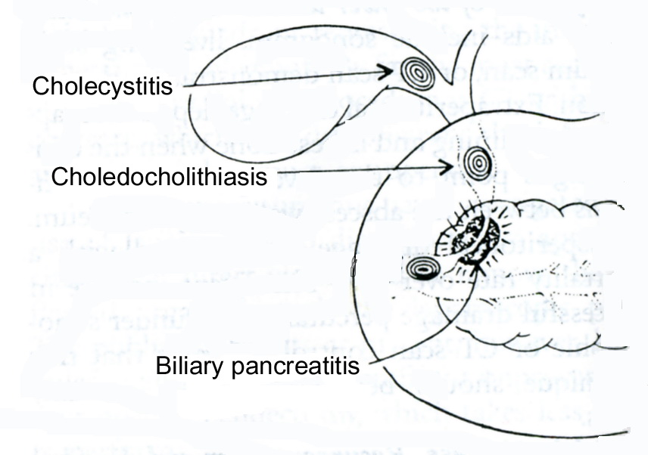
From: Basic surgery/ed., H.C. Polk, Jr., et al. – 5th ed.

Asymptomatic cholelithiasis
- The treatment of asymptomatic cholelithiasis is somewhat controversial. Each year, approximately 1-4% of patients with asymptomatic gallstones develop symptoms or complications of their disease. Most patients do develop symptoms before developing a severe complication of cholelithiasis (CBD stones, chronic pancreatitis, ect.).
- There is little evidence that prophylactic treatment is justified in the management of cholelithiasis, with the exception of calcified or porcelain gallbladder, which should be removed because the risk of malignancy exceeds 25%.

Chronic cholecystitis
Clinical features
- The patient complains of moderate intermittent pain in the right upper quadrant and epigastric region, nausea, and vomiting.
- The pain may radiate to the back or right scapular region.
- Symptoms may be associated with eating fatty foods.
- Laboratory studies are generally normal.

Diagnosis
- Ultrasonography reveals stones in the gallbladder (see Fig. 4-1).
- In a part of patients the gallstones may be detected using CT scan.
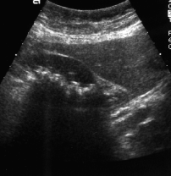
Fig. 4-1. US picture of chronic calculous cholecystitis

Treatment
- Treatment is elective laparoscopic (procedure of choice) (see Fig. 4-2) or open cholecystectomy (see Fig. 4-3). Approximately 95% of patients receiving surgery for cholecystitis secondary to cholelithiasis are completely relieved of their symptoms. Approximately 5% of patients retain mild symptoms that presumably are unrelated to the biliary tree (postcholecystectomy syndrome, see later).
- Nonoperative treatment (oral bile salts) may be appropriate for patients with small stones (up to 1 cm) and functioning gallbladders who are not operative candidates or who refuse surgery.

1 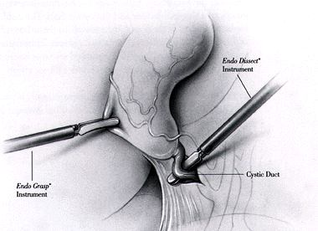2 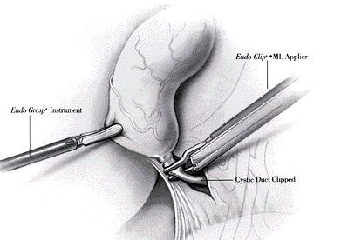 3 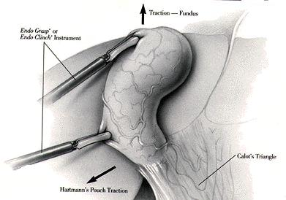

4 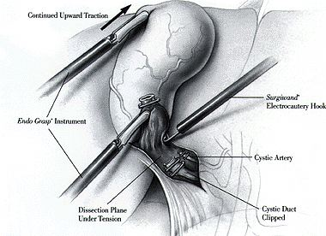 5 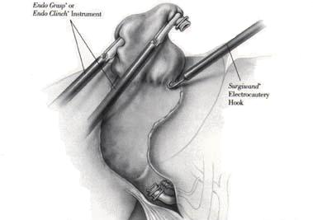
Fig. 4-2. Technique of laparoscopic cholecystectomy

1 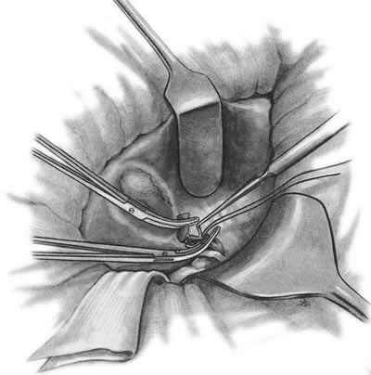 2 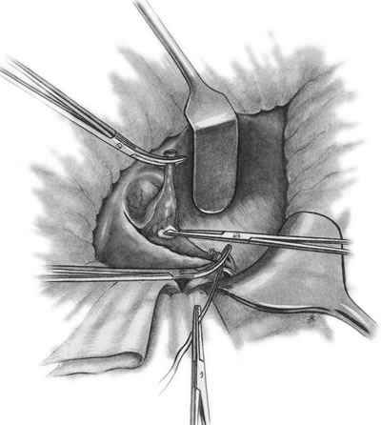 3 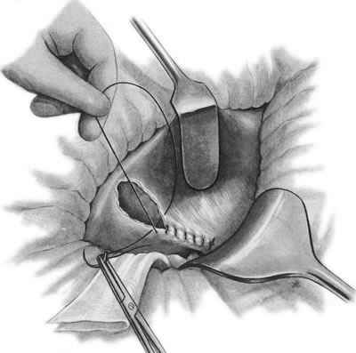
Fig. 4-3. Technique of open cholecystectomy
Acute cholecystitis
Scheme 4-2. Stages of acute cholecystitis

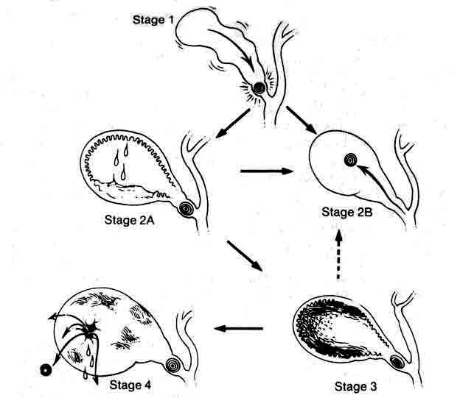
From: Basic surgery/ed., H.C. Polk, Jr., et al. – 5th ed.

Clinical features
- The greatest incidence of acute cholecystitis is in adults age 30-80; women are affected more often than men.
- Most patients give a history consistent with prior chronic cholecystitis except this episode is worse or lasts longer.
- Fever, nausea, and vomiting are characteristic symptoms.
- Right upper quadrant tenderness with or without rebound tenderness and Murphy's sign are common.
- The gallbladder may be palpable.

Laboratory data
- Normal to febrile fever (hyperpyrexic in paravesical abscess formation) is present.
- Slight to moderate leukocytosis and left shift of leukogram (hyper leukocytosis in paravesical abscess formation) is detectable.
- Levels of the following may be elevated in patients with acute cholecystitis although these are characteristic for СBD stones and acute pancreatitis: serum alkaline phosphatase in 23%, bilirubin in 45%, AST in 40%, amylase in 13%.

Diagnosis
- Ultrasonography reveals stones and enlarged gallbladder with thick walls.

Differential diagnosis
Table 4-2. List of diseases to be differentiated with acute cholecystitis
Hepatobilary pathology  Acute pancreatitis  Pancreatic pseudocyst  Cancer of head or body of pancreas  Hepatitis  Tumors of liver  Cysts of liver  Cancer of gallbladder  Urinary tract pathology  Acute pyelonephritis  Paranephritis  Renal or ureteric colic  Gastroduodenal pathology  Perforated or penetrating peptic ulcer  Hiatal hernia | Cardiac pathology  Myocardial infarction  Hepatomegaly due to congestive heart failure  Pericarditis  Pulmonary pathology  Right lower lobe pneumonia  Right pleuritis  Intestinal pathology  Acute appendicitis  Cancer of right flexure of colon  Neurologic/spine pathology  Spinal neuralgia (osteochondrosis, metastatic)  Herpes Zoster

Treatment
Scheme 4-3. Algorithm of management of acute cholecystitis
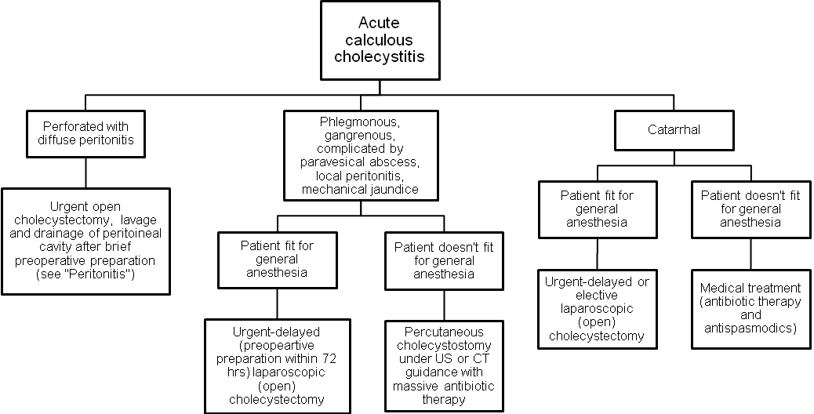
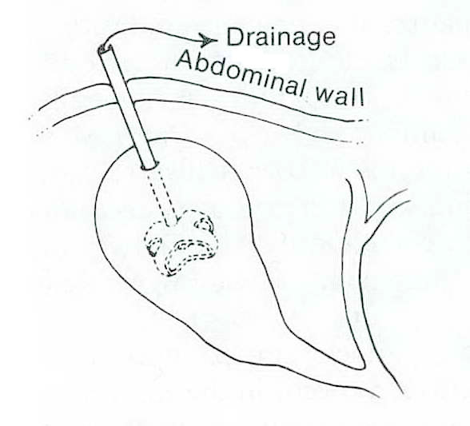
Fig. 4-4. Scheme of cholecystostomy

Acute acalculous cholecystitis
- Acute acalculous cholecystitis is acute or chronic cholecystitis in the absence of stones. Possible causes include: kinking or fibrosis of the gallbladder, thrombosis of the cystic artery, sphincter spasm with obstruction of the biliary and pancreatic ducts, prolonged fasting, dehydration, systemic disease, multiorgan failure associated with trauma, generalized sepsis.
- Treatment is cholecystectomy or percutaneous or laparoscopic cholecystostomy (see Fig. 4-4) if the patient is too ill to tolerate cholecystectomy.

Postcholecystectomy syndrome
- Postcholecystectomy syndrome is the term given to symptoms that develop after or persist despite cholecystectomy.

Table 4-3. Classification of postcholecystectomy syndrome
Biliary

Stone in the common bile duct
Uncomplicated
Complicated
Acute biliary pancreatitis
Acute relapsing pancreatitis
Mechanical jaundice
Cholangitis
Stone in the stump of the cystic duct
Stenosis of the sphincter of Oddi
Uncomplicated
Complicated
Acute biliary pancreatitis
Chronic relapsing pancreatitis
Mechanical jaundice
Cholangitis
Biliary stricture

Extrabiliary

Hiatal hernia
Peptic ulcer
Chronic pancreatitis
Irritable bowel syndrome
Food intolerance
Other gastroenterologic disorders
- Evaluation should be directed toward identifying these extrabiliary and biliary etiologies, and may include endoscopic retrograde cholangiopancreatography (ERCP) (see Chapter 10), magnetic resonance cholangiopancreatography (ERCP) (see Chapter 10) esophagogastroduodenoscopy, upper gastrointestinal series, ultrasound, and CT scan.

BENIGN TUMORS OF LIVER
- In women, oral contraceptive use has increased the incidence of benign primary liver tumors.

Hemangioma
Overview
- Grossly, there may be single or multiple masses, and microscopically, there are vascular lacunae lined with normal endothelial cells.

Clinical features and visualisation data
- Hemangioma, the most common benign hepatic tumor, is usually asymptomatic and is managed by observation.
- Usually, it is discovered as an incidental finding (i.e., calcification on abdominal radiograph or a characteristic mass on ultrasound (Fig. 4-5-a) with evidence of vasculature on duplex scan or CT scan with intravenous contrast (see Fig. 4-5-b)).
- The most accurate method, although invasive, is angiography (see Fig. 4-6)
- Hemangiomas can produce symptoms by compressing adjacent structures or by stretching the liver capsule.
- Percutaneous biopsy under ultrasound or CT guidance (fine needle aspiration, FNA) or biopsy taken laparoscopically confirms the diagnosis because the appearance of lesion (as any benign or malignant tumor of liver) may be very variable.
A 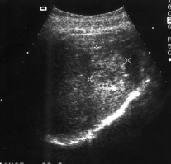 B 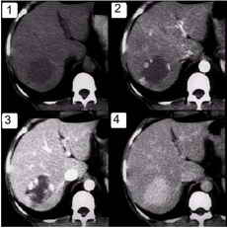
Fig. 4-5. US and CT pictures of hemangioma of liver
1 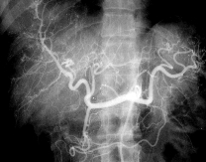 2 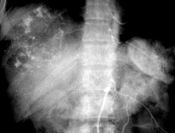
Fig. 4-6. Angiographic pictures of hemangioma of liver

Treatment

Scheme 4-4. Algorithm of management of hemangiomas of liver

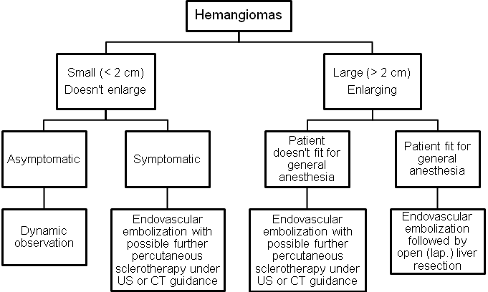

Hepatocellular adenoma
Overview
- Hepatocellular adenoma is an uncommon benign tumor usually seen in women and strongly associated with oral contraceptive use. It is also found in men and women who take anabolic (androgenic) steroids.
- Hepatocellular adenomas are soft tumors with sharply circumscribed edges but no true capsule. Histologically, normal hepatocytes are present, and there is no evidence of malignancy.

Clinical features
- There may be no symptoms or physical findings.
- Approximately 25% of patients have a palpable abdominal mass or abdominal pain.
- Up to 30% of patients present with spontaneous rupture and hemorrhage into the peritoneal cavity.

Visualisation data
- The tumor is usually suspected when a mass is seen on ultrasound or other seal of the liver.
- Angiography is useful because hypervascularity or arterial splaying is frequently present.
- FNA or operative biopsy confirms the diagnosis.

Treatment
- Oral contraceptives, anabolic steroids, and pregnancy should be avoided, and if the absence of these, the tumor frequently regresses. If the diagnosis is confirmed and the lesion is small, intrahepatic, and associated with oral contraceptive use it may be safely observed.
- Occasionally, if the tumor is exophytic on a narrow pedicle it can be easily excised (see Fig. 4-11) (laparoscopic technique is preferable).
- If the tumor is large and superficial or if a woman anticipates pregnancy in the near future, it should be resected because of the risk of spontaneous rupture and hemorrhage.
- In cases of spontaneous rupture with hemorrhage into the peritoneal cavity, the patient should initially be resuscitated. The recommended procedure is hepatic artery ligation. This frequently controls the bleeding and is associated with only minor aberrations in liver function when the liver is not cirrhotic. Hepatic resection in the presence of acute rupture has a high mortality rate. Elective resection should, however, be performed at a later date.
- If the patient is very unstable after rupture in spite of major resuscitative efforts, open packing or angiographic embolization of the hepatic artery may control the hemorrhage.
- The above described tactics may also be used for ruptured hemangiomas (see above).

Focal nodular hyperplasia
Overview
- Focal nodular hyperplasia is the third most common benign liver tumor. It occurs most often in women and has a weak association with oral contraceptive use.
- Single or multiple lesions with a nodular appearance externally and a central scar with radiating septa on cut section are seen. The tumors are composed of hyperplastic hepatocytes with inflammatory cells. Bile duct epithelium is a prominent finding in contrast to hepatocellular adenoma. Overall, the lesions resemble regenerating nodules of cirrhosis.

Clinical features
- Symptoms and physical findings, when they occur, are similar to those seen with hepatocellular adenoma; however, focal nodular hyperplasia is usually asymptomatic and discovered as an incidental finding.
- Spontaneous rupture is rare.
Diagnostics and treatment are similar to those for hepatocellular adenoma.

MALIGNANT TUMORS OF LIVER
Overview
- Primary malignant tumors of the liver account for 0.7% of all cancers.
- In men 90% of primary liver tumors are malignant; in women only about 40% are malignant.

TNM-classification
T - primary tumor
TX Primary tumor cannot be assessed
T0 No evidence of primary tumour
T1 Solitary tumor without vascular invasion
T2 Solitary tumor with vascular invasion or multiple tumours, none more than 5 cm in greatest
dimension
T3 Multiple tumors more than 5 cm or tumor involving a major branch of the portal or hepatic vein(s)
T4 Tumor(s) with direct invasion of adjacent organs other than the gallbladder or with perforation of
visceral peritoneum
N - regional lymph nodes
NX Regional lymph nodes cannot be assessed
N0 No regional lymph node metastasis
N1 Regional lymph node metastasis
M - distant metastasis
MX Distant metastasis cannot be assessed
M0 No distant metastasis
M1 Distant metastasis

Stage grouping
Stage I | T1 | N0 | M0
Stage II | T2 | N0 | M0
Stage IIIA | T3 | N0 | M0
Stage IIIB | T4 | N0 | M0
Stage IIIC | Any T | N1 | M0
Stage IV | Any T | Any N | M1

Hepatocellular carcinoma
Overview
- Hepatocellular carcinoma (hepatoma) is the most common primary malignant liver tumor.
- Incidence of hepatocellular carcinoma varies geographically, being highest in Africa and Asia and lowest in the Western world.
- Men are affected twice as often as women.
- The average age of affected individuals is 50 years, but hepatocellular carcinoma can occur at any age.
- Hepatocellular carcinoma occurs as a solitary mass or as multiple masses. Local invasion, especially into the diaphragm, is common, as are distant metastases
with the lung being most commonly involved (in up to 45% of cases).

Associations
- Chronic hepatitis B virus (HBV) infection (present in as many as 80% of cases worldwide). The risk of developing hepatocellular carcinoma is increased 200-fold for chronic HBV carriers. The risk in male carriers is as high as 50%. Hepatocellular carcinoma is also associated with chronic hepatitis C infection.
- Cirrhosis of the liver (present in approximately 60%-90% of patients), especially macronodular cirrhosis.
- Hemochromatosis with iron overload and cirrhosis.
- Schistosomiasis and other parasitic infestations.
- Environmental carcinogens: industrial substances, including polychlorinated biphenyls; chlorinated hydrocarbon solvents, such as carbon tetrachloride; nitrosamines; vinyl chloride and polyvinyl chloride; organochloride pesticides; organic materials, including anatoxins (produced by Aspergillus flaws or A. fumigatus and found on foods, such as peanuts).

Clinical features
- Hepatocellular carcinoma often presents as a dull aching pain in the right upper quadrant; malaise, fever, and jaundice may also be present.
- Physical examination reveals hepatomegaly (present in 88% of cases), weight loss (in 85%), a tender abdominal mass (in 50%), or findings associated with cirrhosis (60%).
- About 10%-15% of patients present with acute hemorrhage into the peritoneal cavity with resultant shock.
- Paraneoplastic syndromes also may occur in which tumor cells secrete hormone-like substances that cause unusual syndromes, such as Cushing's syndrome.

Laboratory and visualization data
- Liver function tests are usually abnormal, but there is no particular diagnostic pattern.
- Alpha-fetoprotein is elevated in 70%-90% of cases.
- Hepatic ultrasound, CT scan, angioportography, and MRI are the most reliable studies to determine the presence and operability of the lesions (see Fig. 4-7). These studies are positive in up to 90% of cases and can detect lesions as small as 1 cm in diameter. Appearance of lesions may be
- FNA (see Fig. 4-8) or biopsy taken laparoscopically confirms the diagnosis.
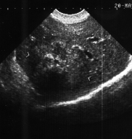
Fig. 4-7. US picture of hepatocellular carcinoma

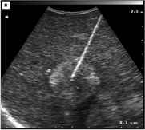
Fig. 4-8. US-guided FNA of hepatic tumor

Treatment
- The only treatment of solitary tumor is surgical resection (see Fig. 4-11). Hemihepatectomy may be used for multiple tumors located in one lobe of liver. Currently, due to introducing of endoscopic vascular staplers, powerful bipolar coagulators, harmonic scalpel, and laparoscopic argon plasma coagulator, these procedures may be performed laparoscopically.
- Chemotherapy (used for multiple masses) has been ineffective when given systemicaily, but administration of drugs into the hepatic artery has given some promising preliminary results.
- To increase the potential for resectability, high-risk individuals (e.g., those with chronic HBV) should be periodically screened by measuring alpha-fetoprotein.
- If lesions are resectable, the average survival is approximately 3 years; the 5-year survival rate is about 20%. The operative mortality rate is as high as 20% but can be nearly 60% in patients with coexistent cirrhosis. If lesions are unresectable, patients have a mean survival time of 4 months.

Cholangiocarcinoma
Overview
- Cholangiocarcinoma is a tumor that arises from the bile duct epithelium; it represents 5%-30% of all primary hepatic malignancies.
- Associated conditions include parasitic infections (e.g., Clonorchis sinensis), primary sclerosing cholangitis.
- A hard greyish mass is found that microscopically shows adenocarcinoma of the biliary epithelium. Metastasis occurs initially to the regional lymph nodes or to the liver.

Clinical features
- Signs and symptoms include right upper quadrant pain, jaundice, hepatomegaly, and occasionally a palpable mass.
- Patients are usually 60-70 years of age.
Diagnostics is similar to those for hepatocellular carcinoma.
Treatment
- Treatment of intrahepatic tumors is resection (see Fig. 4-11) when feasible.
- Overall survival is poor.

Angiosarcoma
Overview
- Angiosarcoma, or malignant hemangioendothelioma is a highly malignant liver tumor composed of irregular spindle cells lining the lumina of hepatic vascular spaces.
- Most cases (85%) occur in men, and there is a high association with chemical agents, especially vinyl chloride, arsenicals, and organochioride pesticides.
Clinical features
- Clinical presentation is similar to that for hepatocellular carcinoma.
- The tumor commonly spreads locally to the spleen (80% of cases) and distantly to the lungs (60% of cases).
Diagnostics is similar to those for described above malignant tumors.
Treatment
- Treatment is resection when feasible, but patients rarely survive 1 year.
Sarcomas other than angiosarcoma are rare but are highly malignant and frequently not curable.

Metastatic tumors of liver
Overview
- Metastatic tumors of the liver are much more common than primary tumors (ratio 20:1).
- The liver is the second most common site of metastasis (exceeded only by regional lymph nodes) for all primary cancers of the abdominal viscera. Over two-thirds of all colorectal cancers ultimately involve the liver, and up to 50% of cancers outside the abdomen metastasize to the liver. Fully one-third of all cancers ultimately spread to the liver, which is the most common site of hematogenous spread.

Clinical features and laboratory data

- Diagnosis may be difficult because liver metastases are often asymptomatic.
- In advanced cases they are mainly presented by jaundice and ascites.
- No single laboratory blood test could predict liver metastases in more than 65% of patients with subclinical disease. This percentage can only be raised by using imaging techniques. Testing for carcinoembryonic antigen has been valuable for predicting the presence of liver metastasis in colorectal cancer as it is positive in over 85% of patients with proven disease. Unfortunately, this test lacks specificity.

Visualization data
- CT scan and MRI are the most accurate imaging techniques, but they are expensive as a screening tests.
- Ultrasonography is almost as reliable as a CT scan, and it provides a reasonable screening test. The appearance of lesions may be quite different depending of the type of primary tumor and age of metastases. More often they are hypoechogenic or hypodensive lesions with regular borders (see Fig. 4-9, 4-10).
- Laparoscopic ultrasound is very beneficial for both diagnostics and staging of the malignant process (see Fig. 4-9-c).
- FNA or operative biopsy confirms the diagnosis.
A 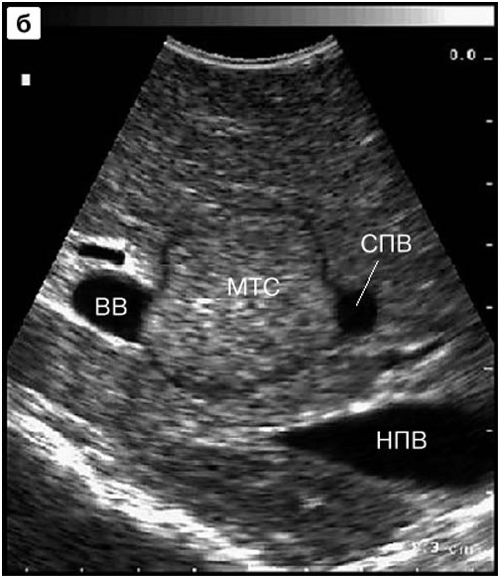 B 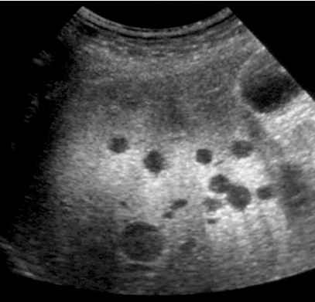 C 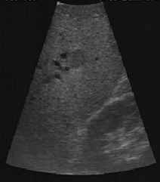
Fig. 4-9. Transabdominal (A,B) and laparoscopic (C) US picture of liver metastases
A 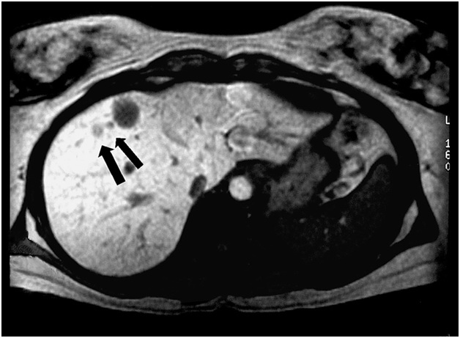 B 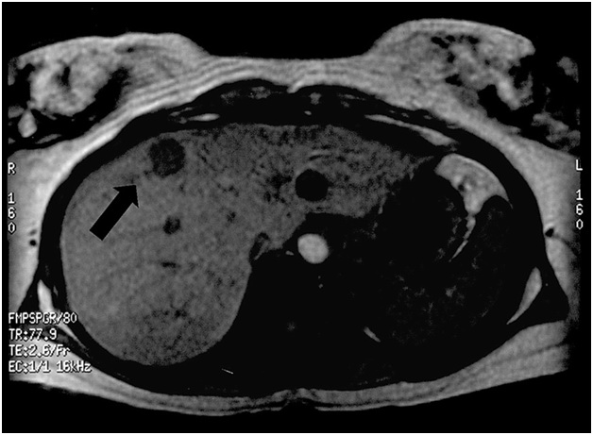
Fig. 4-10. CT picture of liver metastases

Treatment
- Treatment for metastatic disease to the liver depends on the type of primary tumor.
- Chemotherapy for liver metastasis from colorectal cancer has been disappointing.
- Radiation therapy is poorly tolerated by the liver but may be palliative for painful liver metastases.
- Various methods of percutaneous (ultrasound or CT-guided) or operative (open or laparoscopic) ablation of lesions located superficially and deeply in liver tissue, including criogenic destruction, lazer ablation, argon plasma ablation, radiofrequency ablation, ect. show contraversial benefits.
- Surgical resection (see Fig. 4-11) is the most effective mode of therapy but is limited to the few patients who have unilobar liver lesions and no evidence of extrahepatic disease. The incidence of liver metastasis at the time of surgery for primary colorectal cancer is 8%-25%, and approximately one-fourth of these lesions are solitary and resectable, so that about 5% of patients are potential resection candidates. The 5-year survival rate approaches 20%-30% in patients with these criteria. The operative mortality rate is less than 6%, an acceptable risk.
A 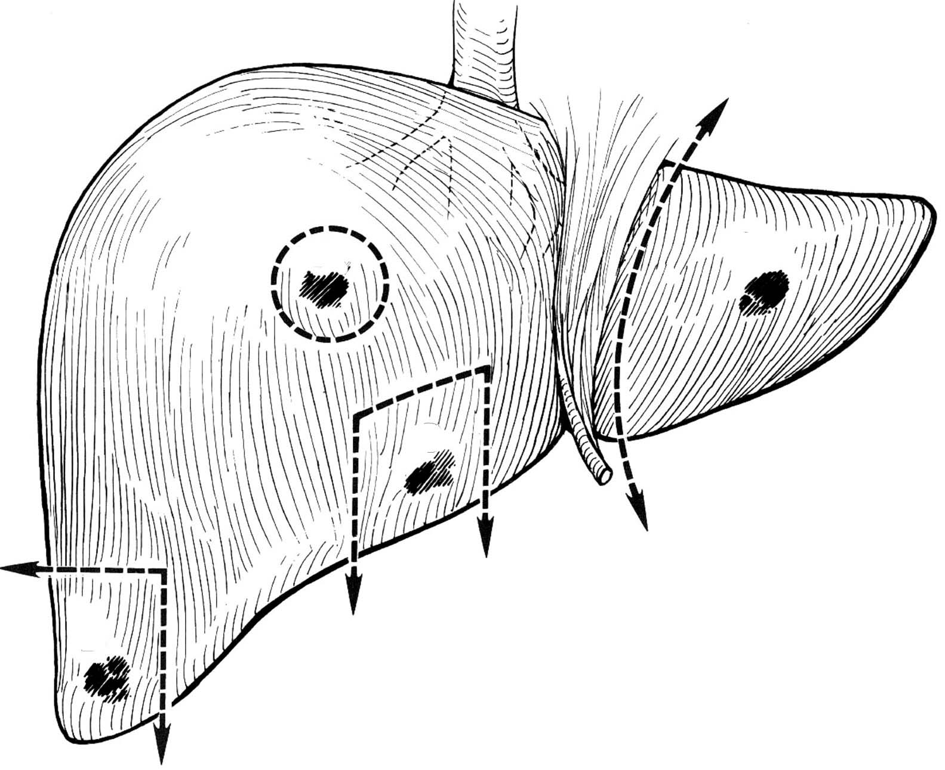 B 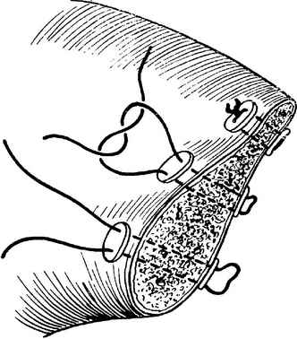 C 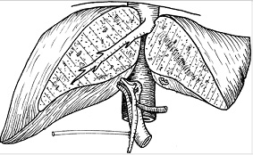 D 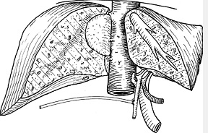
Fig. 4-11. Variants of liver resections

HEPATIC ABSCESSES AND CYSTS
Bacterial abscesses
Overview
- Bacterial abscesses are the most common hepatic abscesses in the Western world.
- These are most commonly secondary to infectious processes in the abdomen, particularly cholangitis, appendicitis, or diverticulitis. They may also result from seeding from a distant infectious source, such as endocarditis.
- In 10%-50% of cases, no source can be identified.
- The infecting organism is related to the primary source. When the source is abdominal, the most common organisms are gram-negative rods (especially Escherichia coli); anaerobes (typically a Bacteroides species); and anaerobic Streptococci (Enterococci), when the source is extra-abdominal, gram-positive organisms predominate.

Clinical features and laboratory data
- Clinical presentation includes sepsis, fever and chills, leukocytosis, and anemia.
- The patient may have right upper quadrant pain, and the liver may be tender or enlarged. Large abscesses may lead to the jaundice.
- On occasion, sepsis may be overwhelming.
- Hemobilia may also occur due to erosion of the abscess into the biliary tree.
- Liver function studies show elevated enzyme levels, particularly alkaline phosphatase.
Visualization data
- Ultrasound and CT scan reveal round-shaped cavity filled by heterogeneous fluid with irregular boards.
- Angiography and FNA may be helpful for differential diagnosis with tumors of liver.
Treatment
- The standard surgical treatment for hepatic abscess is surgical drainage (open and if possible - laparoscopic) and antibiotic therapy, which have good results.
- Hepatic abscesses also are well managed by percutaneous drainage, guided by ultrasound or CT imaging. This closed procedure may be curative, particularly for small abscesses with minimal accompanying necrotic debris and in patients with high risk of general anaesthesia.
- Multiple abscesses are difficult to manage and rely heavily on appropriate antibiotic coverage. It is important to determine the antibiotic sensitivity of the infecting organisms and to administer a full course of antibiotics to reduce the risk of recurrent or persistent infection.
- Mortality rate for hepatic abscess may be as high as 40% in difficult cases.

Amebic abscess
Overview
- Amebic abscess is the second most common hepatic abscess in the Western world and is more common than bacterial abscesses in third world countries.
- Amebic abscess is due to infection with the protozoan Entamoeba histolytica, which typically reaches the portal vein from intestinal amebiasis.
Clinical features
- Clinical presentation includes fever, leukocytosis, hepatomegaly, and right upper quadrant pain.
- The abscess is usually solitary and affects the right lobe of the liver in 90% of patients.
- The pus within the abscess is usually sterile and has the appearance of anchovy paste. Trophozoites are occasionally present in the periphery of the abscess.
- Complications include secondary bacterial infection of the cavity and rupture into adjacent structures, such as the pleural, pericardial, or peritoneal spaces.
Visualization data
- Ultrasound and CT scan reveal a cavity filled by heterogeneous fluid with irregular boards. The cavity may appear like honeycombs.
- Angiography and FNA may be helpful for differential diagnosis with tumors of liver.
Laboratory data
- Occasionally, liver enzyme levels are elevated.
- Indirect hemagglutination titers for Entamoeba are elevated in up to 85% of patients with intestinal infestation and in 98% of patients with hepatic abscess.
Treatment
- Treatment of choice is parenteral antibiotics, particularly metronidazole.
- The abscess is aspirated if it is large or adjacent to important structures, but surgical drainage is not usually necessary.

Hydatid cysts of the liver
Overview
- Hydatid cysts result from infection with the parasite Echinococcus granulosus. Dogs are the definitive host, shedding ova in the feces, which infect intermediate hosts, such as man, sheep, and cattle.
- This infection is endemic in Southern Europe, the Middle East, Australia, and South America – all areas where sheep are raised.
- Hydatid cysts can develop anywhere in the body, but two-thirds occur in the liver followed by lungs, kidneys and spleen (thus, if the hydatid cyst of liver is detected, the chest radiograph and abdominal ultrasound examination are necessary).
- The cyst and cyst lining contain parasites fully capable of spreading the infection. The adjacent compressed liver tissue and scar form the ectocyst, which is not infective and should be retained when evacuating the cyst.
- The most common complication of large cyst is suppuration which is cased by the death of the parasite.
- Hydatid cysts undergo progressive enlargement and may rupture. Cysts may rupture into bile ducts, where the debris can cause biliary obstruction. Cysts may rupture into the free peritoneal cavity, resulting in urticaria, eosinophilia, or anaphylactic shock, and with implantation into other viscera.
- Implantation within the peritoneal cavity and even abdominal wall may appear postoperatively when the surgical technology (while opening the cyst, isolation of operative field by pads moistened by hypertonic saline) was violated.
- About 30% of patients develop cysts in the lungs or other extrahepatic organs.
Clinical features and laboratory data
- Symptoms include liver enlargement and right upper quadrant pain in a patient with a history of exposure to an endemic area.
- The jaundice and ascites may appear when large cyst presents.
- Eosinophilia is present in 40% of patients, and serum tests for the parasite antigen are diagnostic.
- The suppuration is presented by severe abdominal pain, fever and other symptoms of sepsis. These cysts require more rapid term of surgical drainage then those for uncomplicated cases.
Visualization data
- In uncomplicated cases, ultrasound and CT scan reveal a cavity filled by homogeneous fluid with regular boards (see Fig. 4-12, 4-13).
- The characteristic sign of hydatid cyst (unlike solitary, i.e. nonparasytic, cysts) is the presence of well-differentiated capsule (see Fig. 4-14). Solitary cysts are usually located superficially within the liver and rarely suppurate.
- In the case of suppuration of hydatid cyst, ultrasound and CT scan show a cavity filled by heterogeneous fluid and debris, poor differentiation of the capsule, and irregular boards of the cyst (see Fig. 4-12-a).
- FNA with cytological study show elements of the parasite.
A 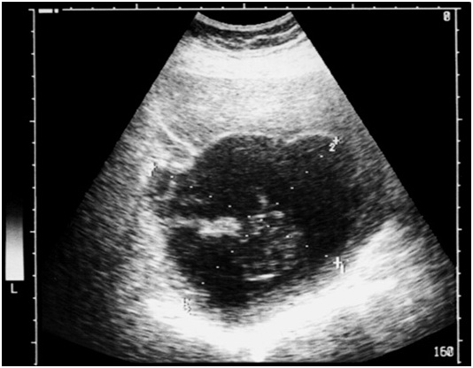 B 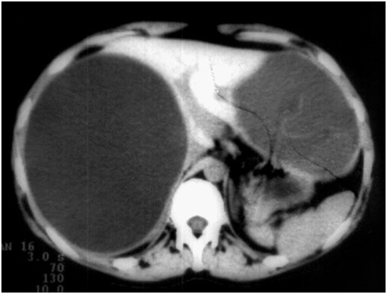
Fig. 4-12. US- and CT picture of hydatid cyst of liver
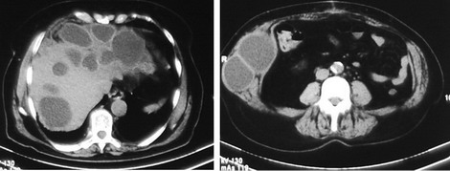
Fig. 4-13. CT picture of multiple recurrent hydatid cysts of liver, and abdominal wall (within drain channels)
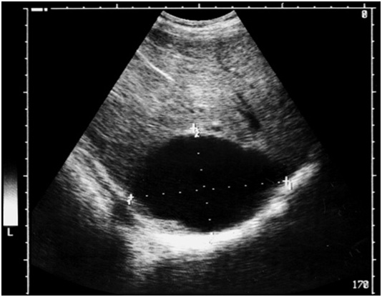
Fig. 4-14. US picture of solitary cyst of liver

Treatment
Scheme 4-5. Algorithm of management of hydatid cysts of liver

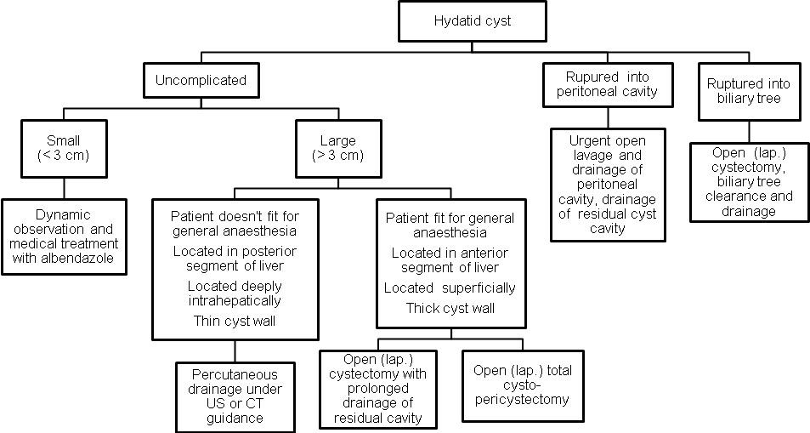
UNCOMPLICATED PEPTIC ULCER DISEASE
Diagram 4-1. Rough structure of etiology of duodenal ulcers
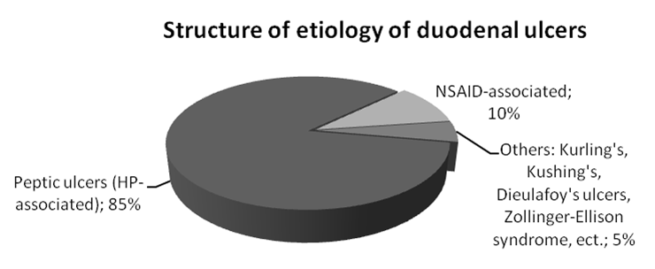

Diagram 4-2. Rough structure of etiology of gastric ulcers
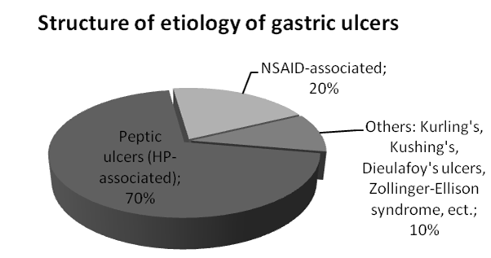

- Peptic ulcers may be found in duodenum or stomach.
- Duodenal ulcers are twice as common as gastric ulcers. Gastric ulcers are more common in men, in the elderly, and in lower socio-economic groups.
- The etiology of peptic ulcer and its treatment depend on its location. According to Johnson classification, there are 4 types of peptic ulcers: I type – ulcer of cardia, fundus, or body of stomach, II type – ulcer of stomach and duodenum, III type – ulcer of antral part of stomach and IV type – duodenal ulcer.

Duodenal ulcers
Overview
- Most duodenal ulcers are found in the first portion of the duodenum, as often on the posterior as the anterior wall.
- About 5% of duodenal ulcers are postbulbar, located in the more distal duodenum.
- Pyloric channel ulcers occur in duodenal mucosa and are treated like duodenal ulcers although they are anatomically located in the stomach. They frequently do not respond to medical therapy and often require surgery, largely because of the development of gastric outlet obstruction.
- Peptic ulceration occurs when imbalance develops between mucosal integrity and acid production.
- Most, though not all, duodenal ulcer patients experience acid hypersecretion. This condition may be related to an increased mass of acid-secreting cells which is strongly related chronic antral gastritis due to Helicobacter pylori infection. This gram-negative rod is found in the antrum of 95% of duodenal ulcer patients. Many patients without ulcer disease may have H. pylori, but eradication of this organism in patients with ulcers may be therapeutic. The parietal cells in duodenal ulcer patients are also more sensitive to gastrin secretion. The feedback inhibition of gastrin release by acid also may be impaired in these patients. Mucosal resistance may also be altered by H. pylori.
Clinical features, laboratory and visualization data
- History of epigastric pain that may radiate to the back is the usual presentation. The pain is relieved by food; however, the period of relief becomes shorter as symptoms progress. The pain typically wakes the patient at night.
- Upper gastrointestinal endoscopy is the major diagnostic tool that can reveal an ulcer lesion with edematous regular boards (see Fig. 4.15), and may be used for biopsy with subsequent histology and quick urease test for detecting H. pylori.
- Upper gastrointestinal radiographs may also be used to diagnose ulcer disease showing a niche in the wall of duodenum (see Fig. 4.16).
- Gastric secretion analysis may be used to provide data on acid output in planning for surgery.
- Serum gastrin levels are obtained in patients with recurrent ulceration after surgery, in those who fail to respond to medical management, and in those with suspected endocrine disorders, such as the Zollinger-Ellison syndrome (gastrinoma). Normal serum gastrin levels are less than 200 pg/ml.
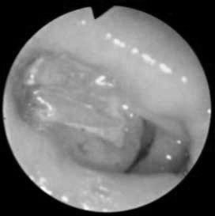
Fig. 4-15. Endoscopic picture of duodenal ulcer
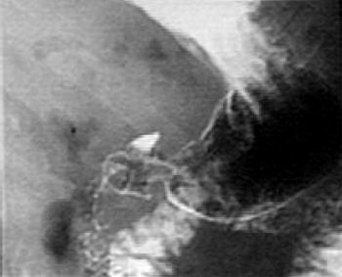
Fig. 4-16. Radiographic picture of duodenal ulcer
Treatment
- Surgical treatment is necessary for patients with frequent recurrences and complications.
- However, patients with high risk of common anaesthesia recurrent cases should be treated conservatively with individual schemes of medical therapy.

Scheme 4-6. Algorithm of management of uncomplicated duodenal ulcers

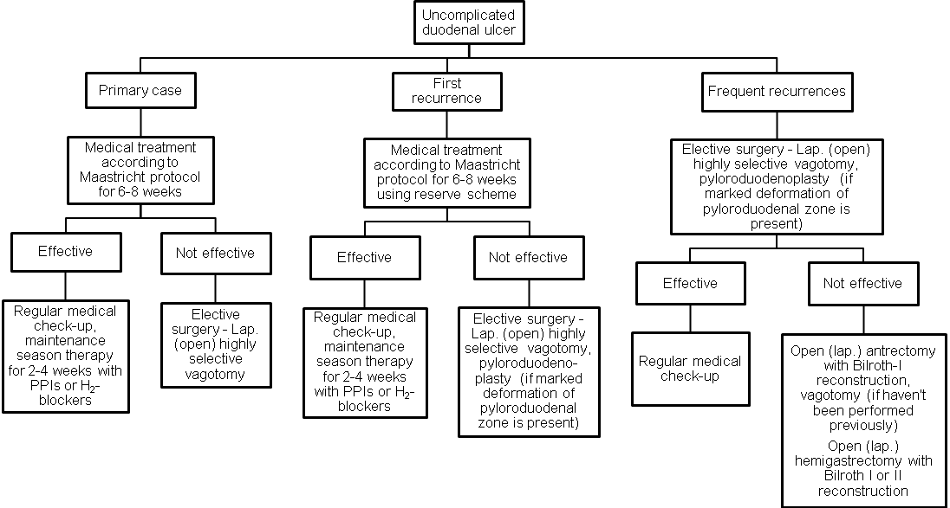
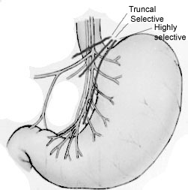

Fig. 4-17. Types of vagotomy

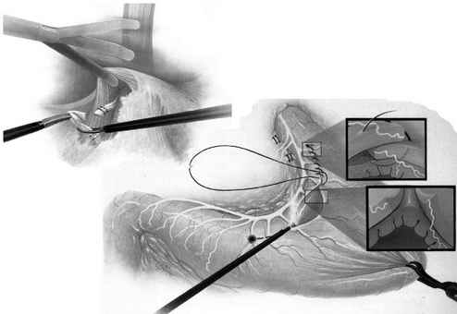
Fig. 4-18. Scheme of laparoscopic Taylor’s procedure - posterior truncal and anterior seromyotomy (the lattest is analoque of highly selective vagotomy) – the procedure of choice for treatment of uncomplicated duodenal ulcers
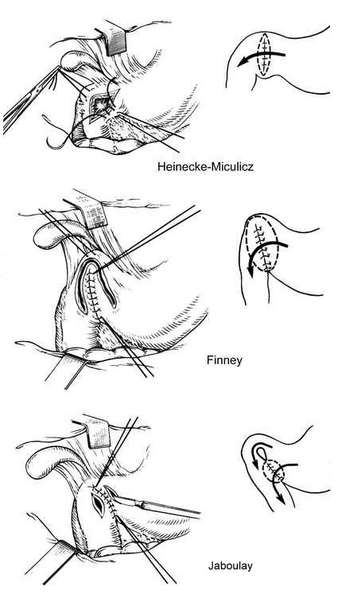
Fig. 4-19. Common types of pyloroduodenoplasty

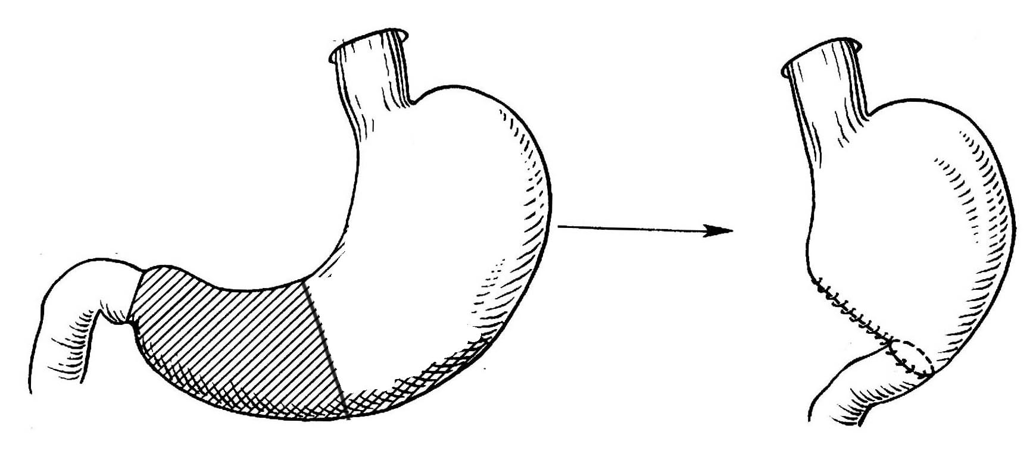
Fig. 4-20. Scheme of antrectomy with Billroth I reconstruction

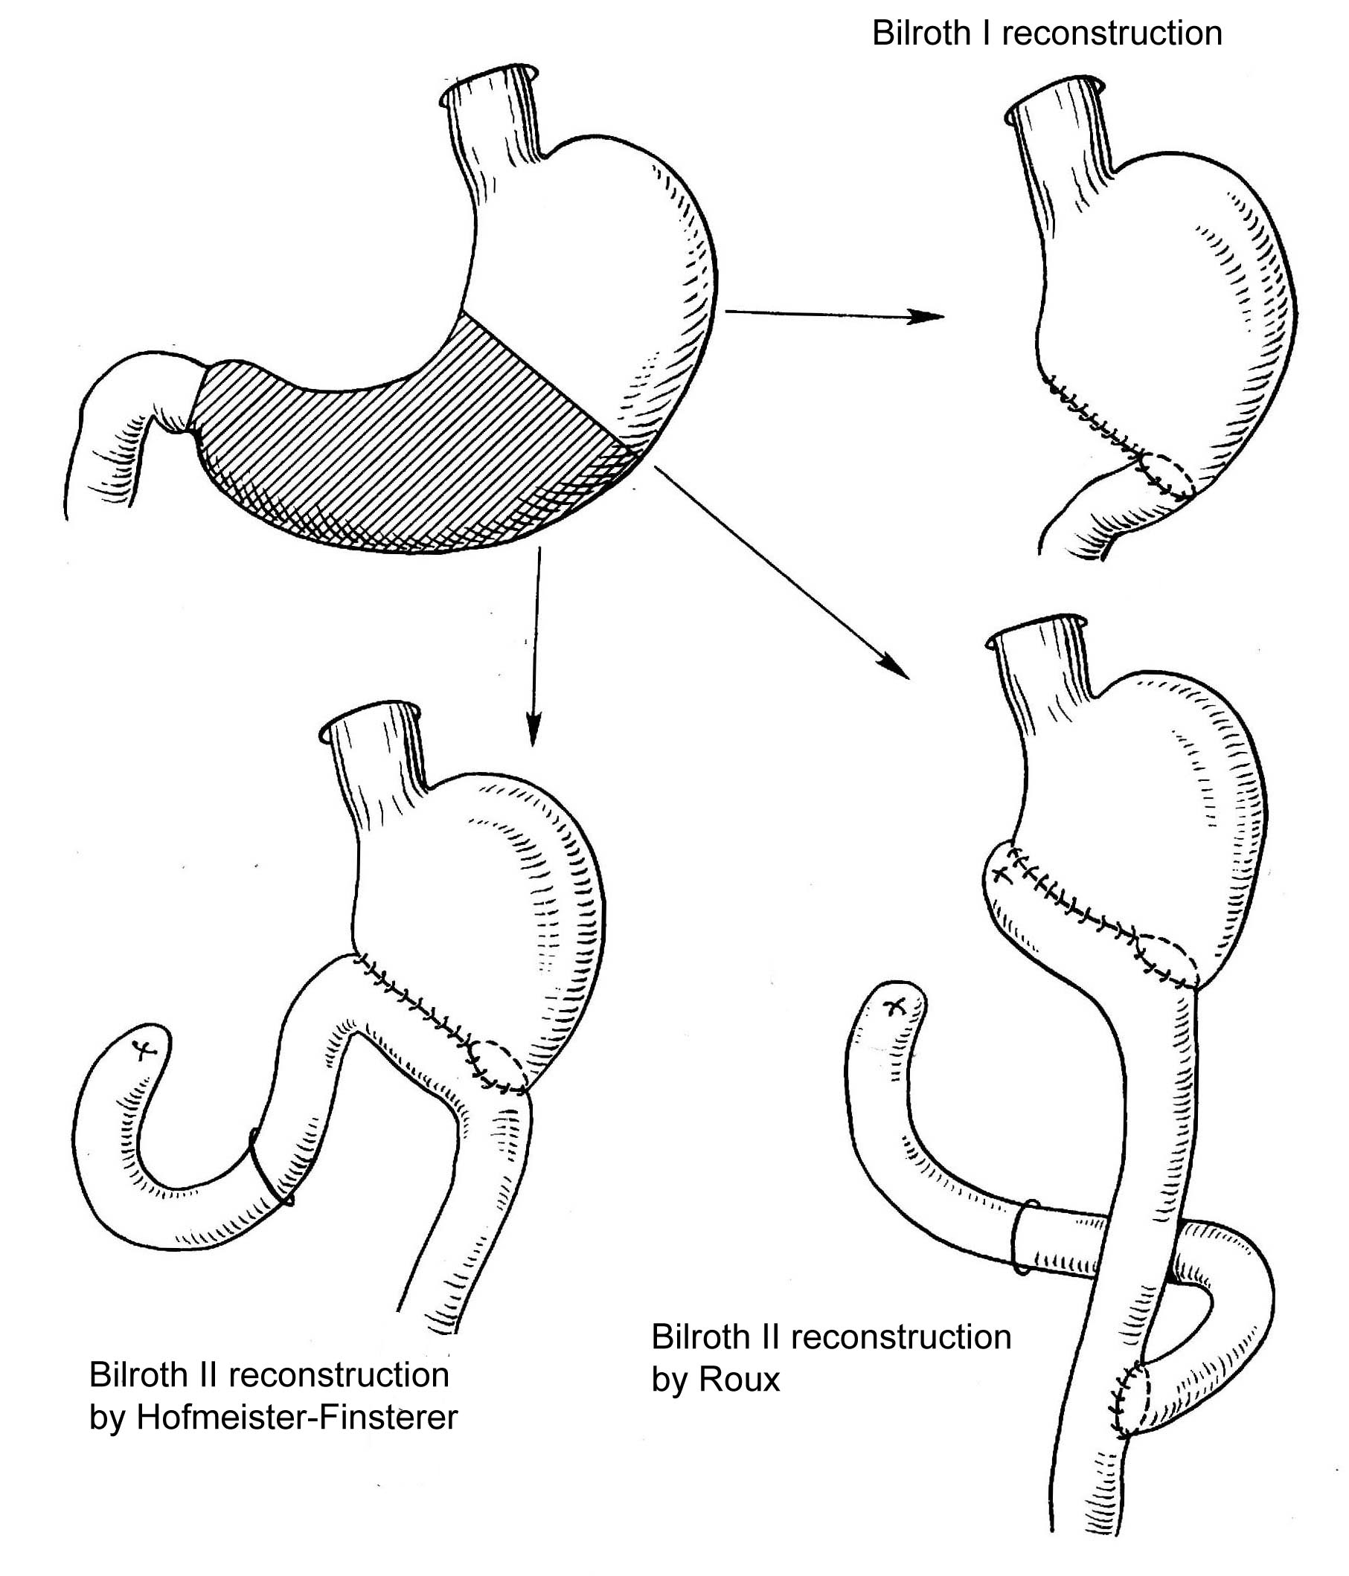
Fig. 4-21. Common variants of hemigastrectomy

Gastric ulcers
Overview
- Most gastric ulcers occur within the body of the stomach, in the angle of stomach (the histologic transition zone between the parietal cells of the body and the gastrin-secreting cells of the antrum).
- Ulcers can occur near the gastroesophageal junction, high on the lesser curve. The surgical approach is different with ulcers in this location since a distal resection would not include the ulcer. They are usually locally excised using atypical resection or proximal hemigastrectomy.
- Pyloric channel ulcers are gastric ulcers that occur near the pylorus. They tend to act like duodenal ulcers and are treated as such.
- The etiology of gastric ulcers is multifactorial and not completely delineated but is clearly different than the acid hypersecretion associated with duodenal ulcer disease. Damage to the gastric mucosal barrier, usually associated with H. pylori infection, appears to be the most important factor.
- Reflux of bile into the stomach is thought to change the mucosal barrier, allowing gastric acid to enter the mucosa and injure it.
- Drugs can alter the mucosal barrier to hydrogen ion. Nonsteroidal anti-inflammatory drugs (NSAIDs), such as indomethacin and salcylates, are common causative agents. Steroids and ethanol have also been implicated. The combination of smoking and salicylate ingestion is strongly implicated in the development of gastric ulcers.
- Persons with gastric ulcers tend to have lower than normal rates of acid secretion, both basal and stimulated. Their serum gastrin levels are аррroximately twice the normal levels.

Gastric ulcers and cancer
- The suggestion that gastric ulcer degenerate into carcinoma now is still controversial. Most authors advocate this because chronic atrophic H.pylori-associated gastritis which predisposes to gastric ulcers may also lead to gastric cancer.
- However, gastric cancer will ulcerate in 25% of cases, and it is, therefore, mandatory to prove histologically that suspicious or non-healing gastric ulcers are not carcinoma. Approximately 10% of gastric ulcers are malignant.

Clinical features, laboratory and visualization data
- History of burning epigastric pain that is relieved by food but recurs 30 to 90 minutes later is the usual presentation of gastric ulcers.
- The initial diagnostic studies include endoscopy (see Fig. 4-22) and upper gastrointestinal radiographs (see Fig. 4-23). Endoscopy, which allows multiple biopsies through the endoscope, is necessary to rule out malignancy.
- Gastric secretion analysis uses a stomach probe to monitor the gastric pH for a 24-hour period.
A 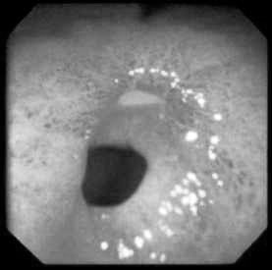 B 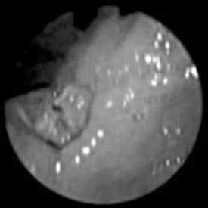
Fig. 4-22. Endoscopic pictures of gastric ulcers

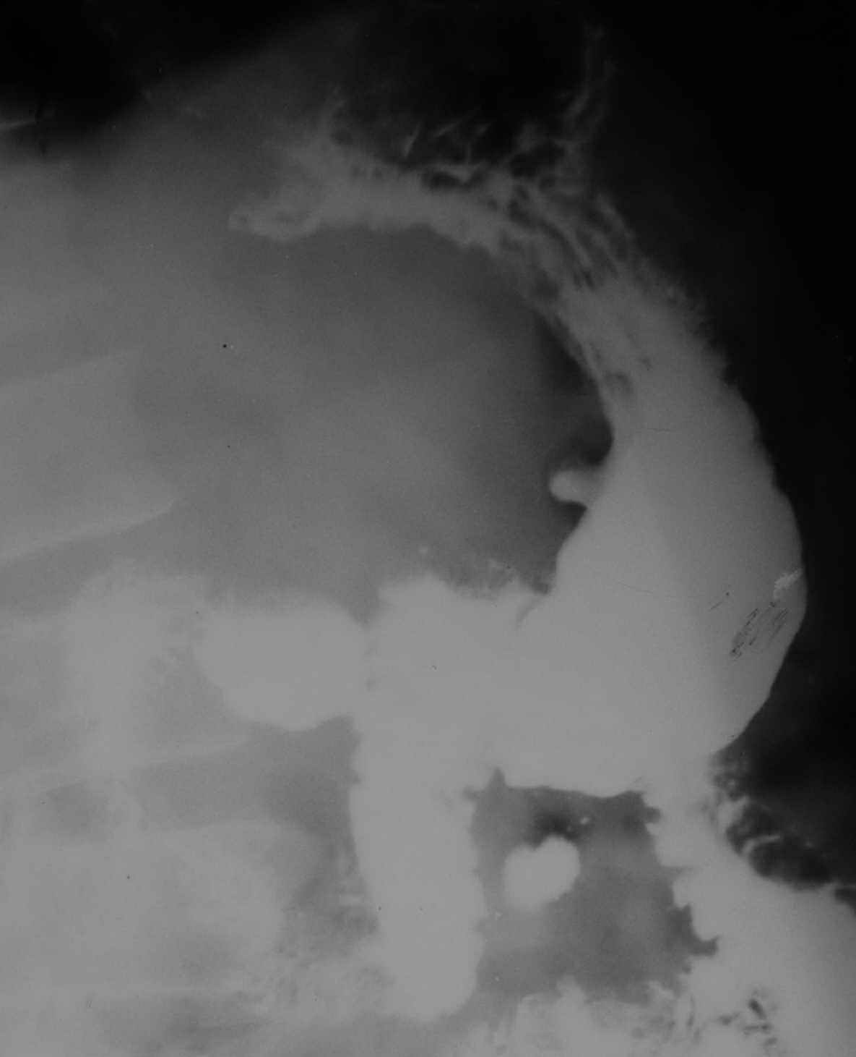
Fig. 4-23. Radiographic picture of ulcer of body of stomach

Treatment
- Surgical treatment is necessary for patients with frequent recurrences, complications and suspected malignancy or high risk of its development (severe metaplasia, or dysplasia).
- For patients who doesn’t fit for common anaesthesia recurrent cases should be treated conservatively with individual schemes of medical therapy.

Scheme 4-7. Algorithm of management of uncomplicated gastric ulcers

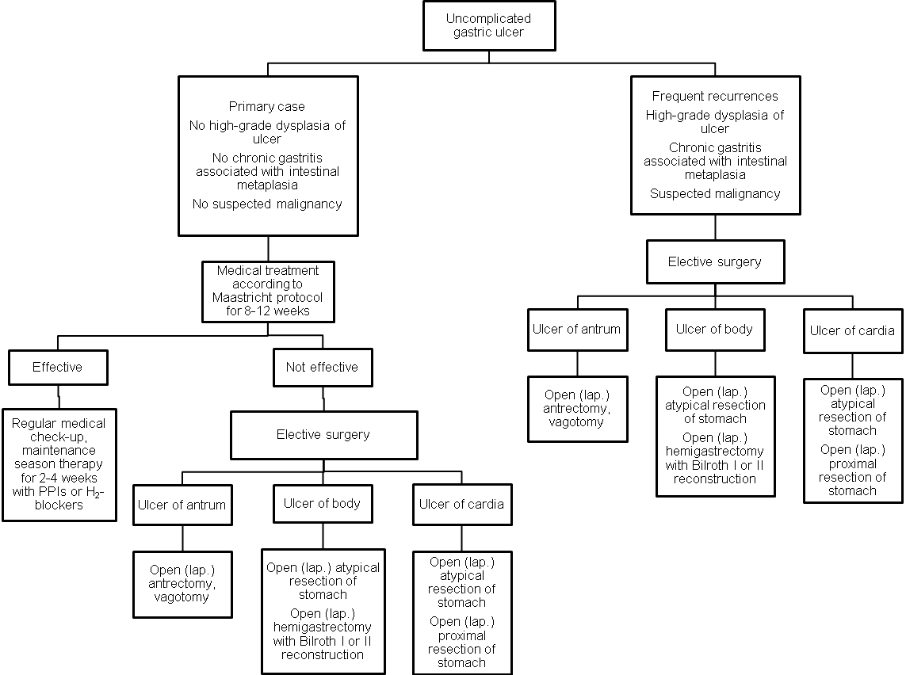
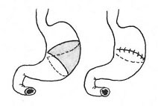
Fig. 4-24. Atypical resection of stomach

Medical treatment of ulcer disease according to Maastricht protocol
- Avoidance of aspirin, caffeine, alcohol, and tobacco is recommended. Stress reduction may be beneficial. Antacid therapy has also been demonstrated its effectiveness.
- Diet should be excluding rough, spicy and fatty food, with graduate food intake.
- Anti-Helicobacter pylori antibiotic therapy includes: amoxicillin (clarythromicin) 500 mg twice a day + metronidazole (tinidazole) 500 mg twice a day, 7 – 10 days course.
- Proton pump inhibitors (PPIs): omeprazole (rabeprazole, ezomeprazole) 20 mg twice a day, 6 – 8 weeks course for duodenal ulcers and 8 – 12 weeks course for gastric ulcers.

Complications specific to gastric surgery
Alkaline reflux gastritis
- Alkaline reflux gastritis is the most common problem after a hemigastrectomy, occurring about 25% of all patients.
- Symptoms are postprandial epigastric pain/nausea, vomiting, and weight loss.
- Endoscopy demonstrates reflux-gastritis and a free reflux of bile.
- Treatment is conversion of the Billroth I or II hemigastrectomy to Roux-en-Y anastomosis.

Afferent loop syndrome
- Afferent loop syndrome is caused by intermittent mechanical obstruction of the afferent loop of a gastrojejunostomy.
- Symptoms include early postprandial distention/pain, and nausea, which are relived by vomiting of bilious material not mixed with food.
- Treatment consists of providing good drainage of the afferent loop, usually by conversion to a Roux-en-Y anastomosis.

Dumping syndrome
- Dumping syndrome affects most postgastrectomy patients but is a significant problem in only a few. It is caused by the release of hypertonic chyme into the small bowel which causes rapid accumulation of fluid and consequent jejunal distention.
- Symptoms may include epigastric fullness or pain, nausea, palpitations, dizziness and diarrhea.
- Signs include tachycardia and elevated blood pressure.
- Conservative measures control most patients' symptoms. They are advised to eat high-carbohydrate diet and not to drink fluids with meals.
- Surgical treatment is used to delay gastric emptying, including interposition of antiperistaltic jejunal loop between the stomach and small bowel and other reconstruction surgery.

Postvagotomy diarrhea
- Postvagotomy diarrhea is common in its mild form but seldom is a disabling problem.
- Symptoms usually improve during the first year after surgery.

Marginal ulcers
- Marginal ulcers are located at the anastomosis between stomach and jejunum (after Billroth II reconstruction), or stomach and duodenum (after Billroth I reconstruction).
- They may be complicated by severe gastrointestinal bleeding and lead to the obstruction of anastomosis.
- Most commonly, treatment include aggressive medical therapy. In advanced cases, including above-mentioned complications with failure to be controlled by conservative measures (endoscopic hemostasis, or balloon dilation, respectively), they require re-resection of stomach along with the anastomosis.

PERFORATED PEPTIC ULCER
Overview
- Perforations of peptic ulcers occur most commonly with ulcers on the anterior surface of the duodenum.
- Gastric perforations are less common.
- Occasionally, ulcers can perforate posteriorly into the lesser sac (covered perforation).

Diagram 4-3. Rough structure of causes of gastrointestinal perforations
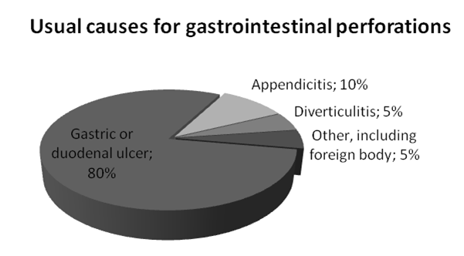

Clinical features and visualization data
- Typical symptoms of perforation include sudden onset of severe abdominal pain, radiation of pain to the shoulder, nausea, and vomiting.
- Signs include a rigid abdomen, symptoms of peritoneal irritation, and shock.
- Liver dullness determined by percussion usually is absent.
- An upright abdominal chest radiograph frequently demonstrates air under the diaphragm (see Fig. 4-25).
- If free air is absent in plane film (in covered perforation), endoscopy may be used to reveal deep ulcer. It may be followed by repeated plane film that will detect air confirming the diagnosis.
- Long-term covered perforation may produce subhepatic abscess with respective clinical presentation and imaging data (see Chapter 2).

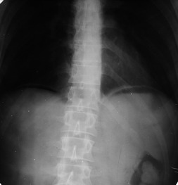
Fig. 4-25. Free air in peritoneal cavity

Treatment
Scheme 4-8. Algorithm of management of perforated duodenal ulcer

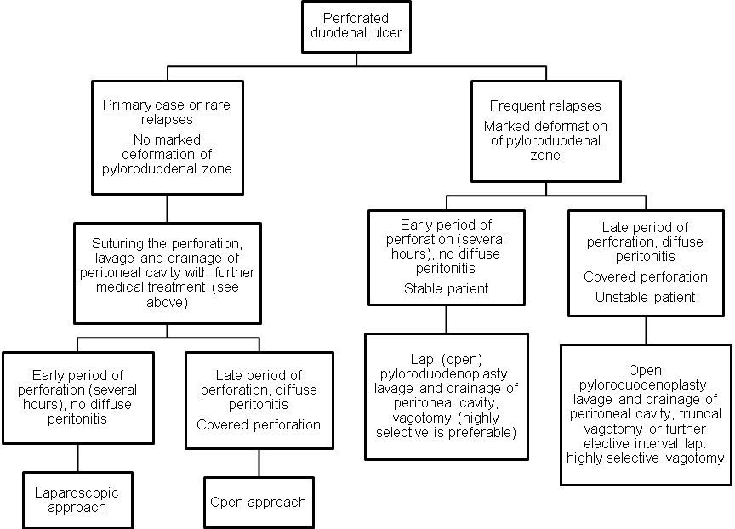

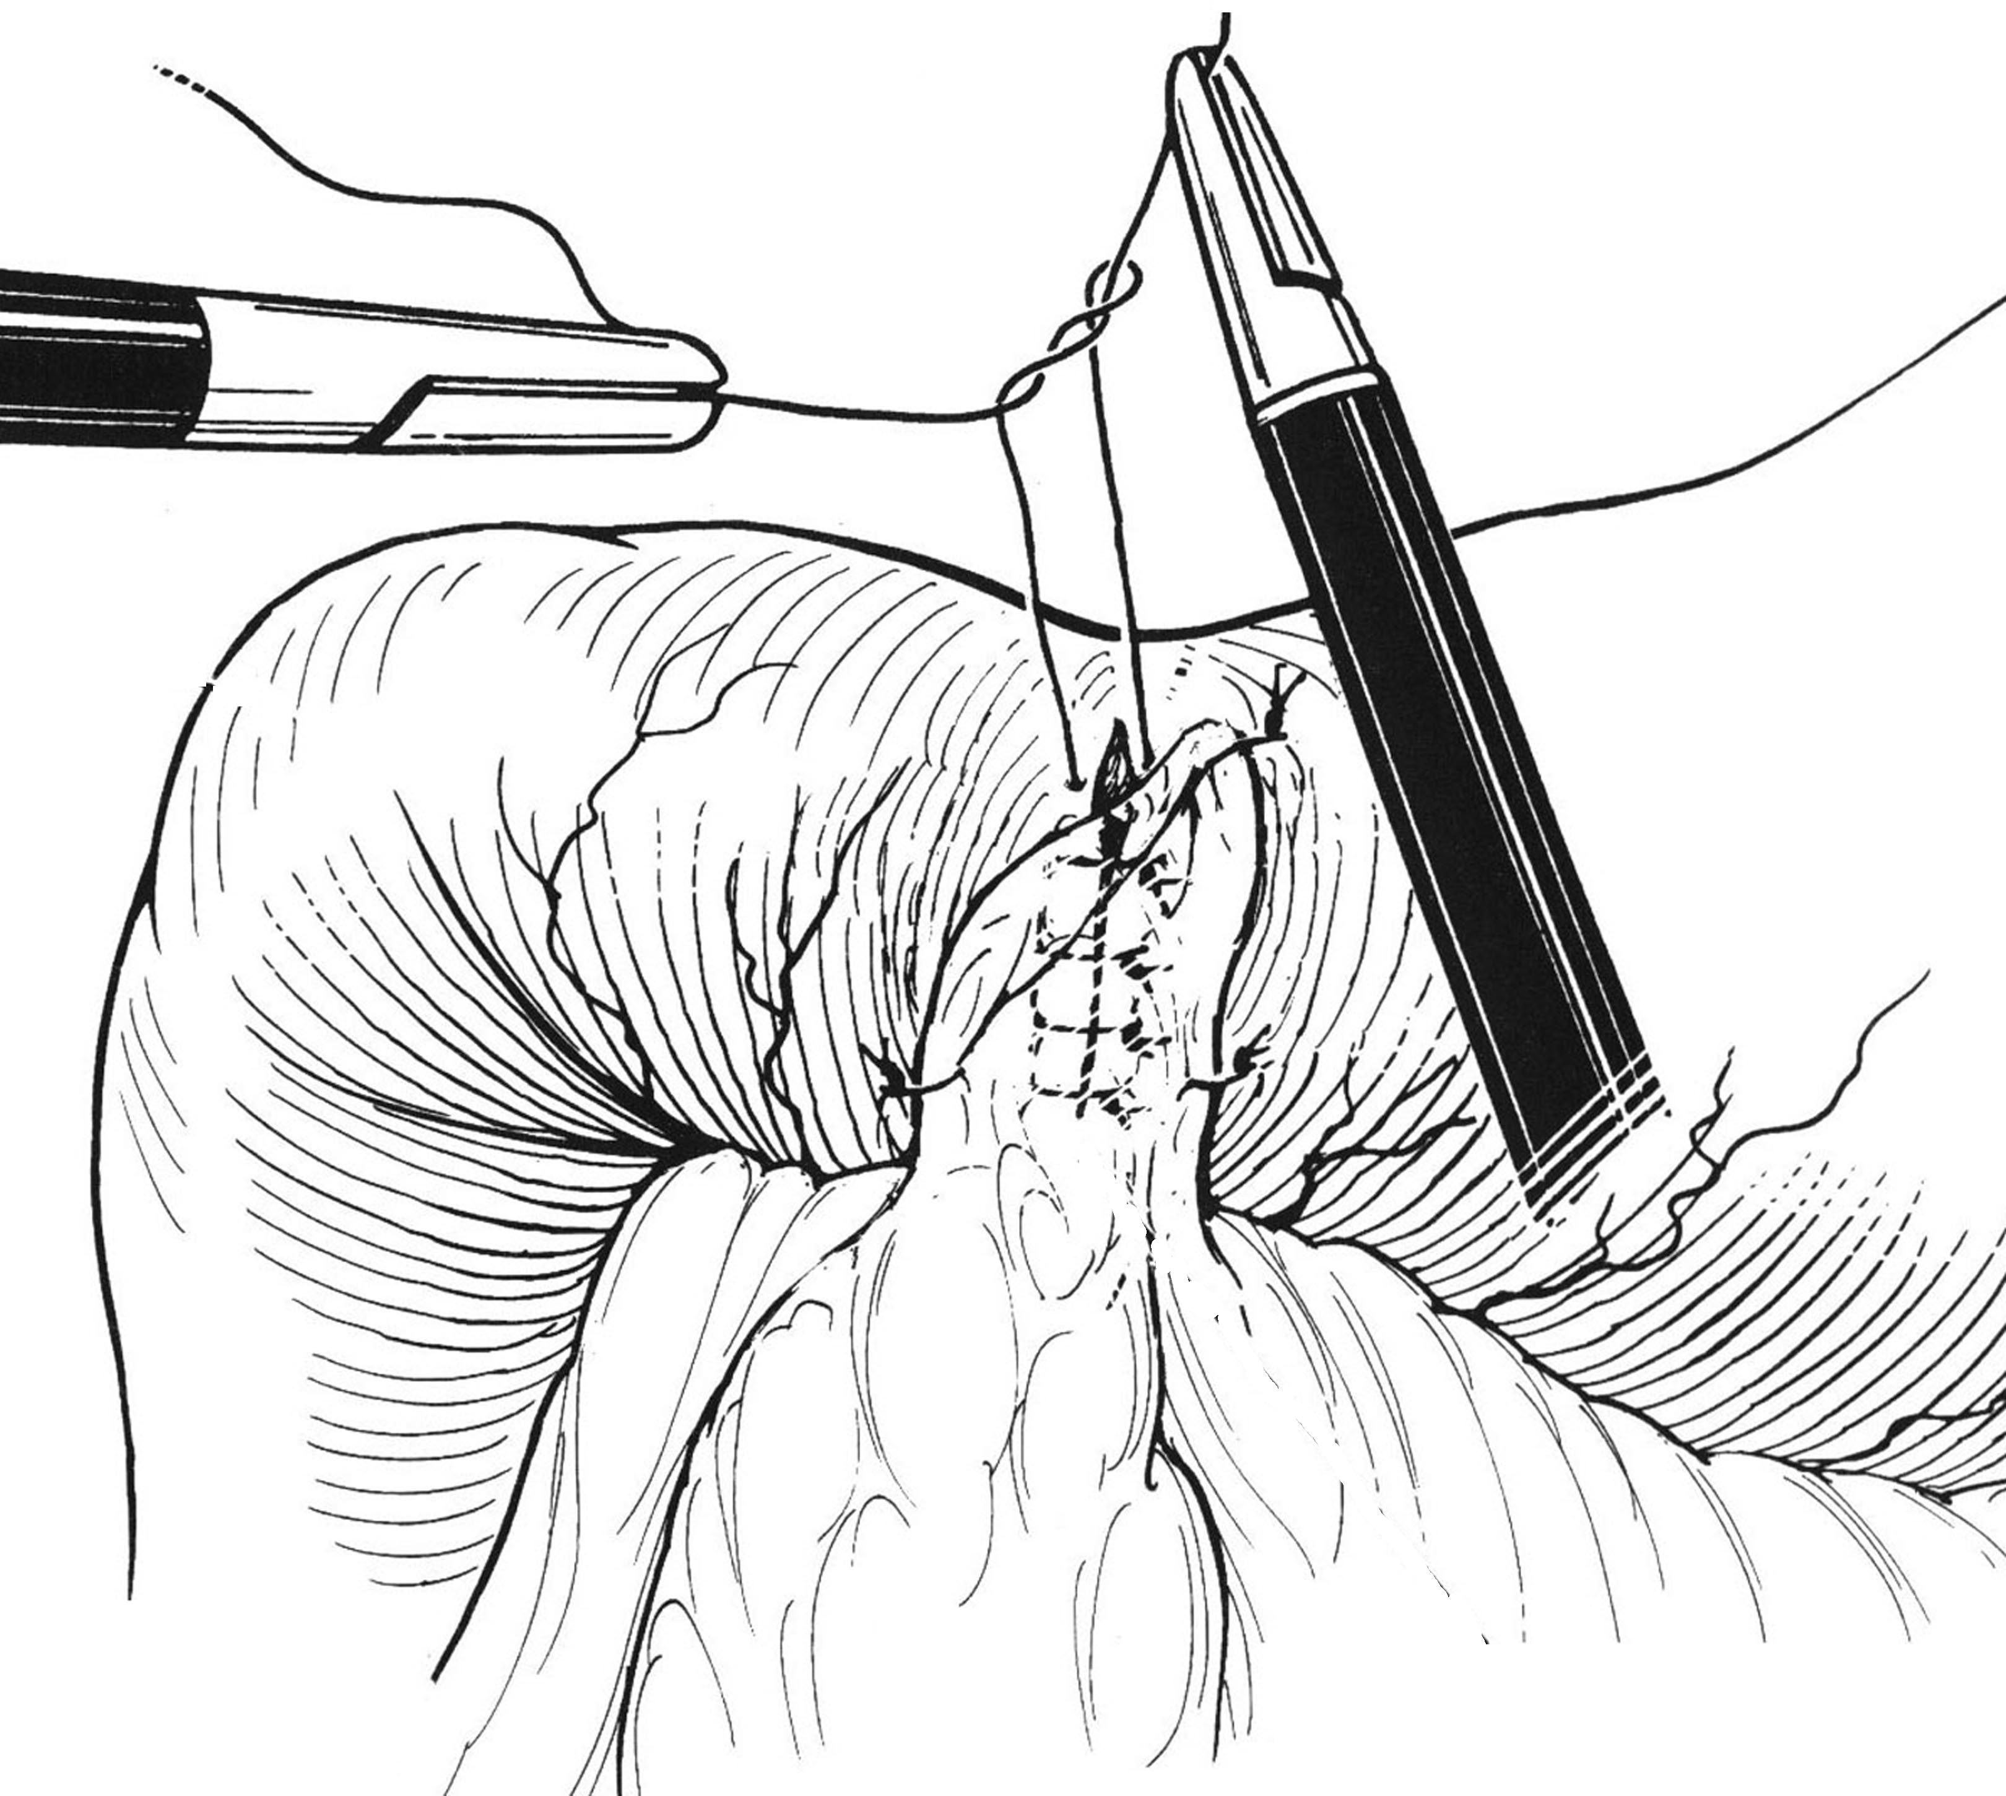
Fig. 4-26. Technique of laparoscopic suturing the perforated peptic ulcer
Scheme 4-9. Algorithm of management of perforated gastric ulcer
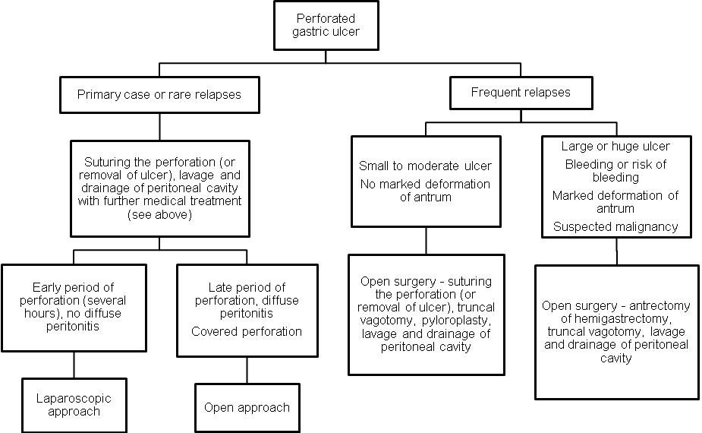

5. Plan and structure of the class
No. | Basic stages of the class | Training aims according to the levels of mastering | Means of training and control | Materials for methodological maintainance of  the class, visibility, and control of knowledges | Terms (in minutes or per cent)
1 | Initial | 1) Giving the training aims of level II (see chapter 2.1)  2) Control testing of initial level of knowledge, readiness of the students for perception of the material | Krok-2 type tests of initial level of knowledge, including software version (see chapter 6.1) | Krok-2 type tests of initial level of knowledge, including software version (see chapter 6.1) | 15 %
2 | Basic | 1) Giving the training aims of levels II – IV (see chapter 2.1)  2) Conduct curation of a patient with the syndrome of “acute abdomen”  3) Take part in the clinical analysis of the intensive care unit patient with the syndrome of “acute abdomen”  4) Perform dressing for a patient in the postoperative period | Observation of patients at the department of robotic and endoscopic surgery  Analysis of specific case histories with the formation of a diagnostic and treatment program to address the need for modern methods. | 1) Schemes, tables (including PowerPoint presentations) of algorithms of diagnostics and management  2) Diagnostic images  3) Illustrations and videos of surgical procedures  4) Equipment  Radiographs  Disease history  5) Untypical tasks in the form of: patient, medical history, test situation assignments, business games, dressing | 70 %
3 | Conclusive | 1) Control testing of theoretical knowledges and practical skills  2) Conclusions  3) Giving the home task | 1) Krok-2 type tests of final level of knowledge, including software version (see chapter 6.3)  2) List of literature for the next class | Krok-2 type tests of final level of knowledge, including software version (see chapter 6.3) | 15 %

6. Materials for methodological maintainance of the class

6.1. Materials for initial stage of the class
1. A 46-years-old woman was admitted to surgical department with complaints of a moderate periodical pain at right subcostal region, and periodical nausea. The symptoms appear every months for the last 1 year, after ingestion of fatty and spicy food. Physical examination of abdomen reveals slight tenderness at the right subcostal region, no rebound tenderness and muscle guarding. There is no history of jaundice. Blood and urine analyses are normal. Ultrasound shows calculi in the gallbladder which is not enlarged, common bile duct measuring 5 mm in diameter, and slight enlargement of pancreas. What’s the most appropriate tactics of managing the patient?

A. Open cholecystectomy
B. Laparoscopic cholecystectomy +
C. Endoscopic retrograde cholangiopancreatography
D. Laparoscopic cholecystectomy, exploration and drainage of common bile duct
E. Percutaneous cholecystostomy under US guidance

2. A 82-years-old woman was admitted to ER with complaints of an intense constant pain at right subcostal region, fatigue, subfebrile temperature, and nausea. The symptoms appeared 3 days ago after ingestion of fatty food. The same attack took place last year. The patient has history of angina pectoris, a dypnea at rest, and peripheral edema. Pulse is irregular, ECG reveals atrial fibrillation. Physical examination of abdomen reveals pronounced tenderness at the right subcostal region, moderate rebound tenderness and muscle guarding. There is no jaundice. There is leukocytosis of 12000/ml and left shift of leukogram. Ultrasound reveals multiple calculi in the gallbladder which is enlarged, with thickened wall, common bile duct measuring 7 mm in diameter, and slight enlargement of pancreas. What’s the most appropriate tactics of managing the patient?

A. Laparoscopic cholecystectomy
B. Open cholecystectomy
C. Percutaneous cholecystostomy under US guidance +
D. Endoscopic retrograde cholangiopancreatography
E. Laparoscopic cholecystectomy, exploration and drainage of common bile duct

A 28-years-old man who had a history of ulcer disease was admitted to ER with complaints of intense (knife-stab) pain at upper part of abdomen and multiple vomiting. The pain appeared 30 minutes ago. Physical examination of abdomen reveals wooden-like muscle spasm, severe diffuse tenderness, and rebound tenderness at all the sites. What’s the most possible sign found at the imaging studies?

A. Abdominal ultrasonography shows fluid in right flank
B. Small bowel follow-through contrast study shows slow passage of contrast medium
C. CT of abdominal cavity shows fluid in right flank
D. Upright abdominal radiography shows free air under the right dome of diaphragm +
E. Chest radiography shows high position of right dome of the diaphragm

A 68-years-old woman was admitted to ER with complaints of intense pain at right upper quadrant of abdomen and multiple vomiting. The pain appeared 3 days ago after ingestion of fatty food. Physical examination of abdomen reveals slight muscle spasm and severe local tenderness at right upper quadrant. What’s the most valuable method of further investigation to make the diagnosis and chose proper tactics?

A. Gastroduodenal endoscopy
B. Upright abdominal radiography
C. Upper gastrointestinal series
D. Barium enema
E. Abdominal ultrasonography +

A 40-years-old woman was admitted to ER with complaints of a cramping pain at right lower quadrant of abdomen irradiating to perineum, fever of 38 °C and single vomiting. There is no diarrhea and constipation. Physical examination of abdomen reveals moderate tenderness in right iliac region and right flank, no rebound tenderness and muscle guarding. Give your presumable diagnosis:

A. Acute appendicitis
B. Acute gastroenteritis
C. Renal colic +
D. Acute salpingitis
E. Bowel obstruction

A 27-years-old woman was admitted to ER with complaints of a constant pain at right lower quadrant of abdomen without irradiation, subfebrile fever and small amount of muddy vaginal discharges. There is no diarrhea and constipation. Physical examination of abdomen reveals moderate tenderness in right iliac region and pubic region, slight rebound tenderness and no muscle guarding. Menstruation was 20 days ago. Give your presumable diagnosis:

A. Acute appendicitis
B. Ruptured ectopic pregnancy
C. Salpingitis +
D. Cancer of cervix of uterus
E. Pelvic appendicular abscess

6.2. Materials for basic stage of the class

A 55-years-old man was operated 2 years ago for cancer of sigmoid colon pT₂N₁M₀: the sigmoidectomy was performed. During regular examination, a hyperechogenic node of 3,5 cm was found in the 4th segment of liver. Contrast-enhanced MRI show increased uptake of the medium by the node, and doesn’t reveal any other nodes, lymphadenopathy and local recurrence of the tumor. US-guided biopsy shows cells of moderately-differentiated adenocarcinoma. The examination of abdomen showed no pathological changes. The patient has no concomitant pathology. What’s the most appropriate tactics of managing the patient?

A. Percutaneous radiofrequency ablation of the node
B. Laparoscopic radiofrequency ablation of the node
C. Open liver segmentectomy +
D. Open left hemihepatectomy
E. Open criogenic destruction of the node

A 35 -years-old man, a sheepman, was admitted to surgical department with complaints of a moderate periodical pain at right subcostal region which appeared 2 weeks ago. While physical examination of abdomen, there is slight tenderness at the right subcostal region, no hepatomegaly. There is no history of jaundice. Blood and urine analyses are normal. Ultrasound reveals unechogenic lesion with regular boards measuring 8 cm in diameter, located deeply in liver parenchima in the 6th and 7th segments. The patient has no concomitant pathology. What’s the most appropriate tactics of managing the patient?

A. Percutaneous drainage of the lesion +
B. Laparoscopic drainage of the lesion
C. Open drainage of the lesion
D. Open right hemihepatectomy
E. Conservative treatment

A 70-years-old man was admitted to ER with complaints of a cramping pain at all the sites of abdomen and multiple vomiting. The last bowel movement was 2 days prior to admission. While physical examination of abdomen, there is marked distention, moderate diffuse tenderness, no rebound tenderness and muscle guarding. Digital examination reveals absence of feces in the rectum. What’s the most valuable method of further investigation to make the diagnosis and chose proper tactics?

A. Abdominal ultrasonography
B. Upright abdominal radiography +
C. Upper gastrointestinal series
D. Small bowel follow-through contrast study
E. Gastroduodenal endoscopy

A 40-years-old woman was admitted to ER with complaints of a cramping pain at right lower quadrant of abdomen irradiating to perineum, fever of 38 °C and single vomiting. There is no diarrhea and constipation. Physical examination of abdomen reveals moderate tenderness in right iliac region and right flank, no rebound tenderness and muscle guarding. Urine analysis shows increased amount of WBC and RBC. What’s the most appropriate sequence of methods of further investigation?

A. Upright abdominal radiography, ultrasonography of abdomen and kidneys, intravenous pyelography +
B. Upright abdominal radiography, barium enema, CT of retroperitoneal space
C. Upright abdominal radiography, gastroduodenal endoscopy, CT of retroperitoneal space
D. Upper gastrointestinal series, small bowel follow-through contrast study, intravenous pyelography
E. MRI of retroperitoneal space, ultrasonography of kidneys, upright abdominal radiography

A 20-years-old man was admitted to ER with complaints of slight constant pain at right iliac region for the last 5 days. 7 days ago he had severe pain at right lower quadrant of abdomen which had diminished with time. Currently while physical examination, the smooth, slightly tender mass is palpated in right iliac region. Patient’s body temperature is subfebrile. There is no diarrhea and constipation. Ultrasound reveals a mass without cavity in the right iliac fossa that measures 7 cm in diameter. What’s the most appropriate tactics of managing the patient?

A. Lower midline laparotomy, appendectomy
B. Laparotomy by McBurney’s incision, appendectomy
C. Laparoscopic appendectomy
D. Case monitoring
E. Conservative treatment with antibiotics and non-steriodal anti-inflammatory drugs +

A 20-years-old man was admitted to ER with complaints of moderate constant pain at right iliac region for the last 5 days, fatigue and fever of 38 °C. 7 days ago he had severe pain at right lower quadrant of abdomen which had deminished with time. Currently, the hard tender mass and moderate rebound tenderness in right iliac region is determined. There is no diarrhea and constipation. Ultrasound reveals a mass with a cavity (fluid collection) measuring 10 сm in diameter. What’s the most appropriate tactics of managing the patient?

- Conservative treatment by antibiotics
- Conservative treatment by physiotherapy
- Surgical treatment – drainage +
- Case monitoring
- Conservative treatment with antibiotics and anti-inflammatory drugs

6.3. Materials for final stage of the class

A patient complains of an extremely intense pain in epigastrium. He has peptic ulcer disease of duodenum for 10 years. The patient is in the forced position being on the right side with legs abducted to stomach. Abdomen has acute tenderness in the epigastrium. Guarding contraction of the abdominal wall muscles is observed. What is the preliminary diagnosis?
- Thrombosis of mesenteric vessels
- Perforation of ulcer
- Acute condition of peptic ulcer disease
- Acute pancreatitis
- Penetration of ulcer into pancreas

A 20 y.o. patient suddely felt ill 12 hours ago. There was pain in epigactric area, nausea, sporadic vomiting. He had taken alcohol before. In few hours the pain localized in the right iliac area. On examination: positive rebound tenderness symptoms. WBC- 12,2&times;10<sup>9</sup>/L. What is the most probable diagnosis?
- Acute appendicitis
- Acute cholecystitis
- Rightside kidney colic
- Perforated ulcer
- Acute pancreatitis

A 75-year-old male patient complains of slight pain in the right iliac region. The abdominal pain arose 6 days ago and was accompanied by nausea. Surgical examination revealed moist tongue, Ps- 76 bpm. AP- 130/80 mm Hg. Abdomen was soft, slightly painful in the right iliac region on deep palpation, the symptoms of the peritoneum irritation were doubtful. In blood: RBCs - 4,0*10~12/l, Hb- 135 g/l, WBCs - 9,5*10~9/l, stab neutrophils - 5%, segmentonuclear - 52%, lymphocytes - 38%, monocytes - 5%, ESR - 20 mm/h. Specify the doctors further tactics:
- Administration of additional examination: abdominal ultrasound, x-ray contrast study of the gastrointestinal tract
- Send the patient home
- Emergency operation for acute appendicitis
- Refer the patient to a district therapist
- Hospitalization, dynamic surveillance

During investigation for chronic, severe, epigastric pain, a 40 year old alcoholic man is found to have multiple areas of narrowing alternating with dilatation ("chain of lakes" appearance) of the main pancreatic duct. The operation of choice is:
- Lateral pancreaticojejunostomy
- Total pancreatectomy
- Distal pancreaticojejunostomy
- Sphincterotomy
- Distal pancreatectomy

A 38 y.o. woman was hospitalized to the surgical unit with vomiting and acute abdominal pain irradiating to the spine. On laparocentesis hemmorhagic fluid is obtained. What disease should be suspected?
- Perforated gastric ulcer
- Renal colic
- Acute enterocolitis
- Acute appendicitis
- Acute pancreatitis

A 45-year-old woman, mother of four children, comes to the emergency room complaining of a sudden onset of the epigastric and right upper quadrant pain, radiating to the back, accompanied by vomiting. On examination, tenderness is elicited in the right upper quadrant, bowel sounds are decreased, and laboratory data shows leukocytosis, normal serum levels of amylase, lipase, and bilirubin. The most likely diagnosis is:
- Perforated peptic ulcer disease
- Sigmoid diverticulitis
- Acute pancreatitis
- Acute cholecystitis
- Myocardial infarction

A 54-year-old female patient has been admitted to a hospital 12 days after the beginning of acute pancreatitis. Objectively: the patient is in grave condition. The body temperature is hectic. Ps - 112 bpm. The abdomen is swollen. Epigastrium palpation reveals a very painful infiltration falling in the localization of pancreas. Abdominal cavity contains fluid. There is an edema of the left lumbar region. In blood: WBCs - 18109/l. What is the required tactics of the patients treatment?
- Increase in antienzymes
- Further conservative treatment
- Massive antibacterial therapy
- Surgical treatment
- Peritoneal dialysis

A 29 y.o. patient was admitted to the hospital with acute girdle pain in epigastric area, vomiting in 1 hour after the meal. On examination: pale, acrocyanosis. Breathing is frequent, shallow. Abdominal muscles are tensed, positive Schotkin-Blumbergs symptom. What is the maximal term to make a diagnosis?
- In 2 hours
- In 3 hours
- In 1 hour
- In 6 hours
- In 0,5 hours

A 43 year old patient had cholecystectomy 6 years ago because of chronic calculous cholecystitis. Lately he has been suffering from pain in the right subcostal area and recurrent jaundice. Jaundice hasnt gone for the last 2 weeks. Stenosing papillitis 0,5 cm long has been revealed. What is the best way of treatment?
- To perform external choledoch drainage
- To treat conservatively: antibiotics, spasmolytics, antiinflammatory drugs
- To perform transduodenal papillosphincterotomy
- To perform endocsopic papillosphincterotomy
- To perform choledochoduodenostomy

A patient complains about pyrosis and permanent pain behind his breastbone. When he bends forward after eating there appears regurgitation. Roentgenological examination revealed extrasaccular cardiofunctional hernia of esophageal opening of diaphragm. Esophagoscopy revealed signs of reflux-esophagitis. What is the necessary tretment tactics?
- Conservative treatment in a surgical department
- Conservative treatment in an outpatients clinic
- Conservative treatment in the therapeutic hospital
- Operation in a surgical department
- Treatment at a health resort

1,5 hour after start of gullet bougienage a 48 year old patient suffering from corrosive stricture felt acute abdominal pain. Previously he had been suffering from duodenal ulcer. Examination revealed that abdomen was very tense and painful; Ps- 110 bpm, painful sialophagia, skin pallor. What is the most probable diagnosis?
- Perforation of abdominal part of esophagus
- Acute myocardium infarction
- Strangulation of diaphragmal hernia
- Thrombosis of mesenteric vessels
- Perforation of duodenal ulcer

3 hours ago a 65-year-old female patient felt sharp abdominal pain irradiating to the right scapula, there was a single vomiting. She has a history of rheumatoid arthritis. Objectively: pale skin, AP- 100/60 mm Hg, Ps- 60/min. Abdomen is significantly painful and tense in the epigastrium and right subcostal areat, there are positive symptoms of parietal peritoneum irritation over the right costal arch, that is tympanitis. What is the tactics of an emergency doctor?
- To take the patient to the rheumatological department
- To perform gastric lavage
- To take the patient to the surgical hospital
- To inject spasmolytics
- To inject pain-killers and watch the dynamics

A patient suffers from suddenly arising crampy pain in the right loin area. 2 hours after the pain had started, hematuria took place. Loin X-ray: no pathological shadows. Ultrasound: pyelocaliectasis on the right, the left part is normal. What is the most probable diagnosis?
- Stone of the right kidney, renal colic
- Intestine invagination
- Tumour of the right kidney pelvis
- Twist of the right ovary cyst
- Acute appendicitis

During an operation for presumed appendicitis the appendix was found to be normal; however, the terminal ileum is evidently thickened and feels rubbery, its serosa is covered with grayish-white exudate, and several loops of apparently normal small intestine are adherent to it. The most likely diagnosis is:
- Crohns disease of the terminal ileum
- Ulcerative colitis
- Perforated Meckels diverticulum
- Ileocecal tuberculosis
- Acute ileitis

7. Literature for teachers

- General Surgery: textbook / S.D. Khimich, M.D. Zheliba, V.P. Andryushchenko et al. — К., 2019. — 536 p., hardcover

- Essential surgery. Editor prof V.V.Grubnik, O.L.Kovalchuk, A.V.Malinovsky. Ternopil, TSM, 2010, 543 p.

- Surgery: a textbook is intended for English-speaking students of higher medical educational institutions of III-IVth levels of accreditation, interns / K. M. Amosova, Ya. S. Bereznyts’kyy, A. O. Burka [et al.]; ed. by Ya. S. Bereznyts’kyy [et al.], 2016. - 711 p.

- Surgery: a textbook is intended for English-speaking students of higher medical educational institutions of III-IVth levels of accreditation, interns / K. M. Amosova, Ya. S. Bereznyts’kyy, A. O. Burka [et al.]; ed. by Ya. S. Bereznyts’kyy [et al.], 2018. - 711 p.

- Essential surgery [Text] : навч. посіб. для студ. вищ. мед. навч. закл. IV рівня акредитації, які опановують навч. дисципліну англ. мовою (протокол № 4 від 01.10.2010 р.) / V. V. Grubnik, O. L. Kovalchuk, A. V. Malynovskyy, O. V. Grubnik. - Ternopil : TSMU "Ukrmedknyha", 2010. - 544 p. : fig., tab. - Текст англ. - Бібліогр.: с. 529-531. - 500 прим. - ISBN 978-966-673-147-3

- Sabiston textbook of surgery: the biological basis of modern surgical practic / [edited by] Courtney M. Townsend, Jr, R. Daniel Beauchamp. B. Mark Evers, Kenneth L. Mattox.—20th edition.
- Surgery Editor. Bereznyts'ky Y.S., Zarharash M.P, Mishalov V.G. Vinnytsia, 2016, 711p.

8. Literature for students

8.1. Basic literature

- General Surgery: textbook / S.D. Khimich, M.D. Zheliba, V.P. Andryushchenko et al. — К., 2019. — 536 p., hardcover

- Essential surgery. Editor prof V.V.Grubnik, O.L.Kovalchuk, A.V.Malinovsky. Ternopil, TSM, 2010, 543 p.

- Surgery: a textbook is intended for English-speaking students of higher medical educational institutions of III-IVth levels of accreditation, interns / K. M. Amosova, Ya. S. Bereznyts’kyy, A. O. Burka [et al.]; ed. by Ya. S. Bereznyts’kyy [et al.], 2016. - 711 p.

- Surgery Editor. Bereznyts'ky Y.S., Zarharash M.P, Mishalov V.G. Vinnytsia, 2016, 711p.

8.2. Additional literature

- Surgery: a textbook is intended for English-speaking students of higher medical educational institutions of III-IVth levels of accreditation, interns / K. M. Amosova, Ya. S. Bereznyts’kyy, A. O. Burka [et al.]; ed. by Ya. S. Bereznyts’kyy [et al.], 2018. - 711 p.

- Essential surgery [Text] : навч. посіб. для студ. вищ. мед. навч. закл. IV рівня акредитації, які опановують навч. дисципліну англ. мовою (протокол № 4 від 01.10.2010 р.) / V. V. Grubnik, O. L. Kovalchuk, A. V. Malynovskyy, O. V. Grubnik. - Ternopil : TSMU "Ukrmedknyha", 2010. - 544 p. : fig., tab. - Текст англ. - Бібліогр.: с. 529-531. - 500 прим. - ISBN 978-966-673-147-3

- Sabiston textbook of surgery: the biological basis of modern surgical practic / [edited by] Courtney M. Townsend, Jr, R. Daniel Beauchamp. B. Mark Evers, Kenneth L. Mattox.—20th edition.

9. Topics for student’s research:
Theme: "Prevention of peritonitis in the postoperative period in surgical patients"
1. A task for UDRS: participation of students in production of illustrative material (tables, slides, presentations).
2. A task for NDRS: preparation of papers, reports at a meeting of scientific student's organization

10. Topic of the next class

Topic 13. Local and diffuse inflammatory processes in abdominal cavity

Elaboration composed by: ass. Chystiakov R S

