ODESSA NATIONAL MEDICAL UNIVERSITY
DEPARTMENT OF ROBOTIC AND ENDOSCOPIC SURGERY

METHODICAL instructive elaboration

of the practical class for the discipline
"Surgical diseases with child's surgery and oncology» for students of the 6-th course of the medical faculty

Topic № 13: “Local and diffuse inflammatory processes in abdominal cavity”.

Discussed and approved at
methodical board of Department
of Robotic and Endoscopic surgery
"28" August 2019
Protocol № 1
Head of the Department
Ass. prof. __________ Malinovsky A.V.

Odessa - 2019

Topic of practical class: “Local and diffuse inflammatory processes in abdominal cavity
1. Significance of topic

Peritonitis - inflammation of the visceral and parietal peritoneum, accompanied by severe general symptoms of the disease of the body and for a short time leads to a serious, often irreversible damage to vital organs and systems. In most cases, peritonitis is not an independent disease, and the complication of acute inflammatory diseases of the abdominal organs (about 85%), 5-8% of the cause of peritonitis is abdominal trauma, and 5-10% - peritonitis is a postoperative complication.
For many centuries, peritonitis usually ended in death. Evidence of peritonitis has existed since ancient times, but by the middle of the XIX century. In the literature only the descriptions of the clinical picture of peritonitis, therapeutic treatment and very restrained surgical tactics were given. Active struggle with peritonitis began at the end of the last century. One of the first successful surgical treatment of peritonitis was McDowell (early 19th century), Hancock (1848), Merten (1861), Keith (1861), and Buchanan (1871). And in the last decade of the XIX century. Mikulicz believed that laparotomy was shown to all patients with purulent peritonitis. The introduction of surgical intervention as an effective therapeutic agent allowed reducing the mortality from acute peritonitis during the period 1890-1924rr. From 90% to 40% (Kirschner (1926)). At the same time, the basic principles of operation in peritonitis, which are in force until now, were defined: early surgical intervention, elimination of the source of infection, sanation of the abdominal cavity. The main role of surgical intervention in the treatment of peritonitis was declared.
Mortality in peritonitis decreased during the introduction of antibiotics (40-50 years of the 20th century), however, it remained at the level of 20-30% during the last decades, and in severe forms, in particular postoperative peritonitis, it reaches 40-50% and does not have a tendency. To decrease. Reduced mortality from peritonitis, as well as from all acute surgical diseases of the abdominal cavity, primarily depends on early diagnosis, timely hospitalization, adequate surgery and intensive treatment of patients in the postoperative period.
All this necessitates the study of etiology, pathogenesis, diagnosis, adequate surgical and conservative treatment of peritonitis.
2. Aims of the class

2.1. Training aims (a student must learn and master):

Level I – Know the etiology and classification of peritonitis, clinical symptomatology, diagnostic and treatment methods

Level II – To learn the main causes of peritonitis, clinical signs of the typical course, diagnostic value of laboratory and instrumental methods of examination of patients and the principles of modern surgical treatment of peritonitis and conservative therapy in the postoperative period

Level III – To master the ability to collect complaints of patients and anamnesis of the disease, to conduct a physical examination, to determine the sequence of diagnostic methods and to interpret them, to establish and correctly formulate a clinical diagnosis, to determine the indications for surgical intervention, to choose an adequate method of surgical intervention, to formulate the basic principles of conservative therapy, to conduct a differential diagnosis.

Level IV – To develop a creative approach in solving complex clinical situations that involve diagnosing complications and determining the optimal diagnostic and tactical algorithm and treatment program in patients with peritonitis.
2.2. Educational aims:

1. Formation of professional personality of doctor.
2. Formation of medical deontology and ethics, professional responsibility.

3. Interdisciplinary integration

№ | Disciplines | To know | To master
Previous disciplines (basic disciplines)
1 | Anatomy and physiology | Anatomical structure of the peritoneum, its blood supply, inertia, functions | Determine the anatomical regions of the abdominal cavity, topography of the internal organs on the abdominal wall
2 | Biochemistry | Basic biochemical parameters of blood | To interpret changes in biochemical blood analysis in peritonitis
3 | Patological anatomy and pathological physiology | The theory of inflammation and its morphological features, etiological factors of the disease | Describe the microprepared and determine the clinically morphological form of peritonitis
Following disciplines (clinical disciplines)
1 | Propaedeutics of internal diseases. | Consistency of patient survey, examination and physical examination of the abdominal organs. | To find complaints, history of the disease, to carry out superficial and deep palpation of the organs of the abdominal cavity.
2 | Pharmacology. | Groups and representatives of antibacterial drugs, protease inhibitors, secretion inhibitors, anesthetics, analgesics, hepatoprotectors, cardiac and respiratory analeptics, hepatoprotectors, colloidal and crystalloid solutions | Determine the scheme of conservative therapy in patients with peritonitis in the postoperative period
3 | Radiology and Radiology. | Informational methods of radiation diagnostics in the examination of patients with peritonitis. | To substantiate the indications and to explain the results of X-ray and ultrasonographic examination of patients.
Inside the discipline (other topics)
1 | Acute appendicitis | Clinic and diagnosis of acute appendicitis | Check the symptoms of Voskresensky, Rovzing, Sitkovsky, Bartomy-Mikhelson, Obraztsov
2 | Acute cholecystitis | Clinic and diagnosis of acute cholecystitis Check the symptoms of Ortner, Ker, Murphy, Mussi-Georgievsky. | Interpret the results of laboratory and radiological examination methods
3 | Acute pancreatitis. | Clinic and diagnosis of acute pancreatitis Check the symptoms of Voskresensky, Meyorobson, Kerte, Mondor, etc., | to evaluate the results of laboratory and instrumental examination methods
4 | Stomach or duodenal ulcer. | Clinic and diagnosis of peptic ulcer complicated by penetration. Check the symptom of Shchotkina-Blumberg and determine percutaneously the area of ​​liver dullness. | To interpret the results of an observational X-ray examination of the abdominal cavity
5 | Acute bowel obstruction | Clinic and diagnosis of acute intestinal obstruction. | Check the symptoms of Valya, Kivul, Sklyarova, and Shlange, as a symptom of the Obukhiv Hospital. Identify X-ray signs of intestinal obstruction

4. Contents of the topic

There are many classifications of peritonitis by its various features.
By clinical course distinguish acute and chronic peritonitis. The latter is predominantly of a specific nature: tuberculous, fungal, parasitic, also found during cancers of the peritoneum, ascites. In clinical practice, surgeons most often face acute peritonitis, a terrible disease, which leads to a disruption of the functioning of all homeostasis systems in the body. That is what it means when using the term peritonitis without any other defining words.
By origin, the primary, secondary and tertiary peritonitis are secreted.
Primary peritonitis caused by a primary lesion of the peritoneum microorganisms penetrated hematogenous, lymphogenous way or the mucosa of the fallopian tubes. As initial varieties emit spontaneous peritonitis peritonitis in children, spontaneous peritonitis in adults (after drainage of ascites, prolonged use of peritoneal dialysis catheter, resulting in translocation of bacteria from the vagina folopiyevi through pipes) and tuberculous peritonitis. Primary peritonitis is rare, its incidence is less than 1%.
Secondary peritonitis occurs most often (80-90% of cases).
As varieties of secondary peritonitis emit:
- peritonitis caused by perforation or destructive diseases of the abdominal cavity (acute appendicitis - 65%, perforated ulcer of the stomach and duodenum - 14%, acute cholecystitis - 12%, acute intestinal obstruction - 3-5%, etc. .);
- posttraumatic peritonitis as a result of a closed injury or penetrating wounds of the abdominal cavity;
- postoperative peritonitis.
Particular difficulty for diagnosis and treatment is tertiary peritonitis. This term is defined by inflammation of the peritoneum, which has a recurrent nature. Previously, such a peritonitis was called "peritonitis without a source of infection," "overwhelming peritonitis." Usually tertiary peritonitis develops in severe, weakened patients who have undergone several operations on the organs of the abdominal cavity. The course of such peritonitis is not manifested by pronounced peritoneal symptoms, marked by a blurred clinical picture, possible polyorganic dysfunction and manifestations of refractory endotoxicosis therapy. Tertiary peritonitis develops due to severe secondary immunodeficiency.
The main difference between the secondary peritonitis and the tertiary is that the clinical picture of secondary peritonitis is due to the protective response of the body in the form of the release of a large number of proinflammatory cytokines in response to the infection of the infectious agent and the development of a destructive process in one of the departments of the abdominal cavity. While tertiary peritonitis is seen as an inability of the body to form an adequate response at the systemic and local levels due to the prevalence of anti-inflammatory cytokines (as a result of the exhaustion of the proinflammatory pool of cytokines) in response to the development of the infectious process in the abdominal cavity. During operation, the source of tertiary peritonitis can often be detected.
The main cause of peritonitis is infection. The main source of microbial contamination of the abdominal cavity is the gastrointestinal tract. Injury of microorganisms into the abdominal cavity is possible with violation of the integrity of the wall of the digestive canal, as well as translocation of bacteria from the intestines against the background of their ischemia or necrosis. The cause of intra-abdominal infection may be infected bile with perforation of the gall bladder, violation of the integrity of the urogenital tract and inflammatory processes of the pelvic organs in women. Sometimes bacteria enter the abdominal cavity hematogenously.
Primary peritonitis is usually a monobacterial infection that develops in patients with cirrhosis of the liver (E.coli, Enterobacter spp., Citrobacter freundii, Klebsiella spp., Staphylococcus viridans, Staphylococcus pneumoniae), in patients with peritoneal dialysis (coagulase negative staphylococci , Staphylococcus aureus, Enterococcus spp., Pseudomonas aeruginosa, sometimes Candida spp.). It is characteristic for secondary peritonitis that when a penetration into the abdominal cavity a significant part of bacteria die under the influence of bactericidal factors of the peritoneum and oxygen (bifido- and lactobacilli, strict anaerobes). Viability is maintained by aerotolerant and optional anaerobes, especially representatives of the Enterobacteriaceae, Pseudomonas aeruginosa, Staphylococcus spp., Streptococcus spp. And Enterococcus spp. In cases of the development of the adhesion process and the formation of limited spaces, it is possible to form anaerobic conditions in them and maintain the viability of anaerobes. In all cases of secondary peritonitis, the main pathogens are E.coli (56-68%), Klebsiella spp. (15-17%), Pseudomonas aeruginosa (15-19%), Enterobacter spp. (6-14%). Citrobacter spp., Serratia marcescens and Morganella morganii are much less common. Among grams of positive bacteria, the infection is most often associated with streptococci (26-35%) and enterococci (10-50%). Almost always, with secondary peritonitis, there is a mixed aerobic-anaerobic flora, with anaerobes mainly represented by the group Bacteroides spp., And to a lesser extent Clostridium spp., Fusobacterium spp., Peptostreptococcus spp. Among secondary peritonitis it is expedient to allocate a group of postoperative, in which the composition of intestinal microflora changes in the direction of prevalence of intra-hospital, polysaccharides bacteria. In cases of complications in the background of immunosuppression, the probability of fungal infections, the main causative agent of which is Candida albicans, is increasing.
Aseptic (abacterial) peritonitis, which occurs when it enters the abdominal cavity of blood, fluid, bile, pancreatic enzymes, meconium, urine when rupture of the abdominal part of the bladder, are also isolated. All these toxic and chemical forms of peritonitis have become infectious for several hours as a result of translocation of bacteria through the intestines due to increased permeability during the development of peritoneal inflammation.
An important clinical significance is the classification of peritonitis by the prevalence of lesions of the peritoneum surface.
1. Local - in the localization of the inflammatory process in 1-2 sections of the abdominal cavity:
a) delimited (inflammatory infiltrate, abscess);
B) not delimited (there is no restriction of adhesions, but the process is localized only in one of the peritoneal pockets).
2. Distributed:
a) diffuse (the process extends beyond the focus of the inflammation and extends to adjacent areas);
B) general (the inflammatory process extends to a significant part or the entire abdominal cavity).
The main purpose of the clinical classification is differentiated therapeutic tactics. If at a local peritonitis after removal of a source sanitation and drainage only zones of a defeat is carried out, at a widespread peritonitis sanation with repeated washing of the entire abdominal cavity is necessary.
Depending on the nature of effusion in the abdominal cavity, distinguish: - serous peritonitis;
- sero-fibrinous peritonitis;
- fibrinous purulent peritonitis;
-Purulent peritonitis;
- fecal peritonitis;
- biliary peritonitis;
- hemorrhagic peritonitis;
- chemical peritonitis.
Peritonitis in the process of development is several stages depending on the time from the moment of the disease and pathophysiological changes that occur in the body:
1) reactive (the first 24 hours);
2) toxic (24-72 years);
3) terminal (more than 72 years).
Pathogenesis. Progress infectious peritonitis defining aggression, the body's defenses and its abnormal response to inflammation. The severity of the patients purulent peritonitis is determined by the severity of endogenous intoxication. This gives rise to consistently develop the following symptoms: pain, inflammation, destroying the integrity of the abdominal cavity, paresis of bowels, intoxication, violation of water-electrolyte and acid-base balance, immunosuppression, disorders of hemodynamics and microcirculation, tissue respiration with the development of hypoxia violation of all types of exchange and the subsequent development of multiple organ failure syndrome.
Morphological picture of peritonitis repeats the main phases typical of the classical acute exudative-destructive inflammatory process: alterations (tissue damage with the release of mediators of inflammation), exudation (circulatory and microcirculatory disorders, migration of leukocytes from the vascular bed to the inflammation center), proliferation (the reaction of reproduction of connective tissue
With peritonitis, the release of biologically active substances - inflammatory mediators. These are primarily cytokines (IL-1, IL-6, IL-8, IL-10, tumor necrosis factor-α (TNF-α), etc.), complement (C3a, C5a), inverse factors (Hageman factor , Platelet activation factor), kinin (bradykinin), lipid metabolites (prostaglandins, leukotrienes), proteases (elastase, collagenase), toxic oxygen products (superoxide, H2O2, OH), nitric oxide, adhesion proteins (selectines, ISAMs, CD 11 / 18). The main producers of proinflammatory mediators at the initial stage are endothelial cells, in the process of activation of which the important part belongs to the components (lipopolysaccharide, peptidoglycans, muramid dipeptidases) of the cell wall of gram (-) flora of the intestines. It is believed that lipopolysaccharide is a key inducer of synthesis of proinflammatory cytokines in peritonitis, triggering a cascade of pathophysiological reactions that lead to the development of multiple organ complications in peritonitis.
Among proinflammatory cytokines, a special place is given to TNF-α, as the earliest mediator of inflammation, which determines the kinetics of products of other biologically active mediators and capable of independently inducing a number of serious complications and immunological disorders. TNF-α stimulates the release of proinflammatory interleukins (IL-1, IL-6, IL-8, etc.), is one of the key mediators responsible for the development of endotoxic shock, DIC, respiratory distress syndrome in adults. FNP-α acts as an endogenous pyrogen, its prolonged hyperproduction leads to cachexia, osteoporosis, vasculitis. TNF-α is the determining factor in the severity of endogenous intoxication syndrome, the degree of multiple organ failure, the severity of the condition and prognosis in patients with peritonitis.
The main point of vascular damage and the formation of endothelial dysfunction in peritonitis is the adhesion and migration of inflammatory cells. Adhesion of leukocytes to the endothelium at the initial stage is determined by the substances of the selectin group of endothelial cells: E-selectin, P-selectin and their ligands on leukocytes. The second stage is the steady adherence of leukocytes to the endothelium due to adhesion molecules of ICAM-I (intracellular adhesion molecule), VCAM-I (vascular adhesion molecule) on endothelial cells and their corresponding ligands (LFA-1, VLA-4) on leukocytes. These processes are the basis for the further migration of leukocytes into para-vasal space. In the early phase of inflammation, growth factors TGFβ (transforming growth factorβ) and PDGF (platelet growth factor) responsible for the formation of matrix proteins and the migration of fibroblasts, thereby defining the repair processes, are released. In the future, the severity of fibrous changes and the formation of the adhesion process depend on the balance between growth factors in peritonitis.
The leading role in the induction of proinflammatory and catabolic processes in the peritoneum play neutrophil granulocytes, oxygen and metabolic products lysosomal enzymes, neutral proteases - collagenase, elastase, cathepsin G, which have a damaging effect on tissue inflammation. The dynamics of inflammation are important biogenic amines - histamine, serotonin, which is the main source of mast cells, basophilic and neutrophilic leukocytes, platelets. Biogenic amines cause vasodilation of the microcirculation, increased capillary permeability, edema, increased mucus secretion. The degree of histaminemiyi correlated with the severity of peritonitis.
Lysosomal enzymes induce the development of two pathobiochemical reactions: 1) selective proteolysis, which activates the system of blood coagulation and fibrinolysis, the calicreatin-kinin system, the complement system, resulting in the formation of biologically active peptides (kinins, anaphyllotoxins), hemocoagulation factors, fibrinolysis and calicreatin-kinin Cascade 2) nonspecific proteolysis, which leads to the degradation or inactivation of plasma proteins, proteinase inhibitors, cell membranes and connective tissue. This leads to damage to the isiocytane-hematitic barrier, that is, the demarcation of the inflammatory center, which promotes the spread of inflammatory process in the peritoneum, the breakthrough of lysosomal and microbial proteases in the hemocycling system. Lysosomal enzymes in the bloodstream activate the extracellular proteolytic system. Hyperactivity of the calicreatin-kinin system of the blood leads to severe hemodynamic disorders (arterial hypotension and shock), in addition, the activation of specific proteolysis leads to coagulopathy, vascular tone, permeability of cell membranes, cellular surfactant destruction, immune system impairment, degeneration in the bloodstream of the bloodstream Proteins There is an unmanageable degradation of the structural proteins of the organism, resulting in protein degeneration in peritonitis. At the same time, a large number of terminal and intermediate products of the protein metabolism - medium molecules (MSM) - appears in the serum of blood.
MSM exhibit pronounced toxic properties: promote the development of immune deficiency, suppress the transformation of lymphocytes and phagocytic activity of leukocytes, have a neurotoxic effect. In addition, MSM separates processes of tissue respiration and oxidative phosphorylation, promote hemolysis of erythrocytes, suppresses erythropoiesis, increase the permeability of capillaries, slow down blood flow, cause red blood cells, reduce protein synthesis. Products of lipid peroxidation also have a significant effect on the development of endogenous intoxication syndrome in peritonitis. One of the reasons for the activation of lipid peroxidation is tissue hypoxia, which leads to destructive changes in cell membranes and organelles membranes, ion transport violations. The primary vasoconstriction of the vessels in peritonitis, which affects perfusion of tissues, after 6-12 h changes with the expansion of the capillaries of the microcirculatory channel. During the 2nd and 3rd days of the onset of peritonitis, pronounced vasodilation, slowing of the blood flow, and the growth of the migration of blood cells from the lumen of the vessels to the tissue are observed. Changes in the microcirculatory channel at this stage become critical, and with the progression of peritonitis - irreversible. Progressive capillaropathy enhances systemic hypoxia, which causes the onset of severe metabolic disorders. Violation of microcirculation leads to accumulation of toxic substances in tissues, which worsens the rheological properties of blood and transcapillary metabolism, promotes a decrease in the volume of circulating blood, hypercoagulation, and reduces vascular tone. As a result, the progressive syndrome of endogenous intoxication leads to multiple organ failure, which occurs most often as a result of disturbance of the function of organs of detoxification.
In the genesis of endotoxicosis in the peritonitis, the development of paralytic intestinal obstruction and, as a consequence, intestinal insufficiency syndrome is very important. With the development of paresis in peritonitis there is a delay in the evacuation of intestinal contents and significant colonization of the small intestine microorganisms from the lower parts of the digestive canal. Changing the nature of the microflora leads to the loss of one of its main functions - antagonistic activity in relation to pathogenic and rotten microorganisms. The latter begin to intensively multiply and function, dramatically reducing the admission to the bloodstream of nutrients. Violated transport of electrolytes, increased secretion in the lumen of the gut. There is a massive diffusion of fluid from the vascular bed into the abdominal cavity and the lumen of the digestive canal, which leads to dehydration of the body, drawing in the pathological process up to 50% extracellular fluid. The products of intestinal rot are formed, the number of microbial toxins increases, which makes the contents of the parectic intestines extremely toxic. Intestinal gas overgrowth, microcirculation and direct action of toxic substances on the mucous membrane leads to a violation of the barrier function of the intestinal wall and the penetration of toxins into the bloodstream and abdominal cavity.
Depending on the quantitative content in the exudate of the protein, distinguish between: - serous exudate (no more than 3% protein and a small number of cells); - fibrinous (contains a significant amount of fibrin); - purulent (neutrophils and protein predominate); - hemorrhagic (contains red blood cells); - mixed. In most cases, from the exudate of the abdominal cavity in the peritonitis sows intestinal rod (80%), 33% in association with other microorganisms (most often with staphylococci, proteus and Pseudomonas aeruginosa).
The clinic is determined by the source of peritonitis (the primary disease), the time during which the process develops, the degree of prevalence of the process, as well as intoxication, paresis of intestines and the presence of multiple organ disorders. For peritonitis is characterized by a number of symptoms, some of which is detected constantly, some are not always. The most common symptoms are the common form of peritonitis.
Permanent symptoms of peritonitis:
• abdominal pain;
• pain in palpation of the abdomen;
• Shchotkin-Blumberg symptom;
• muscle tension of the anterior abdominal wall;
• tachycardia;
• lowering blood pressure;
• change in the nature of breathing (increased frequency, type of respiration, lack of respiratory movements of the abdomen);
• temperature increase, lagging temperature from pulse;
• dry and tongue, thirst;
• nausea, vomiting;
• bloating (later symptom);
• paresis of intestines, gas and feces delay;
• pain during rectal examination;
• leukocytosis in the blood, shift of the leukocyte formula to the left;
• anemia, increased ESR;
• changes in urine (protein, turmeric, cylinders);
• The face of Hippocrates (in later stages of the disease).
Congestive symptoms of peritonitis: chills; • Exudate in the abdominal cavity (it is not always found); • hiccup; • gas in the abdominal cavity; • Dysuric phenomena; • diarrhea (in 3% of cases) with septic peritonitis. The value of these symptoms is different. The main ones are muscle defense (defence musculare), pain, Shchotkina-Blumberg symptom and the impossibility of abdominal breathing with the involvement of the abdominal wall.
Congestive symptoms of peritonitis:
chills;
• Exudate in the abdominal cavity (it is not always found);
• hiccup;
• gas in the abdominal cavity;
• Dysuric phenomena;
• diarrhea (in 3% of cases) with septic peritonitis.
The value of these symptoms is different. The main ones are muscle defense (defence musculare), pain, Shchotkina-Blumberg symptom and the impossibility of abdominal breathing with the involvement of the abdominal wall.
In the reactive stage (the first 24 hours), the leading symptoms are sharp permanent pains, which increase with changes in body position, cough, movements. The patient is usually on the back or on the patient's side with the feet brought to the abdomen, sparing the abdomen during breathing, coughing, avoiding excessive movements, because they increase the pain.
When localization of the inflammatory process in the upper floor of the abdominal cavity is possible irradiation of pain in the back, in the area of ​​the shoulder. Vomiting, as a rule, is not frequent, does not bring relief. Accelerated pulse (90-100 beats per minute), blood pressure normal or decreased. In some diseases that cause peritonitis, a shock is possible (perforation of hollow organs, injury, strangulation obstruction, acute pancreatic necrosis, etc.). When localization of the inflammation center in the pelvis is possible dysuric phenomena, false urges to defecation, irradiation of pain in the sacrum, perineum. Sometimes, with irritation of the large intestine, tenesmia, liquid feces may be present.
When an objective examination of the stomach is determined by the absence of abdominal respiration, protective tension of the muscles, a symptom of Shchotkina-Blumberg, sometimes asymmetry of the abdomen, due to local paresis of intestines. Blood examination reveals leukocytosis and shift of leukocyte formula to the left, moderate increase of glucose and amylase, tendency to decrease albumin and increase of globulins, signs of beginning hypercoagulation. For the toxic stage of peritonitis (24-72 h), the same symptoms are characteristic. However, local signs are smoothed out, the pain decreases, the protective tension of the muscles weakens, and the symptoms of peritoneal irritation become less pronounced. Peristaltic noises of the intestines disappear, develop severe bloating, delay of defecation and gases. At the same time, general manifestations of peritonitis increase in connection with the increase in intoxication. Tachycardia is more than 120 av. / Min., The arterial pressure is reduced, the temperature of the body is hectic (38-39 oC). Breathing is more frequent, wheezing appears in the lungs, oliguria develops, creatinine and urea content in the blood increases. In urine, protein, cylinders are detected. Developed severe disorders of water-electrolyte balance and acid-base balance. Leukocytosis and shift in the formula increase. During this period, the clinical picture of peritonitis is often accompanied by septic shock.
In the terminal stage of peritonitis, the patient's condition worsens even more, local and general manifestations of peritonitis increase. Local changes are manifested by significant abdominal distension, decreased respiratory excursion, rigidity of the abdominal wall and swollen pain throughout the abdomen with a pronounced symptom of Shchotkin-Blumberg. During percussion, along with timpanitis, dullness occurs in the flat abdominal areas due to accumulation of fluid. Peristalsis is not heeded. During a vaginal and rectal examination, it is possible to determine the presence of a painful accumulation of fluid in a ducal space. Patients have a tachycardia 120-140 beats / min., Arterial pressure is lowered. Due to the progression of tissue acidosis respiratory dyspnea develops up to 30-40 breaths for 1 min., With auscultation - breathing is rigid, there is damp wheezing, weakening of the breath in the lower parts. In the terminal stage of peritonitis, the phenomena of hepatic-renal failure (hysteria, inhibition of the patient, oliguria) are increasing. In the biochemical analysis of blood, increased levels of bilirubin, transaminases, urea, creatinine, drop in the level of prothrombin, albumin. In the general blood test due to intoxication, there is a decrease in hemoglobin and red blood cells. The amount of leukocytes is often normal or even reduced along with a significant shift to the left of the leukocyte formula and the presence of toxic grains in leukocytes, indicating the limiting tension of the bone marrow function and the system of mononuclear phagocytes. In urine, protein, red blood cells, cylinders, renal epithelium are detected.
Prediction of the severity of peritonitis. Given the significant difference in the results of the treatment of various forms of peritonitis, the obligatory stage of the diagnostic-tactical algorithm is the timely determination of the severity of the patient's condition and the prognosis of the disease. Currently, most authors of peritonitis recommend the use of the following integrated circuits:
• APACHE II - to assess the severity of patients and the dynamics of the pathological process;
• SOFA or MODS - to dynamically evaluate the severity of multiple organ failure and the effectiveness of therapeutic measures;
• MIP (Mannheim Peritonitis Index) - for intraoperative assessment of peritoneum and abdominal cavity lesions;
• PIR (prognostic index of relaparotomy) - it is advisable to use it as a prognostic criterion for repeated surgical interventions.
The APACHE II scale is the best, although not ideal, system for assessing the severity of a surgical disease (published in 1985 by Knaus et al.). It includes a quantitative assessment of pathophysiological changes caused by the disease, premorbid condition and age of the patient.
APACHE II
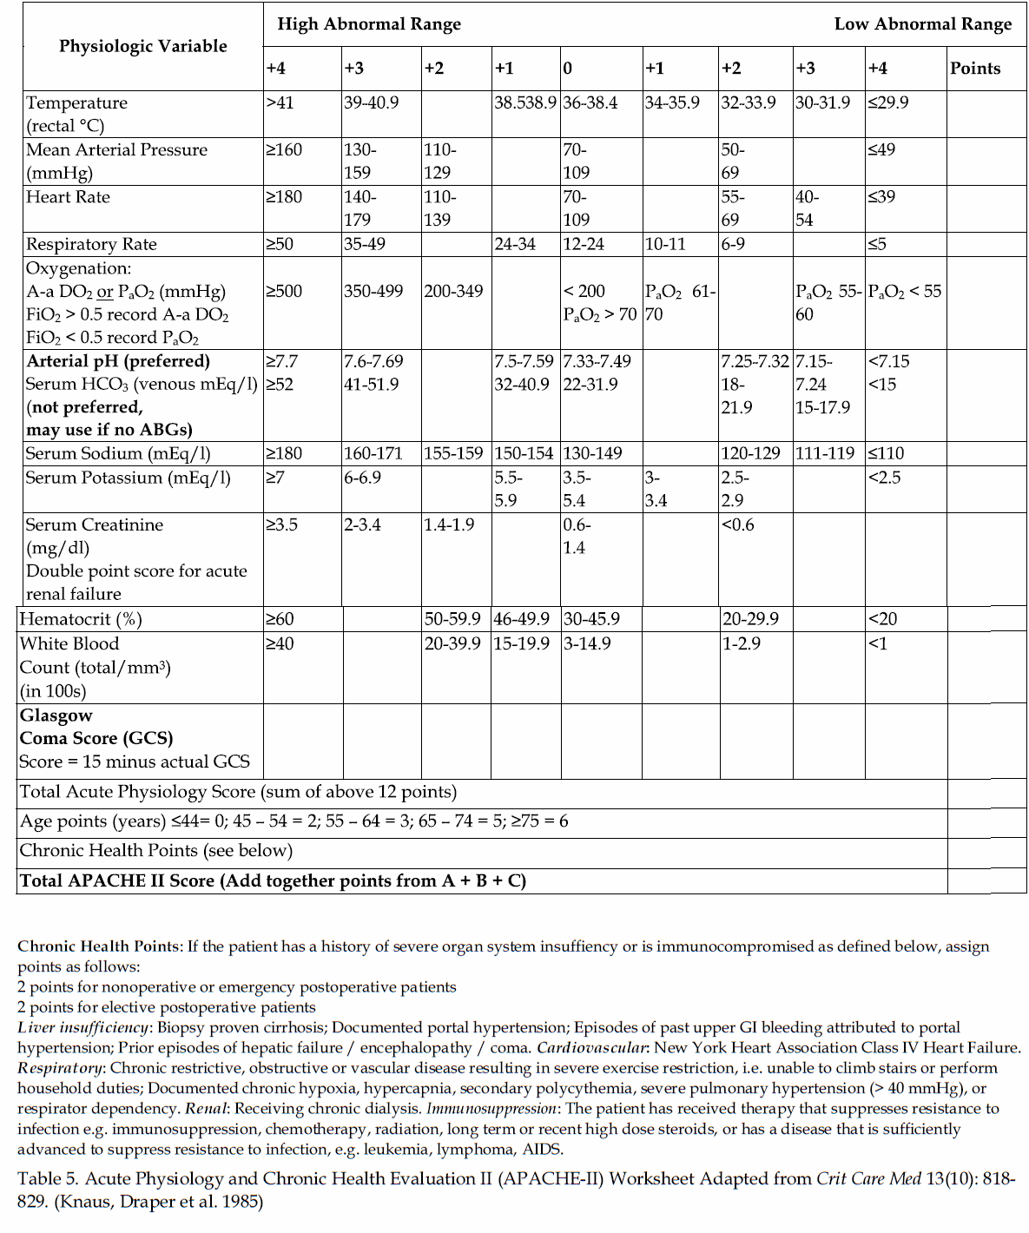
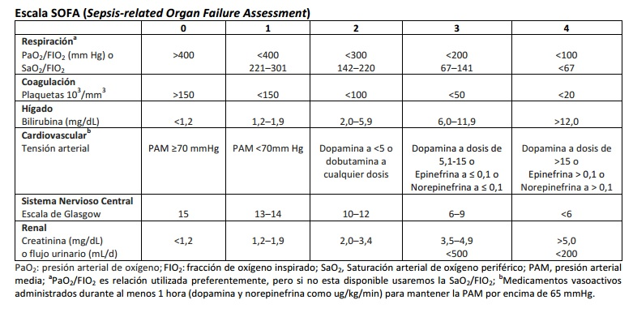

Mannheim peritonitis index score

Risk Factor | Weightage, if any
Age >50 years | 5
Female Gender | 5
Organ Failure* | 7
Malignancy | 4
Preoperative duration of peritonitis >24 hours | 4
Origin of sepsis not colonic | 4
Diffuse generalised peritonitis | 6
Exudates
Clear | 0
Cloudy, Purulent | 6
Faecal | 12

Organ failure: 1) kidneys: creatinine in the blood - more than 177 mmol / l, urea - more than 16.7 mmol / liter, oliguria, diuresis less than 20 ml / h; 2) lungs: pO2 <50 mm Hg, pCO2> 50 mm Hg; 3) shock: hypo- or hyperdynamic state of the blood circulation; 4) bowel obstruction: paralytic over 24 hours or full mechanical obstruction.
MIP involves three degrees of severity of peritonitis: I degree of severity - the MIP is less than 21 points - the mortality 0-11% (an average of 2.3%); ІІ degree of gravity - МІП 21-29 points - mortality - 11-50% (22,3%); III degree of gravity - MIP over 29 points - mortality 41 - 87% (59.1%).
Basic principles of surgical treatment of peritonitis.
Treatment of common peritonitis is based on the clinical form and stage of the process, the nature of the pathogen, the incidence of inflammation, the degree of disruption of metabolic processes and functions of vital organs. Surgical surgery is a central part of the treatment program for all forms of peritonitis. Preoperative preparation, which begins immediately after diagnosis and ends in an operating room, is aimed at:
• eliminating hypovolemia, tissue dehydration and electrolyte disorders;
• medical correction of disorders caused by endogenous intoxication and background illness;
- Ensuring early start of adequate antibiotic therapy.
The intensity of preoperative preparation depends on the stage of acute peritonitis and lasts for an average of 2-4 hours. Operative intervention in the common peritonitis is always performed under multicomponent general anesthesia using artificial ventilation of the lungs. The most rational access is the middle laparotomy, which provides the opportunity for a complete rehabilitation and rehabilitation of all departments of the abdominal cavity.
The main stages of the operation:
- auditory abdominal cavity;
- removal of the source of peritonitis;
- sanation of the abdominal cavity;
- intubation of intestines;
- drainage of the abdominal cavity.
After laparotomy using the system for aspiration, the pathological content is completely removed: manure, blood, bile, fecal masses, etc. Particular attention is paid to the places of the exudate cluster: subdiaphragmatic spaces, lateral canals, small pelvic cavity. Elimination of the source of peritonitis is the main and most responsible stage of the operation. The volume of surgical intervention depends on the cause of peritonitis. If a destructively altered organ is not vital to the body, it is removed (gall bladder, appendix, loop of the dead gut, etc.). With the impossibility of radical removal of the peritonitis source, the affected organ is excreted or removed from the free abdominal cavity.
After eliminating the peritonitis source, the rehabilitation of the abdominal cavity is carried out by repeated washing of all its departments with a warm solution of antiseptic. Flushing is carried out without the inertia of the loops of the small intestine, removing fibrinous strains, until the "clean water" is obtained. After sanation of the abdominal cavity, indications for intubation of the intestines are determined, namely: common peritonitis with the phenomena of paralytic intestinal obstruction, expressed adhesion process in the abdominal cavity. Possible variants of carrying out of a probe for decompression of intestines - nazointestinal intubation, transanal intubation. The advantage should be given to non-invasive methods of decompression of the intestines. The most gentle and effective way of decompressing the small intestine is nasogastrointestinal drainage with Miller-Abbott's probe. Drainage of the small intestine is carried out within 3-4 days until the full recovery of the motor and evacuator function of the digestive canal. When intestine intubation is performed after the connection of the adhesion process, to provide framework function and to prevent early adhesive obstruction, the probe is stored for 7-8 days.
The operation is completed by drainage of the abdominal cavity with silicone tubes, which are installed in the source area of ​​the peritonitis and in all the desensitized places of the abdominal cavity, and by layer wiring of the abdominal wall wounds. The number of drainages depends on the distribution and nature of peritonitis.

Abscesses of the abdominal cavity
Abscesses of the abdominal cavity should be considered not as a complication of peritonitis, but as a beneficial consequence of the widespread unrestricted damage to the peritoneum. Abscesses are formed after surgical intervention for up to 3 weeks and later. The intraperitoneal abscess may be:
- subdiaphragmatic;
- pentagonal;
- periapendicular;
- Interstitial (single or multiple);
- rectum-uterine or rectum-bladder depression.
Classic symptoms of abdominal abscess: abdominal pain and the presence of painful infiltration (according to the localization of the abscess) against the back of the systemic inflammatory reaction (hectic fever, chills, left shift giperleikotsitoz) and intestinal insufficiency. Sometimes the first clinical manifestation of the abscess is eventration. In order to diagnose intraperitoneal abscess, ultrasonography, computed tomography, and X-ray examination of the abdominal cavity are used. Detection of gnawing clusters of fluid involves performing a diagnostic puncture. It should be remembered that local intra-abdominal abscesses do not involve emergency surgery. With adequate visualization of abscess with a predominance of the fluid component, the availability of conditions for access is used by non-invasive puncture technologies, which halved the amount of relaparotomy and reduced mortality. If there is an abscess in the cavity of large sequesterers or extraneous bodies, the disclosure is carried out by a local incision over the projection spot of abscess. The indications for relaparotomy are the difficulty of topical diagnosis of abscess, the multiple nature of abscesses, the combination of abscesses with a new or not eliminated old source of peritonitis, tertiary peritonitis.
Treatment in the postoperative period.
The complex treatment of acute common peritonitis in the postoperative period should include:
• correction of hemodynamics;
• correction of water-electrolyte balance and metabolic disorders;
• Ensuring energy and plastic needs of the organism;
• ensuring normal gas exchange and elimination of microcirculation violations;
• antibacterial therapy;
• detoxification therapy;
• elimination of functional intestinal insufficiency;
• increase of organism's resistance;
• symptomatic therapy.
Infusion therapy is the first step in the treatment of common peritonitis, performing the following main tasks: correction of hemodynamic and metabolic disorders, water-electrolyte, protein, carbohydrate, fatty metabolism, acid-alkaline balance, parenteral nutrition. In the majority of patients with peritonitis, general dehydration, intracellular acidosis and extracellular alkalosis are associated with sequestration of fluid and electrolytes in the "third space". On average, during the postoperative period, a patient with peritonitis loses up to 3000 ml of fluid (30-45 ml / kg). Infusion therapy should begin with transfusion of isotonic sodium chloride solution, balanced saline solutions - Ringer's, Disol, Trisol, etc. Lactobacillus solution, Refortan, Gelofusin, 5% albumin, to provide Fluid retention in the vascular bed. To improve microcirculation, prevention of thrombophobia, introduce Reosorbilact.
To provide the patient with the necessary energy and plastic material spend parenteral nutrition. For this purpose carbohydrates (5% glucose), mixtures of amino acids (Infesol, Aminosol, Aminoplasmal), fat emulsions (Lipofundin, Intralipid), vitamin preparations are introduced. The trace elements are filled with transfusion of plasma, iron - its preparations. Parenteral nutrition should be combined with early enteral, which promotes faster recovery of intestinal motility, reducing fluid loss and absorption of toxic substances, translocations of microorganisms. Treatment of hypovolemia, disgidia, hemodynamic disorders, external respiration, electrolyte balance are the main components of prevention and correction of acid-base balance and acute renal failure.
An important place in the treatment of peritonitis is antibiotic therapy. Conduction of therapy begins immediately before surgery and continues in the postoperative period. Antibacterial drugs for peritonitis are prescribed empirically, at the same time, a collection of intraoperative material for bacteriological examination is carried out. The choice of drugs is based on the most probable etiology of the infectious process. To preparations adequately covering the spectrum of potential pathogens of light and medium severity of peritonitis include:
- Protected aminopenicillins (amoxicillin / clavulanate and ampicillin / sulbactam);
- Combinations of cephalosporins II-III generations (cefuroxime, cefotaxime, ceftriaxone) with anti-anaerobic drugs (metronidazole, ornidazole);
- combinations of fluoroquinolones (levofloxacin, moxifloxacin, ofloxacin, pefloxacin, ciprofloxacin) with anti-anaerobic drugs.
In immunocompromised patients, the probability of peritonitis is increased in fungal etiology. With its laboratory confirmation it is necessary to use antifungal agents.
After receiving the results of the evaluation of the antibiotic susceptibility of the peritonitis agent, the therapy should be corrected, not only by designating more effective drugs in the selection of resistant flora, but using drugs of a more narrow spectrum of action in the allocation of highly susceptible pathogens (de-escalation therapy).
The duration of antibiotic therapy is determined by its efficacy, which is evaluated 48-72 h after the onset. The criteria for the adequacy of antibiotic therapy are: positive dynamics of the underlying disease, normalization of body temperature, the number of leukocytes and rodenuclear neutrophils, stabilization of hemodynamics, absence of external respiration. The duration of effective antibacterial therapy in most cases is 7-10 days.
An important component of postoperative intensive care are extracorporeal methods of detoxification. Taking into account the possibilities, positive effects and disadvantages of one or another method, patients with peritonitis in the phase of severe sepsis or infectious-toxic shock should give preference to hemophiltration, hemodialylation and hemodialysis. Prevention of deep vein thrombosis significantly improves the outcome of treatment for patients with abdominal sepsis. For this purpose, low molecular weight heparin preparations (Fraxiparin, Clexan, Fragmin) are used. To prevent the onset of bleeding from stress ulcers proton pump inhibitors and H2 receptor blockers are used. In addition, an important role in preventing the occurrence of stress ulcers plays an enteral diet.

5. Plan and structure of the class

No. | Basic stages of the class | Training aims according to the levels of mastering | Means of training and control | Materials for methodological maintainance of  the class, visibility, and control of knowledges | Terms (in minutes or per cent)
1 | Initial | 1) Giving the training aims of level I (see chapter 2.1)  2) Control testing of initial level of knowledge, readiness of the students for perception of the material | Krok-2 type tests of initial level of knowledge, including software version (see chapter 6.1) | Krok-2 type tests of initial level of knowledge, including software version (see chapter 6.1) | 15 %
2 | Basic | 1) Giving the training aims of levels II – IV (see chapter 2.1)  2) Observation of patients, disucussion of algorithms of diagnostics and management of patients with local and diffuse inflammatory processes in abdominal cavity | Observation of patients at the department of robotic and endoscopic surgery | 1) Schemes, tables (including PowerPoint presentations) of algorithms of diagnostics and management  2) Diagnostic images  3) Illustrations and videos of surgical procedures | 70 %
3 | Conclusive | 1) Control testing of theoretical knowledges and practical skills  2) Conclusions  3) Giving the home task | 1) Krok-2 type tests of final level of knowledge, including software version (see chapter 6.3)  2) List of literature for the next class | Krok-2 type tests of final level of knowledge, including software version (see chapter 6.3) | 15 %

6. Materials for methodological maintainance of the class

6.1. Materials for initial stage of the class

A 54-year-old female patient has been admitted to a hospital 12 days after the beginning of acute
pancreatitis. Objectively: the patient is in grave condition. The body temperature is hectic. Ps - 112 bpm. The
abdomen is swollen. Epigastrium palpation reveals a very painful infiltration falling in the localization of
pancreas. Abdominal cavity contains fluid. There is an edema of the left lumbar region. In blood: WBCs – 18109/l.
What is the required tactics of the patients treatment?
Increase in antienzymes
Further conservative treatment
Massive antibacterial therapy
Surgical treatment
Peritoneal dialysis
•••••
14 days ago a 49-year-old patient was operated on for perforated appendicitis and disseminated
fibrinopurulent peritonitis. The postoperative period was uneventful. On the 9th day the patient presented with
low-grade fever, abdominal pain, frequent liquid stools. USI of the left mesogastrium reveals a fluid formation
9x10 cm large. In blood: leukocytosis with the left shift. What is your provisional diagnosis?
Liver abscess
Spleen abscess
Interloop abscess
Abdominal cavity tumour
Left kidney cyst
•••••
A 43-year-old patient had been admitted to a hospital with clinical presentations of ischiorectal periproctitis.
On the 12th day of treatment the patients condition deteriorated: there was an increase in the rate of
intoxication and hepatic failure, the body temperature became hectic, AP was 100/60 mm Hg. USI of liver
revealed a hydrophilic formation. In blood: WBCs - 19,6&times;10<sup>9</sup>/l, RBCs.-
3,0&times;10<sup>12</sup>/l, Hb- 98 g/l. What complication was developed?
Budd-Chiari syndrome
Liver necrosis
Pylephlebitis
Hepatic cyst
Liver abscess
•••••
A 20 y.o. patient suddely felt ill 12 hours ago. There was pain in epigactric area, nausea, sporadic vomiting.
He had taken alcohol before. In few hours the pain localized in the right iliac area. On examination: positive
rebound tenderness symptoms. WBC- 12,2&times;10<sup>9</sup>/L. What is the most probable diagnosis?
Acute appendicitis
Acute cholecystitis
Rightside kidney colic
Perforated ulcer
Acute pancreatitis

A 29 y.o. patient was admitted to the hospital with acute girdle pain in epigastric area, vomiting in 1 hour
after the meal. On examination: pale, acrocyanosis. Breathing is frequent, shallow. Abdominal muscles are
tensed, positive Schotkin-Blumbergs symptom. What is the maximal term to make a diagnosis?
In 2 hours
In 3 hours
In 1 hour
In 6 hours
In 0,5 hours

6.2. Materials for basic stage of the class

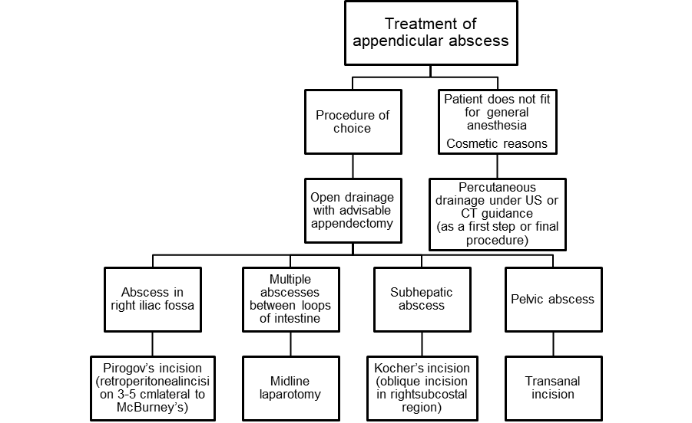

Classification of peritonitis by location

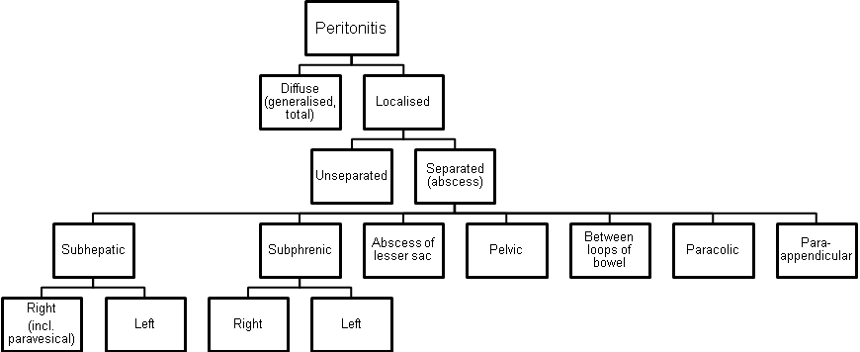
Phases of clinical course of diffuse peritonitis

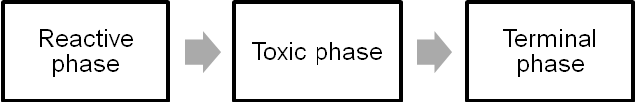

6.3. Materials for final stage of the class

A 54-year-old female patient has been admitted to a hospital 12 days after the beginning of acute
pancreatitis. Objectively: the patient is in grave condition. The body temperature is hectic. Ps - 112 bpm. The
abdomen is swollen. Epigastrium palpation reveals a very painful infiltration falling in the localization of
pancreas. Abdominal cavity contains fluid. There is an edema of the left lumbar region. In blood: WBCs – 18109/l.
What is the required tactics of the patients treatment?
Increase in antienzymes
Further conservative treatment
Massive antibacterial therapy
Surgical treatment
Peritoneal dialysis
•••••
14 days ago a 49-year-old patient was operated on for perforated appendicitis and disseminated
fibrinopurulent peritonitis. The postoperative period was uneventful. On the 9th day the patient presented with
low-grade fever, abdominal pain, frequent liquid stools. USI of the left mesogastrium reveals a fluid formation
9x10 cm large. In blood: leukocytosis with the left shift. What is your provisional diagnosis?
Liver abscess
Spleen abscess
Interloop abscess
Abdominal cavity tumour
Left kidney cyst
•••••
A 43-year-old patient had been admitted to a hospital with clinical presentations of ischiorectal periproctitis.
On the 12th day of treatment the patients condition deteriorated: there was an increase in the rate of
intoxication and hepatic failure, the body temperature became hectic, AP was 100/60 mm Hg. USI of liver
revealed a hydrophilic formation. In blood: WBCs - 19,6&times;10<sup>9</sup>/l, RBCs.-
3,0&times;10<sup>12</sup>/l, Hb- 98 g/l. What complication was developed?
Budd-Chiari syndrome
Liver necrosis
Pylephlebitis
Hepatic cyst
Liver abscess
•••••
A 20 y.o. patient suddely felt ill 12 hours ago. There was pain in epigactric area, nausea, sporadic vomiting.
He had taken alcohol before. In few hours the pain localized in the right iliac area. On examination: positive
rebound tenderness symptoms. WBC- 12,2&times;10<sup>9</sup>/L. What is the most probable diagnosis?
Acute appendicitis
Acute cholecystitis
Rightside kidney colic
Perforated ulcer
Acute pancreatitis

A 29 y.o. patient was admitted to the hospital with acute girdle pain in epigastric area, vomiting in 1 hour
after the meal. On examination: pale, acrocyanosis. Breathing is frequent, shallow. Abdominal muscles are
tensed, positive Schotkin-Blumbergs symptom. What is the maximal term to make a diagnosis?
In 2 hours
In 3 hours
In 1 hour
In 6 hours
In 0,5 hours

7. Literature for teachers

- General Surgery: textbook / S.D. Khimich, M.D. Zheliba, V.P. Andryushchenko et al. — К., 2019. — 536 p., hardcover

- Essential surgery. Editor prof V.V.Grubnik, O.L.Kovalchuk, A.V.Malinovsky. Ternopil, TSM, 2010, 543 p.

- Surgery: a textbook is intended for English-speaking students of higher medical educational institutions of III-IVth levels of accreditation, interns / K. M. Amosova, Ya. S. Bereznyts’kyy, A. O. Burka [et al.]; ed. by Ya. S. Bereznyts’kyy [et al.], 2016. - 711 p.

- Surgery: a textbook is intended for English-speaking students of higher medical educational institutions of III-IVth levels of accreditation, interns / K. M. Amosova, Ya. S. Bereznyts’kyy, A. O. Burka [et al.]; ed. by Ya. S. Bereznyts’kyy [et al.], 2018. - 711 p.

- Essential surgery [Text] : навч. посіб. для студ. вищ. мед. навч. закл. IV рівня акредитації, які опановують навч. дисципліну англ. мовою (протокол № 4 від 01.10.2010 р.) / V. V. Grubnik, O. L. Kovalchuk, A. V. Malynovskyy, O. V. Grubnik. - Ternopil : TSMU "Ukrmedknyha", 2010. - 544 p. : fig., tab. - Текст англ. - Бібліогр.: с. 529-531. - 500 прим. - ISBN 978-966-673-147-3

- Sabiston textbook of surgery: the biological basis of modern surgical practic / [edited by] Courtney M. Townsend, Jr, R. Daniel Beauchamp. B. Mark Evers, Kenneth L. Mattox.—20th edition.
- Surgery Editor. Bereznyts'ky Y.S., Zarharash M.P, Mishalov V.G. Vinnytsia, 2016, 711p.

8. Literature for students

8.1. Basic literature

- General Surgery: textbook / S.D. Khimich, M.D. Zheliba, V.P. Andryushchenko et al. — К., 2019. — 536 p., hardcover

- Essential surgery. Editor prof V.V.Grubnik, O.L.Kovalchuk, A.V.Malinovsky. Ternopil, TSM, 2010, 543 p.

- Surgery: a textbook is intended for English-speaking students of higher medical educational institutions of III-IVth levels of accreditation, interns / K. M. Amosova, Ya. S. Bereznyts’kyy, A. O. Burka [et al.]; ed. by Ya. S. Bereznyts’kyy [et al.], 2016. - 711 p.

- Surgery Editor. Bereznyts'ky Y.S., Zarharash M.P, Mishalov V.G. Vinnytsia, 2016, 711p.

8.2. Additional literature

- Surgery: a textbook is intended for English-speaking students of higher medical educational institutions of III-IVth levels of accreditation, interns / K. M. Amosova, Ya. S. Bereznyts’kyy, A. O. Burka [et al.]; ed. by Ya. S. Bereznyts’kyy [et al.], 2018. - 711 p.

- Essential surgery [Text] : навч. посіб. для студ. вищ. мед. навч. закл. IV рівня акредитації, які опановують навч. дисципліну англ. мовою (протокол № 4 від 01.10.2010 р.) / V. V. Grubnik, O. L. Kovalchuk, A. V. Malynovskyy, O. V. Grubnik. - Ternopil : TSMU "Ukrmedknyha", 2010. - 544 p. : fig., tab. - Текст англ. - Бібліогр.: с. 529-531. - 500 прим. - ISBN 978-966-673-147-3

- Sabiston textbook of surgery: the biological basis of modern surgical practic / [edited by] Courtney M. Townsend, Jr, R. Daniel Beauchamp. B. Mark Evers, Kenneth L. Mattox.—20th edition.

Topic of the next class

Mechanical jaundice.

Elaboration composed by: ass. Chernov Nikolai

