ODESSA NATIONAL MEDICAL UNIVERSITY
DEPARTMENT OF ROBOTIC AND ENDOSCOPIC SURGERY

METHODICAL instructive elaboration

of the practical class for the discipline
"Surgical diseases with child's surgery and oncology» for students of the 6-th course of the medical faculty

Topic № 14: “Mechanical jaundice”.

Discussed and approved at
methodical board of Department
of Robotic and Endoscopic surgery
"28" August 2019
Protocol № 1
Head of the Department
Ass. prof. __________ Malinovsky A.V.

Odessa - 2019

Topic of practical class: “Mechanical jaundice

1. Significance of topic

Mechanical (obstructive) jaundice (MJ) is a serious complication of diseases of the organs of the hepatopancreatotobiliary system, in which the outflow of bile on the various levels of bile ducts is disturbed. The various causes of jaundice, the severe condition of patients greatly complicate the diagnosis, resulting in 18 - 45% of patients do not immediately go to specialized surgical hospitals, and the establishment of the correct diagnosis in them is delayed. Mortality after operations at height MH remains high and makes 7 - 42%. Difficulties in treating patients with MJ are due to the severe initial state of patients, since cholestasis, bile hypertension and cholemia, developing at this symptom complex, cause significant functional and morphological changes in the liver, which lead to rapid development of liver failure. In the case of adherence to bile duct obstruction of purulent cholangitis, the situation becomes even more complicated. On the one hand, increasing hepatic insufficiency and endotoxicosis require urgent surgery to decompress the biliary system; on the other hand, pronounced multiple organ failure significantly increases the operational risk of radical interventions requiring intensive correction of metabolic disturbances and targeted antibiotic therapy. Taking into account the above, the reduction of the timing of diagnosis, rational modern non-invasive methods of treatment for the recovery of bile dysfunction and jaundice elimination, a combination of non-invasive and open-ended operations and a complete postoperative cure of patients are becoming acute. This determines the need to study all aspects of etiology, pathogenesis, diagnosis, differential diagnosis and adequate treatment of diseases that are accompanied by MJ.
2. Aims of the class

2.1. Training aims (a student must learn and master):

Level I – To get acquainted with the etiology and pathogenesis of mechanical jaundice, clinical symptoms, major clinical syndromes, complications.

Level II – Know the exchange of bilirubin in the body, anatomy of the biliary system, clinical signs of a typical course of diseases that are complicated by mechanical jaundice, diagnostic value of laboratory and instrumental methods of examination of patients and the principles of different methods of surgical interventions.

Level III – Be able to identify and analyze complaints of patients and anamnesis of the disease, perform a physical examination, determine the sequence of most informational methods of diagnosis and interpret their results, establish and correctly formulate clinical diagnosis, conduct a differential diagnosis of diseases complicated by obstructive jaundice.

Level IV – Formation of scientifically grounded approach to optimal diagnostic program, adequate conservative treatment of mechanical jaundice and determination of indications for operation and volume of surgical intervention in specific patients.

2.2. Educational aims:

1. Formation of professional personality of doctor.
2. Formation of medical deontology and ethics, professional responsibility.

3. Interdisciplinary integration

№ | Disciplines | To know | To master
Previous disciplines (basic disciplines)
1 | Anatomy and physiology | Anatomical structure of the liver, extrahepatic bile ducts, gallbladder and their functions | Determine the topography of the liver, gallbladder, extrahepatic bile duct, differentiate the elements of hepatodeodenal ligament
2 | Biochemistry | Biochemical composition of bile, exchange of bilirubin, cholesterol and bile acids in the body | Interpret changes in the biochemical analysis of blood in diseases that are complicated by obstructive jaundice
3 | Pathological anatomy and pathological physiology | Morphological signs of inflammatory diseases and tumors of the organs of the hepatopancreatobiliary zone, malformations of the bile duct, composition and mechanism of the formation of gallstones | Describe the macro preparation, determine the clinically morphological form of the disease, which led to mechanical jaundice
Following disciplines (clinical disciplines)
1 | Propaedeutics of internal diseases | Consistency and methodology of the patient's survey, examination, physical examination of the hepatopancreatolytic zone organs | To clarify complaints, anamnesis of the disease, to conduct superficial and deep palpation of the organs of the abdominal cavity, to determine the size of the liver
2 | Pharmacology | Groups and representatives of antibacterial and analgesic drugs, hepatoprotectors, vitamins, hormones, colloidal and crystalloid solutions, amino acid and protein preparations | Determine the scheme of conservative treatment of patients with obstructive jaundice
3 | Radiology | Informational methods of radiation diagnostics in the examination of patients with liver disease, extrahepatic bile ducts, gall bladder and pancreas | To substantiate the indications for the application of ultrasonography, computed tomography, X-ray examination, explain the results obtained
4 | Surgery | Methodical principles of physical examination of patients, diagnostic algorithm, differential diagnosis of diseases that are complicated by jaundice, complications and modern methods of treatment | Conduct a comprehensive examination of the patient, determine the plan of necessary laboratory and instrumental diagnostic methods, conduct differential diagnosis and prescribe the necessary treatment
5 | Anesthesiology and reanimatology | Clinic of urgent states that arise in patients with mechanical jaundice, methods of their diagnosis and treatment | To recognize the symptoms of urgent states, to conduct differential diagnostics and to determine the optimal methods of their therapy

Anatomy.

- Biliary duct
- Partial bile ducts (right and left)
- Common hepatic duct
- Common bile duct: supra-duodenal, retroduodenal pancreatic, intramural, length 1-9 cm, Width up to 8mm - large duodenal nipple Vateri - papillary nipple Vateri - place of fusion of Common bile duct and Wirsong duct, diameter of the mouth 2 - 3mm
- Sphincteri Oddi, Lutkens, Mirizzi
- Gall bladder and bladder duct
5. Plan and structure of the class
The wall of the bile duct has muscle fibers, but they do not matter for the evacuation of bile. The bile flows in accordance with the pressure gradient: the liver secretes bile at a pressure of 300 mm. Water, then the bile accumulates in the bubble that is reduced and it enters the duodenum with a relaxed Oddi sphincter.

Etiology.

MJ occurs when the bile from the liver is injured in the duodenum due to an obstruction due to internal obturation or external compression. Most often its cause is Gallstone disease, complicated by choledocholithiasis (45%). Recently, there is a marked tendency to increase the number of patients with mechanical jaundice of noncalculated origin, associated with papillary stenosis (16-27%), pancreatitis (5-26%), strictures of extrahepatic bile ducts (5-10%), newborns of bile ducts, A large duodenal nipple , a pancreas, a gall bladder, and also parasitic diseases of a liver.
According to the etiological principle, the causes of MJ can be divided into the following main groups:
1.Disorders of development: - Atresia of biliary tract; - hypoplasia of the bile ducts; - cistos of Common bile duct; - diverticulum of the duodenum near the large duodenal nipple.
2. Benign diseases of the bile duct: - gallstone disease , complicated by choledocholithiasis; - wedges stones; - inflammatory strictures of the bile ducts; - acute papillitis, stenosis papillomas.
3. Inflammatory diseases: - acute cholecystitis ; - cholangitis, - pancreatitis (especially chronic indurative); - alveolar echinococcosis in the gate area of ​​the liver.
4. Tumors:
- papillomatosis of the bile ducts;
- cancer of extrahepatic bile ducts and papillomas;
- Cancer of the head of the pancreas;
- metastases and lymphomas in the liver gates.
5. Traumatic bile duct strictures.

Pathogenesis.

The mechanical obstruction of the bile drain leads to stagnation (extrahepatic secondary cholestasis) and increased biliary pressure above 300 mm. Water, expansion and subsequent rupture of gall bladder capillaries, and the introduction of bile in the bloodstream or through the lymphatic tract. This causes direct hyperbilirubinemia (increase in the content of conjugated direct bilirubin), hypercholesterolemia, development of the cholecysic syndrome due to blood circulation in bile acids, bilirubinuria (hence the dark coloration of the urine - "the color of beer") and the presence of bile acids in urine. The absence of bile in the intestine due to a mechanical barrier in the bile ducts leads to the fact that stercobulin with feces (discolored acholichic feces) is not formed and is not isolated.
In the first days of obstructive jaundice, the activity of aminotransferases increases due to increased permeability of hepatocyte membranes and the release of enzymes from them. Hyperbilirubinemia with mechanical jaundice is characterized by an increase in the blood of predominantly bound bilirubin and to a lesser extent unconjugated. Since at the obstructive jaundice immediately after the development of biliary duct obturation, the liver function is slightly disturbed, then bile excretion by hepatocytes continues. Bilirubin, secreted into the lumen of the bile ducts, is absorbed through their wall and enters the Dissa spaces due to communication in the bilious capillaries. Bilirubin is released into the bloodstream from the lung dysfunction of the Diss. Prolonged increase in pressure in the bile ducts causes a violation of the function of the cells of the liver, there is a paroxysm - the return of bilirubin from hepatocyte to the blood. Due to the deterioration of the hepatocyte function, the function of capturing bilirubin also affects, resulting in an increase in the amount of unbound bilirubin in the blood. During this period necrosis of hepatocytes may occur, which increases the activity of aminotransferases in serum. Cholestasis due to mechanical obstruction promptly leads to cholestatic intoxication, cholangitis, increasing liver failure, which manifests itself by inhibition of detoxification and synthetic liver functions. The severity of the patient's condition is largely due to the completeness of the occlusion of the bile duct, its duration, as well as the depth of morphological and functional disorders of the liver.
Classification of mechanical jaundice.
- by etiology:
benign (choledocholithiasis, inflammatory and scar stryctures of the bile duct, papillary stenosis, pancreatitis, etc.) and
malignant (cancer of the pancreas head, bile ducts and papillae);
- according to the clinical course: acute and chronic;
- the degree of bile drop: full and incomplete, as well as intermittent (with "valve" stone in the ducts).

The main clinical syndromes

- Jaundice - a distinct clinical syndrome of many diseases caused by various factors evident yellowing of the mucous membranes, sclera and skin, dark urine. In yellow, all tissues of the body, exudates and transudates are painted. Yellow color is associated with the accumulation in the skin, mucous membranes and other tissues of the pigment bilirubin, due to its high content in the blood. Do not change the color of cornea, hair, nails, as well as saliva, tears and gastric juice.
- Pain - the most common clinical syndrome, especially when undergoing cholelithiasis, except for the yellow coloration of the skin and mucous membranes. The nature, localization, irradiation of the pain and its intensity are largely dependent on the disease that caused the mechanical jaundice.
- Cholestasis is a syndrome characterized by a violation or complete cessation of the excretion of all components of the bile in the intestine, accumulation in the ducts and entering the blood is manifested by biochemical markers of cholestasis, holemeemia and achillis. - Biochemical markers of cholestasis: increase in the level of direct bilirubin, cholesterol, lipoproteins, phospholipids, chalets, and also increased activity of excretory enzymes (γ glutamyltranspeptidase, alkaline phosphatase, leucinaminopeptidase, 5-nucleotidase).
- - Cholemia occurs when the bile acids enter the bloodstream. It is characterized by bradycardia and lowering of arterial pressure under the action of bile acids on the receptors and the center of the vagus nerve, sinus node of the heart and blood vessels. The toxic effect of bile acids on the central nervous system is manifested in the form of astheno-vegetative disorders: irritability, which changes with depression, sleepiness in the afternoon and insomnia at night, headache, increased fatigue. Irritation of sensitive nerve endings of the skin with bile acids leads to itching.
- Achillia is a syndrome due to the inactivation of bile in the intestine during obstructive biliary ducts. In this case, there are disorders of intestinal digestion. Due to the absence of bile acids in the intestines, lipase is not activated, fats are not emulsified, soluble bile acid complexes with fatty acids are formed, therefore 60-70% of fats are not digested, not absorbed and removed from the body together with feces (steatorrhea). Enzymes penetrate into a lump of food, so proteins are not digested, which leads to creators. It also disturbs the absorption of fat-soluble vitamins (retinol, tocopherol, phyloquinone). Without phylocinone (vitamin K1), prothrombin is not formed, blood clot decreases, increased bleeding occurs. The bactericidal action of bile is lost, which causes dysbiosis. The absence of bile acids leads to disturbances in the motility of the intestine: the tonus and intestinal peristalsis weaken, constipation that changes with diarrhea due to increased fermentation processes. Kal is discolored - no sterkosilicon is formed.

Diagnosis

Diagnosis of MJ includes two key points: confirmation of the mechanical nature of jaundice and the determination of a specific cause of bile duct patency. It is based on the results of anamnesis study, clinical picture, laboratory and instrumental examination methods.
Laboratory examination General blood test (leukocytosis, shift of leukocyte formula to the left, acceleration of erythrocyte sedimentation rate); Biochemical blood test (bilirubin, total protein, sugar, potassium, sodium, calcium, creatinine, urea, amylase, AsAT, AlAT, alkaline phosphatase); Coagulogram; General urine test.
Ultrasonography

Ultrasonography is considered the first of the instrumental diagnostic methods and helps with differential diagnosis of liver and hepatocellular jaundice. The most important advantages of the method are: screening nature, non-invasiveness, absence of complications, the possibility of using in a patient's severe condition and during pregnancy, simultaneous evaluation of bile duct and other anatomical structures (liver, pancreas, retroperitoneal space), the possibility of ultrasound guidance with puncture methods of decompression, Biopsy, as well as an objective choice of the method of decompression of the bile ducts.
Ultrasonic criteria for mechanical jaundice:
- increase the Common bile duct diameter by more than 8 mm, and internal liver ducts exceeding 4 mm;
- thickening of the wall of Common bile duct and its non-uniform lumen (cholangitis);
- enlargement and deformation of the gall bladder, heterogeneous content, small concrements, visualization of the stone in the duct;
- visualization of the pathology of the head of the pancreas and, in some cases, papillomas.

Endoscopic examination methods.

In the absence of significant causes that explain the jaundice, and with the expansion of bile ducts, after the UGG patients conduct esophagogastroduodenoscopy. With the help of this method, the pathology of the upper gastrointestinal tract is determined: varicose veins of the esophagus, tumors of the stomach and large duodenal nipples, deformations of the stomach and duodenum as a result of compression from the outside. Gastroduodenoscopy can detect papillary and duodenal cancers, perform a biopsy of the altered site, and evaluate the technical feasibility of endoscopic retrograde cholangiopancreatography.

X-ray methods

Methods that allow visualization of the bile duct with the help of their contrast include endoscopic retrograde cholangiopancreatocography (ERCP), percutaneous throughhepatic cholangiography , and cholecystography. In addition to the diagnostic, these methods also have therapeutic value and allow to decompress bile ducts and conduct the next surgery in favorable conditions for the patient and surgeon.
Contrast include endoscopic retrograde cholangiopancreatocography.

Diagnostic contrast include endoscopic retrograde cholangiopancreatocography is a contrast of bile ducts and ducts of the pancreas through a large duodenal nipple (Vateri) or sometimes through a small duodenal nipple. Along with the possibility of contrasting bile ducts, this method allows you to visually assess the condition of the stomach, duodenum, papillae, as well as to establish the fact of the receipt of bile in the lumen of the gut. In addition, when conducting contrast include endoscopic retrograde cholangiopancreatocography, it is possible to take the material for biopsy from pathologically altered papilla and stenosis of the bile duct. With the help of methods related to the contrast of the bile ducts, it is possible to determine the level of obstruction, but it is not possible to determine the prevalence of the process on adjacent organs, which is especially relevant in patients with suspected bile duct tumor. When conducting contrast include endoscopic retrograde cholangiopancreatocography apply therapeutic manipulations: endoscopic papilloproteinectomy, biliary duct revision Dormia basket, endoscopic leteextraction and lithotripsy, endoscopic stenting, nasobylirnoe drainage. These manipulations include possible complications, including pancreatitis, bleeding from the papilloma section, perforation of the duodenum, cholangitis (with diagnostic contrast include endoscopic retrograde cholangiopancreatocography).

Indications for contrast include endoscopic retrograde cholangiopancreatocography

- clarification of the causes of mechanical jaundice (presence of stones, tumors or strictures);
- differential diagnostics of jaundice in order to confirm or exclude the obstruction of the bile ducts;
- conducting of emergency endoscopic papilloprotectomy for latexation; - clarification of the causes of post-hole cystectomy syndrome;
- the need to clarify the nature of the pathological process in the pancreas;
- Diagnosis of malformation of extrahepatic bile ducts and sclerosing cholangitis.
Contraindications and restrictions
Contraindications to contrast include endoscopic retrograde cholangiopancreatocography
are acute pancreatitis, acute myocardial infarction, stroke, hypertensive crisis, intolerance to iodine preparations.
The use of ERCP is limited to postoperative stomach operations (resection for Billroth II, gastrectomy) when the papilla is difficult to access for endoscopic manipulations; Location of papilla in the wall of deep diverticulum; The presence of an obstruction in the source of the common bile duct, which is technically impossible to bypass (tumor, stricture, etc.).
Symptoms of mechanical jaundice MJ is manifested by the expansion of extrahepatic bile duct above the level of obstruction or throughout. Cholecholithiasis on contrast include endoscopic retrograde cholangiopancreatocography is enlightenment in the extended ducts against the background of contrasting substance. Bile duct tumors can completely close the lumen, so at the lesion level, the duct can not fill the contrast. With incompletely wound bile duct determine the circular contraction of different lengths with uneven contours. The pancreatic cancer looks like a segmental stenosis of the distal department of the choledochus, even narrowing of the pancreatic duct or the complete absence of its contrast.

Percutaneous throughhepatic cholangiography.

With the help of percutaneous throughhepatic cholangiography, bile ducts contrast in the direction of the physiological flow of bile to clarify the localization and extent of obstruction, the degree of damage to the bile duct before cholangiostomy. It is planned as an independent or intermediate manipulation before a surgical operation. For the puncture of the bile ducts use special thin needles. When a puncture is obtained information about the state of the internal and extrahepatic ducts, when non-invasive methods do not provide clear diagnostic criteria. The puncture of the bile duct, the conduction of the strand conductor, buccing the canal and drainage of the bile duct are performed under the control of ultrasonoscopy. After decompression, fill the biliary tree with water-soluble contrast (40-60 ml).
Indications for percutaneous throughhepatic cholangiography
- differential diagnosis of obstructive jaundice;
- suspicion of bile duct anomaly;
- impossibility of contrasting bile ducts by other methods.
Contraindications:
- allergy to contrast agents;
- general difficult condition of the patient;
- a violation of the system of blood clotting;
- liver-renal insufficiency, complicated by ascites;
- Intestinal interposition between the liver and the anterior abdominal wall.
Complication.
- biliary peritonitis;
- bleeding
- the formation of fistulas between the bile ducts and liver vessels with the penetration of bacteria from the biliary system in the bloodstream and the development of septicemia.

Contrasting through the gallbladder.
One of the methods of contrasting biliary tree is the use of cholecystitis. It is imposed by a direct (surgical) or punctuate method under the control of ultrasonography or laparoscopy. A prerequisite for this study is the patency of the duct of the gallbladder. This is usually indicated by bile coming through drainage. More often, the need for external drainage of the gallbladder occurs when the tumors of the distal bile duct or combined mechanical jaundice with acute destructive cholecystitis, when the difficult condition of the patient does not allow for a palliative or radical intervention in the traditional way.

Computer tomography (CT) and magnetic resonance imaging (MRI).

These methods are sensitive and high-precision in diagnosing the causes of obstructive jaundice and allow the identification of patients for surgical intervention. Their diagnostic value, unlike USG, does not decrease with flatulence, ascites, obesity. CT and MRI provide detection of the causes of obstruction and surrounding structures with greater accuracy (92-97%) than ultrasonography, to determine the level, stage and nature of bile duct obstruction, to detect bile duct tumors and metastases in the liver and regional and distal lymph nodes. In addition, the methods of CT and MRI can identify small nodes 1 - 1.5 cm in diameter, the expansion to within 1 mm of pancreatic and bile ducts, to detect minor changes in the bile ducts.
In recent years, magnetic resonance cholangiopancreatography has been used to diagnose the causes of MRI, which makes it possible to assess the nature and extent of strictures of the bile ducts, as well as intracerebral formations. However, this method is deprived of puncture-drainage therapeutic possibilities.

Laparoscopy.
Laparoscopy, if necessary, with a biopsy of the liver, is used if other diagnostic methods are insufficient to establish a diagnosis. With mechanical jaundice, this examination is mainly used to confirm the tumor process (primary or metastatic) in the hepatodeodenal region. The purpose of the study is to determine the operability of the process and aim biopsy.
During laparoscopy performed for the differential diagnosis of acute inflammatory diseases of the abdominal cavity, choledochotomy may be performed with intraoperative cholangiography and subsequent decompression of the bile duct by the method of external drainage, stenting, or letextraction. Choledochoscopy is also possible - examination of the bile duct with the help of special miniature endoscopes (choledochoscopes).

Intraoperative detection of bile duct obturation.
Intraoperative detection of bile duct obstruction is rarely used, due to the widespread introduction of such methods as ultrasonography and contrast include endoscopic retrograde cholangiopancreatocography. This is basically necessary in emergency surgical interventions on the gall bladder in patients at high risk of choledocholithiasis when contrast include endoscopic retrograde cholangiopancreatocography can not be performed.

The methods of intraoperative examination of biliary tract include:
- palpation and measurement of choledoch width;
- transylumination (enlightenment of choledoch with special light bulbs);
- sounding through a choledochotomy hole with the help of probes and other instruments;
- intraoperative cholangiography with the introduction of contrast through the cavity of the bladder duct or a choledochotomy hole;
- intraoperative ultrasound examination.

Differential diagnosis.

Mechanical jaundice must be distinguished primarily from jaundices of another etiology. This is facilitated by clinical, instrumental and laboratory diagnostic methods. Hemolytic jaundice develop on the background of hemolytic anemia in patients prevail indirect bilirubin. In the differential diagnosis of parenchymal jaundice helps explore markers of viral hepatitis. Surgeons often have quite differentiated hepatic jaundice posthepatotselyulyarni with obstructive as the last in the long-standing process leading to the same disorders of hepatocytes, which the liver. In the differential diagnosis of jaundice must remember functional hyperbilirubinemia developing for birth enzymopathies and violation complex metabolism of hemoglobin, leading to constant high blood levels of unbound bilirubin (syndromes Gilbert, Crigler-Najjar, DubinJohnson).

1. Wounds of development: occur in childhood, jaundice from birth; In the absence of surgical treatment, patients die from biliary cirrhosis of the liver.
2.gallstone disease , complicated choledocholithiasis: in anamnesis - an indication of concretions in the gall bladder, an attack of the bilious colic. Before the development of jaundice - pain in the right hypochondrium with typical irradiation, dyspepsia, darkening of the urine, light stools, itching of the skin. Frequent relapses. Ultrasound signs of biliary hypertension, diagnosis of concretions.
3. Inflammatory diseases: acute onset after a mistake in the diet, severe abdominal pain with typical localization and irradiation (cholecystitis, pancreatitis), fever; Ultrasonography and clinically - signs of inflammatory lesions of the gall bladder or pancreas. In alveococcosis, jaundice precedes a prolonged period (for many years) an increase in the size of the alveococcal site. Only when the site is located near the gates of the liver, jaundice can become the first sign of the disease. This disease is manifested predominantly by dull pain in the area of ​​the right hypochondrium and a feeling of a foreign body, especially when tilting the trunk.
4. Tumor diseases: slow-growing jaundice without pain, intense itching of the skin that is poorly treated, signs of cancer intoxication, enlarged painless gall bladder, which is manifested by palpation (Courvoisier symptom), chronic pain in the upper abdomen. Ultrasonography - common extrahepatic bile ducts, tumor of the pancreas head, contrast include endoscopic retrograde cholangiopancreatocography - visualization of tumor lesion (length, level). CT, MRI, laparoscopy help in diagnostics.

Treatment

The main tasks of therapeutic measures in MJ - elimination of cholestasis and prevention of hepatic renal failure
Conservative therapy.
Surgical operations aimed at the elimination of mechanical jaundice remain the main method of treating patients. Liver failure due to jaundice is accompanied by changes in various organs, increasing metabolic disturbances and severe forms of endotoxemia. Therefore, a significant role is assigned to conservative therapy and preoperative preparation of patients, which aims at the normalization of homeostasis, the creation of functional reserves for vital organs, and the treatment of accompanying pathology. Conservative therapy is conducted for the purpose of preoperative preparation of the patient, it depends on the general condition of the patient, the severity of intoxication and the volume of planned surgery.
One of the important tasks in treating patients with mechanical jaundice is the prevention of acute cholangitis. Slowdown of bile ducts leads to the rapid spread of microflora to the main and intrahepatic bile ducts, which causes severe inflammatory reaction, intrahepatic abscesses, liver and kidney failure. In order to prevent infectious complications, antibacterial therapy is prescribed. The complexity of this treatment consists in the fact that before the operation in most patients the unknown nature of the microflora and its sensitivity to antibiotics. Therefore, empirically, antibiotics of broad spectrum are prescribed most often - cephalosporin antibiotics, synthetic penicillins protected by sulbactam or clavulanic acid, derivatives of fluoroquinolone in combination with preparations of metronidazole for injections, as well as derivatives of carbopenem. With the advent of clinical and laboratory signs of acute cholangitis, decompression interventions and complex conservative therapy begin in an emergency. In severe endotoxicosis, methods of extracorporeal detoxification (plasmapheresis, hemodialysis) are used.

Surgical methods of treatment.
At the first stage, decompression (drainage) of extrahepatic bile ducts is performed. After elimination of mechanical jaundice, intoxication and improvement of the liver, they pass to this or that type of final treatment. The volume and type of intervention on the bile duct depends on the completeness and duration of occlusion of the biliary tree, the stage of morphological and functional disorders. There are two main methods of decompression of the biliary system: non-invasive instrumental methods and direct surgical intervention on extrahepatic bile ducts. An important advantage of low-invasive surgical techniques in patients with obstructive jaundice is the combination of high therapeutic and diagnostic efficacy with relatively low traumaticity.

Low-invasive instrumental methods
1. Endoscopic methods
1.1. Endoscopic papilloprotectomy and litoextraction.
Endoscopic papilloprotectomy is a method of choosing elimination of jaundice, which is due to choledocholithiasis, purulent cholangitis, a wedge of a large duodenal nipple, narrowing of the large duodenal nipple (stenotic papillitis). This method can be used in elderly patients with severe concomitant diseases. Indications for this manipulation and the prediction of its effectiveness are based on a precise idea of ​​the nature of the barrier (the size of the concretions, their localization, number, state of the mouth of the common bile duct). If the size of the stone does not exceed the diameter of the bile duct, they can be removed and restore the passage of bile into the duodenum. Successful sanation of the bile duct is possible in more than 90% of patients. After endoscopic papilloprotectomy, mechanical jaundice passes, the risk of developing biliary pancreatitis disappears, the need for urgent choledochotomy in open surgical interventions is eliminated. This is especially true during the development of laparoscopic surgery, when it is impossible to manually palpate the bile duct during surgery.
To normalize outflow of bile or to remove a stone from a bile duct by a papillotomy - a special string under the influence of an electric current dissect a large duodenal nipple with an endoscope with lateral optics. The operation undergoes local nausea, and is usually well tolerated by the patients. If the stone has a small diameter, then after endoscopic papilloprotectomy, it goes independently with the current of bile. In patients with large-sized concretions, spontaneous stones do not pass after this manipulation. Then you need to remove them toolically using the Dormia basket (lioextraction). Summerextraction is contraindicated when the diameter of the concrement exceeds the diameter of the terminal department of the choledochus and the size of the papillotomy aperture. Some patients may have complications of endoscopic papilloprotectomy - bleeding from the papillotomy (2-4%), worsening of pancreatitis (3-5%), retroduodenal perforation.
1.2. Mechanical lithotripsy with lithoextraction.
The effectiveness of mechanical lithotripsy (destruction of stones in the bile duct) reaches 80 - 85%. Methods of mechanical lithotripsy have been widespread in clinical practice. Indications for the application of this method of treatment are single concretions with a diameter of more than 10-15mm, stones with a diameter of up to 10mm in the narrow terminal department of the Common bile duct, multiple stones filling the lumen of Common bile duct and closely adjacent to each other, preservation of the sphincter apparatus of the papillosis in choledocholithiasis of young patients. Contraindications to mechanical lithotripsy are dense immobile stones, which are closely adjacent to the walls of the duct, especially complicated by jaundice and purulent cholangitis, intrahepatic lithiasis, a significant expansion of the intrahepatic ducts.
Mechanical lithotripsy can be performed simultaneously or in several stages, depending on the size and number of concretes and the technical features of this manipulation.
The arsenal of modern instruments for summer extraction consists of hard and soft baskets of Dormia, balloon catheters of the type Fogart. When the diameter of the stone coincides with the terminal department of the choledoch in summer extraction, preferring tough baskets. Soft baskets and balloon catheters are used in small and floating stones.
Litoxpression after lithotripsy is shown to patients who do not want to carry out repeated control trials, with the risk of the insertion of stones in the terminal department of Common bile duct, when combined with choledocholithiasis with cholangitis.
1.3. Endoprosthetics of bile ducts (budding and stenting).
Endoscopic stent implantation is the least traumatic to the patient, allows him to prepare for a planned operation, is characterized by a relatively small traumatism and may be the final stage in the treatment of patients with non-percutaneous bile duct tumors and pancreatic gland, complicated by mechanical jaundice. Stenting is an effective and safe kind of cholanginering.
In patients with tumor obstruction or benign strictures of bile ducts, which are complicated by MJ, in the first stage, boughing is carried out - the introduction of special tools for the expansion of the bile duct in the area of ​​the obstacle. After this, through the working endoscope canal, a stent (x-ray tube) is introduced into the biliary system overhead. Apply different models of plastic and metal stents, which differ in diameter and length. Bile duct endoprosthesis is used as the first stage of treatment to reduce jaundice and improve the general condition of patients in order to undergo radical surgery in the most favorable conditions. When non-percutaneous tumors of the pancreatic biliary zone of stenting may be the final stage of treatment, which improves the quality of life of patients.
In patients with choledocholithiasis, complicated by MJ, with the impossibility of lioextraction and lithotripsy, endoscopic stenting is used to treat jaundice and cholangitis and to prepare for an open operation.
After endoscopic stenting possible complications - migration of stent into the duodenum and obturation of its lumen as a result of incrustation with bile acid salts; At tumor obturation there is a risk of implantation metastasis.
1.4. Nasopharynx drainage.
Nasopharynx drainage is performed as a temporary method of minimally invasive treatment of patients with purulent cholangitis, which can not be endoscopically removed with stones or with high risk of cholestasis after the removal of concretions. In the general bile duct, through the working channel of the endoscope with side optics, a thin drainage tube is introduced which is displayed outwardly through the nose. This method of drainage is used for flushing bile ducts with solutions of antiseptics, prevention and treatment of purulent cholangitis, taking bile for analysis.

2. Percutaneous through hepatic cholangiography.
In the case of "high" block of bile ducts (tumor, stricture, rarely concrement), in addition to retrograde endoscopic methods of decompression, antegrade percutaneous throughheat drainage under USG control with subsequent external, external-internal drainage of the biliary system and bile duct endoprosthesis are used. The puncture of the bile duct, the conduction of the strand conductor, buccing the canal and drainage of the bile duct are performed under the control of ultrasonoscopy. Percutaneous throughhepatic cholangiography is more often associated with MJ, associated with tumorous lesions of the bile ducts, liver, pancreas.
External drainage of bile ducts is used if drainage can not be carried out below the site of obstruction. With external-internal drainage, outflow of bile is also carried out directly in the gut. The endoprosthesis is usually performed after stabilization of the patient's condition. Endoprosthesis, installed in the area of ​​narrowing the duct, serves for normal bile failure. After its installation, the percutaneous drainage is removed. After the reduction of jaundice with the help of Percutaneous throughhepatic cholangiography, with the operability of the tumor undergo radical surgical treatment, which aims to normalize the outflow of bile naturally. Drainage attempts with numerical metastatic lesions are inappropriate, since the volume through the hepatic intervention, traumatic and risk significantly exceeds the possible therapeutic effect.
Direct surgical intervention.
- Cholecystostomy with external drainage.
This method of removing bile from MJ is performed with the impossibility of using non-invasive methods of drainage of bile ducts when localization of obstruction below the ductus cysticus dip. The prerequisite for conducting cholecystostomy is the patency of the duct of the gallbladder. This surgery can be performed in an open way, laparoscopically or by puncture and drainage of the gall bladder under the control of the USG.
Cholecystostomy is characterized by relative ease of execution and safety, the possibility of conducting in patients with elderly patients with severe accompanying pathology, high efficiency.
2. Surgery, aimed at restoring the passage of bile ducts.
These operations are usually performed in the second stage of treatment after reduction of mechanical jaundice and stabilization of the patient's condition or on vital signs at the height of the jaundice: destructive cholecystitis, complicated by perforation and peritonitis; Mirrizzi II syndrome - a large concrement fixed in the area of ​​the cervix of the gall bladder and wrapping the choledochus, strictures and tumors of the extrahepatic bile ducts. The choice of the method of operation is based on the results of preoperative diagnosis and intraoperative examination of the bile ducts, taking into account the general condition of the patient.
Preferably, various variants of choledochotomy and lioextraction are used in housing and communicable surgery, which is complicated by choledocholithiasis, as well as resection of streaks with the addition of biliiodigestive anastomoses in tumors and strictures of the bile ducts. An important point in operations on the biliary system is the choice of the method of completing choledochotomy.
Methods of completing choledochotomy:
- deaf seam of choledochus;
- external drainage of Choledocha;
- biliadygestive anastomoses;
- "hidden" drainage of bile ducts.
2.1. Choledochotomy and lioextraction. These operations are performed in a classical open way, with a mini-accessory or video-laparoscopic method. When open operations use upper-mediate access and oblique incisions in the right hypochondrium (according to Kocher, Fedorov). Intervention on the bile duct in patients with gallstone disease is performed predominantly after cholecystectomy. Choledochotomy is carried out in the supra-duodenal department of the choledochus distal and below the cystic duct (with the possibility of concrement). The front wall of the ducts is stitched with fine threads, trimming and pulling out, which facilitates opening and prevents wounding the back wall. Before opening the lumen of the Choledocha, the surgical wound is separated by swabs and the electrosupplier is brought in. After the incision of the anterior wall, a duct revision is carried out with the help of open-ended tongs, spoons or gentle tweezers, which remove concrements. Balloon catheters are used to remove stones that have migrated to the liver ducts. After summer extraction, it is necessary to ensure that the bile duct passes through sensing, intraoperative cholangiography or choledochoscopy. The operation ends with the imposition of a deaf muffin holedocha only with the unchanged wall of the common bile duct, confidence in the removal of all stones, the absence of signs of cholangitis. In other cases, it is recommended to conduct external drainage of choledochas.
Types of external drainage choledochitis:
- for Kehr - T-draining
- for Vishnevsky, Robson
- through holedohotomnyy hole toward the liver
- on Halsted - in holedohotomnyy hole toward the T duodenum
- for Pikovsky - through the stump of cystic duct
- by Praderi-Smith - through hepatic choledochal drainage
- for Doliotti - external Transpapillary Common hepatic duct drainage. Choledochoduodenostomy holedohoenterostomiyu and barriers used in the distal bile duct, which can not be treated using endoscopic interventions - scar stenosis, pancreatitis indurativny , tumor pankreatobiliarnoyi zone.
There are three basic methods choledochoduodenostomy: the Finsterer - stitching the longitudinal edges of the hole holedohotomnoho longitudinal edges of the hole duodenum; by Sasse - anastomosis between the longitudinal and transverse holedohotomnym bore hole duodenum; by Kirschner - holedohotomnym anastomosis between the transverse hole and cross-hole duodenum.
Laparoscopic choledochotomy and litoextraction are performed at scheduled laparoscopic cholecystectomies in patients with choledocholithiasis in the absence of mechanical jaundice or when it is eliminated with the help of non-invasive methods. Choledochotomy performed in the supra-duodenal part of the choledochus, as well as when the stones are clearly contoured in the lumen of hepathicohledocha - directly above the concrement. After summer extraction, conduct choledochoscopy, examine the distal and proximal divisions of the bile ducts, evaluate the condition of the mucous membrane of the duct, the presence of concretions, the state of the papillomas and its permeability.
For numerous small and medium-sized stones, techniques are used to remove them using a Fogarti catheter under the control of a choledochoscope. Containers in the choledochotomy hole are displaced by the catheter, while some of them can be displaced in the liver duct or remain in the distal part of the bile duct. Therefore, after removal of numerous concrements, a controlling choledochoscopy is mandatory. Removed remnants are removed with Dormia basket or Fogarti catheter. Depending on the phenomena of cholangitis, the degree of dilatation of hepathicohledocha, the level of bile hypertension, the auditory bile ducts are completed by endoprosthesis of the distal department of the choledochus with sewage of the choledochotomous opening tightly, by the external drainage of the choledochus T-drainage or by the endoprosthetics of the distal joint of the bile duct together with internal drainage. When endoprosthesis of choledochus, the endoprosthesis is set so that the distal part of the prosthesis acts in the lumen of the duodenum for 10 - 15 mm.
2.2. By-pass biliiodigestive anastomoses.
These methods of intervention are used if there are doubts about the permeability of the distal part of the extrahepatic bile ducts, as well as in the tumors of the pancreatoduodenal zone and scar strictures of the duct. At high scar strictures of the bile duct carry out reconstruction operations, which are aimed at the recovery of outflow of bile. Among them, the most commonly occurring biliadigestive anastomoses are at different levels of the bile ducts with the loop of the small intestine excluded by Roux. When tumor lesion, after the elimination of jaundice in a non-invasive way, undergoes radical or palliative surgical intervention. Perform a radical operation in 15 to 25% of these patients, with the percentage of resection increased with the distance of the tumor from the gates of the liver. Radical operations consist in resection of the area affected by cancer process (hepatocoholedoha, pancreatoduodenal resection) with the formation of hepatocyanoestomy. Palliative interventions are aimed at creating circumstantial dialysis abnormalities. Different types of anastomoses are used: hepatocyanoanastomosis, choleldoechoedoanastomosis, cholecysto-gastro-or yyunoanastomosis. When planning the use of the gallbladder to perform bypass anastomosis, it is first necessary to determine whether the duct of the gall bladder is passable. The most extensive indications are hepatocyanoanastomosis. In this type of operations can be used as a common hepatic duct, and liver ducts of a smaller caliber. Wide anastomosis is formed with a Roux loop of the small intestine mobilized (length 70 - 75 cm). Its correct formation practically eliminates the relapse of MJ and purulent cholangitis in the late postoperative period.
Tactics of treatment.
At the first stage, complex conservative therapy and non-invasive methods are used to eliminate cholestasis due to the high risk of intraoperative complications and mortality in surgical interventions at the height of jaundice. With increasing jaundice, decompression intervention should be performed urgently within 1-3 days from the time of admission to the in-patient department. It uses a variety of endoscopic methods - endoscopic papilloprotection, lithoextraction, nasopharyngeal drainage, endobliilar stenting, or percutaneous throughhepatic cholangiostomy. In some cases - choledocholithiasis, papillary stenosis - non-invasive methods can lead to a complete cure for a patient with MJ. If these interventions did not become the final treatment, in the second stage, with the decrease of jaundice, in more favorable circumstances, surgical treatment - the final removal of stones, removal of tumors, and the imposition of biliyodigestyvnyh anastomoses.
On vital indications in case of failure of a non-invasive treatment, surgical intervention is performed at the height of jaundice. Then, open surgical interventions are used to restore the flow or drainage of bile ducts.

No. | Basic stages of the class | Training aims according to the levels of mastering | Means of training and control | Materials for methodological maintainance of  the class, visibility, and control of knowledges | Terms (in minutes or per cent)
1 | Initial | 1) Giving the training aims of level I (see chapter 2.1)  2) Control testing of initial level of knowledge, readiness of the students for perception of the material | Krok-2 type tests of initial level of knowledge, including software version (see chapter 6.1) | Krok-2 type tests of initial level of knowledge, including software version (see chapter 6.1) | 15 %
2 | Basic | 1) Giving the training aims of levels II – IV (see chapter 2.1)  2) Observation of patients, disucussion of algorithms of diagnostics and management of patients with mechanical jaundice | Observation of patients at the department of robotic and endoscopic surgery | 1) Schemes, tables (including PowerPoint presentations) of algorithms of diagnostics and management  2) Diagnostic images  3) Illustrations and videos of surgical procedures | 70 %
3 | Conclusive | 1) Control testing of theoretical knowledges and practical skills  2) Conclusions  3) Giving the home task | 1) Krok-2 type tests of final level of knowledge, including software version (see chapter 6.3)  2) List of literature for the next class | Krok-2 type tests of final level of knowledge, including software version (see chapter 6.3) | 15 %

6. Materials for methodological maintainance of the class

6.1. Materials for initial stage of the class

A 43 year old patient had cholecystectomy 6 years ago because of chronic calculous cholecystitis. Lately he
has been suffering from pain in the right subcostal area and recurrent jaundice. Jaundice hasnt gone for the last
2 weeks. Stenosing papillitis 0,5 cm long has been revealed. What is the best way of treatment?
To perform external choledoch drainage
To treat conservatively: antibiotics, spasmolytics, antiinflammatory drugs
To perform transduodenal papillosphincterotomy
To perform endocsopic papillosphincterotomy
To perform choledochoduodenostomy
•••••
A 46-years-old woman was admitted to surgical department with complaints of a moderate periodical pain at right subcostal region, and periodical nausea. The symptoms appear every months for the last 1 year, after ingestion of fatty and spicy food. Physical examination of abdomen reveals slight tenderness at the right subcostal region, no rebound tenderness and muscle guarding. There is no history of jaundice. Blood and urine analyses are normal. Ultrasound shows calculi in the gallbladder which is not enlarged, common bile duct measuring 5 mm in diameter, and slight enlargement of pancreas. What’s the most appropriate tactics of managing the patient?

A. Open cholecystectomy
B. Laparoscopic cholecystectomy
C. Endoscopic retrograde cholangiopancreatography
D. Laparoscopic cholecystectomy, exploration and drainage of common bile duct
E. Percutaneous cholecystostomy under US guidance
….
A 82-years-old woman was admitted to ER with complaints of an intense constant pain at right subcostal region, fatigue, subfebrile temperature, and nausea. The symptoms appeared 3 days ago after ingestion of fatty food. The same attack took place last year. The patient has history of angina pectoris, a dypnea at rest, and peripheral edema. Pulse is irregular, ECG reveals atrial fibrillation. Physical examination of abdomen reveals pronounced tenderness at the right subcostal region, moderate rebound tenderness and muscle guarding. There is no jaundice. There is leukocytosis of 12000/ml and left shift of leukogram. Ultrasound reveals multiple calculi in the gallbladder which is enlarged, with thickened wall, common bile duct measuring 7 mm in diameter, and slight enlargement of pancreas. What’s the most appropriate tactics of managing the patient?

A. Laparoscopic cholecystectomy
B. Open cholecystectomy
C. Percutaneous cholecystostomy under US guidance
D. Endoscopic retrograde cholangiopancreatography
E. Laparoscopic cholecystectomy, exploration and drainage of common bile duct

….
….
A 35-years-old man was admitted to ER with complaints of a melena which was twice this morning. There is a history of chronic relapsing course of ulcer disease of duodenum. Patient’s condition is moderate. Arterial pressure is 120/70 mmHg, pulse rate is 90 beats per minute, skin is slightly pale. Physical examination of abdomen reveals moderate tenderness in the right subcostal and epigastric regions. Hb level is 100 g/l, RBC count is 3´200´000/ml. Endoscopy shows an ulcer of posterior wall of the duodenum, 1.5 cm in diameter, with visible thrombosed vessel in its bottom, i.e. Forrest IIa bleeding. Patient is apparently free of concomitant pathology. What’s the most appropriate tactics of managing the patient?

A. Immediate surgery - suturing of ulcer, truncal vagotomy, pyloroduodenoplasty
B. Endoscopic hemostasis with delayed surgery (suturing of ulcer, truncal or highly selective vagotomy, pyloroduodenoplasty) after preoperative preparation for 2-3 days
C. Endoscopic hemostasis with delayed surgery (suturing of ulcer, truncal vagotomy, pyloroduodenoplasty) after preoperative preparation for 2-4 hours
D. Endoscopic hemostasis with further conservative treatment (packed red blood cells, fresh frozen plasma, proton pump inhibitors, antagonists of somatostatine, ect.)
E. Endoscopic hemostasis, conservative treatment (packed red blood cells, fresh frozen plasma, proton pump inhibitors, antagonists of somatostatine, ect.), with further elective surgery (highly selective vagotomy, pyloroduodenoplasty) 2-3 weeks later

6.2. Materials for basic stage of the class

Scheme 1. An algorithm for the work-up of the jaundiced patient
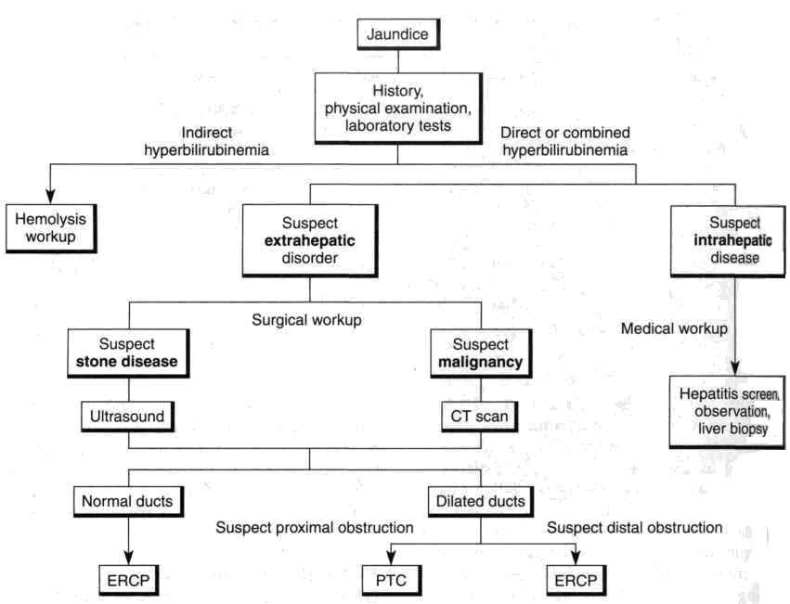
From: Basic surgery/ed., H.C. Polk, Jr., et al. – 5th ed.

Scheme 2. Algorithm of management of choledocholithiasis

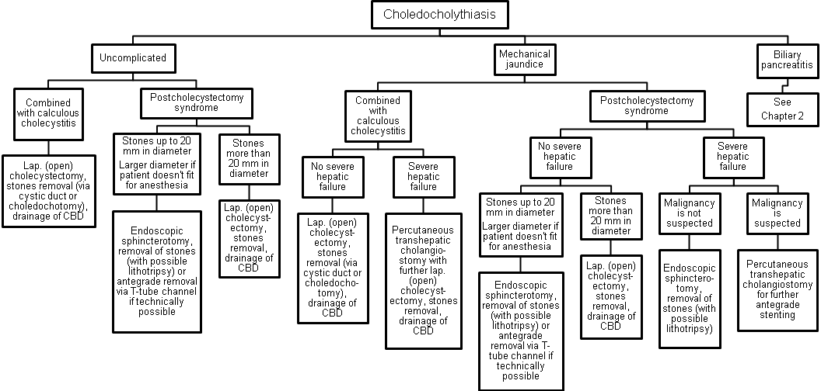
From: Basic surgery/ed., H.C. Polk, Jr., et al. – 5th ed.

Scheme 3. Algorithm of management of biliary strictures
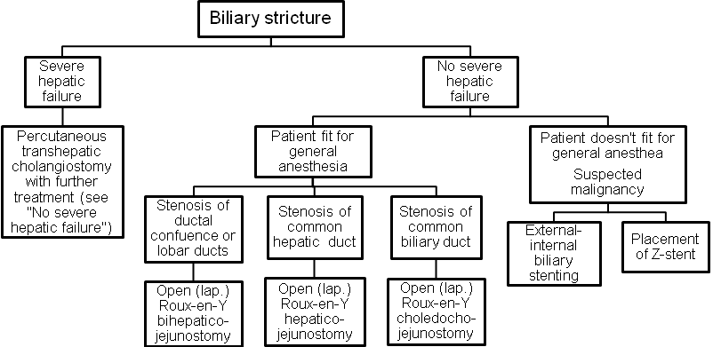

Scheme 4. Algorithm of management of stenosis of sphincter of Oddi
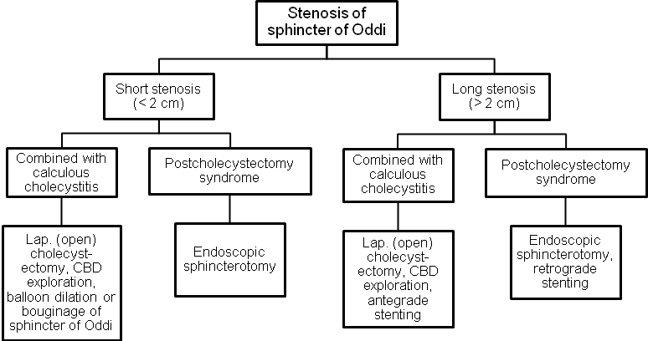

Scheme 5. Algorithm of management of carcinoma of head of pancreas

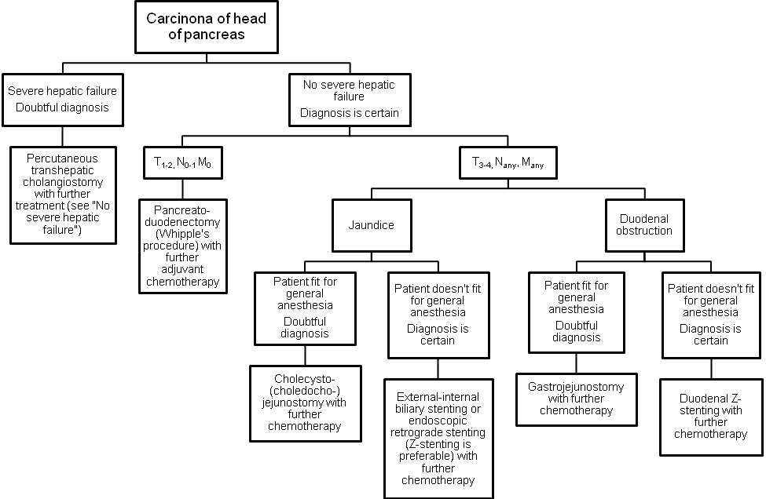

7. Literature for teachers

- General Surgery: textbook / S.D. Khimich, M.D. Zheliba, V.P. Andryushchenko et al. — К., 2019. — 536 p., hardcover

- Essential surgery. Editor prof V.V.Grubnik, O.L.Kovalchuk, A.V.Malinovsky. Ternopil, TSM, 2010, 543 p.

- Surgery: a textbook is intended for English-speaking students of higher medical educational institutions of III-IVth levels of accreditation, interns / K. M. Amosova, Ya. S. Bereznyts’kyy, A. O. Burka [et al.]; ed. by Ya. S. Bereznyts’kyy [et al.], 2016. - 711 p.

- Surgery: a textbook is intended for English-speaking students of higher medical educational institutions of III-IVth levels of accreditation, interns / K. M. Amosova, Ya. S. Bereznyts’kyy, A. O. Burka [et al.]; ed. by Ya. S. Bereznyts’kyy [et al.], 2018. - 711 p.

- Essential surgery [Text] : навч. посіб. для студ. вищ. мед. навч. закл. IV рівня акредитації, які опановують навч. дисципліну англ. мовою (протокол № 4 від 01.10.2010 р.) / V. V. Grubnik, O. L. Kovalchuk, A. V. Malynovskyy, O. V. Grubnik. - Ternopil : TSMU "Ukrmedknyha", 2010. - 544 p. : fig., tab. - Текст англ. - Бібліогр.: с. 529-531. - 500 прим. - ISBN 978-966-673-147-3

- Sabiston textbook of surgery: the biological basis of modern surgical practic / [edited by] Courtney M. Townsend, Jr, R. Daniel Beauchamp. B. Mark Evers, Kenneth L. Mattox.—20th edition.
- Surgery Editor. Bereznyts'ky Y.S., Zarharash M.P, Mishalov V.G. Vinnytsia, 2016, 711p.

8. Literature for students

8.1. Basic literature

- General Surgery: textbook / S.D. Khimich, M.D. Zheliba, V.P. Andryushchenko et al. — К., 2019. — 536 p., hardcover

- Essential surgery. Editor prof V.V.Grubnik, O.L.Kovalchuk, A.V.Malinovsky. Ternopil, TSM, 2010, 543 p.

- Surgery: a textbook is intended for English-speaking students of higher medical educational institutions of III-IVth levels of accreditation, interns / K. M. Amosova, Ya. S. Bereznyts’kyy, A. O. Burka [et al.]; ed. by Ya. S. Bereznyts’kyy [et al.], 2016. - 711 p.

- Surgery Editor. Bereznyts'ky Y.S., Zarharash M.P, Mishalov V.G. Vinnytsia, 2016, 711p.

8.2. Additional literature

- Surgery: a textbook is intended for English-speaking students of higher medical educational institutions of III-IVth levels of accreditation, interns / K. M. Amosova, Ya. S. Bereznyts’kyy, A. O. Burka [et al.]; ed. by Ya. S. Bereznyts’kyy [et al.], 2018. - 711 p.

- Essential surgery [Text] : навч. посіб. для студ. вищ. мед. навч. закл. IV рівня акредитації, які опановують навч. дисципліну англ. мовою (протокол № 4 від 01.10.2010 р.) / V. V. Grubnik, O. L. Kovalchuk, A. V. Malynovskyy, O. V. Grubnik. - Ternopil : TSMU "Ukrmedknyha", 2010. - 544 p. : fig., tab. - Текст англ. - Бібліогр.: с. 529-531. - 500 прим. - ISBN 978-966-673-147-3

- Sabiston textbook of surgery: the biological basis of modern surgical practic / [edited by] Courtney M. Townsend, Jr, R. Daniel Beauchamp. B. Mark Evers, Kenneth L. Mattox.—20th edition.

9. Topics for student’s research

Complications after endoscopic surgery for mechanical jaundice.

10. Topic of the next class

Gastrointestinal bleeding

Elaboration composed by: ass. Chernov Nikolai

