ODESSA NATIONAL MEDICAL UNIVERSITY
DEPARTMENT OF ROBOTIC AND ENDOSCOPIC SURGERY

METHODICAL instructive elaboration

of the practical class for the discipline
"Surgical diseases with child's surgery and oncology" for teachers

Topic 11: “Differential diagnosis, prevention and treatment of acute ulcer of the digestive canal”.

Discussed and approved at
methodical board of Department
of Robotic and Endoscopic surgery
"28" August 2019
Protocol № 1
Head of the Department
Ass. prof. __________ Malinovsky A.V.

Odessa - 2019

Topic of practical class: Differential diagnosis, prevention and treatment of acute ulcer of the digestive canal
1. Significance of topic

Acute erosion and gastrointestinal ulcers are a serious problem in surgery, traumatology and intensive care. Most of them develop outside hospitals (acute erosive-hemorrhagic gastritis) and does not pose a serious threat to the patient. The smallest part of them develops as a complication of severe disease or postoperative period or drug therapy, that is, inpatients. The course of acute ulcers in this contingent of patients is much harder and often represents a threat to the life of the patient. In the structure of all postoperative complications, acute erosion and ulcers of the gastrointestinal tract account for approximately 1-3%. However, given the fact that among acute hospitalized patients acute ulcers most often develop in patients who are in severe and terminal condition (craniocerebral trauma, hepatic-renal failure, shock, sepsis, and so on), this problem is quite acute. The main complications of acute ulcers is massive bleeding (perforations occur relatively rarely), which against the background of a severe condition often lead to death. Describe the pathogenesis and prognostic aspect of acute ulcers can be thus: acute bleeding ulcers of the gastrointestinal tract on the one hand are a sign of the inadequacy of the compensatory possibilities of the organism, on the other hand they can be the "last straw" in the development of the lethal outcome against the background of multiorgan insufficiency. Indeed, the lethality with the development of bleeding from acute erosion and ulcers of the gastrointestinal tract in patients with multiple organ failure is close to 95%. Acute erosion and ulcers are most often localized in the stomach as the organ most sensitive to various adverse factors, amounting to 10-15% of all ulcers of the gastrointestinal tract. Practice shows that patients with multiorgan insufficiency and bleeding from acute ulcers rarely give in to surgical treatment because of an extremely high risk of anesthesia. Given the relatively low effectiveness of conservative interventions, the main emphasis in the intensive care of such patients should be made on the prevention of acute ulcers.
2. Aims of the class

2.1. Training aims (a student must learn and master):

Level I – Know the etiology, pathogenesis, the main clinical manifestations and the data of visualization methods for studying acute erosions and ulcers of the digestive canal.
Level II – Know the technique of performing the following diagnostic and medical manipulations: setting a nasogastric tube, washing the stomach with an orogastric probe, fibrogastroduodenoscopy, colonoscopy, rectoscopy.

Level III – Know the technique of performing the most typical surgical interventions for complicated acute ulcers of the digestive canal: suture bleeding ulcers, vagotomy, suturing perforated ulcers.

2.2. Educational aims:

1. Formation of professional personality of doctor.
2. Formation of medical deontology and ethics, professional responsibility.

3. Interdisciplinary integration

№ | Disciplines | To know | To master
Previous disciplines (basic disciplines)
1 | Anatomy | Anatomy of the stomach, duodenum, small and large intestine
2 | Histology | The histological structure of the stomach, duodenum, small and large intestine
3 | Normal physiology | Motor and secretory functions of the stomach and duodenum. Physiology of the adrenal glands
4 | Biochemistry | Biochemistry of prostaglandins, intestinal peptides, hormones of the adrenal cortex
5 | Pathophysiology | Pathophysiology of peptic ulcer of stomach and duodenum, stress reactions, multi-organ failure, liver failure, renal failure, burn disease, shock, sepsis, craniocerebral trauma.
Following disciplines (clinical disciplines)
1 | Propaedeutics of internal diseases and internal diseases, endocrinology, surgical diseases (previous courses) | Differential diagnosis of peptic ulcer of stomach and duodenum (and its complications), pathology of the adrenal gland, liver failure, renal failure, burn disease, shock, sepsis. | To diagnose and treat peptic ulcer of the stomach and duodenum, incl. Complicated by bleeding and perforation, adrenal gland diseases.
2 | Pharmacology | Mechanism of action, pharmacokinetics, pharmacodynamics, side effects of glucocorticosteroids, proton pump inhibitors, histamine receptor blockers, antacids. | Assign and fill out a prescription form for the following drugs: proton pump inhibitors, histamine receptor blockers, antacids.
Inside the discipline (other topics)
1 | Gastrointestinal bleeding: etiology, pathogenesis, diagnosis, differential diagnosis, treatment tactics | Etiology, pathogenesis, classification, semiotics, methods of conservative and surgical treatment of gastric ulcer and duodenal ulcer and its complications, as well as other diseases that lead to gastrointestinal bleeding. | Diagnose, conduct differential diagnosis and treat (prescribe conservative treatment and well know the methods of surgical treatment) peptic ulcer of the stomach and duodenum and its complications, as well as other diseases that lead to gastrointestinal bleeding. Conduct preoperative preparation and postoperative management of the listed diseases.

4. Contents of the topic

Acute erosion and ulcers of the digestive canal, in particular the stomach, occur in stressful situations associated with severe pathology of internal organs, severe surgical interventions, burns, polytrauma, in particular craniocerebral trauma, the use of certain medicinal substances, etc.
Acute stomach ulcers.
Depending on the causes of the onset, the following types of acute ulcers are distinguished:
1) stress ulcers in patients with polytrauma, shock, sepsis, multiple organ failure, liver failure, renal insufficiency, burn disease (Kurling's ulcer), severe large operations on the thoracic and abdominal organs , On large vessels and operations on the brain;
2) Cushing's ulcer - after surgery on the brain, with craniocerebral trauma and brain tumors as a result of central stimulation of gastric secretion and increase of its aggressive properties in relation to the gastric mucosa;
3) drug ulcers that occur with the intake of acetylsalicylic acid and other non-steroidal anti-inflammatory drugs (NSAIDs), or steroid hormones, as well as cytotoxic drugs.
Typical signs of all acute ulcers are sudden massive life-threatening bleeding or perforation of the ulcer. The optimal way to diagnose acute ulcers is endoscopy. It should be borne in mind that to the appearance of bleeding, acute ulcers occur usually asymptomatically.

Acute erosive gastritis.
This disease is characterized by superficial flat rounded or oblong forms of the mucus membrane of the stomach (erosion). Unlike ulcers, they do not destroy the muscular plate of the mucosa. The causes of their occurrence are the causes mentioned above for ulcers. Quite often erosive gastritis occurs after eating acute food, alcohol, with the development of acute pancreatitis. The main clinical symptoms are bleeding (hematemesis, melena, shock). Diagnosis is established by endoscopic examination.

Pathogenesis.
Drugs (steroid hormones, NSAIDs) reduce the formation of mucus and prostaglandins, thus breaking the protective barrier of the mucous membrane, causing hemorrhages. With the withdrawal of drugs, ulcers and erosion quickly heal. Ischemia of the mucous membrane plays a key role in the development of hemorrhagic gastritis, since it contributes to the weakening of its protective barrier. Also important is coagulopathy, which can be present in hepatic insufficiency, multiple organ failure, sepsis. The most important pathogenetic mechanism for the development of acute erosion and ulcers in renal failure is stimulation of gastrin production by an elevated level of urea.

Treatment.
In acute ulcers and erosive gastritis, conservative treatment is first performed. In almost 90% of cases, conservative treatment can stop bleeding.
Surgical treatment is rarely used. Advantage is given to selective proximal vagotomy, bandage and dressing of bleeding vessels, less often gastrectomy or even gastrectomy (in exceptional cases).
A simple Dielafua ulcer (telangiectasia of the scurvy, complicated by bleeding) is amenable only to surgical treatment: ligation of the bleeding artery through gastrotomic access or atypical resection.
Prevention.
The main measure of prevention is the appointment of injection blockers of H2-histamine receptors or proton pump inhibitors, which (assuming almost complete absence of side effects of these drugs) should be performed in every patient who has a risk of developing acute ulcers.

5. Plan and structure of the class

No. | Basic stages of the class | Training aims according to the levels of mastering | Means of training and control | Materials for methodological maintainance of  the class, visibility, and control of knowledges | Terms (in minutes or per cent)
1 | Initial | 1) Giving the training aims of level I (see chapter 2.1)  2) Control testing of initial level of knowledge, readiness of the students for perception of the material | Krok-2 type tests of initial level of knowledge, including software version (see chapter 6.1) | Krok-2 type tests of initial level of knowledge, including software version (see chapter 6.1) | 15 %
2 | Basic | 1) Giving the training aims of levels II – IV (see chapter 2.1)  2) Observation of patients, disucussion of algorithms of diagnostics and management of patients with acute ulcer of the digestive canal | Observation of patients at the department of robotic and endoscopic surgery | 1) Schemes, tables (including PowerPoint presentations) of algorithms of diagnostics and management  2) Diagnostic images  3) Illustrations and videos of surgical procedures | 70 %
3 | Conclusive | 1) Control testing of theoretical knowledges and practical skills  2) Conclusions  3) Giving the home task | 1) Krok-2 type tests of final level of knowledge, including software version (see chapter 6.3)  2) List of literature for the next class | Krok-2 type tests of final level of knowledge, including software version (see chapter 6.3) | 15 %

6. Materials for methodological maintainance of the class

6.1. Materials for initial stage of the class

Blood typing resulted in positive isohemagglutination reaction with standard sera of A(II) and B(III) groups and
negative reaction with sera of 0(I) and AB(IV) groups. What is this result indicative of?
The third blood group
The fourth blood group
The first blood group
The second blood group
Faulty standard sera

To replace the blood loss replacement 1000 ml of the same group of Rhesus-compatible donated blood was
transfused to the patient. The blood was conserved by sodium citrate. At the end of hemotransfusion there
appeared excitement, pale skin, tachycardia, muscles cramps in the patient. What complication should be
suspected?
Allergic reaction
Pyrogenous reaction
Citrate shock
Citrate intoxication
Anaphylactic shock

A 42-year-old patient with acute haemorrhage and class III blood loss underwent blood transfusion and got
1,8 l of preserved blood and erythromass of the same group and Rh. After the transfusion the patient complained
of unpleasant retrosternal sensations, his arterial pressure dropped to 100/60 mm Hg, there appeared
convulsions. Blood serum calcium was at the rate of 1,7 millimole/liter. What is the mechanism of this
complication development?
Citrate binds calcium ions, hypocalcemia impairs myocardial function
Citrate binds potassium causing severe hypokalemia
Citrate causes the development of metabolic acidosis
Citrate is cardiotoxic and nephrotoxic
The increased citrate rate causes convulsions

A 35 y.o. female patient was admitted to the surgical department with symptoms of ulcerative gastric
hemorrhage. Its been the third hemorrhage for the last 2 years. After conservative treatment vomiting with
blood stopped, hemoglobin elevated from 60 till 108 g/L. General condition became better. But profuse vomiting
with blood reoccured in 2-3- hours. Hemoglobin decreased to 93,1 g/L then to 58,1 g/L. What is the tactics of
treatment?
Deferred surgery
Conservative treatment with following surgery
Conservative treatment
Urgent surgery
Taylors treatment

6.2. Materials for basic stage of the class

Scheme 1. Algorithm of management of patient with gastrointestinal bleeding
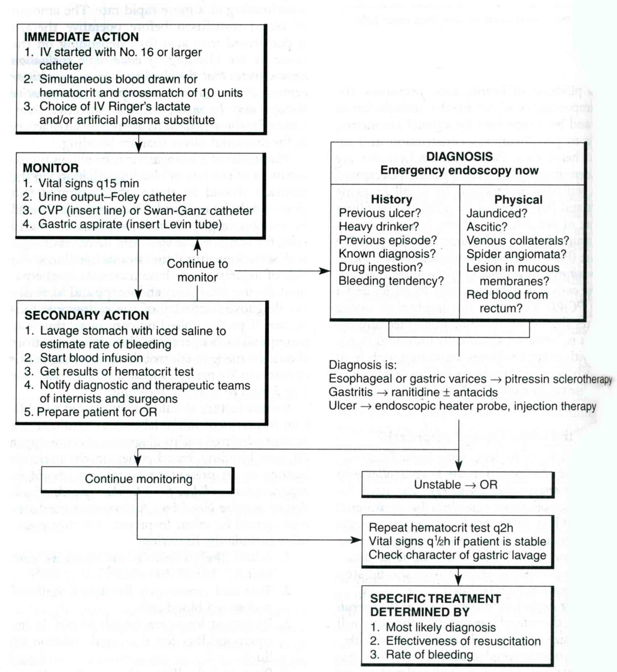
Scheme 2. Diagnostic algorithm for chronic iron-deficiency anemia

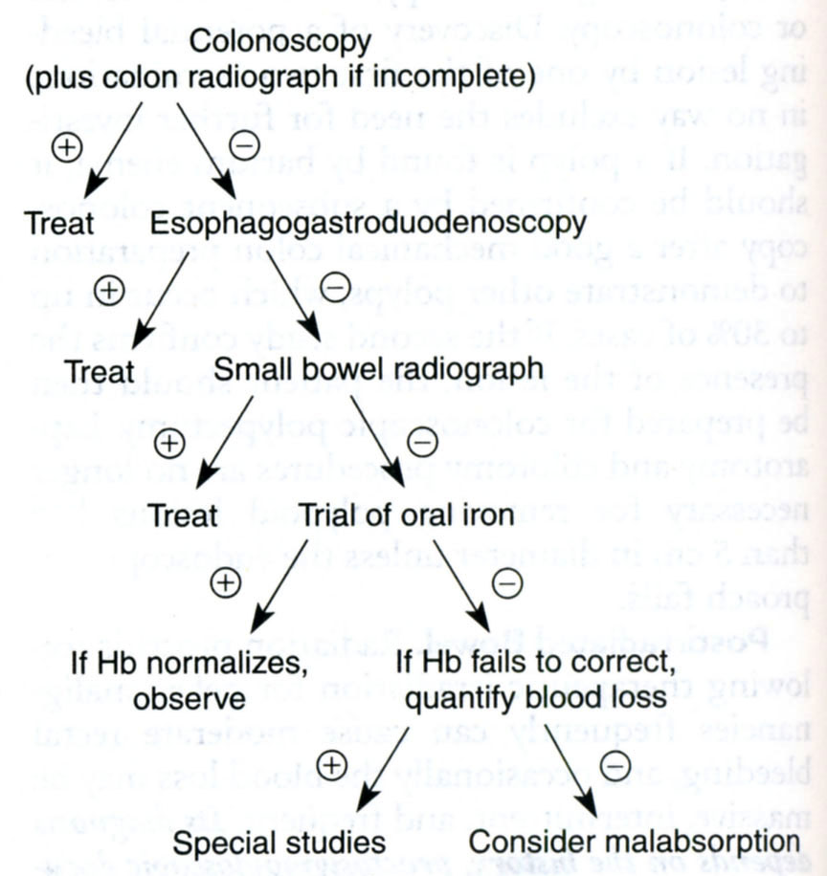
From: Principles of surgery/ed., S.I. Schwartz, et al. – 7th ed.

Table 1. Forrest classification of ulcer bleeding

Acute hemorrhage

Forrest I a (Spurting hemorrhage)
Forrest I b (Oozing hemorrhage)

Signs of recent hemorrhage

Forrest II a (Visible vessel)
Forrest II b (Adherent clot)
Forrest II c (Hematin on ulcer base)

Lesions without active bleeding

Forrest III (Lesions without signs of recent hemorrhage)

Scheme 3. Algorithm of management of bleeding peptic ulcers of duodenum

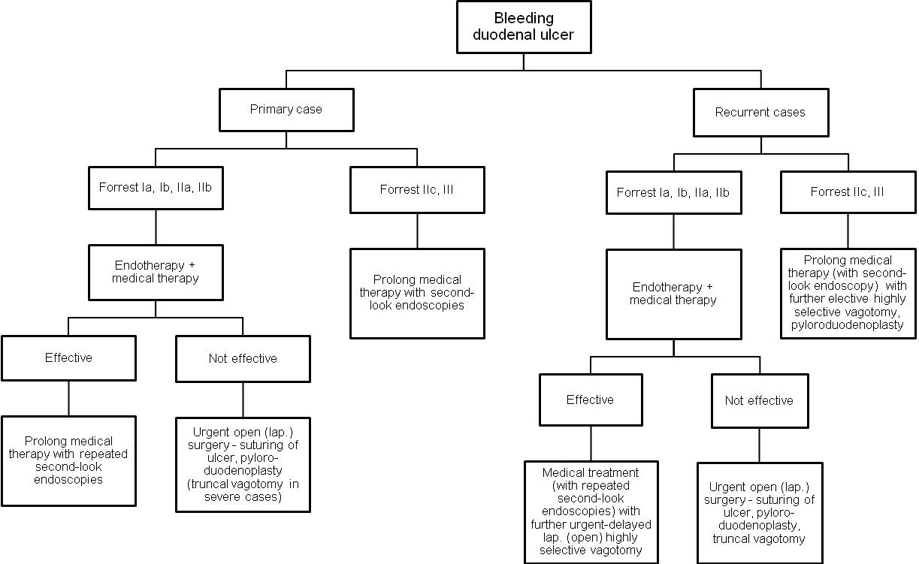

Scheme 4. Algorithm of management of bleeding peptic ulcers of stomach

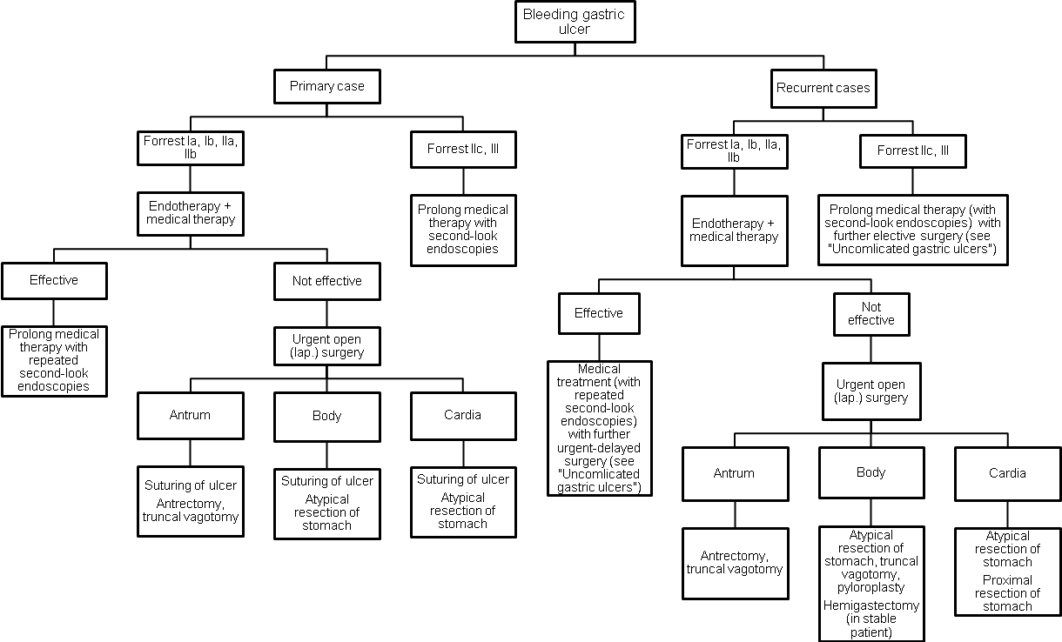

7. Literature for teachers

- General Surgery: textbook / S.D. Khimich, M.D. Zheliba, V.P. Andryushchenko et al. — К., 2019. — 536 p., hardcover

- Essential surgery. Editor prof V.V.Grubnik, O.L.Kovalchuk, A.V.Malinovsky. Ternopil, TSM, 2010, 543 p.

- Surgery: a textbook is intended for English-speaking students of higher medical educational institutions of III-IVth levels of accreditation, interns / K. M. Amosova, Ya. S. Bereznyts’kyy, A. O. Burka [et al.]; ed. by Ya. S. Bereznyts’kyy [et al.], 2016. - 711 p.

- Surgery: a textbook is intended for English-speaking students of higher medical educational institutions of III-IVth levels of accreditation, interns / K. M. Amosova, Ya. S. Bereznyts’kyy, A. O. Burka [et al.]; ed. by Ya. S. Bereznyts’kyy [et al.], 2018. - 711 p.

- Essential surgery [Text] : навч. посіб. для студ. вищ. мед. навч. закл. IV рівня акредитації, які опановують навч. дисципліну англ. мовою (протокол № 4 від 01.10.2010 р.) / V. V. Grubnik, O. L. Kovalchuk, A. V. Malynovskyy, O. V. Grubnik. - Ternopil : TSMU "Ukrmedknyha", 2010. - 544 p. : fig., tab. - Текст англ. - Бібліогр.: с. 529-531. - 500 прим. - ISBN 978-966-673-147-3

- Sabiston textbook of surgery: the biological basis of modern surgical practic / [edited by] Courtney M. Townsend, Jr, R. Daniel Beauchamp. B. Mark Evers, Kenneth L. Mattox.—20th edition.
- Surgery Editor. Bereznyts'ky Y.S., Zarharash M.P, Mishalov V.G. Vinnytsia, 2016, 711p.

8. Literature for students

8.1. Basic literature

- General Surgery: textbook / S.D. Khimich, M.D. Zheliba, V.P. Andryushchenko et al. — К., 2019. — 536 p., hardcover

- Essential surgery. Editor prof V.V.Grubnik, O.L.Kovalchuk, A.V.Malinovsky. Ternopil, TSM, 2010, 543 p.

- Surgery: a textbook is intended for English-speaking students of higher medical educational institutions of III-IVth levels of accreditation, interns / K. M. Amosova, Ya. S. Bereznyts’kyy, A. O. Burka [et al.]; ed. by Ya. S. Bereznyts’kyy [et al.], 2016. - 711 p.

- Surgery Editor. Bereznyts'ky Y.S., Zarharash M.P, Mishalov V.G. Vinnytsia, 2016, 711p.

8.2. Additional literature

- Surgery: a textbook is intended for English-speaking students of higher medical educational institutions of III-IVth levels of accreditation, interns / K. M. Amosova, Ya. S. Bereznyts’kyy, A. O. Burka [et al.]; ed. by Ya. S. Bereznyts’kyy [et al.], 2018. - 711 p.

- Essential surgery [Text] : навч. посіб. для студ. вищ. мед. навч. закл. IV рівня акредитації, які опановують навч. дисципліну англ. мовою (протокол № 4 від 01.10.2010 р.) / V. V. Grubnik, O. L. Kovalchuk, A. V. Malynovskyy, O. V. Grubnik. - Ternopil : TSMU "Ukrmedknyha", 2010. - 544 p. : fig., tab. - Текст англ. - Бібліогр.: с. 529-531. - 500 прим. - ISBN 978-966-673-147-3

- Sabiston textbook of surgery: the biological basis of modern surgical practic / [edited by] Courtney M. Townsend, Jr, R. Daniel Beauchamp. B. Mark Evers, Kenneth L. Mattox.—20th edition.

9. Topics for student’s research

Complications after palliative surgery for bleeding stomach ulcers and 12-colon.

10. Topic of the next class

Trauma of abdomen and retroperitoneal space.

Elaboration composed by: ass. Chernov Nikolai

