Ministry of Public Health of Ukraine

Odessa National Medical University
Department of general and clinical epidemiology and biosafety

METHODICAL DEVELOPMENT

of the practical class for the students:

« Epidemiological method of research and its structure.

Planning of countermeasures and preventive measures »
(for the 5 year students of the medical faculty)
On specialty: 222 «Medicine»
Educational qualification "Master of Medicine"
Professional qualifications "doctor"
Faculty, form of education – medical, day

APPROVED

at the methodical meeting of the department

"31 " August 2020

Minutes № 1
Head of the department
Docent ___________ N.I.Golubyatnikov

Odessa 2020

1. The theme of the practical classes is “Epidemiological method of research and its structure. Planning of countermeasures and preventive measures” – 2 hours.
2. Importance of the theme – the complex epidemiological method is a set of techniques, which are based on the analysis of features and characteristics of diseases distribution at the population level or other phenomena in space, time, among groups, and designed to identify the reasons and circumstances (risk factors) and the mechanisms of sickness formation in order of a substantiation of measures from preventive maintenance of diseases and estimation of their efficiency.
3. Aims of the class
3.1. General aims – to study main principles of the complex epidemiological method.
3.2. Educational aims: connect with formation of the actual questions of deontology and professional responsibility.
3.3. Specific aims:

A student should know a definition of the complex epidemiological method.
3.4. On the basis of the theoretical knowledge on the theme:
To be able:
- to make a plane of countermeasures and preventive measures.
4. Material for individual work before the practical class (interdiscipline integration)
Discipline | To know | To be able
- Previous  Microbiology  Therapy  Infectious diseases  Medical statistic  Social medicine | Principles and method of different laboratory diagnostic of different infectious agents.  Methods of objective examination of the patients.  Etiology, pathogenesis, clinical manifestations, laboratory investigations and treatment of different infectious diseases.  Bases of medical statistic in medicine | To collect anamnesis, make up objective examination
2. Intradiscipline integration  Epidemiological process  Human (animal) being as a source of infection  Epidemiological diagnostics | Source of infection, mechanism of transmission and susceptible organism Antiepidemic measures  Methods of epidemiological diagnostics
3. Next discipline  Hospital surgery | Opportunity to infect the patient during medical manipulation | To make a plan of prophylaxis measures
5. Contents of the theme
STRUCTURE OF COMPLEX EPIDEMIOLOGICAL METHOD
The complex epidemiological method is a set of techniques, which are based on the analysis of features and characteristics of diseases distribution at the population level or other phenomena in space, time, among groups, and designed to identify the reasons and circumstances (risk factors) and the mechanisms of sickness formation in order of a substantiation of measures from preventive maintenance of diseases and estimation of their efficiency.
The method consists of four blocks of techniques: descriptive-evaluative (descriptive), analytical, experimental, forecasting – that ultimately reveals the causal relationships between risk factors and manifestations of health.
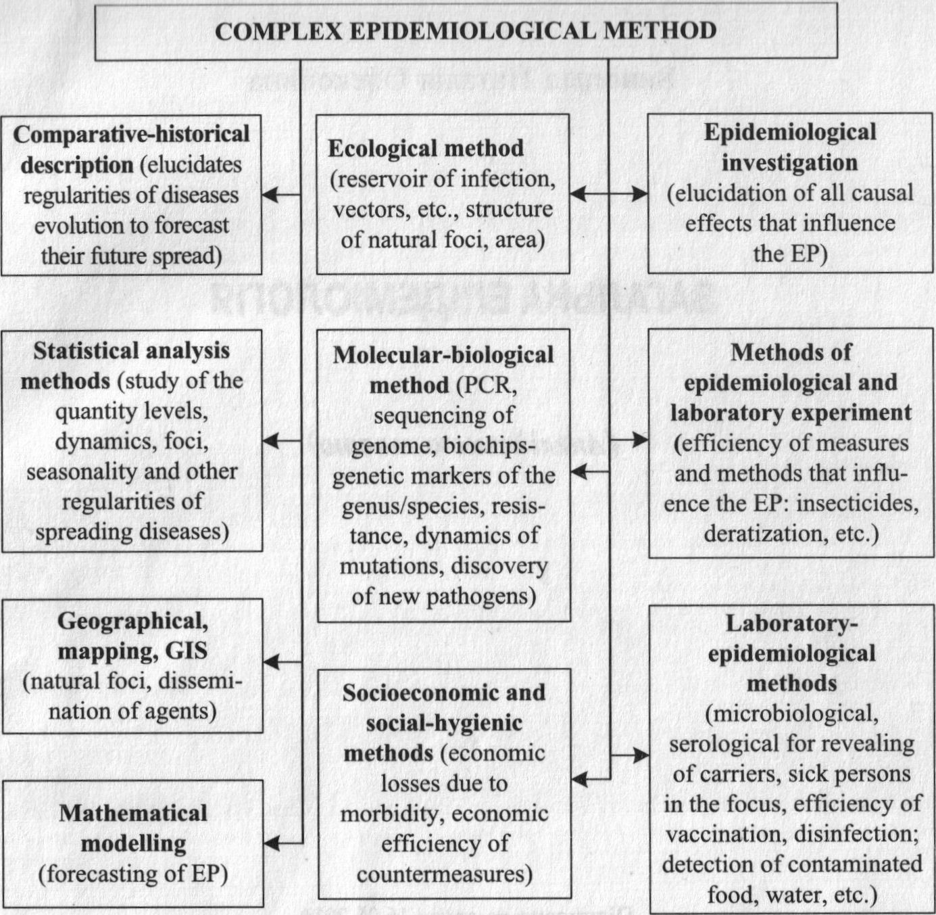

Complex epidemiological method involves the use of many specific and common methods. That can be done to characterize all components of parasitic systems:
- population of humans, animals or the environment (epidemiological investigation and monitoring, ecological),
- population of pathogens (bacteriological, serological, virological, molecular-genetic),
- estimate to quantify and qualitative manifestations of EP, trends and forecasts, taking into account the natural and social environment (geographic and cartographic, statistical, analytical, socio-economic, socio-hygienic, experimental, mathematical modeling, GIS).
Study of EP manifestations and features includes the following stages:
- counting cases or events of baseline data indicated phenomena (manifestations) of health status or disorders: cases of diseases, disability, mortality, morbidity, etc.;
- systematization and statistical processing (descriptive-evaluative stage) – “manage” data – simple cross-tabulations with appropriative measures of association; stratified analysis (confounding and effect modification); multivariate analysis;
- evaluate for causal relationship, detection of a problem;
- generate hypotheses about the risks (factors, time, area, and group);
- testing of working hypotheses;
- epidemiological substantiation of the preventive programs.
Information obtained by processing the report and account forms, results of investigation of the foci of infectious diseases, laboratory study, sanitary-epidemiological intelligence, screening of population and specific groups.
In general, descriptive techniques allow obtaining data on the intensity, dynamics, spatial characteristics and structure of phenomena of the studied problem, the detection of time, groups and areas of increased risk of morbidity (mortality).
Checking the working hypotheses is the task of the next analytical step, where by comparisons among groups, one of which must have control, the degree of probability of events, calculated risks and their relationship, and then – making of an epidemiological prevention programs. The experimental technique allows to simulate the EP for the future and to predict its development.
Using CEM in practice is called epidemiological diagnosis that assesses to estimate the epidemiological status of the population and territory.

Operational and Retrospective Epidemiological Analysis
Different types of epidemiological analysis by the time that analyzes of the EP displays are distinguished:
- retrospective epidemiological analysis (REA) – for the preview time,
- operational epidemiological analysis (OEA) – in the present, and
- prospective analysis – starts in specified time and lasts until the beginning of the analysis of the effects. It is important to use a standardized approach to case definition of the disease by clinical, epidemiological and laboratory criteria.
InfoBase of OEA includes two parts:
- data that directly reflect the status and trends of EP at the analyzed time of and average lasting many years data for the same period (comparison),
- results of continuous monitoring of epidemiologically important objects, social and natural phenomena that can influence at EP.
The first block is formed according to epidemiological investigation of the foci of infectious diseases (single cases, outbreak), epidemiological monitoring by calculating the levels of the structure and dynamics of disease (day, week, month or other period). Second block is included all laboratory studies (results) on/in all epidemiologically significant objects.
Conducting of OEA and REA based on a database composed table, counted intensive, extensive, visibility, standardized measures under generally accepted statistical approaches and techniques. The data structure in the context of infectious diseases or groups of diseases are presented graphically (charts, cartograms, and graphs). Cause-effect relationships are calculated by the correlation analysis, trend and forecast – by small squares techniques. The different computer software (Statistica 7.0 for Windows, Microsoft Excel 2003, Epi_Info, Epi_Map and others) for the calculation and presentation of data are used.
The algorithms of REA which allows identifying the risk (factors, time, groups and place) includes stages:
- develop of analysis strategy (programs);
- collection and primary processing of information (infectious diseases, demographic data, sanitary and hygienic characteristics of the territory, the natural and social conditions – living and labor);
- analysis of the structure and dynamics of morbidity (incidence, prevalence) and mortality (lethality) for specific diseases (long-standing and annual dynamics, by gender, age, socio-household groups, territory), in different types of foci;
- calculation of risks (biological, natural, social),
- estimation of significance (epidemiological, social and economic), and prevention problems,
- optimization of preventive and countermeasures plans.
Epidemiological risk factors are circumstances that determine (cause or increase) the probability of change for the worse of epidemic situation.
Time of risk is a naturally occurring under the influence of risk factors intervals (years, months), characterized by the greatest probability of disease (place, among the total population or specific groups) compared with other intervals. Time of risk is established as a result of long-term observations in the analysis of many years and annual morbidity. Long-term fluctuations of incidence estimated in the analysis over a long period of time (25 years or more). There are three types of long-term fluctuations:
- systematic (trend) rises under the influence of permanent and longterm operating factors (mainly social),
- irregular (pulse) rises, determined randomly on EP distribution of different factors,
- cyclical (periodic) rises periods of increasing and decreasing morbidity, alternating and repeated in a specific order and are influenced by periodically operating factors that are external manifestation of parasitic systems functioning.
At REA defines of EP dynamic, EP trends, the nature of cyclical fluctuations in the intensity dynamics of EP (calculation of average annual increase rate).
It is important to determine the epidemic threshold (upper and lower limit fluctuations in incidence according to long-term observations) for each disease that enables timely detect irregular rises (noncyclic change for the worse of epidemic situation: outbreaks, epidemics, pandemics) by using of computer software (Statistic 7.0 for Windows, Microsoft Excel 2003, Epi lnfo and others).
Annual EP level dynamics that appear as seasonality – natural fluctuations of incidence during epidemic years, due to the action of natural and/or social factors are calculated. The analysis of the seasonal dynamics of morbidity defines the following parameters:
- general characteristic patterns of annual curve;
- beginning and ending of seasonality;
- seasonality ratio (S Ratio) – the proportion of disease risk in the season of the total for the year, expressed as a percentage, using the formula:

S_Ratio = number of diseases in the month of increased morbidity / total number of cases during the year * 100%

- seasonality rate (S_Rate), which shows how many times the incidence in the month increased morbidity than shoulder level, and is defined as:

S_Rate = number of diseases in the month rise of morbidity / number of cases for the remaining months of the year

Place of risk is the spatial unit (geographical or territorial-administrative), characterized by higher comparison with other territories morbidity rates for certain infectious disease due to the presence in the area of natural and/or social risk factors. Thus, the areas of risk determined by the presence of (or more pronounced effect) in a particular area factors shaping the epidemic variant of the pathogen and (or) factors in its dissemination. There are local (epidemic focus), zonal, regional, global place of risk.
Group of risk (contingent of risk) is a part of the population that is exposed mainly to increased risk of contracting a particular disease agent in relation to certain features of the natural and/or social factors.
Risk groups are formed by factors such as age, occupational, place of residence, gender, ethnicity, and others. Their identification may reflect an increased risk of infection, which is caused by the possibility of MTAI due to certain conditions, welfare, etc., especially the immunological structure of the population, the difference in detected and diagnosis of diseases.
When conducting of OEA and REA the important point is to analyze the timeliness of addressing patients’ medical care, scope and time of hospitalization, completeness of SA1 detection and transmission factors, timeliness epidemiological investigation of foci, and for the final disinfection, evaluation of focus index (the average number of cases (carriers) in one focus), and the average duration of the existence of the focus (the average interval from the first to the last case diseases); primary attack rate in focus (the ratio of the number of cases to the number of people available in the focus), the time of focus existence.
Formulation of hypotheses about risk factors based on the study of correlation between the intensity of the possible risk factors and morbidity through a series of logical methods: differences, similarities, concomitant changes analogy residues.
All these reveal problems of prevention and present them in the form of conclusions and recommendations for optimizing epidemic situation of population and territory.

PLANNING PREVENTIVE AND COUNTERMEASURES
Combating infectious diseases is conducted by two ways: organizing preventive measures and countermeasures.
PREVENTIVE MEASURES
MEASURES IN THE SOURCE OF INFECTION
- Early passive/active detection of infectious patients and carriers among people and animals
- Protection of territory against introduction of infection
- Well-timed cure of carriers
- Clinical examination and supervision of recovery patients
- Veterinary control over domestic animals
- Preventive deratization

MEASURES CONCERNING THE MECHANISM OF INFECTIOUS AGENT TRANSMISSION
- Improvement of town/city planning and organization of public services
- The sanitary-hygienic control over sewerage network
- The sanitary-hygienic control over manufacturing and realization of foodstuff, sanitary disposal service
- Disinfection
- Disinsection
- Sterilization

MEASURES CONCERNING POPULATION SUSCEPTIBILITY
- Specific prophylaxis (scheduled immunization)
- Nonspecific measures for strengthening of health

Preventive measures are a set of measures aimed at strengthening public health; develop immunity to infectious diseases; preventing the penetration of infectious agents in groups; improving health culture, i.e. a set of measures to prevent the emergence and spread of infectious diseases among the population. These measures should be divided into three main groups:
- measures concerning of SAI that are aimed at blocking or eliminating ones;
- measures concerning MTAI to interrupt or destruction transmission;
- measures to increase resistance of population.
The basis for the prevention of infectious diseases across a country are social actions, the welfare of the people, providing people with furnished housing, a qualified and accessible health care service, adherence hygienic habits in the home and workplaces, etc.
Countermeasures are a set of measures aimed at quick and full localization and elimination of change for the worse of epidemic situation, including those of arising of epidemic focus, minimizing their negative impact on society. Countermeasures provide the same effect on the three links of the EP, but harsher regime and larger amounts of additional focus on groups of people exposed to risk of infection. The first group of countermeasures is aimed at people who are sources of certain pathogens, the second – by a group of people exposed to a probable risk of infection due to contact with SAI, the third – to block MTAI, the fourth – to protect susceptible populations.
COUNTERMEASURES
MEASURES CONCERNING THE SOURCE OF INFECTION
- Early active detection of infectious patients and carriers among people and animals
- Protection of the territory against introduction of infection
- Well-timed isolation (hospitalization) of patients
- Veterinary control of domestic animals
- Deratization (rodent control)

MEASURES CONCERNING THE PERSONS,
WHICH RUN THE RISK OF EXPOSURE
- Active detection of patients and carriers (interrogation, thermometry, laboratory and instrument methods of examination)
- Isolation-restrictive measures during the maximal incubation period

MEASURES CONCERNING THE MECHANISM OF TRANSMISSION
- Amplified sanitary-hygienic control of the objects of epidemic risk (seweragenet- work, manufacture and realization of food)
- Desinfection
- Disinsection
- Sterilization

Thus, the basis for preventive and countermeasures are three basic principles: comprehensiveness – simultaneous action on all three links of the EP, the impact on the lead “key ” link of EP – one of the components of the primary driving forces of EP for which at this stage are the most rational approach to its blocking, and the detection of risk factors and blocking ones.
6. Information necessary for consolidation of initial knowledge can be found:
1. General epidemiology. Vinogradov N.O. – Ukraine, 2014. – 128P.
2. Infectious Disease in General Medical Practice. Edited by G.Goseph Marr.M.D. Addison-Wesley Publishing Company. 1982, 879p.
3. Infectious Disorders. Professional Care Guide. Springhouse, Pennsylvania, 1995, 280p.
4. Principles and practice of infectious diseases (third edition) Gerald L. Mandell, M.D.R. Gordon Douglas, G.M.D.John E. Bennett, M.D. USA, 1990, 1837p.
5. Park’s textbook of preventive and social medicine.1997. – 629 P.
6.1. Orient chart on individual work with literature sources
№№ | Main tasks | Instructions | Answers
№№ | To learn | To specify | Answers
1. | To study literature for the theme «Epidemiological method of research and its structure. Planning of countermeasures and preventive measures ». | The study of literature: main and additional literature.
№№ | Main tasks | Instructions | Answers
№№ | To learn | To specify | Answers
2. | To be able to make up a plan of the epidemiological inves-tigation of the patients, plan of prophylactic measures. | To be able to exam, to make up a plan of the epidemiological inves-tigation of the patients, plan of prophylactic measures.
7. Material for self-control of the gained knowledge, skills, and habits

7.1. Questions for control of quality of preparation for practical classes:
- Complex epidemiological method.
- Structure of CEM.
- Descriptive-evaluative method of CEM.
- Operative epidemiological analysis.
- Retrospective epidemiological analysis and information necessary for its implementation.
- Tasks and stages of REA.
- Methods of REA.
- Manifestations and analysis of long-term dynamics of morbidity.
- Manifestations and analysis of EP in the annual dynamics of morbidity and reasons for their cause.
- Analysis of the spatial distribution of disease.
- Structure of incidence of social and occupational groups.
- The concept of territory, group, time, and risk factors.
- Preventive measures.
- Countermeasures.

7.2. Case study for practical classes:
Case 1: In district G. in 2009 150 people became sick with hepatitis B (HBV), and 2 patients died. Total population in 01.01.2009 was 208,560 people, and on December 30, 2009 the population decreased by 438 persons.
- Identify the incidence and lethality for HBV in district.
- What information do you need for evaluating the disease social significance?
- Is it advisable to determine seasonality in this case?
Answers:
- a) Mid-year population:
(208,560 + (208,560 - 438)) / 2 = 208,351 citizens;
- incidence:
20835 - 150 x = 150 * 100,000 / 20,835 = 719.9 per 100 thousand people;
100000 - x
- lethality:
50 - 100 % x= 2 * 100 % / 150 = 1.3 %.
2 - x
- Mortality, disability, lost valuable years, the rate of inefficient use of the working population.
- No, not advisable because seasonality is not observed in HBV.
Case 2: The number of measles cases among children aged 10-14 years in the past year was 35 according to the results of REA. Total registered was 150 cases among children.
- Identify the extensive incidence rate of measles in the age group 10-14 years.
- What might indicate the presence of measles cases in this age group?
- What type of data do you need to determine the disease economic significance?
Answers:
- Extensive index:
150 -100 x = 35 * 100 / 150 = 23.3 %.
35 - x
- Poorly conducted vaccination.
- Data on the age structure of the cases, the average duration of a disease case and its cost used to calculate inefficient use of the workforce.
Case 3: There was 1 case of diphtheria, 170 cases of measles, 150 cases of mumps, 10 cases of whooping cough in city L., in 2009.
- Determine the portion of each of the above diseases in the total incidence of respiratory tract infections and their ranking on the epidemiological significance.
- What are other common features for these nosological forms?

Answers:
- a) The total number of disease cases:
1 + 170 + 150 + 10 = 331 cases - 100 %;
- the proportion of diphtheria:
331 - 100 x= 1 * 100 / 331 = 0.3 %;
1 - x
- the proportion of measles:
331 - 100 x= 170 * 100 / 331 = 51.4 %;
170 - x
- the proportion of mumps:
331 - 100 x= 150 * 100 / 331 = 45.3 %;
150-x
- the proportion of whooping cough:
331 - 100 x= 10 * 100 / 331 = 3.0 %;
10 - x
Measles (ranks 1st), mumps (2nd), pertussis (3rd), diphtheria (4th).
- Implementation of vaccination; clinical, epidemiological, and immunological efficacy of immunization, etc.
Case 4: During the REA of the EP of measles in 2006-2008 in K. they received the following information regarding the incidence of total population: 2006 – 27.3, 2008 – 97.5 per 100 thousand people respectively.
- Calculate the rate of increase and growth of measles increase during 3 years.
- Is it sufficient period of observation for determine the periodicity of the EP of measles?
- What reasons could lead to change in the dynamics and parameters of the EP of measles?
Answers:
- a) Growth rate:
27.3 - 100 % T _{g}= 97.5 * 100 % / 27.3 = 357 %;
97.5 - T_{g}
b)increase rate:
T₁ = 357 - 100 % = 257 %.
- No, one needd observation data for at least 10 years.
- Deficiencies in conducting immunization.
Case 5: In the city P. incidence of hepatitis A in the month of seasonal risk was 68 cases, and in off-season period – 26 cases.
- Calculate the index and coefficient of seasonality.
- What countermeasures are most optimal to reduce the intensity of the EP of hepatitis A?
- What information is needed to determine of the risk groups in this case?
Answers:
- a) The total number of hepatitis A cases during 1 year:
68 + 26 = 90 cases;
b)seasonality index (S_Rate):
S_Index = 68 / 26 = 2.6 times;
c)seasonality ratio (S_Ratio):
90 - 100% S Ratio = 68 * 100 / 90 = 75.5 %.
68 - S_Ratio
- Vaccination according to epidemic indications on the risk territory, increase of control over quality of water from centralized and decentralized sources of water supply and other facilities of epidemic risk (organized groups of people, catering and trade enterprises, etc.).
- Demographic data on separate age, occupation, domestic and sex groups; the number of hepatitis A cases among each of them.

7.3. Test for self-control of the initial level of knowledge and skills
1.Select means of the complex epidemiological method:
a.metrology
+b.descriptive evaluation
2.Checking the working hypotheses is conducted at the stage:
a.descriptive-evaluative
b.descriptive
c.planning studies
+d.analytical
3.Select what corresponds to the definition of “risk factor”:
+a.circumstances, the presence of which determines the likelihood of complications of epidemiological situation
b.spatial unit (geographical, or territorial-administrative), characterized by a higher compared to other areas morbidity indicators for certain infectious diseases
c.intervals of time (years, months) when the likely occurrence of disease (on this territory, population or specific groups) in comparison with other time intervals is higher
d.part of the population has a higher risk of contracting a particular disease agent in connection with the action on it of natural and/or social factors
4.Retrospective epidemiological analysis is:
a.epidemiological examination foci due to the emergence of the outbreak
b.fast detection of the reasons of epidemic focus occurs
+c.study of epidemic environment over a period of time past and predict of incident
d.analysis of the results of laboratory tests of samples from salmonellosis focus
5.During implementation of REA determine the actuality of a nosology:
a.cultural
+b.economical
6.Intensive parameters include:
+a.incidence
b.rate of disease
c.Seasonality Rate
d.focus index
7.What information is needed for the retrospective epidemiological analisis:
+a.data on infectious incidence over time in a particular area, demographics, and hygiene-sanitary characteristics of the area, the materials on the natural and social conditions of the territory
b.data on the course of infectious disease of a patient, the results of laboratory testing, data on his immunity state
c.the results of epidemiological investigation of infectious disease and data on hygiene-sanitary conditions at the workplace and at home of the sick persons
8.The purpose of retrospective epidemiological analisis is:
+a.obtaining data on the epidemic situation in a particular area for a few years for make plan on anti-epidemic work in the next few years
b.obtaining data on the hygienic conditions of facilities to prevent the spread of infection beyond epidemic focus
c.assessment of the epidemic situation in a particular area in given time by using of operative information
9.The purpose of operational epidemiological analisis is to obtain information about:
+a.the epidemic situation in the present
b.socio-economic status of the population
c.epidemiological situation in a few years
10.Features of seasonal increasing estimated by:
a.index of hospitalization
+b.index of seasonality
c.index of epidemiological efficiency
d.index of focus
e.index of immunological efficiency
11.Select a quantitative characteristic of epidemic process:
a.risk area
b.risk factors
+c.the intensity of the epidemic process
d.occupational and age risk groups
e.climatic factors
12.Select means of the complex epidemiological method:
a.metrology
+b.analytical
13.Hypotheses about the risk (factors, time, area, group) formulated at the stage:
a.experimental
b.analytical
c.modeling and forecasting
+d.descriptive-evaluative
14.Operational epidemiological analisis does not analyze the results:
a.interview of the patient
b.interview of the members family of the patient
c.review environmental in focus
+d.seasonality
e.laboratory studies of material from the patient
15.During implementation of REA determine the actuality of a nosology:
a.cultural
+b.epidemic processidemiological
16.What section of analysis is not peculiar to the retrospective epidemiological analisis:
a.analysis of risk factors for incidence
b.analysis of the annual dynamics of incidence
c.analysis of long-term dynamics of incidence
+d.assessment of the epidemic situation in the disease focus
e.analysis of the structure and level of nosological incidence
17.The increase of infectious diseases incidence every 7-10 years in the dynamics of epidemic process:
a.seasonality
b.outbreak of disease
+c.periodicity
d.pandemic disease
e.exotic disease
18.The first stage of retrospective epidemiological analisis includes:
a.collecting data on infectious morbidity
b.collect demographic data
c.setting retrospective epidemiological diagnosis
+d.drawing program survey
-analysis of the annual dynamics of morbidity
19.The purpose of retrospective epidemiological analysis is:
a.obtaining data on the epidemic situation of infectious diseases for the purpose of measures to eliminate it
+b.obtaining data on the epidemic situation for past years in a particular area for planning anti-epidemic work
20.Epidemiological diagnostics is:
a.this is an analysis of the level, structure of infectious disease over time in the past and predicts the future incidence
+b.recognizing of features of epidemic situation based at CEM and scientific evidence on the reasons, the conditions and mechanisms of the emergence and spread of infectious diseases
c.this analysis of specific epidemic situation in the area at given time that directly reflects the status and trends of epidemic process
d.study of quality and quantitative features of epidemic process by using the complex epidemiological method
21.What information is needed for the operational epidemiological analisis:
a.number of natural foci, which have been registered for several years
+b.number of persons of certain occupational groups, which were sick at infectious disease in the intervening years
c.seasonality
d.periodicity
22.Principles of preventive and anti-epidemic work are:
a.shot-timely impact
+b.complexly, impact on “key” chain, blocking of risk factors

The aid was composed by the assistant of professor
of the department of general and clinical
epidemiology and biosafety of ONMedU Yu.A.Maxymenko

