Odesa National Medical University

Department of paediatrics dentistry

METHODICAL RECOMMENDATIONS
for students

Academic discipline: “ Propaedeutics of pediatric dentistry”

Lesson № 6 “Preparation carious cavities of the temporary and permanent teeth in children of 3 and 4 classes by Black with teeth by an uncompleted root canal.
Selection of instruments”

Course 2. Faculty of Dentistry
Speciality. 221 “Dentistry”

«Затверджено»
На методичній нараді кафедри
стоматології дитячого віку
протокол № ___ від ______2021р.

Зав. кафедрою ________проф. О.В.Дєньга

Odesa 2021

Preparation carious cavities of the temporary and permanent teeth in children of 3 and 4 classes by Black with teeth by an uncompleted root canal.
Selection of instruments.

1. To Know concrete aims

general principles of preparing of hard tissues of temporal and permanent teeth.
To know the stages of preparing of hard tissues of temporal and permanent teeth with the unformed root and instruments are needed for this purpose .
To know classification of carious cavities on Блеком.
To know the features of carious cavities of ІІІ and ІV of classes after Блеком
5. Able to prepare the carious cavities of ІІІ of class after Блеком in temporal and permanent teeth with the uncompleted forming of root
5. Able to prepare the carious cavities of ІV of class after Блеком in temporal and permanent teeth with the uncompleted forming of root

2 .Base level of preparation
№ п\п | Name of previous disciplines | Gained knowledge, abilities, skills

1. Anatomy to Know the topographical anatomy of temporal and
second teeth for children in different age-old periods,
features of anatomic structure of temporal and
second teeth for children terms of their прорізування.
2. Histology to Know the histological structure of hard tissues
temporal and permanent teeth.

3. Organization of maintenance educational to the module

1. General principles of preparing of hard tissues of temporal and
second teeth.
2. Stages of preparing of hard tissues of temporal and permanent teeth
with the list of necessary for this purpose stomatological instruments.
Elements of carious cavity.
3. Features of carious cavities of IІІ and ІV of classes by Black
4. Technique of preparing of carious cavities of ІІІ of class by Black in
temporal and permanent teeth with the uncompleted forming of root.
Choice of instruments
5. Technique of preparing of carious cavities of ІV of class after Блеком in
temporal and permanent teeth with the uncompleted forming of root .

4. Table of contents of educational material

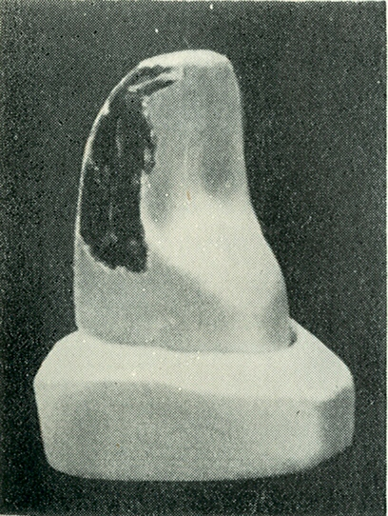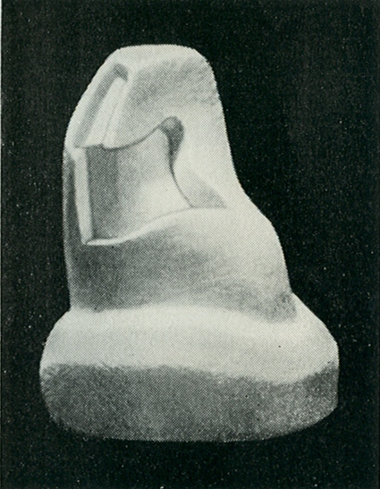
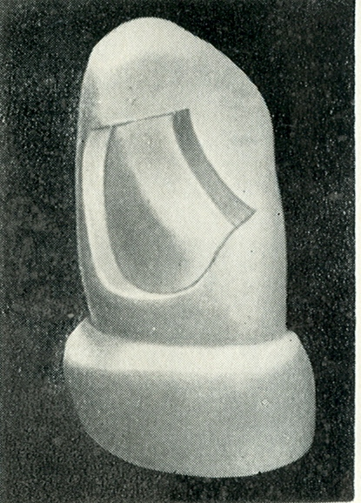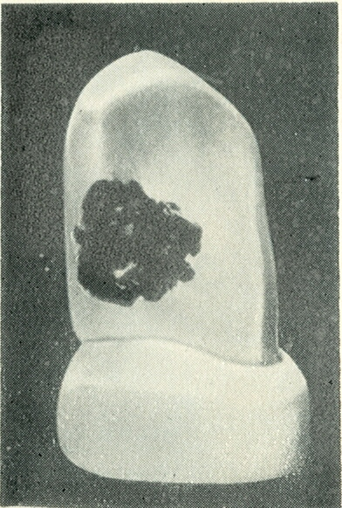

Тechnique of preparing of carious cavities of ІІІ of class by Black in
temporal and permanent teeth with the uncompleted forming of root depending on the depth of defeat a caries and of material for stopping.

Primary teeth
Taking into account the anatomic features of structure of frontal temporal teeth, preparing of carious cavities of ІІІ of class, their opening conduct from a vestibular cavity.
At presence of access of forming of cavities of ІІІ of class conduct as a triangle.

The permanent teeth are with the uncompleted forming of root
At maintenance of dental row access to caries cavities is formed from a langual ( palatal) surface with her next preparing. The classic preparing of caries cavities ІІІ to the class is conducted with maximal maintenance of enamel on a lip surface forming of additional grounds on a palatal surface
At the stored pulp of cavity of ІІІ of class prepare as an oval, taking into account the anatomic form of pulpal chamber. It is important, that walls and bottom of caries cavities were formed at right angles.
To adhere to all principles of preparing of carious cavity, extraordinarily carefully to behave to the tissues of tooth, shut out heat burs. During preparing carefully delete the softened or colored dentine on walls and day of carious cavity
walls of carious cavity carefully prepare to the dense, dentine not changed in color, preparing of bottom conduct carefully a power-shovel and spherical coniferous forest of corresponding size at the small turns of drill. It follows extraordinarily carefully to delete changedthe softened dentine especially пігментований from the walls of carious cavity, only in the places of offspurs of pulp it is possible to leave the small layer of the softened dentine.

At the split defeat of pin and lip or pin and palatal surface of chisels and canines of preparing of carious cavity make out of the most destroyed surface. An additional cavity is created by carving to the enamel within the limits of superficial layers of dentine from a lip and palatal surface.
If a carious cavity appeared on medial and lateralsurfaces, forming of cavity needs to be conducted on each separately. If necessary will form additional grounds, connecting which is not recommended, because probability of break crown increases.
At the deep cavities of III of class with destruction of lip and language surfaces an enamel is carved and form cavity, transient in lip and langual surfaces. In parallel instances expedient creation of the additional deepening is as debatable fossulas in direction of cutting edge and also cutting in приясневій and lateral walls of cavity by means of wheel-shaped or small spherical bur.
Form the cavities of III of class with the use of cone-shaped or fissure bur.

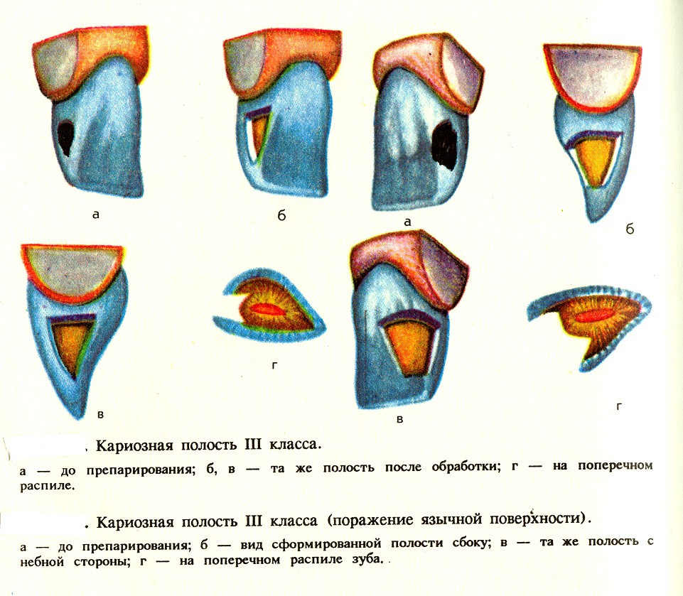

Technique of preparing of carious cavities of ІV of class after Блеком in
temporal and permanent teeth with the uncompleted forming of root depending on the depth of defeat a caries and of material for stopping.
Primary teeth
Class of IV. For children the defects of this class are practically observed only at the complicated caries.
Preparing of carious cavities on the hard tissues of temporal teeth has a row of features, hard tissues which are above pulp related to the skim near location, in connection with it by pulp of chamber, mildness and pliability of hard tissues of temporal teeth. Preparing on hard tissues primary teeth must be very careful, without considerable efforts and pressure, irregular. It is necessary to remember that temporal teeth are less in size from permanent, that is why creation of additional planes, ledges, notches and cutting not always maybe children have plate and circular forms of caries which also creates the row of difficulties during preparing of atypical carious cavities often. Basic principles and rules of preparing of carious cavities of temporal teeth for children suchas well as carious cavities of the second teeth for children.

Carious cavity of ІV of class - on a lip surface
Preparing of cavities of IV of class :
At forming of cavities of IV of class, except a basic cavity form additional. A basic cavity is formed as a triangle, as a cavity of III of class. Additional grounds create as a tail of swallow or intentional point. Carving the hard tissues of tooth is necessary very prudently.
At opening cavities use spherical or by the fissure coniferous forest with the next substituting by a reverse cone for forming of bottom. An additional ground must occupy third of language surface of tooth no less.
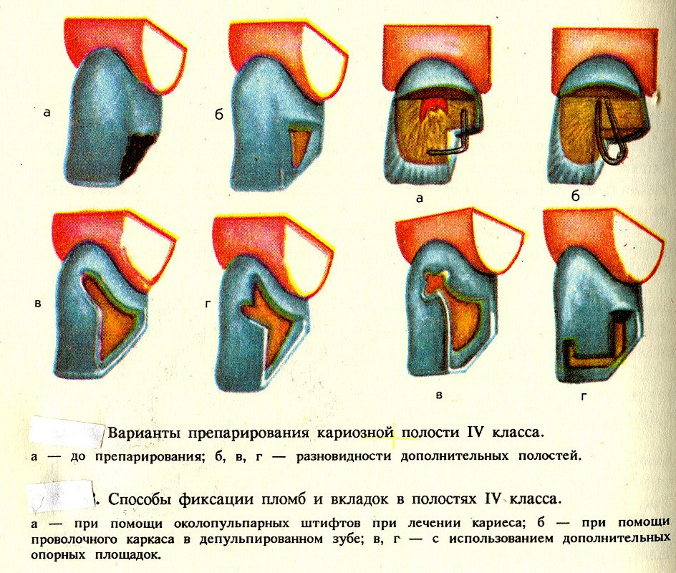
If the corner of crown of the tooth is destroyed insignificantly and as a result of elimination of tooth a plane appeared instead of cutting edge. That an additional ground can be created along this edge by the thin fissure coniferous forest with maintenance, cut to the dentine along an enamel.

Literature.
1.Терапевтическая стоматология детского возраста. Хоменко Л.А., Чайковский Ю.Б., Савичук А.В., Савичук Н.О. и др.// К.:«Книга плюс» - 2013. – p. 267-345.
2.Ніколішин А.К.Терапевтична стоматологія. Том 1// Полтава: «Дивосвіт» - 2012. – p. 76-98.
3.Nikhil Marwah. Textbook of pediatric dentistry.//New Delhi: Jaypee Brothers Medical Publishers. 2011, p. 65-69.
4.Christian H.Splieth. Revolutions in pediatric dentistry //Quintessence Publishing Company, Incorporated: - 2011. – p.7 6-78.
5.David M. Sullivan. Manual of Pediatric dentistry //Lexi-Comp Incorporated,- 2012- p. 54-63.

