ODESSA NATIONAL MEDICAL UNIVERSITY
DEPARTMENT OF NORMAL AND PATHOLOGIC CLINICAL ANATOMY

Methodical Instruction for Lesson

Theme. CONCLUSIVE LESSON ABOUT ANATOMY OF SENSE ORGANS

Medical Faculty

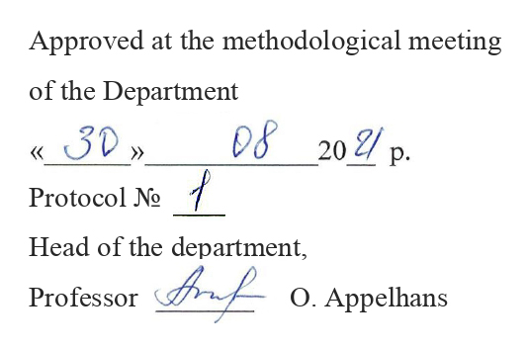
Methodical Instruction for Lesson

Theme. CONCLUSIVE LESSON ABOUT ANATOMY OF SENSE ORGANS

Professional orientation for student: The Human organism gets irritations from the environment and from all the life-support systems of the internal environment. Processes of perception, differentiation and response reactions are provided by such important systems of organism, as the CNS and system of sense organs. Therefore any external affectation of these departments leads to the disbalance of connections, and results in development of different diseases and serious complications.

Aim: The material from practical classes and notes from the lecture are used to strengthen theoretical and practical skills on this section. A student must demonstrate ability to see the general lines of structure of these system and their distinctive features at implementation of certain functions. A student must on specimens and on a corpse, show departments of sense organs, and also to designate their functions.

The student should know:
1. Latin terminology of this theme.
2. Classification of sense organs
3. Concept of an analyzer.
4. Morphological and functional characteristics and pathway of different analyzers
5. Phylo- and onto- genesis of sense-organs.
6. Anomalies and variants of development of sense organs.
7. Age-dependent features of the sense organs.
8. Clinical methods of research of sense organs.

The student should be able:
1. To show and name the olfactory area of the nose.
2. To show localization and specify function of lingual papillae.
3. To show the localization of neurons of all tracts concerned with skin sense.
4. To indicate the cortical ends of all of types of skin sense on specimens of the brain.
5. To show on specimens the lobules of mammary gland, lactiferous ducts.
6. To show and describe the receptor, conducting tracts and cortical areas of olfactory analyzer.
7. To show and describe the receptor, conducting tracts and cortical areas of taste analyzer.
8. On specimens of eye point to and describe every tunics of the eyeball.
9. On a corpse and charts to show and describe the auxiliary apparatus of the eye.
10. On specimens, to describe the nucleus of the eyeball. To show the eye chambers.
11. On charts and pictures, to trace the pathway of visual analyzer.
12. On specimens of brain, to point at the subcortical centers of sight.
13. On charts and pictures, to trace pathway of the pupillary reflex.
14. On a skull, to show topographic structures in which the elements of visual pathway and pupillary reflex are located.
15. To show on a skull the petrosal part of temporal bone, opening of internal acoustic meatus, facial canal, and roof of tympanic cavity.
16. To show the localization of the nuclei of auditory and vestibular analyzers.
17. To show on skull and brain, the place of entrance (output) of vestibulocochlear nerve.
18. To show localization of cortical end of auditory analyzer in the brain.
19. To show localization of cortical end of static and kinetic analyzer in the brain.

To answer orally these questions with demonstration on natural specimens , models, charts:
1. Phylo- and onto- genesis of sense organs.
2. Subcortical centers of sense (midbrain and diencephalon).
3. Cortical centers of all of types of sense, their localization and characteristics.
4. The skin and its structure. Derivatives of skin (hairs, nails, glands). Mammary gland.
5. Organ of smell: structure, functions.
6. Localization and function of lingual papillae.
7. Cortical centers of taste and smell, their localization and characteristics.
8. Eye: structure, topography.
9. Auxiliary, protective, and motor structures of the eye (extrinsic muscles of the eyeball).
10. Lacrimal apparatus of the eye. Place of production and route of outflow of tear.
11. Capsule of eyeball (tunics), its parts, structure, functions.
12. Eyeball, its anatomical structure. Fibrous tunic of eyeball.
13. Vascular tunic, its parts, structure, functions. Accommodation apparatus of the eye.
14. Retina of eye. Its morphological and functional characteristics.
15. Nucleus of eyeball (lens, vitreous body). Refractive media of eyeball.
16. Chambers of eyeball, their borders, connections. Production and routes of circulation of aqueous humor of chambers.
17. Localization and characteristics of subcortical and cortical centers of vision.
18. Ear: its parts. External ear (auricle, external acoustic meatus, tympanic membrane).
19. Middle ear (tympanic cavity, ossicles, auditory tube).
20. Internal ear, anatomical departments.
21. Bony labyrinth. Perilymph – production and routes of circulation.
22. Membranous labyrinth. Endolymph – production and routes of circulation.
23. Structure of spiral organ.
24. Pathway of transmission of sound vibrations.
25. Anomalies and teratosis of sense organs.
26. Age-dependent features of sense organs.
27. Basic clinical methods of research of sense organs.

References:
а) basic
1. Gray's Anatomy for Students / Richard L. Drake Ph.D, A. Wayne Vogl, Adam W.M. Mitchell, - 2010, 2092 p .
2. Clinically Oriented Anatomy / by Keith L. Moore, Anne M. R. Agur, 2013 .
3. Atlas of Human Anatomy / Frank H. Netter,- 5 edition, - 2011 by Saunders, an Imprint of Elsevior Inc .
4. Materials preparation for lectures 6. Materials preparation for practical classes
b) additional
1. Lecture .
2. Human anatomy & physiology / Elaine N. Marieb, Katja Hoehn., San Francisco : Benjamin Cummings, 2010., 8th edition .
3. "Human Anatomy", V.G.Koveshnikov, 2011
4 "Atlas of Human Anatomy", Sobotta, 2010
5 "A Color Atlas of Human Anatomy", R.M.H.McMinn, R.T.Hutchings, J.Pegington, 2006
6 "Gray's Anatomy", Henry Gray F.R.S., 2001

NEXT TOPIC: Review and GENERAL characteristics of cranial nerves. olFactory, optic, oculomotor, abducent and trochlear nerves.
TrigeRminal nerve. 1st and 2nd branches of trigeminal nerve

