SIW Theme 7. Management of a patient with dyspnea.

- Give the definition of the symptom of dyspnea -

____________________________________________________________________________________________

____________________________________________________________________________________________

- What types of shortness of breath do you know?
____________________________________________________________________________________________
____________________________________________________________________________________________

- Name the diseases, accompanied by symptom of shortness of breath
____________________________________________________________________________________________

____________________________________________________________________________________________

- What are the main pathogenetic mechanisms of dyspnea in various diseases
____________________________________________________________________________________________

____________________________________________________________________________________________

____________________________________________________________________________________________

____________________________________________________________________________________________

- Clinical task

Patient R., 48 years old, driver, went to a general practice doctor with complaints on shortness of breath, cough

with purulent sputum, fever up to 37,5°C, sweating, headache, general weakness. Coughs for 20 years, first dry,
then with a small amount of purulent sputum, which volume is gradually increased. Was not treated. The last 5
years, mainly in spring and autumn (after cooling), due to increase of the cough began the increase of body
temperature to 37,2°C. The present deterioration within 2 weeks, when after cooling, increased cough with
expectoration of purulent sputum, fever up to 37,5°C. Appealed to the doctor in the clinic. Bad habits - smokingfor

20 years 1-1. 5 pack of cigarettes a day. Objectively: the condition is satisfactory. Skin is cyanotic, high humidity.
The rib cage is expanded in the anteroposterior direction. Percussion over the lungs sounds with box shade.
Auscultation: on the weakening of breath are heard scattered dry and moist rales on exhalation. From the side of
other organs and systems - without features.
What is a preliminary diagnosis?

____________________________________________________________________________________________

____________________________________________________________________________________________

- What laboratory and instrumental methods of examinations will you designate in presented clinical case
____________________________________________________________________________________________

____________________________________________________________________________________________

____________________________________________________________________________________________

- Describe the presented ECG:
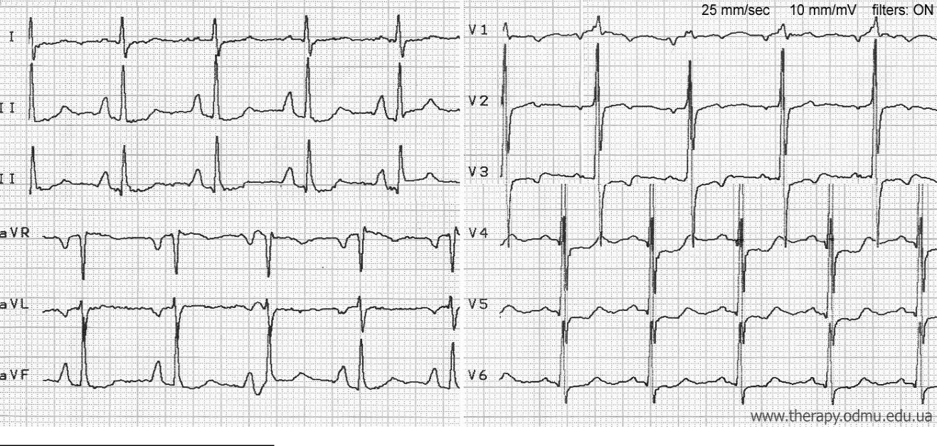

*Homework assignement is written and translated by prof. Kovalevska LA.

- Differential-diagnostic signs of dyspnea due to heart and respiratory failure

Signs | Heart failure | Respiratory failure

Nature of dyspnea

Cyanosis

Percussion data

Auscultation data

Type of respiratory function
violation

ECG-signs

Laboratory signs

- What is the difference between paroxysmal and constant shortness of breath?

____________________________________________________________________________________________

____________________________________________________________________________________________

- Describe the presented X-ray:
