Theme №13: Management of patient with syndrome of bronchial obstruction *

- Specify the criteria of obstructive spirometry and restrictive spirometry (FVC, FEV1, FEV1/ FVC ratio) Obstructive:

Restrictive:

2. Fill to table the signs of the degree of severity of COPD

COPD severity degree | COPD signs
I, mild | -FEV1/FVC<70%
 | -FEV1 80% from proper parameters. Usually, but not always, chronic cough, sputum
II, moderate

III, severe

IV, very severe

3. Complete differential diagnostic criteria in the table

Features | Chronic obstructive bronchitis | Bronchial asthma
Allergy
Heredity
Cough |  | Predominantly paroxysmal
Shortness of breathe | Constant, increased during
 | exacerbations
Daily changes of FEV1 |  | More than 15% from proper
Reverse of obstruction | Not likely
Eosinophilia
Sputum | Presence of macrophages,
 | neutrophils
Edema of the bronchial | Variable
mucosa
Smooth muscle of the |  | Hypertrophy at the level of large

bronchi
airways

4. Describe any changes on spirometry . Is this a restrictive or obstructive pattern?
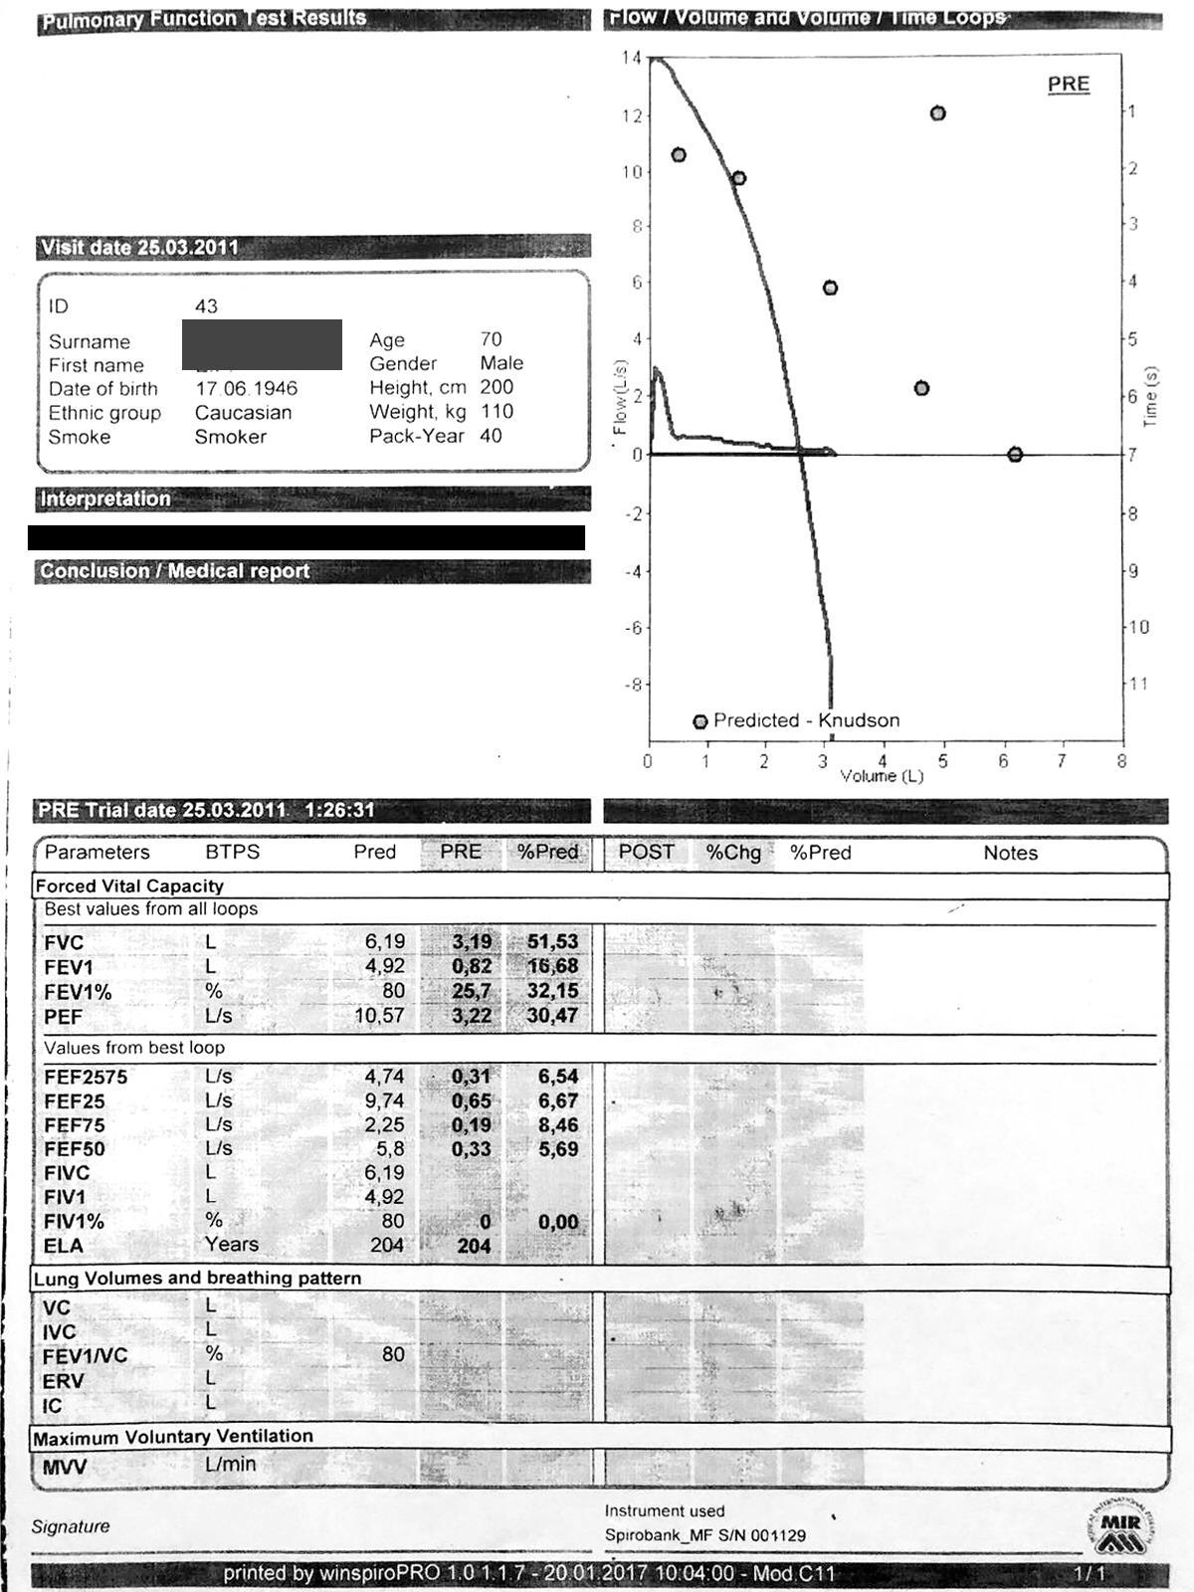

- Patient N., whose spirometry is presented above has CAT scores of 18 and three moderate exacerbation in the past year.

How he would be labelled in GOLD (Grade? Group?) Write the treatment plan for this patient.

