ODESSA NATIONAL MEDICAL UNIVERSITY
Department of Biophysics, Informatics and Medical Equipment

METHODOLOGICAL DEVELOPMENT

IWS
From the discipline "European Standard of Computer Literacy»

Topic: Logical operations Predicates

APPROVED
at the meeting of the department
"30" _August_ 2022_, protocol №1
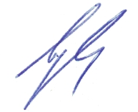

Head of the department, prof. Godlevsky L.S.

Odesa - 2022-2023

Logical operations
Predicate

A predicate is a boolean function whose value may be true or false, depending on the arguments to the predicate.
- Predicates are a generalization of propositional variables.
- A propositional variable is a predicate with no arguments.
Example - Consider the following boolean propositions:
A (Adam is tall)
B (Beth is tall)
C (Carl is tall)
:
Z (Zeke is tall)

We need a different proposition for each person; each of these propositions is either true or false.
We can capture the same set of truth values using a single predicate (or boolean function), Tall(x).
Tall(x) is true whenever person x is tall, and is false otherwise.
- Tall(Adam) is true if proposition A above is true.
- Tall(Beth) is true if proposition B above is true.
- Tall(Carl) is true if proposition C above is true.
Predicates are atomic operands in the logical expressions of predicate logic.

A predicate is a symbol which represents a property or a relation.
In the semantics of logic, predicates are interpreted as relations. For instance, in a standard semantics for first-order logic, the formula R(a,b)} would be true on an interpretation if the entities denoted by a and b stand in the relation denoted by R. Since predicates are non-logical symbol, they can denote different relations depending on the interpretation used to interpret them. While first-order logic only includes predicates which apply to individual constants, other logics may allow predicates which apply to other predicates.

Quantifiers
All we want to know about a given proposition A (Adam is tall) is whether A is true or false.
Given a predicate such as Tall(x), we want to know whether Tall(x) is true for different values of x.
In addition, we might like to know whether Tall(x) is true for every possible value of x, or whether Tall(x) is true for some value of x.
Predicate logic has two additional operators not found in propositional logic (called quantifiers) to express these truth values about predicates.
- Existential quantifier E (there exists): (E x) Tall(x) is true if there exists some value for x such that Tall(x) is true.
- Universal quantifier A (for all): (A x) Tall(x) is true if Tall(x) is true for all values of x.

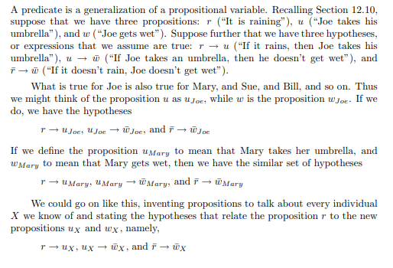
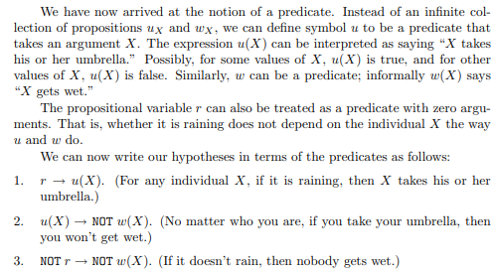

Java examples of chained predicates and to perform ‘logical AND‘ and ‘logical OR‘ operations and collect the elements into a list.

1. Predicate.and() – Logical AND example
In given example, we have used Predicate.and() method which returns a composed predicate that represents a short-circuiting logical AND of this predicate and another.
When evaluating the composed predicate, if first predicate is false, then the other predicate is not evaluated.
Any exceptions thrown during evaluation of either predicate are relayed to the caller; if evaluation of first predicate throws an exception, the other predicate will not be evaluated.

Predicate.and() example
import java.util.Arrays;
import java.util.List;
import java.util.function.Predicate;
import java.util.stream.Collectors;

public class Main
{
public static void main(String[] args)
{
List<Employee> employeesList = Arrays.asList(
new Employee(1, "Alex", 100),
new Employee(2, "Brian", 200),
new Employee(3, "Charles", 300),
new Employee(4, "David", 400),
new Employee(5, "Edward", 500),
new Employee(6, "Frank", 600)
);

Predicate<Employee> idLessThan4 = e -> e.getId() < 4;

Predicate<Employee> salaryGreaterThan200 = e -> e.getSalary() > 200;

List<Employee> filteredEmployees = employeesList.stream()
.filter( idLessThan4.and( salaryGreaterThan200 ) )
.collect(Collectors.toList());

System.out.println(filteredEmployees);
}
}
Program output.
Console
[Employee [id=3, name=Charles, salary=300.0]]

2. Predicate.or() – Logical OR example
In given example, we have used Predicate.or() method which returns a composed predicate that represents a short-circuiting logical OR of given predicate and another predicate.
When evaluating the composed predicate, if first predicate is true, then the other predicate is not evaluated.
Any exceptions thrown during evaluation of either predicate are relayed to the caller; if evaluation of first predicate throws an exception, the other predicate will not be evaluated.
Predicate.or() example
import java.util.Arrays;
import java.util.List;
import java.util.function.Predicate;
import java.util.stream.Collectors;

public class Main
{
public static void main(String[] args)
{
List<Employee> employeesList = Arrays.asList(
new Employee(1, "Alex", 100),
new Employee(2, "Brian", 200),
new Employee(3, "Charles", 300),
new Employee(4, "David", 400),
new Employee(5, "Edward", 500),
new Employee(6, "Frank", 600)
);

Predicate<Employee> idLessThan2 = e -> e.getId() < 2;

Predicate<Employee> salaryGreaterThan500 = e -> e.getSalary() > 500;

List<Employee> filteredEmployees = employeesList.stream()
.filter( idLessThan2.or( salaryGreaterThan500 ) )
.collect(Collectors.toList());

System.out.println(filteredEmployees);
}
}
Program output.
Console
[Employee [id=1, name=Alex, salary=100.0],
Employee [id=6, name=Frank, salary=600.0]]
Java stream chained predicates equivalent to logical operators between predicates.

Formal Language theory

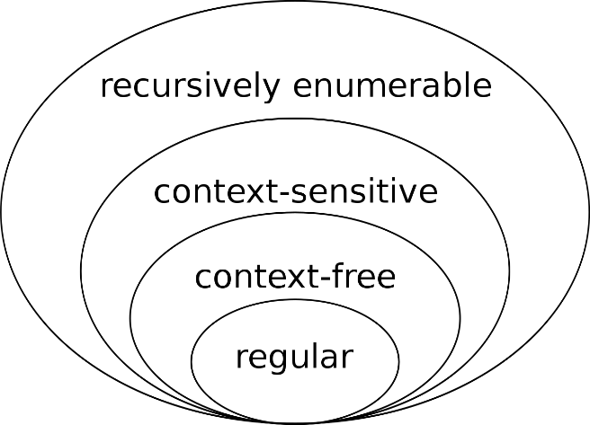
Formal Language theory is a branch of mathematics concerned with describing languages as a set of operations over an alphabet. It is closely linked with automata theory, as automata are used to generate and recognize formal languages. There are several classes of formal languages, each allowing more complex language specification than the one before it, i.e. Chomsky hierarchy, and each corresponding to a class of automata which recognizes it. Because automata are used as models for computation, formal languages are the preferred mode of specification for any problem that must be computed

In mathematics, computer science, and linguistics, a formal language consists of words whose letters are taken from an alphabet and are well-formed according to a specific set of rules.
The alphabet of a formal language consists of symbols, letters, or tokens that concatenate into strings of the language. Each string concatenated from symbols of this alphabet is called a word, and the words that belong to a particular formal language are sometimes called well-formed words or well-formed formulas. A formal language is often defined by means of a formal grammar such as a regular grammar or context-free grammar, which consists of its formation rules.
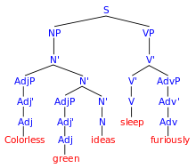
The field of formal language theory studies primarily the purely syntactical aspects of such languages—that is, their internal structural patterns. Formal language theory sprang out of linguistics, as a way of understanding the syntactic regularities of natural languages. In computer science, formal languages are used among others as the basis for defining the grammar of programming languages and formalized versions of subsets of natural languages in which the words of the language represent concepts that are associated with particular meanings or semantics. In computational complexity theory, decision problems are typically defined as formal languages, and complexity classes are defined as the sets of the formal languages that can be parsed by machines with limited computational power. In logic and the foundations of mathematics, formal languages are used to represent the syntax of axiomatic systems, and mathematical formalism is the philosophy that all of mathematics can be reduced to the syntactic manipulation of formal languages in this way.

The first formal language is thought to be the one used by Gottlob Frege in his Begriffsschrift (1879), literally meaning "concept writing", and which Frege described as a "formal language of pure thought."[2]
Axel Thue's early semi-Thue system, which can be used for rewriting strings, was influential on formal grammars.

Words over an alphabet
An alphabet, in the context of formal languages, can be any set, although it often makes sense to use an alphabet in the usual sense of the word, or more generally a character set such as ASCII or Unicode. The elements of an alphabet are called its letters. An alphabet may contain an infinite number of elements;[note 1] however, most definitions in formal language theory specify alphabets with a finite number of elements, and most results apply only to them.
A word over an alphabet can be any finite sequence (i.e., string) of letters. The set of all words over an alphabet Σ is usually denoted by Σ* (using the Kleene star). The length of a word is the number of letters it is composed of. For any alphabet, there is only one word of length 0, the empty word, which is often denoted by e, ε, λ or even Λ. By concatenation one can combine two words to form a new word, whose length is the sum of the lengths of the original words. The result of concatenating a word with the empty word is the original word.
In some applications, especially in logic, the alphabet is also known as the vocabulary and words are known as formulas or sentences; this breaks the letter/word metaphor and replaces it by a word/sentence metaphor.

Definition
A formal language L over an alphabet Σ is a subset of Σ*, that is, a set of words over that alphabet. Sometimes the sets of words are grouped into expressions, whereas rules and constraints may be formulated for the creation of 'well-formed expressions'.
In computer science and mathematics, which do not usually deal with natural languages, the adjective "formal" is often omitted as redundant.
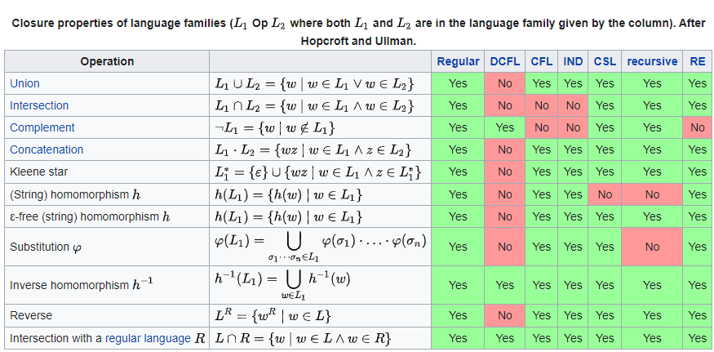
While formal language theory usually concerns itself with formal languages that are described by some syntactical rules, the actual definition of the concept "formal language" is only as above: a (possibly infinite) set of finite-length strings composed from a given alphabet, no more and no less. In practice, there are many languages that can be described by rules, such as regular languages or context-free languages. The notion of a formal grammar may be closer to the intuitive concept of a "language," one described by syntactic rules. By an abuse of the definition, a particular formal language is often thought of as being equipped with a formal grammar that describes it.
/

Programming languages
A compiler usually has two distinct components. A lexical analyzer, sometimes generated by a tool like lex, identifies the tokens of the programming language grammar, e.g. identifiers or keywords, numeric and string literals, punctuation and operator symbols, which are themselves specified by a simpler formal language, usually by means of regular expressions. At the most basic conceptual level, a parser, sometimes generated by a parser generator like yacc, attempts to decide if the source program is syntactically valid, that is if it is well formed with respect to the programming language grammar for which the compiler was built.
Of course, compilers do more than just parse the source code – they usually translate it into some executable format. Because of this, a parser usually outputs more than a yes/no answer, typically an abstract syntax tree. This is used by subsequent stages of the compiler to eventually generate an executable containing machine code that runs directly on the hardware, or some intermediate code that requires a virtual machine to execute.

Formal theories, systems, and proofs
/
This diagram shows the syntactic divisions within a formal system. Strings of symbols may be broadly divided into nonsense and well-formed formulas. The set of well-formed formulas is divided into theorems and non-theorems.
In mathematical logic, a formal theory is a set of sentences expressed in a formal language.
A formal system (also called a logical calculus, or a logical system) consists of a formal language together with a deductive apparatus (also called a deductive system). The deductive apparatus may consist of a set of transformation rules, which may be interpreted as valid rules of inference, or a set of axioms, or have both. A formal system is used to derive one expression from one or more other expressions. Although a formal language can be identified with its formulas, a formal system cannot be likewise identified by its theorems. Two formal systems may have all the same theorems and yet differ in some significant proof-theoretic way (a formula A may be a syntactic consequence of a formula B in one but not another for instance).
A formal proof or derivation is a finite sequence of well-formed formulas (which may be interpreted as sentences, or propositions) each of which is an axiom or follows from the preceding formulas in the sequence by a rule of inference. The last sentence in the sequence is a theorem of a formal system. Formal proofs are useful because their theorems can be interpreted as true propositions.

Interpretations and models
Formal languages are entirely syntactic in nature but may be given semantics that give meaning to the elements of the language. For instance, in mathematical logic, the set of possible formulas of a particular logic is a formal language, and an interpretation assigns a meaning to each of the formulas—usually, a truth value.
The study of interpretations of formal languages is called formal semantics. In mathematical logic, this is often done in terms of model theory. In model theory, the terms that occur in a formula are interpreted as objects within mathematical structures, and fixed compositional interpretation rules determine how the truth value of the formula can be derived from the interpretation of its terms; a model for a formula is an interpretation of terms such that the formula becomes true.

Basic predicate
A basic predicate compares two values or compares a set of values with another set of values.
expressioncomparison-operatorexpressionrow-value-expressioncomparison-operatorrow-value-expressionboolean-expression
comparison-operator
= <> 1 < > <= 1 >= 1
Notes:
- ¹ See Alternative forms.
The six comparison operators can effectively be expressed based on just two of the comparison operators. If the predicate operands are x and y, then the other four comparison operators can be expressed using the following alternative predicates.
Predicate | Alternative predicate
x <> y | NOT (x = y)
x > y | y < x
x <= y | x < y OR x = y
x >= y | y < x OR x = y
Table 1. Predicates and alternative predicates
When the predicate operands are specified as an expression, the data types of the expressions must be comparable. If the value of either operand is null, the result of the predicate is unknown. Otherwise the result is either true or false.
Predicate (with operand values x and y) | Boolean value | If and Only If...
x = y | is True | x is equal to y
x < y | is True | x is less than y
x = y | is False | x is not equal to y
x < y | is False | x = y is True or y < x is True
Table 2. Predicate evaluation with scalar operands
When the predicate operands are specified as a row-value-expression, they must have the same number of fields and the data types of the corresponding fields of the operands must be comparable. The result of the comparison is based on comparisons of the corresponding fields in the row-value-expression operands.
Predicate (with operand values Rx and Ry that have fields Rxi and Ryi where 0 < i < number of fields) | Boolean value | If and Only If...
Rx = Ry | is True | All pairs of corresponding value expressions are equal (Rxi = Ryi is True for all values of i).
Rx < Ry | is True | The first N pairs of corresponding value expressions are equal and the next pair has the left value expression less than the right value expression for some value of N (Rxi = Ryi is True for all values of i < n and Rxn < Ryn is True for some value of n).
Rx = Ry | is False | At least one pair of corresponding value expressions are not equal (NOT (Rxi = Ryi) is True for some value of i).
Rx < Ry | is False | All pairs of corresponding value expressions are equal (Rx = Ry is True) or the first N pairs of corresponding value expressions are equal and the next pair has the right value expression less than the left value expression for some value of N (Rxi = Ryi is True for all values of i < n and Ryn < Rxn is True for some value of n).
Rx comparison operator Ry | is Unknown | The comparison is neither True nor False.
Table 3. Predicate evaluation with row operands

Boolean values
You can use a basic predicate to compare a Boolean value with another Boolean value or with a value of a data type that can be cast to a Boolean value. A value of TRUE is greater than a value of FALSE. For example:
- TRUE = 'on' is TRUE
- DECFLOAT(4.3) = TRUE is TRUE
- '0' <= FALSE is TRUE
- 'yes' <= FALSE is FALSE

Alternative forms
For the comparison operators <>, <=, and >=, alternative forms are also supported. (The forms ¬=, ¬<, and ¬> are supported only in code pages 437, 819, and 850.) Support for these alternative forms is intended only to accommodate existing SQL statements; these forms are not recommended for new SQL statements.
Comparison Operator | Alternative Forms
<> | ^= != ¬=
<= | ^> !> ¬>
>= | ^< !< ¬<

Examples:
EMPNO='528671'
SALARY < 20000
PRSTAFF <> :VAR1
SALARY > (SELECT AVG(SALARY) FROM EMPLOYEE)
(YEARVAL, MONTHVAL) >= (2009, 10)

Recommended Literature

Basic
- Mobile Medicine and General Trends in Medical Informatics / Godlevsky L.S., O.N. Nenova, K.A. Bidnyuk, T.L. Godlevska, A.B. Buzinovsky // Applied medical informatics.- 2016 Vol. 38, No. 1.- P. 49-52.
- Оn the automatic laparoscopic diagnostics of liver state with Haar’s features based cascade and modified Adaboost classifiers / D.N.Bayazitov, N.V. Kresyun, A.B.Buzynovsky et al. //Pathology (Zaporizhia)2017.- 14, № 2(40).- С.182-187.
- The effectiveness of surgeon decision on pain syndrome of pelvic origin treatment women estimated with the model of decision tree /A.B.Buzinovsky, O.S.Kovalenko, N.R.Bayazitov, L.S.Godlevsky //Cybernetics and computer technology.- 2018.- №2(192).- С.60-72.
- Lubliner David J. Biomedical Informatics: An Introduction to Information Systems and Software in Medicine and Health / David J. Lubliner // Auerbach Publications. – 2015. – 434
- Nanette B. Health Information Management Technology: An Applied Approach / B. Nanette // American Helath Information Management Association. – 2016. – 5th ed. – 686 p.
- Mervat Abdelhak. Health Information: Management of a Strategic Resource, / Mervat Abdelhak, Mary Alice Hanken // Saunders. – 2015. – 5th edition. – 800 p.
- Hebda T. L. Handbook of Informatics for Nurses & Healthcare Professionals / T. L. Hebda, P. Czar // Kindle Edition. – 2012. – 5th Edition. – 624 p.

Supplementary
- Barry M.J., Edgman-Levitan S. Shared decision making: pinnacle of patient-centered care/ M.J.Barry, S.Edgman-Levitan // N Engl J Med. – 2012.- Vol.366.- P.780–781.
- Clinical Scenarios in Surgery: Decision Making and Operative Technique (Clinical Scenariosin Surgery Series) First Edition by J.B. Dimick,‎ G.R. UpchurchJr.,‎ C.J. Sonnenday/ Lippincott, Williams and Wilkins, Walter Kluwers.- 2017.- 375 pp.
- Electronic Health Record: Standards, Coding Systems, Frameworks, and infrastructures/ P.K. Sinha, G.Sunder, P. Bendaleetal..- IEEE press. - 2012.- 202 p.
- Nanette B. Health Information Management Technology: An Applied Approach / B. Nanette // American Health Information Management Association. – 2016. – 5th ed. – 686 p.
- Mervat Abdelhak. Health Information: Management of a Strategic Resource, / Mervat Abdelhak, Mary Alice Hanken // Saunders. – 2015. – 5th edition. – 800 p.

Electronic resources:
- Medical Informatics: Computer Applications in Health Care and Biomedicine, 2011 // Electronic resource: https://www.amazon.com/Biomedical-Informatics-Computer-Applications-Biomedicine/dp/0387289860
- Handbook of Medical Informatics / J. H. Editors, V. Bemmel, M. A. Musen // http://www.mieur.nl/mihandbook; http://www.mihandbook.stanford.edu
- Mark A. Musen B. Handbook of Medical Informatics / Mark A. Musen B. // ftp://46.101.84.92/pdf12/handbook-of-medical-informatics.pdf
- Handbook of Biomedical Informatics. https://en.wikipedia.org/wiki/Book:Handbook_of_Biomedical_Informatics
- Biomedical Informatics, 2014 / H. Edward, J. Shortliffe, J. Cimino // http://www.rhc.ac.ir/Files/Download/pdf/nursingbooks/Biomedical%20Informatics%20Computer%20Applications%20in%20Health%20Care%20and%20Biomedicine2014%20-%20CD.pdf

Societies:
- U.S. Office of the National Coordinator for Health IT: http://www.healthcareitnews.com
- http://www.ecdl.org (The official site of the ECDL Foundation)
- https://support.office.com/uk-ua (Microsoft Office reference and training materials)
- http://windows.microsoft.com/uk-ua/windows/help (Reference and educational materials on working in the Microsoft Windows operating system)
- www.imia.org (International Association of Medical Informatics)
- www.mihandbook.stanford.edu (Medical Informatics, Stanford University)
- www.uacm.kharkov.ua (Ukrainian Association "Computer Medicine")
- www.mednavigator.net (Medical search engine)
- www.ncbi.nlm.nih.gov (US National Library of Medicine)
- www.medinfo.com.ua (Medical search system of Ukraine)

Journals:
- Journal of the American Medical Informatics Association: www.jamia.org
- Journals in the Field Biomedical Informatics: Healthcare Informatics www.healthcare-informatics.com

Free of Charge Medical Software:
- https://listoffreeware.com/free-ecg-viewer-software-windows (Free ECG software)
- https://www.researchgate.net/post/Is-there-any-ready-made-tool-box-available-to-analyze-ECG-signalhttps://www.adinstruments.com/products/ecg-analysis (Biosygnal effective analysis)
- https://www.researchgate.net/post/Which-free-software-is-available-for-qualitative-eeg-brianmapping (Analysis of EEG)
- https://www.frontiersin.org/articles/10.3389/fnins.2020.00710/full (EMG/EEG analysis)
- https://sccn.ucsd.edu/eeglab/index.php (EEG-lab,on-line EEG analysis)
- https://opensourcelibs.com/libs/eeg (104 open projects for EEG analysis)
- https://archive.physionet.org/physiotools/other.shtml (Free software for images analysis, recovery EEG from paper strips, and others)

