Odessa National Medical University
Department of Pharmacognosy

methodological developments
workshops
for full-time department faculty

Discipline: "Resursovedenie medicinal plants"
Session № 1 "Resursovedenie science and educational discipline.
resursoznavstvu of HR tasks. The plant world and its wealth. Effect phase of plant development and environmental factors on the formation and dynamics of the accumulation of active substances"

Course 3 Faculty of Pharmacy

approved by
in the methodical meeting of the Department
August 31, 2018
Protocol № 1
Head. Department of
________ prof.Rozhkovsky YV

Odessa 2018
Subject of practical lesson number 1: "Resursovedenie as science and academic discipline. resursoznavstvu of HR tasks. The plant world and its wealth. Effect stages of plant and environmental factors in the development environment for the formation and dynamics of the accumulation of the active ingredients' - (2 hrs.)

1. Background.Resources of medicinal plants is the subject of a special section knowledge - resursovedenie medicinal plants, which operates certain concepts, terms, solves a very important and relevant research questions, evaluation and management of natural resources of medicinal plants as a source of raw materials for domestic production of herbal medicines. Ukraine is incredibly rich in natural plant resources, in particular, medicinal plants, but in recent years their condition worsened, which is very negative impact on the development of the domestic pharmaceutical industry is. Therefore, it is relevant is not only to assess the current state of the natural resources of the Republic of Lithuania in Ukraine, but also to find ways to more effectively use them.

2. Lesson Objectives:
- to expand and consolidate the students' understanding of resursovedenie medicinal plants as a system of rational use of HR resources, its main provisions and terms;
- focus the knowledge of the richness of flora in the natural herbal drugs;
- learn how to conduct a qualitative assessment of natural herbal drugs in accordance with the possible influence of various environmental factors.

2.1. Learning Objectives:

-Know (the level of assimilation of Bespal'ko -II):
1. The object of study and main tasks resursovedenie LR;
2. Basic concepts and terms of discipline;
3. The contents of the theoretical and practical resursovedenie;
4. Current status of the raw materials base of the Republic of Latvia in Ukraine;
5. abiotic and biotic environmental factors that affect the quality of the natural herbal drugs (storage and content BAS)

- Be able to (mastering level -III):
1. Define the basic concepts and terms resursovedenie LR 2. On osnovі Jerel lіteraturi otsіnyuvati Suchasnyj camp prirodnoї sirovinnoї bazi specific vidіv LR;
3. Viznachati that otsіnyuvati mozhlivy vpliv specific faktorіv on yakіst prirodnoї RL vidіv scho traditsіyno zagotovlyuyutsya in Ukraїnі.

2.2. Educational goals:
contribute to the formation of ecological outlook and respect for nature; liability for future pharmacists the use of natural resources, LRS, to arouse interest in the study of HR resources in the region.
3. Interdisciplinary integration:
number  pp | discipline | Know | be able to
one. | previous  Medical botany | Phase of development, the environmental conditions of growth of medicinal plants; | To assess the current conditions of growth of specific types of LR
2. | pharmacognosy | The effect of various factors on the contents of the main storage and a bar RL | Choosing optimum blank areas and periods native RL
3. | Vnutrishnepredmetnaya integration (the topic of this discipline, which integrates that which is studied) ... | Resursovedenie as science and academic discipline.  The raw material base of medicinal plants in Ukraine.  The use of herbal medicines in the Republic of Lithuania and the modern world medical practice.  Accounting for medicinal plant resources, the principles of their management and protection.  Cultivation of Latvia in Ukraine and the world. | develop: on the harvesting instructions, drying and storage of raw wild higher plants, algae, lichens and fungi, newsletters; make reports for doctors and advise the public on matters related to the harvesting and use of raw materials and products of natural origin.

4. Content of the topic
The theoretical material topics outlined in the text of the lecture number 1, and the following sources of information:
1.Rozhkovsky YV, Derevinskaya TI Shevchenko IM, Fizor NS Resursovedenie medicinal plants. A manual for the 5th year students of Faculty of Pharmacy. - Odessa: ONMedU 2012.
2.Mіnarchenko VM, Sereda P.І. Resursoznavstvo. Lіkarskі Roslin: The Teaching-methodical posіbnik. K .: Fіtosotsіotsentr 2004.
3.Zuzuk BM Zuzuk LB Resursoznavstvo lіkarskih Roslyn. Pіdruchnik for stud.farmats.fakultetіv. -Vіnnitsya: NOVA BOOK 2009.

5. Plan and organizational structure of classes

number | The basic stages of employment,  their functions  and content | Ouch.  goals  in development levels | training and controls | Methodological materials. ensuring  and the control of knowledge | duration  min., or  %
one. | preliminary stage  Location -  training room.  Organizational measures. The wording of the objectives.  Control of initial level of knowledge and skills. | II |  | Methodological developments; test items | 1 minute.  2 minutes.  7 min.
2. | The main stage.  Location -  training room.  Carrying out practical work | II-III | Maps, slides,  herbaria,  background  and scientific literature | Methodical development -  "Resursoznavstvo medicinal plants. Laboratory Journal " | 130 min.
3. | The final stage.  Location -  training room.  Check final level of knowledge.  Inspection and assessment of practical skills.  Checking and signing of the protocols in the laboratory journal. Scoring  knowledge.  Summing up the lessons and homework wording. | II-III  II-III |  |  | 15 minutes.  10 min.  10 min.  5 minutes.

6. Materials of methodical maintenance of employment.

6.1. control materials for the preparatory phase of exercises

Test questions:
1. Remember that the plants we call drugs?
2.Navedit examples officinal herbal drugs, which is now widely used only from wild plants of the local flora.
4. What is the terminology used in pharmacy to determine the type of RL?
5. What factors influence the diversity and distribution of wild LR?
6. Basic concepts and definitions: herb (LR) medicinal herbs (RL) phytocoenosis; BAR.
7. Recent data on the status and dynamics of HR resources in Ukraine.

tests:
1. Complete definition of "medicinal plants - a plant that contain the biologically active substances are used, or may be used ...
A medicine as a medicinal plant material "
BA in medicine and pharmacy "
B. as a medicament "
G. as a source for the pharmaceutical industry "
D. therapeutic purposes. "

2. Of all the diverse flora of the Earth (500,000) of scientific medicine during its existence known and used around
A. 250 0000
B. 50000
B. 5000
G. 1000
D. 900

3. The main purpose of resursoznavskih research as part of Pharmacognosy are:
A search for new medicinal plants in local flora
B. Study and definition of reserves RL
B. Organization of the wild herbal drug preparations
G. Determination of existing substances in herbal drugs
D. Establishment of the RL identity

4. BAS accumulation in plants is influenced by various factors: geographical, environmental, climatic, physiological. Thus, the environmental factor is:
A. Phase Development
B. Age of the plants
B. Composition and soil moisture
G. Altitude
D. Geographic Latitude

5. Divide into groups (A, B abiotic-biotic, namely anthropogenic) impacts on the state of the Republic of Lithuania resources: drought (A); firearms lightning (A); firearms from burning stubble (B) through the raw material charge mer (B) drying bogs (B) logging (B).

6. At what level of accumulation of biologically active substances in plants of the nightshade family especially affect the nitrogen content in the soil?
A. Essential Oils
B. Cardiac glycosides
V. Alkaloids
G. saponin
D. Polysaccharides

7. What is the main factor considered when deciding on the optimum timing of the workpiece on the RL RL underground organs?
A. Soil moisture
B. Illumination habitat
V. vegetation period plants
G. The mechanical composition of the soil
D. Mechanisms for excavation of raw materials.

8. What is the main factor considered when deciding on the optimum dates blank essential oil RL - grass?
A. Illumination habitat
B. Humidity
B. Soil moisture
G. The mechanical composition of the soil
D. plant phenological stage

9. The term "grass" in Pharmacognosy and resursovedenii determine:
A. All herbaceous plants
B. grassy herbs
B. aerial parts of herbaceous LR
G. Elevated shoots horsetails, club mosses, grasses and some shrubs
D. cereals.

6.2. Materials of methodical maintenance of the main phase of occupation
Methods of operation, performing the steps of:
A) Determination of the object and the basic tasks resursovedeniya (processing textbooks)
B) Determination of the basic concepts and terms resursovedeniya medicinal plants (processing textbooks)
B) The content of theoretical and practical resursovedeniya (processing textbooks)
D) Assessment of the current state of the raw material base of the Republic of Lithuania in Ukraine (processing of scientific and reference books, vegetation maps, resource maps);
D) abiotic and biotic environmental factors that affect the quality of the natural herbal drugs (storage and content BAS) (treatment of educational and scientific literature).
E) Homework: Resursovedcheskie studies in Ukraine: the institution, the objects, the mechanism to achieve (treatment of textbooks). search for potentially valuable prospects for the Republic of Lithuania on Pharmacy phytochemical markers (treatment of educational and scientific literature).

List of educational and practical tasks to be carried out during the practical sessions:

Exercise 1. With the help of the recommended educational and reference books to conclude its own glossary of terms (concepts) in resursovedenii and give written answers to questions (fill in the table 1)
Table 1

Resursovedenie science

The term (concept), the question | Definition (content) response
one | 2
area
The biological reserve of the RL
Operating margin RL
Thickets, overgrown industrial LR
Herb-LR
Herbal drugs, herbal drugs
The population coenopopulations
plant resources
one | 2
"Grass"
Yields (stock density) RL
The purpose of research resursoznavchih
The main directions of research resursoznavchih
The content of the theoretical resursovedenie
The content of practical resursovedenie
Special use of natural resources of the Republic of Lithuania
The overall use of natural resources of the Republic of Lithuania
Homework:
Stages of development and achievements of Latvia in Ukraine resursovedeniya
Modern research areas potentially valuable for pharmacy LR

Task 2.With the help of the recommended scientific and reference literature to evaluate the current state of the natural resource base of specific types of medicinal plant raw materials and specify the factors that influence it. Response is made in Table 2.
The list of objects of study:herb St. John's wort; grass creeping thyme; chamomile flowers; bearberry leaves; leaves, fruits, blueberries; linden flowers; plantain leaves; buckthorn bark; grass Adonis spring; arnica flowers; valerian rhizomes with roots; rose hips fruits buckthorn; marshmallow root drug; herb marshmallow; rhizome; herb rosemary ordinary; Watch the leaves; cranberry fruit; leaves mother and stepmother. From this list, each student is offered 2 kinds.
Table 2.
The current state of the natural resources of medicinal plant raw materials in Ukraine

Name RL | Name of a plant source LSR | Factors that affect the state of resources | Assess the current state of resources
Eng. (Ukr.) | Lat. | Ros. (Ukr.) | Lat.

Task 3. Mark shown on a map, based on Ukraine (see. Fig. 1) the locus of industrial thickets of specific sources RL, who have experienced the negative impact of radioactive pollution.
The task is performed on the basis of the recommended scientific and educational literature and maps of radioactive contamination of the territory of Ukraine.
The list of objects of study:creeping thyme; blueberries; cranberries; cranberry; Ledum ordinary; Watch a three-sheeted; bearberry; galangal (tormentil) ordinary lily; St. John's wort; yarrow; mountaineer snake.

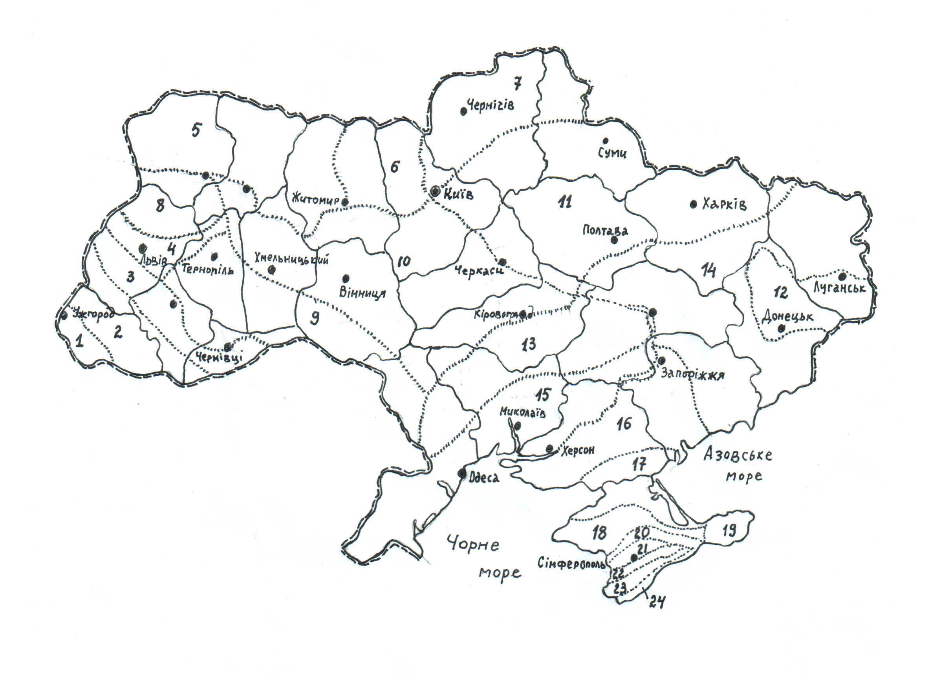
Fig. one.
locus ___ (LR name) ______ who have experienced the negative impact of radioactive contamination of the territory of Ukraine.

6.3. Materials control the final phase of occupation
Questions for self-control:
1. Definition resursovedenie as a science.
2. Value resursovedenie medicinal plants for pharmacy and medicine.
3. Subject resursovedenie study of medicinal plants.
4. The main objectives resursovedenie LR.
5. The theoretical aspect resursovedenie LR.
6. Contents of practical resursovedenie LR.

Tests and situational tasks:
1. The main purpose of resursovedcheskih research as part of Pharmacognosy are:
A search for new medicinal plants in local flora
B. Study and definition of reserves RL
B. Organization of the blanks wild herbal drugs
G. Determination of existing substances in herbal drugs
D. Establishment of the RL identity

2. For the first time the cultivation of medicinal plants for the needs of the domestic medicine in Ukraine became engaged in Lubny on orders
A. President of Ukraine
B. Ministry of the Medical Industry
V. Emperor Peter 1
G. Tsar Alexei Mikhailovich
D. Ministry of Health.

3. For special use of resources does not include harvesting of wild medicinal plant raw materials:
A. For Sale
B. For scientific purposes
B. In order to meet their own needs
G. Legal entities for industrial needs

4. BAS accumulation in plants is influenced by various factors: geographical, environmental, climatic, physiological. Thus, the environmental factor is:
A. Phase Development
B. Age of the plants
B. Composition and soil moisture
G. Altitude
D. Geographic Latitude

5. The maximum period of use of the results of evaluation of resources of wild herbal drugs
A. 2 years
B. 3 years
B. 5-7 years
G. 10 years
D. The term is not set

6. Resources of any kind from the above list are very vulnerable and are reduced due to the land reclamation activities:
A. Astragalus sherstistotsvetkovy
B. periwinkle
B. waterlily yellow
Watch a three-sheeted G.
Verba D. angustifolia

7. What is the main reason for the reduction of natural resources adonis spring, because of which he was listed in the Red Book of Ukraine:
A. Excessive operational load
B. Reclamation activities
B. Radioactive contamination of the territory
G. Destruction of cattle
D. Climate change

8. One of the reasons for the reduction of natural resources some of LR in Ukraine was the inability to use herbal drugs through contaminated with radionuclides due to the Chernobyl accident. Modern scientific evidence on various properties of plants to accumulate radionuclides.
Place in the degree of accumulation of radionuclides (from the highest to the smallest), such LR: cranberries; yarrow; Pulmonaria officinalis; oregano; bearberry; St. John's wort spotted; thyme; comfrey; Ham (camomile) formulation; Ledum ordinary. Explain how the resources of these plants suffer irreparable harm?
Answer: Ledum ordinary - cranberries - oregano - thyme - Pulmonaria officinalis - comfrey - bearberry - St. John's wort spotted - Yarrow - Ham (chamomile) drug.
9. Select from the provided list of crude drug such which are prepared from lower plants: thallus kelp (seaweed) thallus Iceland Moss (lichen), flax seeds; sumac leaves; Castor oil.
10. Select from a medicinal plant is provided list, which is obtained from fungi: Chaga; uterine horns; plantain leaves; Sophora fruit; yarrow.

6.4 Materials of methodical maintenance of self-students: orienting map for the organization of independent work of students with textbooks, Count of logical structure of employment and the like.

number | The main task | indication | Responses
one. | area | to define
2. | The biological reserve of the RL | to define
3. | Operating margin RL | to define
four. | Thickets, overgrown industrial LR | to define
five. | Herb-LR | to define
6. | Herbal drugs, herbal drugs | to define
7. | The population coenopopulations | to define
eight. | plant resources | to define
9. | Yields (stock density) RL | to define
ten. | The purpose of research resursoznavchih | to define
eleven. | The main directions of research resursoznavchih | to define
12. | The content of the theoretical resursovedenie | to define
13. | The content of practical resursovedenie | to define
14. | Special use of natural resources of the Republic of Lithuania | to define
15. | The overall use of natural resources of the Republic of Lithuania | to define

7. Literature teacher
1.Rozhkovsky YV, Derevinskaya TI Shevchenko IM, Fizor NS Resursovedenie medicinal plants. A manual for the 5th year students of Faculty of Pharmacy. - Odessa: ONMedU 2012.
2.Mіnarchenko VM, Sereda P.І. Resursoznavstvo. Lіkarskі Roslin: The Teaching-methodical posіbnik. K .: Fіtosotsіotsentr 2004.
3. Zuzuk BM Zuzuk LB Resursoznavstvo lіkarskih Roslyn. Pіdruchnik for stud.farmats.fakultetіv. -Vіnnitsya: NOVA BOOK 2009.
4. Medicinal raw materials of vegetable and animal origin. Farmakogonoziya: Study posobie.-Ed. G.P.Yakovleva. SPb .: SpetsLit 2006.
5. MіnarchenkoV.M., Timchenko І.A. Atlas lіkarskih Roslyn Ukraine (ekologіya, resources that receptionists). K .: Fіtosotsіotsentr 2002.
6. Wild Useful flora of the south of Ukraine: A Handbook. Lukyanchuk II, Popova EN, Yurgelaytis NG Odessa: AO Bakhvi 1996.
7. The determinant of higher plants Ukraine / Dobrochaeva DN, Kotov MG, Prokudin YN et al. -K .: Naukova dumka, 1987.
8. Medicinal plants of Ukraine / Ivashin DS, Katina ZF, Rybachuk NE and others. Yield .: 1986.
9. Atlas of areas and resources of medicinal plants of the USSR M .: GUGK, 1980.

8. Literature for students
Basic Operation
1. Resursovedenie medicinal plants. A manual for the 5th year students of Faculty of Pharmacy / Rozhkovsky YV, Derevinskaya TI Shevchenko IM, Fizor NS - Odessa: ONMedU, 2012. -S.5-12.
2. Mіnarchenko VM, Sereda P.І. Resursoznavstvo. Lіkarskі Roslyn. The Teaching-methodical posіbnik. -K .: Fіtosotsіotsentr, 2004. - S. 3-19.
3. Zuzuk BM Zuzuk LB Resursoznavstvo lіkarskih Roslyn. Pіdruchnik for stud.farmats.fakultetіv. -Vіnnitsya: NOVA BOOK, 2009.- S.5-15.

FIND FURTHER
1. Mіnarchenko VM, Timchenko І.A. Atlas lіkarskih Roslyn Ukraine (horologіya, resources that receptionists). - K .: Fіtosotsіotsentr, 2002. - S. 12 - 167.
2.Serbіn AG, L.M.Sіra, T.O.Slobodyanyuk. Farmatsevtichna botanіka. Pіdruchnik / Pid. Ed. L.M.Sіroї. Vinnitsa: Nova Book 2007.
3.Opredelitel higher plant Ukraine / Dobrochaeva DN, Kotov MG, Prokudin YN et al. -K .: Naukova dumka, 1987.
4. Atlas of areas and resources of medicinal plants of the USSR M .: GUGK, 1980.

9.Tema following classes: The raw material base of medicinal plants in Ukraine. Wild, cultivated the Republic of Lithuania in Ukraine. Papers and non-medicinal plants (4 hrs.)

Methodical development developed _______ al. Gerasimyuk NV

