ODESSA NATIONAL MEDICAL UNIVERSITY
Department of General and Clinical Epidemiology and Biosafety

I APPROVE
Head of Department
_____ (Kozishkurt OV)

“ August 27, 2021

METHODICAL DEVELOPMENT
OF THE INDEPENDENT STUDENTS’ WORK

Course IV Faculty of Dentistry

Course "CURRENT PROBLEMS OF HIV INFECTION"

Topic № 1: " HIV epidemic as a global process "

The independent students’ work was
developed by:
MD, Assoc.
__________ (Kozishkurt OV)

The independent students’ work is discussed at the methodical meeting of the department "27" August 2021
Protocol № 1

Odessa - 2021
1. The theme is “HIV epidemic as a global process” – 2 hours.
2. Importance of the theme – HIV infection is an infectious disease caused by human immunodeficiency virus (HIV), which demonstrates high tropism to immune system cells and may cause progressive failure of human immunity. Disease is characterized with long-lasting latent course and slow gradual progression from asymptomatic carrying to firm inconvertible damages of the immune system, which manifest with severe life threatening conditions, and without antiretroviral therapy patients die mostly from fatal opportunistic infections or malignancies.
3. Aims of the class
3.1. General aims – to study the epidemiological situation of HIV/AIDS in the world and Ukraine, Odessa region.
3.2. Educational aims: connect with formation of the actual questions of deontology and professional responsibility.
3.3. Specific aims:
To interpret epidemiologic and pathogenetic patterns of HIV-infection.
3.4. On the basis of the theoretical knowledge on the theme:
To be able:
- To interpret epidemiologic and pathogenetic patterns of HIV-infection.
4. Material for individual work (interdiscipline integration)
Discipline | To know | To be able
- Previous  Microbiology  Therapy  Infectious diseases  Medical statistic  Social medicine | Principles and method of different laboratory diagnostic of different infectious agents.  Methods of objective examination of the patients.  Etiology, pathogenesis, clinical manifestations, laboratory investigations and treatment.  Bases of medical statistic in medicine | To collect anamnesis, make up objective examination
2. Intradiscipline integration  Epidemiological process  Human (animal) being as a source of infection  Epidemiological diagnostics | Source of infection, mechanism of transmission and susceptible organism Antiepidemic measures  Methods of epidemiological diagnostics
3. Next discipline  Hospital surgery | Opportunity to infect the patient during medical manipulation | To make a plan of prophylaxis measures
5. Contents of the theme
HIV infection poses a global threat today. An estimated 33.3 million people are living with HIV/AIDS, and there are some 2.6 million new infections each year. Globally, HIV/ AIDS is the leading cause of mortality among women of reproductive age. Every day, more than 6800 people become infected with HIV and more than 5700 die, mostly because they have no access to HIV prevention, treatment and care services. Despite progress made in scaling up the response over the last decade, the HIV pandemic remains the most serious infectious disease challenge to global public health. Of eight key areas covered by the Millennium Development Goals, six - reduced poverty and child mortality, increased access to education, gender equality, improved maternal health and efforts to combat major infectious diseases – are being undermined by continuing transmission of HIV and its progression to AIDS.
Over the last years there have been major advances in our understanding of the epidemiology, molecular biology, pathogenesis, clinical management and prevention of HIV infection. Introduction of highly active antiretroviral therapy (HAART) has become a great achievement of clinical medicine. Optimal antiretroviral therapy (ART) increases the length and quality of life of HIV-infected patients, and reduces the onward transmission of the virus. But it is still unable to eliminate disease and to prevent infection globally. Disease remains poorly controlled in some developing countries. At global, national and local levels the HIV epidemic comprises a multitude of problems such as drug resistance, absence of vaccines for specific prevention and treatment of infection, poor availability of careful management and medical care in some regions with high level of morbidity, such as Sub-Saharan Africa. Therefore in such countries taken preventive measures have not significantly reduced the continuing spread of infection.
Effective control over HIV infection is in combining international medical, scientific, financial and humanitarian efforts to solve these problems.
The clinical effects of human immunodeficiency virus infection are diverse, ranging from an acute retroviral syndrome associated with primary HIV infection to a prolonged asymptomatic state to advanced HIV disease. Symptoms associated with acute HIV infection are nonspecific and may be attributed to any acute viral syndrome, such as flu, acute infectious mononucleosis, rubella and so on. Clinical manifestations of HIV-related diseases are extremely diverse. Despite remarkable advances in medical research, improving efficacy of laboratory diagnostics HIV infection remains difficult to diagnose. Early recognition and differential diagnoses of HIV/AIDS require considerable erudition from physicians of any specialization, experience, and extensive knowledge of all branches of clinical medicine to provide qualified medical care and essential treatment of patients. The background information on HIV infection, including the current epidemiologic situation in the world, strategies for HIV/AIDS control, and guidelines for the management of cases and contacts are needful for practical doctors, clinicians of any specialization and public health professionals. Knowledge of the practical aspects of clinical management and new scientific achievements in this field may improve local epidemic situation in any region and global HIV/AIDS control.
The purpose of this tutorial is to present the most current information available on the scope of the epidemic, on its pathogenesis, treatment, and prevention, and on prospects for vaccine development. Above all, the aim is to provide a solid scientific basis and practical clinical guidelines for a state-of-the-art approach to HIV-infected patients. The tutorial contains tests and tasks for self-assessment to improve learning of the presented information
HIV/AIDS Worldwide
HIV infection/AIDS is a global pandemic, with cases reported from virtually every country (see Fig. 1 in color insert).
In 2009, 33.3 million individuals were living with HIV infection (range: 31.4-35.3 million) according to the Joint United Nations Program on HIV/AIDS (UNAIDS). More than 95 % of people living with HIV/AIDS reside in low- and middle-income countries; - 50 % are female, and 2.1 million are children <15 years (Fig. 1).
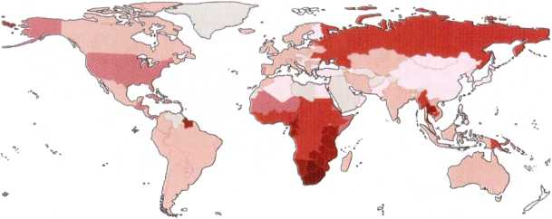
Fig.1. Global prevalence of HIV infection (Source: UNAIDS, 2009)
In 2009, there were an estimated 2.6 million new cases of HIV infection worldwide, including 370,000 in children <15 years. In 2009, global AIDS deaths totaled 1.8 million (including 260,000 children <15 years). According to UNAIDS statistics global HIV prevalence has been level since 2001. HIV incidence likely peaked in the late 1990s at > 3 million new infections per year. Recent reductions in global HIV incidence likely reflect natural trends in the pandemic as well as the results of prevention programs resulting in behavior change.

Tab.1. Global summary of the AIDS epidemic, 2009, 2015
 | 2009 | 2014 | 2015
Number of people living with HIV
Total  Adults  Women  Children under 15 years | 33.3 million [31.4-35.3 million]  30.8 million [29.2-32.6 million]  15.9 million [14.8-17.2 million]  2.5 million [1.6-3.4 million] | 36.9 million [34.3-41.4 million]  34.3 million [31.8-38.5 million]  17.4 million [16.1-20.0 million]  2.6 million [2.4-2.8 million] | 36.7 million [34.0-39.8 million]  34.9 million [32.4-37.9 million]  17.8 million [16.4-19.4 million]  1.8 million [1.5-2.0 million]
People newly infected with HIV
Total  Adults  Children under 15 years | 2.6 million [2.3-2.8 million]  2.2 million [2.0-2.4 million]  370 000[230 000-510 000] | 2.0 million [1.9-2.2 million]  1.8 million [1.7-2.0 million]  220 000 [190 000-260 000] | 2.1 million [1.8-2.4 million]  1.9 million [1.7-2.2 million]  150 000 [110 000-190 000]
AIDS deaths
Total  Adults  Children under 15 years | 1.8 million [1.6-2.1 million]  1.6 million [1.4-1.8 million]  260,000[150 000-360 000] | 1.2 million [980 000-1.6 million]  1.0 million [760 000-1.8 million]  150 000 [140 000-170 000] | 1.1 million [940 000-1.3 million]  1.0 million [840 000-1.2 million]  110 000 [84 000-130 000]
The HIV epidemic has occurred in “waves” in different regions of the world, each wave having somewhat different characteristics depending on the demographics of the country and region in question and the timing of the introduction of HIV into the population (see Fig. 10 in color insert). Although the AIDS epidemic was first recognized in the United States and shortly thereafter in Western Europe, it very likely began in Sub-Saharan Africa, which has been particularly devastated by the epidemic. More than two-thirds of all people with HIV infection (~ 22.5 million) live in that region, even though Sub-Saharan Africa is home to just 10-11% of the world’s population. Within the region, Southern Africa is worst affected. In eight Southern African countries, available seroprevalence data indicate that > 15% of the adult population aged 15-49 is HIV-infected. In addition, among high-risk individuals (e.g. commercial sex workers, patients attending STD clinics), who live in urban areas of Sub-Saharan Africa, seroprevalence is now > 50% in some countries. According to projections of the United Nations Population Division, life expectancies in several highly affected countries could drop to < 40 years, well below what they would have been without HIV /AIDS and below levels reached in the pre-AIDS era.
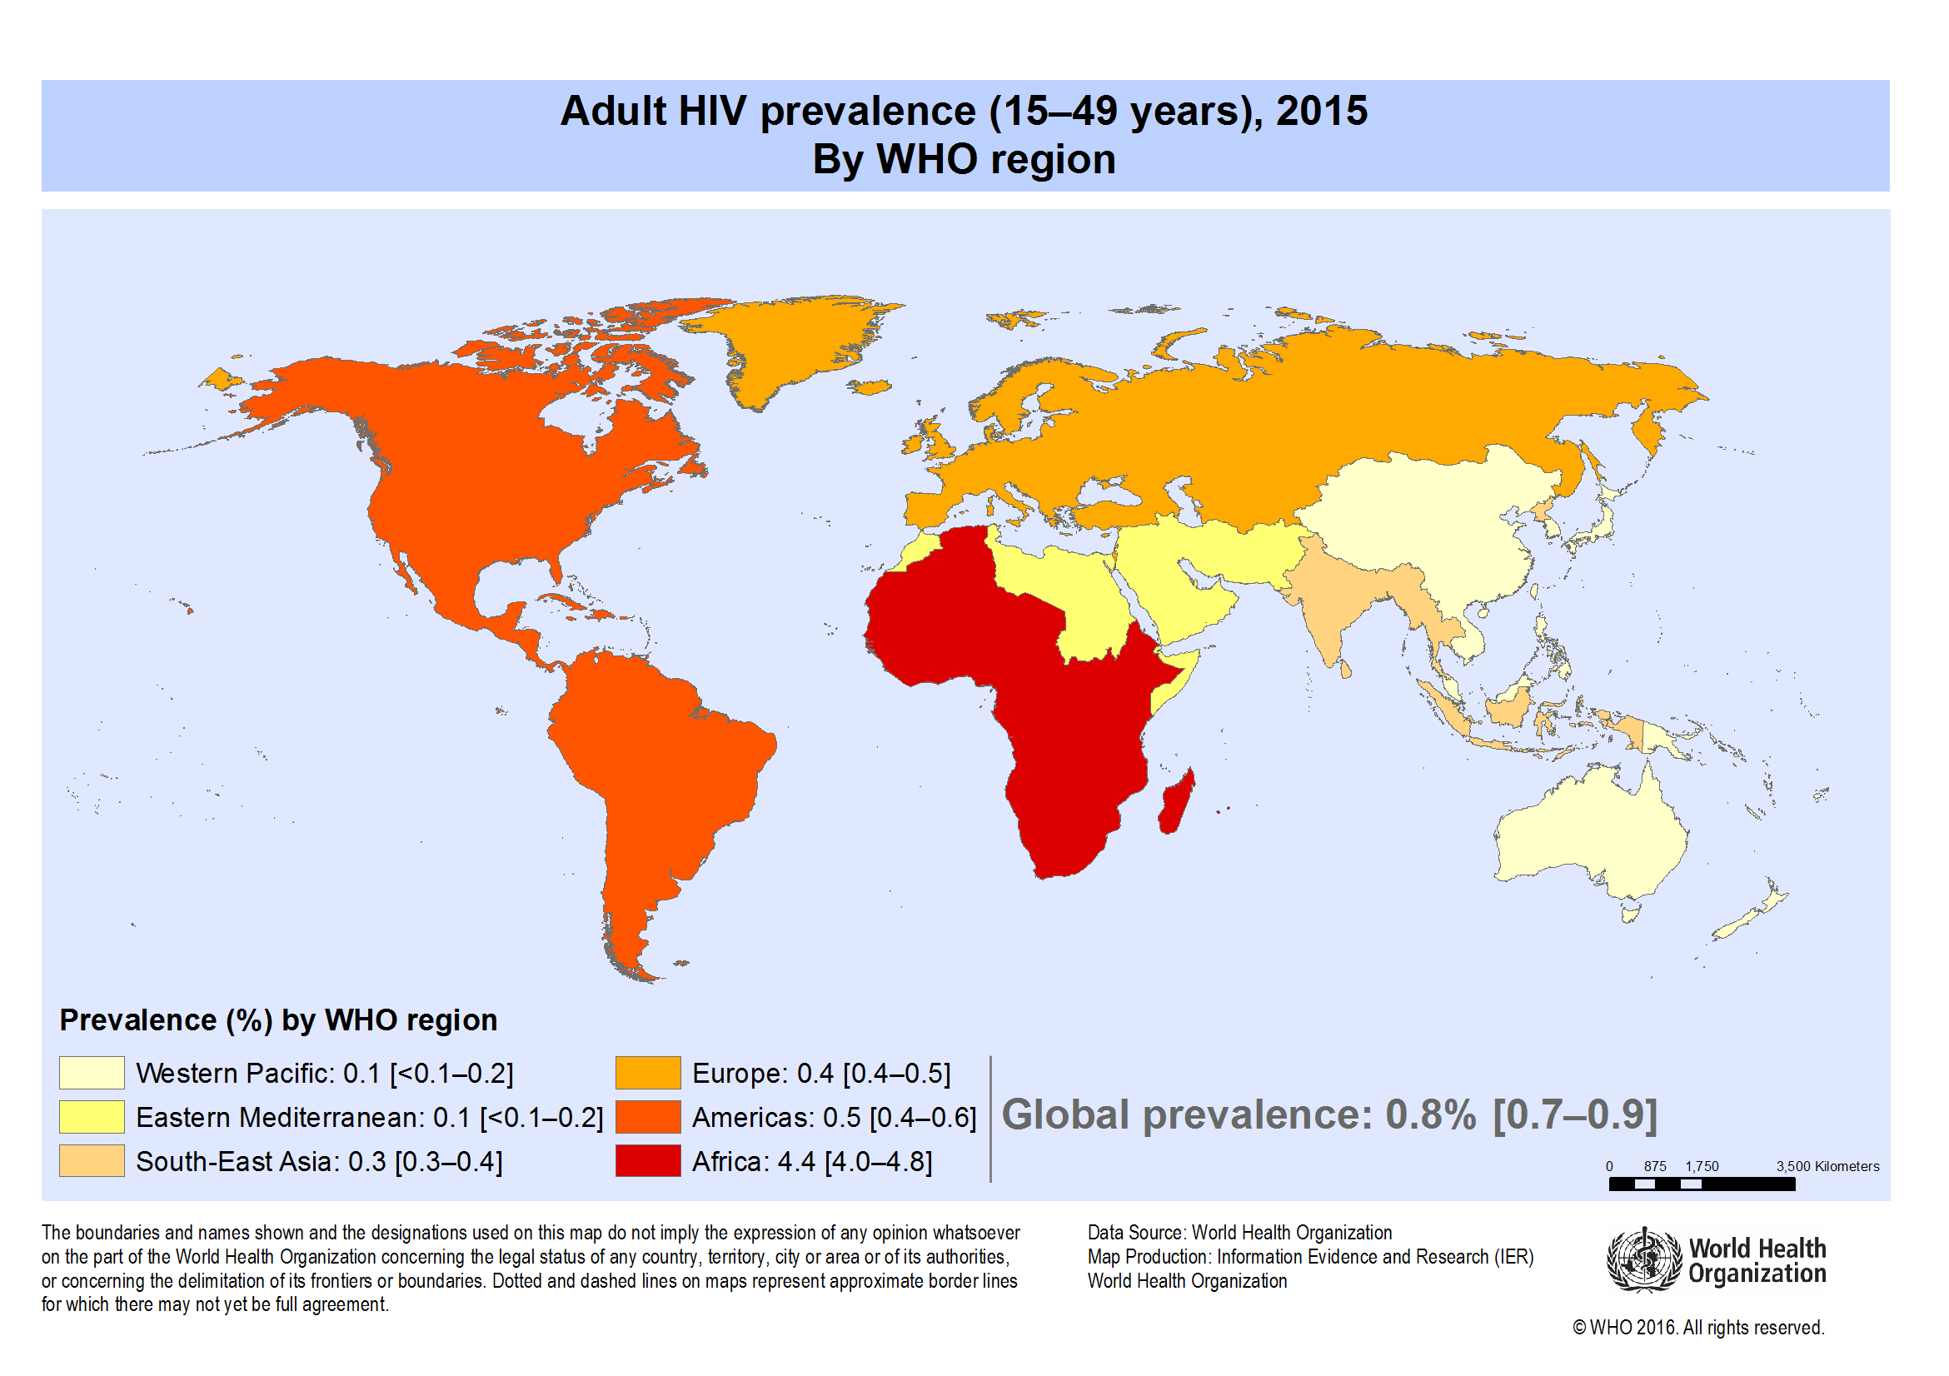
Fig.1a. World: Adult HIV prevalence (15-49 years), 2015 – By WHO region
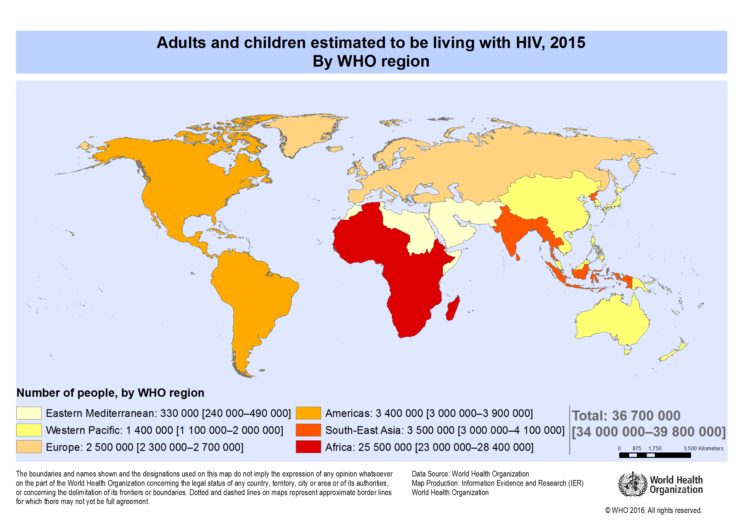
Fig.1b. World: Adults and children estimated to be living with HIV, 2015 – By WHO region
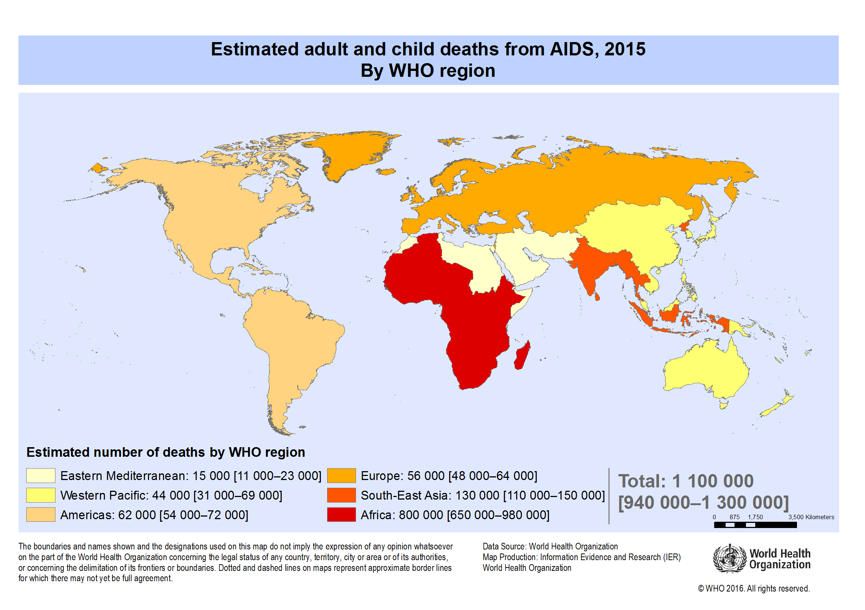
Fig.1c. World: Estimated adult and child deaths from AIDS, 2015 – By WHO region

The major mode of HIV transmission worldwide is heterosexual sex.

Tab.3. Regional HIV and AIDS statistics and features, 2014
 | Adults and children living with HIV | Adults and children newly infected with HIV | Adult prevalence  (15-49)[%] | Adult and child deaths due to AIDS
Sub-Saharan Africa | 25.8 million  [24.0-28.7 million] | 1.4 million  [1.2-1.5 million] | 4.8%  [4.5-5.1%] | 790 000  [670 000-990 000]
Middle East and North Africa | 240 000  [150 000-320 000] | 22 000  [13 000-33 000] | 0.1%  [<0.1-0.1%] | 12 000  [5 300-24 000]
Asia and the Pacific | 5.0 million  [4.5-5.6 million] | 340 000  [240 000-480 000] | 0.2%  [0.2-0.2%] | 240 000  [140 000-570 000]
Latin America | 1.7 million  [1.4-2.0 million] | 87 000  [70 000-100 000] | 0.4%  [0.4-0.5%] | 41 000  [30 000-82 000]
Caribbean | 280 000  [210-340 000] | 13 000  [9 600-17 000] | 1.1%  [0.9-1.3%] | 8 800  [5 700-13 000]
Eastern Europe and Central Asia | 1.5 million  [1.3-1.8 million] | 140 000  [110 000-160 000] | 0.9%  [0.7-1.0%] | 62 000  [34 000-140 000]
Western and Central Europe and North America | 2.4 million  [1.5-3.5 million] | 85 000  [48 000-130 000] | 0.3%  [0.2-0.5%] | 26 000  [11 000-86 000]
TOTAL | 36.9 million  [34.3-41.4 million] | 2.0 million  [1.9-2.2 million] | 0.8%  [0.7-0.9%] | 1.2 million  [980 000-1.6 million]
HIV/AIDS in Ukraine
The HIV/AIDS epidemic situation in Ukraine continues to worsen. Driven initially by injection drug use and increasingly by heterosexual transmission, the number of new infections in this region has increased dramatically over the past decade. According to the Joint United Nations Program on HIV/AIDS (UNAIDS) Ukraine is currently referred to as one of the countries demonstrating the highest HIV incidence rate in Europe and Central Asia.
According to the Ministry of Health of Ukraine, more than 161,119 HIV infection cases were recorded in the country as of late 2009. In 2009, 19,840 new HIV infection cases were recorded in Ukraine (43.2 per 100,000 population). HIV prevalence in Ukraine is estimated at 1.3% and annual HIV diagnoses in the country have more than doubled since 2001.
Although the number of newly recorded HIV infection cases has increased annually since 1999, a decrease in the growth rate of this indicator has been observed during 2006-2009: 16.8%, 10.5%, 7.6%, and 5.7%, respectively. These data prove the decreasing intensity of the HIV/AIDS epidemic process in Ukraine. Of all officially recorded HIV cases among Ukrainian citizens since the beginning of the epidemic, 101,182 people (220.9 per 100,000 population) were under clinical observation as of 1.1.2010, including 11,827 with diagnosed AIDS (25.8 per 100,000 population). It is universally recognized that official data do not reflect the real scale of the HIV/AIDS epidemic in Ukraine, particularly the real number of HIV-infected people. Data only provide information on people who have been tested for HIV antibodies, in whom HIV infection was found, and who were entered into the official national register of HIV infection cases. A considerably larger number of Ukrainians may be infected but are not aware of their status. Updated HIV/AIDS estimates for Ukraine show that 360,000 HIV-infected people aged 15 and over were living in Ukraine at the beginning of 2010. These data differ from official statistics of the number of people living with HIV/AIDS and under clinical observation in specialized health facilities (101,182) at the beginning of 2010. The difference between these indicators proves that only 28% of people living with HIV in Ukraine, or every fourth individual, has received an HIV test and knows his or her HIV-positive status. These data are a result of the latest national assessment of the HIV/AIDS situation in Ukraine as of early 2009. A considerable number of national and international organizations involved in the HIV/AIDS epidemic monitoring process in Ukraine contributed to generation of this assessment, which became a component of the global assessment of HIV/AIDS as of the end of 2009. The estimated data will be used as forecasts to calculate the number of HIV-infected people in need of treatment, care and support. Along with routine epidemiological surveillance, a modern method of epidemiological HIV surveillance - second generation HIV surveillance (SES) – has been implemented in Ukraine since 1997. Results of sentinel epidemiological studies in 2008-2009 revealed high rates of HIV infection among representatives of at-risk groups.
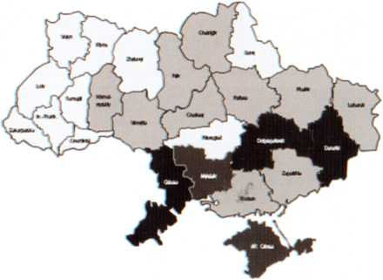

Number of registered cases
 | <1,000
 | 1,000-3,999
 | 4,000-8,999
 | >9,000

* - Data on the number of officially registered cases of HIV infection currently under medical care at the regional level in Ukraine as of July 01, 2007
Fig.2. HIV infection in Ukrainian region (Source: UNAIDS, 2007 AIDS epidemic update)

Distribution of HIV infection in Ukrainian regions is presented in (see Fig. 2 in color insert). National HIV prevalence is highest in Donetsk, Dnipropetrovsk, Mykolaiv, Ode- sa regions, and Crimea (Ukrainian AIDS Center, 2007). The relative proportions of HIV transmission routes in Ukraine are: 40.1% – sharing needles with infected persons (among IV IDUs); 38.4% – sexual transmission; 19.4% – maternal- fetal/infant transmission; 2.1% – unknown. Between 39% and 50% of the estimated 375,000 people who inject drugs in Ukraine are living with HIV.

6. Information necessary for consolidation of initial knowledge can be found:
1. Vinograd N.O. General epidemiology./ Vinograd N.O. – Ukraine. – 2014. – 128p.
2. Infectious Disease in General Medical Practice. Edited by G.Goseph Marr.M.D. Addison-Wesley Publishing Company. 1982. – 879p.
3. Infectious Disorders. Professional Care Guide. Springhouse, Pennsylvania, 1995, – 280p.
4. Principles and practice of infectious diseases (third edition) Gerald L. Mandell, M.D.R. Gordon Douglas, G.M.D.John E. Bennett, M.D. USA. – 1990. – 1837p.
5. Park’s textbook of preventive and social medicine.1997. – 629 p.
6. Голубовська О.А. HIV Infection – ВІЛ-інфекція /О.А. Голубовська, О.А. Гудзенко, І.В. Шестакова. – К.: ВСВ «Медицина». - 2011. – 288 с.
7. The Global HIV_AIDS Epidemic _ The Henry J. Kaiser Family Foundation.html
8. http://www.unaids.org/sites/default/files/media_asset/20150714_epi_core_en.ppt
9. http://www.who.int/hiv/data/epi_core_2016.png
10. http://www.who.int/hiv/pub/arv/global-AIDS-update-2016_en.pdf
6.1. Orient chart on individual work with literature sources
№№ | Main tasks | Instructions | Answers
№№ | To learn | To specify | Answers
1. | To study literature for the theme «HIV epidemic as a global process». | The study of literature: main and additional literature.
2. | To be able to make up a plan of epidemiological investigation of the patients, plan of prophylactic measures. | To be able to exam, to make up a plan of the epidemiological inves-tigation of the patients, plan of prophylactic measures.

The aid was composed by the lecturer
of the department of general and clinical
epidemiology and biosafety of ONMedU Yu.A.Maxymenko

