ODESA NATIONAL MEDICAL UNIVERSITY

DEPARTMENT OF PHYSIOLOGY

METHODICAL DESIGNATIONS
to independent work for students (IWS)

Academic discipline Physiology
Section "Physiology of HNA, labor activity and sensory systems"
Topic Physiology of sensory systems’

Class IWS «Physiology of the auditory and vestibular sensory systems»

Course II Faculty pharmaceutical

Methodical development is discussed and
accepted at the methodical meeting of the department

«17» 06 2021 .
Report № 14

The Head of the Physiology Department, The Honored Worker of the Science and
Technique of the Ukraine , Doctor of Medical Sciences,
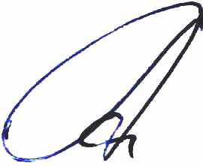

Professor __________ О.А. Shandra

Оdessa – 2021

Section "Physiology of HNA, labor activity and sensory systems"
Topic Physiology of sensory systems

Class IWS «Physiology of the auditory and vestibular sensory systems»

1. Relevance of the topic. Knowledge of the physiology of the auditory and vestibular analyzer and ability to conduct its research by simple clinical methods allow doctors to differentiate physiological and pathological phenomena associated with the functioning of the auditory and vestibulary systems.

2.. General objectives: learn the modern definition of :
-- Structural and functional organisation of the auditory sensory system, the main and the additional structures.
- The conducting and cortical departments of the auditory sensory system.
-The central mechanisms of the analysis of the sound information. Theory of the sound perception. Binaural audition.
-Structural and functional organisation of the vestibular sensory system. The receptor , conducting and cortical departments.
- The perception of the position of the head in space and in motion.

3. Interdisciplinary integration..
Disciplines | To know | To be able to
1.Previous disciplines:  Anatomy  Histology | Anatomical structures that form the human visual system.  Histological structures that form the human visual system. | Name anatomic structures that form the human visual system.  Show under the microscope the histological structures that form the human visual system.
2. The following disciplines:  ENT  Psychiatry | Innervation of the ear  Functional (hysterical) sensory disorders | Reveal the syndroms of the ear injury  Differentiate the organic and functional sensory disorders
3.Intradisciplinary integration:  Physiology of the CNS | The main principles of the coordinating function of the CNS | Explain the mechanism of the integrative function of the CNS

4. Materials for gaining professional knowledge, skills:
List of educational practical tasks which must be executed during practical classes :
- Determination of the bone conduction of the sound (Webers research)
- Determination of the bone and air conduction of the sound (Rinnes research)

4.1. Method for determination of the bone conduction of the sound (Webers research)
For work are needed: tuning fork, rubber tube, cotton swab.
The object of the research a person.
Work process. A person sits on a chair and the tuning folk is attached to the middle part of the parietal area. Under normal conditions a person hears the sound of the equal strength with both ears. Then one ear is closed by a cotton swab and the research is repeated. A person notes that now he can hear the sound much better with the ear that is closed by a cotton swab. This intensification of the sound is due to the irritation of the apparatus that perceives the sound conducting apparatus of one of the ears.To make sure that the part of the sound energy disperses in the condition of passing through the external auditory meatus it is necessary to connect the external auditory meatuses with the rubber tube and to put the tuning fork on the head to 2 persons. Under these conditions the first person will hear a sound due to the spreading of the sound waves from the external auditory meatus of the another person.
The results of work and their formalisation.. The received data are written into the record and compared with the indexes in different patients.

Method of determination of bone and air conduction of the sound (Rinnes research)
For work is needed a tuning folk.
The object of the research a person.
Work process. A person sits on a chair and the tuning folk is attached to the mastoid. Under normal conditions a person hears a sound that is slowly fading. As soon as the sound disappears ,the tuning fork is set to the ear. The sound appears again. Under the conditions of the unjury of the sound conducting apparatus there is a phenomena  a sound of the tuning fork is not heard when it is located near the external auditory meatus, but it is heard when the tuning fork is transferred to the mastoid.
The results of the work and their formalisation. The received data are written into the record and compared with the indexes in different patients.

5.Materials for self control of gaining knowledge, skills, abilities are provided by this work:
  - Structural and logical scheme of the subject of the topic:

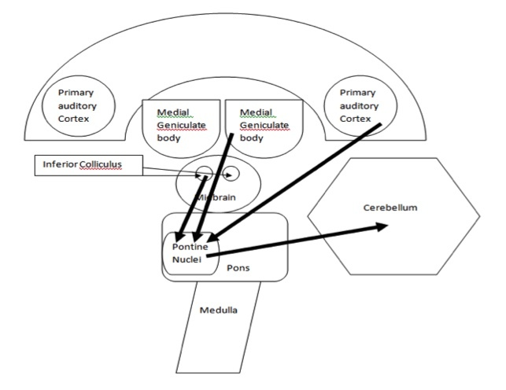
- All needed information for the formation of knowledge and skills you can find in the books:

The main literature:

- Moroz V.M. / Physiology : [textbook] / V.M. Moroz, O.A. Shandra. – 2016. – P. 8–12.
- Guyton A. Textbook of Medical Physiology / John E. Hall., A. Guyton – [12th International ed.]. – Philadelphia : Saunders Elsevier, 2011. – 1091 p.
- Human Movement, Structure and Function / Nigel Palastanga, Roger Soames. – 6th ed., 2012. – P.32–38.
- Blakemore SJ, Wolpert D, Frith C. 2000. Why can't you tickle yourself? Neuroreport 11: R11-6
- Bushdid C, Magnasco MO, Vosshall LB, Keller A. 2014. Humans Can Discriminate More than trillion Olfactory Stimuli. Science (New York, N.Y 343: 1370-72
- Goodwin AW, Macefield VG, Bisley JW. 1997. Encoding of object curvature by tactile
afferents from human fingers. Journal of neurophysiology 78: 2881-8
- Haddad R, Lanjuin A, Madisen L, Zeng HK, Murthy VN, Uchida N. 2013. Olfactory cortical
neurons read out a relative time code in the olfactory bulb. Nature neuroscience 16: 949-
U227
- Kaas JH. 1983. What, if anything, is SI? Organization of first somatosensory area of cortex.
Physiological Reviews 63: 206-31

6.2 Approximate map for the organization of the independent work with educational literature:

№ | The main tasks | Designations | Answers
 | The conception of the auditory sensory system. | The meaning of the auditory system in perception of the world.
 | Structural and functional organisation of the auditory system. | To draw a scheme of the structure of the sensory system.
 | The central mechanisms of analyses of the sound information. | The theory of sound perception.
 | Perception of the positiion of the head in the space and during motion. | Binaural audition.

6.3. Materials for the control of the preparatory stage of knowledge:
Questions for the preparation to the class:
1.Draw the scheme of the auditory analyzer and point on it the main structures
2.Draw the scheme of the helix structure.
3.Describe the electrical phenomena in the helix.
4.Describe the sound sensation: mode(tonality) and volume, auditory sensitivity, binaural audition.
5.Draw the scheme of the afferent and efferent connections of the vestibular system.
6.Draw the scheme of the construction of the otolithic apparatus.
7.Describe the motional reactions of th vestibular analyzer.

7.Materials for self control of gaining knowledge, skills, abilities are provided by this work:
7.1. Tests:

1 A patient consulted a doctor about loss of taste at the root of tongue. The doctor established that this was due to a nerve damage. What nerve was damaged?
A.Supralaryngeal
B.Trigeminal
C.Vagus
D.Facial
E.Glossopharyngeal

2.Cerebral hemorrhage caused serious disturbance of taste sensibility. What brain structure is most likely to be damged?
A.Hippocampus
B.Substantia nigra
C.Amygdaloid body
D.Postcentral gyrus
E.Hypothalamus

3.In course of an experiment thalamocortical tracts of an experimental animal were cut through. The animal didnt lose the following sensations:
A.Exteroceptive
B.Auditory
C.Olfactory
D.Visual
E.Nociceptive

4.A patient has been prescribed the salt-free diet. What changes to the salt taste sensitivity threshold should be expected?
A.No changes
B.Increase
C.Increase followed by a decrease
D.Decrease
E.Little change

5.A patient has an acute painfullness of face skin. What nerve is damaged?
A.Trigeminal
B.Vagus
C.Facial
D.Glossopharyngeal
E.Oculomotor

6. Four months ago a 43 year old patient had a traumatic amputation of his lower extremity. Now he complains of sensing the amputated extremity and having constantly grave, sometimes unbearable pain in it. What type of pain does he have?
A.Thalamic
B.Reflex
C.Causalgia
D.Neuralgia
E.Phantom

7. A patient has a haemorrhage into the posterior central gyrus. What type of sensitivity on the opposite side will be disturbed?
A.Skin and proprioceptive
B.Auditory
C.Auditory and visual
D.Olfactory
E.Visual

8. A man has normal sensitivity of his finger skin, however he doesn't sense his wedding ring around the finger. What process induced by wearing of the ring has caused this phenomenon?
A.Development of the fibrous tissue
B.Impaired circulation
C.Abnormality of the receptor structure
D.Receptor adaptation
E.Abnormality of the epidermis structure

9. During a neuro-surgical operation the occipital areas of cerebral cortex are stimulated. What sensations will the patient have?
A.Gustatory
B.Visual
C.Auditory
D.Tactile
E.Olfactory

10. While shifting the gaze to the closely situated object the refracting power of eyes optical mediums will increase by 10 diopters. It results from changing of such eye structure:
A.Lens
B.Vitreous body
C.Muscle that dilatates pupil
D.Liquid of the anterior chamber of eye
E.Cornea

Answer 1.Е, 2.D, 3.С, 4.D, 5.A, 6.E, 7.A, 8.D, 9.В, 10.A.

І11.1 Task for UDRS and NDRSA for the theme of the next class: «To write an essay about the base of the research of the central mechanisms of the acoustic information analyse.»

Methodical development made ass.Kopiova N.V.

