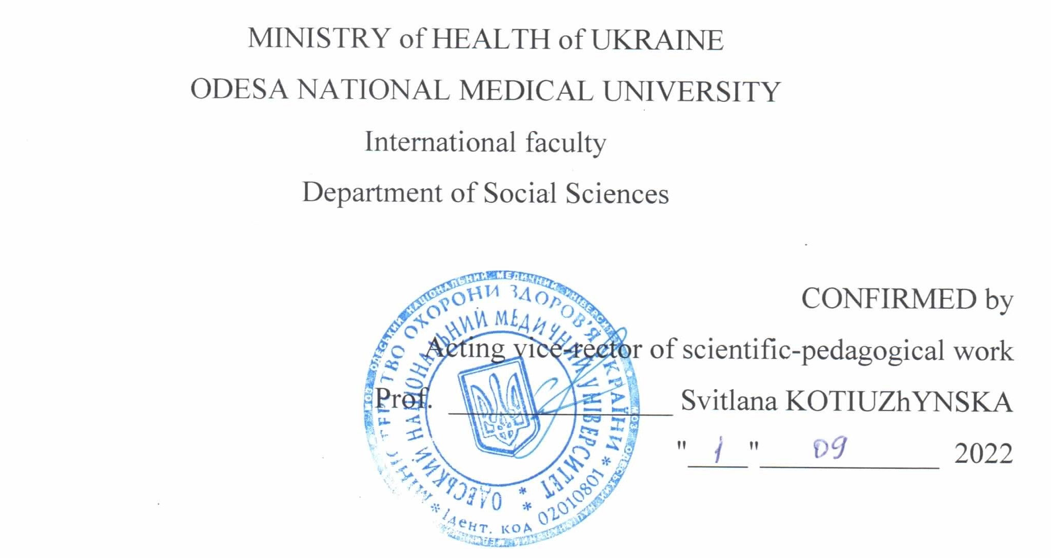
WORK PROGRAM ON THE DISCIPLINE
"Ukrainian national idea"

Level of higher education: second (master's degree)

Branch of knowledge: 22 "Health Care"

Specialty: 226 "Pharmacy, industrial pharmacy"

Educational qualification: "Pharmacy, industrial pharmacy"

Odesa – 2022

The working program is compiled on the basis of the educational and professional program “Pharmacy, industrial pharmacy” for the training of specialists of the second (master’s) level of higher education in the specialty 226 “Pharmacy, industrial pharmacy” of the field of knowledge 22 “Health care”, approved by the Academic Council of ONMedU (minutes No. 9 dated 23/06/2022).

Authors:
PhD in History, Associate Professor Tetyana Podkupko-Dychkova
PhD in History, Associate Professor Olena Uvarova
PhD in Politics, Associate Professor Mykola Kulachynskyi

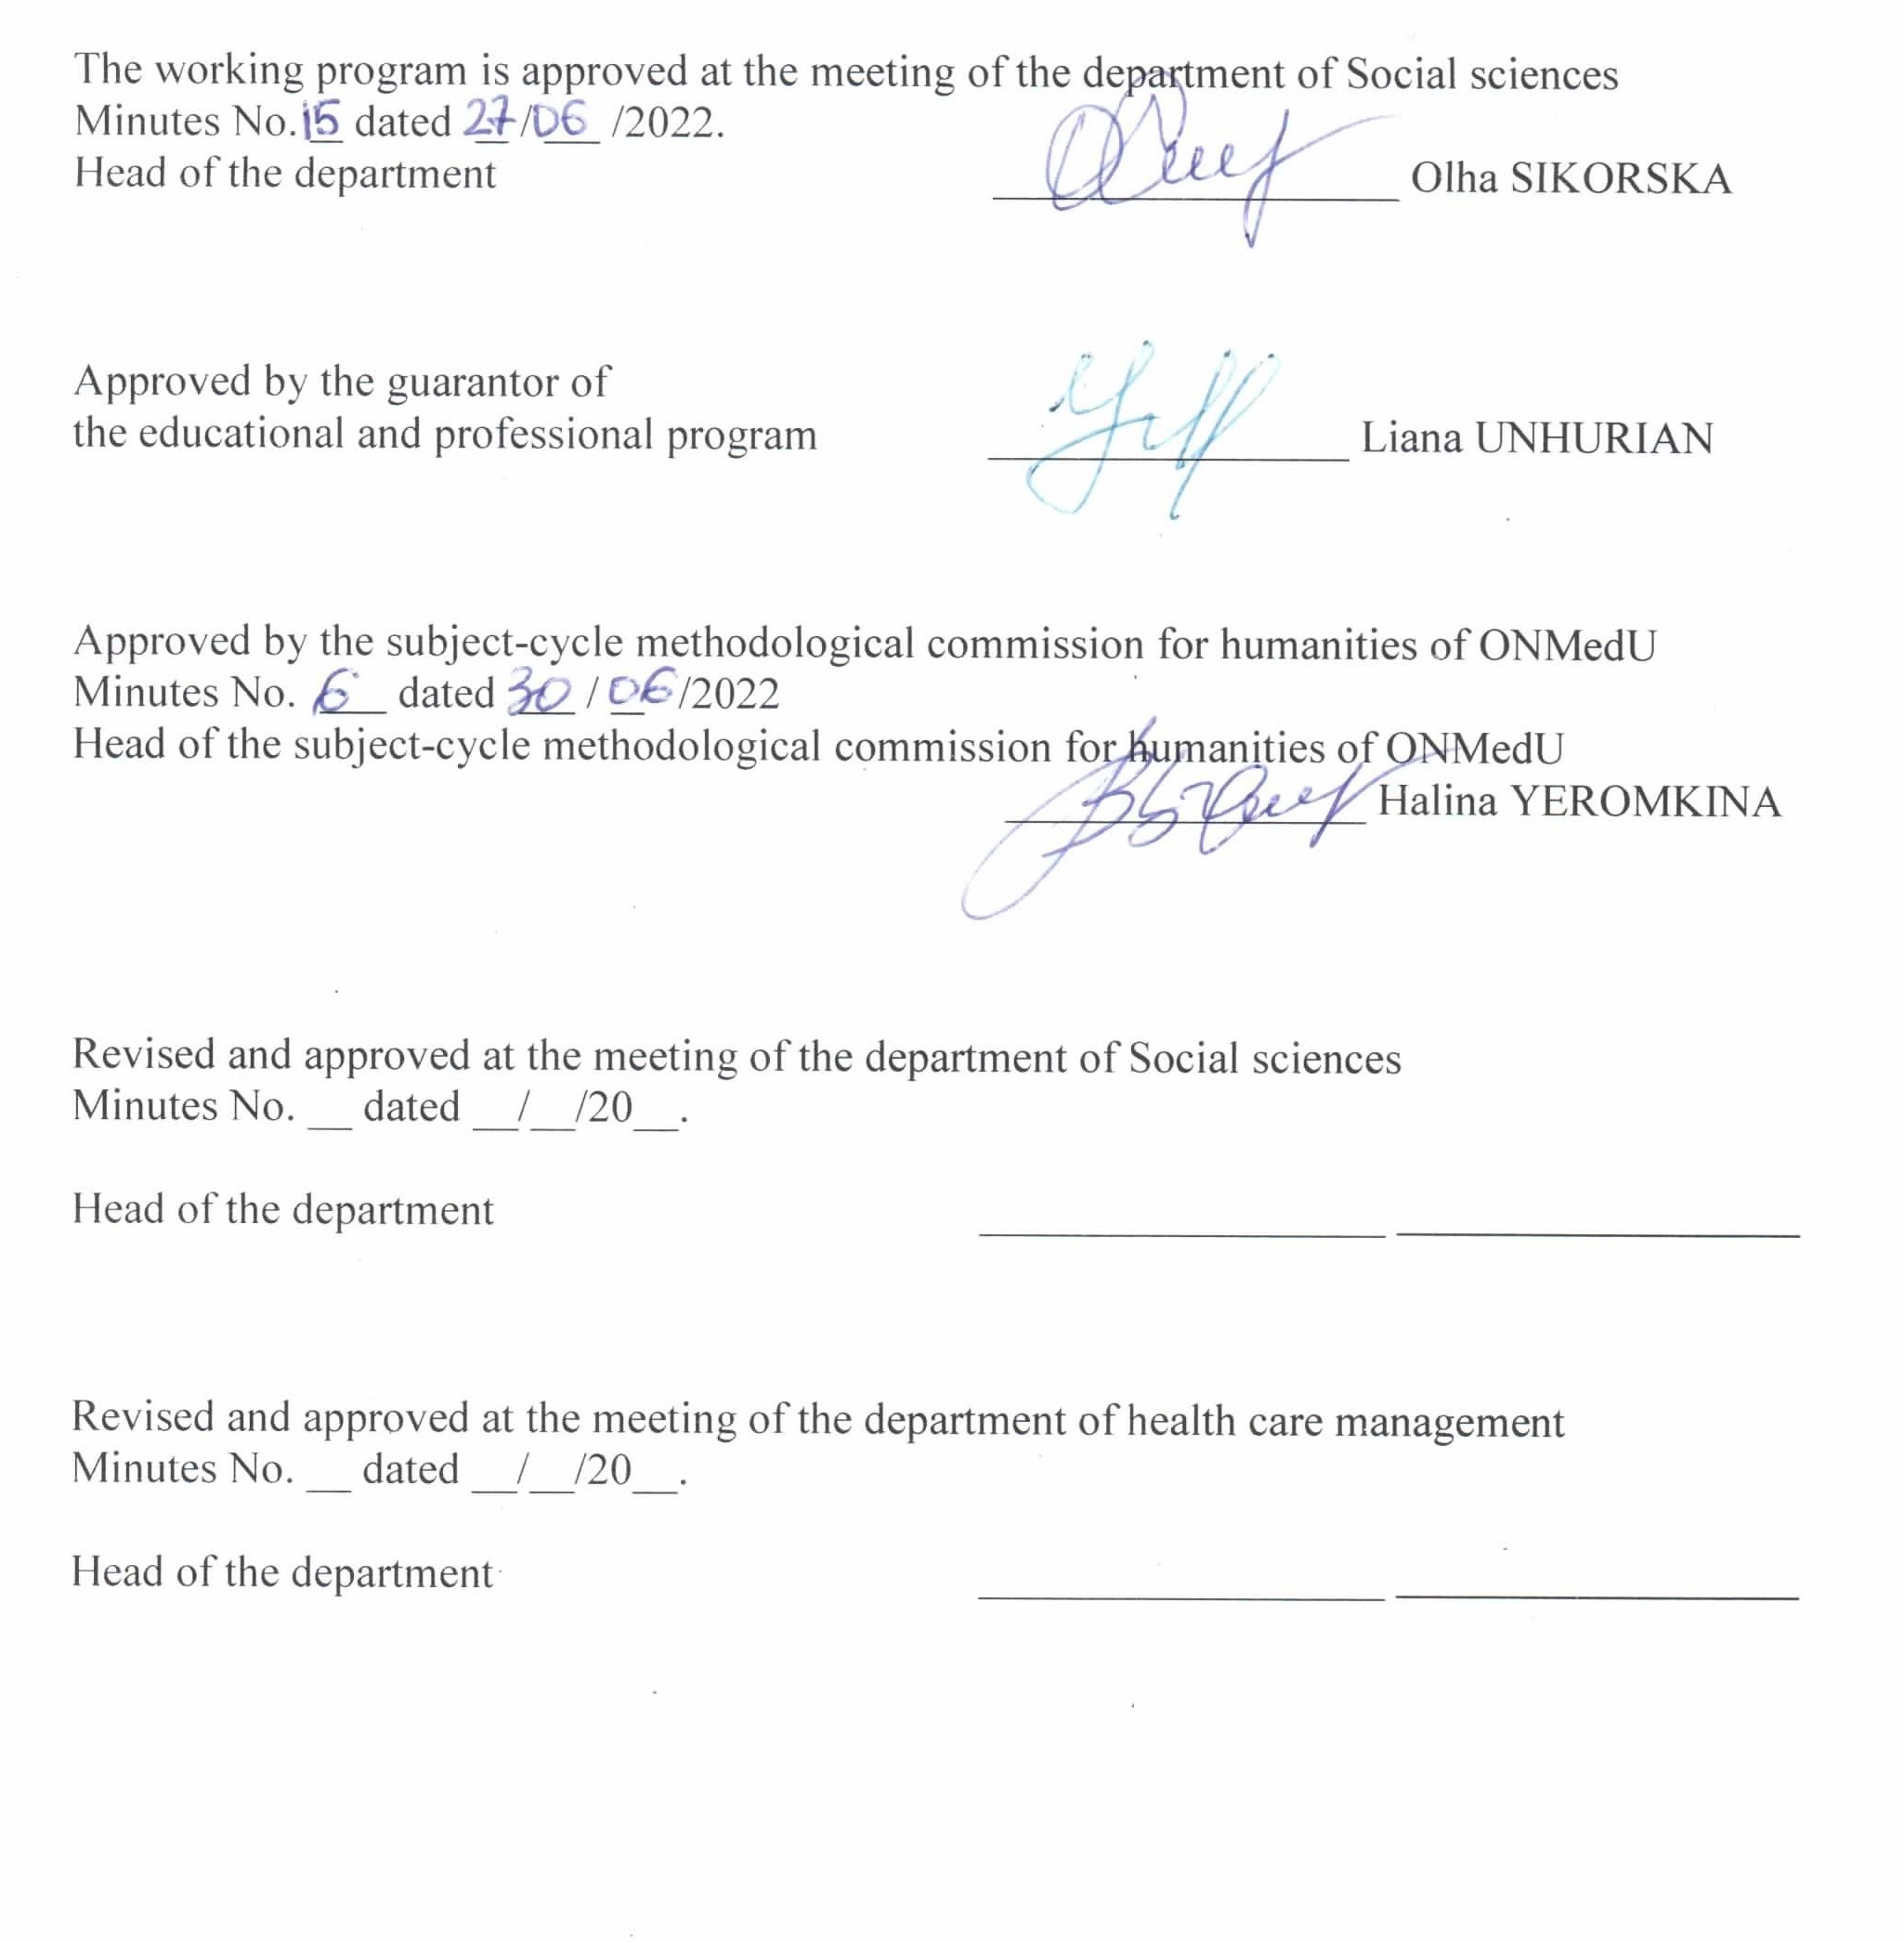

1. Description of the discipline

Name of indicators | Field of knowledge, specialty, specialization, level of higher education | Characteristics of the discipline
Total number:  Credits of ECTS: 3  Hours: 90 | Field of knowledge  22 «Health care»  Specialty  226 "Pharmacy, industrial pharmacy"  Level of higher education second (master’s degree) | Full-time (day) education  Elective discipline
Total number:  Credits of ECTS: 3  Hours: 90 |  | Course: 1
Total number:  Credits of ECTS: 3  Hours: 90 |  | Semester: ІІ
Total number:  Credits of ECTS: 3  Hours: 90 |  | Lectures (0 hours)
Total number:  Credits of ECTS: 3  Hours: 90 |  | Seminars (30 hours)
Total number:  Credits of ECTS: 3  Hours: 90 |  | Practical classes (0 hours)
Total number:  Credits of ECTS: 3  Hours: 90 |  | Laboratories (0 hours)
Total number:  Credits of ECTS: 3  Hours: 90 |  | Independent work (60 hours)
Total number:  Credits of ECTS: 3  Hours: 90 |  | including individual tasks (0 hours)
Total number:  Credits of ECTS: 3  Hours: 90 |  | Form of final control – Credit Test

2. Purpose and objectives of the discipline

The purpose: acquisition of knowledge and formation of competences in the field of social sciences by the student of higher education; obtaining modern scientifically based information about the search for the Ukrainian national idea in the context of the development of world state, political thought and philosophy; assimilation of knowledge in the field of ethnology and the history of political thought, features of state formation at various historical stages, periods of independent statehood, as well as at the time when Ukrainian lands were annexed by other states; development of practical abilities and skills of analysis of ideas and opinions in the field of searching for a national idea, identification and self-identification; development of high social, state, humanistic, spiritual and cultural ideals, moral-ethical and aesthetic criteria and principles of life.
The task: get acquainted with the origins and main stages of the development of Ukrainian and world political thought, ethnology; - learn the essence, the main problems of the formation and expression of the Ukrainian national idea; - learn to practically use the acquired knowledge.

The process of studying the discipline is aimed at forming elements of following competencies:
Integral - Ability to solve typical and complex problems, including those of a research and innovation nature in the field of medicine. Ability to continue learning with a high degree of autonomy.
General (GC):
GC1. Ability to abstract thinking, analysis and synthesis
GC 2. Ability to learn and master modern knowledge
GC 3. Ability to apply knowledge in practical situations
GC 4. Knowledge and understanding of the subject area and understanding of professional activity
GC 5. Ability to adapt and act in a new situation
GC 6. Ability to make reasonable decisions
GC 7. Ability to work in a team
GC 8. Ability to interpersonal interaction
GC 10. Ability to use information and communication technologies
GC 11. Ability to search, process and analyze information from various sources
GC 12. Determination and persistence in relation to assigned tasks and assumed responsibilities
GC 13. Awareness of equal opportunities and gender issues
GC 14. Ability to realize one's rights and responsibilities as a member of society, to be aware of the values of public (free democratic) society and the need for its sustainable development, the rule of law, the rights and freedoms of a person and a citizen in Ukraine
GC 15. Ability to preserve and increase moral, cultural, scientific values and achievements of society based on understanding the history and patterns of development of the subject area, its place in the general system of knowledge about nature and society and in the development of society, technology and technologies, to use various types and forms of motor activity for active recreation and leading a healthy lifestyle
GC 16. Ability to evaluate and ensure the quality of the work performed.

Special professional (SC):
SC 24. Adherence to ethical principles when working with patients and laboratory animals
SC 25. Adherence to professional and academic integrity, being responsible for the reliability of the obtained scientific results

Program learning outcomes are:
PLO 1. Having a thorough knowledge of the structure of professional activity. Being able to carry out professional activities that require updating and integration of knowledge. To be responsible for professional development, the ability for further professional training with a high level of autonomy.
PLO 21. Searching for the necessary information in the professional literature and databases of other sources, analysing, evaluating and application of this information.
PLO 27. Communication freely in the state language and English, both orally and in writing to discuss professional activities, research and projects.

Results of studding of the discipline:
know: prerequisites and sources of emergence, the main stages of the development of the Ukrainian national idea; - features and conditions of the development of political thought, cultural features in different periods of independence, self-reliance, as well as the times when Ukrainian lands became part of other states; - the role and place of the national idea in state creation, in the life of a professional and a person; - the main directions of historical and modern political thought; leading features, stages and types of nation-building.
be able: Analyze the information obtained as a result of scientific research, summarize, systematize and use it in professional activities. Take into account data on socio-economic processes in society for the population. To plan and implement professional activity on the basis of normative legal acts of Ukraine.
master the skills: the ability to abstract thinking, analysis and synthesis, the ability to learn and be modern; knowledge and understanding of the subject area and understanding of professional activity; the ability to apply knowledge in practical situations; ability to communicate in the state language; skills of using information and communication technologies; the ability to adapt and act in a new situation; ability to choose a communication strategy; ability to work in a team; demonstrate interpersonal skills; the ability to act on the basis of ethical considerations (motives); certainty and persistence in relation to the tasks and duties taken.
3. The content of the discipline:
Theme 1. The subject of the study of the Ukrainian national idea. The main problems of the study of the Ukrainian national idea. Ideas of freedom and justice, goodness and truth. Trends in problem formation and study. Categorical and conceptual apparatus. The main tasks of the course. Interconnection with other scientific disciplines.
Theme 2. The emergence of Ukrainian nationalism and periods of its development. The main stages of the development of Ukrainian political thought, its peculiarities and characteristic features. Periodization of the history of Ukrainian state formation. The formation of the Ukrainian nation under the conditions of the absence of its own statehood. The need to resist social enslavement and external enemies.
Theme 3. The problem of defining the essence of the nation and nationalism: Ukrainian and European contexts The relationship between nations and the national idea. The search for the foundation of the nation: historical context. Ethnic and national. Language is the soul of a nation. Country and state.
Theme 4. National aspects of the formation of Russia-Ukraine and the ideology of state building (V-X centuries). Settlement of the Slavs and the formation of the ancient Russian ethno-cultural community. The era of the emergence of social associations (unions of tribes and tribal principalities). The evolution of the East Slavic community in mutual connection with the formation of statehood. Ancient states that objectively accelerated ethnogenetic and cultural processes and phenomena.
Theme 5. Formation of political thought and national idea in the princely era of the 12th - 13th centuries. Formation of the system of state and political views of early feudal Kyivan Rus. Dependence of political thinking on religious worldview. The role of the clergy in compiling written records of the political thought of the princely era. The importance of the authority of the government in socio-political thought. The impact on Kyivan Rus of the achievements of European civilization in the field of philosophy, law, history, and culture.
Theme 6. Political and national consequences of the feudal fragmentation of Russia-Ukraine (XI-XII centuries) Galicia-Volyn State. Triumvirate of the Yaroslavichs. Meeting of princes in Lyubech. Specific fragmentation. "Collective suzerainty". The main princes are joint suzerains. Prerequisites for the composition of the Ukrainian medieval nationality. Territorial basis of composition of Ukrainian medieval nationhood. The formation of the Ukrainian nation under the conditions of the absence of its own statehood.
Theme 7. Development of social and political thought in the Lithuanian-Polish era. General characteristics of social changes. A period of decline and loss of political traditions, long-term foreign enslavement. Solving the problems of formation and protection of the statehood of the nation. Defense of the right to existence of the Ukrainian people.
Theme 8. Domestic political ideas of the Renaissance. The main characteristics of political ideas in Ukraine during the Renaissance. Bright representatives and their creativity. The role of law as the basis for the functioning of the Christian state. The relationship between secular and spiritual authorities. The idea of ​​church reformation. Criticism of the union and the decision of the episcopate. Boycott of government policies aimed at the enslavement and assimilation of Ukrainians. Brotherhood and democratic orders.
Theme 9. The Ukrainian national revolution of the middle of the 17th century and the formation of the Ukrainian national idea. Traditions of national state formation. Formation of Cossack political autonomism. Denationalization of the traditional elite. Zaporozhye Sich. Showing society. The tendency to take over the "historical mission of the national spokesman of the Ukrainian people" by the Cossacks.
Theme 10. The national idea of ​​the Cossack-Hetman state. Democracy is a characteristic feature of Cossack social life. Elements of the parliamentary system. The role of education and moral self-improvement. Ideas of the Western Reformation.
Theme 11. Liquidation of Ukrainian statehood at the end of the 18th century and the national-state idea. The attack of tsarism on the autonomy of Ukraine. Strengthening the positions of tsarism: economic, political, spiritual. Model of Russia's implementation of political plans and economic measures in Left Bank Ukraine. The role of the elite in the protection of Ukrainian autonomy.
Theme 12. The potential of the Ukrainian national revival of the first half of the 19th century. General characteristics of the era. National composition of the population. Stages of national revival. Public organizations and movements of the first half of the 19th century. Masonry. Its influence on the socio-political opinion of Ukraine. Decembrist movement.
Theme 13. Development of thought about the Ukrainian national idea in the second half of the 19th century. Cyril and Methodius Society (1846–1847). Socio-political conditions for the creation of the Cyril and Methodius Society and the main political ideas of its representatives. Main theses, organizational and program provisions. The idea of ​​a federation of Slavic peoples on the basis of unity, complete freedom and autonomy of the states that are part of this federation.
Theme 14. Socio-political views in the second half of the 19th century. Accents of political views. Contribution to the development of socio-political thought of M. Maksimovich. Periodization and conditions of the romantic-populist worldview. Romanticism in the socio-political thought of Ukraine. Formation of political opinion with populist ideology.
Theme 15. Strengthening of the national movement in Western Ukrainian lands at the beginning of the 19th century. Romanticism. Founders, actors, results of activity. "Dniester Mermaid".
Theme 16. The national idea during the Ukrainian revolution at the beginning of the 20th century. New conditions for the formation of social and political opinion. M. Michnovsky. Ukraine as an independent state with a republican system. Absence of the leading nationally conscious stratum - intelligentsia, internal unity. Propaganda of the idea of ​​national solidarity. Political views of M. Hrushevskyi. Ukrainian national movement from February to November 1917. Ukrainian People's Republic. Ukrainian hetman state. The days of the UNR Directory: the crisis of Ukrainian state-building.
Theme 17. Political regimes on Ukrainian lands in the 20s and 30s of the 20th century. The nature of Soviet statehood. Peculiarities of national Soviet statehood. State formation of the USSR. Formation of the Soviet political system. "Shot Revival". Carpathian Ukraine (1938-1939).
Theme 18. Concepts and ideas of the main directions of Ukrainian thought in the interwar period. M. Hrushevskyi. The evolution of opinions about the form of Ukrainian statehood. The problem of local self-government and representative democracy. V. Vynnychenko. Socialist views. Evolutionism, reformation. The social-democratic model of the national state.
Theme 19. Socio-political views of Ukrainian dissidents. The formation of a cell of Ukrainian dissidents - the "sixties". Representatives: Lina Kostenko, Vasyl Simonenko, Ivan Drach, Ivan Svitlichnyi, Yevhen Sverstyuk, Mykola Vingranovskyi, Alla Gorska, Ivan Dzyuba, Vasyl Stus, Mykhailo Osadchyi, Igor and Iryna Kalyntsi, Ivan Gel and the Horyn brothers. Valentyn Moroz, Levko Lukyanenko, Vyacheslav Chornovil.
Theme 20. Development of an independent Ukrainian state and the national idea. Activation of social and political life. State building: The problem of elites and leadership. Government and opposition in the parliament. Declaration on State Sovereignty of Ukraine. Act of Proclamation of Independence of Ukraine. Referendum and presidential elections of December 1, 1991. State legal acts of Ukraine in the early 1990s.
Theme 21. Modern formulation of the national idea in Ukraine. Stages and key figures. Socio-political opinion of Ukraine of the 21st century. Views of the presidents of Ukraine. Political projects. Chronicle of state formation. Constitution of Ukraine. The position of domestic political science at the current stage. Diversity of researched problems. State-building ideology. The rallying of Ukrainians during the full-scale military invasion of the Russian Federation.

4. The structure of the discipline:
Themes | Number of hours
Themes | Total | including
Themes | Total | lectures | seminars | practical classes | labora-  tories | Indepen-dent work
Theme 1. The subject of the study of the Ukrainian national idea. | 2 | 0 | 2 | 0 | 0 | 0
Theme 2. The emergence of Ukrainian nationalism and periods of its development. | 2 | 0 | 2 | 0 | 0 | 0
Theme 3. The problem of defining the essence of the nation and nationalism | 2 | 0 | 2 | 0 | 0 | 0
Theme 4. National aspects of the formation of Russia-Ukraine and the ideology of state building (V-X centuries). | 2 | 0 | 2 | 0 | 0 | 0
Theme 5. Formation of political thought and national idea in the princely era of the 12th - 13th centuries | 2 | 0 | 2 | 0 | 0 | 0
Theme 6. Political and national consequences of the feudal fragmentation of Russia-Ukraine (XI-XII centuries) Galicia-Volyn State. | 10 | 0 | 0 | 0 | 0 | 10
Theme 7. Development of social and political thought in the Lithuanian-Polish era. | 2 | 0 | 2 | 0 | 0 | 0
Theme 8. Domestic political ideas of the Renaissance | 2 | 0 | 2 | 0 | 0 | 0
Theme 9. The Ukrainian national revolution of the middle of the 17th century and the formation of the Ukrainian national idea. | 2 | 0 | 2 | 0 | 0 | 0
Theme 10. The national idea of ​​the Cossack-Hetman state | 2 | 0 | 2 | 0 | 0 | 0
Theme 11. Liquidation of Ukrainian statehood at the end of the 18th century and the national-state idea. | 2 | 0 | 2 | 0 | 0 | 0
Theme 12. The potential of the Ukrainian national revival of the first half of the 19th century. | 2 | 0 | 2 | 0 | 0 | 0

Theme 13. Development of thought about the Ukrainian national idea in the second half of the 19th century. | 2 | 0 | 2 | 0 | 0 | 0
Theme 14. Socio-political views in the second half of the 19th century. | 10 | 0 | 0 | 0 | 0 | 10
Theme 15. Strengthening of the national movement in Western Ukrainian lands at the beginning of the 19th century | 10 | 0 | 0 | 0 | 0 | 10
Theme 16. The national idea during the Ukrainian revolution at the beginning of the 20th century. | 2 | 0 | 2 | 0 | 0 | 0
Theme 17. Political regimes on Ukrainian lands in the 20s and 30s of the 20th century. | 10 | 0 | 0 | 0 | 0 | 10
Theme 18. Concepts and ideas of the main directions of Ukrainian thought in the interwar period | 10 | 0 | 0 | 0 | 0 | 10
Theme 19. Socio-political views of Ukrainian dissidents. The formation of a cell of Ukrainian dissidents - the "sixties". | 2 | 0 | 2 | 0 | 0 | 0
Theme 20. Development of an independent Ukrainian state and the national idea | 10 | 0 | 0 | 0 | 0 | 10
Theme 21. Modern formulation of the national idea in Ukraine. | 2 | 0 | 2 | 0 | 0 | 0

Individual task | 0 | 0 | 0 | 0 | 0 | 0
Total hours | 90 | 0 | 30 | 0 | 0 | 60

5. Themes of lectures
Not provided by the working program.

6. Themes of seminars
№ | Theme | hours
1 | Seminar № 1  Theme. The subject of the study of the Ukrainian national idea. The main problems of the study of the Ukrainian national idea. Ideas of freedom and justice, goodness and truth. Trends in problem formation and study. Categorical and conceptual apparatus. The main tasks of the course. Interconnection with other scientific disciplines. | 2
2 | Seminar № 2  Theme. The emergence of Ukrainian nationalism and periods of its development. The main stages of the development of Ukrainian political thought, its peculiarities and characteristic features. Periodization of the history of Ukrainian state formation. The formation of the Ukrainian nation under the conditions of the absence of its own statehood. The need to resist social enslavement and external enemies. | 2
3 | Seminar № 3  Theme. The problem of defining the essence of the nation and nationalism: Ukrainian and European contexts The relationship between nations and the national idea. The search for the foundation of the nation: historical context. Ethnic and national. Language is the soul of a nation. Country and state. | 2
4 | Seminar № 4  Theme. National aspects of the formation of Russia-Ukraine and the ideology of state building (V-X centuries). Settlement of the Slavs and the formation of the ancient Russian ethno-cultural community. The era of the emergence of social associations (unions of tribes and tribal principalities). The evolution of the East Slavic community in mutual connection with the formation of statehood. Ancient states that objectively accelerated ethnogenetic and cultural processes and phenomena. | 2
5 | Seminar № 5  Theme. Formation of political thought and national idea in the princely era of the 12th - 13th centuries. Formation of the system of state and political views of early feudal Kyivan Rus. Dependence of political thinking on religious worldview. The role of the clergy in compiling written records of the political thought of the princely era. The importance of the authority of the government in socio-political thought. The impact on Kyivan Rus of the achievements of European civilization in the field of philosophy, law, history, and culture. | 2
6 | Seminar № 6  Theme. Development of social and political thought in the Lithuanian-Polish era. General characteristics of social changes. A period of decline and loss of political traditions, long-term foreign enslavement. Solving the problems of formation and protection of the statehood of the nation. Defense of the right to existence of the Ukrainian people | 2
7 | Seminar № 7  Theme. Domestic political ideas of the Renaissance. The main characteristics of political ideas in Ukraine during the Renaissance. Bright representatives and their creativity. The role of law as the basis for the functioning of the Christian state. The relationship between secular and spiritual authorities. The idea of ​​church reformation. Criticism of the union and the decision of the episcopate. Boycott of government policies aimed at the enslavement and assimilation of Ukrainians. Brotherhood and democratic orders. | 2
8 | Seminar № 8  Theme. The Ukrainian national revolution of the middle of the 17th century and the formation of the Ukrainian national idea. Traditions of national state formation. Formation of Cossack political autonomism. Denationalization of the traditional elite. Zaporozhye Sich. Showing society. The tendency to take over the "historical mission of the national spokesman of the Ukrainian people" by the Cossacks. | 2
9 | Seminar № 9  Theme. The national idea of ​​the Cossack-Hetman state. Democracy is a characteristic feature of Cossack social life. Elements of the parliamentary system. The role of education and moral self-improvement. Ideas of the Western Reformation. | 2
10 | Seminar № 10  Theme. Liquidation of Ukrainian statehood at the end of the 18th century and the national-state idea. The attack of tsarism on the autonomy of Ukraine. Strengthening the positions of tsarism: economic, political, spiritual. Model of Russia's implementation of political plans and economic measures in Left Bank Ukraine. The role of the elite in the protection of Ukrainian autonomy. | 2
11 | Seminar № 11  Theme. The potential of the Ukrainian national revival of the first half of the 19th century. General characteristics of the era. National composition of the population. Stages of national revival. Public organizations and movements of the first half of the 19th century. Masonry. Its influence on the socio-political opinion of Ukraine. Decembrist movement. | 2
12 | Seminar № 12  Theme. Development of thought about the Ukrainian national idea in the second half of the 19th century. Cyril and Methodius Society (1846–1847). Socio-political conditions for the creation of the Cyril and Methodius Society and the main political ideas of its representatives. Main theses, organizational and program provisions. The idea of ​​a federation of Slavic peoples on the basis of unity, complete freedom and autonomy of the states that are part of this federation. | 2
13 | Seminar № 13  Theme. The national idea during the Ukrainian revolution at the beginning of the 20th century. New conditions for the formation of social and political opinion. M. Michnovsky. Ukraine as an independent state with a republican system. Absence of the leading nationally conscious stratum - intelligentsia, internal unity. Propaganda of the idea of ​​national solidarity. Political views of M. Hrushevskyi. Ukrainian national movement from February to November 1917. Ukrainian People's Republic. Ukrainian hetman state. The days of the UNR Directory: the crisis of Ukrainian state-building. | 2
14 | Seminar № 14  Theme. Socio-political views of Ukrainian dissidents. The formation of a cell of Ukrainian dissidents - the "sixties". Representatives: Lina Kostenko, Vasyl Simonenko, Ivan Drach, Ivan Svitlichnyi, Yevhen Sverstyuk, Mykola Vingranovskyi, Alla Gorska, Ivan Dzyuba, Vasyl Stus, Mykhailo Osadchyi, Igor and Iryna Kalyntsi, Ivan Gel and the Horyn brothers. Valentyn Moroz, Levko Lukyanenko, Vyacheslav Chornovil. | 2
15 | Seminar № 15  Theme. Modern formulation of the national idea in Ukraine. Stages and key figures. Socio-political opinion of Ukraine of the 21st century. Views of the presidents of Ukraine. Political projects. Chronicle of state formation. Constitution of Ukraine. The position of domestic political science at the current stage. Diversity of researched problems. State-building ideology. The rallying of Ukrainians during the full-scale military invasion of the Russian Federation | 2
In all |  | 30

7. Themes of practical classes
Not provided by the working program.

8. Themes of laboratories
Not provided by the working program.
9. Themes of independent students work

№ | Theme | Hours
1 | IW № 1  Theme. Political and national consequences of the feudal fragmentation of Russia-Ukraine (XI-XII centuries) Galicia-Volyn State. Triumvirate of the Yaroslavichs. Meeting of princes in Lyubech. Specific fragmentation. "Collective suzerainty". The main princes are joint suzerains. Prerequisites for the composition of the Ukrainian medieval nationality. Territorial basis of composition of Ukrainian medieval nationhood. The formation of the Ukrainian nation under the conditions of the absence of its own statehood. | 10
2 | IW № 2  Theme Socio-political views in the second half of the 19th century. Accents of political views. Contribution to the development of socio-political thought of M. Maksimovich. Periodization and conditions of the romantic-populist worldview. Romanticism in the socio-political thought of Ukraine. Formation of political opinion with populist ideology. | 10
3 | IW № 3  Theme. Ukrainian lands within the Austria-Hungarian Empire.  Political situation on the Right-Bank Ukraine and Western Ukraine in the second half of the 17th – 18th century. The Haydamaks. Koliyivschina (1768). Oprishki’s movement. The Three divisions of Poland. The reforms in Austria-Hungary in the middle of the 19th century. Ukrainian revival. Political life. | 10
4 | IW № 4  Strengthening of the national movement in Western Ukrainian lands at the beginning of the 19th century. Romanticism. Founders, actors, results of activity. "Dniester Mermaid". | 10
5 | IW № 5  Theme. Political regimes on Ukrainian lands in the 20s and 30s of the 20th century. The nature of Soviet statehood. Peculiarities of national Soviet statehood. State formation of the USSR. Formation of the Soviet political system. "Shot Revival". Carpathian Ukraine (1938-1939). | 10
6 | IW № 6  Theme. Theme 20. Development of an independent Ukrainian state and the national idea. Activation of social and political life. State building: The problem of elites and leadership. Government and opposition in the parliament. Declaration on State Sovereignty of Ukraine. Act of Proclamation of Independence of Ukraine. Referendum and presidential elections of December 1, 1991. State legal acts of Ukraine in the early 1990s. | 10
In all: |  | 60

10. Themes of individual task
1. The emergence of Ukrainian ethnology and periods of its development. 2 The nation as a subject of social life. 3. Genesis of the Ukrainian nation 4. Traditions of Ukrainian national state-building 5. Title nation, national minorities, ethnic groups. 6. Conflicts in the field of national relations 7. National identity after the declaration of Ukraine's independence. 8. Social structure of the nation. 9. The nation in the context of civil society. 10. Political parties in the life of the national community. 11. National elite. 12. Ukraine in the globalized world. 13. Philosophical principles of national renewal. 14. National dignity is the key to the affirmation of the nation and the virtue of a free person. 15. Culture of the Ukrainian national community. 16. The national idea is a reference point for the nation's state self-assertion. 17. Ideology of national liberation and state formation. 18. The national state as the ideal of the nation.

11. Methods of training
During lectures and seminars methods are used:
- for the transmission and perception of educational information - verbal, visual, practical;
- for cognitive activity of students - explanatory-illustrative, reproductive, problematic teaching, part-search, research;
- To achieve goals and objectives - methods of mastering new knowledge, skills and competences, testing and evaluation of knowledge, skills and abilities; methods of oral presentation of knowledge, fixing of educational material, independent work of students on comprehension and assimilation of new material of work on application of knowledge in practice and development of skills and abilities, verification and evaluation of knowledge, skills and abilities;
- To achieve a holistic approach to activities in the learning process - the methods of organization and implementation of educational and cognitive activities; stimulation and motivation of learning, control, self-control, control and correction, self-correction, mutual correction in learning.

12. Control methods
Control measures include current control.
The current educational activity of students is controlled by workshops in accordance with specific goals and during the individual work of a teacher with students.
The following diagnostic tools for student preparation are used:
- oral questioning in accordance with the methodological instructions developed by the teacher;
- block of test tasks;
- independent work;
- writing abstracts and scientific reports (individual work).
Estimation of students takes place in every seminar (must be asked at least 30 % of students). Current educational activity of student is evaluated on a 4-point (traditional) scale: "5", "4", "3", "2".
Criteria of evaluation during seminars:
- the grade "excellent" is given to a student who worked systematically during the seminar, showed versatile and deep knowledge of the program material, is able to successfully perform the tasks provided for by the program, mastered the content of the main and additional literature, realized the interrelationship of individual sections of the discipline, their importance for the formation personality, showed creative abilities in understanding and using educational program material, showed the ability to independently update and replenish knowledge; the level of competence is high (creative);
- the grade of "good" is assigned to a student who has demonstrated complete knowledge of the curriculum material, successfully completes the tasks provided for by the program, has mastered the basic literature recommended by the program, has shown a sufficient level of knowledge in the discipline and is capable of their independent updating and renewal during further education and professional activity; the level of competence is sufficient (constructive and variable);
- the grade of "satisfactory" is given to a student who has demonstrated knowledge of the main curriculum material to the extent necessary for further study, copes with the tasks provided for by the program, made some mistakes in the answers, but has the necessary knowledge to overcome the mistakes made under the guidance of a scientific pedagogical worker; the level of competence is average (reproductive);
- the grade "unsatisfactory" is assigned to a student who did not demonstrate sufficient knowledge of the main curriculum material, made fundamental mistakes in the performance of the tasks provided for by the program, cannot use the knowledge in further studies without the help of a teacher, did not manage to master the skills of independent work; the level of competence is low (receptive-productive).
Evaluation of independent students work. Independent student’s work, which is provided in the program, is monitored and evaluated in the current control.
The work program of the course involves an individual independent student’s work (optional) that has three types:
1) report for the annual University Research Conference. Preparing students for the conference is led by a teacher who acts as supervisor. In the event of failure of student speech it is not allowed to participate in the conference, and individual tasks are not counted.
2) abstract for seminar. Preparation task is led with the teacher.
3) production of teaching aids (visual tools - maps, presentations, displays, etc.). Preparation task is led with the teacher.
Subjects of individual tasks can be offered by teacher or student. Marks for individual tasks are added to the current academic activities.
Final control is not provided by the program.
As a result of studying this discipline a student receives a "credit test" that is set on the basis of current educational activity of student (the average mark for current educational activity must be at least 3.00) and no absence or their work off in time.
Test exposed at the end of the discipline on the basis of current estimates as the average mark (the arithmetical mean of the estimates for the traditional scale, rounded to two (2) decimal places).

13. Distribution of points received by applicants for higher education
The average score for discipline is converted into traditional mark by 4-point scale and regarded as a ratio of the arithmetic average to the percent of required knowledge. The resulting arithmetic average of discipline allows for the conversion of a mark for a 200-point scale ranging for further rating scale (ECTS) under credit transfer system.
average grade point average (ccurrient / discipline) x 40
National mark | Points
«5» | 185-200
«4» | 151-184
«3» | 120-150
«2» | <120

Converting of traditional mark for discipline by ECTS
The subsequent calculations are conducted by the Information and Computing Center of the university. In accordance with the points on a 200-point scale, students are evaluated on a rating scale ESTS. Students who are enrolled in one course at the same specialty, based on the number of points gained in the discipline, are ranked on a ESTS scale as follows:
ECTS mark | Statistical indicators
«А» | Best 10 % of students
«В» | Next 25 % of students
«С» | Next 30 % of students
«D» | Next 25 % of students
«E» | Last 10 % of students
Ranging by assigning ratings «A», «B», «C», «D», «E» held by deans-office for students of the course enrolled for one specialty and successfully completed study the subjects. Students who have been assessed «FX» and «F» ("2") is entered into the list of students that are ranked, even after retaking credit. These students after retaking automatically receive score «E».
Multipoint and four-point scales describing the actual progress of each student mastering the discipline. ECTS scale is relative, comparative, rating, which sets student belonging to the group better or worse among the reference group of fellow students (faculty, specialty). Therefore, grade "A" in ECTS-scale not equal evaluation "excellent", "B" not equal "good" and so on. Typically, the marks «A», «B», «C», «D», «E» does not coincide with the "5", "4", "3" on the traditional scale.

14. Methodological support of the academic discipline consists of:
- Working program in the discipline
- Syllabus
- methodical development of lectures
- methodical recommendations for seminars for students
- guidelines for individual work of students
- tests of current control

15. List of control questions
1. The main problems of the study of the Ukrainian national idea. Ideas of freedom and justice, goodness and truth. 2. Trends in the formation and study of the national idea. 3. The main stages of the development of Ukrainian political thought, its peculiarities and characteristic features. 4. Periodization of the history of Ukrainian state formation. 5. The formation of the Ukrainian nation in the absence of its own statehood. 6. The relationship between nations and the national idea. The search for the foundation of the nation: historical context. 7. Ethnic and national. Language is the soul of a nation. Country and state. 8. Settlement of the Slavs and the formation of the ancient Russian ethno-cultural community. The era of the emergence of social associations (unions of tribes and tribal principalities). 9. The evolution of the East Slavic community in mutual connection with the formation of statehood. Ancient states that objectively accelerated ethnogenetic and cultural processes and phenomena. 10. The ancient Russian state as a multi-ethnic country. 11. Consolidation of the territory and structure of the state, determination of its borders, which generally coincided with the ethnic borders of the Eastern Slavs. Completion of the composition of the state territory of Russia. 12. Formation of the system of state and political views of early feudal Kyivan Rus. Dependence of political thinking on religious worldview. 13. The importance of authority in social and political thought. Basic social and political ideas in Kyivan Rus. 14. Correlation of the medieval political thought of the contemporary world with examples of the ancient Russian social and political heritage. 15. The impact on Kyivan Rus of the achievements of European civilization in the field of philosophy, law, history, and culture. 16. The formation of the Ukrainian nation in the absence of its own statehood. 17. The struggle between the medieval religious worldview and the idea of ​​anthropocentrism. Proclamation of people's rights to satisfy earthly needs, ideas of personal freedom, a just social order. 18. Birth and formation of centers of national consciousness. Kyiv-Mohyla Academy. 19. The tendency to take over the "historical mission of the national spokesman of the Ukrainian people" by the Cossacks. 20. The attack of tsarism on the autonomy of Ukraine. Strengthening the positions of tsarism: economic, political, spiritual. 21. The presence in ideological constructions of motives for the presence of one's own statehood as a component of the well-known enlightened concept of the social contract. 22. Socio-political conditions for the creation of the Cyril and Methodius Society and the main political ideas of its representatives. Main theses, organizational and program provisions. The idea of ​​a federation of Slavic peoples. 23. Romanticism in the socio-political thought of Ukraine. Formation of political opinion with populist ideology. 24. Propaganda of the idea of ​​national solidarity. 25. Peculiarities of national Soviet statehood. 26. M. Hrushevskyi. The evolution of opinions about the form of Ukrainian statehood. 27. Social-democratic model of the national state. 28. The phenomenon of the "sixties" and their ideas. 29. Activation of socio-political life. State building: The problem of elites and leadership. 30. Socio-political opinion of Ukraine of the 21st century. Views of the presidents of Ukraine. Political projects.

16. Literature
Basic
- Alkov V. History of Ukraine and Ukrainian Culture : the textbook for international students. Kharkiv : KhNMU, 2018. 146 p.
- History of Ukraine and Ukrainian culture: student’s guide for foreign students. / M.I. Suliatytskyi, Kh.M. Butchak. Львів: «Новий Світ 2000», 2019. 216 с.
- Kravchenko N. B. History of Ukrainian Statehood: ХХ -the beginning of the ХХІ century. Textbook for students of English-speaking groups. Куiv: Еditing and Publishing Division NUBiP of Ukraine, 2017.
- Romanko I.I. History of Ukraine and Ukrainian Culture. Scientific and Methodical Complex for Foreign Students. Part 1. Course of lectures. Kropyvnytskyi: FA NAU, 2019. 396 p.
- Romanko I.I. History of Ukraine and Ukrainian Culture. Scientific and Methodical Complex for Foreign Students. Part 2. Guidelines for practical classes. Kropyvnytskyi: FA NAU, 2019. 300 p.
- Podkupko T.L. Examples of the synthesis of eastern and western cultures in the northern Black Sea region in the middle of the XVII cent. IVth International Academic Conference "Current Trends of the Intercultural Communication: Social and Humanitarian Aspects" (27.12.2018, Warsaw): Set of abstracts of conference participants. Edited by Sofiia Sokolova. Józefów: Alcide De Gasperi University of Euroregional Economy, 2018. Р. 8-11.
Additional
- Historical Dictionary of Ukraine / I. Katchanovski, Z. E. Kohut, B. Y. Nebesio, M. Yurkevich. USA : Scarecrow Press, 2013. 914 p.
- Magocsi R. P. A history of Ukraine: the land and its peoples. Toronto : University of Toronto Press, 2010. 894 p.
- Subtelny O. Ukraine. A History. Canada : The University of Toronto Press, 2009. 784 p.
- The History of World and Ukrainian Culture : Manual for students of higher schools / K.A. Ivanova, G.F. Krivtchikova. Kharkiv : NUPh : Golden Pages, 2013. 360 p.
- History of Ukraine and Ukrainian culture: student’s guide for foreign students. / M.I. Suliatytskyi, Kh.M. Butchak. Львів: «Новий Світ – 2000», 2019. – 216 с.
- The Gates of Europe: a History of Ukraine / Serhii Plokhy. - New York, 2015.

17. Information resource
1. http://www.encyclopediaofukraine.com - Internet Encyclopedia of Ukraine
2. http://www.ukraine.ua – Official website of Ukraine

