Ministry of Health of Ukraine
Odessa National Medical University
Faculty of Pharmacy

Department of Organization and Economics of Pharmacy

Discipline organization and economics of pharmacy

Year of study 4 Term 7

GUIDELINES FOR LECTURE #3
“Non-prescription (OTC) drugs, criteria. The Меdicine Classifications in pharmaceutical practice. Organization of pharmaceutical care.”

Discussed and approved
at the meeting of the Department
of Organization and Economics of Pharmacy
Minutes # 1 31/08/ 2022
Head of the Department, Prof. L.M. Unhurian

Odessa, 2022

Text of the Lecture

- Classification of medicinal products.
According to Directive of the European Parliament and of the Council of the European Union 2001/83/EC of 6 November 2001 “On the Community code relating to medicinal products for human use” (Title VI Article 70)
The classification of the medicinal product :
— a medicinal product subject to medical prescription,
— a medicinal product not subject to medical prescription.
Medicinal products shall be subject to medical prescription where they:
— are likely to present a danger either directly or indirectly, even when used correctly, if utilized without medical supervision,
— are frequently and to a very wide extent used incorrectly, and as a result are likely to present a direct or indirect danger to human health,
— contain substances or preparations thereof, the activity and/or adverse reactions of which require further investigation,
— are normally prescribed by a doctor to be administered parenterally.

- Clarifying terminology
One area of confusion is the definition of and demarcation between drugs, dietary supplements, and cosmetics. FDA’s definitions of these categories are provided in the following. While FDA does not use the term “OTC medications,” we use it in this material interchangeably with “OTC drugs.”
Drugs / OTC Drugs
Drugs (prescription and OTC drugs) are substances intended for use in the diagnosis, cure, mitigation, treatment, or prevention of disease. OTC drugs are defined as safe and effective for use by the general public without a doctor's prescription.
Dietary Supplements (including Herbal Ingredients)
A dietary supplement is a product taken by mouth that contains a "dietary ingredient" intended to supplement the diet. Permitted ingredients of dietary supplements include vitamins, minerals, herbs or other botanicals, and amino acids.
Cosmetics
Cosmetics are “articles intended to be rubbed, poured, sprinkled, or sprayed on, introduced into, or otherwise applied to the human body... for cleansing, beautifying, promoting attractiveness, or altering the appearance."

- Over-the-counter (OTC) medicines
Over-the-counter (OTC) medications—drugs available to consumers without a prescription—play an increasingly vital role in the healthcare system and are the most prevalent means of treating the majority of common health problems. Over-the-counter medicine is also known as nonprescription medicine. There are over 80 therapeutic categories of OTC drugs which can be grouped in 12 broad therapeutic classes:
• Analgesics and antipyretics
• Cold, cough, and allergy products
• Nighttime sleep-aids
• Gastrointestinal products
• Dermatological products
• Other topical products (including dermal and vaginal antifungals, anorectal medications, head lice products, hair loss products, and otics)
• Ophthalmic products
• Oral health care products
• Menstrual products
• Nicotine replacement products
• Weight loss aids
• Vaginal contraceptives and emergency contraceptives

Over-the-counter (OTC) medicines are drugs that consumer buy at the pharmacy without a prescription.They are safe and effective when consumer follows the directions on the label and as directed by health care professional.
Different regulators (for example, the U.S. Food and Drug Administration (FDA)) determine whether medicines are prescription or nonprescription. Fact is, today’s OTC medicines offer greater opportunity to treat more of the aches and illnesses most likely to appear in our later years. Each year, millions of patients use OTC drugs on a routine basis to self-treat common health care ailments.
Pharmacists have to provide patients with the necessary information to make proper selections when choosing OTC products and can encourage them to thoroughly read the labels of OTC products and to always ask questions if they are uncertain about the selection of and proper use of OTC products.
There are some prescription medicines that are available as OTC medicines in lower dosages. For example: “Prescription strength” hydrocortisone ointment (2.5 %) is available by prescription only, but a lower dosage form (0.5%) can be purchased OTC.
Some products are legally classified as OTC medications, although they are available only in a pharmacy “behind the counter." For example, some cold and allergy medicines containing ephedrine and pseudoephedrine are stored behind the counter. These products have been moved “behind the counter” to help prevent illegal drug production. The ingredients, ephedrine and pseudoephedrine, are used to make methamphetamine—a powerful, highly addictive stimulant often produced illegally in home laboratories.

- Differences between prescription and OTC medicines

Prescriptions medicine | OTC medicines
A doctor’s prescription is required; other licensed healthcare providers, such as nurse practitioners or physician assistants, can also write a prescription for medicine (under the authority of a doctor) | Does NOT require a prescription to purchase
Can only be dispensed from a pharmacy (community, online, or mailorder) by a licensed pharmacist | Available for purchase on store shelves in a pharmacy and in stores such as supermarkets or small convenience stores
Prescribed for and intended for use by one person only | OTC medicines can be used by more than one person; however, because of the risk of contamination, some OTC medicines are NOT recommended for sharing (e.g., eye drops, ointments)
Requires a medical diagnosis and decision by a licensed healthcare professional as to which medicine is used | Relies on self-diagnosis; product is chosen based on self-care decision
Usually more powerful than OTC medications | OTC medicines have a wider margin of safety than prescription medicines
Can be used to treat both minor ailments and more serious diseases and illness | Used to treat minor ailments
Can be harmful if misused | Also can be harmful if misused

5. The labeling of OTC medicines
The OTC labeling rule applies to more than 100,000 OTC drug products.
Before simplifying the OTC label, the regulators conducted extensive research on how consumers use OTC drug product labels. Reading the product label is the most important part when using over-the-counter (OTC) medicines (available without a prescription). The OTC medicine label has always contained important usage and safety information for consumers, but now that information will be more consistent and even easier to read and to understand. In USA the FDA has issued a regulation to make sure the labels on all OTC medicines (from a tube of fluoride toothpaste to a bottle of cough syrup) have information listed in the same order; are arranged in a simpler eye-catching, consistent style; and may contain easier to understand words.
The makers of OTC medicines widely use tamper-evident packaging for their products. This is to help protect consumers against possible criminal tampering. Drug products with tamper-evident packaging have a statement on the packaging describing this safety feature.
All nonprescription, over-the-counter (OTC) medicine labels have detailed usage and warning information so consumers can properly choose and use the products. Below is an example of what the OTC medicine label looks like:
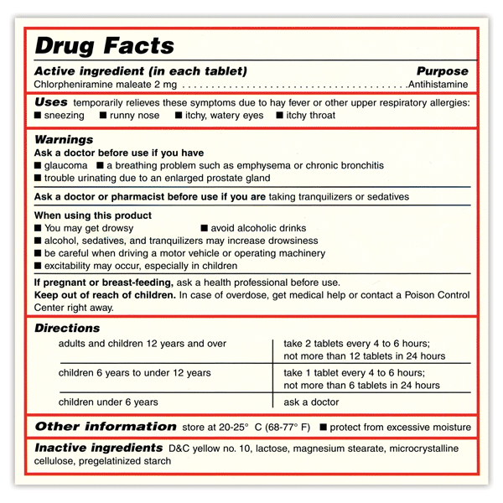
- Active Ingredient. Therapeutic substance in product; amount of active ingredient per unit.
- Uses. Symptoms or diseases the product will treat or prevent.
- Warnings. When not to use the product; conditions that may require advice from a doctor before taking the product; possible interactions or side effects; when to stop taking the product and when to contact a doctor; if you are pregnant or breastfeeding, seek guidance from a health care professional; keep product out of children’s reach.
- Inactive Ingredients. Substances such as colors or flavors.
- Purpose. Product action or category (such as antihistamine, antacid, or cough suppressant.
- Directions. Specific age categories, how much to take, how to take, and how often and how long to take.
- Other Information. How to store the product properly and required information about certain ingredients (such as the amount of calcium, potassium, or sodium the product contains)

- Pharmacist Counseling to Patients Using OTC-drugs (Fig. 1)

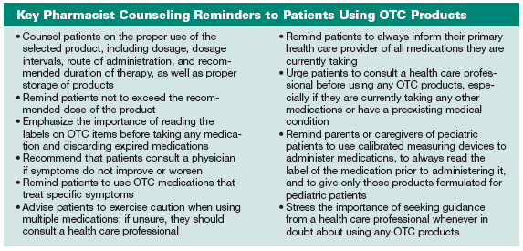

- The Anatomical Therapeutic Chemical (ATC) Classification: definitions, purpose, structure and principles
The ATC classification system classifies therapeutic drugs. In the ATC classification system, the drugs are divided into different groups according to the organ or system on which they act and their chemical, pharmacological and therapeutic properties.
General principles for ATC Classification

- Only one ATC code for each route of administration
Medicinal substances are classified according to the main therapeutic use or pharmacological class on the basic principle of only one ATC code for each route of administration (e.g. oral formulations with similar ingredients and strength will have the same ATC code). This is an important principle for ATC classification as it allows aggregation of data in drug utilization monitoring and research without counting a pharmaceutical product more than once. This principle is strictly handled by the WHO Centre so that users in different countries shall be able to classify a pharmaceutical product (defined by active ingredient/s, route of administration and strength) in the same way.
A pharmaceutical product may be approved for two or more equally important indications, and the main therapeutic use may differ from one country to another. This will often give several classification alternatives. Such drugs are only given one code, the main indication being decided on the basis of the available information. Problems are discussed in the WHO International Working Group for Drug Statistics Methodology where the final classification is decided. Cross-references will be given in the guidelines to indicate the various uses of such drugs.

- More than one ATC code for a medicinal substance
A medicinal substance can be given more than one ATC code if it is available in two or more strengths or routes of administration with clearly different therapeutic uses. A medicinal substance can be given more than one ATC code if it is available in two or more strengths or routes of administration with clearly different therapeutic uses.
Example of different strengths:
Finasteride is available in two different strengths. A low strength tablet for the treatment of male pattern baldness is classified under D11AX - Other dermatologicals. A high strength tablet used in the treatment of benign prostatic hypertrophy (BPH) is classified under G04C - Drugs used in BPH.
Example of different administration forms:
Prednisolone in single ingredient products is given several ATC codes due to different therapeutic use and different formulations.
A07EA01 Intestinal antiinflammatory agents (enemas and foams)
C05AA04 Antihemorrhoidals for topical use (suppositories)
D07AA03 Dermatological preparations (creams, ointments and lotions)
H02AB06 Corticosteroids for systemic use (tablets, injections)
R01AD02 Nasal decongestants (nasal sprays/drops)
S01BA04 Ophthalmologicals (eye drops)
S02BA03 Otologicals (ear drops)

- Inclusion and exclusion criteria
The coverage of the system is not comprehensive. A major reason why a substance is not included is that no request has been received.
Substances which fulfil one of the following criteria will normally be included in the ATC system:
- new chemical entities or biologicals proposed for licensing. A new chemical entity is normally not included in the ATC system before an application for marketing authorisation is ready for submission in at least one country.
- existing well defined chemical entities with an approved marketing authorization in one or more countries. An INN should preferably be established for the substance. Alternatively other official names, e.g. USAN or BAN names should be available.
- herbal medicinal products assessed and approved by regulatory authorities based on dossiers including efficacy, safety, and quality data (e.g. the well-established use procedure in EU).
Other medicinal products are considered on a case by case basis. Complementary, homeopathic and herbal traditional medicinal products are in general not included in the ATC system.

- New ATC groups and “other” groups (X groups)
A new medicinal substance not clearly belonging to any existing ATC 4th level will as a main rule be placed in an X group ("other" group) in the relevant 3rd level. To avoid a situation of several 4th levels with only one single substance in each, new specific 4th levels are as a general rule only established when at least two substances with marketing authorisations fit in the group. In addition, a new 4th level should be regarded a benefit for drug utilization research. New and innovative pharmaceutical products will therefore often be classified in an X group and such groups could be established for only one single substance.

- Classification of combination products
Pharmaceutical products containing two or more active ingredients are regarded as combinations (incl. combination packages) and given different ATC codes from plain products containing one active ingredient. The classification of combination products is a challenge in any classification system. As for plain products, combinations are in general classified according to their main therapeutic use or pharmacological class. A medicinal product containing an analgesic and a tranquillizer, and used primarily to ease pain, should be classified as an analgesic. Likewise, combinations of analgesics and antispasmodics will be classified in A03 Drugs for functional gastrointestinal disorders if the antispasmodic effect of the product is considered most important.

- Structure of the classification

The structure of the classification has 5 levels. The first one allows active substances to be classified into 14 main groups, which are divided into pharmacological/therapeutic subgroups (2nd level). The 3rd and 4th levels are chemical/pharmacological/therapeutic and the 5th is the chemical substance.
The 1st level of the classification represent the organ or system in the body on which the therapeutic effect is exerted:
A Alimentary tract and metabolism
B Blood and blood forming organs
C Cardiovascular system
D Dermatologicals
G Genitourinary system and sex hormones
H Systemic hormonal preparations, excl. sex hormones and insulins
J Antiinfectives for systemic use
L Antineoplasticand immunomodulatingagents
M Musculo-skeletal system
N Nervous system
P Antiparasiticproducts, insecticides and repellents
R Respiratory system
S Sensory organs
V Various

Example: complete classification showing the structure of the code

A ALIMENTARY TRACT AND METABOLISM (1st level, anatomical main group)
A10 DRUGS USED IN DIABETES (2nd level, therapeutic subgroup)
A10B BLOOD GLUCOSE LOWERING DRUGS, EXCL. INSULINS (3rd level, pharmacological subgroup)
A10BA BIGUANIDES (4th level, chemical subgroup)
A10BA02 METFORMIN (5th level, chemical substance)

Metformin is sold both under brand names, and also as a generic drug. Common brand names include:
- Glucophage
- Riomet
- Fortamet
- Glumetza
- Obimet
- Dianben
- Diabex
- Diaformin

