MINISTRY OF HEALTH OF UKRAINE

ODESA NATIONAL MEDICAL UNIVERSITY

Departments of Pediatrics №2

CONFIRMED by

Vice-rector for research and educational work

____________________ Svitlana KOTYUZHYNSKA

September 1st, 2022

METHODOLOGICAL RECOMMENDATIONS

on LECTURE for students

International Medical Faculty, сourse 4

Educational discipline "PEDIATRICS"

Approved
at the meeting of the department of Pediatrics №2
Protocol No. 1 dated 28/08/2022

Head of the department of Pediatrics №2 __________________ Tetiana STOIEVA
Signature

Authors:
Head of the department of Pediatrics №2, MD, PhD in Pediatrics, DM, Professor Stoieva Tetiana
Associate Professor of the department of Pediatrics №2, PhD in Pediatrics Prokhorova Svitlana
Associate Professor of the department of Pediatrics №2, PhD in Pediatrics Titkova O. V.
Associate Professor of the department of Pediatrics №2, PhD in Pediatrics Portnova O. O.
Associate Professor of the department of Pediatrics №2, PhD in Pediatrics Vesilyk N. L.
Associate Professor of the department of Pediatrics №2, PhD in Pediatrics Godlevska T. L.
Assistant of the department of Pediatrics №2, PhD in Pediatrics Fedin M. V.
Assistant of the department of Pediatrics №2, PhD in Pediatrics Jagiashvili O. V.
Assistant of the department of Pediatrics №2, PhD in Pediatrics Reshetilo O.V.
Assistant of the department of Pediatrics №2, PhD in Pediatrics Soboleva H. B.
Assistant of the department of Pediatrics №2 Bratkova L. B.

Lecture № 2 «Bronchial asthma in children».
1. Substantiation and currency of the topic. Asthma is a chronic medical condition. In the developed world has recently focused on asthma because of its rapidly increasing prevalence, affecting up to one in four urban children. The International Study of Asthma and Allergies in Childhood (ISAAC), a monumental study which involved 155 centers in 56 countries was one of the first to reliably compare the prevalence of asthma worldwide. Surveying nearly half a million children 13-14 years of age, this study found great disparities (as high as a 20 to 60-fold difference) in asthma prevalence across the world, with a trend toward more developed and westernized countries having higher asthma prevalence. Rote westernization however does not explain the entire difference in asthma prevalence between countries, and the disparities may also be affected by differences in genetic, social and environmental risk factors. There are also worldwide disparities in asthma mortality, which is most common in low to middle income countries. Current research therefore suggests that the prevalence of childhood asthma has been increasing, and this increased prevalence is greater than that in adults.

2. Goal of lecture:
- Educational: to acquaint students with modern ideas about etiology and pathogenesis, classification, clinical course, and additional methods of diagnostics of bronchial asthma in children, the student should be able to diagnose this pathology, prescribe treatment and to plan preventive measures.
- Educative: read s contribution of scientists to the study of bronchial asthma in children, to be able to bring the parents of treatment is the prevention expediency activities for bronchial asthma in children.
3. Plan and organization of lecture structure.
№ | Basis and content of lecture | Purpose of lecture | Type and equipment | Time
1 | 2 | 3 | 4 | 5
I. | Preparatory stage | I | Auditorium of the | 5%
1.  2. | Purpose of lecture  Positive justify of students |  | university, showing a: patients, x-rays, codogramms, tables, slide-show.
II. | Main stage  The lecture | II |  | 90%
3 | List of the lecture:
 | 1 .Presentations
 | 2. Risk factors
 | 3. Etiology and pathogenesis
 | 4. Clinical
 | Presentations
 | 5. Gasification
 | 6. Methods
 | Diagnostics
 | 7. Differential
 | Diagnostics
 | 8. Preventive
 | Measures
III | Final stage | III |  | 5%
4. | Conclusion
5. | Answer the questions
6. | Questions to independent
 | work

4. Content of lecture materials:
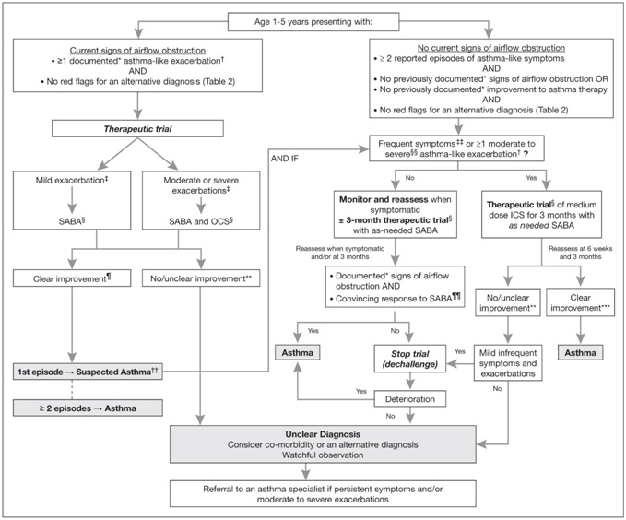

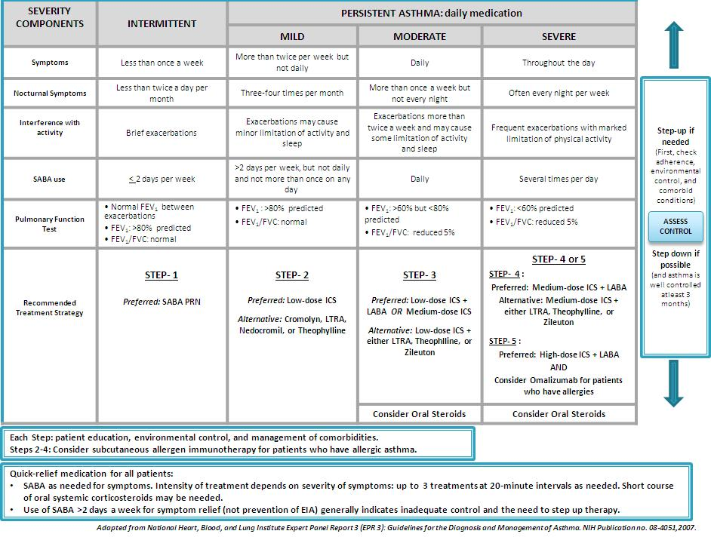
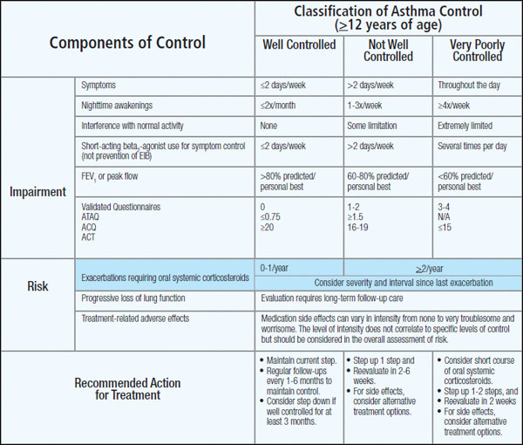
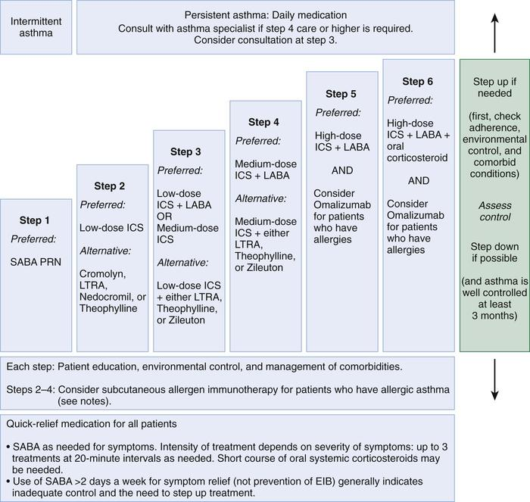

Bronchial asthma in children
Asthma is a chronic inflammatory condition of the lung airways resulting in episodic airflow obstruction. This chronic inflammation heightens the “twitchiness” of the airways—airways hyperresponsiveness (AHR)—to provocative exposures. Asthma management is aimed at reducing airways inflammation by minimizing proinflammatory environmental exposures, using daily “controller” anti-inflammatory medications, and controlling co-morbid conditions that can worsen asthma. Less inflammation typically leads to better asthma control, with fewer exacerbations and decreased need for “quick-reliever” asthma medications. Exacerbations can, nevertheless, still occur.
Early intervention with systemic corticosteroids greatly reduces the severity of such episodes.
Advances in asthma management and especially pharmacotherapy enable all but the uncommon child with severe asthma to live normally.
ETIOLOGY.
Although the cause of childhood asthma has not been determined, contemporary research implicates a combination of environmental exposures and inherent biological and genetic
vulnerabilities. Respiratory exposures in this causal environment include inhaled allergens, respiratory viral infections, and chemical and biological air pollutants such as environmental tobacco smoke. In the predisposed host, immune responses to these common exposures can be a stimulus for prolonged, pathogenic inflammation and aberrant repair of injured airways tissues. Lung dysfunction (i.e., AHR and reduced airflow) develops. These pathogenic processes in the growing lung during early life adversely affect airways growth and differentiation, leading to altered airways at mature ages. Once asthma has developed, ongoing exposures appear to worsen it, driving disease persistence and increasing the risk of severe exacerbations.

Early Childhood Risk Factors for Persistent Asthma:
- Parental asthma Allergy
- Atopic dermatitis
- Allergic rhinitis
- Food allergy
- Inhalant allergen sensitization
- Food allergen sensitization
- Severe lower respiratory tract infection
- Pneumonia
- Bronchiolitis requiring hospitalization
- Wheezing apart from colds
- Male gender
- Low birthweight
- Environmental tobacco smoke exposure
- Reduced lung function at birth.

Classification of bronchial asthma:
- Forms: immune (atopic, infective-depending, mixed), nonimmune (aspirin, dyshormonal, exercise induced).
- Period of the disease: exacerbation, attack, after-attack period, status asthmaticus, extra attack period.
- Severity: mild, moderate, severe.
- Complications: pulmonary heart, emphysema, atelectasis, pneumothorax, neurologic and endocrine disturbances.
PATHOGENESIS. Airflow obstruction in asthma is the result of numerous pathologic processes. In the small airways, airflow is regulated by smooth muscle encircling the airways lumens; bronchoconstriction of these bronchiolar muscular bands restricts or blocks airflow. A cellular inflammatory infiltrate and exudates distinguished by eosinophils, but also including other inflammatory cell types (neutrophils, monocytes, lymphocytes, mast cells, basophils), can fill and obstruct the airways and induce epithelial damage and desquamation into the airways lumen. Helper T lymphocytes and other immune cells that produce pro-allergic, proinflammatory cytokines (IL-4, IL-5, IL-13) and chemokines (eotaxin) mediate this inflammatory process. Pathogenic immune responses and inflammation may also result from a breach in normal immune regulatory processes (regulatory T lymphocytes that produce IL-10 and transforming growth factor [TGF]–β) that dampen effector immunity and inflammation when they are no longer needed. Airways inflammation is linked to AHR or hypersensitivity of airways smooth muscle to numerous provocative exposures that act as triggers, 4 as well as airways edema, basement membrane thickening, subepithelial collagen deposition, smooth muscle and mucous gland hypertrophy, and mucus hypersecretion—all processes that contribute to airflow obstruction.

CLINICAL MANIFESTATIONS AND DIAGNOSIS. Intermittent dry coughing and/or expiratory wheezing are the most common chronic symptoms of asthma. Older children and adults will report associated shortness of breath and chest tightness; younger children are more likely to report intermittent, nonfocal chest “pain.” Respiratory symptoms can be worse at night, especially during prolonged exacerbations triggered by respiratory infections or inhalant allergens. Daytime symptoms, often linked with physical activities or play, are reported with greatest frequency in children. Other asthma symptoms in children can be subtle and nonspecific, including self-imposed limitation of physical activities, general fatigue (possibly due to sleep disturbance), and difficulty keeping up with peers in physical activities. Asking about previous experience with asthma medications (bronchodilators) may provide a history of symptomatic improvement with treatment that supports the diagnosis of asthma. Lack of improvement with bronchodilator and corticosteroid therapy is inconsistent with underlying asthma and should prompt more vigorous consideration of asthma-masquerading conditions. During asthma exacerbations, expiratory wheezing and a prolonged expiratory phase can usually be appreciated by auscultation. Decreased breath sounds in some of the lung fields, commonly the right lower posterior lobe, are consistent with regional hypoventilation owing to airways obstruction. Crackles (or rales) and rhonchi can sometimes be heard, resulting from excess mucus production and inflammatory exudate in the airways. The combination of segmental crackles and poor breath sounds can indicate lung segmental atelectasis that is difficult to distinguish from bronchial pneumonia and can complicate acute asthma management. In severe exacerbations, the greater extent of airways obstruction causes labored breathing and respiratory distress manifested as inspiratory and expiratory wheezing, increased prolongation of exhalation, poor air entry, suprasternal and intercostal retractions, nasal flaring, and accessory respiratory muscle use. In extremis, airflow may be so limited that wheezing cannot be heard.
DIFFERENTIAL DIAGNOSIS. Many childhood respiratory conditions can present with symptoms and signs similar to asthma. Besides asthma, other common causes of chronic, intermittent coughing include rhinosinusitis and gastro-esophageal reflux (GER). Both GER and chronic sinusitis can be challenging to diagnose in children. Often, GER is clinically silent in children, and children with chronic sinusitis do not report sinusitis-specific symptoms such as localized sinus pressure or tenderness. In addition, both GER and rhinosinusitis are often co-morbid conditions with childhood asthma and, if not specifically treated, make asthma difficult to manage.
In early life, chronic coughing and wheezing can indicate recurrent aspiration, tracheobronchomalacia, a congenital anatomic abnormality of the airways, foreign body aspiration, cystic fibrosis, or bronchopulmonary dysplasia. In older children and adolescents, vocal cord dysfunction (VCD) can present as intermittent daytime wheezing. In this condition, the vocal cords close inappropriately, during inspiration and sometimes exhalation, producing shortness of breath, coughing, throat tightness, and often audible laryngeal wheezing and/or stridor. In most VCD cases, spirometric lung function testing will reveal “truncated” and inconsistent inspiratory and expiratory flow-volume loops, a pattern that differs from the reproducible pattern of airflow limitation in asthma that improves with bronchodilators. VCD may also be visualized with laryngoscopy. VCD can coexist with asthma. VCD does not respond to traditional asthma therapy. Speech therapy is the treatment of choice for VCD.
LABORATORY FINDINGS. Lung function tests can help to confirm the diagnosis of asthma and determine disease severity.
PULMONARY FUNCTION TESTING.
Forced expiratory airflow measures are helpful in diagnosing and monitoring asthma and in assessing efficacy of therapy. Lung function testing is particularly helpful in children with asthma who are poor perceivers of airflow obstruction or when physical signs of asthma do not occur until airflow obstruction is severe. Many asthma guidelines promote spirometric measures of airflow and lung volumes during forced expiratory maneuvers as standard for asthma assessment. Spirometry is helpful as an objective measure of airflow limitation. Knowledgeable personnel are needed to perform and interpret spirometry tests. Valid spirometric measures are dependent on a patient's ability to perform properly a full, forceful, and prolonged expiratory maneuver, usually feasible in children >6 yr of age (with some younger exceptions). Reproducible spirometric efforts are an indicator of test validity; if, on 3 attempts, the FEV1 (forced expiratory volume in 1 sec) is within 5%, then the highest FEV1 effort of the 3 is used. This standard utilization of the highest of 3 reproducible efforts is indicative of the effort-dependence of reliable spirometric testing. In asthma, airways blockage results in reduced airflow with forced exhalation and smaller partialexpiratory lung volumes. Because asthmatics are typically hyperinflated, FEV1 can be simply adjusted for full expiratory lung volume—the forced vital capacity (FVC)—with an FEV1/FVC ratio. Generally, an FEV1/FVC ratio <0.80 indicates significant airflow obstruction. Normative values for FEV1 have been determined for children, based on height, gender, and ethnicity. Abnormally low FEV1 as a percentage of predicted norms is 1 of 4 criteria used to determine asthma severity in the National Institutes of Health (NIH)–sponsored asthma guidelines. The guidelines cutoff criteria of FEV1 <80% and <60% of predicted for moderate and severe asthma, respectively, are controversial for children with asthma, many of whom can have near-normal or even supra-normal airflow despite having the other hallmarks of moderate to severe disease.
Measuring exhaled nitric oxide (FENO), a marker of airway inflammation in asthma, can help titrate medications and confirm the diagnosis of asthma. Peak expiratory flow (PEF) monitoring devices provide a simple and inexpensive home-use tool to measure airflow and can be helpful in a number of circumstances. “Poor perceivers” of airflow obstruction due to asthma can benefit by monitoring PEFs daily to assess objectively airflow as an indicator of asthma control or problems that would be more sensitive than their symptom perception. PEFs vary in their ability to detect airflow obstruction; in some patients, PEFs decline only when airflow obstruction is severe. Therefore, PEF monitoring should be started by measuring morning and evening PEFs (best of 3 attempts) for several weeks for patients to practice the technique, to determine a “personal best,” and to correlate PEF values with symptoms (and ideally spirometry). PEF variation >20% is consistent with asthma.
Radiology. Chest radiographs (posteroanterior and lateral views) in children with asthma often appear to be normal, aside from subtle and nonspecific findings of hyperinflation (flattening of the diaphragms) and peribronchial thickening. Chest radiographs can be helpful in identifying abnormalities that are hallmarks of asthma masqueraders (aspiration pneumonitis, hyperlucent lung fields in bronchiolitis obliterans), and complications during asthma exacerbations (atelectasis, pneumomediastinum, pneumothorax). Some lung abnormalities can be better appreciated with highresolution, thin-section chest CT scans. Bronchiectasis is sometimes difficult to appreciate on chest radiograph, but is clearly seen on CT scan and implicates an asthma masquerader such as cystic fibrosis, allergic bronchopulmonary mycoses (aspergillosis), ciliary dyskinesias, or immune deficiencies.
Other tests, such as allergy testing to assess sensitization to inhalant allergens, help with the management and prognosis of asthma. In a comprehensive U.S. study of 5–12 yr old asthmatic children (Childhood Asthma Management Program [CAMP]), 88% had inhalant allergen sensitization by allergy prick skin testing.
TREATMENT.
The key elements to optimal asthma management are well recognized. The NIH National Heart, Lung and Blood Institute (NHLBI) developed current asthma management guidelines. For childhood asthma, a joint publication of the American Academy of Allergy, Asthma and Immunology, the American Academy of Pediatrics, and the NIH, entitled Pediatric Asthma: Promoting Best Practice, has been updated to reflect the 2002 National Asthma Education and Prevention Program (NAEPP) Update. These guidelines describe 4 principle components to optimal asthma management.
Principles of Asthma Pharmacotherapy. The NAEPP guidelines offer a stepwise approach to management based on asthma severity categorized as mild intermittent, mild persistent, moderate persistent, and severe persistent asthma. The classification of asthma severity is based on the following parameters: (1) frequency of daytime and (2) nighttime symptoms, (3) degree of airflow obstruction by spirometry, and/or (4) PEF variability. For younger children (5 yr of age) are considered alternative controllers for mild persistent asthmatics. Combination therapy of a low-to-medium dose ICS with a long-acting β-agonist (LABA; preferred) or a leukotriene modifier or theophylline is a mainstay therapy for moderate persistent asthma in older children and adults. While the use of medium-dose ICS alone is an alternative therapy for older children and adults with moderate persistent severity, for infants and young children, it is considered a preferred treatment for moderate persistent asthma. Severe persistent asthmatics should receive high-dose ICS, a long-acting bronchodilator, and routine oral corticosteroids if needed. Daily controller therapy is not recommended for mild intermittent asthma. SABAs are the recommended quick-reliever medications for symptoms and exercise pretreatment for all asthma severity levels.
INHALED CORTICOSTEROIDS (ICS). The NAEPP guidelines recommend daily ICS therapy as the treatment of choice for all patients with persistent asthma. ICS therapy has been shown to reduce asthma symptoms, improve lung function, reduce AHR, reduce “rescue” medication use and, most important, reduce urgent care visits, hospitalizations, and prednisone use for asthma exacerbations by about 50%. ICS therapy may lower the risk of death due to asthma. It can achieve all of the goals of asthma management and, as a result, is viewed as first-line treatment for persistent asthma.
There are currently 5 ICSs that are approved by the FDA, and the NAEPP guidelines provide an equivalence classification, although direct comparisons of efficacy and safety outcomes in children are lacking. Newer forms are being developed (mometasone furoate, ciclesonide) that may enhance the efficacy-to-safety profile of ICS therapy while allowing for less frequent dosing. ICSs are available in MDIs, DPIs, or in suspension for nebulization. Fluticasone propionate, mometasone furoate and, to a lesser extent, budesonide are considered “2nd-generation” ICSs in that they have increased antiinflammatory potency and reduced systemic bioavailability for potential adverse effects, owing to extensive first-pass hepatic metabolism. The selection of the initial ICS dose is based on the determination of disease severity. A fraction of the initial ICS dose is often sufficient to maintain good control after this has been achieved.
Although ICS therapy has been widely used in adults with persistent asthma, its application in children has lagged due to concerns of the potential for adverse effects with chronic use. Generally, clinically significant adverse effects that occur with chronic systemic corticosteroid therapy have not been seen or have been only very rarely reported in children receiving ICSs in recommended doses. The risk of adverse effects from ICS therapy is related to the dose and frequency with which ICSs are given. High doses (≥1,000 μg/day in children) and frequent administration (4 times/day) are more likely to cause local and systemic adverse effects. Children who are maintained on higher ICS doses are also likely to require systemic corticosteroid courses for asthma exacerbations, further increasing the risk of corticosteroid adverse effects.
SYSTEMIC CORTICOSTEROIDS. ICS therapy has allowed the large majority of children with asthma to maintain good disease control without maintenance (qod) oral corticosteroids. Oral corticosteroid therapy is used primarily to treat asthma exacerbations and in rare patients with severe disease who remain symptomatic despite optimal use of other asthma medications. In these severe asthmatics, every attempt should be made to exclude any co-morbid conditions and to keep the oral corticosteroid dose at ≤20 mg qod. Doses exceeding this amount are associated with numerous adverse effects. To determine the need for continued oral corticosteroid therapy, a taper of the oral corticosteroid dose (over weeks to several months) should be considered, with close monitoring of the patient's symptoms and lung function.
When administered orally, prednisone, prednisolone, and methylprednisolone are rapidly and nearly completely absorbed, with peak plasma concentrations occurring within 1–2 hr. Prednisone is an inactive pro-drug that requires biotransformation via first-pass hepatic metabolism to prednisolone, its active form. Corticosteroids are metabolized in the liver into inactive compounds, with the rate of metabolism influenced by drug interactions and disease states. Anticonvulsants (phenytoin, phenobarbital, carbamazepine) increase the metabolism of prednisolone, methylprednisolone, and dexamethasone, with methylprednisolone most significantly affected. Rifampin also enhances the clearance of corticosteroids and can result in diminished therapeutic effect. Other medications (ketoconazole, oral contraceptives) can significantly delay corticosteroid metabolism. Macrolide antibiotics (erythromycin, clarithromycin, troleandomycin) delay the clearance of only methylprednisolone.
Children who require chronically administered oral cortico-steroids are at risk of developing associated adverse effects over time. Essentially all major organ systems can be adversely affected by chronically administered oral corticosteroid therapy. Some of these effects occur immediately (metabolic effects). Others can develop insidiously over several months to years (growth suppression, osteoporosis, cataracts). Most adverse effects occur in a cumulative dose- and duration-dependent manner. Children who require routine or frequent short courses of oral corticosteroids, especially with concurrent highdose ICSs, should receive corticosteroid adverse effects screening and osteoporosis preventive measures.
LONG-ACTING INHALED β-AGONIST (LABA). Although LABAs (salmeterol, formoterol) are β-agonists, they are consid ered to be daily controller medications, not intended for use as “rescue” medication for acute asthma symptoms or exacerbations, nor as monotherapy for persistent asthma. Salmeterol has a prolonged onset of action, with maximal bronchodilation about 1 hr after administration, whereas formoterol has an onset of action within 5–10 min. Both medications have a prolonged duration of effect of at least 12 hr. Given their long duration of action, they are well suited for patients with nocturnal asthma and for individuals who require frequent SABA use during the day to prevent exercise-induced bronchospasm. Their major role is as an “add-on” agent in patients who are suboptimally controlled on ICS therapy alone. For those patients, several studies have found the addition of LABA to ICS to be superior to doubling the dose of ICS, especially on day and nocturnal symptoms. There are also controller formulations that combine ICS with LABA (fluticasone/salmeterol, budesonide/formoterol).
LEUKOTRIENE-MODIFYING AGENTS. Leukotrienes are potent pro-inflammatory mediators that can induce bronchospasm, mucus secretion, and airways edema. Two classes of leukotriene modifiers have been developed: inhibitors of leukotriene synthesis and leukotriene receptor antagonists (LTRA). Zileuton, the only leukotriene synthesis inhibitor, is not approved for use in children 12 yr old with moderate to severe asthma, documented hypersensitivity to a perennial aeroallergen, and inadequate disease control with inhaled and/or oral corticosteroids. It is given every 2–4 wk subcutaneously based on body weight and serum IgE levels. Its clinical efficacy as an “add-on” therapy for patients with moderate to severe allergic asthma has been demonstrated in large clinical trials, with asthmatics receiving omalizumab having fewer asthma exacerbations and symptoms while reducing their ICS and/or oral corticosteroid doses. It is generally well tolerated, although local injection site reactions can occur. Hypersensitivity reactions (including anaphylaxis) and malignancies have been very rarely associated with Omalizumab use.
Quick-Reliever Medications. Quick-relief or “rescue” medications (short-acting inhaled βagonists, inhaled anticholinergics, and short-course systemic corticosteroids) are used in the management of acute asthma symptoms.
SHORT-ACTING INHALED β-AGONISTS (SABA). Given their rapid onset of action, effectiveness, and 4–6 hr duration of action, SABAs (salbuterol, levalbuterol, terbutaline, pirbuterol) are the first drugs of choice for acute asthma symptoms (“rescue” medication) and for preventing exercise-induced bronchospasm. β-agonists bronchodilate by inducing airway smooth muscle relaxation, reducing vascular permeability, reducing airways edema, and improving mucociliary clearance. Levalbuterol, or the R-isomer of albuterol, has less tachycardia and tremor, which can be bothersome to some asthmatics. Overuse of β-agonists is associated with an increased risk of death or near-death episodes from asthma. This is a major concern for some patients with asthma who rely on the frequent use of SABAs as a “quick fix” for their asthma, rather than using controller medications in a preventive manner. It is helpful to monitor the frequency of SABA use, in that use of at least 1 MDI/mo or at least 3 MDIs/year (200 inhalations/MDI) indicates inadequate asthma control and necessitates improving other aspects of asthma therapy and management.
ANTICHOLINERGIC AGENTS. As bronchodilators, the anticholinergic agents (ipratropium bromide) are much less potent than the β-agonists. Inhaled ipratropium is primarily used in the treatment of acute severe asthma. When used in combination with albuterol, ipratropium can improve lung function and reduce the rate of hospitalization in children who present to the emergency department with acute asthma. Ipratropium is the anticholinergic formulation of choice for children because it has few central nervous system adverse effects and it is available in both MDI and nebulizer formulations. Although widely used in children with asthma exacerbations of all ages, it is approved by the FDA for children >12 yr of age. A severe exacerbation of asthma that does not improve with standard therapy is termed status asthmaticus. Immediate management of an asthma exacerbation involves a rapid evaluation of the severity of obstruction and assessment of risk for further clinical deterioration. For most patients, exacerbations will improve with frequent bronchodilator treatments and a systemic corticosteroid course. The optimal management of a child with an asthma exacerbation should include, however, a more comprehensive assessment of the events leading up to the exacerbation and the underlying disease severity. Indeed, the frequency and severity of asthma exacerbations helps to define the severity of a patient's asthma. Whereas most children who experience life-threatening asthma episodes have moderate to severe asthma by other criteria, some children with asthma appear to have mild disease except when they suffer severe, even near-fatal exacerbations. The biological, environmental, economic, and psychosocial risk factors associated with asthma morbidity and death can further guide this assessment.
PROGNOSIS. Recurrent coughing and wheezing occurs in 35% of pre–school-age children. Of these, ⅓ continue to have persistent asthma into later childhood, while ⅔ improve on their own through the preteen years. Asthma severity by the ages of 7–10 yr of age is predictive of asthma persistence in adulthood. Children with moderate to severe asthma and with lower lung function measures are likely to have persistent asthma as adults. Children with milder asthma and normal lung function are likely to improve over time, with some becoming periodic (disease-free mo to yr); however, complete remission for 5 yr in childhood is uncommon.
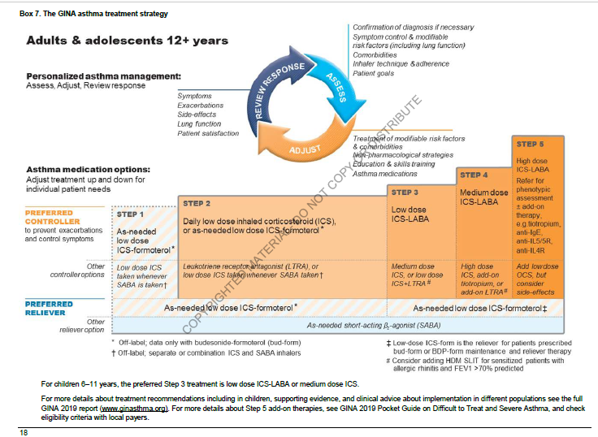

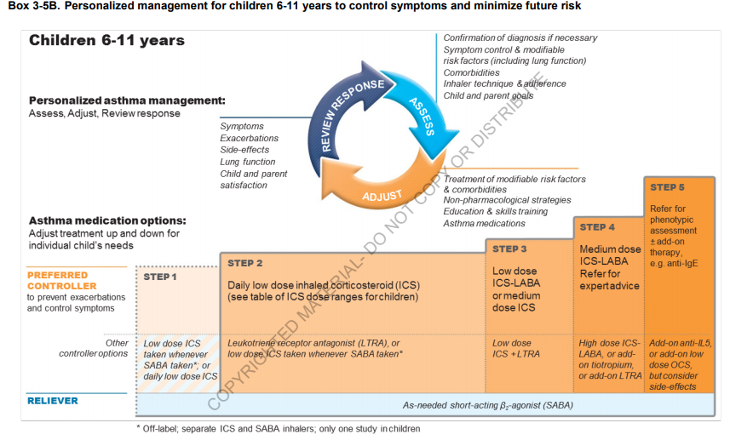
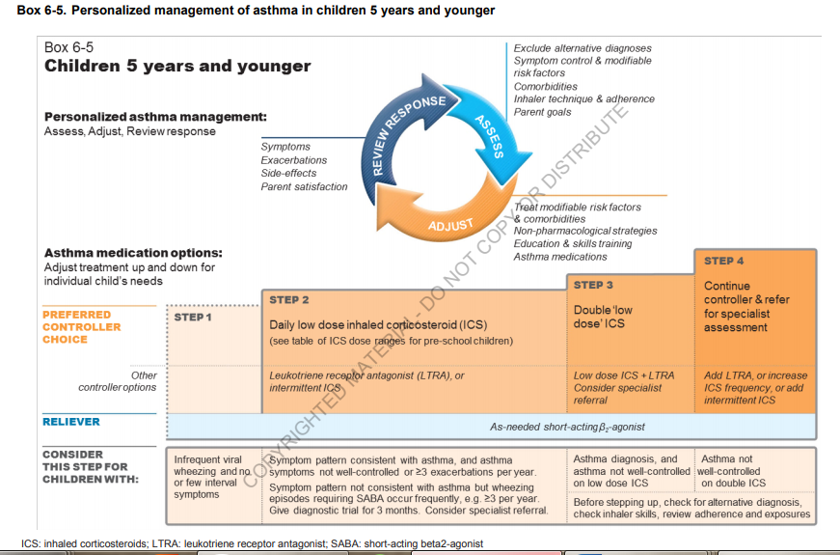

- Materials which activate students at lecture
Control questions:
1). Spread the word and the incidence of asthma in the pediatric population, the risk factors for the disease.
2). Classification of asthma in the form period severity.
3). The clinical picture of asthma attack.
4). Respiratory function tests.
4). Method of spirometry.

6. General material and methodical lecture support.
Lecture type - combined; equipment – department auditoria, patient presentation, X-ray, multimedia slides.

а) from present lecture topic
Literature:
- Kliegman, R.M., St Geme, J.W., Blum, N.J., Shah, S.S., Tasker, R.C., Willson, K.M., & Behrman, R.E. (Eds.). (2019). Nelson Textbook of Pediatrics (21st ed.). 4264 p.
- A. Deschildre, I. Pin, K. El Abd et al., “Asthma control assessment in a pediatric population: comparison between GINA/NAEPP guidelines, Childhood Asthma Control Test (C-ACT), and physician’s rating,” Allergy, vol. 69, no. 6, pp. 784–790, 2014.
- Bush A, Fleming L. Diagnosis and management of asthma in children. BMJ (2015) 350:h996. 10.1136/bmj.h996
- Global Initiative for Asthma GINA Report: Global Strategy for Asthma Management and Prevention (2017).
- British Thoracic Society/Scottish Intercollegiate Guideline Network, British Guideline on the Management of Asthma (2016).
- Bossley CJ, Saglani S, Kavanagh C, Payne DN, Wilson N, Tsartsali L, et al. . Corticosteroid responsiveness and clinical characteristics in childhood difficult asthma Eur Respir J. (2009) 34:1052–9. 10.1183/09031936.00186508.

b). on the topic of the next lecture:
- Kliegman, R.M., St Geme, J.W., Blum, N.J., Shah, S.S., Tasker, R.C., Willson, K.M., & Behrman, R.E. (Eds.). (2019). Nelson Textbook of Pediatrics (21st ed.). 4264 p.
- Ailes, E. C., Gilboa, S. M., Riehle-Colarusso, T., Johnson, C. Y., Hobbs, C. A., Correa, A. & Honein, M. A. (2014). Prenatal diagnosis of nonsyndromic congenital heart defects. Prenatal Diagnosis, 34(3), 214–222.
- Alkan, F., Sertcelik, T., Yalın Sapmaz, S., Eser, E. & Coskun, S. (2017). Responses of mothers of children with CHD: quality of life, anxiety and depression, parental attitudes, family functionality. Cardiology in the Young, 27(9), 1748–1754.
- Barnett P, Postma AV. Genetics of congenital heart disease: Beyond half-measures. Trends Cardiovasc Med. 2015;25:302–304.
- Diagnosis, imaging and clinical management of aortic coarctation. Dijkema EJ, Leiner T, Grotenhuis HB. Heart. 2017;103:1148–1155.

Questions
1. Definition of asthma in children.
2. The risk factors for the bronchial asthma in children.
3. Pathogenesis of asthma based on modern understanding about the role of immune and non-immune mechanisms.
4. The clinical picture of asthma attack .Evaluation criteria of severity.
5. Diagnosis of asthma.
6. Treatment of bronchial asthma in children depending of the age.

Task
Task 1. Oksana, 16 years, is ill with a bronchial asthma from 3 years. The condition of the girl has worsened, disease symptoms daily, are not always stopped ₂ -agonist of short action during the last 3 month. PEF - 50-60 %. Daily PEF deviation - 30-35 %. Physical activity is considerably limited.
1. Define disease severity?
2. What PEF index is normal?
3. What daily PEF deviation is normal?
4. How many time per day it is necessary to monitor of PEF?
5. What basic therapy corresponds to the given course severity?

Task 2. Maxim, 3 years, has had marked 3 episodes of the labored breathing, dyspnea, dry persuasive cough after the using of raspberry, strawberry in food, tangerines, within 1 year. In the anamnesis - exhudative catarrhal diathesis. The father of the boy suffers atopic dermatitis and an allergic rhinitis, at mother - a food allergy.
1. Make the presumable diagnosis.
2. With what diseases it is necessary to carry out differential diagnostics?
3. What additional methods of investigation are necessary for spending for diagnosis statement?
4. What contributing factors are present at the anamnesis at the child?
5. What causal allergens are significant for the patient?

b). for next lecture topic
Literature:
- Ailes, E. C., Gilboa, S. M., Riehle-Colarusso, T., Johnson, C. Y., Hobbs, C. A., Correa, A. & Honein, M. A. (2014). Prenatal diagnosis of nonsyndromic congenital heart defects. Prenatal Diagnosis, 34(3), 214–222.
- Alkan, F., Sertcelik, T., Yalın Sapmaz, S., Eser, E. & Coskun, S. (2017). Responses of mothers of children with CHD: quality of life, anxiety and depression, parental attitudes, family functionality. Cardiology in the Young, 27(9), 1748–1754.
- Barnett P, Postma AV. Genetics of congenital heart disease: Beyond half-measures. Trends Cardiovasc Med. 2015;25:302–304.
- Diagnosis, imaging and clinical management of aortic coarctation. Dijkema EJ, Leiner T, Grotenhuis HB. Heart. 2017;103:1148–1155.

Questions:
- Anatomical and physiological of the cardiovascular system of children of different age groups.
- Etiology and pathogenesis of congenital heart diseases.
- Clinical forms of congenital heart diseases in children.
- Clinical characteristics of CHD in children.
- Principles of treatment of various forms of CHD in children.
- Principles of rehabilitation of children with CHD.

Task

Task 1. The girl 7 y. complains of the raised delicacy, fatigability, a dyspnea during physical exercises, giddiness, periodical pains over the heart, sensation of increased heartbeat. At examination attracts attention pallor of a skin and the visible mucous. Percussion: borders of relative cardiac dullness are dilated, more to the right. Auscultative picture: intensification of I tone on an apex, intensification and splitting of II th tone on a pulmonary artery, in II intercostal spaces to the left of a breastbone - systolic hum of average intensity, irradiates to the left clavicle and V point. On the X-ray of thorax organs: intensification of a pulmonary drawing at the expense of an arterial bed. Shades of lung roots and a pulmonary artery are dilated. A heart waist it is smoothed because of a protrusion of pulmonary artery arch . From the anamnesis it is known, that the girl often is ill with a pneumonia and a bronchitis with congestive wet cough, and mother a lot of time worked with the computer during pregnancy, and in the first trimester had a flu.
1. Possible diagnosis.
2. Group classification of given CHD?
3. What group of etiological factors has affected a birth of the child with CHD?
4. What of data of the anamnesis and objective inspection, and also X-ray point well for the group of defects chosen by you on classification?
5. What of additional tool methods of research is the most informative for statement of diagnosis CHD?
Task 2. A mother of the 8-month child appealed for the medical aid to the hospital with complains of that, that a boy has lack of weight, refuse from the breast-feeding. During the feeding in the area of the nasolabial triangle cyanosis appears, and while high cry -- cyanosis of the whole body. From the anamnesis it is known that during the pregnancy mother was ill with influenza, besides was spending a lot of time with the computer. Objective examination: the skin is pale, acrocyanosis; while the palpation of the chest – “cat-like purring” on the second intercostals space left from the breast bone; while auscultation systolic murmur on the second intercostals space left from the breast bone, in the third-forth intercostals spaces left – intensive systolic murmur, on the back (in the interscapular space) – the murmur of the collateral circulation.
Doctor formed a provisional diagnose: congenital heart disease -- Fallot’s tetrad.
- To what group on the classification this malformation belongs?
- What etiological factors had influence on the burning of the child with congenital heart disease?
- What supplemental methods are necessary to make to form the final diagnosis?
- What typical Fallot’s tetrad’s sign can you see on the X-ray plate?
- Call the elements of the Fallot’s tetrad.

8. Literature, which was used for the lecture preparation by lector:

- Kliegman, R.M., St Geme, J.W., Blum, N.J., Shah, S.S., Tasker, R.C., Willson, K.M., & Behrman, R.E. (Eds.). (2019). Nelson Textbook of Pediatrics (21st ed.). 4264 p.
- Ghai ”Essential pediatrics ” 9th Edition. 2019. 814 p.
- Global Initiative for Asthma GINA Report: Global Strategy for Asthma Management and Prevention (2017).
- Primary Care Respiratory Society UK Asthma Guidelines Briefing Document (2017).
- British Thoracic Society/Scottish Intercollegiate Guideline Network, British Guideline on the Management of Asthma (2016).
- National Institute for Health and Care Excellence Asthma: Diagnosis, Monitoring and Chronic Asthma Management (2017).

