MINISTRY OF HEALTH OF UKRAINE

ODESA NATIONAL MEDICAL UNIVERSITY

Departments of Pediatrics №2

CONFIRMED by

Vice-rector for research and educational work

____________________ Svitlana KOTYUZHYNSKA

September 1st, 2022

METHODOLOGICAL RECOMMENDATIONS

on LECTURE for students

International Medical Faculty, сourse 4

Educational discipline "PEDIATRICS"

Approved
at the meeting of the department of Pediatrics №2
Protocol No. 1 dated 28/08/2022

Head of the department of Pediatrics №2 __________________ Tetiana STOIEVA
Signature

Authors:
Head of the department of Pediatrics №2, MD, PhD in Pediatrics, DM, Professor Stoieva Tetiana
Associate Professor of the department of Pediatrics №2, PhD in Pediatrics Prokhorova Svitlana
Associate Professor of the department of Pediatrics №2, PhD in Pediatrics Titkova O. V.
Associate Professor of the department of Pediatrics №2, PhD in Pediatrics Portnova O. O.
Associate Professor of the department of Pediatrics №2, PhD in Pediatrics Vesilyk N. L.
Associate Professor of the department of Pediatrics №2, PhD in Pediatrics Godlevska T. L.
Assistant of the department of Pediatrics №2, PhD in Pediatrics Fedin M. V.
Assistant of the department of Pediatrics №2, PhD in Pediatrics Jagiashvili O. V.
Assistant of the department of Pediatrics №2, PhD in Pediatrics Reshetilo O.V.
Assistant of the department of Pediatrics №2, PhD in Pediatrics Soboleva H. B.
Assistant of the department of Pediatrics №2 Bratkova L. B.

Lecture № 3: The most widespread congenital heart disease in children
l. Substantiation and currency of the topic. A congenital heart defect (CHD) is a defect in the structure of the heart and great vessels of a newborn. Most heart defects either obstruct blood flow in the heart or vessels near it or cause blood to flow through the heart in an abnormal pattern, although other defects affecting heart rhythm (such as long QT syndrome) can also occur. Heart defects are among the most common birth defects and are the leading cause of birth defect-related deaths.
Affecting approximately one in every 125 babies born, congenital heart defects are the most common birth defect. Forty thousand people are born each year with a CHD; 4,000 will not survive their first year. Twice as many children die each year from a CHD than all forms of Pediatric Cancers combined. The eight most common defects account for 80% of all congenital heart diseases, while the remaining 20% consist of many independently infrequent conditions or combinations of several defects. Ventricular septal defect (VSD) is generally considered to be the most common type of malformation, accounting for about 1/3 of all congenital heart defects. The incidence is higher when a parent or a sibling has a heart defect (4-5%), in stillborns (3-4%), abortuses (10-25%), and premature infants (2%). The number of adults with problems connected to a congenital heart defect is rising, passing the number of children with congenital heart defects in most Western countries. This group is referred to as grown-up congenital heart disease (GUCH) patients.
2. Goal of lecture:
- Educational: to acquaint students with modern ideas about etiopathogenesis, classification, clinical course, and additional methods of diagnostics congenital heart defects in children, the student should be able to diagnose this pathology, prescribe treatment and to plan preventive measures.
- Educative: read s contribution of scientists to the study of functional congenital heart defects in children, to be able to bring the parents of treatment is the prevention expediency activities for congenital heart defects in children.
3. Plan and organization of lecture structure.
№ | Basis and content of lecture | Purpose of lecture | Type and equipment | Time
1 | 2 | 3 | 4 | 5
I. | Preparatory stage | I | Auditorium of the | 5%
1.  2. | Purpose of lecture  Positive justify of students |  | university, showing a: patients, x-rays,
II. | Main stage  The lecture | II | codogramms, tables, slide-show. | 90%
3 | List of the lecture:
 | 1 .Presentations
 | 2. Risk factors
 | 3. Etiopathogenesis
 | 4. Clinical
 | Presentations
 | 5. Gasification
 | 6. Methods
 | Diagnostics
 | 7. Differential
 | Diagnostics
 | 8. Preventive
 | Measures
III | Final stage | III |  | 5%
4. | Conclusion
5. | Answer the questions
6. | Questions to independend
 | work

- Content of lecture materials:
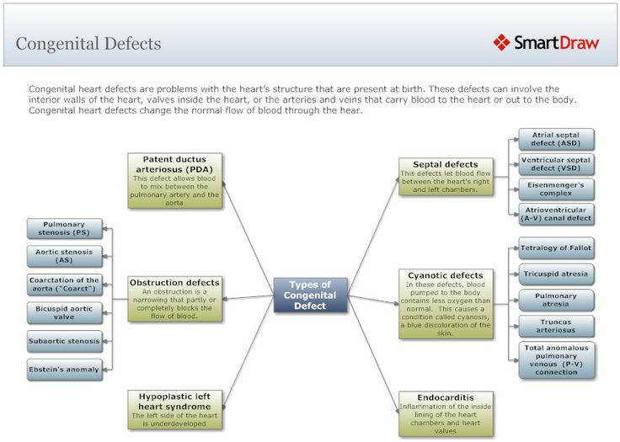
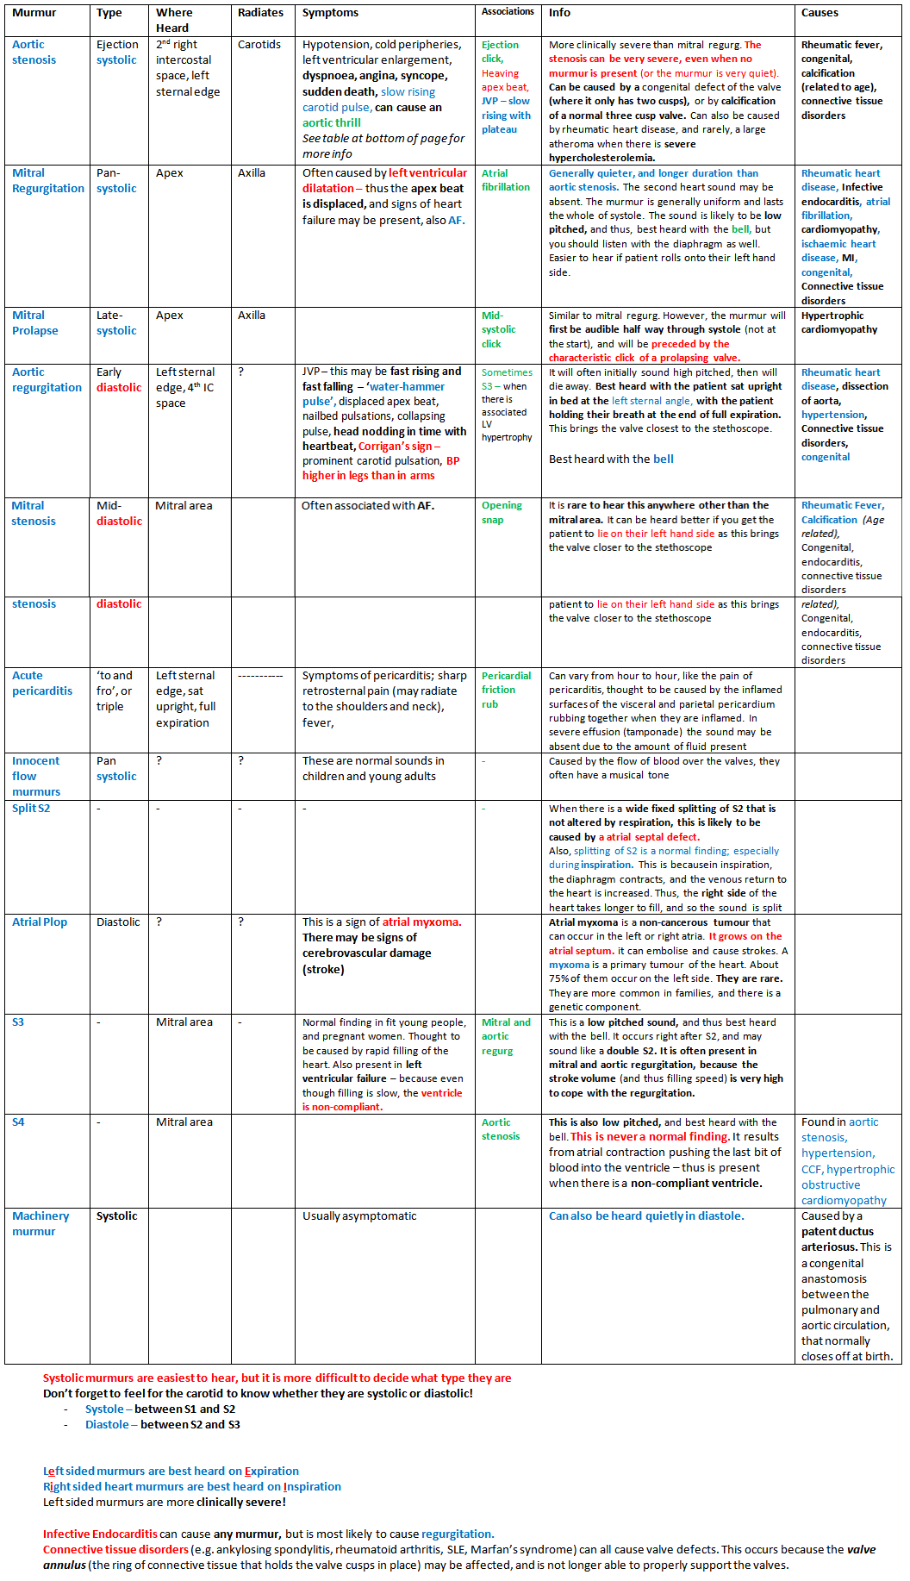

Congenital heart failure in children
Congenital heart failures are one of the most common diseases. They effect people of different age; they present social problem, leading to stable loss of working ability. Mistakes in diagnostics of these failures are not infrequent, in spite of sufficient knowledge of their clinical picture.
Because timely diagnosis of certain heart failures may provide their radical curation by surgery, requirements to proper diagnosis of failure are greatly increased. Modern methods of examination, including such complex invasive methods, as probing of right and left section of the heart, contrast methods of investigation (ventriculography) and non-invasive methods. They are electrocardiogram (ECG) and echocardiogram, which are in 100% of cases assist in making a proper diagnosis. A patient with heart failure, first of all, is referred to poly clinic. Therefore, thorough physical examination of the patient in combination with using simple instrumental methods (x-ray, ECG, FCG) must give maximum information for making a diagnosis.
All clinical manifestation of any heart failure can be combined into the following three syndromes:
- Syndrome of valve lesion.
- Syndrome of pathologic process, causing the development of heart fail
ure (rheumatic process, prolonged septic endocarditis and so on).
- Syndrome of disturbances of the systemic circulation.
Let's consider the clinical and diagnostic contents of each syndrome.
1. Syndrome of valve lesion includes two groups of symptoms. The first group is valve "direct" symptoms, brought about by functional disturbances of pathologic injured valve and changed circulation. They are aus-cultative symptoms, which are pathognomonic for these heart diseases, which are manifested by sound changes, murmurs and additional sounds. Difference of these signs makes a diagnosis of heard failure reliable. The diagnosis of heart failure is doubtful, if these symptoms are absent, although in rare cases "aphoriic" failure may also occur. Direct auscultative symptoms are relative to some pulpatory data, which are equivalents of auscultative data (for example, "systolic" or "diastolic" fremitus, which are equivalents of systolic and diastolic murmur). The main method of revealing direct symptoms is auscultation, which can be supplemented by ECG data. A great number of clinicists prefer auscultation, as this method is simple, informative and available. But we should note that to get maximal information on auscultation, it is necessary to create conditions, providing the increase and acceleration of circulation through injured valve and improving the sound of auscultation. It is possible in certain position of the patient and after physical loading. Thus, "direct" signs of heart failure must be revealed actively and purposefully.
The second group is indirect symptoms, caused by: a) development of compensatory hypertrophy and dilatation of different section of the heart; b) circulatory disturbances (increase or decrease of it). Percussion, X-ray, echocardiogram, ECG, reveal compensatory hypertrophy and dilatation of the heart. Limitations in possibilities of these methods are connected with difficulties of detection the initial degrees of myocardium hypertrophy. It should be remembered that absence or insignificance of these symptoms does not exclude the diagnosis of heart failures, if there are direct signs. Symptoms, caused by circulatory disturbances in different vascular areas, depend on the marked degree of the valve defect. They are symptoms of the changed blood flow in the systemic circulation in the patients with mitral and aortic stenosis. Decrease of circulation may be manifested both by complaints of general character (weakness, fatigue) and specific sensation (headache, giddiness, chest pain, syncope). Besides of circulation in the systemic circulation have a number of objective signs (pallor, decrease of arterial pressure, pulse changes). Disturbances of blood flow in the pulmonary circulation leads to pulmonary hypertension. There are breathlessness on exertion and at rest, attacks of cardiac asthma, con-jective rales, edema of the lungs. Absence of symptoms of this group must not interfere into making the diagnosis of heart failure, in having "direct" valve signs.
- Syndrome of pathologic process, caused by development of heart
failure. Evaluation of symptoms of main pathologic process must be made, taking into consideration anamnestic, clinical and the whole complex of biochemical and immunological data, allowing to determine the main no- zoform (rheumatic process, prolonged septic endocarditis).
- In making a full diagnosis of heart failure the physician must re veal and define more precisely degree of circulation disturbances - circu latory insufficiency on the basis of clinical laboratory signs and find out the cause, brought about by the development of circulatory insufficiency in each case.
MITRAL STENOSIS (stenosis of the left atrio-ventricular opening).
Mitral stenosis is frequently met in acquired heart failure. It may be met in "pure" form and in combination with insufficiency of the mitral valve. Practically, all cases of mitral stenosis are consequence of rheumatism. Area of the left atrio-ventricular opening is big enough (4.0-6.0 sm²), that's why its decrease by half results in hemodynamic disturbances. Obstruction of the mitral opening is an obstacle to flow of blood from the left atrium, therefore, to provide normal circulation and normal filling of the left ventricle a number of compensation mechanism are turned on. In the left atrio-ventricular cavity the pressure is increased (to 20-25 mm Hg, norm - 5 mm). This pressure increase leads to increase the gradient between the left atrium and the left ventricle. This makes the flow of blood through the mitral valve to the left ventricle in obstructive opening earlier. Systole of the left atrium is prolonged and blood flows into the left ventricle longer. These two compensation mechanisms - increase of pressure in the left atrium and extension of systole of the left atrium - compensate in-tocardial circulation at first.
Progressive decreasing of the opening causes further growth of the pressure in the cavity of the left atrium, which leads to retrograde increasing of pressure in the pulmonary veins and capillaries. The pressure in the pulmonary atresia is increased (hypertension of the pulmonary circulation). The degree of pressure increased in the pulmonary artery is proportional to elevation of pressure in the left atrium; the gradient between them remains unchanged (20 mm Hg). This way of pressure increase in the pulmonary artery is passive and pulmonary hypertension is called passive (retrograde) as pressure in the pulmonary circulation is increased, first of all, in the vein and after that in arterial vessels (to 60 mm Hg). As a result, hypertrophy of the right ventricle is formed (reflex of Kitaev) - reflex stenosis of the arte-rioles as result of stimulation of baroreceptors and significant increase of pressure to 180-200 mm Hg. Increase of pressure in the right ventricle makes systole of the right atrium difficult - development of pressure in the cavity - hypertrophy of the myocardium. Later on weakening of the right ventricle begins (dystrophic, sclerotic changes) - the so-called right ventricle insufficiency is decompensation in the systemic circulation. Pulmonary hypertension causes such symptoms as breathlessness on physical exertion, cough, sometimes haemoptysis, fatigue and weakness.
Objective symptoms are "fades mitrales" - mitral color of cheeks, cyanosis of the lips, tip of the nose. On examination the area of the heart is
projected in the lower portion of the breastbone (hypertrophy of the right ventricle). Palpation confirms intensified pulsation of the right ventricle. After physical exertion in supine position on the left side diastolic fremitus ("cat murmur") may be determined by palpation. The intensified second sound may be palpated in the second left intercostal space to the left of the breastbone. Symptom of Nesterov - symptom of two hammers - the palm is placed on the apex, and fingers on the area of the second intercostal space to the left of the breastbone. The palm as a stroke of the first hammer feels the clapping first sound and the fingers as a stroke of second hammer feel the second sound. On percussion the relative upper outline of the heart is increased upward due to auriculae atrii sinistra and to the right due to the right heart.
Auscultation gives significant signs to diagnosis. They are:
1. Intensification of the first sound on the apex of the heart (clapping), due to not full filling of the left ventricle and its quick contraction, great amplitude of moving of the valve. On the apex of the heart we may auscultate the sound followed after the second sound, which is connected with sharp movement of cusps of the valve. Thus, on the apex triple melody is determined. That is the clapping first sound, the second sound and clasp of the opening.
Intensification of the second sound is often combined with its doubling, which is caused by different closure of the valve of the pulmonary artery and aorta. Short diastolic murmur on the apex of the heart is characteristic symptom of auscultation.
The treatment of this failure is surgical - mitral valvotomy.
MITRAL INSUFFICIENCY (mitral regurgitation).
There is functional and organic mitral insufficiency. Functional insufficiency is not consequence of lesion of the mitral valve, but not full closing of mitral the opening may be brought about by a number of causes:
- organic diseases of the heart;
- changes of the papillary muscles tones and acceleration of circulation in vegetative vascular dystony. These forms are relative mitral insufficiency and they are not heart failure, although hemodynamic disturbances have the same character, as in true failure. Organic mitral insufficiency is a con sequence of stable anatomic lesion of the valve or tendon threads. Rheumatism (75%), atherosclerosis, prolonged septic endocarditis are causes of these failures in a number of cases. There are two ways of rheumatic insufficiency of the mitral valve. The first variant is initial "pure" insufficiency, when there are shortening of cusps and often tendon thread. The second variant is wrinkling of cusps of the valve and deposit of calcium salts that promote the development of insufficiency at the later stage of mitral stenosis.
Incomplete closing of the mitral valve cusps causes regurgitation of blood from the left ventricle into the left atrium during systole. Regurgitation determines the severity of heart failure. Due to regurgitation of blood into the left atrium, more blood accumulates in it than in the norm. Extra amount of blood in the left atrium dilates its walls and further more blood enters the left ventricle. The increased inflow of blood into the left ventricle causes its dilatation and hypertrophy, which is a compensatory reaction. Failure is compensated by powerful left ventricle for a long time. Further passive venous pulmonary hypertension without significant increase of pressure in the pulmonary artery occurs. Therefore, hyperfunc-tion and hypertrophy of the right ventricle don't develop greatly.
Appearance of the patient is without any peculiarities. On examination and palpation of the heart area no pathology is marked, if regurgitation is not significant. Insignificant regurgitation "cardiac hump back" is observed, due to marked hypertrophy of the left ventricle. It is usually sides to the left of the breastbone. Other consequence of hypertrophy and dilatation of the left ventricle is intensified and spread apical impulse, localizing in the V intercostal space and displace to upwards. Sometimes, apical impulse may be localized in the VI intercostal space. By percussion we can determine increase of reliable heart outlines to the left, hi marked regurgitation the same is observed upward at the expense of the left atrium. Auscultation gives more informative signs. The first sound is weakened or absent completely, due to disturbances of closing of the mitral valve (absence of period of closing valves). Intensification of the second sound over the pulmonary artery is marked moderately. The bifurcation of the second sound is frequently auscultated, due to delay of the aortal component of the sound, so that period of releasing of increased amount of the blood from the left ventricle becomes prolonged. The third sound is frequently auscultates at the apex of the heart, presenting intensification of the physiologic third sound of the heard (in norm the third sound is determined in young persons and children) and is brought about by vibration of the walls of the left ventricle on inflow of blood from the atria. Increased amount of blood in mitral insufficiency intensifies vibration of the ventricular walls. By timbre the third sound differs from "sound of opening" of the mitral valve. The third sound is more dull and auscultated at more limited area. The most characteristic auscultative symptom of mitral insufficiency is systolic murmur, arising due to the wave of regurgitation from the left ventricle into the left atrium through the opening between untightly closed mitral cusps. Intensity of murmur varies widely and it is connected with markedness of the valve defect. Systolic murmur is auscultated best of all at the heart apex. Prognosis in mitral insufficiency depends on the degree of the valve defect. Moderate mitral insufficiency quickly results in development of severe circulatory insufficiency.
One of the methods of surgical treatment is implantation of artificial mitral valve.
AORTIC STENOSIS (stenosis of the aortic ostium).
The rate of the failure is 20-25% among the acquired heart failures. The cause of aortal stenosis may be the following diseases. They are rheumatism, prolonged septic endocarditis, and atherosclerosis. Frequently aortic stenosis is observed, when aortic stenosis is formed due to adhesion of the aortal valve cusps, Mengeberg failure that is calcification of the valves. Stenosis of the aortic ostium creates significant obstacles on the way of blood flow from the left ventricle into the systemic circulation. To provide relatively satisfactory blood supply of the organism a number of compensatory mechanisms are turned on. They are prolongation of the left ventricle systole of pressure in the cavity of the left ventricle. These symptoms further promote development of marked hypertrophy of the left ventricle. There is no significant enlargement of the cavity of the ventricle. No other failure gives such vivid hypertrophy of the myocardium as aortic stenosis. In development of decompensation the pressure in the left atrium is increased. Passive venous pulmonary hypertension arises in the pulmonary veins.
CLINICAL PICTURE.
Appearance of the patient is without any peculiarities. Pallor may be noted in marked stenosis. On examination and palpation of the heart area intensified apical beat and vibration of all atrium area may be observed. It is the so-called "heart" impulse: apical impulse is displaced downwards and to the left (the VI intercostal space the anterior armpit line). On palpation at Bodkin's point and especially in the second intercostal space to the right of the breastbone, systolic fremitus is determined. On percussion, during the period of compensation, relative dullness of the heart is not increased significantly, as hypertrophy of the left ventricle has concentric character. In development of cardiac insufficiency and ventricular dilatation, the left outline is displaced to outside. Auscultation is very informative. The first sound is usually preserved or weakened, due to extended systole of the left ventricle. The second sound is more frequently weakened and it may not be determined. The main auscultative sign is intensive systolic murmur. Epicenter of the murmur is Botkin's point or the second intercostal space to right of the breastbone. The murmur is transmitted to the jugular and subclavicular area, at carotid artery, much better on the right than on the left. Murmur in aortic stenosis has characteristic timbre - scrapping, sawing, vibrating and blowing. Heart failure may be corrected by surgery - aortic commissurotomia and more effectively by implantation of the artificial valve.
AORTAL INSUFFICIENCY.
The rate of the failure is 14%. The causes are: rheumatism (80% of all the cases), prolonged septic endocarditis, syphilis, trauma of the chest, atherosclerosis. All these factors bring about morphologic lesions of the aortic valves - shortening of the cusps. The main haemodynamic disturbances are connected with regurgitation of blood from the aorta into the left ventricle during its diastole, as a result of incomplete closing of the aortic valves. The volume of returned blood depends on area of defect and composes from 5 to 50% and more of systole volume. Back flow of blood into the left ventricle causes its enlargement, degree of which is proportional to volume of the returned blood. In consequence of the intensified work realize increased of the flow amount of blood, the left ventricle becomes hypertrophied. The degree of this hypertrophy is moderate, hi compensation condition the left atrium functions in the normal condition. Further haemodynamic overload of the left atrium arises - passive pulmonary hypertension (conjection of the pulmonary circulation) - hyperfunction of the right ventricle and insufficiency of the right ventricle. On examination, in marked aortic defect we may observe outward symptoms, connected with changes of pressure in the aorta and the whole arterial system -symptom of Muse. That is synchronic shaking of the heart to pulse, pupil pulsation, carotid pulsation ("dance of carotid"), capillary pulse - synchronic to pulse changes of intensity of nail color. On examination and palpation of the heart area there may be revealed intensified spread apical beat and vibration of all left side of the chest ("heart impulse"). Apical impulse is downward to the VI intercostal space and displaced to the left median armpit line. On palpation of the jugular fosa we may determine pulsation, caused by the arch of the aorta. On percussion we may note extended outline of the heart to the left. On auscultation of the heart, the first sound is dull, due to absence of the period of the closed valves. The second sound is weakened or disappears, due to wrinkling cusps of the aortic valve. The degree of weakening is proportional to markedness of the valve defect. The main auscultative sign of aortic insufficiency is diastolic murmur, caused by the returned wave of blood from the aorta into the left ventricle. The murmur has a number of characteristic peculiarities. It arises after the second sound, gradually decreasing in its intensity to the end of diastole. The sound is characterized by soft, blowing one. The murmur auscultated best of all at Bodkin's point. Changes of pulse and arterial pressure are also observed. Systolic pressure is increased and diastolic is decreased. The pulse is high and quick. This depends on quick pressure increase in the arterial system and its quick decrease.
Treatment of aortic insufficiency is implantation of the artificial valve.

5. Materials which activate students at lecture
Control questions:
1). Anatomical and physiological of the cardiovascular system of children of different age groups.
2). Classification of congenital heart disease.
3). Risk factors on congenital heart disease in children.
4). Clinical features of congenital heart disease.

6. General material and methodical lecture support.
Lecture type - combined; equipment – department auditoria, patient presentation, X-ray, multimedia slides.

7. Materials for student's self-paced training .
а) from present lecture topic
Literature:
- Kliegman, R.M., St Geme, J.W., Blum, N.J., Shah, S.S., Tasker, R.C., Willson, K.M., & Behrman, R.E. (Eds.). (2019). Nelson Textbook of Pediatrics (21st ed.). 4264 p.
- Ailes, E. C., Gilboa, S. M., Riehle-Colarusso, T., Johnson, C. Y., Hobbs, C. A., Correa, A. & Honein, M. A. (2014). Prenatal diagnosis of nonsyndromic congenital heart defects. Prenatal Diagnosis, 34(3), 214–222.
- Alkan, F., Sertcelik, T., Yalın Sapmaz, S., Eser, E. & Coskun, S. (2017). Responses of mothers of children with CHD: quality of life, anxiety and depression, parental attitudes, family functionality. Cardiology in the Young, 27(9), 1748–1754.
- Barnett P, Postma AV. Genetics of congenital heart disease: Beyond half-measures. Trends Cardiovasc Med. 2015;25:302–304.
- Diagnosis, imaging and clinical management of aortic coarctation. Dijkema EJ, Leiner T, Grotenhuis HB. Heart. 2017;103:1148–1155.

Questions
- Etiology and pathogenesis of congenital heart diseases.
- Clinical forms of congenital heart diseases in children.
- Clinical characteristics of CHD in children.
- Principles of treatment of various forms of CHD in children.
- Principles of rehabilitation of children with CHD.

Task

Task 1. A boy 8 years old with the congenital heart disease- ventricular septal defect.
- To what group on the classification this malformation belongs?
- What groups of etiological factors do you know that can lead to the burning with the congenital heart disease?
- What can you hear while auscultation of the child with the congenital heart disease?
- What method of examination is more informative to form diagnosis the congenital heart disease?
- Call the main directions of the congenital heart disease treatment.

Task 2 A mother of the 12-years old boy appealed for the medical aid with complains of the headache, ache in the chest, frequent nasal bleedings. Objective examination: the boy had “athletic” complication, a differentiated cyanosis (pink skin of the upper part of the trunk and cyanotic low parts), by palpation -- absence of the pulse on the left femoral artery.
Questions:
- What is the diagnosis?
- To what group of classification this malformation belongs?
- What clinical sign is more informative for this congenital disease?
- What phases of clinical course do you know?
- Mention the methods of then diagnostics of the congenital heart disease.

b). for next lecture
Literature
1. Kliegman, R.M., St Geme, J.W., Blum, N.J., Shah, S.S., Tasker, R.C., Willson, K.M., & Behrman, R.E. (Eds.). (2019). Nelson Textbook of Pediatrics (21st ed.). 4264 p.
2. Drossman, DA, and Hasler, WL (2016). Rome IV-functional GI disorders: disorders of gut-brain interaction. Gastroenterology. 150, 1257-1261.
2. Saps M, Nichols-Vinueza DX, Rosen JM, et al. Prevalence of functional gastrointestinal disorders in Colombian School children. J Pediatr 2014;164:542–545.e1.
3. Lewis ML, Palsson OS, Whitehead WE, et al. Prevalence of functional gastrointestinal disorders in children and adolescents. J Pediatr 2016; 177:39–43 Tasks.
4. Van Tilburg MA, Hyman PE, Walker L, et al. Prevalence of functional gastrointestinal disorders in infants and toddlers. J Pediatr 2015; 166:684–689.

Questions
1. Define the regurgitation syndrome, functional dyspepsia and intestinal colic.
2. Prevalence in the pediatric population, the risk factors of the disease.
3. Classification regurgitation syndrome, functional dyspepsia and intestinal colic.
4. The clinical picture of these diseases.
5. Syndrome Diagnosis regurgitation, functional dyspepsia and intestinal colic.

Task
Task 1. A 12-years-old girl. complains of increased her body temperature within the limits of 37, 5 – 38, 5˚C, pain and edema in both knee joint regions. In the patient’s past are mentions about frequent tonsillitis. The sharp morbidity and hyperemia in the regions of both knee- and ankle joints are revealed by physical examination. A ring-shaped pink-pale rush is discovered on the abdomen’s skin. The left heart’s border is found to 1,5cm entoectad from midclavicular line, cardiac sounds are muted and rough systolic murmur on the heart’s apex and tachycardia are displayed. Her BP is 90/50 mm Hg and pulse rate makes 110 beats per minute.
- Make a nosologic diagnosis
- Enumerate main criteria of this disease
- What kind of cardiac tissues are affected by this patient?
- Make a clinic diagnosis
- Prescribe an aetiotropic treatment

Task 2. A patient is 13-years-old girl has turned to neurologist complaining of irritability, spontaneous contractions of mimic muscles and changes of handwriting. One month before this consultation she suffered tonsillitis. The muscular hypotonia, hyperreflexia, heart’s borders dilation, deafness of cardiac sounds accompanied by soft systolic apical murmur and tachycardia were objectively unclosed.

- Indicate the reason of described neurological disturbances
- What symptoms may be disclosed by this patient?
- Make a clinic diagnosis
- What clinic course’s versions of that disease do you know?
- Prescribe the prophylactic therapy with bicilline-5

- Literature, which was used for the lecture preparation by lector:

- McKechnie, A. C., Pridham, K. & Tluczek, A. (2016). Walking the “Emotional Tightrope” from pregnancy to parenthood: Understanding parental motivation to manage health care and distress after a fetal diagnosis of complex congenital heart disease. Journal of Family Nursing, 22(1), 74.
- Van Velzen C, Clur S, Rijlaarsdam M, Bax C, Pajkrt E, Heymans M, Bekker M, Hruda J, de Groot C, Blom N, et al. Prenatal detection of congenital heart disease-results of a national screening programme. BJOG. 2015:123: 400–407.
- Coarctation of the aorta: strategies for improving outcomes. Nguyen L, Cook SC. Cardiol Clin. 2015;33:521–530.
- American Heart Association. About Congenital Heart Defects Accessed 3/12/2015.
- Risk factors for coarctation of the aorta on prenatal ultrasound: a systematic review and meta-analysis. Familiari A, Morlando M, Khalil A, et al. Circulation. 2017;135:772–785.
- Echocardiography of coarctation of the aorta, aortic arch hypoplasia, and arch interruption: strategies for evaluation of the aortic arch. Goudar SP, Shah SS, Shirali GS. Cardiol Young. 2016;26:1553–1562.

