ODESA NATIONAL MEDICAL UNIVERSITY

Departments of Pediatrics №2

CONFIRMED by

Vice-rector for research and educational work

____________________ Svitlana KOTYUZHYNSKA

September 1st, 2022

METHODOLOGICAL RECOMMENDATIONS

on practical classes for students

International Medical Faculty, сourse 4

Educational discipline "PEDIATRICS"

Approved
at the meeting of the department of Pediatrics №2
Protocol No. 1 dated 28/08/2022

Head of the department of Pediatrics №2 __________________ Tetiana STOIEVA
Signature

Authors:
Head of the department of Pediatrics №2, MD, PhD in Pediatrics, DM, Professor Stoieva Tetiana
Associate Professor of the department of Pediatrics №2, PhD in Pediatrics Prokhorova Svitlana
Associate Professor of the department of Pediatrics №2, PhD in Pediatrics Titkova O. V.
Associate Professor of the department of Pediatrics №2, PhD in Pediatrics Portnova O. O.
Associate Professor of the department of Pediatrics №2, PhD in Pediatrics Vesilyk N. L.
Associate Professor of the department of Pediatrics №2, PhD in Pediatrics Godlevska T. L.
Assistant of the department of Pediatrics №2, PhD in Pediatrics Fedin M. V.
Assistant of the department of Pediatrics №2, PhD in Pediatrics Jagiashvili O. V.
Assistant of the department of Pediatrics №2, PhD in Pediatrics Reshetilo O.V.
Assistant of the department of Pediatrics №2, PhD in Pediatrics Soboleva H. B.
Assistant of the department of Pediatrics №2 Bratkova L. B.

- Topic 26. Practical lesson № 30, 31: «Malabsorption syndrome» - 4 h.

- Background.
Despite the efforts of doctors and scientists to solve the problem of malabsorption syndrome, it has not been fully successful. This pathology is unfortunately quite common among the European population and 2.5% of people are carriers of the abnormal gene of cystic fibrosis. Despite the establishment of a healthcare industry in the fight against cystic fibrosis, the establishment of medical centers, clinics, health centers, the forecast still remains unfavorable. Even in economically developed countries, where the genetic screening, and treatment is the most modern scientific and practical level, only half of patients survive to 20 years. Thus, cystic fibrosis, like other options of absorption disorders remain a serious problem of modern pediatrics.

3. Training goals:
3.1. Common goals:
- To introduce students to create understanding of the epidemiology, etiology, clinical presentation of functional and organic diseases of the biliary system
- The student must know to learn how to set right diagnosis
- Give students the opportunity to acquire the skills technique of objective research of patient
- Give students the ability to explore the theoretical, clinical, experimental patients to establish clinical diagnosis.

3.2. Educational goals:
Demonstrate possession of the moral and deontological principles of a medical specialist and professional subordination principles in pediatrics.
See the contribution of local scientists in studying the problem of malabsorption, celiac disease, be able to explain the sick child, her parents need early diagnosis, treatment, clinical examination, prevention of these diseases
4. Materials for the classroom self-preparation (interdisciplinary integration).

Discipline | Know | Be able to
Anatomy | The anatomical structure of the digestive system in children. | Determine the peculiarities of children.
Normal Physiology | Functional digestive system | Determine the peculiarities in children
Pathological anatomy and physiology | Morphological and functional changes in the digestive system | Faithfully evaluate the nature of the process. Use knowledge of morphology for diagnosis. Use knowledge of pathogenesis for appointment pathogenetic therapy. Use knowledge to explain the clinical disease.
Biochemistry | Lowering cholesterol, zahalniht lipids and lipoproteins, increased lipase trypsin | faithfully estimate
Propaedeutics childhood diseases  Anatomical and fiziolohichni features of the digestive system. | Semiotyka violations. Methodology of the survey. | Conduct a clinical examination of children with pathology of the digestive system.
Pediatrics | Methods differential diagnosis and diagnosis of diseases of organs of digestion in children. | Hold Differential diagnosis

5. Content of the topic
Malabsorption can affect macronutrients (eg, proteins, carbohydrates, fats), micronutrients (eg, vitamins, minerals), or both, causing excessive fecal excretion, nutritional deficiencies, and GI symptoms. Malabsorption may be global, with impaired absorption of almost all nutrients, or partial (isolated), with malabsorption of only specific nutrients.
Pathophysiology
Digestion and absorption occur in three phases:
- Intraluminal hydrolysis of fats, proteins, and carbohydrates by enzymes—bile salts enhance the solubilization of fat in this phase
- Digestion by brush border enzymes and uptake of end-products
- Lymphatic transport of nutrients
The term malabsorption is commonly used when any of these phases is impaired, but, strictly speaking, impairment of phase 1 is maldigestion rather than malabsorption.
Digestion of fats
Pancreatic enzymes (lipase and colipase) split long-chain triglycerides into fatty acids and monoglycerides, which combine with bile acids and phospholipids to form micelles that pass through jejunal enterocytes. Absorbed fatty acids are resynthesized and combined with protein, cholesterol, and phospholipid to form chylomicrons, which are transported by the lymphatic system. Medium-chain triglycerides are absorbed directly.
Unabsorbed fats trap fat-soluble vitamins (A, D, E, K) and possibly some minerals, causing deficiency. Bacterial overgrowth results in deconjugation and dehydroxylation of bile salts, limiting the absorption of fats. Unabsorbed bile salts stimulate water secretion in the colon, causing diarrhea.
Digestion of carbohydrates
The pancreatic enzyme amylase and brush border enzymes on microvilli lyse carbohydrates and disaccharides into constituent monosaccharides. Colonic bacteria ferment unabsorbed carbohydrates into carbon dioxide, methane, hydrogen, and short-chain fatty acids (butyrate, propionate, acetate, and lactate). These fatty acids cause diarrhea. The gases cause abdominal distention and bloating.
Digestion of proteins
Gastric pepsin initiates digestion of proteins in the stomach (and also stimulates release of cholecystokinin that is critical to the secretion of pancreatic enzymes). Enterokinase, a brush border enzyme, activates trypsinogen into trypsin, which converts many pancreatic proteases into their active forms. Active pancreatic enzymes hydrolyze proteins into oligopeptides, which are absorbed directly or hydrolyzed into amino acids.
Etiology
Malabsorption has many causes (see Table: Causes of Malabsorption). Some malabsorptive disorders (eg, celiac disease) impair the absorption of most nutrients, vitamins, and trace minerals (global malabsorption); others (eg, pernicious anemia) are more selective.
Pancreatic insufficiency causes malabsorption if > 90% of function is lost. Increased luminal acidity (eg, Zollinger-Ellison syndrome) inhibits lipase and fat digestion. Cirrhosis and cholestasis reduce hepatic bile synthesis or delivery of bile salts to the duodenum, causing malabsorption. Other causes are discussed elsewhere in this chapter.
Acute bacterial, viral, and parasitic infections (see also Overview of Gastroenteritis) may cause transient malabsorption, probably as a result of temporary, superficial damage to the villi and microvilli. Chronic bacterial infections of the small bowel are uncommon, apart from blind loops,systemic sclerosis, and diverticula. Intestinal bacteria may use up dietary vitamin B₁₂ and other nutrients, perhaps interfere with enzyme systems, and cause mucosal injury.
Causes of Malabsorption
Mechanism | Cause
Inadequate gastric mixing, rapid emptying, or both | Billroth II gastrectomy  Gastrocolic fistula  Gastroenterostomy
Insufficient digestive agents | Biliary obstruction and cholestasis  Cirrhosis  Chronic pancreatitis  Cholestyramine-induced bile acid loss  Cystic fibrosis  Lactase deficiency  Pancreatic cancer  Pancreatic resection  Sucrase-isomaltase deficiency
Abnormal milieu | Abnormal motility secondary to diabetes, scleroderma, hypothyroidism, or hyperthyroidism  Bacterial overgrowth due to blind loops (deconjugation of bile salts), diverticula in the small intestine  Zollinger-Ellison syndrome (low duodenal pH)
Acutely abnormal epithelium | Acute intestinal infections  Alcohol  Neomycin
Chronically abnormal epithelium | Amyloidosis  Celiac disease  Crohn disease  Ischemia  Radiation enteritis  Tropical sprue  Whipple disease
Short bowel | Intestinal resection (eg, for Crohn disease, volvulus,intussusception, or infarction)  Jejunoileal bypass for obesity
Impaired transport | Abetalipoproteinemia  Addison disease  Blocked lacteals due to lymphoma or TB  Intrinsic factor deficiency (as in pernicious anemia)  Lymphangiectasia

Symptoms and Signs
The effects of unabsorbed substances, especially in global malabsorption, include diarrhea, steatorrhea, abdominal bloating, and gas. Other symptoms result from nutritional deficiencies. Patients often lose weight despite adequate food intake.
Chronic diarrhea is the most common symptom and is what usually prompts evaluation of the patient. Steatorrhea—fatty stool, the hallmark of malabsorption—occurs when > 7 g/day of fat are excreted. Steatorrhea causes foul-smelling, pale, bulky, and greasy stools.
Severe vitamin and mineral deficiencies occur in advanced malabsorption; symptoms are related to the specific nutrient deficiency (see Table: Symptoms of Malabsorption). Vitamin B12 deficiency may occur in blind loop syndrome or after extensive resection of the distal ileum or stomach. Iron deficiency may be the only symptom in a patient with mild malabsorption.
Symptoms of Malabsorption
Symptom | Malabsorbed Nutrient
Anemia (hypochromic, microcytic) | Iron
Anemia (macrocytic) | Vitamin B₁₂, folate
Bleeding, bruising, petechiae | Vitamins K and C
Carpopedal spasm | Ca, Mg
Edema | Protein
Glossitis | Vitamins B₂ and B₁₂, folate, niacin, iron
Night blindness | Vitamin A
Pain in limbs, bones, pathologic fractures | K, Mg, Ca, vitamin D
Peripheral neuropathy | Vitamins B₁, B₆, B₁₂
Amenorrhea may result from undernutrition and is an important manifestation of celiac disease in young women.
Diagnosis
- Diagnosis typically clinically apparent from a detailed patient history
- Blood tests to screen for consequences of malabsorption
- Stool fat testing to confirm malabsorption (if unclear)
- Cause diagnosed with endoscopy, contrast x-rays, or other tests based on findings
Malabsorption is suspected in a patient with chronic diarrhea, weight loss, and anemia. The etiology is sometimes obvious. For example, patients with malabsorption due to chronic pancreatitis usually have had prior bouts of acute pancreatitis. Patients with celiac disease can present with classic lifelong diarrhea exacerbated by gluten products and may have dermatitis herpetiformis. Patients with cirrhosis and pancreatic cancer can present with jaundice. Abdominal distention, excessive flatus, and watery diarrhea occurring 30 to 90 min after carbohydrate ingestion suggest deficiency of a disaccharidase enzyme, usually lactase. Previous extensive abdominal operations suggest short bowel syndrome.
If the history suggests a specific cause, testing should be directed to that condition (see Figure: Suggested evaluation for malabsorption.). If no cause is readily apparent, blood tests can be used as screening tools (eg, CBC, RBC indices, ferritin, vitamin B₁₂, folate, calcium, albumin, cholesterol, PT). Test results may suggest a diagnosis and direct further investigation.
Suggested evaluation for malabsorption.
Macrocytic anemia should prompt measurement of serum folate and B₁₂ levels. Folate deficiency is common in mucosal disorders involving the proximal small bowel (eg, celiac disease, tropical sprue, Whipple disease). Low B₁₂ levels can occur in pernicious anemia, chronic pancreatitis, bacterial overgrowth, and terminal ileal disease. A combination of low B₁₂ and high folate levels is suggestive of bacterial overgrowth, because intestinal bacteria use vitamin B₁₂ and synthesize folate.
Microcytic anemia suggests iron deficiency, which may occur with celiac disease. Albumin is a general indicator of nutritional state. Low albumin can result from poor intake, decreased synthesis in cirrhosis, or protein wasting. Low serum carotene (a precursor of vitamin A) suggests malabsorption if intake is adequate.
Confirming malabsorption
Tests to confirm malabsorption are appropriate when symptoms are vague and the etiology is not apparent. Most tests for malabsorption assess fat malabsorption because it is relatively easy to measure. Confirmation of carbohydrate malabsorption is not helpful once steatorrhea is documented. Tests for protein malabsorption are rarely used because fecal nitrogen is difficult to measure.
Direct measurement of fecal fatfrom a 72-h stool collection is the gold standard test for establishing steatorrhea but unnecessary with gross steatorrhea of obvious cause. However, this test is available routinely in only a few centers. Stool is collected for a 3-day period during which the patient consumes ≥ 100 g fat/day. Total fat in the stool is measured. Fecal fat > 7 g/day is abnormal. Although severe fat malabsorption (fecal fat ≥ 40 g/day) suggests pancreatic insufficiency or small-bowel mucosal disease, this test cannot determine the specific cause of malabsorption. Because the test is messy, unpleasant, and time consuming, it is unacceptable to most patients and difficult to do.
Sudan III staining of a stool smear is a simple and direct, but nonquantitative, screening test for fecal fat. Acid steatocrit is a gravimetric assay done on a single stool sample; it has a reported high sensitivity and specificity (using 72-h collection as the standard). Near-infrared reflectance analysis (NIRA) simultaneously tests stool for fat, nitrogen, and carbohydrates and may become the preferred test in the future; this test is currently available in only a few centers.
Measurement of elastase and chymotrypsin in the stool can also help differentiate pancreatic and intestinal causes of malabsorption; both are decreased in pancreatic exocrine insufficiency, whereas both are normal in intestinal causes.
The d-xylose absorption test can be done if the etiology is not obvious; however, it is currently rarely used because of the advent of advanced endoscopic and imaging tests. Although it can noninvasively assess intestinal mucosal integrity and help differentiate mucosal from pancreatic disease, an abnormal d-xylose test result requires an endoscopic examination with biopsies of the small-bowel mucosa. As a result, small-bowel biopsy has replaced this test to establish intestinal mucosal disease.
d-Xylose is absorbed by passive diffusion and does not require pancreatic enzymes for digestion. A normal d-xylose test result in the presence of moderate to severe steatorrhea indicates pancreatic exocrine insufficiency rather than small-bowel mucosal disease. Bacterial overgrowth syndrome can cause abnormal results because the enteric bacteria metabolize pentose, thus decreasing the d-xylose available for absorption.
After fasting, the patient is given 25 g of d-xylose in 200 to 300 mL of water po. Urine is collected over 5 h, and a venous sample is obtained after 1 h. Serum d-xylose < 20 mg/dL or < 4 g in the urine sample indicates abnormal absorption. Falsely low levels can also occur in renal diseases, portal hypertension, ascites, or delayed gastric emptying time.
Diagnosing the cause of malabsorption
More specific diagnostic tests (eg, upper endoscopy, colonoscopy, barium x-rays) are indicated to diagnose several causes of malabsorption.
Upper endoscopy with small-bowel biopsy is done when mucosal disease of the small bowel is suspected or if the d-xylose test result is abnormal in a patient with massive steatorrhea. Endoscopy allows visual assessment of small-bowel mucosa and helps direct biopsies to affected areas. Aspirate from the small bowel can be sent for bacterial culture and colony count to document bacterial overgrowth if there is clinical suspicion. Video capsule endoscopy can now be used to examine areas of the distal small intestine that are beyond the reach of a regular endoscope. Histologic features on small-bowel biopsy (see Table: Small-Bowel Mucosal Histology in Certain Malabsorptive Disorders) can establish the specific mucosal disease.
Small-Bowel Mucosal Histology in Certain Malabsorptive Disorders
Disorder | Histologic Characteristics
Normal | Fingerlike villi with a villous:crypt ratio of about 4:1; columnar epithelial cells with numerous regular microvilli (brush border); mild round cell infiltration in the lamina propria
Celiac disease(untreated) | Virtual absence of villi and elongated crypts; increased intraepithelial lymphocytes and round cells (especially plasma cells) in the lamina propria; cuboidal epithelial cells with scanty, irregular microvilli
Intestinal lymphangiectasia | Dilation and ectasia of the intramucosal lymphatics
Tropical sprue | Range from minimal changes in villous height and moderate epithelial cell damage to virtual absence of villi and elongated crypts with lymphocyte infiltration in the lamina propria
Whipple disease | Lamina propria densely infiltrated with periodic acid-Schiff–positive macrophages; villous structure possibly obliterated in severe lesions
Small-bowel x-rays (eg, small-bowel follow-through, enteroclysis, CT enterography) can detect anatomic conditions that predispose to bacterial overgrowth. These include jejunal diverticula, fistulas, surgically created blind loops and anastomoses, ulcerations, and strictures. Abdominal flat plate x-rays may show pancreatic calcifications indicative of chronic pancreatitis. Barium contrast studies of the small bowel are neither sensitive nor specific but may show findings suggestive of mucosal disease (eg, dilated small-bowel loops, thinned or thickened mucosal folds, coarse fragmentation of the barium column). CT, magnetic resonance cholangiopancreatography (MRCP), and ERCP can establish the diagnosis of chronic pancreatitis.
Tests for pancreatic insufficiency (eg, secretin stimulation test, bentiromide test, pancreolauryl test, serum trypsinogen, fecal elastase, fecal chymotrypsin) are done if history is suggestive but are not sensitive for mild pancreatic disease.
The ¹⁴ C-xylose breath test helps diagnose bacterial overgrowth. ¹⁴C-xylose is given orally, and the exhaled ¹⁴CO₂ concentration is measured. Catabolism of ingested xylose by the overgrowth of flora causes ¹⁴CO₂ to appear in exhaled breath.
The hydrogen (H₂) breath test measures the exhaled hydrogen produced by the bacterial degradation of carbohydrates. In patients with disaccharidase deficiencies, enteric bacteria degrade nonabsorbed carbohydrates in the colon, increasing exhaled hydrogen. The lactose-hydrogen breath test is useful only to confirm lactase deficiency and is not used as an initial diagnostic test in the evaluation of malabsorption. The ¹⁴C-xylose and hydrogen breath tests have replaced bacterial cultures of aspirates taken during endoscopy for diagnosis of bacterial overgrowth syndrome.
The Schilling test assesses malabsorption of vitamin B₁₂. Its 4 stages determine whether the deficiency results from pernicious anemia, pancreatic exocrine insufficiency, bacterial overgrowth, or ileal disease.
- Stage 1: The patient is given 1 mcg of radiolabeled cyanocobalamin po concurrent with 1000 mcg of nonlabeled cobalamin IM to saturate hepatic binding sites. A 24-h urine collection is analyzed for radioactivity; urinary excretion of < 8% of the oral dose indicates malabsorption of cobalamin.
- Stage 2: If stage 1 is abnormal, the test is repeated with the addition of intrinsic factor. Pernicious anemia is present if intrinsic factor normalizes absorption.
- Stage 3: Stage 3 is done after adding pancreatic enzymes; normalization in this stage indicates cobalamin malabsorption secondary to pancreatic insufficiency.
- Stage 4: Stage 4 is done after antimicrobial therapy with anaerobic coverage; normalization after antibiotics suggests bacterial overgrowth.
Cobalamin deficiency secondary to ileal disease or ileal resection results in abnormalities in all stages.
Tests for less common causes of malabsorption include serum gastrin (Zollinger-Ellison syndrome), intrinsic factor and parietal cell antibodies (pernicious anemia), sweat chloride (cystic fibrosis), lipoprotein electrophoresis (abetalipoproteinemia), and serum cortisol (Addison disease).
To diagnose bile acid malabsorption, which may occur with diseases of the terminal ileum (eg, Crohn disease, extensive resection of terminal ileum), patients can be given a therapeutic trial of a bile acid binding resin (eg, cholestyramine). Alternatively, the selenium homocholic acid taurine (SeHCAT) test can be done. In this test, ⁷⁵Se-labeled synthetic bile acid is given orally and, after 7 days, the retained bile acid is measured with a whole-body scan or gamma camera. If bile acid absorption is abnormal, retention is less than 5%.

Celiac disease.
Etiology
Celiac disease is a hereditary disorder caused by sensitivity to the gliadin fraction of gluten, a protein found in wheat; similar proteins are present in rye and barley. In a genetically susceptible person, gluten-sensitive T cells are activated when gluten-derived peptide epitopes are presented. The inflammatory response causes characteristic mucosal villous atrophy in the small bowel.
Epidemiology
Celiac disease mainly affects people of northern European descent. Prevalence estimates based on serologic screens among blood donors (sometimes confirmed by biopsy) indicate the disorder may be present in about 1/150 in Europe, especially in Ireland and Italy, and perhaps 1/250 in some parts of the US. Current prevalence estimates in some regions are as high as 1/100.
The disease affects about 10 to 20% of 1st-degree relatives. Female:male ratio is 2:1. Onset is generally in childhood but may occur later.
Patients who have other diseases, such as lymphocytic colitis, Down syndrome, type 1 diabetes mellitus, and autoimmune (Hashimoto) thyroiditis, are at risk of developing celiac disease.
Symptoms and Signs
The clinical presentation varies; no typical presentation exists. Some patients are asymptomatic or have only signs of nutritional deficiency. Others have significant GI symptoms.
Celiac disease can manifest in infancy and childhood after introduction of cereals into the diet. The child has failure to thrive, apathy, anorexia, pallor, generalized hypotonia, abdominal distention, and muscle wasting. Stools are soft, bulky, clay-colored, and offensive. Older children may present with anemia or failure to grow normally.
In adults, lassitude, weakness, and anorexia are most common. Mild and intermittent diarrhea is sometimes the presenting symptom. Steatorrhea ranges from mild to severe (7 to 50 g of fat/day). Some patients have weight loss, rarely enough to become underweight. Anemia, glossitis, angular stomatitis, and aphthous ulcers are usually seen in these patients. Manifestations of vitamin D and calcium deficiencies (eg, osteomalacia, osteopenia, osteoporosis) are common. Both men and women may have reduced fertility; women may not have menstrual periods.
About 10% of patients have dermatitis herpetiformis, an intensely pruritic papulovesicular rash that is symmetrically distributed over the extensor areas of the elbows, knees, buttocks, shoulders, and scalp. This rash can be induced by a high-gluten diet.

Diagnosis
- Serologic markers
- Small-bowel biopsy
The diagnosis of celiac disease is suspected clinically and by laboratory abnormalities suggestive of malabsorption. Family incidence is a valuable clue. Celiac disease should be strongly considered in a patient with iron deficiency without obvious GI bleeding.
Confirmation requires a small-bowel biopsy from the second portion of the duodenum. Findings include lack or shortening of villi (villous atrophy), increased intraepithelial cells, and crypt hyperplasia. However, such findings can also occur in tropical sprue, severe intestinal bacterial overgrowth, eosinophilic enteritis, infectious enteritis (eg, giardiasis), and lymphoma.
Because biopsy lacks specificity, serologic markers can aid diagnosis. Anti-tissue transglutaminase antibody (tTG) and anti-endomysial antibody (EMA—an antibody against an intestinal connective tissue protein) have sensitivity and specificity > 90%. These markers can also be used to screen populations with high prevalence of celiac disease, including 1st-degree relatives of affected patients and patients with diseases that occur at a greater frequency in association with celiac disease. If either test is positive, the patient should have a diagnostic small-bowel biopsy. If both are negative, celiac disease is extremely unlikely. These antibodies decrease in titer in patients on a gluten-free diet and thus are useful in monitoring dietary adherence. All diagnostic serologic testing should be done with patients following a gluten-containing diet.
Other laboratory abnormalities often occur and should be sought. They include anemia (iron-deficiency anemia in children and folate-deficiency anemia in adults); low albumin, calcium, potassium, and sodium; and elevated alkaline phosphatase and PT.
Malabsorption tests are not specific for celiac disease. If done, common findings include steatorrhea of 10 to 40 g/day and abnormal results with d-xylose and (in severe ileal disease) positive Schilling tests.
Pearls & Pitfalls
- Strongly consider celiac disease in patients with iron deficiency but no apparent GI bleeding.
Prognosis
Complications of celiac disease include refractory disease, collagenous sprue, and intestinal lymphomas. Intestinal lymphomas affect 6 to 8% of patients with celiac disease, usually manifesting after 20 to 40 yr of disease. The incidence of other GI cancers (eg, carcinoma of the esophagus or oropharynx, small-bowel adenocarcinoma) also increases. Adherence to a gluten-free diet can significantly reduce the risk of cancer. If people who have been doing well on a gluten-free diet for a long time once again develop symptoms of celiac disease, physicians usually do upper endoscopy with small bowel biopsy to check for signs of intestinal lymphoma.
Treatment
- Gluten-free diet
- Supplements to replace any serious deficiencies
Treatment of celiac disease is a gluten-free diet (avoiding foods containing wheat, rye, or barley). Gluten is so widely used (eg, in commercial soups, sauces, ice creams, and hot dogs) that a patient needs a detailed list of foods to avoid. Patients are encouraged to consult a dietitian and join a celiac support group. The response to a gluten-free diet is usually rapid, and symptoms resolve in 1 to 2 wk. Ingesting even small amounts of food containing gluten may prevent remission or induce relapse.
Small-bowel biopsy should be repeated after 3 to 4 mo of a gluten-free diet. If abnormalities persist, other causes of villous atrophy (eg, lymphoma) should be considered. Lessening of symptoms and improvement in small-bowel morphology are accompanied by a decrease in anti-tissue transglutaminase antibody and anti-endomysial antibody titers.
Supplementary vitamins, minerals, and hematinics may be given, depending on the deficiencies. Mild cases may not require supplementation, whereas severe cases may require comprehensive replacement. For adults, replacement includes ferrous sulfate 300 mg po once/day to tid, folate 5 to 10 mg po once/day, calcium supplements, and any standard multivitamin. Sometimes children (but rarely adults) who are seriously ill on initial diagnosis require bowel rest and TPN.
If a patient responds poorly to gluten withdrawal, either the diagnosis is incorrect or the disease has become refractory. Corticosteroids can control symptoms in refractory disease.
Key Points
- Celiac disease involves an inflammatory response to gluten that causes villous atrophy and malabsorption.
- People of northern European heritage are most often affected.
- Suspect the diagnosis if the serologic markers anti-tissue transglutaminase antibody and anti-endomysial antibody are present and confirm the diagnosis with a small-bowel biopsy.
- Instruct the patient to follow a gluten-free diet and replace any vitamin or mineral deficiencies.

Carbohydrate intolerance.
Pathophysiology
Disaccharides are normally split into monosaccharides by disaccharidases (eg, lactase, maltase, isomaltase, sucrase [invertase]) located in the brush border of small-bowel enterocytes. Undigested disaccharides cause an osmotic load that attracts water and electrolytes into the bowel, causing watery diarrhea. Bacterial fermentation of carbohydrates in the colon produces gases (hydrogen, carbon dioxide, and methane), resulting in excessive flatus, bloating and distention, and abdominal pain.
Etiology
Enzyme deficiencies can be
- Congenital (eg, rare deficiencies of lactase or sucrase-isomaltase)
- Acquired (primary)
- Secondary
Acquired lactase deficiency (primary adult hypolactasia) is the most common form of carbohydrate intolerance. Lactase levels are high in neonates, permitting digestion of milk; in most ethnic groups (80% of blacks and Hispanics, > 90% of Asians), the levels decrease in the post-weaning period rendering older children and adults unable to digest significant amounts of lactose. However, 80 to 85% of whites of Northwest European descent produce lactase throughout life and are thus able to digest milk and milk products. It is unclear why the normal state of > 75% of the world’s population should be labeled a “deficiency.”
Secondary lactase deficiency occurs in conditions that damage the small-bowel mucosa (eg, celiac disease, tropical sprue, acute intestinal infections [see Gastroenteritis]). In infants, temporary secondary disaccharidase deficiency may complicate enteric infections or abdominal surgery. Recovery from the underlying disease is followed by an increase in activity of the enzyme.
Symptoms and Signs
Symptoms and signs of carbohydrate intolerance are similar in all disaccharidase deficiencies. A child who cannot tolerate lactose develops diarrhea after ingesting significant amounts of milk and may not gain weight. An affected adult may have watery diarrhea, bloating, excessive flatus, nausea, borborygmi, and abdominal cramps after ingesting lactose. The patient often recognizes early in life that dairy causes GI problems and avoids eating dairy products. Symptoms typically require ingestion of more than the equivalent of 250 to 375 mL (8 to 12 oz) of milk. Diarrhea may be severe enough to purge other nutrients before they can be absorbed. Symptoms may be similar to and can be confused with irritable bowel syndrome.

Diagnosis
- Clinical diagnosis
- Hydrogen breath test for confirmation
Lactose intolerance can usually be diagnosed with a careful history supported by dietary challenge. Patients usually have a history of diarrhea and/or gas after ingestion of milk and dairy foods; other symptoms, such as rash, wheezing, or other anaphylactic symptoms (particularly in infants and children), suggest a cow's milk allergy. Milk allergy is rare in adults and also may cause vomiting and symptoms of esophageal reflux, which are not manifestations of carbohydrate intolerance. The diagnosis is also suggested if the stool from chronic or intermittent diarrhea is acidic (pH < 6) and can be confirmed by an H₂ breath test or a lactose tolerance test.
In the hydrogen breath test, 50 g of lactose is given orally and the hydrogen produced by bacterial metabolism of undigested lactose is measured with a breath meter at 2, 3, and 4 h postingestion. Most affected patients have an increase in expired hydrogen of > 20 ppm over baseline. Sensitivity and specificity are > 95%.
The lactose tolerance test is less sensitive, about 75%, although specificity is > 95%. Oral lactose (1.0 to 1.5 g/kg body weight) is given. Serum glucose is measured before ingestion and 60 and 120 min after. Lactose-intolerant patients develop diarrhea, abdominal bloating, and discomfort within 20 to 30 min, and their serum glucose levels do not rise to > 20 mg/dL (< 1.1 mmol/L) above baseline.
Treatment
- Dietary restriction
Carbohydrate malabsorption is readily controlled by avoiding dietary sugars that cannot be absorbed (ie, following a lactose-free diet in cases of lactase deficiency). However, because the degree of lactose malabsorption varies greatly, many patients can ingest up to 375 mL (18 g of lactose) of milk daily without symptoms. Yogurt is usually tolerated because it contains an appreciable amount of lactase produced by intrinsicLactobacilli. Cheese contains lower amounts of lactose than milk and is often tolerated, depending on the amount ingested.
For symptomatic patients wishing to drink milk, lactose in milk can be predigested by the addition of a commercially prepared lactase, and pretreated milk is now available. Enzyme supplements should be an adjunct to, not a substitute for, dietary restriction. Lactose-intolerant patients must take calcium supplements (1200 to 1500 mg/day).
Key Points
- Disaccharide deficiency (usually of lactase) can be acquired or, rarely, congenital.
- Undigested disaccharides, such as lactose, create an osmotic load that causes diarrhea.
- Intestinal bacteria metabolize some undigested disaccharides, producing gases that cause distention and flatus.
- Confirm clinical diagnosis by doing a hydrogen breath test.
- Dietary restriction is usually adequate treatment.

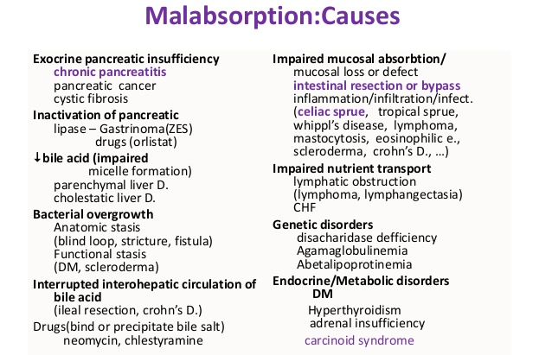
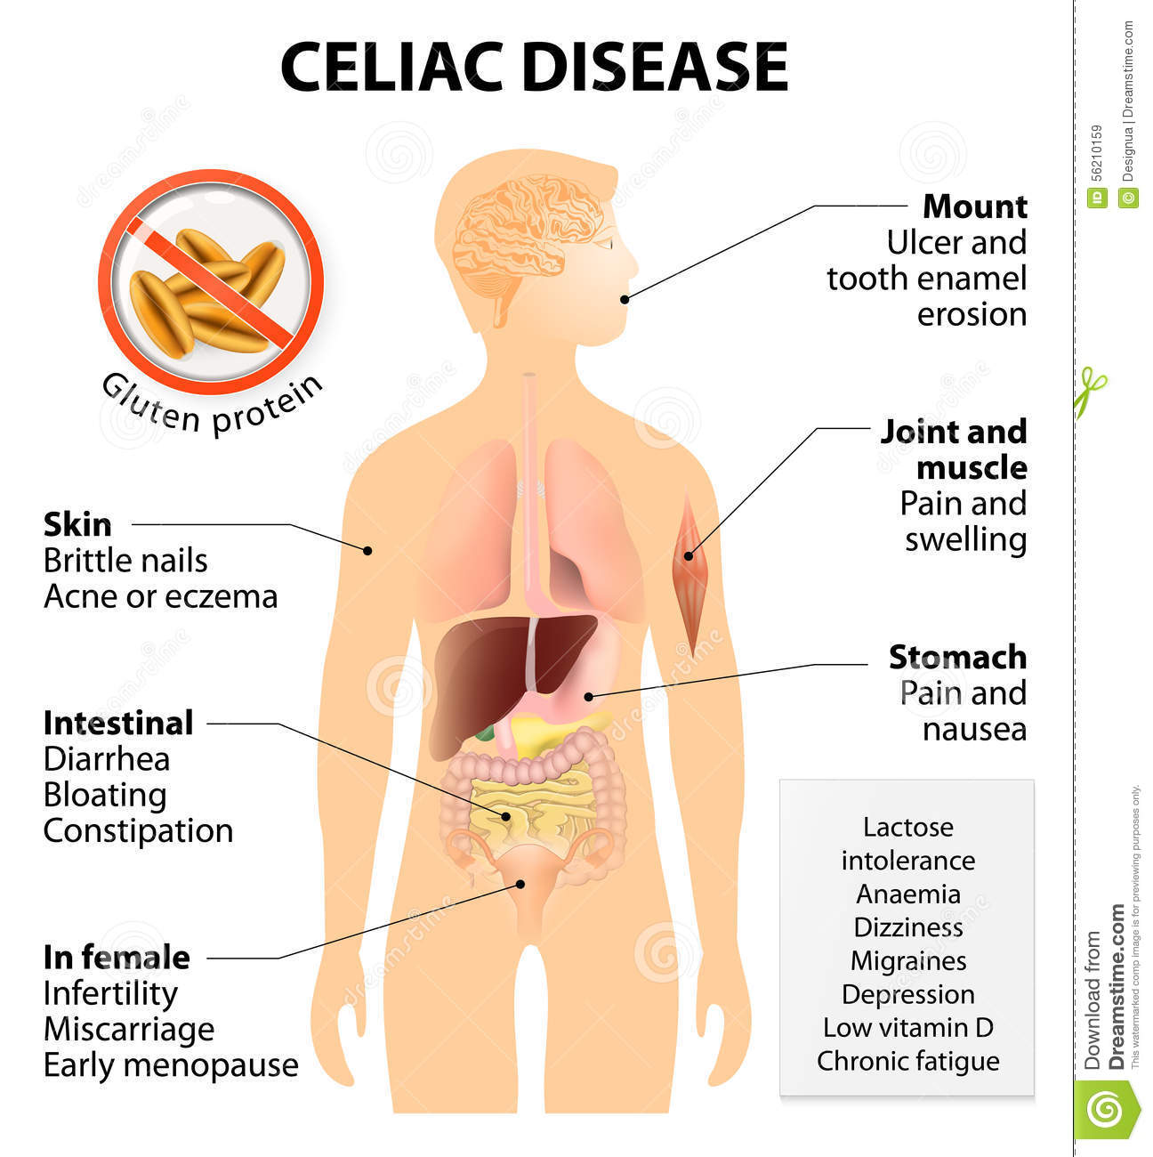

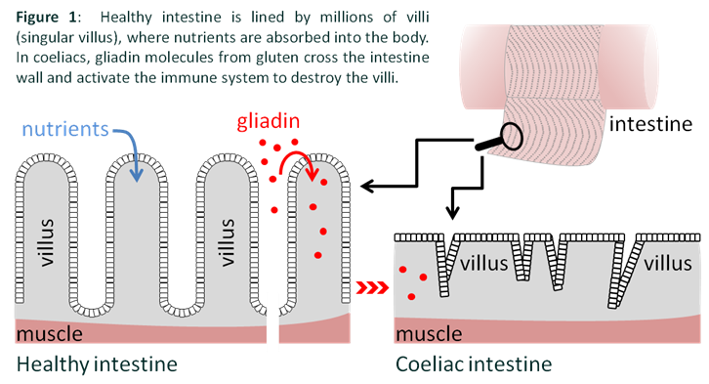
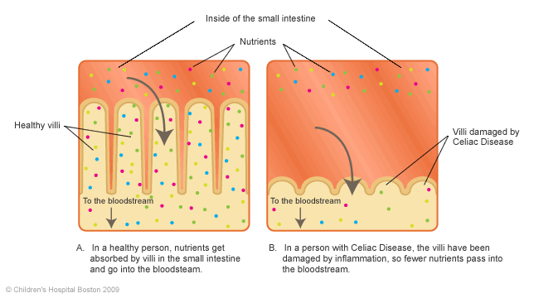
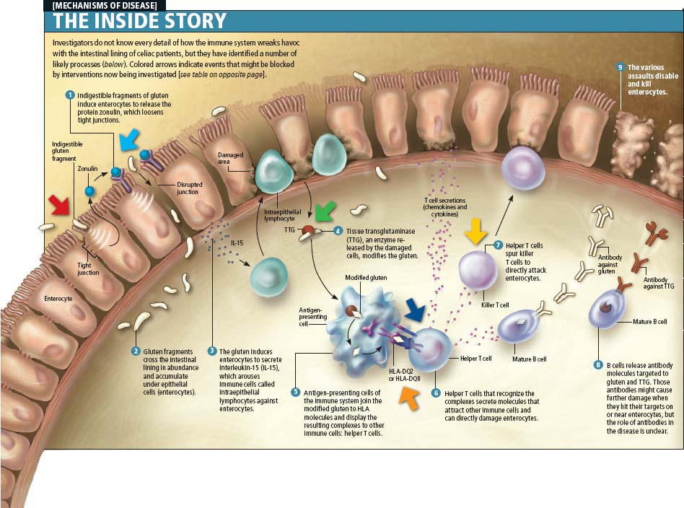
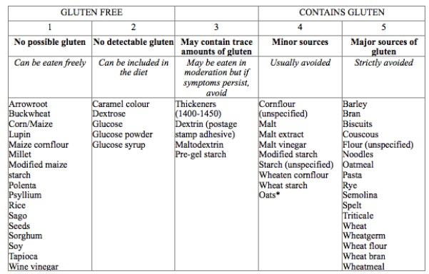
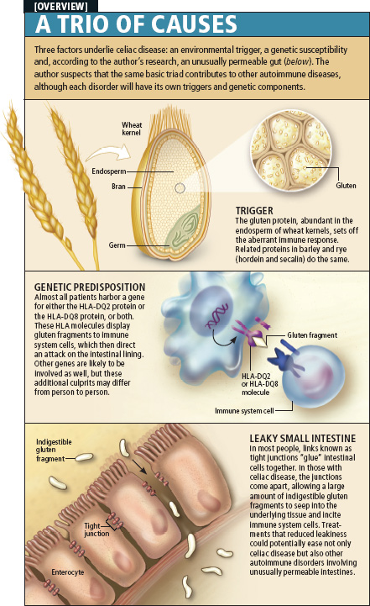
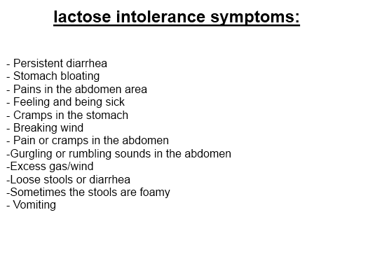

6. Materials of methodical maintenance of employment.
6.1. Etiology and pathogenetic factors of malabsorption syndrome in children.
- To classify malabsorption syndrome.
- Draw up a plan of examination and analyze information of laboratory and instrumental inspections at typical malabsorption syndrome.
- To put a preliminary diagnosis of malabsorption syndrome.
- Demonstrate possession of the principles of treatment, rehabilitation and prevention of malabsorption syndrome.
-Features of physical development of children of all ages, rates of weight, height, body surface area at different ages and formulas for calculating
- The mechanisms of intestinal absorption of nutrients
- Basic anatomical and physiological characteristics of digestion in children
- The main causes of malabsorption in children
- Clinical symptoms of malabsorption syndrome, characteristic of pathophysiology
- Algorithm of malabsorption syndrome diagnosis to identify its etiological nature
- Persistent diarrhea syndrome in infants and older: differential diagnosis
- Celiac disease: epidemiology, health care record
- Lactase insufficiency: epidemiology, health care record
- Intestinal dysbiosis: classification, clinical, prevention

6.2. The information necessary for the formation of knowledge, skills can be found in textbooks:
- basic:

- Kliegman, R.M., St Geme, J.W., Blum, N.J., Shah, S.S., Tasker, R.C., Willson, K.M., & Behrman, R.E. (Eds.). (2019). Nelson Textbook of Pediatrics (21st ed.). 4264 p.
- Ghai ”Essential pediatrics ” 9th Edition. 2019. 814 p.
- Clark R, Johnson R. Malabsorption Syndromes. Nurs. Clin. North Am. 2018 Sep;53(3):361-374.

- additional:
1. Caio G, Volta U, Sapone A, Leffler DA, De Giorgio R, Catassi C, Fasano A. Celiac disease: a comprehensive current review. BMC Med. 2019;17:142.

6.3. The estimated card for independent work with literature
N | Main Task | Recommendation | Answers
1 | 2 | 3 | 4
1 | Acquaint with literature and educational goals | Give information about epidemiology of the disease  Give the definition of the disease studied.
2 | Etiology | Fill the scheme of etiological factors
  …% |  | …% |  | …% |  | …%
3 | Pathogenesis | Fill the scheme of pathogenetic factors
  Pathogenesis
4 | Clinical data | Make differential diagnosis of this disease and similar to its condition
5 | Diagnosis | Make and explain diagnosis according to the results of clinical, laboratory and instrumental data.
6 | Treatment | Make program of treatment. Write prescription of preparations which is used for the treatment of this disease
  Rp… |  | Rp… |  | Rp… |  | Rp…
7 | Prophylaxis and rehabilitation | Fill the scheme of dispensary control
  N | Specialist | Time

7. The quality of self-training materials.
A. Questions for self-control
1. The main causes of malabsorption syndrome in children.
2. Lactase insufficiency: definition, etiology, pathogenesis.
3. The main clinical forms of lactase insufficiency, classification, course.
4. Key diagnostic criteria lactase insufficiency.
5. Diagnostic methods and differential diagnosis of lactase insufficiency.
6. Treatment, clinical supervision for children with lactase insufficiency.
7. Celiac disease: etiology, pathogenesis, clinic.
8. Diagnosis and treatment of celiac disease.
9. Etiology, pathogenesis, clinical manifestations and treatment of exudative enteropathy.
10. The main forms disucrase insufficiency: etiology, pathogenesis, clinical manifestations, diagnosis, especiallity of diet.

B. Tests for self-control
1. Child '12 for a month complaining of abdominal pain, particularly after taking fatty foods, emotional lability. The doctor suggests a child with chronic pancreatitis. What research is most informative for the diagnosis of adoption?
A. ECG
B . Complete blood count
C + . Ultrasonography of the abdomen
D. Іntragastral pHmetry
E. Urinalysis

2. The 13 year girl is treated for 2 years on chronic pancreatitis. How often should preventive treatment be placed in such a child?
A. month
B. Do not provide
+ C. Two times a year
D. Once a year
A. Three times a year

3. The 10 years child complains of appetite loss, abdominal pain of goofy character, weight loss, tendency to diarrhea. Ill about a year. Objectively: pale skin, stomach pain on palpation in the area of Desjardins. What is the most likely diagnosis?
A. functional disorders of the biliary tract
B.Chronic hepatitis
+ C. Chronic pancreatitis
D. Stomac Ulcer
F. Mesadenitis

4. Boy '14 years, is at gastroenterology with chronic pancreatitis. Periodically complained of abdominal pain after eating fatty foods and physical activity. What is the frequency of dispensary review within 1 year after diagnosis?
A. Every month
+ B. Every 3 months
C. Every 6 months
D. 1 per year
E. Review is not required

5. Child '10 for a month complaining of abdominal pain, particularly after taking fatty foods, emotional lability. In recent days vomiting which is not bringing relief. The doctor suggests a child exacerbation of chronic pancreatitis. Which table to assign the child, after water and tea breaks?
A. Table №1
+ B. Table №5P
S. Table №15
D. Table №10
E. Table №3

8. Boy '15 periodically complained of abdominal pain after eating fatty foods and physical activity. While admission to the hospital the doctor suggests that patients has chronic pancreatitis. What research is main to establish the diagnosis?
A. Complete blood count
+ B. elastase d-1 in feces
S. worm eggs in feces
D. Urinalysis
E. Determination of pH

9. Girl 9 years old admitted to hospital with complaints of abdominal pain with aching character, tendency to diarrhea. Ill about a year. An objective examination - pale skin, stomach pain on palpation. In laboratory studies creatorrhea,steatorrhea found in feces. Your diagnosis?
A. Functional disorders of the biliary tract
+ B. Chronic pancreatitis
C.Chronic hepatitis
D. Ulcer disease
E. Acute intestinal infection

10. Child '13 is in hospital with exacerbation of chronic pancreatitis. What preparation shows that patient?
+ A. famotidine
B. Bіseptol
S. Vіferon
D. Diphenhydramine
E. Aspіrіn

11. Girl '15 admitted to hospital with complaints of vomiting, which does not bring relief, abdominal pain. The examination diagnosis - chronic pancreatitis. What antagonist pancreatic secretions necessary to appoint such a pain?
A. Vіferon
+ B. Octreotіde
C. famotidine
D. Penicillin
E. Aspіrіn

12. Child '14 is on dispensary to the gastroenterologist about chronic pancreatitis. Last exacerbation was observed about a year ago. At what resort you can send the patient?
A. Zielona horka
B. Kuyalnyk
+ C. Truskavets
D. Solotvino
E. In Crimea

13. Patient '16 complains of weight loss, increased flatulence and gas emission of unpleasant odor, belching, bad taste in the mouth, release of large amounts of liquid unformed stool, pain in the iliac area which decreases as the gas discharge and after defecation. Your diagnosis?
A. chronic gastroduodenitis
B. chronic pancreatitis
C. Chronic cholecystocholangitis
D. Irritable bowel syndrome
E. Malabsorbtion syndrome +

14. Boy '14 complains of pain in the right iliac region, bloody diarrhea, joint pain, fever. On contrasting test ileocecal transition narrowed. Your diagnosis?
A. UC
B. Crohns disease +
C. Tuberculous іleotiflіtis
D. Celiac disease
E. Pseudomembranous colitis

15. Adolescents 14 y.o. complaints of weakness, weight loss. Condition worsens when using pastry. Sick from early childhood. Has reduced weight back in physical development. What is the cause of the disease?
A. Celiac disease +
B. Worm invasion
C. Maldigestion syndrome
D. intestine dysbiosis
E. deficiency of lactase

8. Materials for the classroom self-study:
8.1. List of educational practical tasks which must be performed in the practical (lab) classes:
1. To assess the state of the child.
2. Collect medical history and conduct a physical examination of the patient.
3. To evaluate the results of additional research methods.
4. Formulate a diagnosis according to the modern classification of diseases.
5. Assign treatment of the patient.
6. Create a plan of follow-up.
7. To render the first aid in malabsorption syndrome
8. To write recipes preparations for the treatment of malabsorption syndrome in children.

9. Instructional materials for learning professional skills, skills:
9.1. Methods of work, perform the steps
1. Establishing the diagnosis.
2. Identify a complaint, analyze the history data, to find the typical clinical symptoms characteristic of malabsorption syndrome.
3. Conduct a differential diagnosis.
4. Formulate the main clinical diagnosis, comorbidities, complications.

10. Materials for self-control of mastering knowledge, skills, abilities
Tests
1. The patient, 15 years old, complains of bloating and rumbling in the abdomen, excessive discharge of gas, liquid stool of foam character, with a sour odor that appear after eating foods with milk. What is the cause of this symptom is most likely?
A. Lactase deficiency +
B. Celiac disease
C. bile acids deficiency
D. Intestinal diskinesia
E. Malabsorption syndrome

2. The patient, 12 years old, took a massive antibiotic therapy, now complains of diffuse abdominal pain, frequent liquid defecations (4-6 times a day), general weakness. Abdominal palpation is soft, painful in the lower divisions, liver and spleen not palpable. Use of what drug is appropriate in this case?
A. Imodium
B. Pansonorm
C. Essenciale
D. Linex +
E. Motilium

3. Patient, 18 years old, ​​complained of intermittent pain in the left abdomen, nausea after eating pastry, frequent liquid bowel movements. Lost 5 kg within two months. OBJECTIVE: patient of reduced feeding, soft abdomen, rumbles. Defecation 3-4 times a day, with the admixture of neutral fat. What pathology most likely causes a picture?
A. Celiac disease+
B. Chronic pancreatitis.
C. Chronic hepatitis
D. Chronic enterocolitis
E. Autoіmmune gastritis

