MINISTRY OF HEALTH OF UKRAINE

ODESA NATIONAL MEDICAL UNIVERSITY

Departments of Pediatrics №2

CONFIRMED by

Vice-rector for research and educational work

____________________ Svitlana KOTYUZHYNSKA

September 1st, 2022

METHODOLOGICAL RECOMMENDATIONS

on practical classes for students

International Medical Faculty, сourse 4

Educational discipline "PEDIATRICS"

Approved
at the meeting of the department of Pediatrics №2
Protocol No. 1 dated 28/08/2022

Head of the department of Pediatrics №2 __________________ Tetiana STOIEVA
Signature

Authors:
Head of the department of Pediatrics №2, MD, PhD in Pediatrics, DM, Professor Stoieva Tetiana
Associate Professor of the department of Pediatrics №2, PhD in Pediatrics Prokhorova Svitlana
Associate Professor of the department of Pediatrics №2, PhD in Pediatrics Titkova O. V.
Associate Professor of the department of Pediatrics №2, PhD in Pediatrics Portnova O. O.
Associate Professor of the department of Pediatrics №2, PhD in Pediatrics Vesilyk N. L.
Associate Professor of the department of Pediatrics №2, PhD in Pediatrics Godlevska T. L.
Assistant of the department of Pediatrics №2, PhD in Pediatrics Fedin M. V.
Assistant of the department of Pediatrics №2, PhD in Pediatrics Jagiashvili O. V.
Assistant of the department of Pediatrics №2, PhD in Pediatrics Reshetilo O.V.
Assistant of the department of Pediatrics №2, PhD in Pediatrics Soboleva H. B.
Assistant of the department of Pediatrics №2 Bratkova L. B.

- Topic 11. Practical lesson №12, 13 - "Bronchial asthma"– 4 h.
- Background
Disease does not always have a favorable forecast. Disease is characterized by presence of various accompanying conditions and complications. Problem with treatment is widely discussed. Therapy of such pathological condition includes a regimen, a diet, etiotropic, pathogenetic and symptomatic components. It is important to carry out preventive maintenance of this disease in children age.
- Purpose of the lesson
3.1. General purpose
get acquainted with modern views on the etiology and pathogenesis of bronchial asthma in children, clinical manifestations and functional methods of diagnosis. The principles of rational therapy, the question of rehabilitation of bronchial asthma in children. Learn how to provide first aid in severe bronchial asthma.
3.2. Educational goals
Get acquainted with the works of the department staff on the problems of diagnosis and differentiated therapy of bronchial asthma in children. Have an idea of ecological, technological and medical aspects of environmental protection to the human body. Know about the deontological principles when dealing with a sick child and his parents.
3.3. Specific objective to know
1. Definition of asthma
2. Prevalence and incidence of asthma in pediatric populations.
3. Risk factors for the disease
4. Understanding the chronic allergic inflammation and bronchial hyper reactivity.
5. Mechanisms of early and late allergic responses in the pathogenesis of asthma.
6. Modern classification of asthma.
7. Clinical picture of asthma attack.
8. Hematological, immunological and spirogram signs of the disease.
9. Basic therapy of asthma
3.4. On the basis of theoretical knowledge on the topic:
- Master the techniques / know /:
1.Collect allergic history.
2. Identify risk factors for asthma.
3. Conduct the clinical examination of the patient.
4. Select the most informative methods to further investigation to determine the diagnosis and differential diagnosis.
5. Evaluate the results of laboratory and functional diagnostic methods.
6. Establish the diagnosis according to the classification.

4. Materials extracurricular self-study (interdisciplinary integration).
№ | Discipline | Know | Be able to
1 | 2 | 3 | 4
 | Previous disciplines  - Pat. Anatomy  - Pat. Physiology  - Histology  - Microbiology  - Propadeutics Pediatrics. | Morphologіcal changes of the respiratory epithelium.  Pathogenesis of disease  The building wall of the respiratory system in children of all ages.  The role of viruses and microorganisms in the occurrence of bronchial asthma  Anatomical and physiological characteristics of breathing in children. | Use knowledge of morphology for diagnosis.  Use knowledge of pathogenesis for the purpose of therapy.  Use knowledge to explain the clinical disease.  Verify the causative agent with additional methods.  Possess the methods of inspection of the breathing in children.Rate the additional methods . Select the main pathological symptoms(syndromes) lesions of the respiratory organs.
2. | Next disciplines  - Hospital Pediatrics  - Hospital Therapy | Etio-pathogenesis, main clinical forms, principles of treatment and prevention of bronchial asthma in children.  Acute and chronic respiratory infections. | Examine patients, prescribe treatment, prevention, conduct differential diagnosis with major clinical forms.  Examine, treat and prevent.
3 | Interdisciplinary integration | Differentiate with pneumonia, cystic fibrosis, obstructive bronchitis and chronic non specific lung diseases. | Evaluation of immunological, cytological, microbiological, biochemical investigations. Give conclusion of result of spirogram, peak flow- metery and x-ray of the chest.

5. Contents of theme
Etiology: Allergens: exogenic (infectious and non-infectious); endogenic.
Etiology: Allergens: exogenic (infectious and non-infectious); endogenic.
Pathogenesis: a) immunological stage; b) pathochemical stage; c) pathophysiological stage.
Classification:
- Form: infectious, infectious non-allergic.
- Severity: mild, moderate, severe.
- Period: before attack, attack, post attack, between attack.
- Complications.
Main characteristic signs of atopical bronchial asthma are: a) hereditary predisposition to allergic diseases; b) signs of allergic constitution; c) marked attack of dyspnoea; d) normal body temperature during the attacks; e) fast effect of symptomatomimetic drugs; f) positive allergic tests with non-infectious allergens.
Main characteristic signs of infectious allergic bronchial asthma are: a) prolonged attacks; b) subfebrile temperature during attacks; c) high eosinophilia; d) poor or no effect of symptomatomimetic drugs; e) positive allergic tests with infectious allergens.
Diagnostics: a) allergic case history; b) additional methods of investigation; c) differential diagnosis (foreign body in the bronchi, whooping cough, false croup, tuberculosis bronchoadenitis, acute respiratory infection, acute pneumonia).
Principles of treatment:
- Elimination of the attack (rest, oxygenotherapy, airotherapy, antihistamine remedies, counter-attracting procedures, glucocorticoid hormones, adrenomimetic and spasmolytic drugs).
- Anti-recurrent measures: a) general restorative measures; b) elimination of contact; c) medications; d) sanatorium-cohort treatment.
Prophylaxis:
- Primary (day regime, hypoallergic diet, restorative measures, sanation of the foci of chronic infection).
- Secondary ( defection of allergens, hyposensitization, physiotherapy, sanation of the foci of chronic infection, organization of regime, sanatorium-curort treatment).
Practical work of the student:
1st stage
Making a diagnosis: 1) To establish complaints, history findings and clinical symptoms characteristic of bronchial asthma. 2) To make differential diagnosis with similar diseases using clinical symptoms and data of laboratory and instrumental methods of investigation. To make a differential diagnosis according to the classification.
2nd stage
To administer treatment. Therapy depends on the form and period of the disease: during the attack all efforts are directed at control of dyspnea attack (removal of allergen, decrease of edema of the mucous membrane, broncholytic effect, dilution of sputum), then adrenomimetics, antihistamine remedies, physiotherapeutic methods, exercise therapy, vitamin, stimulation of adrenal glands are administered.
3rd stage
Administering of measures directed at prophylaxis of recurrences of the disease, rehabilitation. Determination of individual prognosis of the disease.
Allergic injuries of the respiratory tract (respiratory allergies) have an important place among respiratory diseases in children. Bronchial asthma is a classic and widespread disease among them. Importance of the problem has increased for the last two decades and increase the severity of its course (in the USA 3,2-11,4 % of children suffer from bronchial asthma). Mortality from bronchial asthma has increased too (in the USA 0,2-0,3 of 100 000).
Bronchial asthma is an allergic disease, which is characterized by an increased reactivity of the trachea and bronchi to various stimuli. It is manifested by widespread constrictions of the airways. Immunologic process is an important point in allergies development. Hereditary, infective, psychological and other factors are of importance too.
Physicians, in studying hereditary predisposition to bronchial asthma, reveal that presence of asthma in parents 1.5-3 times increase amount of asthma development in children and forms, combined with eczema 3,3 times. Allergic diseases in children may be risk factors. Presence of eczema in children promotes bronchial asthma development in 30-100 % of cases.
Formula feeding promotes allergization of the organism. Environmental influence is of importance too.
The higher index of morbidity with bronchial asthma is noted in the regions, adjoining to industrial objects and in the regions with heavy traffic. In rural area, morbidity is less. Any substance, which is possible to cause allergic reaction, is an important factor in development of bronchial asthma. Antigens are substances, which have signs of genetically foreign information and in introduction into the organism; they cause development of specific immunologic reactions. They are substances not only of protein origin, but also of complex polysaccharides, lipopolysaccharides, polypeptides, and nuclear acids.
Antigen properties are connected with molecular size (not less, than 10 000). Antigens may be of exogenous and endogenous origin. Exoallergens by Ado A. D. classification compose two big groups. They are non infective and infective. Depending on this, there are two forms of bronchial asthma: atopic (allergic) and infective-allergic. They differ by etiologic factors, clinical course and require different treatment.
Allergic condition in atopic form of bronchial asthma develops under the influence of noninfective allergens (pollen of plants, various dusts, life allergens and others).
There are polyvalent allergies in majority of patients.
The main pathophysiologic mechanism of development of atopic form of bronchial asthma is the allergic reaction of the immediate type. Non infective allergens cause formation of specific allergic antibodies-reagents in the organism, which belong to immunoglobulin E class by the physio-chemical properties. Reagents join allergens to mast cells. It is considered, that ability of reaction on specific antigens and immune response are genetically coded.
Specific diagnostics of atopic bronchial asthma is based on detection of reagents in patients.
Skin allergy test. Positive test testifies that specific antibodies are present on the patients' skin. However, negative test does not exclude etiologic role of this allergen in bronchial asthma, in which shock-organ is not the skin, but the mucous membrane of the respiratory tract. Challenge nasal and inhalation tests are considered to be more objective.
Lately, method of determination of immunoglobulin E in the blood serum has become more popular (in patients with atopic form of bronchial asthma, it is much higher than in healthy people, especially in dermo respiratory syndrome. Degranulation of basophils and mast cells, degranulation by Shelly are additional methods of investigations. Revealing of increased contents of histamine, acethylcholin, bradikinin, serotonin and other biologic active substances in blood are indirect evidence.
At present, most of allergologists determine atopic form of bronchial asthma in majority of children and the younger is the child, the more frequently this form is met. Infective-allergic form of bronchial asthma increases in senior age.
Cell mechanism of increased sensitivity has a great importance in infective-allergic form of bronchial asthma. Bacterial allergens, having common determinants with the bronchopulmonary tissues of the patients are very important in pathogenesis of this form of bronchial asthma. Macrophages and lymphoid cells are the main mechanism of cell allergic reactions. They obtain and transmit the information from allergen to target cells and determine the picture of the allergic reactions.
Method of qualitative determination of T-system condition and specific sensitized lymphocyte function have been elaborated and used.
Reaction of blast transformation of lymphocytes with specific allergens, method of plaque formation, reaction of neutrophil injury, reaction of inhibition of macrophage migration from capillaries are widely used in practice. Challenge tests are used by special indications. Information about the role of prostaglandins has appeared in bronchial asthma. Prostaglandins are highly active biologic substances, received, at first, from the secret of the prostate gland. Prostaglandin F_{2A} is secreted under the influence of some biologically active substances (histamine, serotonin and others) and gives bronchospastic effect.
On the contrary, prostaglandin of E group promotes control of spasms. It is considered that disturbance of quantity of prostaglandins F and E in the pulmonary tissue have certain significance in pathogenesis of the attack.
There are three stages of allergic reaction (by Ado):
The first one is immunologic (interaction of specific antigen with antibody in the area of shock organ – mast cells, basophils, cells of the connective tissue).
The second one is pathochemical, when biologic active substances are secreted from cells. They are histamine, kinins and others.
The third one is pathophysiological, when tissue-effectors are injuried under the influence of realized substances:
- development of the smooth muscle contraction of the bronchi;
- edema in the bronchi walls as a result of vasomotor changes;
- hypersecretion of the mucous glands of the bronchi.
Definite significance has dyscoordination of function of the respiratory muscles that leads to disturbance of respiration rhythm.
Vasomotor disturbances and hypersecretion are predominant in children of early age. Functional condition of the central nervous system and peculiarity of hormone regulation influence the course of bronchial asthma.
Classification of bronchial asthma:
- Forms: immune (atopic, infective-depending, mixed), non immune (aspirin, dyshormonal, exercise induced).
- Period of the disease (exacerbation, attack, after-attack period, status asthmaticus, extra attack period).
- Severity (mild, moderate, severe).
- Complications (pulmonary heart, emphysema, atelectasis, pneumothorax, neurologic and endocrine disturbances).
Asthma attack is typical for the course of bronchial asthma. Attack frequently begins late in the evening or at night and lasts from some minutes to some hours or days. The patient complains of laboured breath, spastic cough. Children of early age become restless.
The patient older age thrust their arms forward for support. They take forced position. They try to create support for the respiratory muscles to fix the shoulder girdle and to alleviate breath. Pallor and edema of the face, cyanosis of the skin and mucosa are manifested. They look very tired. The chest is hyper resonant, because it is in condition of maximal inspiration.
In the act of breathing additional muscles take part (pectoral, the direct muscles of the abdomen). Breathlessness is manifested in majority of children (it marked more when child is younger). Inspiration is usually short and expiration is prolonged and noisy (expiratory wheezing). Rales and whistle are heard at the distance.
Bandbox sound, low position of diaphragm, decreased excursion of the diaphragm on breathing are defined by percussion.
On auscultation we can define the weakened breathing, abundance of whistling and bussing rales and moist rales in children of the first year of life. The heart outlines are narrowed at the experience of lung emphysema. The heart sounds are dull, not infrequently accent of the second sound is on the pulmonary artery. If the attack is prolonged the condition of child is especially severe. The clinical picture of the attack may change, depending on the patient’s age, preceding condition and factors, causing the attack.
Atypical course (asthmatic bronchitis) is frequently noted in children of early age. Zvjagintceva S.G. explains this by anatomic and physiologic peculiarities of the bronchi in children of early age. The phases of the secretory disturbance predominate in pathogenesis of the process. Due to this, attack develops slowly, lasts long and asthma is marked little (due to the smooth muscles fibers are scarce and their constrictive ability is decreased). Abundance of the mucus discharges is noted, frequently the temperature increases. Spasmolytics give mild effect.
Asthmatic condition lasts from some days to some weeks.
There are three stages of the status.
The first is initial (or subcompensation) – dyspnoea, hyperventilation, disturbance of acid – base condition, abundance of rales, congestion in the lungs.
The second stage is decompensation – dyspnoea (inspiration/expiration – Ѕ) respiratory insufficiency, hypersecretion, insufficiency of the right ventricle, hypercapnia. The area with rales is alternated with dumb areas.
The third stage is hypoxemic coma. There are dumb areas over the lung, atelectasis.
The mild course is characterized by rare attack of asthma (3-4 times per year). The attack is mild. General condition doesn’t change. Attack is sensitive to remedies.
The children are practically healthy in the remission. Deformation of the chest, disturbances of the central nervous system function is not noted. Indices of the external breath correspond to the age norm.
In the moderate course of the disease (more than 50 %). Attacks are repeated every month. Their duration is several days. Period of exacerbation lasts for a week and the half. In this period changes in the respiratory system disappear. Circulation is normalized. However, even remission is characterized by increased fatigue, irritability, deviation of the indices of the external breathing. Pallor and gray colour of the skin are noted, sometimes light cyanosis around of the mouth, retardation in weight and growth. Deformation of the chest is noted in half of the patients.
The severe course is characterized by frequent, severe and difficult for controlling attack (spasmolytics give brief effect). The attack period is short. Sometimes period of exacerbation lasts some months.
In the prolonged course the children are physically retarded, have marked chest deformation and a part of children develop chronic pulmonary heart. On spirogram obstructive type of ventilation disturbance is noted.
Treatment: Treatment of bronchial asthma is a difficult problem, depending on the period of the disease, form and individual and age peculiarities.
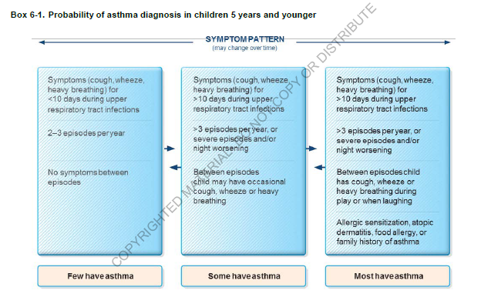
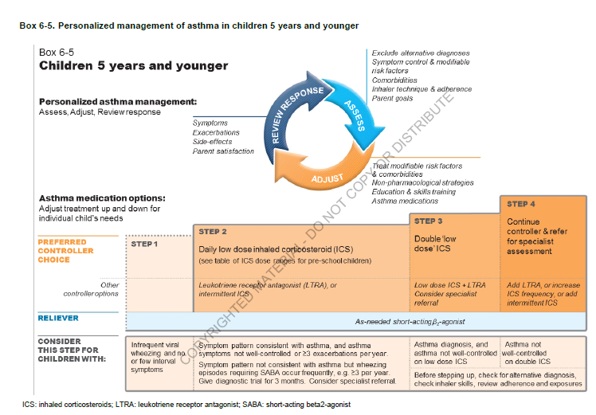

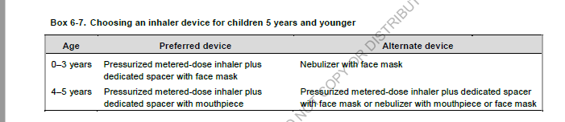
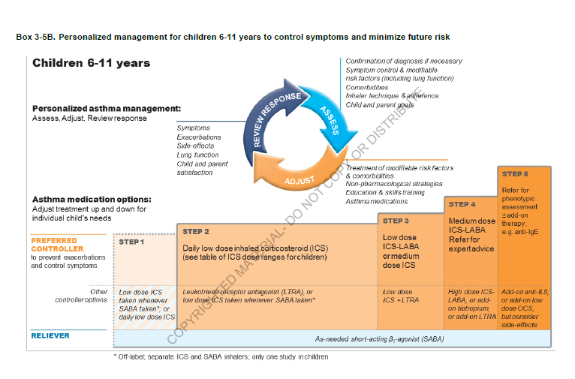
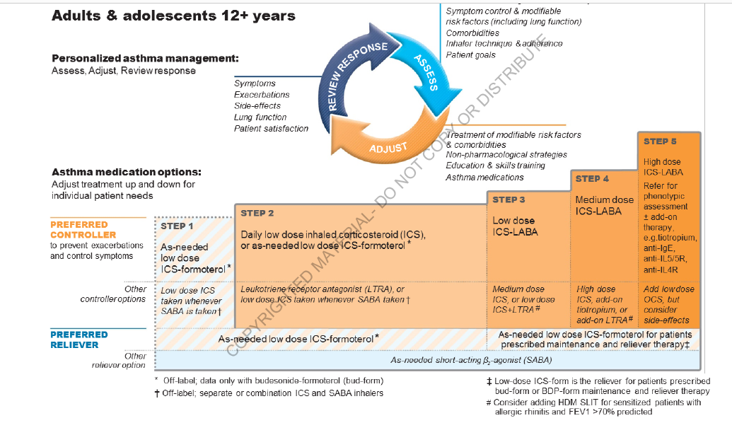

6. Materials of methodological support classes
6.1. Methodological support of classes
- Definition
- Spread.
- Pathogenesis.
- Classification.
- Clinical features.
- Diagnostics.
- Treatment
6.2. Information necessary for the formation of knowledge - skills can be found in the literature
- basic:
- Kliegman, R.M., St Geme, J.W., Blum, N.J., Shah, S.S., Tasker, R.C., Willson, K.M., & Behrman, R.E. (Eds.). (2019). Nelson Textbook of Pediatrics (21st ed.). 4264 p.
- Ghai ”Essential pediatrics ” 9th Edition. 2019. 814 p.
- Global Initiative for Asthma. Global Strategy for Asthma Management and Prevention. https://ginasthma.org/wp-content/uploads/2021/05/GINA-Main-Report-2021-V2-WMS.
- Treatment of mild-to-moderate asthma in childhood and adolescence in 2021. Lancet Respir Med. 2021; 9: 443-445).

- additional:
- Dharmage SC, Perret JL, Custovic A. Epidemiology of Asthma in Children and Adults. Front Pediatr. 2019;7:246. [PMC free article] [PubMed]
- Remick K, Gausche-Hill M, Joseph MM, et al. , Pediatric readiness in the emergency department. Pediatrics 2018:142:e20182459.
- Tesse R, Borrelli G, Mongelli G, Mastrorilli V, Cardinale F. Treating Pediatric Asthma According Guidelines. Front Pediatr. 2018;6:234.

6.3. The estimated card for independent work with literature
N | Main Task | Recommendation | Answers
1 | 2 | 3 | 4
1 | Acquaint with literature and educational goals | Give information about epidemiology of the disease  Give the definition of the disease studied.
2 | Etiology | Fill the scheme of etiological factors
  …% |  | …% |  | …% |  | …%
3 | Pathogenesis | Fill the scheme of pathogenetic factors
  Pathogenesis
4 | Clinical data | Make differential diagnosis of this disease and similar to its condition
5 | Diagnosis | Make and explain diagnosis according to the results of clinical, laboratory and instrumental data.
6 | Treatment | Make program of treatment. Write prescription of preparations which is used for the treatment of this disease
  Rp… |  | Rp… |  | Rp… |  | Rp…
7 | Prophylaxis and rehabilitation | Fill the scheme of dispensary control
  N | Specialist | Time
7. Materials for self-control on the quality of training.
А. Questions for self-control:
1. Definition of asthma
2. Spread the word and the incidence of asthma in the pediatric population, the risk factors for the disease.
3. Pathogenesis of asthma based on modern understanding about the role of immune and non-immune mechanisms.
4. Classification of asthma in the form period severity.
5. The clinical picture of asthma attack .Evaluation criteria of severity.
6. Diagnosis of asthma, score allergic status, hematologic, spirogram, immunological features.
B. Tests for self-control:
1. Boris, 12 years old , is ill with bronchial asthma from age 10. What groups of risk factors could lead to disease development?
A. Contributing
B. Contributing, causal, making.
C. Causal, the asthmas promoting occurrence causing an aggravation
D. Causal, causing an aggravation
+Е. The contributing, causal asthmas promoting occurrence causing an aggravation

2. Katya, 7 years old , is ill with bronchial asthma within 1 year. What factors could be contributing in disease development?
A. Atopy
B. Hereditary, allergens, pregnancy pathology, ARVI
C. Hereditary
+D. Hereditary, аtopy, hyperactive bronchial tubes
E. Hyperactive bronchial tubes

3. Anatoly, 6 years old , is ill with bronchial asthma since 2 years. At allergen-test on what groups of allergens it is necessary to pay attention to in the anamnesis?
A. Food allergens
B. Household allergens
C. Epidermal allergens
D .Pollen allergens
+E. All the above

4. Sergey, 15 years old , is ill with bronchial asthma from age 5. Disease aggravations connects with using of eggs and citrus. What other factors can cause an aggravation of bronchial asthma?

A. Allergens, heredity, physical activity, ARVI
B. Allergens, physical, psychoemotional loading,
+C. ARVI, change of meteoconditions, ecological factors
D. Psychoemotional loading
Е. ARVI, allergens

5. In Andrey, 4 years old, asthma attacks at night, decreased expiratory volume and spastic cough are observed within 1 year. Parents of the child connects the given symptoms with the use of honey and chocolate in food. The similar symptoms appears also after ARVI. The father of the child suffers from atopic dermatitis, the grandfather - bronchial asthma. Think of what disease that is most probable?
+A. Bronchial asthma
B. Obstructive bronchitis
C. Atopic dermatitis
D. Acute simple bronchitis
E. None of the above

6. Natasha, 8 years old , has been established the diagnosis of bronchial asthma. What is the criteria of the disease severity ?
A. Quantity of day symptoms
B. Quantity of admissions of school, and/ kindergarten
C. Quantity of night symptoms
+D. Quantity of day, night symptoms, index of peak flow, daily deviation of peak flow, frequency of β-2-agonist of short action usage.
E. index of peak flow, daily deviation of peak flow.

7. Masha, 12 years old, is ill with bronchial asthma for 5 years. Frequency of day symptoms is once a week, night - 3-4 times a month, peak flow in remission is 83 %. Define severity of disease course?
A. Intermittent
+B. Mild intermittent
C .Moderate intermittent
D. Severe persistent
E. Status asthmaticus

8. Sveta, 11 years old, has aggravations of bronchial asthma - 1-2 times a month. They are short, are stopped independently. In the period of remission the sleeping and physical activity are not broken. Indicator PEF is 90 %. Define disease course severity?
+A. Intermittent
B. Mild intermittent
C. Moderate intermittent
D. Severe persistent
E. Status asthmaticus

9. In 13 years old Victor, are marked daily day symptoms of bronchial asthma, night symptoms - 3-4 times a week, are stopped by salbutamol. In the period of remission the sleeping and physical activity are disorded. PEF - 65 %., daily deviation PEF - 30 %. Define disease course severity?
A. Intermittent
B. Mild persistent
+C. Moderate persistent
D. Severe persistent
E. Status asthmaticus

10. Oksana, 16 years old, is ill with bronchial asthma since 3 years. For last 3 months the condition of the girl has worsened, disease symptoms are every day, not always stopped by ₂ – agonists of short action. PEF - 50-60 %. Physical activity is considerably limited. Define severity of disease course?
A. Intermittent
B. Mild persistent
C. Moderate persistent
+D. Severe persistent
E. Status asthmaticus

11. Feodor's parents, 3 years old, within 1 year marked 4 episodes of complicated breathing, short wind, dry persuasive cough against ARVI. In the anamnesis the boy has exhudative catarrhal diathesis, an allergy on protein of cow milk, orange juice, strawberry. The father of the boy suffers from atopic dermatitis, the mother - a food allergy. What additional methods of investigation are necessary for diagnosis?
A. Blood analysis
B. Allergen-test
C .Level of IgE
+D. All the above
E. None of the above

12. Alexey, 6 years old, the presumable diagnosis of bronchial asthma is established. What additional methods of inspection are necessary for diagnosis confirmation?
A. Allergen-test
B. Level of IgE
S. Spirography
D. Peak flowmeter
+E. All the above

13. Valerya, 9 years old, the diagnosis of bronchial asthma is established. What methods of investigation are not included into the program of disease diagnostics?
A. Spirography
+B. Echoencephalography
C. Peak flowmeter
D. Spirography with the dosed physical activity
E .Spirography with pharmacological tests

14. The index of PEF in Julia, 14 years, is 83 %. What level of PEF is considered normal?
A. More than 70 %
B. Less than 70 %
+C. More than 80 %
D. Less than 30 %
E. More than 30 %

15. In Xenia, 3 years old, on the basis of complaints, the anamnesis, data of objective investigation, functional and laboratory tests the diagnosis of bronchial asthma is established. Causally-significant allergens are food, household, medications. what recommendations should the doctor give about the food to parents?
+A. Elimination of causally-significant allergens
B. Elimination of the products containing purine
C. Vitamins in of foods
D. Elimination of fats
E. Limitation water loading

16. Victoria, 10 years old, is ill with bronchial asthma from age 5. Frequency of attacks 1-2 times a quarter. Attacks are short. Physical activity is not limited. PEF - 90 %. What basic therapy is recommended for the girl?
+ A. Basic therapy is not needed
B. Oral corticosteroids, β ₂-agonists or theophylline of long action
C. Intal (or tailed)
D. β2-agonists or theophylline of prolonged action
Е Inhalation of corticosteroids

17. Svetlana, 12 years, is ill with bronchial asthma, intermittent. Basic therapy was not received. Symptomatic preparations were recommended only. What preparations are used for knocking over of an attack of bronchial asthma?
A. Inhalation of corticosteroids
+В. β2-agonists of short action
C. Theophylline of the prolonged action
D. β2-agonists the prolonged action
E. Cromolyn

18. Michael, 12 years, is ill with bronchial asthma for 3 years. Frequency of day symptoms - 2 times a week, night - 3-4 times a month. PEF - 82 %, fluctuations daily PEF - 25 %. Make the program of basic therapy.
+A. Inhalation of corticosteroids in the minimum doses or cromolyn, β2-agonists or theophylline od prolonged action
B .Inhalation of corticosteroids in the minimum doses or cromolyn
С. β2-agonists or theophylline of prolonged action
D. Oral corticosteroids
Е β2-agonists of short action

19. Sofia, 10 years, is ill with bronchial asthma. Daily attacks of asthma are marked. The periods of remission not more than 3-5 days. PEF - 45 %, daily deviation of PEF - 37 %. Compose the program of basic therapy.
A. Inhalation of corticosteroids in the minimum doses, β2-agonists or methylxanthines of prolonged action
B. Inhalation of corticosteroids in moderate doses, β2-agonists or methylxanthines of prolonged action.
+ C. Inhalation of corticosteroids in high doses or oral steroids, β2-agonists or methylxanthines of prolonged action.
D. Cromolyn, β2-agonists or methylxanthines of prolonged action
E. Basic therapy is not recommended

20. The diagnosis bronchial asthma, atopic, severe persistent course has been established in 14 years old Alla. What preparations are recommended for symptomatic therapy?
A.Teopek
+B. Salbutamol
C. Salmoterol
D. Natrium cromolyn
E. Zafirlukast

21. Nastya, 12 years, is ill with bronchial asthma, moderate persistent. For basic and symptomatic therapy was used inhaled corticosteroids, β2-agonists of short and long action. Name delivery systems for medicinal substances.
A. The dosed inhaler
B. Spacer
C. Diskhaler
D. Nebulizer
+E. All the above

22. Stas, 15 years,is ill with bronchial asthma, persistent mild degree. Frequency of day symptoms - 2 times a week, night - 2 times a month. Name group of preparations of choice in algorithm of managing an attack of bronchial asthma.
+А β2-agonists of short action
В β2-agonists of long action
C. Methylxanthines of long action
D.Inhalation of corticosteroids
E.Leukotrienes receptors blockers

23. Katya, 8 years, received basic therapy, according to 3 steps. However the condition of the girl has worsened. Asthma attacks were registered daily, sometimes per day, PEF - 35 %. The patient has been transferred on 4 step of basic therapy. What groups of preparations correspond to the given step?
A. Cromolyn, β2-agonist or methylxanthines of long action
В β2-agonists of short action
+C. Inhaled corticosteroids in the maximum doses, oral steroids, β2-agonists or methylxanthines of prolong action
D. Inhaled corticosteroids in average therapeutic doses, β2-agonists or methylxanthines of long action
E. Inhaled corticosteroids in the minimum doses, β2-agonists or methylxanthines of long action

24. Nagya, 11 years, is ill with bronchial asthma for 6 years. The course degree - severe persistent is established. She receives inhalation corticosteroids n a complex of basic therapy. Name the basic advantages of the given group of preparations against system steroids.
+A. Local action in the absence of system effects.
B .Comfortable for introduction
C. Pleasant taste
D. Economic effectiveness
E. All listed

B. Tasks for self-control:
1. Sergey, 15 years, is ill with bronchial asthma from age 5. Frequency of attacks - 1-2 times a month. They are stopped by salbutamol. Disease aggravations connects with use of eggs and citrus.
1. What group of allergens is causally-significant for the patient?
2. Name groups of allergens.
3. What other factors can cause an aggravation of bronchial asthma?
4. Make the plan of additional inspection.
5. What groups of preparations are used in algorithm of management of asthma symptoms?

2. Andrey, 4 years, has asthmatic attacks at night, decreased expiratory volume, spastic cough for 1 year. Parents of the child said the given symptoms connects with the use of honey and chocolate in food. The similar semiology appears also after ARVI. The father of the child suffers from atopic dermatitis, the grandfather - bronchial asthma.
1. What disease is possible to think of?
2. With what diseases it is necessary to do differential diagnosis?
3. What groups of allergens are causally-significant for the given patient?
4. What contributing factors are present at the anamnesis of the boy?
5. Make the plan of additional inspection.

3. Oksana, 16 years, is ill with bronchial asthma from age 3. The condition of the girl has worsened, disease symptoms daily, are not always stopped β ₂ -agonist of short action during the last 3 months. PEF - 50-60 %. Daily PEF deviation - 30-35 %. Physical activity is considerably limited.
1. Define disease severity?
2. What PEF index is normal?
3. What daily PEF deviation is normal?
4. How many time per day it is necessary to monitor PEF?
5. What basic therapy corresponds to the given course severity?

4. Maxim, 3 years, has had marked 3 episodes of labbored breathing, dyspnoea, dry persuasive cough after the use of raspberry, strawberry , tangerines, within 1 year. In the anamnesis - exudative catarrhal diathesis. The father of the boy suffers from atopic dermatitis and allergic rhinitis; at mother - a food allergy.
1. Make the presumable diagnosis.
2. With what diseases it is necessary to carry out differential diagnostics?
3. What additional methods of investigations are necessary for making the diagnosis?
4. What contributing factors are present at the anamnesis at the child?
5. What causal allergens are significant for the patient?

5. Кarina, 8 years has had bronchial asthma since age 2. She receives basic therapy, according to 2 steps. However the condition of the girl has worsened. Day attacks of asthma are registered every day, night - 2-3 times per week, PEF - 70 %, physical activity is limited, b₂ - agonists is used every day. Patient is translated on 3 step of basic therapy.
1. What severity course of bronchial asthma corresponds to the given step?
2. What groups of preparations correspond to the given step?
3. What anti-inflammatory preparations are shown the girl?
4. With what diagnostic techniques will the patient carry out self-checking?
5. What PEF is normal?

6. Dasha, 9 years, has had bronchial asthma for 3 years. Day attacks are not more often 2 times per week, night - 3-4 times per month. They are stopped by salbutamol. PEF - 82 % from norm, daily deviation of PEF - 23 %.
1. Define disease severity course.
2. What daily deviation of PEF is normal?
3. What diet is necessary to recommend for the girl?
4. What regimen is necessary for the patient?
5. What basic therapy corresponds to the given severity level?

7. Alexander, 12 years, has suffered bronchial asthma since age 3. Causally-significant allergens: strawberry, an orange, lake fish, house dust, pollen. Day episodes are registered every day, night - not more often 1 time per week. Inhalations of salbutamol is every day. PEF - 72 %, daily deviation of PEF - 30 %.
1. What groups of allergens are causally-significant?
2. What group of preparations concerns salbutamol?
3. Determine time of action of salbutamol beginning.
4. Define severity course of bronchial asthma
5. Appoint basic therapy according to severity of the patient.

8. Maxim, 5 years, has suffered bronchial asthma since age 2 . The allergic anamnesis is burdened: exudative catarrhal diathesis, allergic rhinitis. From the family anamnesis: the father- bronchial asthma,the grandfather and the uncle - eczema. Day symptoms of disease is once a month, night is 1 time per quarter. Attacks are short-term, are stopped independently or by inhalations of salbutamol. PEF - 85-90 % from norm, daily PEF deviation - 10-15 %.
1. What atopic diseases takes place in the patient?
2. What predisposing risk factors are in the boy?
3. Define disease course severity.
4. Name criteria of estimation of course severity of bronchial asthma
5. Make the program of therapy for the patient.

9. Jury, 15 years, has suffered bronchial asthma since age 5. The allergic anamnesis: atopic dermatitis, urticaria. Causally-significant allergens: eggs, wheat flour, peaches, bananas, popular pollen, household dust, wool of cat. Sometimes he reacts to physical activity. Day symptoms are registered once a week, night - not more often 1 time per month. According to a PEF diary, PEF - 82-85 % from norm, daily PEF deviation - 25-30 %
1. Name causally-significant allergens for the patient?
2. What risk factors of development of asthma are present in the boy?
3. Name methods of functional diagnostics of bronchial asthma?
4. Define disease course severity.
5. Make the program of basic therapy for the patient.
10. Inna, 8 years, has suffered bronchial asthma since age 5. Day attacks are every day, night - 1-2 times per week. The present attack has developed after a game with a cat. Position in bed is compelled - orthopnoea, breathing is noisy, expiratory dyspnoea, distant rales. The thorax has barrel-like form.There is expressed periorbital cyanosis. The accessory muscles take part in respiration. Percussion - a bandbox sound, auscultation – harsh breathing, dry whistling rattles. PEF - 34 % from norm.
1. Define the disease period
2. Define disease course severity
3. Name criteria of course severity of an attack of bronchial asthma
4. Make the plan of investigation of the child
5. Make algorithm of an attack management.

11. The boy of 5 years from 1st pregnancy. He was on breast feeding till 2 months of age. Since 2 months of age there were skin signs of exudative catarrhal diathesis. Further aggravations arose after the use of eggs, fish, strawberry. The first attack of asthma has arisen at age 2. Since then frequency of attacks is 2-3 times a week. Last attack was 1 month ago. Attacks are stopped by inhalations ₂-agonists. From the anamnesis it is known, that the grandmother is ill with bronchial asthma.
1. Diagnose according to modern classification.
2. Define risk factors of bronchial asthma development in the anamnesis.
3. Name criteria of asthma course severity estimation
4. Make the plan of the patient investigation.
5. Name the preparations of the first line recommended for symptomatic therapy of disease.

12. The 9 years old girl, has an attack of asthma, dry persuasive cough, which appeared after ARVI arising. At examination: the thorax is in inspiratory position, percussion - bandbox sound, at auscultation - a considerable quantity of dry whistling rales. Breathing rate - 42 in mins, heart rate - 120 in a minute. Tones of heart are dull. Position is forced - the girl sits, fixing the top humeral belt. From the anamnesis it is known, that episodes of bronchoobstruction repeat 4-5 times a year after ARVI.
1. Make the presumable diagnosis.
2. What anamnestic data are necessary for diagnosis statement?
3. With what diseases it is necessary to carry out differential diagnosis?
4. Make the plan of additional investigation.
5. Name broncholytics groups.

13. A 12 years old child is ill BA from age 3. He receives basic therapy by inhaled corticosteroids in the minimum doses, salmetrol. For last month the condition of the child has worsened. The quantity of attacks of asthma, night cough has become frequent (every night). PEF - 75 %. Requirement for inhalations of b₂-agonists - 5 times a week.
1. To what severity of bronchial asthma course there corresponds to the condition of the child?
2. Reconsider and modify basic therapy.
3. What group of preparations concerns salmetrol?
4. Duration of salmetrol action.
5. Name representatives of corticosteroids inhalation group.

8. Classroom materials for self-study.
8.1. List of educational practical tasks that must be completed during the practical exercises:
1.Collect history, provide data that indicate the nature of the allergic disease.
2. Identify the most informative features of the disease during objective and laboratory and instrumental examination of the patient.
3. Clinical diagnosis by modern classification.

9. Instructional materials for learning professional skills.
9.1. Methods of work Stages of the possible
1. Evaluate the data and medical history of the disease, identify risk factors.
2. Conduct the clinical examination of the patient with skin disease.
3. Make a plan to further investigation.
4. Evaluate the results of laboratory and instrumental examination.
5. Formulate a clinical diagnosis according to the classification.

10. Materials for self-control of mastering knowledge, skills, abilities
Tests
1. Boris, 12 years old, he ia ill with of bronchial asthma from 10 of age. What groups of risk factors could lead to disease development?
A. Contributing
B. Contributing, causal, making.
C. Causal, the asthmas promoting occurrence causing an aggravation
D. Causal, causing an aggravation
+Е. The contributing, causal asthmas promoting occurrence causing an aggravation

2. Katya, 7 years old , is ill with bronchial asthma within 1 year. What factors could be contributing in disease development?
A. Atopy
B. Hereditary, allergens, pregnancy pathology, ARVI
C. Hereditary
+D. Hereditary, аtopy, hyperactive bronchial tubes
E. Hyperactive bronchial tubes

3. Anatoly, 6 years old , is ill with bronchial asthma since 2 years. At allergen-test on what groups of allergens it is necessary to pay attention to in the anamnesis?
A. Food allergens
B. Household allergens
C. Epidermal allergens
D .Pollen allergens
+E. All the above

4. Sergey, 15 years old , is ill with bronchial asthma from age 5. Disease aggravations connects with using of eggs and citrus. What other factors can cause an aggravation of bronchial asthma?

A. Allergens, heredity, physical activity, ARVI
B. Allergens, physical, psychoemotional loading,
+C. ARVI, change of meteoconditions, ecological factors
D. Psychoemotional loading
Е. ARVI, allergens

5. In Andrey, 4 years old, asthma attacks at night, decreased expiratory volume and spastic cough are observed within 1 year. Parents of the child connects the given symptoms with the use of honey and chocolate in food. The similar symptoms appears also after ARVI. The father of the child suffers from atopic dermatitis, the grandfather - bronchial asthma. Think of what disease that is most probable?
+A. Bronchial asthma
B. Obstructive bronchitis
C. Atopic dermatitis
D. Acute simple bronchitis
E. None of the above

