ODESA NATIONAL MEDICAL UNIVERSITY

Departments of Pediatrics №2

CONFIRMED by

Vice-rector for research and educational work

____________________ Svitlana KOTYUZHYNSKA

September 1st, 2022

METHODOLOGICAL RECOMMENDATIONS

on practical classes for students

International Medical Faculty, сourse 4

Educational discipline "PEDIATRICS"

Approved
at the meeting of the department of Pediatrics №2
Protocol No. 1 dated 28/08/2022

Head of the department of Pediatrics №2 __________________ Tetiana STOIEVA
Signature

Authors:
Head of the department of Pediatrics №2, MD, PhD in Pediatrics, DM, Professor Stoieva Tetiana
Associate Professor of the department of Pediatrics №2, PhD in Pediatrics Prokhorova Svitlana
Associate Professor of the department of Pediatrics №2, PhD in Pediatrics Titkova O. V.
Associate Professor of the department of Pediatrics №2, PhD in Pediatrics Portnova O. O.
Associate Professor of the department of Pediatrics №2, PhD in Pediatrics Vesilyk N. L.
Associate Professor of the department of Pediatrics №2, PhD in Pediatrics Godlevska T. L.
Assistant of the department of Pediatrics №2, PhD in Pediatrics Fedin M. V.
Assistant of the department of Pediatrics №2, PhD in Pediatrics Jagiashvili O. V.
Assistant of the department of Pediatrics №2, PhD in Pediatrics Reshetilo O.V.
Assistant of the department of Pediatrics №2, PhD in Pediatrics Soboleva H. B.
Assistant of the department of Pediatrics №2 Bratkova L. B.

- Topic 14. Practical lesson № 16, 17: «The most common congenital heart defects in children» - 4 h.
2. Background
Congenital heart diseases occupies the 2nd place by frequency among developmental defects of the internal organs and anomalies of the CNS. High frequency of this pathology at an early child’s age, serious course, high percentage of disability and mortality determines the importance of early discovery of the congenital defects of the heart and main vessels, exact topical diagnosis and opportune surgical correction of them. In connection with this a physician of any specialty must know the basic clinical signs of the congenital heart diseases.

3. Purpose of the lesson
3.1. It is necessary to be able to expose the congenital heart diseases, which are observed in children more often, give the recommendations in treatment and dispensary observation.

3.2. Educational goals
get acquainted with the works of the department staff on the problems of diagnosis and differentiated therapy of congenital heart diseases in children. Have an idea of ecological, technological and medical aspects of environmental protection to the human body. Know about the deontological principles when dealing with a sick child and his parents.

  - Specific objective to know
- Anatomical and physiological peculiarities of CVS (human anatomy, normal and pathological physiology, histology, propaedeutic therapy, propaedeutics of children’s diseases)
- Accordance of physical development of a child (propaedeutics of children’s diseases)
- Examination of organs of blood circulation (propaedeutic therapy, propaedeutics of children’s diseases)
- Estimation of data of objective and subsidiary methods of investigation with taking into account of morpho-functional peculiarities (propaedeutic therapy, propaedeutics of children’s diseases, roentgenology)
- Interpretation of discovered changes on the basis of breach of hemodynamics (pathophysiology, general surgery)

3.4. On the basis of theoretical knowledge on the topic:
1. Expose the possible etiologic causes of the heart diseases in anamnesis
2. Determine the clinical signs of the CHD
3. Estimate the data of clinical and instrumental methods of investigation
4. Formulate a topical diagnosis on the basis of clinical and laboratory data
5. Make a plan of treatment and prophylactic measures.

4. Materials extracurricular self-study (interdisciplinary integration).

№ | Discipline | Know | Be able to
1 | 2 | 3 | 4
 | Previous disciplines  - Pat. Anatomy  - Pat. Physiology  - Histology  - Microbiology  - Propadeutics Pediatrics. | Morphologіcal changes of the CVS.  Pathogenesis of disease  The building wall of the CVS in children of all ages.  The role of viruses and microorganisms in the occurrence of congenital heart diseases in children.  Anatomical and physiological characteristics of CVS in children. | Use knowledge of morphology for diagnosis.  Use knowledge of pathogenesis for the purpose of therapy.  Use knowledge to explain the clinical disease.  Verify the causative agent with additional methods.  Possess the methods of inspection of the CVS in children.Rate the additional methods . Select the main pathological symptoms(syndromes) lesions of the cardiovascular system.
2. | Next disciplines  - Hospital Pediatrics  - Hospital Therapy | Etio-pathogenesis, main clinical forms, principles of treatment and prevention of congenital heart diseases in children.  Features of acquired heart diseases in adults. | Examine patients, prescribe treatment, prevention, conduct differential diagnosis with major clinical forms.
3 | Interdisciplinary integration | Growth and physical developmental retardation, protein energy insufficiency, congenital malformations of respiratory tract, inflammatory and non inflammatory diseases of the heart. | Make differential diagnosis with the given diseases.

5. Contents of theme
Basic concepts
Congenital heart defects are one of the most common congenital anomalies, occurring in approximately 1% of live births. Among congenital defects, VVS is the leading cause of infant mortality.
The most common VVS diagnosed in childhood are muscular and perimembranous DMSHP, secondary DMPP. The most common "blue" BBC is the tetrad of Fallot.
 | Factors contributing to the emergence of VVS
Ecological  1-2% with isolated exposure | Biological :  - maternal diseases (diabetes mellitus, rubella, systemic lupus erythematosus)  - TORCH - infections ( rubella virus) • age of mother/father
Ecological  1-2% with isolated exposure | Chemical:  • influence of various industrial and household substances • mother's intake of teratogenic agents (lithium, isotretinoin, anticonvulsants), alcohol, narcotic substances.
Ecological  1-2% with isolated exposure | Physical:  - different types of radiation  - vibration
Genetic | Chromosomal aberrations:
7-8% of the Air Force | - trisomy 13 (Patau syndrome) • trisomy 18 (Edwards syndrome)  - trisomy 21 Down syndrome  - monosomy X (Shereshevsky-Turner)  - trisomy X (Klinefelter syndrome)
7-8% of the Air Force | Subchromosomal deletions ( microdeletions )/duplications  - D and Georgie syndrome (22q11.2 microdeletions)  - Williams and Buren syndrome (7p11.23 microdeletions) Mutations of one gene:  - Marfan syndrome (fibrillin-1 genes)  - Holt-Oram syndrome ( TXB5)  - Noonan syndrome ( PTPN11)  Defects of one gene can cause isolated  (non-syndromal) VVS
Approximately 72% of patients with congenital heart defects do not have any genetic etiology.
The risk of VVS recurrence in a family varies depending on the cause. The risk is negligible for new mutations, 2-5% for non-syndromal multifactorial congenital heart disease, and 50% for an autosomal dominant mutation. It is important to identify genetic factors, as most patients with BVS live into adulthood and potentially make a name for themselves.

Features of normal fetal blood circulation:
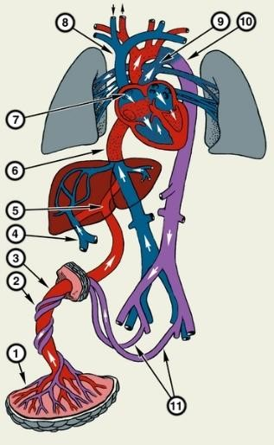
- Right-to-left shunting of blood through the patent ductus arteriosus (connects the pulmonary artery to the aorta) and the foramen ovale (connects the right and left atria) around non-ventilated lungs due to the high resistance of the pulmonary arterioles and the low resistance to blood flow in the systemic circulation. About 90-95% of the output of the right ventricle bypasses the lungs and enters the large circle of blood circulation.

- The fetal ductus arteriosus is kept open due to low systemic PaO 2 (25 mm Hg) and local production of prostaglandins.

- The foramen ovale remains open due to the pressure difference in the atria: the pressure in the left atrium is low due to the small blood flow through the pulmonary veins, the pressure in the right atrium is relatively high due to the inflow of a large volume of blood from the placenta.

- Usually, these two structures close naturally
shortly after birth.
Changes in the perinatal period
- The first breath → increase in pulmonary blood flow → ↓ pulmonary resistance of arterioles due to vasodilatation due to expansion of the lungs and increase in ↑ PaО 2 .
- Increased venous return from the lungs ↑ pressure in the left atrium → ↓ pressure difference between the left and right atria → functional closure of the foramen ovale .
- ↑ PaО 2 → narrowing of umbilical arteries → cessation of placental blood flow → ↓ arterial return to the right atrium → ↓ pressure in the right atrium.
- The systemic resistance becomes higher than the pulmonary resistance → a change in the direction of the blood flow through the ductus arteriosus - blood shunting from left to right (the so-called transitional circulation). This condition lasts from the moment of birth to the age of approximately 24-72 hours. High PaО 2 + changes in the metabolism of prostaglandins → narrowing and closing of the ductus arteriosus. As soon as the duct closes, an adult type of blood circulation is formed.
During the period of transitional circulation, unfavorable factors can return the circulation to the fetal type: asphyxia with hypoxia and hypercapnia causes narrowing of the pulmonary arterioles and dilation of the ductus arteriosus, which restores right-to-left shunting of blood through the newly opened ductus arteriosus and/or foramen ovale → persistent pulmonary hypertension or persistent fetal blood circulation (severe hypoxemia). Treatment is aimed at eliminating the conditions that caused vasoconstriction.
Congenital heart anomalies are classified as (in exemplary order of decreasing frequency):
Cyanotic : _ Acyanotic :
- Tetrad of Fallot - shunts from left to right :
- Transposition of main arteries • Interventricular defect • _ Atresia of the tricuspid valve of the septum
- Atresia of the pulmonary artery • Atrial muscle defect
- Common arterial trunk of the septum
- Total anomalous pulmonary venous • In the open ductus arteriosus
return • Atrioventricular defect partitions
- obstructive lesions :
- Pulmonary artery stenosis
- Aortic stenosis
- Coarctation of the aorta
- Hypoplasia of the left heart syndrome
Physiological consequences of congenital anomalies of the heart vary greatly - from heart murmurs or pulse difference in an asymptomatic child to severe cyanosis, heart failure or vascular insufficiency. The degree of these changes is determined by disturbances in systemic blood circulation.
Air ducts, depending on the type, affect hemodynamics in different ways, from minor disturbances to pressure or volume overload , with the formation of heart failure (HF). HF develops when the cardiac output is insufficient to meet the metabolic needs of the body or the inability of the heart to cope with venous return, which causes pulmonary edema (in case of left ventricular failure ), edema, primarily in dependent tissues and organs of the abdominal cavity (in case of right ventricular failure), or both options Classification according to Marder takes into account changes in intracardiac and central hemodynamics

Right to left shunt . Cyanotic air ducts are characterized by shunting
of deoxygenated venous blood on the left side of the heart, reducing the systemic oxygen saturation of arterial blood → cyanosis develops (> 5 g/dL of deoxygenated hemoglobin). Consequences of chronic hypoxemia include:
polycythemia, thromboembolism, blood coagulation disorders, brain abscess and hyperuricemia, hypercyanotic attacks (tetrad of Fallot).
Depending on the abnormality, pulmonary blood flow can be reduced, normal or increased (forming heart failure). Heart murmurs with a variable sound are not specific.
Left-to-right shunts - oxygenated blood from the left side of the heart/aorta is directed to the right side of the heart/pulmonary artery through an opening or junction between the 2 parts. After birth, pulmonary vascular resistance remains high for some time, and the shunt through this connection may be minimal or bidirectional. During the first 24-48 hours of life, pulmonary vascular resistance progressively decreases → ↑ blood flow from left to right. Therefore, additional blood flow to the right side increases pulmonary blood flow and pressure in the pulmonary artery to varying degrees. The greater the increase, the more severe the symptoms; minor left-to-right shunting usually causes no symptoms or signs. High-pressure shunts (in the ventricles or high-caliber arteries) become apparent in days to weeks; low-pressure shunts (atrial septal defects) become apparent much later. In the absence of treatment, significant shunts (large defect of the interventricular septum - DMSHP, open ductus arteriosus - VAP) lead to:
- development of pulmonary hypertension and Eisenmenger's syndrome
- development of signs of heart failure
- developmental delay in childhood
- overloading of the volume of the left ventricle → an increase in the resistance of the respiratory tract.
Obstructive lesions cause difficulties in blood flow with the formation of a pressure gradient through the obstruction →:
- g hypertrophy of the ventricles (pressure overload proximal to the obstruction)
- heart failure
- heart murmur (turbulent current through an obstructed area)
Flow-dependent VVS. Some CVDs depend on patent ductus arteriosus to maintain systemic blood flow (hypoplastic left heart syndrome, critical aortic stenosis, coarctation of the aorta) or pulmonary blood flow (pulmonary atresia, severe tetrad of Fallot). With these disorders, maintaining an open arterial duct is vital with the help of intravenous administration of exogenous prostaglandins until the final recovery (through surgical intervention).
Manifestations of VBS are diverse, usually include:
- Heart failure syndrome. In infants, symptoms and signs of heart failure include:
  - tachycardia ;
  - tachypnea ;
  - shortness of breath when feeding;
  - diaphoresis, especially when feeding;
  - anxiety, irritability, rapid fatigue during feeding, during mobile play;
  - hepatomegaly;
  - most babies do not have dilatation of the cervical veins, but they sometimes have severe swelling of the periorbital region.
older children with heart failure are similar to those in adults.
- Syndrome of respiratory disorders : shortness of breath, frequent colds, recurrent diseases of the lower respiratory tract .
- Syndrome of chronic systemic hypoxia :
  - cyanosis: central - bluish color of lips and tongue and/or nail beds (saturation <85%); perioral and acrocyanosis (blueness of the hands and feet) - without cyanosis of the lips or nail bed, more often caused by narrowing of peripheral vessels, and not
g hypoxemia, and is a common, normal phenomenon in newborns;
  - retardation in growth and development, exacerbated by shortness of breath during feeding, insufficient nutrition, increased metabolic needs in HF, frequent respiratory tract infections;
  - symptoms of drumsticks and temporal glasses.
4. Cardiac syndrome:
- heart/chest pain: in infants, may present with unexplained significant irritability ( during or after feeding), and may be caused by anomalous departure of the left coronary artery from the pulmonary artery
- palpitation
- interruptions in the work of the heart
- swelling and pulsation of neck vessels
- deformation of the chest
- changes in blood pressure and characteristics of the peripheral pulse
- be able to characteristics of the apical impulse in hypertrophy/dilatation of the left
ventricle
- systolic/diastolic "cat's purr" in stenoses
- expansion of the borders of the heart in accordance with the expanded sections, determined percussionally, or radiologically, or electrocardiographically,
- the appearance of noises characteristic of each defect and a change in the auscultatory melody of the heart:
✓ bleeding from left to right and obstructive lesions - usually a systolic murmur
✓ increase in current through the pulmonary or aortic valve - increasing regressive mesosystolic murmur (systolic ejection)
✓ regurgitation current through the ventricular valve or through a defect of the interventricular membrane - holosystolic (pansystolic) noise, shadows S1 as its intensity increases
✓ a patent ductus arteriosus usually results in a continuous 2-tone murmur, with a more pronounced sound during systole (triggered by higher pressure) than during diastole, uninterrupted S2
✓ abnormal 2nd sound (S2-single or sharply split), systolic click, gallop rhythm or irregular rhythm.
- Circulatory shock in newborns can be the first manifestation of some abnormalities (syndrome of hypoplasia of the left parts of the heart, critical stenosis of the aorta, interrupted arch of the aorta, coarctation of the aorta): extremely severe manifestations, cold extremities, weakening of the pulse, low blood pressure, as well as a reduced response to stimuli.
- Syncopal conditions (anomalous departure of the coronary artery or inherited syndromes of rhythm disturbances): often without warning symptoms, against the background of physical exertion ( high school athletes are often affected).
Diagnostics
- Antenatal: detailed collection of anamnesis of the pregnant woman, identification of risk factors for the birth of a child with developmental anomalies, prenatal ultrasound screening in the prescribed period of pregnancy, if a malformation is suspected - focused ultrasound of the fetus on an expert-class device, fetal echocardiography, karyotyping of the fetus.
- Postnatal: a detailed collection of complaints, objective examination, laboratory diagnostics (clinical blood analysis, biochemical blood analysis, COS), instrumental diagnostics (pulsokimetry: measurement of preductal and postductal saturation - measurement of saturation on the right arm and any leg, preferably simultaneously ; measurement of blood pressure: on the right arm and any leg; ECG: position of the electrical axis of the heart, overload of the heart, coronary changes, arrhythmias; X-ray of the chest organs, CT, MRI, angio/ventriculography; ECHO-KG: detailing of the defect, determination of treatment tactics).
General approaches to the management of patients with VVS:
1. Conservative therapy of heart failure: diuretics, ACE inhibitors, beta-blockers, digoxin, salt restriction, oxygen therapy, prostaglandin E 1 ):
- in case of suspicion of critical VVS/when confirming the diagnosis: intravenous infusion of prostaglandin E1 at a dose of 0.05-0.1 μg/kg/min
- oxygen therapy: ↓ hypoxemia and relieves the respiratory distress syndrome in HF, if possible, the fraction of inspired oxygen (Fio2) should be kept at the level of <40% to minimize the risk of damage to the lung epithelium. Ventilator may be necessary in severe condition; in other cases, additional oxygen should be administered judiciously or even postponed (in case of left-to-right shunts or obstructive defects of the left heart, increased excess pulmonary circulation)
- diuretics: furosemide as an initial bolus of 1 mg/kg intravenously or 1-3 mg/kg orally every 8-24 hours, titrate the dose based on the volume of urine; potassium-sparing diuretics (spironolactone 1 mg/kg orally 1-2 times/day, if necessary, titrate up to 2 mg/kg/dose)
- ACE inhibitors (captopril 0.1-0.3 mg/kg orally 3 times/day)
- beta-blockers (carvedilol, metoprolol)
- inotropic drugs: dopamine or dobutamine can maintain blood pressure, but ↑ heart rate and afterload, myocardial oxygen consumption.
- digoxin is used less frequently than in the past, but may have a role in children with heart failure who have large left-to-right shunts and in some post-operative patients with HF
- nutrition: restriction of salt intake, dietary modifications may be necessary depending on the specific disorder and manifestation:
✓ with critical defects, especially with obstructive lesions of the left heart, it may be recommended to refrain from feeding in order to minimize the risk of developing necrotizing enterocolitis.
✓ with left-to-right shunts, it is recommended to use food with an increased calorie content; ✓ tube feeding is sometimes required to support growth.
2. Surgical repair or transcatheter intervention.
Transcatheter procedures:
- balloon atrioseptostomy - palliative treatment of severe cyanosis in newborns with transposition of main arteries;
- balloon dilatation of severe aortic valve stenoses or pulmonary valve stenoses in ;
- closure of cardiac shunts (more often atrial septal defect and open ductus arteriosus).
3. Prophylaxis of endocarditis with antibiotics is necessary for children with congenital heart defects who have the following symptoms:
- Untreated cyanotic VVS (including palliative shunts and ducts)
- Completely cured of VVS within the first 6 months. after surgery, if a prosthetic material or device was used
- Healed VVS with residual defects in or near the place of installation of a prosthesis or prosthetic device - Mechanical or bioprosthetic valve
- Previous cases of endocarditis.

Atrial septal defect (ASD)
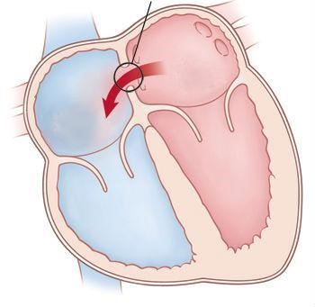
The basis of hemodynamic disorders is the discharge of blood from the LP to the PP and enrichment of the MCC. It is often detected only by an asymptomatic heart murmur. Symptoms of HF usually do not appear during the first 10 years of life.
Usually, during the first months of life, hemodynamic compensation and regression of the clinical picture occur.
Typical symptoms :
- Persistent pallor , graceful physique, lag in physical development.
- Rapid fatigue, dizziness, fainting, shortness of breath during physical exertion.
- Propensity to colds.
- Cerebral or systemic thromboembolic phenomena (stroke): the passage of microemboli from the venous bed through DMPP ( paradoxical embolism), often associated with arrhythmias.
- Rarely , if DMPP has not been diagnosed and corrected for decades, Eisenmenger syndrome develops.
Objectively:
- the borders of the heart are increased to the right and up due to the atria
- gentle systolic murmur with an epicenter above the LA (it is better to listen with the patient lying down)
- strengthening of the I tone, the II tone over the LA is strengthened and often split
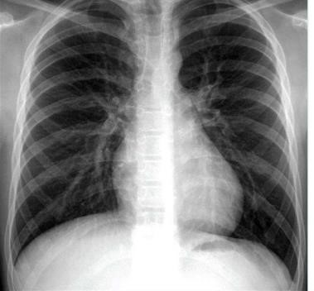
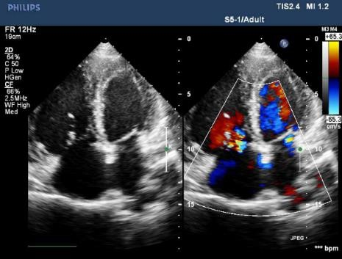
The diagnosis of DMPP is assumed during a cardiological examination, X-ray of the chest, ECG and confirmed by two-dimensional echocardiography with color flow and Doppler examination.
ECG: signs of overloading of the right parts of the heart with
g hypertrophy of the right ventricle and atrium, incomplete or complete blockade of the right leg of the bundle of His.
Treatment
- Observation and periodic echocardiography (usually, approximately every 3-5 years). Most small (<3 mm), centrally located DMPPs close spontaneously; many defects 3-8 mm in size spontaneously close by 3 years. These and defects probably represent stretching of the foramen ovale, and not true ostium secundum DMPP.
- Transcatheter closure or surgical intervention. DMPP ostium primum and venous sinus do not close spontaneously. Moderately large DMMM (signs of volume overload of the right ventricle according to echocardiography) should be closed, as a rule, at the age of 2-6 years. Earlier recovery may be considered for children with chronic lung disease. Transcatheter closure using various commercial devices (Amplatzer ® or Gore HELEX ® septal occluders) is preferred when appropriate anatomical features are presented, such as adequate septal tissue margins and distance from vital structures (aortic root, pulmonary veins, tricuspid annulus). In another case (defects of the venous sinus and ostium primum), surgical intervention is indicated. If DMPP is eliminated in childhood, perioperative mortality approaches zero and long-term survival approaches that of the general population.
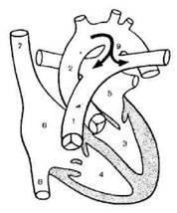
OPEN DUCtus Arteriosus (DUC) - preservation of the fetal connection (ductus arteriosus) between the aorta and the pulmonary artery after birth.
  - Enrichment of MCC.
  - Left-right shunt.
  - Physiological consequences depend on the size of the duct.
  - A small duct rarely causes symptoms.
  - The large duct causes a strong left-to-right shunt. Over time, a large shunt leads to an increase in the left side of the heart, pulmonary artery hypertension and increased pulmonary vascular resistance, causing Eisenmenger's syndrome.
  - Clinical picture:
- depends on the size of the unfused ductus arteriosus and the gestational age at the time of delivery.
- infants and younger children with small VAP usually have no symptoms;
- infants with large patent ductus arteriosus may present with signs of heart failure (eg, developmental delay, poor appetite, rapid breathing, shortness of breath during feeding, tachycardia).
- premature babies: respiratory failure, apnea, deterioration of mechanical requirements for ventilation or other serious complications (necrotic enterocolitis, GPN).
- heart failure occurs quickly in premature babies.
- large ductal shunt in a premature baby is often one of the main causes of severe lung disease.
Objectively :
- systolic tremor of the anterior chest wall to the left of the sternum
- expansion of heart boundaries
- dulling of the percussion sound in the II MRI to the left of the sternum (Gerhardt's zone ) .
- b most children have normal 1st and 2nd heart sounds and peripheral pulse.
- constant "machine" systole -d diastolic murmur of Gibson is better heard in the upper part of the left edge of the sternum in II MR.
- full-term infants with significant blood loss due to VAP have a full peripheral pulse with a wide pulse pressure.
- premature babies with a significant shunt have a frequent pulse and a hyperdynamic precardial space. Heart murmurs occur in the pulmonary region; the murmur can be continuous systolic with a short diastolic component or only systolic, depending on the pressure in the pulmonary artery. Some children do not have audible heart murmurs .

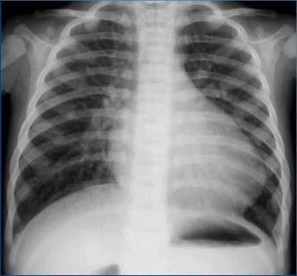
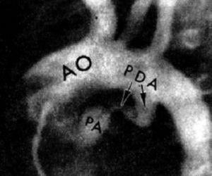
Diagnostics
The diagnosis is assumed on the basis of clinical examination data with the support of chest X-ray and ECG and established on the basis of two-dimensional echocardiography with color flow and Doppler examination.
Echocardiography provides important information about the hemodynamic significance of VAP by evaluating a number of parameters , including :
- The size of the VAP (often in (comparable to the size of the left pulmonary artery)
- Flow rates in VAP
- The presence of an increase in the left parts of the heart
- The presence of diastolic backflow in the descending aorta 5. Presence of diastolic antegrade flow in the left pulmonary artery.
Treatment
1. Supportive medication therapy:
- limitation of the family
- diuretics (usually thiazide )
- n maintenance of hematocrit ≥ 35
- ensuring a neutral temperature of the environment
- use of positive end-expiratory pressure (PEEP) to improve gas exchange.
- in premature children with clinical manifestations - therapy with inhibitors of cyclooxygenase (COX) (for example, indomethacin, ibuprofen on lysine ). Three doses of indomethacin should be prescribed intravenously every 12-24 hours, depending on diuresis ; if the diuresis is <0.6 ml/kg/h, the drug is stopped. An alternative to ibuprofen is lysine doses and 10 mg/kg orally, and then 2 doses of 5 mg/kg with a 24-hour interval. If fluid restriction and/or the use of COX inhibitors have not been successful, the patent ductus arteriosus is surgically ligated. • in full-term children, the use of COX inhibitors is usually ineffective.
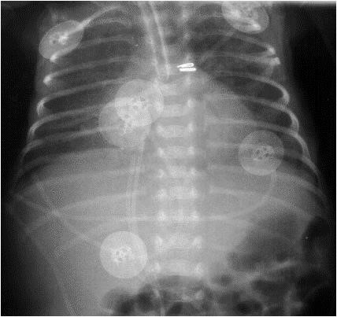
2. In some cases, transcatheter closure or surgical intervention is used:
• Transcatheter closure has become the preferred method of treatment for children with VAP >1 year of age. Various devices are available
for catheter occlusion • (coils, septal duct occluders).
prophylaxis :
1. Antenatal corticosteroid therapy - prophylactic
RDSN
2. Respiratory therapy o REER is not less than 5 mm H 2 O o Shortening the duration of inhalation
o Hyperoxia leads to a decrease in blood pressure - O 2 is a vasodilator for the vessels of the lungs o Adequate oxygenation and absence of episodes of hypoxia, apnea prophylaxis, "soft" methods of respiratory therapy are important: NCPAP, early extubation, INSURE
(self -surfactant intubation - extubation)
3. Limitation of the amount of fluid administered to 130 - 150 ml/kg per day
4. Daily monitoring of weight and diuresis
5. Going out in conditions of high air humidity
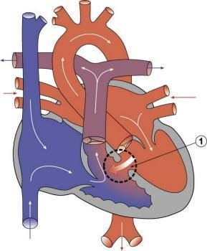
INTERVENTRICULAR MEMBRANE DEFECT (DMSHP) - an opening in the interventricular membrane, which leads to the connection between the ventricles. Large defects lead to a significant left-to-right blood shunt and are the cause of shortness of breath during feeding and low growth rates during childhood.
Classification
- Perimembranous (also called conoventricular);
- Trabecular muscle;
- Subpulmonary defects of the excretory tract (supragmatic, conoseptal, double-committed subaortic)
- Defects of the afferent tract (atrioventricular septum, according to the type of atrioventricular canal)
Clinical manifestations
- Symptoms depend on the size of the defect and the size of the left-right shunt. Children with a small ventricular septal defect usually have no symptoms and are characterized by normal growth and development. In children with a large defect, symptoms of heart failure appear at the age of 4-6 weeks, when pulmonary vascular pressure decreases .
- Frequent infections of the lower respiratory tract may occur .
- An untreated patient may develop symptoms of Eisenmenger syndrome.
- Small and ventricular septal defects are usually accompanied by high pitched short systolic murmurs
- Moderate and large DMSHP cause an intense systolic murmur over the entire region of the heart, which is directed to the right side of the chest and to the back with the punctum maximum in
IV MR to the left of the sternum, "belting noise", the appearance of the 3 tone is accompanied by chest tremors.
6. With large defects equalizing the pressure in the left and right ventricles, the systolic murmur is often attenuated.
The diagnosis of DMSHP is assumed during a clinical examination, it is confirmed by chest X-ray and ECG and established on the basis of echocardiography data.
Chest X -ray : cardiomegaly, increased pulmonary vascular pattern. ECG: hypertrophy of the right ventricle
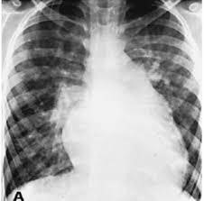
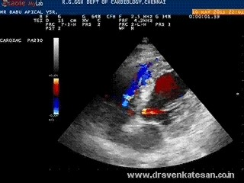
g hypertrophy of the ventricles and sometimes enlargement of the atrium. ECG and X-ray of the chest with small DMSH are usually normal.
Treatment
- In connection with heart failure, drug therapy (for example, diuretics, digoxin, ACE inhibitors)
- Surgical intervention. Small defects of the interventricular septum, especially the muscular layer, often close spontaneously during the first few years of life. A small defect that remains open does not require medical or surgical treatment. Larger defects are less likely to close spontaneously. In such cases, it is necessary to correct the defect in the first 6 months of life.
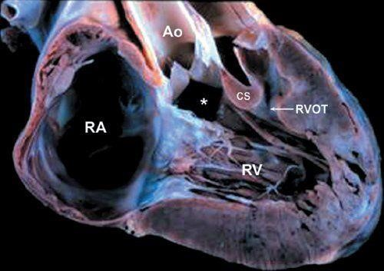
TETRADE OF PALLO
Multi-component air force:
- Stenosis of the excretory department of the PN
- DMSHP
- Dextroposition of the aorta
- Myocardial hypertrophy of the right ventricle
Pathophysiology depends on the degree of outflow obstruction from the right ventricle. Moderate obstruction can lead to a pure left-to-right shunt through the DMSP; severe obstruction causes a shunt to the right
to the left, which leads to low systemic arterial blood saturation (cyanosis), which does not respond to additional oxygen administration.
Hypercyanotic attacks. In some children with uncorrected tetrad of Fallot, most often between the ages of several months and 2 years, sudden attacks of severe cyanosis and hypoxia can occur, which can lead to death . An attack can be triggered by any event that significantly reduces oxygen saturation (eg, crying, defecation), or dramatically reduces systemic vascular resistance (eg, playing, kicking on waking), or by the sudden onset of tachycardia or hypovolemia.
Clinical manifestations
- Pronounced cyanosis and shortness of breath during feeding (severe obstruction of the outflow tract of the right ventricle)
- Poor body weight gain .
- Auscultation: coarse systolic ejection murmur near the left middle and upper edge of the sternum. An interventricular septal defect is usually asymptomatic because it is large and has no pressure gradient. II heart tone (S2), as a rule, is single, as the pulmonary component is noticeably reduced. Right ventricular shocks and systolic chest vibration may be present.
Hypercyanotic attacks:
- can be triggered by activity
- g hyperpnea (rapid and deep breaths)
- irritability, prolonged crying
- increasing cyanosis
- decrease in intensity or disappearance of heart murmurs 6. most often occur in young children
- the peak incidence occurs in 2-4 months.
- severe attacks can lead to lethargy, convulsions, and sometimes death.
- during the game, some babies may periodically squat down, taking a position that increases systemic vascular resistance and pressure in the aorta, which reduces shunting of the ventricles from right to left and, therefore, increases the saturation of arterial blood with oxygen.
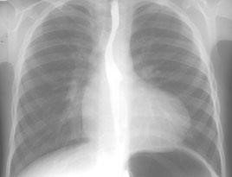
The diagnosis of tetrad of Fallot is assumed on the basis of history and data of clinical examination with the support of chest X-ray and ECG and is established with the help of two-dimensional echocardiography with color flow and Doppler examination.
X-ray of the chest organs reveals a heart in the form of a wooden shoe with a concave main segment of the pulmonary artery and a reduced pulmonary vascular pattern. The right aortic arch is present in 25%.
ECG shows hypertrophy of the right ventricle, and can also reveal hypertrophy of the right atrium.
Treatment
- For newborns with pronounced symptoms - introduction of prostaglandin E1
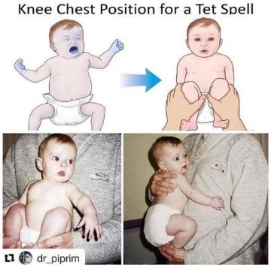
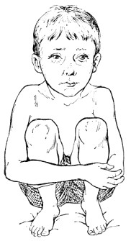
- With hypercyanotic attacks:
- immediate intervention
- take a knee-chest position. For babies, immediately press their knees to their chest (older children usually squat spontaneously and do not develop seizures
- to ensure peace
- oxygen supply
- intravenous infusion of fluid to increase blood volume
- medical treatment includes morphine, phenylephrine, and beta-blockers (propranolol or esmolol).
- systemic arterial pressure can be increased with the help of ketamine at 0.5-3 mg/kg intravenously or at 2-3 mg/kg intramuscularly ( ketamine also has a beneficial sedative effect).
- in the presence of metabolic acidosis - sodium bicarbonate, intravenous injection in the amount of 1 mEq/kg
- tracheal intubation, extracorporeal membrane oxygenation (ECMO), or emergency surgery may be necessary.
- Propranolol orally in doses and from 0.25 to 1 mg/kg every 6 hours (before surgery) can prevent relapses
- Most experts believe that even one significant attack indicates the need for operative surgical correction.
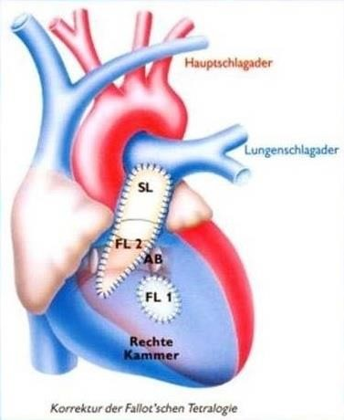
3. Radical treatment: elimination of the defect of the interventricular septum by applying a patch, expansion of the outlet of the right ventricle by muscle resection, pulmonary valvuloplasty and, if necessary, an increase in the patch of the pulmonary trunk. IN therefore , if there is significant hypoplasia of the pulmonary valve ring, a transannular patch is placed. Surgical intervention is usually carried out selectively at the age of 2-6 months, but it can be performed at any time in the presence of symptoms or in the presence of severe obstruction of the outflow tract of the right ventricle.
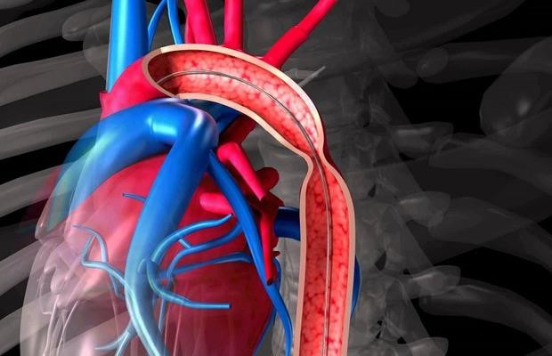
COARCTATION OF THE AORTA - localized narrowing of the lumen of the aorta, which leads to hypertension of the upper extremities , hypertrophy of the left ventricle and insufficient perfusion of the organs of the abdominal cavity and lower extremities.
Symptoms:
- depend on the severity of the anomaly
- headache
- chest pain _
- lameness
- cold extremities
- fatigue
- intermittent lameness.
If the coarctation is significant, circulatory shock with renal failure (oliguria or anuria) and metabolic acidosis may develop in the first 7 to 10 days of life and mimic the results of other systemic diseases such as sepsis.
Less severe coarctation may be asymptomatic during childhood. Mild symptoms may appear as the child grows older. Hypertension in the upper extremities is often present, but heart failure rarely develops after the neonatal period. Rupture of an intracerebral aneurysm is rare as a result of subarachnoid or intracerebral hemorrhage.
Typical symptoms during physical examination:
- solid pulse
- hypertension on the upper extremities
- decrease or delay of the pulse on the femoral artery
- BP gradient with low or unmeasurable BP in the lower extremities .
- fulminant heart failure and shock may develop.
- a soft noise can be heard outside the coarctation site .
- expansion of the intercostal collateral arteries can lead to continuous murmurs in the intercostal spaces.
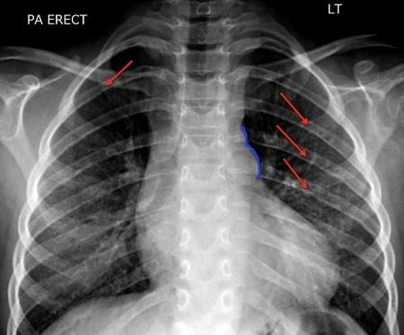
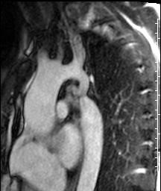
The diagnosis is established using echocardiography, CT or MR angiography.
Radiograph:
- narrowing in the form of the number 3 in the upper left shadow of the mediastinum.
- the heart has a normal size , except for cases of heart failure.
- expanded intercostal collateral arteries can erode the 3rd-8th ribs, as a result of which notches are formed on the ribs.
ECG:
- g hypertrophy of the left ventricle
- can be normal.
- in newborns and small children - hypertrophy of the right ventricle.
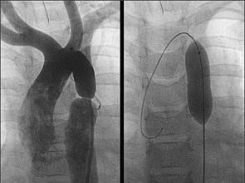
Treatment
- Newborns with severe symptoms - immediate appointment of prostaglandin E1
- With arterial hypertension - beta-blockers (ACE inhibitors are contraindicated). After coarctation correction, hypertension may persist or develop years after recovery and may be treated with beta-blockers, ACE inhibitors, angiotensin II receptor blockers, or calcium channel blockers.
- Surgical correction or balloon angioplasty (sometimes with the installation of a stent ) . The choice of surgical method depends on the anatomy and preferences of the center.
- Children with very mild coarctation and no signs of hypoperfusion of the lower part of the body are monitored before correction.

6. Materials of methodological support classes
6.1. Methodological support of classes
- Definition
- Spread
- Pathogenesis.
- Classification.
- Clinical features.
- Diagnostics.
- Treatment
6.2. Information necessary for the formation of knowledge - skills can be found in the literature
- basic:
- Kliegman, R.M., St Geme, J.W., Blum, N.J., Shah, S.S., Tasker, R.C., Willson, K.M., & Behrman, R.E. (Eds.). (2019). Nelson Textbook of Pediatrics (21st ed.). 4264 p.
- Sun HY,Proudfoot JA,McCandless RT, Prenatal detection of critical cardiac outflow tract anomalies remains suboptimal despite revised obstetrical imaging guidelines. Congenital heart disease. 2018 Sep
- Apostolopoulou SC,Manginas A,Kelekis NL,Noutsias M, Cardiovascular imaging approach in pre and postoperative tetralogy of Fallot. BMC cardiovascular disorders. 2019 Jan 7
- Nelson textbook of pediatrics, 2 volume set. Edition: 21st, 2019. PDF format. http://pediacalls.com/e-books/nelson-textbook-of-pediatrics-21st-edition/.
- Nelson Pediatric Abx 2022 URL: https://apps.apple.com/ru/app/nelson-pediatric-abx-2022/id1611269134
- Neonatology: a textbook in 3 volumes/ T. K. Znamenska, Yu.G. Antipkin, M.L. Aryaev and others; under the editorship T.K. Znamenska. Lviv: T.V. Marchenko Publisher, 2020, T. 1. 407 p.; T. 2. 455 p.; T 3. 379 p.
- Pediatrics. Differential diagnosis. Emergency conditions./edited by Aryaev M.L., Kotova N.V. Odesa: ONMedU, 2017. 280 p.

- additional:
- Pediatric Nephrology/ Tetiana Stoieva, Tamara Godlevska, OksanaNikytenko, Maksym Fedin, Kateryna Doikova; under the editorship Tetiana Stoieva. – Odesa: Politechperiodika, 2018. – 181 p.
- Pediatric pulmonology / Stoieva T.V., Vesilyk N.L., Soboleva K.B., Sytnyk V.V., Doikova K.M.; under the editorship T. V. Stoiva.— Odesa: Polytechperiodika, 2020.— 222 pp.: 59 illustrations, 88 tables.— (Series "Guide to Pediatrics").
- Nelson Essentials of Pediatrics E-Book 8th Edition / Karen Marcdante, Robert M. Kliegman. 2018. - 178 pages
- Blueprints Pediatrics (Blueprints Series) 7th Edition / Wolters Kluwer Health; 7th edition/ 2019. - 416 pages
- Case Files Pediatrics, Fifth Edition (LANGE Case Files) 5th Edition / Eugene C. Toy, Robert J. Yetman, Mark D. Hormann. 2017. - 577 pages
- Song WS, Kim CY, Lee BS, Kim EAR, Kim KS, Jung E. Morbidity and mortality of very low birth weight infants with congenital heart disease. Korean Circulat J. (2020) 50:1113–23.
- Derakhshan R, Barfeii N, Sadeghi T. Frequency of Congenital Heart Disease in Neonates with Extra Cardiac Anomalies. International Journal of Pediatrics-Mashhad. 2020;8(7):11597-602.

6.3. The estimated card for independent work with literature
N | Main Task | Recommendation | Answers
1 | 2 | 3 | 4
1 | Acquaint with literature and educational goals | Give information about epidemiology of the disease  Give the definition of the disease studied.
2 | Etiology | Fill the scheme of etiological factors
  …% |  | …% |  | …% |  | …%
3 | Pathogenesis | Fill the scheme of pathogenetic factors
  Pathogenesis
4 | Clinical data | Make differential diagnosis of this disease and similar to its condition
5 | Diagnosis | Make and explain diagnosis according to the results of clinical, laboratory and instrumental data.
6 | Treatment | Make program of treatment. Write prescription of preparations which is used for the treatment of this disease
  Rp… |  | Rp… |  | Rp… |  | Rp…
7 | Prophylaxis and rehabilitation | Fill the scheme of dispensary control
  N | Specialist | Time

7. Materials for self-control on the quality of training.
A. Questions for self-control.

- Anatomical and physiological of the cardiovascular system of children of different age groups.
- Etiology and pathogenesis of congenital heart diseases.
- Clinical forms of congenital heart diseases in children.
- Clinical characteristics of CHD in children.
- Principles of treatment of various forms of CHD in children.
- Principles of rehabilitation of children with CHD.

B. Tests for self-control.

1. A 14-years-old, one year ago had complaints of headache, dizziness, bleeding from nose, fast fatigue, shortness of breath at physical activity. The cardiologist diagnosed a congenital heart disease.. The most likely diagnosis is?
- Ventricular septal defect(VSD)
- Atrial septal defect(ASD)
- Tetralogy of Fallot(ToF)
- Coarctation of aorta
Е. Mitral insufficiency

2. A 1.5-year-old child, complaints are not present, but an attentive examination attracts attention to fast fatigue and shortness of breath at physical activity. Cyanosis is not present. Borders of heart relatively dull, are expanded to the right. In the 2nd intercostal space at the left, systolic noise is listened, accents and splitting of II tone. An electrocardiogram showed the incomplete blockade of the right branch of His bundle. The most compatible diagnosis is?
- Ventricular septal defect(VSD)
- Atrial septal defect(ASD)
- Tetralogy of Fallot (PoF)
- Mitral stenosis
- Mitral valve prolapse

3. Child О, 6 months old, already born in maternity hospital is diagnosed with cyanotic attacks during which the skin takes a violet shade, variable heart murmurs. Doctors of polyclinic thought about tetralogy of Fallot, transpositions of the main vessels, stenosis of aorta, Ebstein disease. What should be excluded from the listed defects at once?
- Tetralogy of Fallot (ToF)
- Trilogy of Fallot
- Transposition of the great arteries
- Aortic stenosis
- Ebstein disease

4. A 10 -year-old child B. During planned examination at school, the doctor diagnosed CHD(congenital heart defect) - coarctation of aorta. Which of the revealed peripheral signs is the main diagnostic criterion?
- Fatigue
- Nasal bleeding
- Difference between the AP on upper and lower extremities.
- Cold feet
- Headache
5. In child С, 4 years old, is suspected of CHD. Rough trembling at the heart bases at the left, continuous murmurs "machinery murmur " in the 2nd intercostal space at the left and in the same place, accent of II tone is thus defined. What defect are these changes characteristic?
- Pulmonary artery stenosis
- Aortic stenosis
- Patent ductus arteriosus
- Tricuspid insufficiency
- Tricuspid stenosis

6. Child О, 2 years old , poor growth, ARVI, after physical activity exhibit shortness of breath and tachycardia. Over heart area, murmur is listened. Congenital heart disease is suspected. What are the tactics of the local pediatrician?
- To direct for consultation by the chief of the polyclinic
- Direct for electrocardiogram, phonocardiogram, echocardiogram
- Direct for consultation by the cardio-rheumatologist
- Treat independently
- Direct for chest X-ray

7. Child С, 5 years old, does not give any complaints. In the course of planned inspection child is examined by all experts. The cardiologist diagnosed ventricular septal defect(VSD). Specify the diagnostic criterion confirming this diagnosis.
- Capillary pulse
- Rough systolic murmur in the IV intercostal space at the left side of the sternum
- II tone accent in the II intercostal space at right side of the sternum
- Pericardial murmur
- Continuous murmur

8. Child А, 14 years old, one year ago there were complaints of headache, dizziness, bleeding from nose, fast fatigue, shortness of breath at physical activity. The cardiologist diagnosed a congenital heart disease. About what defect does this speak of?
- Ventricular septal defect (VSD)
- Atrial septal defect (ASD)
- Patent ductus arteriosus
- Coarctation of aorta
- Mitral insufficiency

9. A boy of 10 years, of an athletic constitution, complains of frequent headaches, pains in lower extremities. At examination increased BP , weak pulsation of feet vessels , systolic murmurs at the back in the interscapular area is revealed. What CHD can be suspected?
- Patent ductus arteriosus
- Ventricular septal defect (VSD)
- Coarctation of aorta
- Tricuspid atresia
- Isolated pulmonary artery stenosis.

10. Girl with obvious signs of Down syndrome, the following changes are revealed: Stenosis of pulmonary artery, high VSD, dextraposition of aorta, hypertrophy right ventricle. What CHD are the given changes characteristic?
- А. Coarctation of aorta
- В. Transposition of the great arteries
- С. Tetralogy of Fallot(ToF)
- Д. Patent ductus arteriosus
- Е. Isolated pulmonary artery stenosis

11. A 3 months old child has poor physical development. Edema and ascites are revealed. VSD is suspected . In what stage of compensatory hyperfunction is the heart of the given patient?
- First
- Second
- Third
- Fourth
- Fifth

12. A 3 years old child has arrived the cardiologic department. Does not give complaints. At auscultation rasping scraping systolic hum with epicentre in IV-V intercostal spaces to the left of the breast bone, with small area of conduction. At an electrocardiogram and X-ray investigations, no pathology is found. What CHD is observed at this patient?
- Coarctation of aorta
- Ventricular septal defect (VSD)
- Patent ductus arteriosus
- Д. Atrial septal defect (ASD)
- Е. The isolated stenosis of a pulmonary artery

13. A7 years old patient has arrived with complaintsof dyspnea, tussis, cyanosis, delicacy, fatigability, frequent pulmonary infections, formed cardiac hump. Dilation of heart borders in by a diameter and upwards, the diffuse apical beat displaced downwards is objectively revealed. At auscultation to the left of the breast bone in III-IV intercostal space - the systolic hum leads over all cardiac area and to the back. The BP of the arms is lowered. What CHD is the reason of the child’s arrival in the clinic?
A. Patent ductus arteriosus
B. Atrial septal defect(ASD)
C. Transposition of the great arteries
D. High ventricular septal defect(VSD)
E. Isolated pulmonary artery stenosis

14. Child with high VSD, the intensity of hum in III-IV intercostal space to the left of the breast bone has decreased, the accent of II tone has strengthened, there was constant dyspnea and cyanosis. What signs of a symptom-complex are observed in the given patient?
- progressing pulmonary hypertension
- progressing arterial hypertension
- progressing pulmonary hypotension
- progressing arterial hypotension
- progressing renal hypertension

15. 6 months old boy has cyanosis of labium, nose, dactyls, dyspnea during feeding. Objectively: the left half of thorax projects out, apical beat strengthened a little, in III-IV intercostal space there is systolic tremor, At auscultation - rasping systolic hum at the left is heard. On X-ray, heart is of normal dimensions, right ventricle-hypertrophy, the "boot" form on an electrocardiogram . What heart disease becomes perceptible?
- Coarctation of aorta
- Tetralogy of Fallot (ToF)
- Patent ductus arteriosus
- Д. Ventricular septal defect (VSD)
- ASD

16. Boy 3 y.o was discharged out from the cardiology unit where he stayed in connection with dyspneic-cyanotic attacks. What is the further prophylaxis of attacks?
A. Curantil
B. Propranolol
C. Diazepam
D. Digoxin
E. Amiodarone

17. Mother during pregnancy had rubella infection and the child was born with:
A.Down syndrome
B. Trilogy of Gregg
С. "Labium leporium", «the wolf mouth»
D. polydactyly
E. hydrocephaly

C. Tasks for self-control.

1. The girl 7y.o complains of the increased appetite, fatigability, dyspnea during physical exercises, giddiness, periodical pains over the heart, sensation of increased heartbeat. At examination: pallor of skin and the visible mucous. Percussion: borders of relative cardiac dullness are dilated, more to the right. Auscultative picture: intensification of I tone on the apex, intensification and splitting of II tone on pulmonary artery, in II intercostal spaces to the left of the sternum - systolic hum of average intensity, irradiates to the left clavicle and V point. On the X-ray of thorax organs: intensification of pulmonary drawing at the expense of an arterial bed. Shades of lung roots and pulmonary artery are dilated. A heart waist it is smoothed because of a protrusion of pulmonary artery arch . From the anamnesis it is known, that the girl often is ill with pneumonia and bronchitis with congestive wet tussis, and mother spends a lot of time working with the computer during pregnancy, and in the first trimester had a flu.

1. Possible diagnosis.
2. Group classification of the given CHD?
3. What group of etiological factors has affected the child born with CHD?
4. What data of the anamnesis and objective inspection, and also X-ray point well for the group of defects chosen by you on classification?
5. What additional methods of investigation is the most informative for confirmation of diagnosis CHD?

2. A mother of an 8-months old child appealed for medical aid at the hospital with complaints of the boy’s lack of weight, refusal to breast-feeding. During feeding in the area of the nasolabial triangle cyanosis appears, and whith high cry -- cyanosis of the whole body. From the anamnesis is known that during the pregnancy mother was ill with influenza, besides was spending a lot of time with the computer. Objective examination: the skin is pale, acrocyanosis; while the palpation of the chest – “cat-like purring” on the second intercostal space left from the breast bone; while auscultation- systolic murmur on the second intercostal space left from the breast bone, in the third-forth intercostals spaces left – intensive systolic murmur, at the back (in the interscapular space) – the murmur of the collateral circulation.
Doctor formed a provisional diagnose: congenital heart disease -- Fallot’s tetrad.
Questions:
- To what group of classification does this malformation belongs?
- What etiological factors had influence on the birth of this child with congenital heart disease?
- What additional methods are necessary to make, to form the final diagnosis?
- What typical Fallot’s tetrad sign can you see on the X-ray film?
- Give the elements of the Fallot’s tetrad.

3. A boy 8 years old with the congenital heart disease- ventricular septal defect.
Questions:
- To what group of classification does this malformation belongs?
- What groups of etiological factors do you know that can lead to the birth of the child with the congenital heart disease?
- What can you hear while auscultating the child with this congenital heart disease?
- What method of examination is more informative to form diagnosis of the congenital heart disease?
- Give the main directions of the congenital heart disease treatment.

4. A mother of a 12-years old boy appealed for medical aid with complaints of headache, ache in the chest, frequent nasal bleedings. Objective examination: the boy had “athletic”constitution, differentiated cyanosis (pink skin of the upper part of the trunk and cyanotic low parts), by palpation -- absence of the pulse on the left femoral artery.
Questions:
- What is the diagnosis?
- To what group of classification does this malformation belongs?
- What clinical sign is more informative for this congenital disease?
- What phases of clinical course do you know?
- Give the methods of diagnosis of the congenital heart disease.

5. A girl, 5 years old complains of undue weakness, fatigability, exercise dyspnea, vertigo, fatigability, periodical pain in the heart area, palpitation. In examination: paleness of the skin and mucous. Percussion results: the borders of relative heart dullness are enlarged to the left size. Auscultation results: the first tone on the apex is amplified, the second heart sound over the pulmonary artery is amplified and splitting, in the second interscostal space left from the breastbone – systolic murmur of mean intensity, with the irradiation to left clavicle and the fifth point. On the X-ray film, you can see the lung pattern is enriched and enhancement for the account of arterial bloodstream. Root of lung shadow and pulmonary artery shadow are enlarged. Waist of the heart is flat, because of bulging of the pulmonary artery arch.
From the anamnesis is known that the girl is very often ill pneumonia, bronchitis with the congestive productive cough, and mother during the pregnancy was working with the computer and in the first trimester was ill with influenza.
Questions:
- What is the diagnosis?
- To what group of classification does this malformation belongs?
- What etiological factors had influence on the birth of the child with congenital heart disease?
- What facts from anamnesis, objective and X-ray examination are talking about the group of the malformation by the classification that you choose?
- What additional instrumental method is more informative for the diagnosis a congenital heart disease?

6. A child with the diagnosis Fallot’s tetrad in some time after the remodelation surgery of the deformity, starts to complain of the undue weakness, fatigability, exercise dyspnea, dull pain above the heart region, fever, chill with profuse sweating. Examination results: the skin is pale with earthy tint. Petechias with the light spot in the center were founded on the upper part of the trunk and extremities, on the conjunctiva. Palpation results: enlargement of the liver and hypersplenism. Auscultation results: heart sounds are muffled and an intensive systolic murmur of the mitral regurgitation is heard on the apex of the heart; on the second intercostals space right from the breast bone systolic murmur of the aortic regurgitation is heard.
Clinical blood analysis: leukocytosis, ESR increase, anemia.
Questions:
- What is the diagnosis?
- What findings from the objective examination are talking about vessel lesion?
- What is the differential diagnosis of this disease?
- What drugs are basic in the treatment of this disease?
- Give the conditions for drug’s prescription.

8. Classroom materials for self-study.
8.1. List of educational practical tasks that must be completed during the practical exercises:
1. Work at the bedside. Collect complaints, medical history, examine the child's organs and systems.
2. On the basis of medical history, complaints and objective laboratory data to formulate a clinical diagnosis.
3. Prescribe the treatment to determine the indications for surgery.
4. Identify rehabilitation measures.

9. Instructional materials for learning professional skills.
9.1. Methods of work Stages of the possible
List of educational practical tasks that must be completed during the practice session:
Assess the data and medical history of the disease, the risk factors that contributed to the development of the disease.
2. Conduct a clinical examination in a patient with CHD.
3. To plan additional tests.
4. Evaluate the results of laboratory and instrumental data.
5. Formulate a clinical diagnosis according to the classification

10. Materials for self-control of mastering knowledge, skills, abilities
Tasks
1. At Maxim, 15 years, has marked sinus bradycardia on an electrocardiogram . The boy complaints to rare dizzinesses, sweating. Heart rate - 52/minutes the blood pressure - 90/60 mm.hg.
1. What changes on an electrocardiogram are typical for sinus bradycardia?
2. What principal causes of changes on an electrocardiogram can be at the patient?
3. What rhythm disorders does take place on ECG?
4. What additional methods of investigations is necessary to recommend to the boy?
5. Make the program of rehabilitation.

2. Roma,14 years old, has been hospitalized with complaints to pains in the region of the heart, the sudden palpitation, unpleasant sensations in chest, dizziness. Objectively: skin is pale, and cold. On the electrocardiogram – heart rate more than 200 /minute, precedes complex QRS wave Р, interval P - R is a little extended.
1. How it is possible to treat the given condition?
2. What is the basic mechanism of development of the given rhythm disorder?
3. What other forms of the given rhythm disorder do you know?
4. Prescribe the additional methods of diagnosis?
5. Algorithm of urgent therapy.

3. Dasha, 12 years, complaints to the dizziness, unpleasant sensations in the heart region, faults of cardiac activity. Signs of supraventricular tachycardia on an electrocardiogram are registered.
1. What changes will be marked on an electrocardiogram?
2. What are the principal causes extrasystole?
3. Classification of extrasystolia depending on localisation of heterotophic center.
4. The basic methods of investigation of children with extrasystole.
5. Name the basic preparations for treatment of extrasystole.

