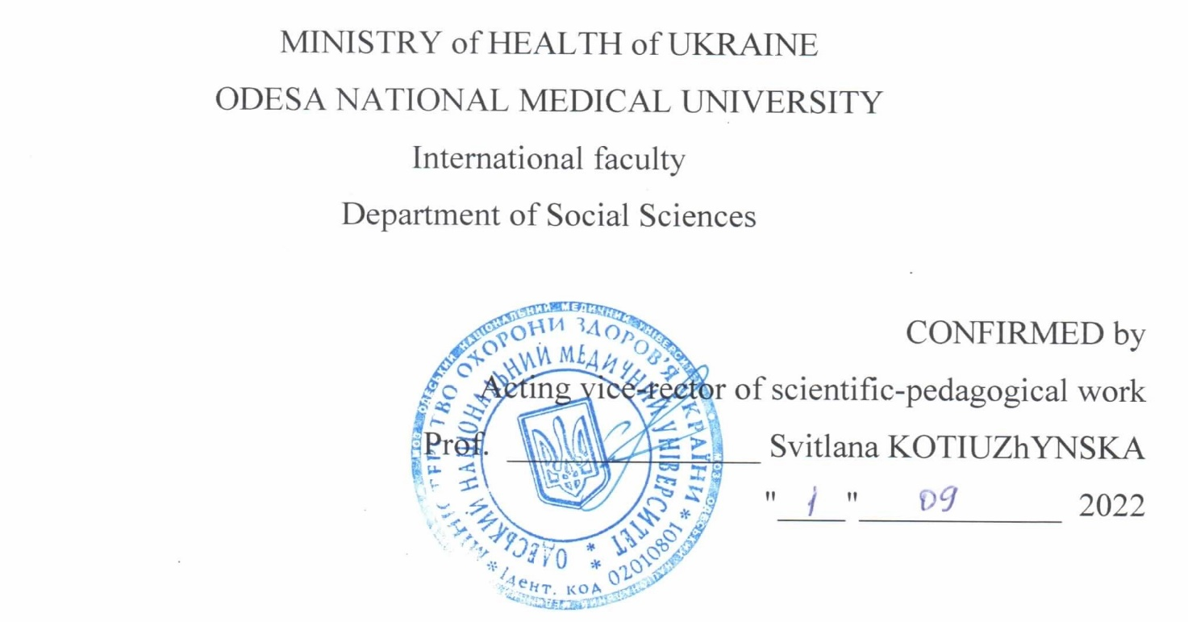

Working program of the academic discipline "Ukrainian for Specific Purposes"

Level of higher education: second (master’s degree)

Field of knowledge: 22 «Health care»

Specialty: 222 «Medicine»

Educational and professional program: Medicine

2022-2023

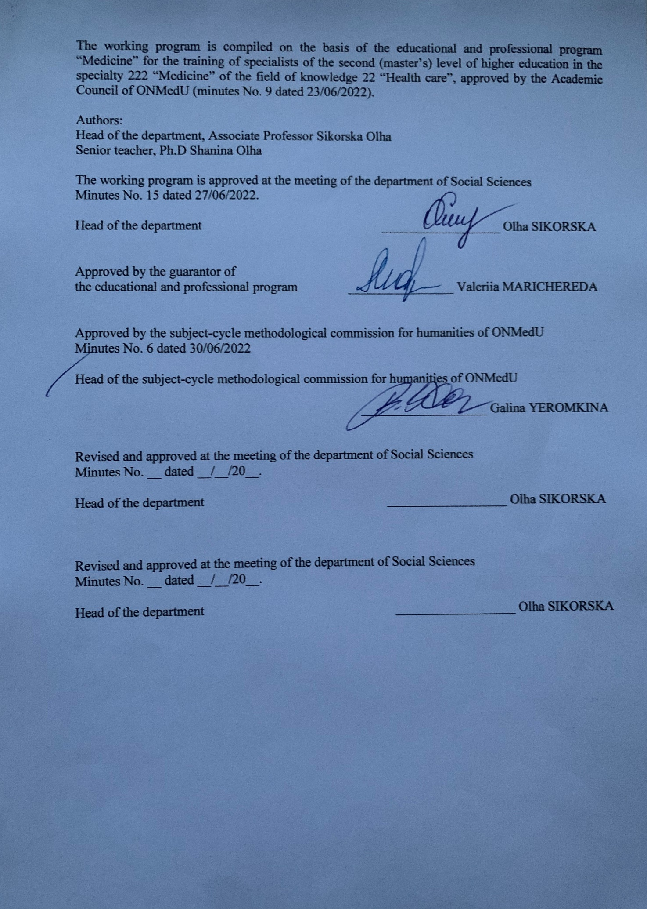

- Description of the discipline:

Name of indicators | Field of knowledge, specialty, specialization, level of higher education | Characteristics of the discipline
Total number:  Credits of ECTS: 3  Hours: 90  Content module:2 | Field of knowledge  22 «Health care»  Specialty  222 «Medicine»  Level of higher education second (master’s degree) | Full-time (day) education  Compulsory discipline
 |  | A year of preparation:1
 |  | Term: І
 |  | Lectures (0 hours)
 |  | Seminars (0 hours)
 |  | Practical classes (42 hours)
 |  | Laboratory classes (0 hours)
 |  | Independent work (48 hours)
 |  | including individual tasks (0 hours)
 |  | Form of final control – Differentiated Credit

2. The purpose and tasks of the educational discipline, competencies, program learning outcomes
The purpose of teaching the subject: Continuation of the formation of a national and linguistic personality, communication skills of future specialists, studying the peculiarities of the professional language.
The tasks of the discipline are the following:
- Mastery of the basic concepts of the course "The Ukrainian Language (for Specific Purposes)";
- Awareness of the importance of the state language in professional communication;
- Mastering the basics of professional medical language;
- Mastering the norms of medical documents.

The process of studying the discipline is aimed at forming elements of the following competencies:
Integrated (ІC): Ability to solve typical and complex problems, including research and innovation in the field of medicine. Ability to continue learning with a high degree of autonomy.
General (GC):
GC 1 Ability to abstract thinking, analysis and synthesis.
GC 2 Ability to learn and master modern knowledge.
GC 3 Ability to learn and master modern knowledge.
GC 8 Ability to interpersonal interaction.
GC 11 Ability to search, process and analyse information from various sources.
GC 13 Awareness of equal opportunities and gender issues.
GC 15 Ability to preserve and increase moral, cultural, scientific values and achievements of society based on understanding the history and patterns of development of the subject area, its place in the general system of knowledge about nature and society and in the development of society, technology and technologies, to use various types and forms of motor activity for active recreation and leading a healthy lifestyle.
Special (SC):
SC 16 Ability to fill medical documentation, including electronic forms.
SC 21Ability to clearly and unambiguously convey one's own knowledge, conclusions and arguments on health care problems and related issues to specialists and non-specialists, in particular to people who are studying.
SC 25 Adherence to professional and academic integrity, being responsible for the reliability of the obtained scientific results.
Program learning outcomes are:
PLO 21 Searching for the necessary information in the professional literature and databases of other sources, analysing, evaluating and application of this information.
PLO 25 Conveying one’s knowledge, conclusions and arguments on health care problems and related issues to specialists and non-specialists clearly and unambiguously.

As a result of studying the discipline, the higher education getter has to
Know: the language at the level of professional communication in all its richness of lexical, phonetic, morphological, syntactic, stylistic means, including terminology and to have ability to compose, translate and edit medical texts, ability to draw up basic types of documents.
Be able to:
- analyse the appropriateness of using lexical, morphological, and syntactic language tools in accordance with communicative intentions;
- have knowledge of terminology and skills in working with highly specialized dictionaries;
- determine the appropriateness of using lexical, morphological, syntactic language tools in accordance with communicative intentions;
- use lexical, grammatical, stylistic, and syntactic features;
- analyse the main body of vocabulary during the study with an emphasis on the terminology of the specialty.

3. The content of the educational discipline

Content module 1.

Lexical, grammatical and spelling peculiarities of medical professional speech

Theme 1. Modern Ukrainian as a means of professional communication.
Language as a social phenomenon. Language and speech in the life of society. Language as a communicative, sign-symbolic environment of the people and the individual. Functions of language. Literary language. Its features. Language norms. Types of language norms. The language of professional communication as a functional type of the modern Ukrainian literary language.
Theme 2. Lexical aspect of the professional language of physicians. Phraseological units in professional speech.
The lexicon. Vocabulary of the language. Unambiguous and polysemous words. Vocabulary of the Ukrainian language by origin. Vocabulary of the Ukrainian language by usage. Active and passive vocabulary. Phraseology. Sources of phraseology.
Theme 3. Terminology in professional communication. Lexical and semantic relations in scientific terminology. Features of Ukrainian medical terminology.
A term as a basic element of the professional language of medicine. Basic concepts of terminology. Medical term. Sources of medical terminology. Composition and structural organization of the Ukrainian medical terminology system. Groups of modern Ukrainian medical terminology. Term-eponym in medicine. Lexical and semantic relations in scientific terminology (synonyms, antonyms, homonyms, paronyms). Features of term formation in the field of medical terminology. Culture of term use. Problems of functioning of Ukrainian medical terminology. The main stages of development of Ukrainian medical terminology.
Theme 4. Dictionaries in professional communication. Types of dictionaries, their function and role in improving speech culture.
The concept of lexicography. Encyclopedic and linguistic dictionaries. Medical dictionaries and reference books. Types of dictionaries. Problems of standardization and codification of the terminology system. Modern codification practice. Organization of resources of the national dictionary base. Ukrainian electronic dictionary. The role of dictionaries in improving the level of language culture of physicians.
Theme 5. Morphological aspect of the medical professional language.
The concept of morphology, morphological norms. Norms and basic morphological categories: gender, number, case, degrees of comparison, person. Parts of speech as basic morphological units, principles of their classification. Morphological categories and syntactic properties of independent parts of speech. Specifics of the use of grammatical forms of independent parts of speech in business documents. Peculiarities of using official parts of speech in business documents.
Theme 6. Syntactic aspect of the professional language of physicians.
The concept of syntax. Types of syntactic units. Main and secondary members of the sentence. Principles of sentence classification. Difficult cases of coordination of the predicate with the subject: control and agreement in phrases. Variants of violations of syntactic rules. Features of building simple sentences: word order in the sentence, use of homogeneous members, adjectival and adverbial phrases. Typical mistakes related to the construction of complex sentences. Syntactic features of business writing.
Theme 7. Features of Ukrainian speech etiquette. Communicative signs of speech culture. Speech etiquette of a doctor.
Language and speech. Speech culture and its features. Speech etiquette, its history, structure, types, purpose. Ukrainian speech etiquette as an expression of ethnic identity, a model of universal language activity of the people. Etiquette language formulas and tone of communication. Features of the etiquette of official business and scientific communication. Culture of speech of a medical worker as an integral part of medical deontology. Iatrogenic effect of the word. The meaning of the word in the work of a doctor. Features of communication of medical workers in different situations.
Theme 8: Public speaking and its genres.
From the history and theory of public speaking. Public speaking as a genre of oratory. Culture of perception of public speaking. Report, speech, lecture, performance, review, message as genres of public speaking. Presentation as a type of public speaking. Features of the organization and presentation of the project. Business card. Types of business cards. Rules for designing a business card.
Theme 9: The stylistic aspect of the professional language of healthcare professionals.
The concept of functional styles of the modern Ukrainian language (colloquial, artistic, journalistic, scientific, official business, confessional, epistolary, oratorical). Interaction of functional styles of the modern Ukrainian language in the field of professional speech. The concepts of "special language", "professional language", "professional communication". Modern Ukrainian literary language as the basis of a special language. Varieties of medical professional language.
Theme 10. Scientific style in professional speech. Structure and types of scientific text.
Scientific style: key features, linguistic means, sub-styles and genres, functional purpose. Extracts, plan, theses. Features of note-taking. Abstract. Abstract as a form of processing scientific literature. Production of a scientific text. Formatting of scientific text, citations, references, bibliography. The article. Review and feedback. Rules of abbreviation in scientific and business texts. Technical rules of transfer.
Theme 11. Presentation of the student's research work. Abstract, its types and defense.
Abstract as a form of processing scientific literature. Basic requirements for the content of the abstract. Objects of abstracting. Documents that are not subject to abstracting. Structure of the abstract. Types of abstracts.
Theme 12: The document is the main form of realization of the formal business style.
The concept of a document, documentation, documentation, record keeping. Classification of documents. The form of the document. The form. General requirements for document execution. Rules for registration of details. Textual norms of business style. Design of the document page. Textual rubrication. Requirements for the language of business papers. Power of attorney (personal, official). The receipt. Certificate. Types of documents on personnel and contractual issues. Employment agreement. The contract. Labour agreement.

Content module 2.

Style features of business and professional communication. Culture of public speaking

Theme 13. Culture of written business speech of physicians: general characteristics. Documents on personnel.
The concept of a document, documentation, record keeping. Classification of documents. Types of personal official documents. Application, types of applications. Autobiography. Resume. Characteristics.
Theme 14: Requirements for the preparation and execution of administrative and clerical documents.
Purpose of organizational and administrative documents, their types and groups. Order, instruction, resolution. Purpose, details. Purpose, features, types of reference and information documents. Act, report, minutes, extract from minutes. Purpose, details. Letter, classification of letters. Etiquette of business correspondence.
Theme 15: Professional documentation of physicians. Features of its preparation and design.
Record keeping in medical institutions. Standardization of medical records. Basic requirements for medical records. Principles of classification of medical records. Genre types of medical records. Functions performed by medical documents. Types of medical documents: Medical history (medical card of an inpatient); Card of a patient of a day hospital of a polyclinic, hospital at home; Voucher for a patient to be admitted by a doctor; Certificate of temporary disability of students, students of technical schools, vocational schools; about the disease, quarantine of a child attending school, kindergarten; Sick leave; Extract from the medical card of an outpatient (inpatient) patient; Prescription; Forms of laboratory tests. Medical certificate.
Theme 16. Medical discourse: communicative-pragmatic and suggestive aspects.
Discourse in modern linguistics: approaches and problems. Medical discourse as a type of institutional discourse. Suggestibility as the basis of medical discourse. Pragmatic features in doctor-patient interaction. Positive and negative personality traits of a doctor as the main factor of communicative behaviour. Communicative strategies and tactics in medical discourse as a manifestation of suggestive influence. Doctor-patient interaction: positive and negative suggestive influence. Speech clichés as a means of suggestiveness in medical discourse. Language game as an element of suggestive influence in the doctor-patient interaction.
Theme 17. Effective language communication. Tactics of persuasion.
Listening as a prerequisite for competent speech: reflective and non-reflective listening. The speaker and the audience. Classification of public speaking. Contact with the audience. Taking into account the characteristics of the audience. Practical rules of persuasion: - the golden rule of rhetoric; - ten iron rules of persuasion. Tactics of persuasion. Psychological principles of influencing a person during communication. The main types of persuasion. Influence on the subconscious Tactics of persuasion. Types of interlocutors. Rhetorical methods. Speculative techniques. Psychological principles of influence on a person during communication: - the principle of contrast; - the principle of mutual exchange; - the principle of social proof; - the principle of affection; - the principle of similarity.
Theme 18: Speech image of a doctor.
Image as a phenomenon of the modern world. Psychological foundations of the doctor's image. Building an effective image. Professional image of a doctor. Features of creating a business image in medical practice. Image and leadership. Leadership in the mechanism of medical power. Image of a doctor as a leader. Image-making and its features in medical institutions. Communicative competence is the basis of the professional image of a modern doctor. Doctor and patient: aspects of the relationship. Effective communication in the doctor-patient system.
Theme 19: Peculiarities of translating medical texts.
Medical translation is a type of scientific and technical translation. The main areas of medical translation. The main types of word formation. Features of medical translation. Classification and lexical features of medical instructions. Causes of information loss in translation. Analysis of differences in grammar, syntactic and morphological structures of languages.
Theme 20: Fundamentals of communicative linguistics.
Communicative linguistics as a science and an academic discipline. Nature, components and forms of communication. Means of language code in communication. Intercultural communication. Analysis of communicative situations.

Differentiated credit.

4. The structure of the discipline.

Themes | Hours
Themes | Total | including
Themes | Total | Lectures | Seminars | Practical classes | Laboratory classes | ISW
Content module 1.
Lexical, grammatical and spelling peculiarities of medical professional speech
Theme 1. Modern Ukrainian as a means of professional communication. | 4 | 0 | 0 | 2 | 0 | 2
Theme 2. Lexical aspect of the professional language of physicians. Phraseological units in professional speech. | 4 | 0 | 0 | 2 | 0 | 2
Theme 3. Terminology in professional communication. Lexical and semantic relations in scientific terminology. Features of Ukrainian medical terminology. | 4 | 0 | 0 | 2 | 0 | 2
Theme 4. Dictionaries in professional communication. Types of dictionaries, their function and role in improving speech culture. | 4 | 0 | 0 | 2 | 0 | 2
Theme 5. Morphological aspect of the medical professional language. | 6 | 0 | 0 | 2 | 0 | 4
Theme 6. Syntactic aspect of the professional language of physicians | 6 | 0 | 0 | 2 | 0 | 4
Theme 7. Features of Ukrainian speech etiquette. Communicative signs of speech culture. Speech etiquette of a doctor | 4 | 0 | 0 | 2 | 0 | 2
Theme 8. Public speaking and its genres. | 4 | 0 | 0 | 2 | 0 | 2
Theme 9. The stylistic aspect of the professional language of healthcare professionals. | 4 | 0 | 0 | 2 | 0 | 2
Theme 10. Scientific style in professional speech. Structure and types of scientific text. | 4 | 0 | 0 | 2 | 0 | 2
Theme 11. Presentation of the student's research work. Abstract, its types and defense. | 6 | 0 | 0 | 2 | 0 | 4
Theme 12. The document is the main form of realization of the formal business style. | 4 | 0 | 0 | 2 |  | 2
Total for content module 1 | 54 | 0 | 0 | 24 | 0 | 30
Content module 2.
Style features of business and professional communication. Culture of public speaking
Theme 13. Culture of written business speech of physicians: general characteristics. Documents on personnel. | 4 | 0 | 0 | 2 | 0 | 2
Theme14. Requirements for the preparation and execution of administrative and clerical documents. | 4 | 0 | 0 | 2 | 0 | 2
Theme15. Professional documentation of physicians. Features of its preparation and design. | 4 | 0 | 0 | 2 | 0 | 2
Theme16. Medical discourse: communicative-pragmatic and suggestive aspects | 4 | 0 | 0 | 2 | 0 | 2
Theme17. Effective language communication. Tactics of persuasion. | 4 | 0 | 0 | 2 | 0 | 2
Theme18. Speech image of a doctor. | 4 | 0 | 0 | 2 | 0 | 2
Theme19: Peculiarities of translating medical texts. | 4 | 0 | 0 | 2 | 0 | 2
Theme20: Fundamentals of communicative linguistics. | 6 | 0 | 0 | 2 | 0 | 4
Total for content module 2 | 34 | 0 | 0 | 16 | 0 | 18
Differential credit. | 2 | 0 | 0 | 2 | 0 | 0
Individual classes | 0 | 0 | 0 | 0 | 0 | 0
Total | 90 | 0 | 0 | 42 | 0 | 48

5. Themes of lectures / seminars / practical classes/ laboratory classes

5.1. Themes of lectures
Lecture classes are not provided.

5.2. Themes of seminars
Seminar classes are not provided.

5.3. Themes of practical classes

№ | Theme | Hours
1. | Modern Ukrainian as a means of professional communication. | 2
2. | The lexical aspect of the professional language of physicians. Phraseological units in professional speech. | 2
3. | Terminology in professional communication. Lexical and semantic relations in scientific terminology. Features of Ukrainian medical terminology. | 2
4. | Dictionaries in professional communication. Types of dictionaries, their function and role in improving speech culture. | 2
5. | Morphological aspect of medical professional language. | 2
6. | The syntactic aspect of the professional language of physicians. | 2
7. | Features of Ukrainian speech etiquette.  Communicative signs of speech culture. Speech etiquette of a doctor. | 2
8. | Public speaking and its genres. | 2
9. | The stylistic aspect of the professional language of medical professionals. | 2
10. | Scientific style in professional speech. Structure and types of scientific text. | 2
11. | Presentation of a student's research paper. Abstract, its types and defence.
12. | The document is the main form of realization of the formal business style. | 2
13. | Culture of written business speech of physicians: general characteristics. Documents on personnel. | 2
14. | Requirements for the preparation and execution of administrative and clerical documents. | 2
15. | Professional documentation of doctors. Features of its preparation and design. | 2
16. | Medical discourse: communicative-pragmatic and suggestive aspects. | 2
17. | Effective language communication. Tactics of persuasion. | 2
18. | Speech image of a doctor. | 2
19. | Peculiarities of translating medical texts. | 2
20. | Fundamentals of communicative linguistics. | 2
 | Differentiated credit | 2
Hours in all |  | 42

5.4. Themes of laboratory classes
Laboratory classes are not provided.

6. Themes of independent work of a higher education getter

№ | Themes | Hours
1. | Ukrainian (for professional purposes) as an academic discipline. The alternation of vowels. Consonant alternation. | 2
2. | Changes in consonant groups in word formation and inflection. Translation of medical texts. | 2
3. | Peculiarities of using lexical items in the speech of physicians. Spelling of prefixes and suffixes in medical terms. | 2
4. | Lengthening and doubling of consonants. Translation of medical texts. | 2
5. | The current state and problems of Ukrainian medical terminology. Spelling of complex words - medical terms. Translation of medical texts. | 4
6. | Typical errors of word usage in the speech of doctors. Apostrophe in the Ukrainian language. | 4
7. | Spelling of words and terms with a soft sign. Translation of medical texts. | 2
8. | Peculiarities of using independent and official parts of speech in business documents. Genitive case of masculine nouns of the second declension. Translation of medical texts. | 2
9. | Syntactic features of business writing. Punctuation in simple and complex sentences. Translation of medical texts. | 2
10. | Peculiarities of communication of medical workers in different communication situations. The use of numeral forms in medical documents. Translation of medical texts. | 2
11. | Oral communication in the field of professional activity of a doctor. Writing "И" and "І" in borrowed words. Translation of medical texts. | 4
12. | Culture of perception of public speaking. Spelling of adverbs. Translation of medical texts. | 2
13 | Medical professional language in the history of the Ukrainian literary language. Writing не and ні with different parts of speech. Translation of medical texts. | 2
14 | Structure and types of scientific text. Forms of prepositions in a medical text. Translation of medical texts. | 2
15 | Business papers as a means of written professional communication. Spelling of surnames, names, patronymics. Translation of medical texts | 2
16 | Standardization of medical records. The culture of its design and reading. | 2
17. | Surzhyk and anti-surzhyk. Difficulties in word use. Direct and indirect word order in a sentence. Translation of medical texts. | 2
18. | Capitalize proper and common names. | 2
19. | Orthoepy as a means of improving professional speech. Difficulties of emphasis. Translation of medical texts. | 2
20. | Student's scientific work. Preparation and defence of the abstract.  Preparation for the differential test. | 4
Hours in all: |  | 48

7. Teaching methods

The following teaching methods are used in practical classes: diagnostics (conversation, observation, testing, creative and independent work); informing (demonstration, counselling, storytelling, group training, final test control);
Independent work (researching scientific and information sources); practical work (performing training exercises and tasks); development of creative activity (conducting language research); operational method (business games, self-criticism, solving communication situations).

8. Forms of control and evaluation methods
(including criteria for evaluating learning outcomes)

Current control: oral questioning, testing, evaluation of practical skills, evaluation of communication skills during a role-playing game, solving situational tasks, evaluation of activity in the classroom.

Final control: differentiated credit.
Assessment of the ongoing learning activity at the practical class:
1. Assessment of theoretical knowledge on the topic of the lesson:
- methods: survey;
- maximum grade - 5, minimum grade - 3, unsatisfactory grade – 2;
2. Assessment of practical skills on the topic of the lesson:
- methods: assessment of the correctness of practical tasks.
- maximum grade - 5, minimum grade - 3, unsatisfactory grade - 2;
3. Assessment of communication skills on the topic of the lesson:
- methods: assessment of: a) communication skills
- maximum grade - 5, minimum grade - 3, unsatisfactory grade - 2.

Criteria for the ongoing assessment in the practical class:
Assessment | Assessment criteria
Excellent  «5» | The higher education getter is fluent in the material, works systematically, demonstrates versatile and deep knowledge of the program material, is able to successfully complete the tasks provided for by the program, has mastered the content of the main and additional literature, he \ she has realized the interconnection of individual sections of the discipline, their importance for the future profession, has shown creativity in understanding and using the educational and program material, has shown the ability to independently update and replenish knowledge; the level of competence is high (creative);
Good  «4» | The higher education getter has a good command of the material, successfully completes the tasks provided for by the program, has mastered the basic literature recommended by the program, he \ she has shown a sufficient level of knowledge of the discipline and is capable of updating and updating them independently in the course of further study and professional activity; the level of competence is sufficient (constructive and variable);
Satisfactory  «3» | The higher education getter has insufficient knowledge of the material, shows knowledge of the basic educational and program material to the extent necessary for further study and subsequent work in the profession, copes with the tasks provided for by the program, makes some mistakes in answers and in the performance of tasks, but has the necessary knowledge to overcome the mistakes made under the guidance of a scientific and pedagogical worker; the level of competence is average (reproductive);
Unsatisfactory  «2» | The higher education getter does not master the material, does not show sufficient knowledge of the basic educational and program material, makes fundamental mistakes in performing the tasks provided for by the program, cannot use the knowledge in further study without the help of the teacher, he \ she has not been able to master the skills of independent work; the level of competence is low (receptive and productive).

The higher education getter is admitted to the differential credit if he or she fulfills the requirements of the curriculum and if he or she has received at least 3.00 points for the current educational activity.

The structure of differential credit
Content of the evaluation activity | Number of points
An answer to a theoretical question. | 2
Written assignment of themes IHEGW. | 2
Translation of a professional text. | 1

Criteria for assessing the learning outcomes of higher education getter in differentiated credit:
Assessment | Assessment criteria
Excellent  «5» | The higher education getter demonstrates excellent theoretical knowledge of the program material. He/she has in-depth knowledge of the basic rules of Ukrainian spelling, clearly and concisely defines the basic concepts of theoretical material, and has a large vocabulary that allows him/her to translate texts at a high level. The student's speech must comply with the norms of the Ukrainian literary language. He \ she has a high level of knowledge of the Ukrainian language, shows special creative abilities, independently develops his or her own talents and inclinations.  The level of competence is high (creative).
Good  «4» | The higher education getter demonstrates theoretical knowledge of the basic material, being able to apply the studied material at the level of standard situations, partially control his/her own learning actions, and provide individual examples to support certain statements.  The higher education getter’s answer requires clarification, correction and additional questions. The higher education getter understands the main content of the material studied, but cannot always give an accurate and concise answer to the teacher's questions. He \ she has difficulties in performing a practical task due to insufficient knowledge of the IHEGW topics.  The level of competence is sufficient (constructive and variable).
Satisfactory  «3» | The higher education getter can reproduce a small part of the theoretical material, he \ she shows knowledge and understanding of the main provisions, with the help of the teacher, can analyse the educational material, compare and draw conclusions, and correct mistakes.  When translating the text, he / she makes a large number of mistakes due to a low level of knowledge of the lexical and spelling norms of the Ukrainian language.  The level of competence is average (reproductive).
Unsatisfactory  «2» | The higher education getter cannot reproduce the theoretical material, gave incorrect answers to all questions, does not know the basic rules for maintaining and compiling documentation, and did not demonstrate knowledge of Ukrainian spelling.  The level of competence is low (receptive and productive).

9. Distribution of points, obtained by the student

The grade for the course is made up of 50% of the grade for current academic achievement and 50% of the grade for the final credit.
The average grade for a course is converted into a national grade and converted into points on a multi-point scale (200-point scale).
The conversion of the traditional grade into a 200-point grade is performed by the University's Information Technology Department using the Contingent program according to the formula:
Grade point average (current academic achievement in the discipline) х 40

Conversion table of traditional to multi-point
National grade for the discipline | Sum of points for the discipline
Excellent («5») | 185 – 200
Good («4») | 151 – 184
Satisfactory («3») | 120 – 150
Unsatisfactory («2») | Less than 120

According to the ECTS rating scale, the achievements of higher education getter in the educational component who study in one course of one specialty are evaluated according to the points they receive by ranking, namely:

Conversion of traditional grade in the discipline and the sum of points to the ECTS scale
Evaluation on the ECTS scale | Statistical indicator
А | The best 10% higher education getters
В | Next 25% higher education getters
С | Next 30% higher education getters
D | Next 25% higher education getters
Е | Next 10% higher education getters

10. Methodological support

- Academic program of the discipline
- Syllabus
- Methodological developments for practical classes
- Guidelines for independent work of higher education getters
- Multimedia presentations
- Situational tasks
- Practical exercises
- Electronic bank of test tasks in the discipline.

Educational and methodical literature:
- Антоненко-Давидович Б. Як ми говоримо. – К.: Центр навчальної літератури, 2019. – 284 с.
- Васенко Л.А., Дубчинський В.В., Климець О.М. Фахова українська мова. – К.: Центр навчальної літератури, 2019. – 272 с.
- Гінзбург М.Д. Українська мова: практичний посібник на щодень. – К.: ЦУЛ, 2019. – 672 с.
- Єгорова Т.Д. Практичний курс української мови. 2-ге вид. Випр. – К. : Центр навчальної літератури, 2019. – 160 с.
- Українська мова (за професійним спрямуванням) : підручник / С.М. Луцак, Н.П. Литвиненко, О.Д. Турган та ін.; за ред. С.М. Луцак. –К.: ВСВ «Медицина», 2017. – 360с.

11. Questions for credit:

1. Language as a social phenomenon. Language and speech in the life of society. Functions of language.
2. Literary language, its features. Types of language norms.
3. The language of professional communication as a functional type of the modern Ukrainian literary language.
4. Medical professional language in the history of the Ukrainian literary language.
5. The concept of vocabulary, lexicology and phraseology. The word, its lexical meaning. Principles of phraseology classification.
6. Vocabulary of the modern Ukrainian language by its origin and sphere of use.
7. Language clichés, compound names, stamps as phraseological expressions of the nominative type.
8. Features of the use of lexical items in the speech of medical workers.
9. The concept of terminology, terminology system, terminology, term. Sources of enrichment of the terminological system of the language.
10. General scientific, interdisciplinary and highly specialized terminology. Medical terms, professionalisms and medical jargon.
11. Culture of term use. Features of the use of synonymous terms. Terms in different styles of speech.
12. Current state and problems of Ukrainian medical terminology.
13. The concept of lexicography. Encyclopaedic and linguistic dictionaries. Medical dictionaries and reference books.
14. The role of dictionaries in improving the language culture of medical professionals.
15. The concept of morphology, morphological norms.
16. Parts of speech as basic morphological units, principles of their classification. Morphological categories and syntactic properties of independent parts of speech.
17. Specificity of the use of grammatical forms of independent parts of speech in the texts of documents.
18. Difficult cases of determining the gender and declension of nouns.
19. Creating degrees of comparison of adjectives.
20. Specificity of declension and compatibility of numerals.
21. Features of the use of official parts of speech in the texts of documents.
22. The concept of syntax. Types of syntactic units. Main and secondary members of the sentence. Principles of sentence classification.
23. Difficult cases of coordination of the predicate with the subject; control and coordination in phrases. Variants of violations of syntactic norms.
24. Features of the construction of simple sentences.
25. Typical mistakes associated with the construction of complex sentences.
26. Syntactic features of business papers.
27. Culture of speech, features that characterize it.
28. Speech etiquette, its history, structure, types, purpose.
29. Ukrainian speech etiquette as an expression of ethnic identity, a model of universal language activity of the people.
30. Features of the etiquette of official business and scientific communication.
31. Culture of medical speech as an integral part of medical deontology.
32. Communication, its functions. Types, forms, features of oral communication.
33. The concept of non-verbal communication. Non-verbal means and etiquette of professional communication.
34. The concept of business communication. Individual and collective forms of business communication.
35. Telephone conversation etiquette. Ethical standards in the use of mobile phones.
36. Discussion. Forms of discussion organization. Requirements for the behaviour of discussion participants.
37. History of public speaking.
38. Public speaking as a genre of oratory. Culture of perception of public speaking.
39. Report, speech, lecture, message as genres of public speaking.
40. Presentation as a type of public speaking.
41. Business card. Rules for designing a business card.
42. The concept of functional styles of the modern Ukrainian language. Typology of styles (purpose, characteristic features, genre varieties).
43. Scientific style: key features, linguistic means, sub-styles and genres, functional purpose.
44. Abstract as a form of processing scientific literature. Abstract and summary.
45. Abstracts. Article. Formatting of scientific text, citations, references, bibliography.
46. Review and feedback. Features of writing.
47. Rules of abbreviation in scientific and business texts. Technical rules of transfer.
48. The concept of a document, documentation, documentation, record keeping.
49. Classification of documents.
50. The form of the document. The form. General requirements for registration of details. Textual norms of business style.
51. Types of personal official documents. Application, types of applications.
52. The power of attorney. The receipt. Requirements for their execution.
53. Types of documents on personnel and contractual issues. Autobiography.
54. Resume. Characteristics of the person. Letter of recommendation.
55. Purpose of organizational and administrative documents. Their types and groups. Instructions, charters, regulations, rules,
56. Order: purpose, details, text structure, types.
57. Purpose, features, types of reference and information documents. Reference. Memo (report, explanatory). Report.
58. Minutes, extract from the minutes.
59. Business letters. The etiquette of business correspondence.
60. Record keeping in medical institutions. Basic requirements for documentation. Types of medical records. Features of its preparation and design.
61. Medical discourse: communicative-pragmatic and suggestive aspects.
62. Effective language communication. Tactics of persuasion.
63. Speech image of a doctor.
64. Features of translation of medical texts.
65. Fundamentals of communicative linguistics.

12. Recommended literature

Basic:
National textbook:
Українська мова (за професійним спрямуванням): підручник / С.М. Луцак, Н.П. Литвиненко, О.Д. Турган та ін.; за ред. С.М. Луцак. –К.: ВСВ «Медицина», 2017. – 360с.
1. Антоненко-Давидович Б. Як ми говоримо. – К.: Центр навчальної літератури, 2019. – 284 с.
2. Васенко Л.А., Дубчинський В.В., Климець О.М. Фахова українська мова. – К.: Центр навчальної літератури, 2019. – 272 с.
3. Гінзбург М.Д. Українська мова: практичний посібник на щодень. – К.: ЦУЛ, 2019. – 672 с.
4. Єгорова Т.Д. Практичний курс української мови. 2-ге вид. Випр. – К.: Центр навчальної літератури, 2019. – 160 с.
5. Сікорська О.О. Українська мова // Українська мова. Історія України. Історія української культури : практикум / О. Ю. Колтунов, О.О. Сікорська, О. О. Уварова [та ін.]. – Одеса : ОНМедУ, 2012. – С. 7-169. – (Б-ка студента-медика).
6. Українська мова (за професійним спрямуванням): підручник / С.М. Луцак, Н.П. Литвиненко, О.Д. Турган та ін.; за ред. С.М. Луцак. – К.: ВСВ «Медицина», 2017. – 360 с.

Additional:
1. Бас-Кононенко О. В. Українська мова. Теорія, завдання, тести : [навч. посібник] /
О. В. Бас-Кононенко, Л. П. Гнатюк. – К.: Знання, 2014. – 405 с.
2. Голод Р.Б. Українська мова (за професійним спрямуванням): [навчальний посібник] / Р.Б. Голод, О.М. Мельничук, Л.І. Сілевич. – Івано-Франківськ: Видавництво ІФНМУ, 2013.- 212 с.
3. Ділова українська мова: навч. посібник / В. В. Білик, С.Л. Брайченко,
О.Ю. Колтунов та інші. — Одеса. 2009. - 248 с.
4. Золотухін Г.О., Литвиненко Н.П., Місник Н.В. Фахова мова медика: Підручник. – К.: Здоров’я, 2002.- 392 с.
5. Козаченко Г. В. Українська мова за професійним спрямуванням : [навч. посібник] /
Г. В. Козаченко. – К.: ВСВ «Медицина», 2013. – 336 с.
6. Левченко О.П. Науковий стиль: культура мовлення: [навчальний посібник] /
О.П. Левченко. – Львів: Вид-во Львівської політехніки, 2012. – 204 с.
7. Лисенко Н.О. Культура наукової мови: [навчальний посібник] / Н.О. Лисенко,
Н.В. Піддубна, О.О. Тєлєжкіна. – Х.: Тім Пабліш Груп, 2015. – 224 с.
8. Микитюк О. Р. Сучасна українська мова: самобутність, система, норма: [навч. посібник] / О. Р. Микитюк. – 2-ге вид., доповн. – Львів : Вид-во Львів. політехніки, 2012. – 440 с.
9. Пономарів О. Д. Українське слово для всіх і для кожного / О. Д. Пономарів. – К.: Либідь, 2013. – 360 с.
10. Тетарчук І.В. Українська мова за професійним спрямуванням: [навчальний посібник для підготовки до іспитів] / І.В. Тетарчук, Т.Є. Дяків. – К.: «Центр учбової літератури», 2014. – 186 с.
11. Шутак Л.Б. Культура професійного спілкування: контрольні вправи і тестові завдання : [навчальний посібник для студентів вищих навчальних закладів І – ІV рівнів акредитації] / Л.Б. Шутак, А.В. Ткач, Г.В. Навчук. – Чернівці : Видавництво БДМУ, 2012. – 182 с.

Dictionaries:
1. Бріцин В. М., Тараненко О. О. Українсько-російський і російсько-український словник: Сфера ділового і професійного спілкування. – К. : Вища школа, 2011 – 551 с.
2. Дорошенко Т. С. Сучасний український правопис / Т. С. Дорошенко, І. А. Череп. – Х. : Торсінг плюс, 2011. – 320 с.
3.Литвиненко Н.П., Місник Н.В. Медицина в термінах і визначеннях. – К.: Книга плюс, 2013.
4. Новий український тлумачний словник: близько 20 000 слів і словосполучень / [уклад. : Н. Д. Кусайкіна, Ю. С. Цибульник]; за заг. ред. В. В. Дубічинського. — Харків : Клуб сімейного дозвілля, 2010. — 608 с.

Electronic information resources:
1. Державна мова – мова професійного спілкування – http://www.studopedia.info/.
2. Культура писемного ділового мовлення – http://www.linguistika.com.ua.
3. Нормативно-директивні документи МОЗ України – http://mozdocs.kiev.ua/?nav=8.

