ODESSA NATIONAL MEDICAL UNIVERSITY
The Department of Oral Surgery

STUDY GUIDE:
«Extraoral fixation of mandible bone fractures with and without bone defect. Rudko appliance and others, their structures, biomechanical features of application. Compressive-dystraction ostheosynthesis. Types of healing of mandible fractures»

(for the forth-year students of the stomatological faculty)

Approved
by the methodical council
of the department
«_30_» ____08___2023
Record № __1__
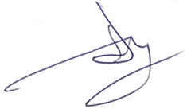
Head of the department
Professor A.G. Gulyuk

Odessa - 2023

The purpose of the lesson:
To cover methods of extraoral fixation of mandible bone fractures with and without bone defect. To study types of healing of mandible fractures

The plan of the lesson:
- Methods of temporary transport immobilization. Orthopedic and surgical treatment of fractures of the facial bones.
- Rehabilitation of the patients with fractures of the facial bones.

Treatment of the fractures of bones according to traumatology standards consists usually from two stages. The first stage includes transport immobilization of the fragments administering anesthetics to prevent a secondary displacement of the fragments, pain management, prevention of shock. Unfortunately, in the maxillofacial traumatology this is often neglected and fails to be performed due to a number of reasons. The second stage includes specialized aid in hospital which presupposes a number of procedures to treat the patient.
For transport immobilization are used both routine means, such as Entin chin-bandage, Pomerantseva-Urbanskaya chin-bandage, ligature binding of the teeth, various spoon splints, and impromptu means – chin-bandages, slats, pencils, spatulas. Transport immobilization is aimed at short term transportation of the patient from the scene of the event to the medical establishment.
The second stage is the treatment proper. It includes a number of mandatory routine procedures concerning treatment of the fracture itself and medical procedures determined by individual features of the patient, extent, character of the injury, concomitant injuries and possible complications.
Mandatory components of the treatment of any injured bone is successive fulfillment of the following manipulations using appropriate types of anesthesia:
1. Reposition of the fragments, which can be manual, instrumental, single-step, prolongated, sanguineous.
2. Fixation of the fragments, which can be performed by orthopedic (conservative) methods using different splints, made directly at the dental chair (Tiegerstedt), default (Vasil’ev), or laboratory (Vankevich, Port etc). The other method of fragment fixation can be surgery, such as osteosynthesis, when the fragments are connected with one another by means of various supra-osseous, infra-osseous, trans-osseous fixing devices (osseous suture, screws, shafts, nails, plates, miniplates etc) using extra- or intraoral access. Extraoral fixing compressing devices (Rudko, Bernadsky, Panchokha, Karapetjan, Ruzin-Zakharov etc) are used. Combining orthopedic and surgical methods is also possible (Donskoy, Kononenko-Ruzin).
3. Immobilization of the fragments, i.e. providing stability of the jaw, cessation of its mobility. This manipulation is done by means of arch bars and heavy interarch elastics (used to pull teeth and bony segments together), application of plaster-of-Paris bandages, or other sling chin-bandages. In case of compressing osteosynthesis or rigid and firm fixation achieved at the expense of other fixing devices (plates, extraoral devices), there is no need for complete immobilization.
In the treatment of fractures of maxillary and zygomatic bones the same principles are observed using in the first case orthopedo-surgical methods with Zbarzh device, Adams bone suspension etc. In fractures of zygomatic bones sanguineous reposition of the fragments with their fixation by means of various methods (Limberg hook, Khodorovich forceps, tamponade of the sinus to hold the fragments, miniplates) is performed.
Along with performance of the mandatory procedures concerning treatment of the bone fracture, the task of treating the patient with the fracture is to be solved, namely:
1. Creation of optimum conditions for the course of reparative osteogenesis. The factors to consider are the patient’s age, sex; staging of the process of osteogenesis which rate and quality depend upon the term after the injury and concomitant diseases, kind and quality of reposition and fixation and medico-geographic conditions etc. To provide the abovementioned conditions, appropriate medication and physiotherapy are used. An average term of forming provisional callus without complications is up to 4-6 weeks.
2. A crucial task is the necessity to prevent complications of the inflammatory character and their treatment. Their frequency is determined by predominant number of open into the oral cavity and thus infected fractures, delayed visit to the doctor (on average 2-5 days), presence of infected or damaged teeth in the crack of the fracture. To prevent complications in any particular case the extent of the therapy, fate of the tooth in the crack of the fracture etc. should be considered.
3. Finally, the terminal stage includes measures directed at restoration of the function of the injured bone, restoration of mastication. At this stage in order to eliminate post-immobile contracture, methods of physiotherapy, remedial gymnastics, myogymnastics, medications improving tissue trophism, nerve conductivity are used. If indicated, intrahistologic fixing devices are removed. An average term of treatment of fractures of the mandible is 4-6 weeks for non-complicated and 8-12 weeks for complicated fractures. The terms for maxillary fractures without closed craniocerebral injury are up to 3 weeks, for complex fractures depending on severity of the fracture and closed craniocerebral injury – from 4-6 to 20-22 weeks. The term for zygomatic fractures is up to 2-3 weeks without complications and comminuted trauma.

Начало формы
Конец формы
Начало формы
Конец формы
Начало формы
Конец формы

1 Principles of extraoral fixation

General considerations
Temporary versus definitive treatment
Theoretically, the mandibular external fixator could be used to achieve definitive bone healing. Nevertheless, the external fixator does not offer the same degree of stability compared to internal devices (reconstruction plates).
Most often, the application of the external fixator device will be on a temporary basis only, with subsequent replacement by an internal fixation system.
Frame design
The external pin fixation device gives a high degree of freedom for the frame assembly as the pins can be placed selectively into each segment and connected with short bars to constitute a subunit. Subsequently, the subunits are joined with further connecting elements to make up the complete framework. In this process each subunit can be manipulated into a reduced position until final tightening of the whole construct.
Other limitations of external fixators
Some disadvantages of an external fixator are:
- The extensive amount of hardware necessary to the complex construction
- The quality of the bony reduction is not guaranteed as the fragment ends are not often surgically exposed

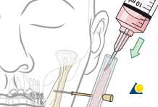

Alternative: biphasic pin fixation
An alternative to the modular technique is the biphasic pin fixation (also known as Joe Hall Morris fixation).
Subsequent to the first phase where fracture alignment is achieved with adjustable connecting rods between the pin pairs (not shown in the illustration), is the second phase when the aligned pins are covered with a silicon tube, eg, endotracheal tube, injected with methyl methacrylate resin. Alternatively the pins can be connected with a moldable plastic shield that hardens after application.
Finally the adjustable rods are removed. This procedure is highly flexible and results in a lean construct.

Biomechanical considerations
To optimize the framework stability it is recommended to:
- Choose large pin diameters
- Use at least two pins in each fragment
- Keep a large distance between the pin pairs
- Place pins next to fracture line as close as possible to the fracture line but not less than 1 cm
- Place the connecting rods or plastic bar close to the skin surface in order to keep the lever arms short.

2 MMF
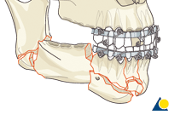
If the major fragments are able to be aligned using any of the current MMF techniques, these are used for simplification of the overall assembly process.

3 Pin insertion
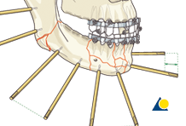

General consideration for pin insertion
The pin insertion is done through the soft-tissue envelope overlaying the safe zones.
A pair of two pins, if possible, is inserted into each major fragment at appropriate distance to each other and the adjacent fracture lines.
The length of the threaded portion of the pins is chosen to attain bicortical engagement.
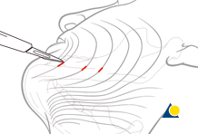

Stab incision
Make a small stab incision to prepare for pin insertion at the predetermined screw locations in the posterior mandible.
The stab incision is done with the blade parallel to the RSTL (relaxed skin tension lines).
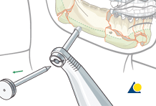

Soft-tissue dissection and protection
Bluntly dissect a soft-tissue canal onto the bone and pass a trocar for soft-tissue protection through the canal until it contacts the bone.
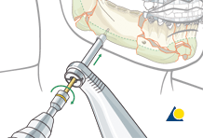

Pin insertion
A self-drilling pin is loaded into a handle. Using the trocar as a guide, the pin is driven into the bone down to its stopping bevel. Then the handle is disengaged from the pin and the trocar is removed.
If a self-drilling pin is not available or not advisable due to fragment instability, make sure to predrill prior to pin insertion.
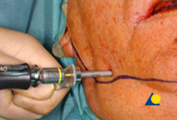
Clinical photograph shows pin insertion.

4 Frame assembly
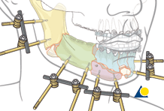

Creation of subunits
The two pins in each fragment are connected with a rod and two clamps (as illustrated). The example here shows four subunits.
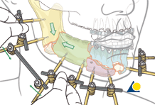

Linking the two posterior subunits
1.) Apply a connecting rod loosely between two subunits using rod-to-rod clamps.
2.) One fracture is manually reduced by manipulating two subunits.
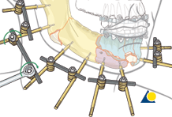
3.) Tighten the rod-to-rod clamps
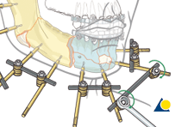

Linking the anterior subunits
Repeat steps 1), 2), and 3) for the two anterior subunits.
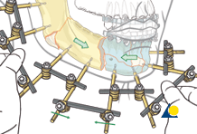

Final frame assembly
Now only one fracture gap is left between two large assembled mandibular portions as a result of connecting the anterior and posterior subunits. This gap is reduced and fixed through a connecting rod.
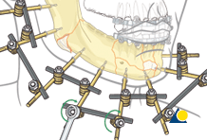
Illustration shows the final assembly of the external fixator using the modular technique.
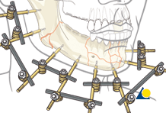
MMF is removed after the final external fixator assembly to allow for mandibular function.
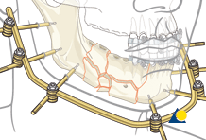

Alternative: using a bow
When a large circumference of the mandible requires external fixation, a bow-shaped rod can be directly attached to the pins.

Answer the questions:

- Methods of orthopedic and surgical treatment of facial fractures.
- Tasks and principles of rehabilitation of the patients with injuries of the facial bones, prevention of complications.
- Methods of extraoral fixation, surgical approach.

References:
- Ruzin G.P., Lectures on oral and maxillofacial surgery. – Kharkov: «Edena» LTD, 2010. – 176 p.
- https://www2.aofoundation.org/ [online resource]

