ODESSA NATIONAL MEDICAL UNIVERSITY
The Department of Oral Surgery

STUDY GUIDE:
« Mandible osteosynthesis: indications and contraindications. Application of metal pins, bone plates and frames, miniplates and screws. Compressive mandibular osteosynthesis.»

(for the forth-year students of the stomatological faculty)

Approved
by the methodical council
of the department
«_30_» __08_____2023
Record № __1__
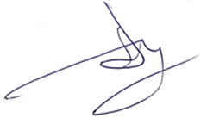
Head of the department
Professor A.G. Gulyuk

Odessa - 2023

The purpose of the lesson:
To introduce methods of direct surgical fixation of fractures of the facial bones.

Plan of the lesson:
- Types of direct fixing devices
- Indications for application of surgical fixation
- Peculiarities of application of metal pins, bone plates and frames, miniplates and screws. Compressive mandibular osteosynthesis.

Surgical Approaches
Intraoral approach
- Advantages over the extraoral approach are that it is quicker to perform, results in no extraoral scar and less risk to the facial nerve, and can be performed under local anesthesia.
- Complication rates and infection rates appear to be similar between the intraoral and extraoral approaches when large numbers of patients are studied.
- Symphysis and parasymphysis fractures can be accessed through a genioplasty-type incision. Identification of the mental neurovascular bundle is important to preserve its integrity.
- Body, angle, and ramus fractures can be accessed through a vestibular incision that may extend onto the external oblique ridge as high as the mandibular occlusal plane. Extending the incision higher predisposes the buccal fat pad to prolapsing onto the surgical field. The entire surface of the ramus and the subcondylar region can be exposed by stripping the buccinator and temporal tendon with a notched ramus retractor and periosteal elevator. Bauer retractors placed in the sigmoid and antegonial notch can help in gaining access to the subcondylar and ramus regions.
Submandibular approach
- The submandibular approach often is referred to as the Risdon approach since he first described it in 1934.
- Make the skin incision approximately 2 cm below the angle of the mandible in a natural skin crease.
- Dissect the subcutaneous fat and superficial cervical fasciae to reach the platysma muscle.
- Sharply dissect the platysma to reach the superficial layer of the deep cervical fascia. The marginal mandibular nerve runs just deep to this layer.
- Carry dissection to bone through the deep cervical fascia with the aid of a nerve stimulator. Carry the dissection down to the level of the pterygomasseteric sling.
- Sharply divide the sling to expose the bone. 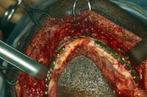Mandibular fracture. Intraoperative view demonstrating fixation of mandibular segments. 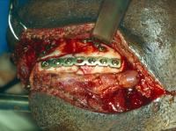Mandibular fracture. Left lateral view. 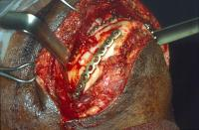Mandibular fracture. Right lateral view. 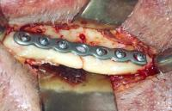Mandibular fracture. Open reduction rigid internal fixation of left mandibular body fracture. 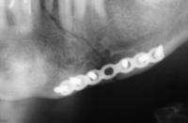Mandibular fracture. Postoperative radiograph demonstrating reduction and fixation.
Retromandibular approach
- Hinds first described this approach in 1958.
- Make the incision approximately 0.5 cm below the lobe of the ear and continue it inferiorly 3-3.5 cm. Place it just behind the posterior border of the mandible; it may extend below the level of the mandibular angle.
- Carry the dissection through the scant platysma, superficial musculoaponeurotic layer (SMAS), and parotid capsule.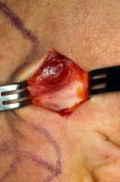Retromandibular approach to right mandibular condylar fracture.
- The marginal mandibular branch and the cervical branch of the facial nerve may be encountered.
- The retromandibular vein runs vertically in this region and commonly is exposed. This vein rarely requires ligation unless it has been transected inadvertently.
- Carry out sharp incision through the pterygomasseteric sling.
- Strip the muscle off the lateral surface of the mandible superiorly, which gives access to the ramus and subcondylar region of the mandible. 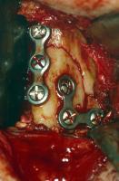Intraoperative view. Fixation of right mandibular condyle fracture.
Preauricular approach
- This approach is excellent for exposure to the temporomandibular joint.
- Make the incision sharply in the preauricular folds, approximately 2.5-3.5 cm in length as described by Thoma and Rowe.
- Take care not to extend the incision inferiorly, since it may encounter the facial nerve as it enters the posterior border of the parotid gland.
- Carry the incision and dissection along the perichondrium of the tragal cartilage. Some surgeons advocate making the incision through the tragus.
- The temporal fascia is encountered along the superior portion of the incision. Take care to be sure one is deep to the superficial temporal fascia or the temporoparietal fascia.
- Make an incision through the superficial (outer) layer of the temporalis fascia beginning from the root of the zygomatic arch just in front of the tragus anterosuperiorly toward the upper corner of the retracted flap.
- Insert the sharp end of a periosteal elevator in the fascial incision, deep to the superficial layer of temporalis fascia, and sweep it back and forth.
- Once the periosteal elevator dissection is approximately 1 cm below the arch, sharply release the intervening tissue posteriorly along the plane of the initial incision.
- Retract the entire flap anteriorly, exposing the joint capsule. Fracture location dictates whether the capsule is opened.

Intraoperative Details
Concomitant dentoalveolar injuries should be evaluated and treated concurrently with treatment of mandibular fractures. Teeth in the line of fracture should be evaluated and if necessary, extracted. Whether teeth in the line of mandibular fractures are associated with increased morbidity is a controversial subject. Neal, Wagner, and Alpert reported that there was no statistical difference whether teeth in the line of fracture were removed or retained when examining 257 fractures with teeth in the line of fracture (molars, premolars, anteriors). Amaratunga looked at 191 patients with 226 fractures and used the following criteria for removal of teeth in the line of fracture:
- Excessive mobility
- Root exposure due to distraction of the fracture
- Tooth fracture with pulp exposure
- Caries with pulp exposure
Fractures were treated with maxillomandibular fixation (MMF) for 4 weeks or open reduction. He found that 13.7% of teeth removed in the line of fracture had complications and that 16.1% of teeth retained in the line of fracture had complications. He concluded that there was no significant difference between the number of complications in the teeth removed and teeth retained groups, which indicates that noninfected teeth in the line of fracture can be preserved when antibiotics are used. After a review of the literature, Shetty and Freymiller made the following recommendations concerning teeth in the line of mandibular fracture:
- Intact teeth in the fracture line should be left if they show no evidence of severe loosening or inflammatory change.
- Impacted molars, especially full bony impactions, should be left in place to provide a larger repositioning surface. Exceptions are partially erupted molars with pericoronitis or those associated with a follicular cyst. 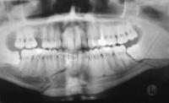Left mandibular angle fracture involving tooth #17. Right mandibular body fracture. 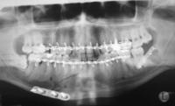Tooth #17 was extracted. A superior border plate was placed at the left mandibular angle. An inferior border plate was placed for the right mandibular body fracture.
- Teeth that prevent reduction of fractures should be removed.
- Teeth with crown fractures may be retained provided emergency endodontics is performed.
- Teeth with fractured roots must be removed. 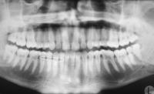Right mandibular body fracture. Left mandibular angle fracture going through tooth #17. 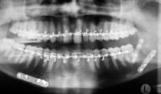Right mandibular body and left mandibular angle fractures status post fixation. Tooth #17 was extracted.
- Teeth with exposed root apices tend to develop pulpal or periodontal complications.
- Teeth that appear nonvital at time of injury should be treated conservatively due to potential for recovery.
- Perform primary extraction when there is extensive periodontal damage.

Complications

Delayed union and nonunion
- Delayed union and nonunion occur in approximately 3% of fractures.
- Delayed union is a temporary condition in which adequate reduction and immobilization eventually produce bony union.
- Nonunion indicates a lack of bony healing between the segments that persists indefinitely without evidence of bone healing unless surgical treatment is undertaken to repair the fracture.
- Nonunion is characterized by pain and abnormal mobility following treatment.
- Radiographs demonstrate no evidence of healing and in later stages show rounding off of the bone ends.
- The most likely cause for delayed union and nonunion is poor reduction and immobilization.
- Infection is often an underlying cause. Carefully assess teeth in the line of fractures for possible extraction or they may be a nidus for infection.
- Decreased blood supply can lead to a delay in healing. Excessive stripping of the periosteum, especially in comminuted and edentulous fractures, can lead to delayed healing.
- Alcoholics have been shown to have an increased incidence of delayed union and nonunion. These patients usually are at increased likelihood to sustain a mandibular fracture. Whether metabolic and vitamin deficiencies, poor compliance with intermaxillary fixation, poor bone quality, impaired local blood supply, or, most likely, a combination of the above reasons is the cause for an increased incidence of nonunion and delayed union is unknown.

Infection
- In some studies, particularly those without antibiotics, infection may occur in more than 50% of patients.
- Systemic factors include alcoholism, immunocompromise, and lack of antibiotic coverage.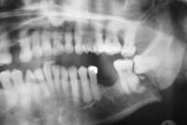Mandibular fracture. Patient with poorly controlled type 1 diabetes with left open, complete, moderately displaced mandibular angle fracture between teeth #17 and #18.
- Local factors include poor reduction and fixation, fractured teeth in the line of fracture, and comminuted fractures.
- Most infections are mixed in nature, with alpha-hemolytic streptococci and Bacteroides organisms found most commonly.
- When infection is present it must be managed with debridement of sequestra, drainage, and antibiotic therapy. Apply rigid internal fixation with or without intermaxillary fixation across the fracture site. If a gap is present between the bone ends, a bone graft may be necessary. Mandibular fracture. Patient with poorly controlled type 1 diabetes with left open, complete, moderately displaced mandibular angle fracture between teeth #17 and #18. 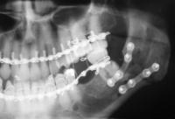
- Mandibular fracture. Treated initially with a superior border plate and an inferior border plate as well as extraction of tooth #17.
- 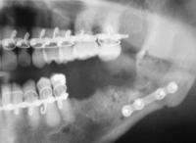
- Mandibular fracture. Patient returns with infected nonunion of left mandibular angle and loose hardware. The superior border plate was removed. Tooth #18 was extracted. The patient was treated with intravenous and oral antibiotics. 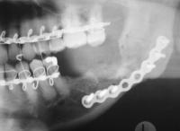
- Mandibular fracture. Rigid fixation with an 8-hole plate. Two holes in the center are used to span the fracture site. 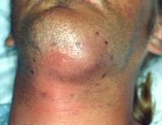Mandibular fracture. Patient lost to follow-up at local county jail presents with infected nonunion of mandibular symphysis.

Malunion
- Malunion is defined as improper alignment of the healed bony segments. Not all malunions are clinically significant.
- When a dentate portion is involved in the malunion, a malocclusion can result.
- These malocclusions may be treated with orthodontics or osteotomies after complete bony union

Ankylosis
- Ankylosis is a rare complication of mandibular fractures.
- It is most likely to occur in children and is associated with intracapsular fractures and immobilization of the mandible.
- Ankylosis is believed to occur secondary to intra-articular hemorrhage, leading to abnormal fibrosis and ultimately ankylosis.
- Ankylosis may result in disturbed growth and underdevelopment of the affected side in children. The use of only short periods of intermaxillary fixation in children can help reduce the occurrence of this complication.

Nerve injury
- The inferior alveolar nerve and its branches are the most commonly injured nerves. The prominent sign of inferior alveolar nerve deficit is numbness or other sensory changes in the lower lip and chin.
- Damage to the marginal mandibular branch of the facial nerve is rare. More commonly, nerve damage caused by trauma in the region of the condyle, ramus, and angle of the mandible and by lacerations along its course is seen.
- Most of the sensory and motor functions of these nerves improve and return to normal with time.

Outcome and Prognosis
- A higher prognosis is achieved with removal of grossly carious and periodontally involved teeth.
- Treatment should occur as soon as possible for patient comfort. Prolonged delay in treatment may contribute to technical complications.
- Immobilization of the fracture segments is perhaps the most important aspect in avoiding delayed union, nonunion, and infection.
- Little difference seems to exist between the infection rates of intraoral and extraoral open reduction procedures.
- Alcohol abuse plays a major role in the etiology of mandibular fractures. It results in a higher rate of complications either secondary to noncompliance or as a result of metabolic dysfunction.

Future and Controversies
- The advent of resorbable plates and screws opens a new arena for the treatment of mandible fractures in the pediatric population. More controlled prospective studies on the use of resorbable plates are necessary prior to their use for pediatric and adult patients with mandible fractures.
- Rigid fixation techniques have evolved from larger, thicker plates to smaller, low-profile plates while maintaining adequate fixation.
- The use of endoscopic techniques may broaden the indications for open reduction of condylar fractures.

Answer the questions:

- Methods of surgical treatment of facial fractures.
- Surgical approaches for direct surgical fixation
- Intraoperative details of providing named treatment
- Complications of bone healing

References:

- Thoma KH. Historical review of methods advocated for treatment of jaw fractures with ten commandments for modern fracture treatment. Am J Orthodont Oral Surg. 1944;30:399.
- Barton JR. A systemic bandage for fractures of the lower jaw. Am Med Recorder Phila. 1819;2:153.
- Moon H. Mechanical appliances for treatment of fracture of the jaws. Br J Dent Sci. 1874;17:303.
- Spiessl B. Rigid internal fixation of fractures of the lower jaw. Reconstr Surg Traumatol. 1972;13:124-40. [Medline].
- Cienfuegos R, Cornelius CP, Ellis 3rd E, Kushner G. CMF Mandible - Diagnosis - AO Surgery reference. AO Foundation. Available at http://www.aofoundation.org/wps/portal/. Accessed Jan 31, 2008.
- Ellis E 3rd, Moos KF, el-Attar A. Ten years of mandibular fractures: an analysis of 2,137 cases. Oral Surg Oral Med Oral Pathol. Feb 1985;59(2):120-9. [Medline].
- Champy M, Loddé JP, Schmitt R, Jaeger JH, Muster D. Mandibular osteosynthesis by miniature screwed plates via a buccal approach. J Maxillofac Surg. Feb 1978;6(1):14-21. [Medline].
- Ellis E 3rd, Miles BA. Fractures of the mandible: a technical perspective. Plast Reconstr Surg. Dec 2007;120(7 Suppl 2):76S-89S. [Medline].
- Brook IM, Wood N. Aetiology and incidence of facial fractures in adults. Int J Oral Surg. Oct 1983;12(5):293-8. [Medline].

