ODESSA NATIONAL MEDICAL UNIVERSITY
Department of Oral Surgery

STUDY GUIDE:
«Mandibular dislocations: etiology, clinic, treatment. Congenital disorders of temporomandibular joint. Diseases of temporomandibular joint in children. Classification, clinic, treatment.»

(for the forth-year students of the stomatological faculty)

Approved
by the methodical council
of the department
«_30_» __08_____2023
Record № __1__
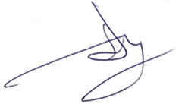
Head of the department
Professor A.G. Gulyuk

Odessa - 2023

The purpose of the lesson:
To introduce etiology, clinic, treatment of mandibular dislocations, congenital disorders of temporomandibular joint, diseases of temporomandibular joint in children.

The plan of the lesson:
- Dislocation of TMJ, clinical manifestation, methods of repositioning.
- Congenital disorders of temporomandibular joint.
- Diseases of temporomandibular joint in children.

Dislocation of TMJ is comparatively frequent and present from 1.5 to 6% of all dislocations that occur in human body.
Owing to the structure of TMJ, frontal dislocations prevail when caput mandibulae comes out of the articular fossa forwards rolling over the articular tubercle of temporal bone. A blow into the jaw, excessive opening of the mouth while yelling, yawning or during dental manipulations make it possible. Posterior dislocation, i.e. intrusion of caput mandibulae into the outer auditory passage with fracture of its internal osseous wall is very rare. Dislocation can be uni- or bilateral. In a flat form of the joint, which is more common for women or in secondary adentia, development of habitual temporomandibular joint luxation is possible.
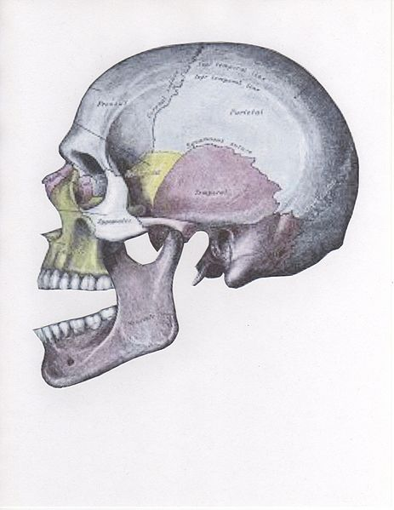
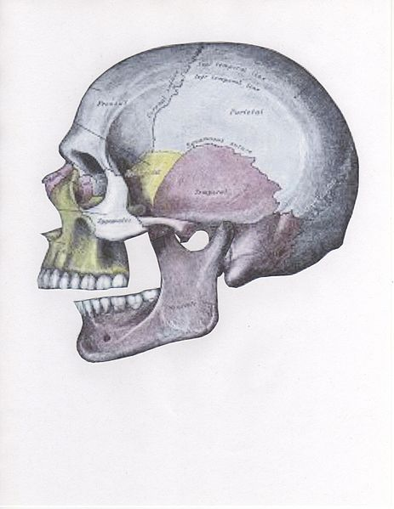

Anterior dislocation Posterior dislocation
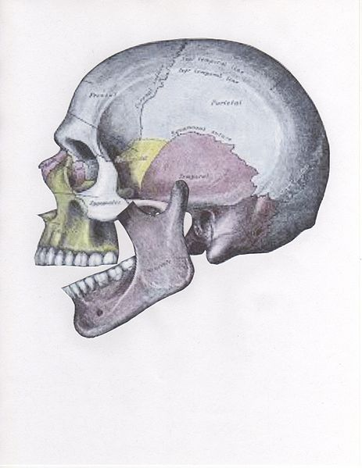
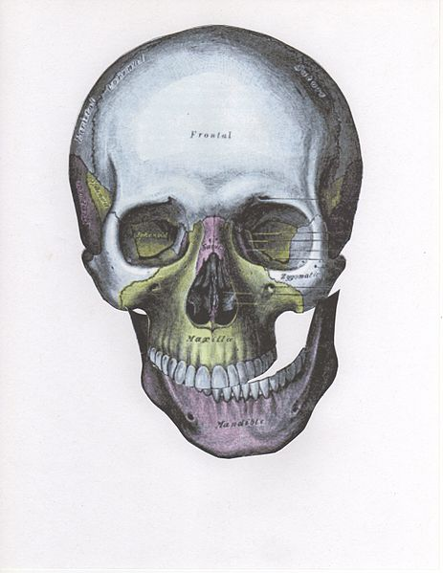

Superior dislocation Lateral dislocation

There are four different positions of jaw dislocation: posterior, anterior, superior and lateral. The most common position is anterior. Anterior dislocation shifts the lower jaw forward if the mouth excessively opens. This type of dislocation may happen bilaterally or unilaterally after yawning. The muscles that are affected during anterior jaw dislocation are the masseter and temporalis which pull up on the mandible and the lateral pterygoid which relaxes the mandibular condyle. Posterior dislocation is common for people who get injured after being punched in the chin. This dislocation will push the jaw back affecting the alignment of the mandibular condyle and mastoid. Superior dislocations occur after being punched as the mouth remains open. Since great force occurs in a punch, the angle of the jaw will be forced upward moving towards the condylar head. Lateral dislocations move the jaw away from the skull and are likely to happen with other jaw fractures.

Success of dislocation repositioning is determined by term of its occurrence, condition of the muscular system and anatomic peculiarities of the facial skull of the patient.
There are conservative and surgical methods of repositioning dislocation. Of the conservative methods, the most common are intraoral methods by Hippocrates, Popescu. Gershuni introduced extraoral method of repositioning. Surgical repositioning is done by means of Limberg hook or after complete exposure of the lesion area. 10-14 days’ immobilization of the mandible in postsurgical period is mandatory.
In case of flat joint and habitual temporomandibular joint luxation operation to heighten the articular tubercle of temporal bone is performed.

Pediatric temporomandibular joint (TMJ) dysfunction, resulting from either soft tissue or skeletal disorders, may be congenital, developmental, or post-traumatic in origin. Congenital TMJ dysfunction is the least common. Allori et al. (2008) reviewed their experience with pediatric TMJ dysfunction and developed a new classification system. Records of all patients with trismus or restricted mandibular excursion treated at the Institute of Reconstructive Plastic Surgery between 1976 and 2006 were reviewed. Clinical records, cephalograms, computed tomography, magnetic resonance images, and pathologic specimens were reviewed. All cases were stratified according to soft tissue and/or skeletal pathology. Skeletal abnormalities were further characterized as intra-, peri-, or extra-capsular. Thirty-three patients (ranging in age from 2 days of life to 19 years at diagnosis; mean age 5.4 years) were identified with TMJ dysfunction. Nine cases (27%) were due exclusively to soft tissue pathology, including post-irradiation scarring, fibrosis, infection, and tumor. The remaining 24 cases (73%) were skeletal in origin and were evenly divided between acquired and congenital cases. Acquired skeletal deformities included 11 (91.7%) intracapsular ankyloses and 1 (8.3%) extracapsular ankylosis (coronoid process to zygoma); etiology included infection, trauma/surgery, and degenerative rheumatic disorders. In contrast, congenital skeletal deformities accounted for 2 intracapsular ankyloses (16.7%) and 10 (83.3%) extracapsular ankyloses or mechanically restrictive skeletal disorders (e.g., coronoid hypertrophy without ankylosis). The data appear, at first, consistent with previously published population studies that principally attribute TMJ dysfunction to acquired pathology, specifically trauma (or surgery) and infection. However, in contradistinction to prior published reports, authors observed a significantly higher percentage of congenital cases of TMJ skeletal disorders. Classification based upon joint involvement revealed that most of these cases involved extracapsular pathology, such as coronoid hypertrophy or zygomatic hypoplasia. Only a minority of congenital cases were intracapsular ankyloses characterized by gleno-condylar fibro-osseous fusion. Because precise diagnosis and classification directs the choice of therapy, they provided a new classification scheme to differentiate between soft tissue and skeletal pathologies and to better characterize the extent of capsular involvement. Protocol-based preoperative CT is recommended to aid in classification and the selection of treatment modalities, which are discussed critically.

Answer the questions:

- Describe main types of dislocation of the mandible and their clinical picture.
- Treatment of acute and habitual dislocations of the mandible.
- Name and describe congenital disorders of TMJ.
- Describe disorders of TMJ that are frequent in children, their diagnostics and treatment.

References:
- Miloro Michael, Peterson’s principles of oral and maxillofacial syrgery. – BC Decker Inc., 2004. – 1502 p.
- Moore U. J., Principles of oral and maxillofacial surgery. – Blackwell Science, 2001. - 276 p.
- Pedlar Johnatan, Frame John W., Oral and maxillofacial surgery. – Churchill Livingstone, 2004. – 280 p.

