ODESSA NATIONAL MEDICAL UNIVERSITY
The Department of Oral Surgery

STUDY GUIDE:
«The fractures of the nasal bones and cartilages. Diagnosis, clinical course, treatment. Anterior and posterior nasal tamponade.»

(for the forth-year students of the stomatological faculty)

Approved
by the methodical council
of the department
«_30_» ___08____2023
Record № __1__
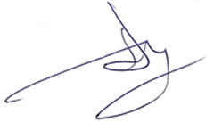
Head of the department
Professor A.G. Gulyuk

Odessa - 2023

The purpose of the lesson:
To introduce clinical picture, details of diagnosis and treatment of nasal fractures.

The plan of the lesson:
- Structure and etiology of mechanic injuries of the facial bones.
- Main clinical signs, principles of diagnostics of fractures of the mandible.
- Main clinical signs, principles of diagnostics of fractures of the middle region of the face.
Methods of temporary transport immobilization. Orthopedic and

Current standards of care for trauma patients, whether polytrauma or only with craniomaxillofacial injuries, follow the Advanced Trauma Life Support (ATLS) protocol relating to Airway, Breathing, Circulation, Disability, and Environment in that sequence. In the polytrauma patient, on admission a number of injuries take higher priority than the craniomaxillofacial ones. Craniomaxillofacial injuries need to be diagnosed, a treatment plan established, and a sequence fitted into the total treatment plan for the patient at an early stage.

Nose examination

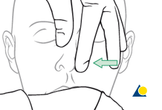
Examination of the nose starts with inspection for swelling or asymmetry, followed by palpation. Characteristic signs for nasal fractures are:
- Pain
- Bleeding
- Swelling
- Compromised nasal airway
- Crepitation
- Palpable bony dislocation
The illustrated testing of the nasal airway passage is a simple method to gather information on the function of the internal patency of the nose.
If the nasal airway passage is compromised the reason has to be investigated.
Note: Remember that obstruction of the nasal airway may also be caused by foreign bodies, preexisting septum deviation, malignancies, etc.

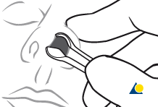
Nasal inspection using a speculum with appropriate light (headlights are recommended) allows for examination of the nasal cavity. If further clinical examination of more posterior or cranial parts have to be performed, additional nasal endoscopy may be indicated.
It is very important to rule out a septal hematoma, as this has to be drained to avoid an infection which can result in septal perforation. Nasal packing or splints should be inserted to prevent recurrence of hematoma.

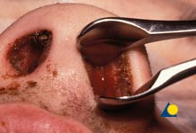
This clinical photograph shows septal hematoma.
Clinical photograph shows delayed drainage of septal hematoma resulting in infection. This patient did not present to the emergency room until 1 week following sustaining nasal trauma.

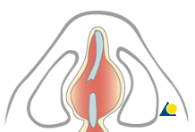
An undetected septal hematoma may also result in the formation of neocartilage, resulting in a widening of the septum and narrowing of the nasal airways.

Начало формы
Конец формы
Начало формы
Конец формы
Начало формы
Конец формы

Closed reduction of nasal fractures

1General considerations
2Fracture reduction instruments
3Reduction of nasal bones
4Closed reduction
5Reduction of the nasal septum
6Splinting

1 General considerations
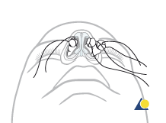enlarge

Bleeding
Most nasal fractures cause significant bleeding. Proper techniques for hemostasis should be applied prior to any diagnostic procedure and any definitive treatment of nasal fractures.
Click here for more details on hemostasis.

Choice of anesthesia
Local anesthesia
Closed reduction of nasal fractures can be performed under local anesthesia in the majority of patients.
The nasal cavity should be prepared with cotton pledgets moistened in a solution with topical anesthetic with vasoconstrictor. In addition, local anesthetic is injected to block the infraorbital nerve.
IV sedation can be added for the comfort of the patient.
General anesthesia
General anesthesia is an option according to the surgeon’s and/or patient’s preference.

2 Fracture reduction instruments
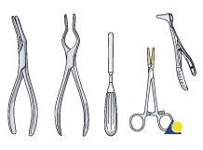enlarge
Instruments commonly used for closed treatment of nasal fractures are:
- Asch septum-straightening forceps
- Walsham septum-straightening forceps
- Boies nasal fracture elevator
- Mayo hemostat with rubber tubing
- Killian nasal septum speculum

3 Reduction of nasal bones
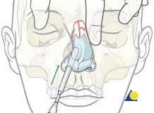enlarge

In laterally displaced fractures
Commonly laterally displaced fractures on one side are medially depressed on the other side. We will describe their treatment together.
Place an instrument (eg, Boies elevator) in the depressed side along the lateral wall of the nose to a point below the nasal frontal angle.
Place a finger along the lateral side of the nose above the depressed area.
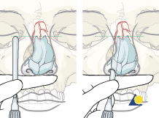enlarge
Pearl: correct instrument placement
Prior to the endonasal placement of the elevator, it is placed against the outside of the nose to the level of the medial canthus. The index finger is then placed against the edge of the elevator and is used as a stop when the elevator is placed intranasally to ensure that it can not be advanced too far superiorly.
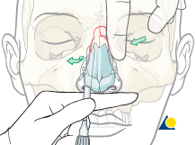enlarge
Carefully position the instrument under the depressed nasal bone.
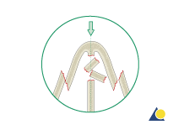enlarge

In centrally depressed fractures
Sometimes the frontal processes of the maxillae are displaced laterally with the nasal bones impacted inside them.
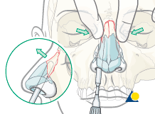enlarge
Reduction requires elevation of the nasal bones anteriorly and repositioning of the frontal processes medially.
The elevator must not be inserted too far into the nasal cavity.
In this case the elevator is placed in the nose and lifts the nasal dorsal pyramid anteriorly, while simultaneously the thumb and index finger put medial pressure on the displaced frontal processes of the maxillae.

4 Closed reduction
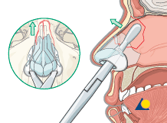enlarge
Alternative technique
In some cases, Asch or Walsham forceps can be used to elevate the dorsum and disimpact the displaced septum.

5 Reduction of the nasal septum
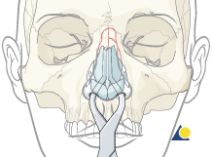enlarge

Reduction of the nasal septum
The Asch or Walsham septum-straightening forceps are used to straighten the nasal septum.
Grasp the nasal septum with the blades of the instrument and gently manipulate the septum into proper alignment.
enlarge
Centrally depressed fractures require posterior to anterior elevation which can often be achieved by reducing the nasal septum.

6 Splinting
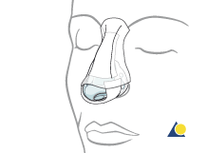enlarge
Nasal bones
After reduction, adhesive strips are placed over the skin of the nasal dorsum and the nasal bones are splinted using an external splint that conforms to the patients nose. If the nasal bones are comminuted or loose, they should be supported with an intranasal packing, which should be placed prior to placing the external splint.
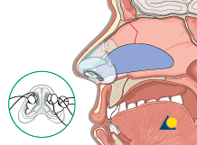enlarge
Nasal septum
The nasal septum can be stabilized with splints or packs.
Removal of packings and splints
Hemostatic packs are removed after 24 hours. Packs that are supporting the nasal bones are left in place as long as the external splint is in place. (Various surgeons leave these in place from anywhere between 5-10 days).
The patient should be prescribed antibiotic treatment for as long as the nasal packs are in place.

Answer the questions:
  - Describe protocol of diagnosis of nasal fractures.
  - Describe protocol of surgical aid in case of nasal fractures.

References:
1. https://www2.aofoundation.org/ [online resource]

