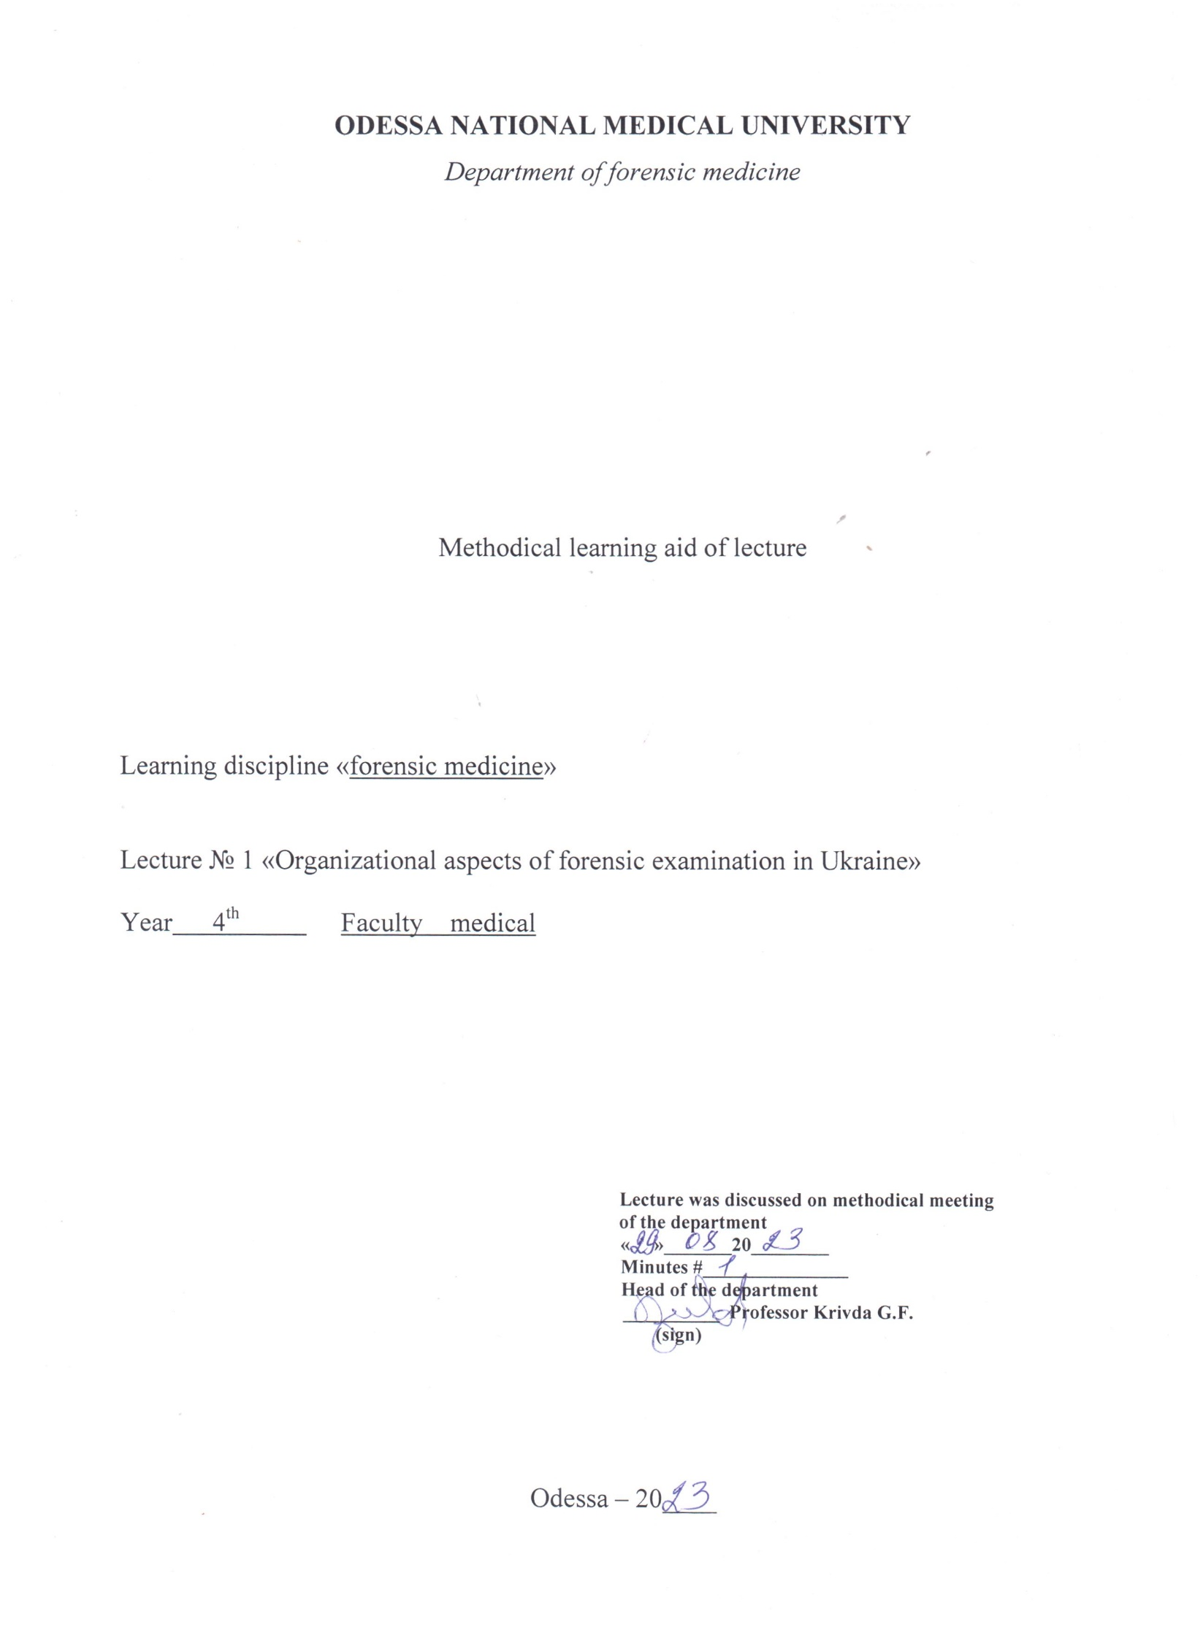

Lecture № 1 Theme: “Organizational aspects of forensic examination in Ukraine” 2 h.

1.Actuality of theme. Rationale for the topic.
Questions arise while inquiring of cases connected with investigation of crimes commited against health and life of person. Solution of such questions is connected to medical and biological know ledge. It is done by forensic medical expertise and specialist - forensic medical experts. According to valid legislation it is rightful for the physician of any speciality to be drawn for carrying-out the forensic medical examination, if it is necessary. That's why, the know ledge of organizational principles and Procedural standards of forensic medical expertise regulating forensic medical expert activity is necessary for physicians of any speciality.

2. Educational aims
Study the organization of forensic-medical service in Ukraine, Procedural standards and legislative normative-legal deeds, which regulate this carrying-out.

Tasks

- Know works of famous forensic medics of Ukraine - M.S.Bokarius, I.O.Koncevich, M.I.Raisky, A.F.Rubeshansky, Y.S.Sapozhnikov, A.M.Fadeev and their contribution into the development of forensic medicine's theory and practice.
- Know the concept of "codes" their variety and questions they regulate;
- Know the principles of organization of the Forensic medical service in Ukraine;
- Know the structure of forensic-medical expertise's office and functions of its' subdivisions;
- Know the rights, tasks and responsibility of physicians and while carrying-out forensic-medical experts’ functions.
- Be able to interpret articles of criminal code (CC) and criminal-procedural code (CPC) of Ukraine;

3.Materials for the student’s independent work (interdisciplinary integration)
# | Discipline | Student should know | Student should be able to do
1. | Social medicine, management and economics of health protection with course of law principles | Concept of codes, their varieties and questions they regulate | Use and interpret articles of mentioned legislative documents

4. Contents of the theme
Basic terminological concepts:
Code is sole systematized legislative deed, which includes law standards regulating appointed branch of social relations.
Criminal code (CC) is list of laws, which determines reasons, conditions and principles of criminal responsibility, system and order of figuring out the level of punishment, conditions and kinds of discharge from criminal responsibility or punishment, features of social dangerous actions (crimes) and level of responsibility that applies to the individuals guilty in committing them.
Criminal-procedural code (CPC) is a list of laws, which includes systematized standards and rules regulating activity of disclosing bodies, pretriality investigation, public prosecutor's office, law-court considering question of coming out crimes, disclosure and punishment guiltiers and determining the rights and tasks of all participating in criminal judgemaking.
Forensic expertise (forensic medical examination) is an investigation of the material objects, facts and processes which has available information about case's circumstances. This case is in execution of disclosing bodies, preceding investigation or law-court. Forensic expertise is carrying-out by expert on the grounds of special knowledge.
Forensic-medical expertise is variety of forensic expertise for solution medical or biological questions arising while inquiring of cases in disclosing bodies, preceding investigation or law-court.
Forensic expert is person who has necessary knowledge for inferring on investigating question.
Forensic-medical expert is person with title of physician, had special education and holding the post of forensic-medical expert in forensic-medical expert organization.
Physician-expert is physician of any specialty, who is drawn by investigating or disclosing organs or law-court for executing forensic-medical expert functions.
Forensic-medical physician-examiner is person who is drawn by investigator for examination of the cadaver at the place where it was discovered, and who can be as state forensic-medical expert or physician of any specialty.
Forensic-medical expertise is appointing for solution medical and biological questions arising into practice activity of disclosing bodies, investigation and law-court. The order its appointing and carrying-out is regulating by CC and CPC, law "About forensic expertise", "Principles of legislation of Ukraine on health protection" (1992), order №6 of MPH (1995). Events of compulsory appointing forensic-medical expertise are regulating by law too.
Forensic-medical expertise is appointing by investigator or law-court. They compose suitable resolution.
They entrust with forensic-medical expertise to forensic-medical expert. CPC regulating also possibility of drawing to expertise physician of any speciality, if he has necessary knowledge for inferring. He is named physician-examiner. If decision no composing, they carrying-out investigation of appointed object. There are following objects of forensic-medical examination or investigation: the cadavers of persons are perished from violent death or with suspicion on violent death; the victims, the accused and other persons; the material evidences and materials of criminal and civil cases. This objects may be examined while carrying-out primary, additionally or reitery expertise, which may be carrying-out individually, committely or complexly.
The investigator and physician-with investigator's permission must be present into carrying-out of expertise.
Forensic-medical expertise of any object can be carrying-out only by state forensic-medical expert organization, and it's investigation - by commercial organization or separate citizens, if they have license for such as activity.
State forensic-medical expertise is formed to instantional principle. It consists of locality separation of forensic-medical expertise's office, regional office (office of Kiev-city) and main forensic-medical expertise's office of MPH of Ukraine. The structure-functional component of forensic-medical expertise is office. The office consists of functional subdivisions such as departments and separations. The office has 5 departments replaying to expertise's objects, and 5 separations ensuring carrying-out fundamental laboratory investigations. There are departments of office:
- Department of forensic-medical expertise of cadavers.
- Department of forensic-medical expertise of victims, accused and other persons.
- Department of forensic-medical expertise of material arguments.
- Department of committal expertise' s.
- Department of duty forensic-medical experts.
There are locality and interlocality separations in the office. The department of forensic-medical expertise of material arguments has 5 separations, such as:
- separation of forensic-medical histology
- separation of forensic-medical immunology
- separation of forensic-medical criminalistics
- separation of forensic-medical toxicology
- separation of forensic-medical cytology.
The forensic-medical expertise and examining of corresponding objects are carrying-out in departments and separations of forensic-medical expertise's office.
Thus, the determination cause of death, character and mechanism of body injuries rise, the death coming time is carrying-out in department of forensic-medical expertise of cadavers.
The body injuries severity degree determination, the doubtful sexual state determination, if sexual crimes are committed, are carrying-out in department of forensic-medical expertise of alive persons.
Department of committal expertise's carry-out examinations, if previous expertise and other materials of case are not corresponding, if the inferences are not substantiated or person appointed the expertise has doubts about its rightly, and also if it necessary to determine the date of fertilization, suitability for insemination, the percentage of professional workability's loss and adequacy of medical aid when medics are attracting to criminal responsibility to the "professional offences".
Department of forensic-medical expertise of material arguments elucidating the available material argument and questions, if its can be the argument in the case. The forensic-histological, forensic-immunological, forensic-medical-criminalistical, forensic toxicological and forensic-cytological expertise's are carrying-out.
The forensic-histological expertise's are carrying-out for determination pathological and traumatic changes at sender objects, for determination or confirmation the cause of death, remoteness and healing of injury etc.
The forensic-immunological expertise's are carrying-out for determination of the available, specific and blood group of objects by human's origin, for determination the mother hood, father hood and children's substitution.
The forensic-medical-criminalistical expertise's are carrying-out for determination, injury's tools, its differentiation and identification, person's identification determining the character and element's composition of microobjects, tracks, reconstruction of situation, in which were the injuries done.
The forensic-toxicological expertise's are carrying-out for discovering and determining chemical substances of objects by biological origins and others arguments.
The forensic-cytological expertise's are carrying-out for determination available cells of human's tissue in tracks and materials arguments, and its specific, group, sexual and organic-tissual due.
The forensic-medical expertise's are carrying-out by specialists - forensic-medical experts. While it's carrying-out examiner has accordance rights and tasks. Besides, forensic-medical experts take responsibility according to CC.
According to investigator's resolution or agreement of justice the expert must carry-out full investigation of objects and make detailed and objective conclusion. Besides, he must at most save investigative objects, as it possible.
It is rightful for the forensic-medical experts (physician-experts):
1. To know aim and task of expertise.
2. Get to know with materials of case.
3. To petite about additional materials.
4. To point out on determining while expertise facts, being of importance, if this question's are not discussing.
5. To be present at the interrogations and others investigation's actions.
6. To make questions concerning subjects of expertise to person, which are under investigation.
7. To petit about invitation and drawing to expertise the necessity specialists.
8. To receive the recompense to the expertise, if it's carrying-out is not official work.
9. The professional rights distributing on the forensic-medical experts are foreseeing by "Principles of legislation of Ukraine on health protection" (article 77) and by law "About State service".
10. The forensic-medical experts necessarily must be insured by State against the occasion of illness on AIDS.
Forensic-medical expert is responsible of expertise which he is carrying out of him, according to CC, the same:
- if the evidence is untruthfully;
- if the information of preceding investigation or dislocation are making know;
- if expert rejects from carrying-out of entrusted tasks.
If State guaranteeing the independence of expert and his true conclusion, its are ensuring:
- by order of expert's appointing;
- by prohibition of interfering of any one into carrying-out of expertise;
- by existence of forensic expertise's institutions, which are separating from disclosing bodies and preceding investigation;
- by the criminal responsibility of expert, if evidence is untruthfully;
- by possibility to appoint repeatedly expertise;
- by presence of participants of process while carrying-out of expertise.
Forensic-medical expertise can be carried out into trial sitting.
The results of expertise are legalizing into document under name "The conclusion of expert". The results of forensic-medical investigation are legalizing into document which named "Deed of forensic-medical investigation". This documents consist of 3 parts-entrance, descriptive (investigative) and conclusive parts.

5. Materials of activation of students during the lecture
Key concepts: forensic medicine, signs of forensic medicine, forensic medical examination, objects of forensic medical examination
- Materials of didactic provision of the class
The classroom for the lecture is the departmental auditorium equipped with multimedia and slide projectors. Visual and illustrative materials: PowerPoint presentation "History and Development of Forensic Medicine", "Organisational and Legal Aspects of Forensic Medicine", tables "Objects of Forensic Medicine", "Structure of the Bureau of Forensic Medicine", "Regulatory Acts Regulating the Activities of a Forensic Expert".
7. Materials for self-preparation of students:
A.Tasks for self-control of the initial level of knowledge. To determine rightly answers according to presented letter's code:
1. The carrying-out of forensic-medical expertise are foreseen:
1 - by government's rights;
2 - by demands of relations;
3 - by articles of codes;
4 - by verbal instruction of main physician of medical organization;
5 - by specialization of medical organization.

2. The physician of any speciality can be drawn for carrying-out the expertise: - Yes - No
3. The physician of any speciality who is drawn for carrying-out forensic-medical expertise, is named:
1 - The expert;
2 - The forensic-medical expert;
3 - The physician- expert;
4 - The consultant;
5 - The treating physician.

4. The physician-examiner take responsibility of carrying-out expertise like forensic-
medical expert: - Yes –No

5. While carrying-out of expertise the expert is obliged:
1 - to appear for summon of investigator, public prosecutor, law-court;
2 - to consult with lawyer;
3 - to give rightly answers on questions;
4 - to know criminal-processual code;
5 - to keep investigating secret.

6. It is rightful for physician-expert while carrying-out expertise:
1 - to know aims and tasks of expertise;
2 - get to know with materials of case;
3 - to give rightly answers on questions;
4 - to know criminal-processual code;
5 - to keep the investigating secret.

7. It is rightful for expert or physician-expert while carrying-out of expertise:
1 - to know aims and tasks of expertise;
2 - get to know with materials of case;
3 - to be present at the interrogations;
4 - to reject from answers on questions, if it don't entering to his competence;
5 - to ask give the time for acquainting with necessary literature.

8. The forensic-medical expert, like the physician-expert, take responsibility according to the Criminal Code for:
1 - the rejection from answers on questions, if it don't entering to his competence;
2 - the evading from carrying-out of expertise;
3 - the reject without worthy reasons;
4 - the untruthful evidence;
5 - the making known the investigating secret.

9. There are worthy reasons when the physician-expert may to reject from carrying-out expertise:
1 - the unwillingness to carry-out the expertise;
2 - the interest into results of expertise;
3 - medical speciality is surgeon;
4 - uncompetention in the making questions;
5 - medical speciality is pediatrician.

10.The forensic-medical expertise according to Criminal-Processual Code is appointing necessarily for:
1 - determining the kind of violent death;
2 - determining the causes of death;
3 - determining character and severity degree of body injuries;
4 - of crimes are sexual;
5 - determining the age.

11.The instantionality of forensic-medical expertise foresee it's carrying-out:
1 - by locality, interlocality forensic-medical expertise;
2 -by forensic-medical expertise of criminalistics separations;
3 - by regional forensic-medical experts;
4 -by experts of public prosecutor's office;
5 - by forensic-medical experts of Main office of FME.

12.The forensic-medical expertise are enter into organs of health protection's system: - Yes -No 13.The forensic-medical expertise are carrying-out into such organization, as:
1 - laboratory;
2 - medical-criminalistic separation;
3 - forensic-medical expertise's office;
4 - legal scientific-research institute;
5 - criminalistic department.

14.The office of forensic-medical expertise has:
1 - policlinic;
2 - tanatological department;
3 - department of material arguments' expertise;
4 - locality, interlocality and municipal separations;
5 - department of forensic-medical expertise of victims, accused and other persons.

15.The forensic-medical expertise's office has such separations ,as:
1 - cytological;
2 - immunological;
3 - histological;
4 - medical-criminalistical;
5 - toxicological.

16.The pieces of visceral organs are examining in forensic-histological separation for:
1 - substantiating the diagnose;
2 - definition of diagnose;
3 - determining the character of injuries;
4 - defining of healing;
5 -determining the remoteness of injury.

17.The blood and visceral organs are examining in forensic-toxicological separation for:
1 - the definition of blood group;
2 - determining the remoteness of death coming;
3 - determining the poisonous substances;
4 - defining the healing of injuries;
5 - determining category of death.

18.The forensic-immunological separation examining:
1 - the medical documents;
2 - the results of event's place's examination;
3 - the material arguments by biological origin;
4 - the objects of criminal actions;
5 - the physician's case.

19.There objects of forensic-medical expertise are:
1 - the minutes of cadavers' examinations at the place where it was discovered;
2 - the cadavers;
3 - the a live persons;
4 - the material arguments;
5 - the medical documents.

Literature
Main:
1.Forensic Medicine B.V. Mykhailychenko, A.M. Biliakov, I.G. Savka ; Рік видання. —. 2019
Additional:
        - Bernard Knight. Simpson’s Forensic Medicine, Eleventh Edition. London. Sydney. Auckland, 1983
        - Parikh’s Textbook of Medical Jurisprudence and Toxicology. Fifth Edition. Bombay, India.
        - Thomas A. Gonzales. Legal Medicine. Second |Edition. New York
        - Journal of Clinical Forensic Medicine ## 1- 6 – 1999

