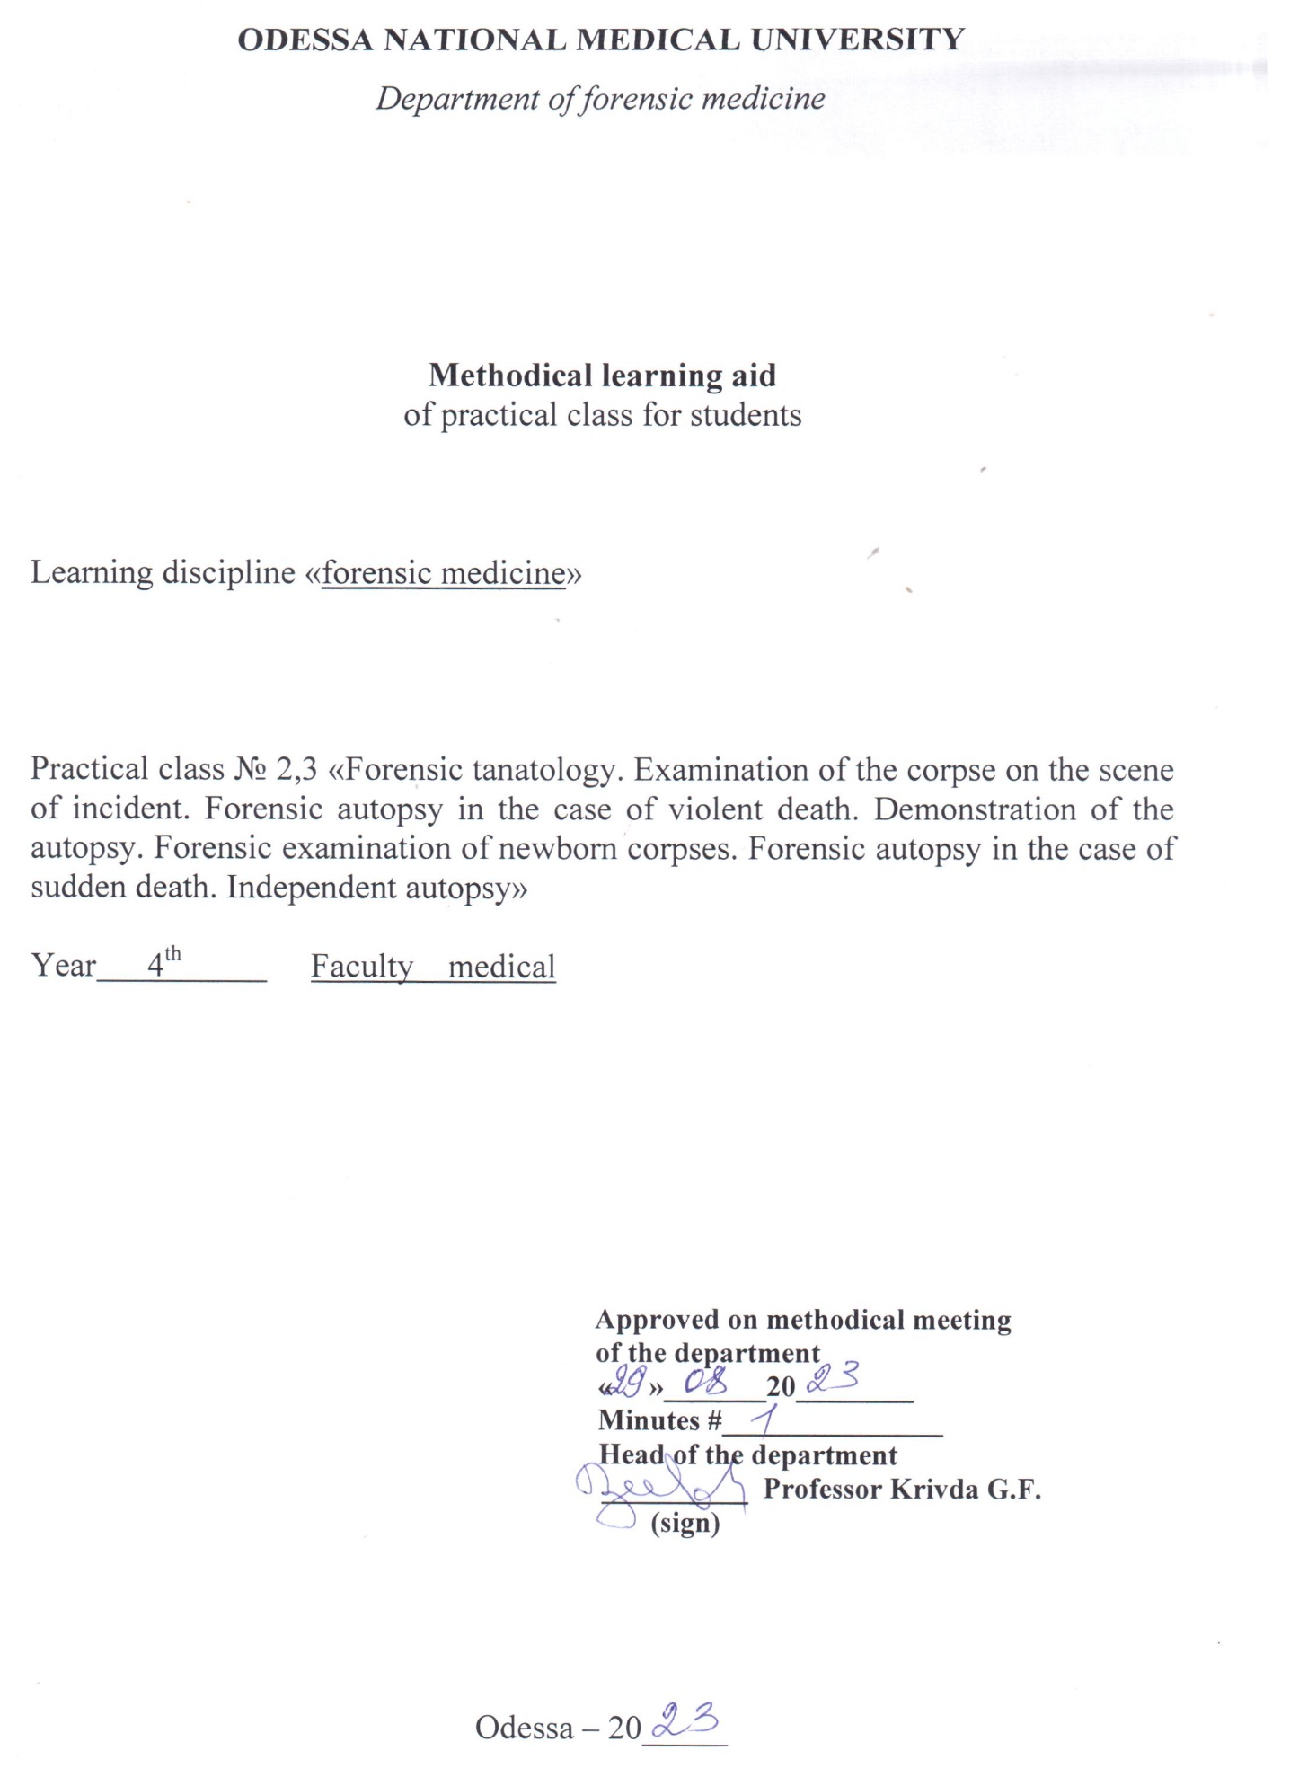

Theme “Forensic tanatology. Examination of the corpse on the scene of incident. Forensic autopsy in the case of violent death. Demonstration of the autopsy. Forensic examination of newborn corpses. Forensic autopsy in the case of sudden death. Independent autopsy”

Motivational characteristics

Inspection of the scene of incident is an important investigation procedure. If the coroner is absent at the moment, any doctor can be involved in inspection of the place of incident. According to Ukrainian Criminal Procedure Code, primary external examination of the corpse on the place of its detection is performed with help of the coroner, and if he absent – with the help of any other doctor. That’s why each doctor should be accompanied with the rules of examination of the corpse on the scene of incident

Educational aims

Study with general questions as for the inspection of the scene of incident and primary examination of the corpse on the scene of death. Study the works of Ukrainian prominent scientists M.S. Bokarius and Yu.S. Sapozhnikov, which laid the foundation of the principles of inspection of the scene of incident

Tasks

- Know the meaning of the concept “scene of incident”
- Understand the role of the expert in the sphere of forensic medicine in the inspection of the place of incident
- Study the rules of the primary examination of the corpse on the scene of the death
- Be able to perform a description of the corpse on the place of its detection (examine and describe injuries and post-mortem signs)
- Be able to determine the time of death according to the description of post-mortem signs
- Be able to answer the investigator’s questions as for the primary examination of the corpse on the place of incident

Materials for the student’s independent work (interdisciplinary integration)

# | Discipline | Student should know | Student should be able to do
1. | Previous disciplines:  Normal Anatomy | Structure of the human body | Determine correctly the part of the body
2. | Further disciplines | - | -
3. | Intradisciplinar integration:  - FME of the injuries by sharp objects  - FME of the injuries by dull objects  - FME of the falling from a height  - FME of the gunshot injuries  - FME in case of car accidents  - FME in case of mechanic asphyxia | Peculiarities of sharp objects  Peculiarities of dull objects  Mechanism of the fall  Peculiarities of gunshot injuries  Peculiarities of car accidents  Peculiarities of the neck’s injuries | Describe injuries, caused by such objects  Describe injuries, caused by such objects  Describe the injuries  Describe gunshot injuries  Describe the injuries  Describe the injuries

Content of the theme (text of theses), graphologic structure of the class

Inspection of the scene of incident is an important investigation procedure. Doctor-expert, specialist in forensic medicine, during the primary examination of the corpse on the place of incident should:
    - Verify the death; if the signs of biological death are absent – perform complex of reanimation means
    - Determine the pose and position of the corpse on the place of incident
    - Correctly detect the correspondence of the scene of detection of the corpse and scene of its death
    - Detect injuries on the corpse and its clothes
    - Help the detective-investigator in his action on the place of incident
    - Help the detective-investigator to detect, describe and pack the material evidences of biological origin and instruments of the injuries
    - Consult the detective-investigator

Procedure of the external examination of the corpse:
- determine the place of the corpse’s position and its pose;
- detect the objects, which located on the corpse and near it;
- describe the corpse, noticing the general data about the corpse, presence and degree of the post-mortem changes, supravital reactions, peculiarities of the corpse’s parts and presence of the injuries with determination of their peculiarities
- describe the “deathbed of the corpse”

Position of the corpse should be detected correctly according to the surrounding subjects with orientation to the immobile subjects, which are constantly located (cannot change their position) as for its position. Each subject and object near the corpse should be leaved without any changes and should be described (the name of the subject or object and its position according to the position of the corpse). All this concern the traces of blood, urine, vomiting masses and all other traces of biological origin. Their seizes are always measured. When examining the clothes, one should name the form, kind of their material, color, print, condition of buttons, presence of dirt and deformation, presence of the clothes, content of the pockets, etc. Describing the foot-wear, it is necessary to pay attention on its sole.
During the examination of the corpse it is necessary to mention anatomical-constitutional data: sex, age, body length, degree of nourishment, color of the skin covers. Post-mortem signs are described in such a way: signs of cooling on the different body parts, presence of rigor mortis, livores mortis and signs of superficial drying and putrefaction (if it is present). Body temperature is measured in rectum three times in 30 minutes during 1 hour with simultaneous measuring of the surrounding temperature.

Post-mortem changes are examined especially thoroughly. Color of livores mortis and their location are thoroughly described. Dynamometry of livores mortis is also performed with the help of dynamometer: its working part is pressed perpendicularly in the center of the livores mortis during 3 seconds. Time of examination of livores mortis is measured with the help of the watch, time of their restoration (renovation) – with the help of chronograph. The degree of rigor mortis in muscles and drying of skin and mucous membranes are also described.

Performing of supravital reactions is begun from the Chako’s test (knocking by strong impact with the neurological hammer on the different points). Pupil’s reaction starts from the detection of their seizes; then Beloglasov’s test is performed (eye is compressed from the sides, than the researcher detects the change of the form of the eye). In 10-15 min after the compression pupil looks like cat’s pupil. Also pharmacological test with pilocarpinum or atropine is performed. 1% solution of pilocarpinum is introduced by syringe in the anterior chamber of the eye from the temporal side not far from the margin of cornea. Needle is located parallel to the iris. After installation of pilocarpinum time of the maximal narrowing of the pupil is detected. Test with atropine is based on the dilatation of the pupil. If the pupil’s reaction lasts for 3 – 5 sec, then death occurred 5 hours ago, if 6 – 15 sec, than 10 – 14 hours ago, if 20 – 30, than 24 hours ago.
A strong impact by metal pin in the middle third of m.biceps is performed to detect the idiomuscular tumor.
Description of the body parts is begun from the examination of the head, face, external acoustic and nasal pores and oral cavity.
Peculiarities of teeth and gums are detected during the examination of oral cavity. Form of the neck, its length, presence or absence of injuries are detected during the examination. If it is possible not to take over the clothes, than one should describe form of the breast, safety of the ribs and condition of the mammary glands in women. When examining the abdomen, it is necessary to detect its form and configuration, external genital tract – its condition, presence or absence of developmental defects, signs of urination or dirt, signs of ejaculation in males, condition of hymen and bartholin glands in female.
During examination of the extremities it is necessary to detect the conditions of bones and joints after compression. Condition of palms and soles is detected when describing upper and lower extremities.
Injuries on the corpse are described after examination of definite parts of the body (after examination of the head, neck, trunk, upper and lower extremities). Description of the injuries is performed in proper form according to the rules of forensic medicine: localization of the injuries, their form and seizes, peculiarities and condition of the skin around them, etc. Any manipulations in the injuries’ region are forbidden.
It is necessary to detect the character of the surface where the body is located during the examination (deathbed of corpse). Presence of the prints on the corpse, signs of dirt, blood and other biological substances and any objects under the corpse are also detected.
When the protocol is almost finished, it is necessary to establish, where the corpse and all material proofs will be transported (delivered). Time of the finishing of examination is also detected in protocol. Detectives-investigators, experts and observers, who participated in this investigation moment, sign the protocol. Plan of the examination of scene of incident with detection of the corpse’s and material proofs position is added to the protocol.

SUDDEN DEATH
Death, that happens suddenly or very quickly, as usual after the hidden disease, we call the sudden death.
The sudden death is characterized by three main signs:
1. It is caused by the hidden or acute disease, it is not caused by the damage.
2 . It comes very quickly.(sec, min or a couple of hours)
3. It happens suddenly.
SIDS (sudden infant death syndrome) the sudden unexpected death of an infant less than two year old (peak occurrence between two and six months) from an unidentifiable cause. There appear to be many factors involved, the most important of which the baby is laid to sleep: babies who sleep on their fronts (the prone position) have an increased risk. Other factors increasing the risk include parental smoking, overheating with bedding, prematurity, and a history of sudden death within the family. About half of affected infants have had a viral upper respiratory tract infection within the 48 hours preceding their death, many of these being due to the respiratory sincytial virus.
The causes of sudden death in juveniles are endocarditis, miocarditis of the different nature or valvular defect.
The causes of sudden death at the adult and old persons are: the disease of cardio – vascular system (atherosclerosis and hypertension more often).
The sudden death from the infection diseases.
The sudden death is the most often caused by the fly. Dangerous infections: plaque, pox, cholera, glanders.
To make the diagnosis of infection disease the expert should keep the special rules of the autopsy.
The sudden death from the diseases of the respiratory tract.
At the infant - the processes of the respiratory tract: bronchitis, stenosing laryngotracheitis.
At the adult - the flaccid pneumonia, that causes the cardio –pulmonary insufficiency.
Patients with tuberculosis of the lungs die from the lung’s bleeding.

The sudden death from the diseases of the CNS
Tumors of the brain and its meninx. Patients die from the acute edema of the brain of bleeding in to the tumor or surrounding brain’s tissues.

The sudden death from the disease of the digestive system.
Patients die because of the acute bleeding from the varicose enlargement of the veins of the esophagus.
The sudden death from the allergic diseases.
Anaphylactic shock. Angioneurotic edema.
The sudden death due to pregnancy and delivery.
The most often it happens due to the eclampsia or toxicosis of pregnancy.

Control of the initial level of the students’ knowledge using tests with supplying of missed information and with answers – tasks of the 11th level and situational tasks
Task 1
A corpse of a male nearly 50 years old was detected in a room with +20ºC temperature; livores mortis are not so expressed – they disappear and restore in 5 sec. rigor mortis is detected only in the facial muscles. Body’s surface under the clothes is warm. Body temperature in the rectum at the beginning of the examination is +35ºC, in an hour - +33,8ºC. Muscular tonus is well detected on the shoulder. Chako’s test is positive. Detect the time of the death.

Task 2
During the examination of the corpse, found in the garage (surrounding temperature is +16 ºC, it was detected: livores mortis are well expressed on the posterior surface of the body, after the compression by dynamometer they disappear and restore in 10 sec, rigor mortis is absent. Connective tissue of the eyes is shiny, dump, supravital reactions (idiomuscular swelling and muscles reaction on the electric current) are positive. On the uncovered regions of the body skin is cold and under the clothes is warm. Detect, when has the death occurred?

Task 3
A male corpse, nearly 35 years old, was found hanging in the loop on the tree in the forest. Tissues of the face, neck and superior part of the breast are dry and thickened. Other regions of the body are in putrefaction with large amount of insects. A corps is partially skeleted. Detect the time of the death occurrence.

Task 4
A male corpse, nearly 40 years old, was found in a flat. It was lying in the bed in pants and cotton T-shirt. Environmental temperature is +20 ºC during the examination at 8 p.m. corpse is cold and without injuries. Temperature in the rectum is +20 ºC, in an hour - +20 ºC. Pupils do not reduce (decrease) after introduction of 0.1 ml of 1% solution of pilocarpinum in the anterior chamber. Chako’s test is negative, idomuscular swelling of the shoulder is absent. Mimic muscles do not react on the electric current. Detect the time of the death occurrence.
Answers
Task 1 – 2 – 4 hours have passed from the moment of death till the moment of examination of livores mortis
Task 2 – 4 – 6 hours have passed from the moment of death till the moment of examination of livores mortis
Task 3 – 3 – 6 months have passed from the moment of death till the moment of examination of the corpse
Task 4 – 24 – 48 hours have passed from the moment of death till the moment of examination of livores mortis
Control tests
1. Who performs the examination of the corpse on the scene of the incident?
A. Paramedic doctor, witness of the death
B. Observers
C. Detective-investigator
D. A doctor, involved in the examination of the scene of incident
E. Regional inspector
2. Who describes the position of the corpse on the scene of incident?
A. Detective-investigator
B. Regional inspector
C. Any doctor
D. Expert-criminalist
E. A specialist in forensic medicine
3. Who makes the “Protocol of inspection of the scene of incident and of the corpse”?
A. Coroner
B. Detective-investigator
C. Observers
D. Regional inspector
E. A doctor, involved in the examination of the scene of incident
4. What means should perform a doctor, involved in the examination of the scene of incident, if there are no absolute signs of death?
A. Perform an external examination
B. Call an ambulance
C. Supply the first aid means
D. Refuse from the examination
E. Wait for the coroner
5. What should the coroner detect at first during the examination of the corpse on the scene of incident?
A. Pose of the corpse
B. Cause of the death
C. Signs of the death
D. Time of the death’s occurrence
E. Presence of the injuries
Answers on the tests:
1 – C, 2 – A, 3 – B, 4 – C, 5 – B

Literature
Main:
      - Babanin A.A., Belovitskiy O.V., Skrebkova O.Yu. Forensic medicine: Textbook. – Simferopol, 2007. – 464 p.; 24 sh.ill.
Additional:
        - Bernard Knight. Simpson’s Forensic Medicine, Eleventh Edition. London. Sydney. Auckland, 1983
        - Parikh’s Textbook of Medical Jurisprudence and Toxicology. Fifth Edition. Bombay, India.
        - Thomas A. Gonzales. Legal Medicine. Second |Edition. New York
        - Journal of Clinical Forensic Medicine ## 1- 6 – 1999

Oriental card for student’s independent work with literature with the topic of the task

Material for self-control

A. Questions for self-control
1. Determine the concept “scene of incident”
2. Determine the concept “inspection of the scene of incident”
3. Methods of inspection
4. Regions of inspection
5. Protocol of the examination of the corpse
6. Tasks for the doctor-expert during the external examination of the corpse on the scene of incident
7. Description of the corpse’s position
8. Description of the corpse’s pose
9. Description of the corpse’s clothes
10. Description of post-mortal signs
11. Description of supravital reactions
12. Description of the injuries on the corpse
13. Description of the deathbed of the corpse
14. Peculiarities of examination of the corpse in the case of car accidents
15. Peculiarities of examination of the corpse in the case of mechanic asphyxia
16. Peculiarities of examination of the corpse in the case of gun-shot injuries
17. Peculiarities of examination of the corpse in the case of falling from height
18. Questions, which become clear for the doctor after the examination

B. Tests for self-control
1. Which test from the mentioned beneath helps to detect the time of the death’s occurrence?
A. Biloglasov’s test
B. Breslau’s test
C. Galen’s test
D. Crioscopic test
E. Suncov’s test

2. Which tests are considered the supravital reactions?
A. Biloglasov’s test
B. Reaction of the pupils on the pilocarpinum
C. Galen’s test
D. Liarchet’s test
E. Reaction of the skeletal muscles on the electric irritation

3. Where on the body do the livores mortis located, if it was detected hanging in the loop
A. Livores mortis are absent
B. On the neck
C. On the back
D. On the legs
E. On the posterior surface of the corpse

4. Which sign is considered to be the absolute one?
A. Absence of the respiration
B. Rigor mortis
C. Cooling of the corpse till +33ºC
D. Absence of consciousness
E. Absence of pulse

Answers
1 – A, 2 – A, B, D, 3 – D, 4 – B

C. Tasks for self-control
Task 1
A corpse nearly 60 years old in red T-shirt and pants was found in the forest. Environmental temperature is +22ºC, corpse when touching is cold. Temperature in the rectum is +21ºC and it does not change in an hour. Livores mortis are few, located on the posterior surface of the body, after the compression with dynamometer they do not change. There is a wound 2 x 0,5 cm with Rovn margins and sharp endings on the anterior surface of the breast; the beginning of the wound channel is visible. Which questions can the doctor answer on the place of incident?

Task 2
Corpse of male nearly 50 years old was found on the floor in the flat. Livores mortis located on the back. Corpse is lying on the abdomen. Livores mortis after the compression do not change. Rigor mortis is well developed in all muscles. Which questions can the doctor answer on the place of incident?

Answers
Task 1: When has the death occurred? What injuries are on the body?
Task 2: When has the death occurred? Whether the position and pose of the corpse were changed after the death?

Materials for independent work before the class

List of the practical skills, which are necessary to be performed during the class:
- Detect the scene of incident (by the model of the scene of incident)
- Detect the mechanism of the event (by the model of the scene of incident)
- Perform the description of the corpse on the scene of incident (by the model of the scene of incident and mannequin)

Instructive materials for the professional skills and abilities:
- Models of the scene of incident
1. In the case of care-accident
2. In the case of gun-shot wound
3. In the case of drowning
4. In the case of murder by sharp object

Methodics of the work, stages of performing
- Determine the scene of incident
- Determine location of the corpse and environmental elements
- Detect the corpse’s pose
- Describe the clothes of the corpse
- Describe the injuries on the corpse
- Describe traces of biological origin on the scene of incident
- Purpose the character and mechanism of event

Materials for self-control for learning the practical skills, knowledge, according to this theme
Tests of the different levels (tests, which included in base of the rector control). Watch the table with tests of rector control.

Tasks for student’s educational research work on the theme

