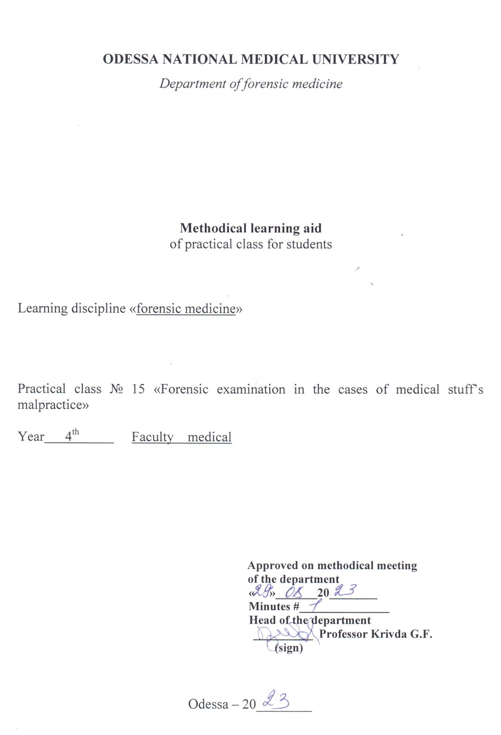

Theme “Law aspect of the health protection. Forensic examination of the professional offences of medical stuff”

Motivational characteristics
Theme is important because it is related with deontology and ethics and has significant practical meaning for each doctor. This lecture should provoke the moral responsibility of the doctors, and remind them the criminal one, because the number of the offences of medical stuff recently had increased. Before practicing as a doctor students have to receive knowledge in the law field and understand, that they have to do all their best to avoid the offence in their practice.

Educational aims

- Know the classification of then offences of medical stuff
- Know the mechanism of the forensic-medical examination of professional offences of medical worker’s
- Know the items of Criminal Code, which regalement the doctor’s practice
- Be able to differ a medical mistake, a case in medical practice, ignorant and criminal actions of medical stuff
- Be able to apply medico-legal knowledge in further practice to avoid the offences

Materials for the student’s independent work (interdisciplinary integration)

# | Discipline | Student should know | Student should be able to do
1.
2.

Content of the theme (text of theses), graphologic structure of the class

Consent
A doctor does not have an automatic right to submit anyone to a medical examination or treatment. A physical examination, if conducted without the consent of the patient, could constitute in law (a) a criminal offence, an assault, either common or indecent, depending on the type of examination, or (b) a trespass upon the person. Therefore, it is important that the doctor should understand the different forms of consent, and also the circumstances in which each would be appropriate.

Occasions when consent not required
- On admission to H.M. Prison—for routine examination.
- On a court order, of a person suffering from a notifiable disease or tuberculosis.
- On the probation order of a court.
- Of immigrants at ports and airports.
- Of milk or food handlers.
- Of school children, in state schools.
Thus all these cases are where refusal to allow examination might jeopardise the health of the community as a whole, or a substantial portion of it. In all other cases consent is necessary to medical examination.

Validity of consent
For a person's consent to Joe valid it must be genuine and freely given. He must understand exactly what he is consenting to, and within reason what any possible results or complications might be. Alleged lack of such 'informal' consent is increasingly a grounds for legal action by patients against doctors; the use of complex modem methods of treatment, or participation in clinical trials requires especial care in this respect. The consent must not be obtained by any sharp practice or blackmail, such as making some action of the doctor dependent on the consent of the person to some other procedure. Consent obtained by force, or fear, or fraud is always invalid.
The fact of consent when appropriate must be clearly stated. The fact that the patient doesn't say no, or obeys without saying anything, does not indicate consent.
It is especially important to remember to ensure that consent is valid when dealing with persons suspected or accused of having committed some criminal offence.
Forms of consent
1 Implied.
2 Express—oral or written.

Implied
i.e. by the behaviour of the patient. Thus the fact that a patient attends the surgery or summons the doctor to his house, complaining of illness, implies that he consents to a general physical examination, to determine the nature of the ailment. This implied consent is sufficient for all normal medical practice, but not if intimate examinations are to be made, e.g. rectal or vaginal examinations.

Express i.e. specifically stated by the patient either orally or in writing.

Oral consent — where possible this should be given in the presence of a third party, otherwise the doctor has no proof of its existence if subsequently challenged. Oral consent should be sought before any of the intimate examinations, rectal or vaginal, before the performance of procedures such as a gastric test meal, or the taking of blood samples. A third person who is a disinterested party, i.e. not a friend or relative of the patient, should be present when an intimate examination is made to protect the doctor from subsequent accusations of indecent assault.

Written consent — this is necessary for the major procedures such as the administration of anaesthetics or the performance of operations. It is also necessary for examinations of persons accused of criminal offences. The protection societies have indicated the ideal consent form to be used in hospital, which makes it clear that the nature of the procedure and any complications have been explained to the patient, who also understands that the procedure is not to be carried out by any particular doctor.
Valid consent cannot be obtained for a procedure which is illegal, such as euthanasia.

Consent in special cases

Normally consent as described above is given by the person concerned. However, this may not be possible, or may need to be qualified.

By a spouse

In operations interfering with marital rights, such as abortion or sterilization, the consent of the patient is paramount, but the consent of the spouse should also be sought, though this cannot override the wishes of the patient. If the patient is unconscious or otherwise unable to give valid consent, then the consent of the spouse will be valid. Forms appropriate to the special circumstances have been prepared by the protection societies.

Minors

Under 16 years of age. The consent of the parent or guardian is necessary. If neither is available then the consent of the person in loco parentis, e.g. the headmaster of the child's school, is valid, in an emergency.
On occasion parents may refuse permission for a procedure on their child which is necessary to save life, on religious grounds, e.g. blood transfusion is objectionable to Jehovah's Witnesses. It is possible then for a magistrate's court to order the child's removal from the care of the parents to that of a 'fit person', e.g. a county welfare officer, who may then give valid consent. However the Minister of Health has advised hospitals against adopting this procedure. Even if the doctor acts without consent, in such circumstances, provided that he does so in good faith to preserve the child's life, then he is unlikely to be in danger of legal action.

Over 16 years of age. Such a person can give valid consent, even though not yet 18. However, it is advisable to consult parents if practicable.

Consent in emergency

If the patient is unconscious and no-one is available who could give consent, the doctor is entitled to carry out any procedures necessary to preserve life, but no more. Thus he may give blood transfusions, perform operations to relieve raised intracranial tension, etc. But a badly damaged limb, for instance, should not be amputated, provided that it does not constitute a danger to life, even if there is no doubt that subsequently it will be useless, without first obtaining the patient's consent.

Refusal of consent

In certain circumstances a patient may withhold consent to life-saving procedures. Thus a Jehovah's Witness who has been stabbed may refuse a blood transfusion, or a prisoner on hunger strike may refuse nourishment Such situations put the doctor in considerable difficulties, and require him to consult his protection society, but in general it is advisable to respect the patient's wishes, even if this results in his death.
Negligence

Any citizen can be guilty of negligence. For a person to be judged negligent:
1. He must owe a duty to another person.
2. He must have committed a breach of that duty.
3. As a result the person to whom the duty was owed must have suffered some damage.
Translating this into terms of medical practice:
1. The person must be the doctor's patient, Le. someone for whose medical care the doctor accepts responsibility.
2. The doctor must have done something which is not approved medical practice, or, more commonly, have omitted to do something which is considered accepted practice in the circumstances.
3. As a result of the action or omission the patient has suffered injury.
For example—a person attends casualty and is seen by the Casualty Officer (who accepts responsibility). He has suffered a fall on the hand which is painful, but no X-ray is taken and therefore no fracture diagnosed (omission of approved medical practice). Due to malunion of the fracture arthritis develops with incapacity of that hand (the patient has suffered damage).

When is duty owed?

This is from the moment that the doctor undertakes advice or treatment, whether under contract or gratuitously, e.g. at the scene of an accident. The doctor has no legal obligation to undertake the care of any patient, but once the obligation is accepted then he is liable to exercise proper skill and care in the management of the case.

Standard of duty

No doctor is expected to be perfect or infallible. The standard of competence which the patient is entitled to expect is that of an ordinary competent practitioner in the grade or speciality to which the doctor belongs. Thus the degree of skill expected in any one field of medicine is that of the average practitioner in that field. But a doctor would be ill-advised to go outside his sphere of competence. Thus a general practitioner performing major surgery will be expected to exercise the degree of skill of an average surgeon, unless he was forced to act in an emergency, when no surgeon was available.

Breaches of duty

Approved practice

If a doctor has followed approved medical practice, this will be taken as evidence of due care. Departure from approved practice, e.g. failure to take X-rays or to give antisera in appropriate circumstances is risky, leaving the doctor little defence if anything goes wrong. Doctors are expected to keep reasonably up to date by reading medical journals, but no-one is expected to read all the journals and be aware of all advances.

Accurate diagnosis

No doctor guarantees accuracy of diagnosis, and therefore cannot be considered negligent if an inaccurate diagnosis is made, unless it is shown that he did not exercise proper care in making it, e.g. failure to examine the abdomen of a child suffering from appendicitis, or failure to keep the child under observation if such a condition were suspected.

Risks of treatment

Some risks are inherent in any form of treatment and the doctor will not be negligent if they cause damage provided that he has taken reasonable care to avoid them, e.g. broken needle during injection. However, he may be negligent if he doesn't warn the patient beforehand of any appreciable risk involved, or inform him after a mishap has occurred.
Thus a needle would not be anticipated to break, and the patient need not be warned of the possibility. However, if it has broken then the patient should be told and arrangements made to remove the broken piece. If the doctor fails to notice mat the needle has broken, or, having discovered this, does not tell the patient or make arrangements to prevent further damage, then he is negligent.

Communication with other doctors

Failure to inform a general practitioner of a person's discharge from hospital and treatment might constitute negligence if there was a reasonable possibility of some complication of the condition occurring. It has been held that such communication must be direct. To advise the patient to attend his own doctor or to give him a verbal message for the doctor in such circumstances is insufficient. This applies more to emergency treatment.

Attendance on patients

Failure to attend a private or Health Service patient promptly when called may be held negligent when due to forgetfulness or laziness.

Res ipsa loquitor. This is a legal term meaning 'the thing speaks for itself. Thus if after an operation the patient is found to have a swab or a pair of forceps left in the abdomen, this cannot be considered reasonable treatment, and the facts automatically indicate negligence. The onus then shifts to the doctor, to explain the facts if he can, or to show that the negligence was not his.
Criminal Negligence

This is rare, and only occurs if the negligence is so gross that compensation is an inadequate redress and it constitutes a crime deserving punishment. This type of negligence is seen in a grossly careless act which results in death of a patient, as in obstetric delivery while drunk, or administration of an anaesthetic while under the effects of drugs. The doctor will then probably be charged with manslaughter and, upon conviction, may also be struck off the Medical Register.

Injury before Birth

Following a Law Commission Report a new form of action has arisen in which a child can sue for injuries sustained before it was born, as for instance in a road accident to the pregnant mother (Congenital Disabilities (Civil liability) Act 1976).

Medical defence societies

In any question of negligence the doctor would be well advised to consult his medical defence society before taking any action, in particular before making any admission. He should also remember that under the provisions of the Administration of Justice Act 1970, the Court can compel the disclosure of a patient's medical records and so he should be careful to ensure that the records are complete, accurate, and do not contain any derogatory comments, exposure of which could be embarrassing for him.

Professional Secrecy—Privileged Occasions

Normally a person is responsible for his statements and their consequences and may be sued for slander or libel, i.e. defamation of character. However, there are occasions when it may be necessary for a doctor as a duty to the public to make a statement which is derogatory. Then the doctor's statement is privileged if he acted in accordance with the rules, and he has a complete defence.
Usually any information received by a doctor from a patient is confidential and may not be disclosed to any other person. However its disclosure may be compelled in a court of law, even when treatment is given under a promise of secrecy, e.g. for venereal disease.

Absolute privilege

This applies to any statements made in Parliament or in a court of law. No one can be sued over any statements made in these places.

Qualified privilege

This provides protection against legal action when persons make statements in the course of their legal or social duty, but only if certain rules are observed:
1 The statement must not be malicious.
2 It must only be made to those having an interest or duty to receive it.
For example the statement on a death certificate that a person has suffered from syphilis is privileged, but the same statement made in conversation to a general member of the public is not protected and may result in legal action. Or, if a person is suffering from an infectious disease the doctor may need to inform the patient's employer, and would be protected against subsequent legal action, but not if the statement was also made to the patient's workmates.
Thus a doctor must be very careful, when making statements about a patient, to whom he makes the statements.

Secrecy

At times there may be a difficult conflict between a doctor's duty to respect the confidence of his patient and to divulge information for the benefit of the community. Thus in the case of a motorist who is found to suffer epileptic attacks, it may be necessary to inform his employer or works medical officer, if the patient refuses to disclose the facts himself. However regulations now permit the issue of a driving licence to an epileptic who has had no fits during the day for 3 years. Recently, the Road Traffic Act 1974, includes a clause requiring drivers who became aware that they are suffering from a relevant disability to report this to the Secretary of State, and also if they have a prospective disability. The Secretary of State could then require the driver to authorise his doctor to release information about his disability to the licensing authority, who have a special section dealing with such information. Pregnancy in a girl under 16 years needs to be disclosed to the parents, but over 16 the girl's consent must be obtained first. A doctor was accused, though acquitted of serious professional misconduct for disclosing to her parents that a girl of 16 had been prescribed contraceptive pills by a clinic.
In the case of a road traffic accident the law obliges a doctor to divulge information to the police, but generally the doctor should observe secrecy.

Literature
Main:
- Babanin A.A., Belovitskiy O.V., Skrebkova O.Yu. Forensic medicine: Textbook. – Simferopol, 2007. – 464 p.; 24 sh.ill.

Additional:
        - Bernard Knight. Simpson’s Forensic Medicine, Eleventh Edition. London. Sydney. Auckland, 1983
        - Parikh’s Textbook of Medical Jurisprudence and Toxicology. Fifth Edition. Bombay, India.
        - Thomas A. Gonzales. Legal Medicine. Second |Edition. New York
        - Journal of Clinical Forensic Medicine ## 1- 6 – 1999

