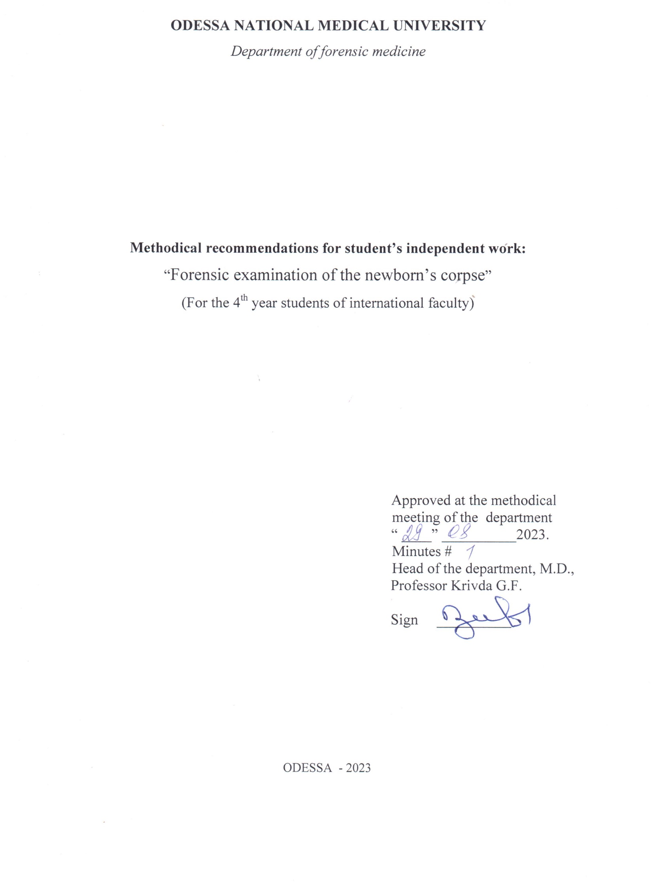
Theme: ” Forensic examination of the newborn’s corpse” 4 h.

Importance of theme is made by peculiarities in techniques of section and special questions of juridical workers for medico-legal examiner.

Educational aims
1. Get acquainted the students with peculiarities of the examinational actions in cause of examination of the newborn corpses.
2. Student must know the medico-legal classification of death of the newborns corpses, the sources for the diagnostics, position of death, results of the examinations, additional examinations of corpse.

3. Student should prepare the medico-legal documentation – act of medico-legal examination of newborn corpse (on the practical lesson).

4. Student, using the logical and clinical meaning must make the medico-legal conclusion and results under deciding of the different situational tasks in course of newborn death.

4. Interdisciplinar integration
№ | Dicipline | To know | To do
1. | Past disciplines pediatrics
2. | This discipline | The medico-legal examination of the newborn corpses, the methods of examination | The act and conclusion of medico-legal examinaiton
3. | Intradiscipline integration does not integrate

Content of the theme
The determination of newborn child:

In legal medicine the period of newborn is very short part of time – first 24 hours. It is determined by juridical determination of children killing-killing by mother her child in time of delivery or after it.
The newborn child is determined by presence of umbilical cord, labor tumor, smegma and tracks of blood and placenta, and meconium in intestine crassum.
Umbilical cord is a cord organ which connects fetus and placenta through feto-placental blooding makes.
Umbilical cord must be studied and written under medico-legal examination properly. Special attention should be paid to its free end (cut, tored); whether it is binded, what material and knot has been used.
Labor tumor is located on the lied part of fetus-head or nates or scrotum.
It is formed in the result of imbibition of pius tissues by fluid with blood.
On the sections the labor tumor gel character yellow-red color.
It disappears in two-three days. If compression of head was considerable and strong, heamatoma can form under periosteum of cranium bones. Such injury is called kephalohaematoma. It disappears in 2-4 weeks depending on its measures.
Mekonium (melena neonatarum) is the dark green (sometimes – brown or red with blood) homogenous mass which can be determined in intestine crassum, in anus and on the nates. Meconium disappears from tenues in 1-2 days (sometimes on 3-4 day).
Smegma is fat grey and white mass-product of sebaceous glandules which consists of cholesterine and fat acids with cells of epidermis and little hairs.
Maturity of the fetus is normal term of position of fetus in the maternal organism.
Maturity is a level of the physiological development of newborn.

The middle measures of maturity newborn body

SIGN | MEASURE
length | 50-54 sm.
mass | 2500-3500gr.
circumference of the head | 32-34,5 sm.

Measures of head:
right | 12 sm.
big standing | 13,5 sm.
little standing | 9,5 sm.
big transversal | 9,2-10 sm.
little transversal | 8 sm.
wide of shoulders | 11-12 sm.
distance between trochanteres of the femors | 9-10 sm.
circumference of thorax | 30 sm.
circumference of aorta over valves | 20 mm.
circumference of truncus pumonalis | 26,5 mm.

Maturity characterized by enough development of fat tissue, presence of little hairs on the region of the shoulders, hairs on head with length 2-3 sm. Cartilages of nose and eyes must be elastic, compact, nails on the hands more then ends of fingers on the foots-till ends. Genitals must be formed right: for boys-testis in scrotum, for girls-big sexual lips shorts the little sexual lips.
In the examinational practice length of intranatal life is determined after length of body. Under length more then 25sm. We divide it on 5 and get number of moon month. Remainder is swear in next month of life.
Determination of liveborn or deadborn. Sign of liveborn is appearance of extranatal pulmonar respiration for life action fetus. Dead bone is born of fetus in which the extranatal respiration does not appear.
For determination of lifeborn we use the live probes-pulmonar and intestinal. The pulmonar tissue is lied under histological examination. Air in the lungs and in digestive tract before section can be determined under corpse x-raying.
Determination of the life activity.
Life activity appears before quite maturity (end of 10 moon month). Absence of newborn’s life activity can be a result of strong immaturity or congenital teratisms.
The causes of death of the fetuses and newborns.
There are antenatal, intranatal death of fetus and postnatal death of newborn. Death of fetus and newborn can be forced and unforced. Unforced death has place before, during, after labor. As the role the forced death occurs after labor, sometimes-during or before labor.

6. PLAN: organized structure of lesson.
№ | General stages of lesson, its function and composition | Training aim on the levels | Methods of control and studying | Materials for methodic supplying of control | Time
1. | Primary stage organization of lesson, teacher aim, control of primary level of the knowledge | General notion about corpse examinations of the newborn corpse | The programmed questions, tests of primary level of the knowledge | The tables, macropreparations, micropreparations | 15 min.
2. | General stage of formation of making the corpse examination and life body under mechanic asphyxia | Study the methods of examination of the newborns corpses | The programmed questions, level controls, deciding of situational tasks | The tables, macropreparations, micropreparations, tests, situational tasks | 135 min.
3. | Final stage(control and correction of level of professional making of examination)  The results of lesson. | Control of knowledge | The tests of final level of the knowledge | The tables, macro-, micropreparations | 30 min.

Literature
Main:
1.Forensic Medicine B.V. Mykhailychenko, A.M. Biliakov, I.G. Savka ; Рік видання. —. 2019
Additional:
        - Bernard Knight. Simpson’s Forensic Medicine, Eleventh Edition. London. Sydney. Auckland, 1983
        - Parikh’s Textbook of Medical Jurisprudence and Toxicology. Fifth Edition. Bombay, India.
        - Thomas A. Gonzales. Legal Medicine. Second |Edition. New York
        - Journal of Clinical Forensic Medicine ## 1- 6 – 1999

