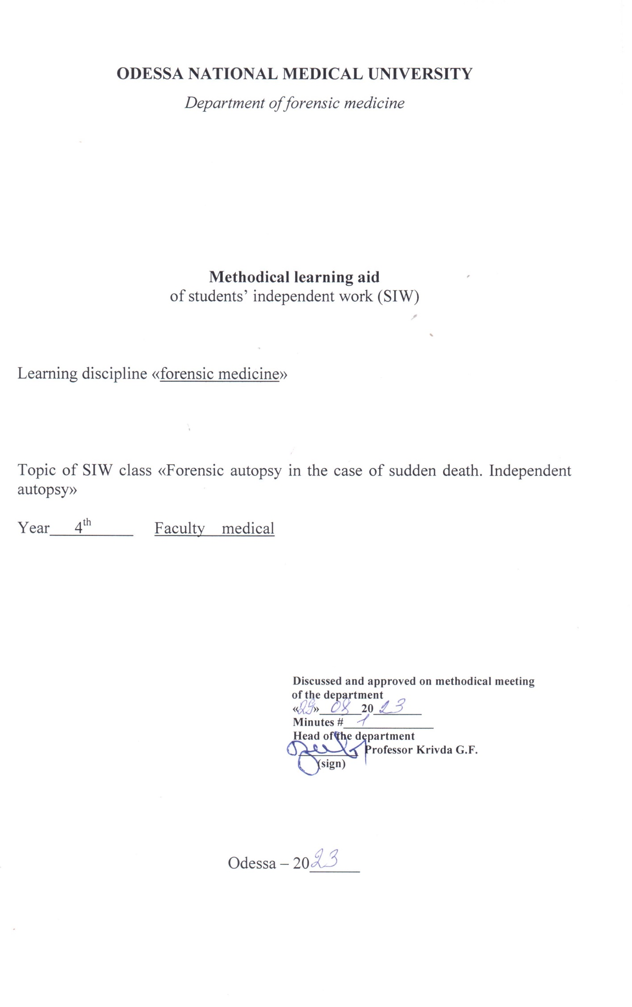

Theme:” Forensic autopsy in the case of sudden death. Independent autopsy”-4h

The sudden death is very often observed at the experimental practice.

Educational aims
To acquaint the students with the peculiarities of the experimental acting in the case of the sudden death, so as it looks like the violent death
Student should know what is sudden death, course for the diagnostic, results of the cadaver’s examination, additional lab examinations of the cadaver.
Student should know how to fill in medical documents – deed of forensic medical examination of cadaver.(This practical experience fixes at the practical studies).
Student with the help logical and clinical way of thinking should learn how to fill in the deed of forensic medical examination and conclusions to the different problems in the cases of sudden death.

4.Intradisciplinary integration:

# | Discipline | Student should know | Student should be able to do
1 | Previous disciplines (pathological anatomy)
2 | This discipline (that provides) | The forensic medical sings of the sudden death, methods of the examination | To fill in the deed of forensic medical examination
3 | Intra-subject integration

Content of the theme
Death, that happens suddenly or very quickly, as usual after the hidden disease, we call the sudden death.
The sudden death is characterized by three main signs:
1. It is caused by the hidden or acute disease, it is not caused by the damage.
2 . It comes very quickly.(sec, min or a couple of hours)
3. It happens suddenly.

SIDS (sudden infant death syndrome) the sudden unexpected death of an infant less than two year old (peak occurrence between two and six months) from an unidentifiable cause. There appear to be many factors involved, the most important of which the baby is laid to sleep: babies who sleep on their fronts (the prone position) have an increased risk. Other factors increasing the risk include parental smoking, overheating with bedding, prematurity, and a history of sudden death within the family. About half of affected infants have had a viral upper respiratory tract infection within the 48 hours preceding their death, many of these being due to the respiratory sincytial virus.
The causes of sudden death in juveniles are endocarditis, miocarditis of the different nature or valvular defect.
The causes of sudden death at the adult and old persons are: the disease of cardio – vascular system (atherosclerosis and hypertension more often).

The sudden death from the infection diseases.
The sudden death is the most often caused by the fly. Dangerous infections: plaque, pox, cholera, glanders.
To make the diagnosis of infection disease the expert should keep the special rules of the autopsy.

The sudden death from the diseases of the respiratory tract.
At the infant - the processes of the respiratory tract: bronchitis, stenosing laryngotracheitis.
At the adult - the flaccid pneumonia, that causes the cardio –pulmonary insufficiency.
Patients with tuberculosis of the lungs die from the lung’s bleeding.

The sudden death from the diseases of the CNS
Tumors of the brain and its meninx. Patients die from the acute edema of the brain of bleeding in to the tumor or surrounding brain’s tissues.

The sudden death from the disease of the digestive system.
Patients die because of the acute bleeding from the varicose enlargement of the veins of the esophagus.

The sudden death from the allergic diseases.
Anaphylactic shock. Angioneurotic edema.

The sudden death due to pregnancy and delivery.
The most often it happens due to the eclampsia or toxicosis of pregnancy.

6.Plan: organizational structure of the study.
# | The main stages of the study its functions and contents | Educational aims | Methods of the study and control | Methodical providing of the control | Time
1 | Preparing. Organization of the study. The study aim, control of the initial knowledge. | General idea about the sudden death. Forensic medical classification. | Question, tests of the initial knowledge | Tables, micro-,macro-preparations | 15 min
2 | The corpse examination with, the sudden death. | The study the methods of the corps examination with the sudden death | Question, tests, the boundary control. | Tables, micro -,macro-preparations | 15 min
3 | The final stage(the control ad correction of the professional level of the corpse examination providing) | The control of the knowledge that have been learned | Test of the boundary control | Tables, micro-,macro-preparations | 30 min.

Literature
Main:
1.Forensic Medicine B.V. Mykhailychenko, A.M. Biliakov, I.G. Savka ; Рік видання. —. 2019
Additional:
        - Bernard Knight. Simpson’s Forensic Medicine, Eleventh Edition. London. Sydney. Auckland, 1983
        - Parikh’s Textbook of Medical Jurisprudence and Toxicology. Fifth Edition. Bombay, India.
        - Thomas A. Gonzales. Legal Medicine. Second |Edition. New York
        - Journal of Clinical Forensic Medicine ## 1- 6 – 1999

