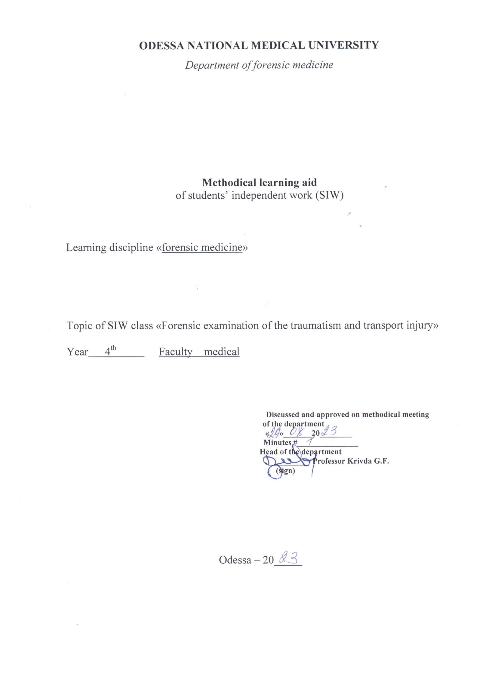
Theme “Forensic examination of the traumatism and transport injury”-6 h.

Motivational characteristics
Transport injuries is one of the most spread injuries. Death in the result of the transport accidents occur in large part of the cases. Transport traumatism, predominantly vehicular traumatism, is very high in Ukraine and it’s rates elevates on 15 – 20% annually. It places the first position in the structure of violental death. From the other hand it is the cause of invalidization and long-lasting health failure
That’s why doctor of any speciality should be acquainted with peculiarities of transport injury and signs, on which attention is paid during the forensic-medical examination of the affected person.

Educational aims

- Know the mechanism of development of the injuries resulted by various groups of transport
- Know the signs of each kind of transport injury, which are important during the forensic-medical examination
- Be able to perform the forensic-medical examination in the case of transport injury
- Be able to determine the cause of death, resulted by transport injury
- Be able to determine the degree of the gravity of body injury and seize of the loss of general working ability resulted by various kinds of transport accidents

Materials for the student’s independent work (interdisciplinary integration)

# | Discipline | Student should know | Student should be able to do
1. | Normal anatomy | Structure of the human skeleton
2. | Pathological anatomy | Pathomorphology of the inflammatory process | Determine the period and stage of the inflammatory process
3. | Traumatology | Traumatism and its outcomes | Determine the kind of traumatism

Content of the theme (text of theses), graphologic structure of the class
VEHICULAR INJURIES
Persons involved in vehicular accidents sustain a large variety of injuries. These injuries often assume definite pattern in the case of a pedestrian or a driver or a passenger. With increasing use of vehicles, such accidents are so common nowadays that a medical man may be asked to draw an opinion from the injuries found on the body. Although the distribution and severity of the injuries vary from case to case, there is some general underlying pattern common to most cases.

Injuries to Pedestrians
In the case of pedestrians, three patterns of injuries are often seen: primary impact injuries by the vehicle striking the victim, secondary injuries due to the victim falling on the ground, or other solid object, and run-over injuries due to the vehicle running over some part of the victim. The primary impact injuries are sometimes subdivided into two groups: those injuries due to initial impact of the vehicle, and those due to a subsequent impact with the same vehicle.
Primary impact injuries: These are direct injuries caused by the impact between the vehicle and the pedestrian. The height of the pedestrian often determines the site and nature of injuries. They are usually found on the head in children and on the side of the trunk in adults, due to the fender, lights, radiator, or bonnet hitting the body. If a pedestrian is struck from behind, he may sustain a fracture dislocation of the lumbar spine or thoracic spine. If he is facing the vehicle, he may sustain intra-abdominal injuries and/or injuries to the chest and thoracic contents. Sometimes, even the pelvis may be fractured. Bumper fractures, that is, fracture of the tibia and fibula of one or both legs, are often due to impact by the bumper. Absence of bumper injuries suggests that the victim was struck on the side by the vehicle. Not infrequently injuries are at different levels on the two legs suggesting that the victim was walking or running when struck. External injuries may be found in any region of the body, which has been struck by the vehicle and sometimes the pattern might correspond with some portion of the vehicle. The importance of scaled photography of such a patterned injury particularly in the hit and run type of accident cannot be over-emphasized as a means of preserving valuable evidence.
Secondary injuries: These are found on parts opposite to primary impact and on the head, and are due to the person violently falling on the ground. They are most pronounced over the unclothed areas of the body, but may be found also beneath the clothing, even if this remains intact. Injuries due to contact with the ground include abrasions and bruises over the head, legs, hands and hips, and lacerations over the bone prominences, and are usually soiled with traces of dirt. Fractures of ribs are common. Occasionally, the skull or cervical spine may be fractured. In these cases there is frequently contra-coup brain damage indicating that the injury was due to a moving head hitting a fixed surface. All kinds of intracranial hemorrhages and brain injuries may occur.
Run-over injuries: Children are often involved in accidents of this nature. The severity of injuries produced by the running over will depend upon the part of the body run over and the weight and speed of the vehicle. When a limb is run over by the wheel of a light motor vehicle, the skin and subcutaneous fat may be dragged away from the deeper muscles with or without any break in the continuity of the skin. If the wheel of a heavy vehicle passes over the head, trunk or extremity, that part is crushed. Tyre marks may be present on the unclothed parts or even clothed parts, if the clothes are not thick. The grease and oil stains from the undercarriage will be present on the clothing and wound. And the hot exhaust pipe under the vehicle may cause burns. If the wheel moves over the trunk, rupture of viscera may occur, and if it moves over a fleshy part, an avulsion injury may result. In vehicular accidents, specimen of hair from the victim should be taken for comparison with material which may be found on a suspected vehicle. A sample of blood should also be taken so that it may be analyzed for the presence and amount of alcohol, if any, since the question of contributory negligence may subsequently arise. The blood should also be grouped to facilitate subsequent comparison with suspect staining. The condition of the eyes as regards opacities of the cornea or lens or blindness should also be observed, as these may have contributed materially to the accident.

Driver or Passenger Injuries
When vehicles are involved in collisions with other vehicles, drivers or passengers may be thrown out from the vehicle on the road surface and usually sustain multiple injuries. Due to severe impact, the skull might fracture, the scalp might lacerate and on occasion, there may be fracture of the cervical spine, and in addition, there may be injuries due to contact with the ground. In traffic accidents, the driver may be thrown on to the steering wheel and may sustain lesions of the chest-wall, heart and liver, the so-called steering wheel injuries, if the impact is severe. Fractures of the knees and leg bones are also common, and laceration of the aorta at the level of the aortic ligament is by no means rare. He may sustain fatal head injuries and so also the passengers, if they are thrown against the windscreen, the side, or the roof of the vehicle. When fragments of broken glass or sharp metal penetrate the body, death may be caused by hemorrhage. Seat belts greatly reduce the risk of serious head injuries. The importance of seat-belts in the prevention of the injuries resulting from automobile collisions particularly those due to ejection from automobile cannot be over-emphasized. If the driver is alive, a sample of his blood should be taken, so that it may be analyzed for the presence and amount of alcohol, if any, and other commonly used drugs such as anti-histaminics, hypnotics, and tranquillizers, which have deleterious effect on concentration and performance.

RAILWAY INJURIES
These may be suicidal or accidental. A simple decapitation is commonly an indication of suicide and rarely accident. Traumatic amputation of the limbs or trunk is commonly an indication of accident or rarely a person throwing himself in front of a moving train. The nature of the injuries will depend upon the position of the person when struck. On electrified lines, electric burns and charring may be found, the extent of which will depend upon the duration of contact with the live rail, and may include bone.
Suicidal Injuries
If a person jumps in front of a train, the injuries are very severe and although primary impact may be demonstrated, usually they are too extensive to afford any helpful interpretation. On occasions, a simple decapitation may occur.
Accidental Injuries
These are sustained while walking on the rails or crossing them; while leaning out of the window; during a fall from a train; and during collisions.
Rail walking and crossing: While walking on the rails, the injuries are usually gross and consist of impact injuries caused by contact with parts of the front of the engine and secondary injuries due to being thrown and possibly run over. While crossing, the primary impact will be on the side and will usually involve the head and shoulders.
Leaning out of a window: This will produce almost exclusively head injuries, the injured person being either found in the carriage or on the side of the line.
Fall from a train: Such injuries are usually in the nature of multiple abrasions with impact injuries due to striking objects. Shock is usually a prominent feature.
Collisions: The victim will frequently show characteristic fractures of the legs similar to those found in motor car accidents. In addition, transmitted force may cause compression fractures of the spine. And, secondary injuries due to falling parcels or luggage usually occur.

Difficulties in Diagnosis of Death from Railway Accidents
While it may be difficult to give any opinion if the body is decomposed or badly crushed into pulp, it is possible in a number of cases to come to some definite conclusion by considering the following factors: scene of crime, injuries, hypostasis and rigor mortis.
Scene of crime: Evidence of extensive blood stains covering a large area may indicate that the person was living at the time of accident.
Injuries: Presence of marks of throttling or stab injuries definitely points to homicide. The nature of railway injuries, whether antemortem or postmortem, solves much of the problem. The age of the various injuries as determined by naked eye and microscopic examination are also helpful.
Hypostasis: The incidence, extent and degree of fixation of postmortem lividity is important. It may provide a valuable clue about the time since death, which may be different from the time of accident.
Rigor mortis: The presence and extent or absence of rigor mortis should be noted. It may offer supplementary evidence about the time since death.

AIRCRAFT INJURIES
These result from either crash accidents or flight accidents. Majority of aircraft accidents are crash accidents occurring while landing or taking off. Flight accidents are normally very few.
Crash Accidents
The sudden deceleration on crashing is responsible both for the break-up of the aircraft and for most of the injuries to the occupants. Both while landing or taking off, the passengers are usually secured to their seats by lap-type safety belts. On crashing, the forward moment of the upper part of the body across the safety belt throws the head on to back of the seat in front resulting in fractured skull. The impact may be sufficiently severe to cause rupture of the liver, spleen, kidney and abdominal aorta. Fire may occur in a fatal crash and complicate the primary injuries by incineration. The fire contains a high proportion of carbon monoxide fumes. Should therefore the occupants survive the impact as well as the fire, they are likely to be overtaken by carbon monoxide from the fumes before they can escape.
The great problem in the aircraft crash is that of identification since the bodies are either burnt and charred or are dismembered and scattered over a wide area, sometimes inaccessible for some days. The data for identification as detailed in the chapters on identification of mutilated bodies, and examination of decomposed bodies, mutilated bodies, fragmentary remains and bones would help to solve the problem.
Flight Accidents
The deliberate destruction of commercial aircrafts in flight has important medic-olegal implications. The main difficulty facing the investigators is to distinguish sabotage from explosive decompression due to structural failure.

Literature
Main:
1.Forensic Medicine B.V. Mykhailychenko, A.M. Biliakov, I.G. Savka ; Рік видання. —. 2019
Additional:
        - Bernard Knight. Simpson’s Forensic Medicine, Eleventh Edition. London. Sydney. Auckland, 1983
        - Thomas A. Gonzales. Legal Medicine. Second |Edition. New York
        - Journal of Clinical Forensic Medicine ## 1- 6 – 1999

Tests for self-control

1. Specific signs of vehicular injury:
1. One-sided injuries
2. Predomination of the internal injury over the external ones
3. Radiator print as an abrasion
4. Print of the clothes on the body
5. Contamination on the skin, which copies the tyre’s protector

2. Characteristic signs of vehicular injury:
1. Print of the protector
2. Skin ruptures
3. Change of the configuration of body part
4. One-sided fractures of the ribs
5. Print of the clothes on the body

3. Injuries to pedestrians are accompanied with:
1. Multiple abrasions on the body
2. One-sided ribs’ fractures
3. Two-sided ribs’ fractures
4. Focal hemorrhages in the ligamental apparatus of internal organs
5. One-sided vertical pelvic fractures

4. Evidential signs of the run-over injuries:
1. Compression of the head
2. Skin ruptures
3. One-sided ribs’ fractures
4. Two-sided ribs’ fractures
5. Lineal bruise on the body

5. Evidential signs of the driver or passenger injuries:
1. Fractures of the cervical part of vertebral column
2. Fractures of the chest
3. Localization of the injuries on the anterior body surface
4. Print of the detail, located inside the car
5. Arch-like bruise on the chest or abdomen

6. Injury, resulted by lorry and car, differs by:
1. Properties of the injuries
2. Localization of the bumper-fracture
3. Print of the protector on the skin and clothes
4. Localization of the signs of general contusion of the body
5. Properties of the skull’s fractures

7. Characteristic signs of railway injury:
1. Variety and spreadness of the injuries
2. Lines of abrasion resulted by the train wheels
3. Wedge-like defect of the tissue in the zone of contact
4. Deformation of the body
5. Two-sided vertical pelvic fractures

8. Dislocation of the internal organs is observed during:
1. Run-over crash
2. Bike crash
3. Contact car crash
4. Run-over by the train
5. Dragging of the body by the train

