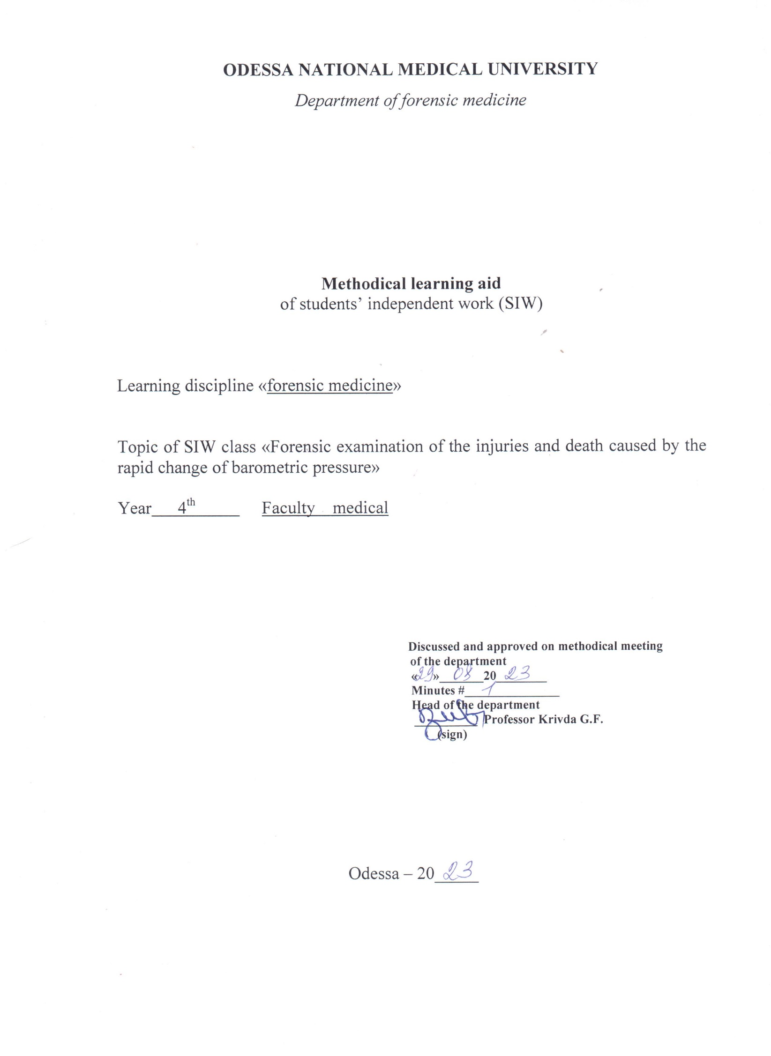
Theme “Forensic examination of the injuries and death caused by the rapid change of barometric pressure”

Motivational characteristics

Each doctor in its practice can face with the injuries, caused by the change of barometric pressure. Beside, in the case of investigatory necessity any doctor can be involved as forensic expert to perform examination of the injured person

Educational aims

Tasks

- Know the pathologic physiology of the injury
- Know the clinical signs during the barometric injury
- Be able to detect pathological changes in internal organs as a result of barometric injury
- Be able to examine the corpse on the scene of incident, if the barometric injury is suspected

Materials for the student’s independent work (interdisciplinary integration)

Discipline | Student should know | Student should be able to do
Previous disciplines:  Normal Anatomy  Biochemistry  Pathological physiology  Propedeutics of internal diseases | Structure of the internal organs  Biochemical changes, which accompany the barometric injury  Etiology and pathogenesis of barometric injury  Symptoms of barometric injury | Extract organs and tissues  Perform clinical, laboratory and appliance////////diagnosis

Content of the theme (text of theses), graphologic structure of the class

Circumstances of appearing of the injuries in the case of change of barometric pressure are various: dangerous situations in the planes, accidents during the diving, explosion works, during staying in the high mountains. During the barometric injury the intactness of the pulmonary tissue and blood vessels breaks, in the result of what air penetrates in organs, tissues and blood system. Gaseous embolism and pneumothorax develop. General effect on the organism of sharp increase of barometric pressure causes barometric injury of the lungs, organ of audition and accessory nasal cavities. Barometric injury of the organ of audition and additional (accessory) nasal cavities do not play role in the genesis of death.
It usually accompanies barometric pulmonary injury and is the evidence of the general sharp increase of atmospheric pressure.
Examination of the corpse during the suspected barometric injury is begun from the incision of chest.
2. Tests on air embolism (Syncov’s test). During performing of Syncov’s test the incision is begun from the manubrium of the stern, than its body is compressed on the level of the 2nd intercostals and is extracted. Margins of the incised pericardium are taken by the forceps. Water is filled in the pericardial cavity to cover the heart. Through the layer of the water by sectional knife the anterior wall of right ventricle is pierced. Bulbs of the air are the evidences of gaseous embolism (if signs of putrefaction are absent).
3. Tests on pneumothorax are performed. After the middle incision of the soft tissues (till the thoracic cavity is opened) from the lateral surface of the breast cutaneo-muscular part (like a pocket) is separated till the middle or posterior inguinal line. Pocket is filled with water. In the water near the cavity by the sectional knife not injuring the lung one of the intercostals gaps is cut. Bulbs witness about the pneumothorax.
4. Test with vascular plexus of the brain is performed: vascular plexi are extracted and put in the cold water after the incision of the brain. If the vascular plexus rises to the surface, than it is the evidence of the gaseous embolism, because gas in the vascular plexi appears only in severe putrefaction or during the arterial embolism.
5. Oval and round bulbs of the air are detected in the lumens of the vessels during the microscopical examination of non-colored vascular plexus, placed on the glass.
6. Test on presence of the air in the middle ear is performed: cavity of the skull is filled with water; cavity of the middle ear is incised through the pyramid of the temporal bone. Presence of the bulbs in the water is an evidence of gaseous embolism.
7. Macroscopical examination of the main vessels of arterial and venous channel is performed.
8. X-ray examination of carotid arteries and left part of the heart is performed to detect gas.

Forensic data of gaseous embolism

- Discovering the materials of the case it is necessary to definite the fact of staying of the dead person deep under the water and performing by him of Kasson works, using of the aqualung, proper appliance and so on.
- During the external examination of the corpse it is detected:
- acute cyanosis of the skin and mucous membranes;
- widely-spread livores mortis with multiple minipunctual hemorrhages;
- swelling of the eyelids;
- subcutaneous emphysema on the neck and on the breast;
- ruptures of the tympanic membrane with hemorrhages.
- During the internal examination of the corpse it is detected:
- enlargement of the pulmonary volume;
- multicolored appearance of the pulmonary surface and on the incision;
- changing of the emphysematous parts with hemorrhages and ruptures of the pulmonary tissue;
- hemorrhages in the mucous membrane of trachea and small bronchi;
- presence of the liquid blood or its coagulants in the tracheal cavity and in small bronchi;
- presence of the air bulbs in the blood coagulants;
- presence of the air emboli in the epicardial veins in main arterial and venous vessels, arterial and venous vessels of the internal organs, in the meninx, vascular plexus, mesentery, mediastinal vessels;
- plethora of the internal organs with multiple hemorrhages in serous and mucous membranes;
- injury of the structures of middle ear and tympanic labyrinth.
- Thin interalveolar septi with ruptures and ruptures of small bronchi with hemorrhages are detected during the histological examination.

General effect of the low atmospheric pressure on the human organism
Pathological changes, which occur during the decrease of atmospheric pressure, are caused by two main reasons: decrease of the partial pressure of the oxygen in the inhaled air and decrease of atmospheric pressure (decompression). Syndrome of explode decompression develops in the case of the sharp change of atmospheric pressure.
Evidences of the syndrome of explode decompression:
- crepitation during the palpation of the skin;
- presence of the gaseous bulbs in the foramens of the vessels of all internal organs;
- parts of inflation of the pulmonary tissue;
- regions of atelectasis;
- ruptures of alveoli and capillaries;
- small ruptures and hemorrhages, located along the bronchial bifurcation (they are clearly seen on the histological preparations during the small magnification of the microscope);
- hemorrhages in the accessory nasal cavities;
- hemorrhages and ruptures of tympanic membrane;
- injuries of the temporal bone;
- adipose embolism in capillaries of the large circle of blood circulation;
- erythrocytic agglutinates are detected in the liver; they appeare around the gaseous bulbs in hepatocytes in the result of intracellular forming of gaseous bulbs;
- enlarged endoplasmatic reticulum and changes nuclei (by histological examination);

Specific injury, which happens during the damage of the scuba –appliance is called compression of the diver. Decrease of the amount of the air in the scuba-shirt causes the compression of the chest by the surrounding water. Pressure under the helmet decreases (in the comparison with the surrounding).
Compression of the scuba diver in the helmet, what is accompanied by the fractures of the bones of skull, cervical part of the vertebral column, clavicles, scapulas, ribs, acute enlargement of the head and neck, swelling of the face, ruptures of the skin in the mouth angles, massive hemorrhages in the mucous membrane of the eyes, swelling of the eyelids, sometimes, protrusion of the eyes, massive hemorrhages in the orbital cellular tissue, and horizontal branch-like hemorrhages along the clavicles are observed during the acute change of the pressure.
During the internal examination it is detected: swelling and diffuse hemorrhages in soft tissues, acute plethora and swelling of the brain substance and meninges, hemorrhages in the soft meninx and perivascular hemorrhages in the brain substance.

Literature
Main:
      - Babanin A.A., Belovitskiy O.V., Skrebkova O.Yu. Forensic medicine: Textbook. – Simferopol, 2007. – 464 p.; 24 sh.ill.
Additional:
        - Bernard Knight. Simpson’s Forensic Medicine, Eleventh Edition. London. Sydney. Auckland, 1983
        - Parikh’s Textbook of Medical Jurisprudence and Toxicology. Fifth Edition. Bombay, India.
        - Thomas A. Gonzales. Legal Medicine. Second |Edition. New York
        - Journal of Clinical Forensic Medicine ## 1- 6 – 1999

Oriental card for student’s independent work with literature with the topic of the task

Main tasks | Instructions | Answers
Study  Clinical signs of barometric injury, pathologic physiology of barometric injury | Name the main etiological factors of barometric injury  Principles of diagnosing and expert criteria

Tasks for self control

Situational tasks

Task 1
Mr. K during the diving felt acute headache, feeling of heel, dyspnea. Soon salivation, sweating and acute tiredness developed. In some minutes Mr. K has died. During the forensic examination of the corpse general asphyctic signs were detected. During the special technical examination damage in the valve of inhalation was detected.
Explain the possible cause of the death

Task 2
After the diving in Mr. N developed a condition, which accompanied by the pain in the joints, skin itching, disturbance of the vision. In some time he lost his consciousness. While examining the case it was detected, that extraction from the water was very quick.
Explain the possible cause of the death

Task 3
Witnesses saw, than during the diving Mr. P began to do impulsive movements, and then calmed down and stopped moving at all. After his extraction from the water and releasing from the appliance, he lost his consciousness and in some minutes died. During the external examination it was detected: enlarged head and neck, swelling of the face, small skin rupture in the mouth angles, protrusion of the eyes and large hemorrhages in the cellular tissues of the orbits. Horizontal hemorrhages located along the clavicles. During the internal examination swelling and hemorrhages in the small tissues of the head, acute plethora of the meninges and substance of the brain were detected.
Explain the possible cause of the death

Task 4
A group of alpinists rised in the mountains over 5 km high. At first they were very gay and excited, and felt tiredness and drowsiness. Some of them had bleeding from the nose and ears. The leader called the rescue helicopter, alpinists were taken off the mountain and supplied by the medical care.
Explain the diagnosis

Tests for self-control

1. What organs can be affected by barometric injury?
A. Lungs
B. Heart
C. Ear
D. Kidneys
E. Accessory nasal cavities

2. Barometric injury develops when the pressure in lungs increases (decreases) on:
A. 20 – 40 mm of h c
B. 50 – 60 mm
C. 80 – 120 mm
D. 120 – 150 mm
E. 150 – 200 mm

3. What stages does the development of gaseous embolism contain during the barometric pulmonary injury?
A. Reaching of the air into the pulmonary capillaries
B. Reaching of the air into the pulmonary venous system
C. Air or gas reaches the left atrium
D. Air reaches the left ventricle
E. Air reaches the aorta and arteries of large circle of blood circulation

4. Morphological signs of barometric injury are:
A. Blood in trachea and bronchi
B. Enlargement of the lungs
C. Large focal hemorrhages in pulmonary tissue
D. ruptures of the walls of small bronchi and interalveolar septs
E. Hemorrhages in the lumen of respiratory tract and peribronchial septs

5. Possible causes of death during barometric injury:
A. Gaseous embolism of the arteries of the brain
B. Acute blood loss
C. Adipose embolism
D. Two-sided pneumothorax
E. Pneumonia

6. Morphological signs of barometric injury of organ of audition and nasal cavity are:
A. Fractures of the nasal bones
B. Hemorrhages in the tympanic membrane
C. Hemorrhage in the external acoustical pore
D. Injury of the structures of the middle ear and acoustic labyrinth
E. Ruptures of the tympanic membrane

7. Build the stages of the toxic effect of oxygen during the elevation of the pressure:
A. Disappearance of the excitability of chemoreceptors of the blood channel
B. Slowing of respiration
C. Decrease of the volume of circulating blood
D. Narrowing of the vessels
E. “Asphyxia” of the tissues

8. Possible causes of the death of the man when diving on the depth in scuba-diver appliance are:
A. Poisoning by nitrogen
B. Poisoning by carbon dioxide
C. Poisoning by carbon oxide
D. Poisoning by the substances, which form methemoglobin
E. Poisoning by oxygen

9. What mixture prevents the poisoning in scuba-diver appliance?
A. Oxygen-helium
B. Oxygen
C. Air
D. Oxygen-hydrogen
E. Oxygen-nitrogen

10. Clinical signs of decompression are:
A. Pain in joints
B. Skin itching
C. Disturbance of the vision
D. Paralysis
E. Loss of consciousness

11. Factors, which cause the pathological changes from the effect of decreased atmospheric pressure:
A. Decrease of the partial pressure of the oxygen in the inhaled air
B. Decrease of the atmospheric pressure
C. Increase of nitrogen dioxide in the inhaled air
D. Elevation of the partial pressure of the nitrogen
E. Elevation of the atmospheric pressure

12. External signs of the compression of scuba diver:
A. Acute enlargement of the head and neck
B. Cyanosis and swelling of the face
C. Ruptures of the skin in the mouth angles
D. Hemorrhages in the cellular tissue of the orbits with protrusion of the eyes
E. Horizontal hemorrhages along the clavicles

13. External signs of the compression of scuba diver:
A. Hemorrhages under the endocardium of the left ventricle
B. Plethora and swelling of the substances and meninges of the brain
C. Hemorrhages in soft meninx and in the brain substance
D. Hemorrhages in the mucous membrane of the stomach
E. Swelling and hemorrhage in soft tissues of the head, face and neck

14. Pathological changes during the “mountain disease” develop in such stages:
A. Excitability of chemoreceptors of the vessels of glome and arch of aorta
B. Rapid evacuation of the carbon dioxide from the organism
C. Suppression and paralysis of the respiratory center
D. Irritation of the respiratory center
E. Pulmonary hyperventilation

15. The main evidence of the death during the oxygen insufficiency during barometric injury is:
A. Characteristic clinical signs
B. Data of the circumstances of the death
C. Specific morphological picture
D. Data of special technical investigations
E. Exclusion of the injuries, diseases and poisonings

