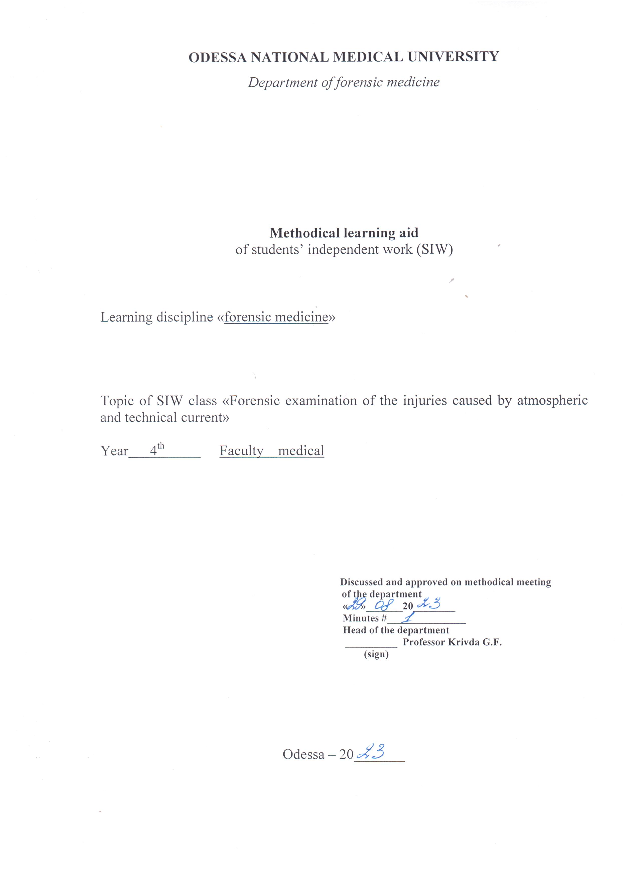

Theme “Forensic examination of the injuries caused by atmospheric and technical current”

Motivational characteristics
Injuries by electric current are specific; knowledge on this theme is necessary for prophylaxis of such injuries, in-time supply of first aid means and forensic examination of the death caused by technical or atmospheric current.

Educational aims:
Study the course of the injuries by technical and atmospheric current and peculiarities of forensic examination of the corpse to detect and to prove the causes of the death in such cases

Tasks
- Know mechanism of the effect of electric current on the human’s organism
- Know methods of detection of mineral content of objects of biological origin
- Know peculiarities of the course of injuries by technical and atmospheric current
- Know peculiarities of inspection of the scene of incident in the case of electric current injury
- Be able to explain the death’s cause in the case of injury by technical and atmospheric current
- Be able to perform color reaction on iron, aluminum, cuprum, etc.

Materials for the student’s independent work (interdisciplinary integration)

# | Discipline | Student should know | Student should be able to do
1. | Physics | Effect of the electric current on the human’s organism
2. | Pathological anatomy | Tissues, extracted for histological examination | -

Electric injury occurs during the accidental contact with the source of current. Also injuries by technical current occur in the case of “step current” and in the case of “current flows”.
Technical characteristics of electric current – voltage, amperage, kind of the electric current, resistance of the skin, kind of the electric loop, duration of the contact.
Human factors –age, sex, weight mass, physical condition, presence of alcoholic intoxication – have also a direct influence on the outcome of the injury.
Physiological phenomena (things), which occur during the contact with the source of the current, depends on amperage of the current and manifests by the threshold feeling of its effect (0,6 – 1,5 mA) till the hand ache (5 – 7 mA) with convulsions, stupor (8 – 10 mA) and life danger (beginning from 25 mA).
Electric current has a specific and non-specific effect on the human organism.
Specific influence (effect):
- biological effect – irritation of skeletal muscles, muscles of internal organs, endocrine glands, nervous receptors;
- electrolytic effect – decomposition of liquid electrolytes of the body, disturbance of cellular membranous potential, ionic balance, skin impregnation by the metal;
- heat effect – forming of burns, melting of the bones;
- mechanic effect – dislocation and abruption of the extremities.

Non-specific effect is a result of secondary phenomena, which accompany the electric processes. Contact with current flows or scorching wire cause burns and inflammation of the clothes. Mechanical injuries appear, when the body is thrown back.
In the critical voltage (43 V) electric current crosses the skin resistance and spreads all over the body according to the current flows. Electric mark forms in the places of entering and exit of electric current.
Death because of technical current can occur in the result of cardiac fibrillation and myocardial ischemia in the result of coronar spasm, paralysis of respiratory center, simultaneous stop of respiration and cardiac activity (mixed form) and electric shock.
As for the kind of the death electric trauma is most always an accident, but also suicides and murders with sources of technical current occur.

Forensic examination of the death from technical electric current
Inspection of the scene of incident:
- During the inspection of the scene of incident it is necessary to switch off the source of technical electric current;
- It is necessary to be sure, that current flows between the body and source of technical current is broken

Examination of the corpse on the scene of incident
- Death is verified according to the signs of death, if they are absent, reanimation means are performed;
- Source of technical electric current, with which human contacted, is detected
- Position of the body as for the source of current is detected
- Examine the source of technical electric current and search there parts of biological origin – epidermis, hair, blood, which are taken of the forensic immunological examination
- Describe the corpse on the scene of incident. Especial attention is paid on the injuries on the body and clothes

During the examination of the clothes attention is paid on its condition – dampness, kind of a tissue, its thickness, deformation, presence of the signs of thermal (burning) or mechanic (rupture) effect of the current; on shoes – presence of melted nails, signs of burning
During examination of the corpse it is necessary to pay attention on the places of body’s contact with source of technical current, where electric marks can locate.
Electric mark is a thick forming, usually light-yellow- or grey-yellow-colored, oval-from, bottom, which is sunken, and elevated margins. It can look like abrasion or roseola. Electric marks can be atypical: dislayering (separation) of epidermis, regions of skin’s compression, superficial wounds, burnt hair with their curling and change of the skin’s color.

Forensic autopsy of the corpse
1. During the autopsy electric marks are described thoroughly and signs of sudden death are detected.
2. Material for laboratory analysis:
a) electric marks
- forensic histological examination is performed to detect the changes in the skin caused by electric current;
- forensic medical-criminalystic examination is performed to find out the metallization, which has the origin from the current conductor. Control of intact skin is necessary from the symmetric region;
- on hysto-chemical examination character changes from the effect of electric current and vital reactions are detected;
- on biochemical examination to detect the vital skin reaction. Control of the intact skin from symmetric region is necessary.
b) blood (5 ml) from the cavities of the right and left cardiac ventricles on the photometric examination to detect electrolytic disturbances in the blood, serum and erythrocytes;
c) pieces of internal organs on forensic histological examination;
d) blood and urine on forensic toxicological examination (to detect alcohol)
Results of laboratory analyses of electric marks
Electric mark has such histological signs:
- coagulation necrosis of skin layers;
- presence of cavities in the epidermal layers;
- separation of the horny layer or epidermis with forming of the vesicle;
- forming of the focal decomposition in the basal skin layer, homogenization and stratification of dermal fibers;
- stretching of the basal layer cells, epithelial cells of hair follicles, secretion ducts of sebaceous and sweat glands.
Decrease of nucleic acids and acid glucosaminoglycanes are detected in the electric marks histologically.
Elevated level of serotonin and free histamine are detected during biochemical test.
It is necessary to detect metallization from the current source. Metallization is detected on the clothes, if the injury occurred through it.
Metallization is detected by:
- macrochemical reactions on paraffin cuts, if the kind of the metal is known;
- contact-diffuse method;
- modern chemical-analytic methods of analysis of chemical elements, emission-spectral analysis, atomic-absorb spectro-photometric analysis
Increased level of the metal in electric mark in comparison with its level in control is the evidence of metallization.
During the fire-photometric examination of the blood changes of electrolytic content are detected – increase of K/Na coefficient in the blood, erythrocytes and blood serum.

Injury caused by atmospheric electricity
Injuries by lightning usually occur in the summer, especially in the regions with increased thunderstorm activity. Lightning can injury human in direct way or by electric appliance, phone or radio. Both lethal and non-lethal injuries occur.
Lightning causes injuries by its mechanic, heat and electrolytic effect.
1. Examination of the corpse on the scene of incident begins from death’s verification. Attention is paid on:
- presence of the destroyed burnt trees;
- location of the clothes on the distance from the corpse;
- presence of “fulgurites” in the sand;
- throwing of the human body back from the high objects, effected by the lightning, because of the increased air pressure;
- presence on the corpse of “lightning figures”

Forensic autopsy of the corpse
During the examination of the clothes such signs are detected:
- of mechanic effect: ruptures of the clothes with strict and burnt edges; miscorrelation between the injuries of the body and damages of the clothes, separation of the clothes’ parts and throwing them away from the corpse, damages of the underwear with intactness of the clothes;
- of heat effect: spindle-like thickening of the wool or synthetic fibers in the places of ruptures, melting of the metal buttons, presence on the sole of the shoes with melted nails;
- electrolytic effect: rarefied or decomposed wool or viscose threads.

On the examination of the body it is detected:
- cataleptic rigor mortis;
- quick spread of rigor mortis;
- “lightning figures” on the skin;
- manifestation of the lightning’s mechanic effect (presence of the foramens on the skin with burnt margins, different forms of the skin injuries in the entrance and exit of the lightning);
- manifestation of heat effect (charring of epidermis and skin, burns and burn vesicles without fluid; burnt hair, “photos” of the metal parts of the clothes with metallization of the skin, charring of the hair with vacuolization, presence of microcraters, which look like “melted glass”);
- signs of sudden death, numerous small ruptures with hemorrhages in the lungs, encephalon and other organs;
- coagulation necrosis of epidermis and superficial layers of the skin and preserved general condition of the skin are detected during histological examination of the skin from the entrance of the lightning in the body

Literature
Main:
      - Babanin A.A., Belovitskiy O.V., Skrebkova O.Yu. Forensic medicine: Textbook. – Simferopol, 2007. – 464 p.; 24 sh.ill.
Additional:
        - Bernard Knight. Simpson’s Forensic Medicine, Eleventh Edition. London. Sydney. Auckland, 1983
        - Parikh’s Textbook of Medical Jurisprudence and Toxicology. Fifth Edition. Bombay, India.
        - Thomas A. Gonzales. Legal Medicine. Second |Edition. New York
        - Journal of Clinical Forensic Medicine ## 1- 6 – 1999

Oriental card for student’s independent work with literature with the topic of the task

Main tasks | Instructions | Answers
Study  1. General information | Concept “electric trauma”  Electric trauma in the case of step voltage  Standard current loops
2. Peculiarities of the electric current effect | Specific effect  Non-specific effect
3. Diagnostic means of the death from the technical current effect | Electric mark  Macro- and microscopic examination of electric mark  Color and macrochemical reactions on the metals
4. Injuries from the atmospheric electricity | Lightning  Forms and spread of the “lightning signs”
5. Peculiarities of the corpse’s examination, affected by the lightning

Tests for self-control
Choose one correct answer
1. What trace can remain on the body of injured person from the effect of technical electricity?
1. Scalds, necrosis
2. Electric mark, metal’s impregnation
3. Electrogenic swelling
4. Injury
5. Each of mentioned traces or their combination

2. Which sign is peculiar for the electric current’s effect on the human body?
1. Electric mark
2. “Figure of flashlight”
3. Electrogenic swelling
4. Epidermolysis
5. Each of mentioned signs or their combination

3. Which is the main factor of effect of electric current on the human organism?
1. Strain
2. Strength of current
3. Lasting of the effect of electric current
4. Frequency of amplitude of the current
5. Resistance

4. During which organism’s condition effect of electric current reduces?
1. Tiredness
2. Sleep, narcosis
3. Overheating
4. Alcoholic poisoning
5. Excitement

5. All mentioned factors intensify the effect of electric current, except:
1. Age (children or aged persons)
2. Cardio-vascular diseases
3. Elevated excitement
4. Diseases of nervous system
5. Condition of sleep or narcosis

6. What peculiarities of electric mark characterize the contacting with the body of conductor?
1. Signs of charring
2. Form of electric mark
3. Depth of electric mark
4. Metalization
5. Disturbance of histostructure of the skin

7. Which method can detect the metal traces in the region of electric mark?
1. Visual
2. Microscopic
3. Contact-diffusive
4. Spectroscopic
5. Photographic

Choose several correct answers
8. Who participates in inspection of scene of incident during the injury by electric current?
1. Forensic-medical expert
2. Investigator
3. Expert-engineer
4. Doctor of ambulance

9. What is considered to the conditions of effect of electric current?
1. Resistance of body tissues
2. Place, square of the contact with electric conductor
3. Period of current’s effect
4. Way of current’s spreading through the organism
5. Physical condition of the victim

10. Which meteorological conditions contribute to the development of electric injury?
1. Humid rainy weather
2. High environmental temperature, when sweating intensifies
3. Houses with increased humidity (bath-house, bathrooms, etc.)
4. Speed of air circulation
5. Change of atmospheric pressure

11. What is the mechanism of current’s effect on the human organism?
1. Heat effect
2. Mechanical effect
3. Electrolytic effect
4. Ionized effect
5. Toxic effect

12. What kind of death can occur in the result of electric current’s effect?
1. Instantly
2. Slow
3. Interrupted
4. Late
5. Sudden

13. Which of mentioned below morphological signs are detected on the autopsy of the corpses of persons, who died because of electric injury?
1. Fractures and fissures of the bones
2. Melting of the bone with forming of balls – “jewels”
3. Ruptures of internal organs, their plethora and swelling
4. Small-punctual hemorrhages in the substances of the brain
5. Dislocation in the joints

14. Which of the mentioned below signs are peculiar for the injuries by electric current?
1. Anisocory
2. Necrosis of the muscles by the way of current’s spreading, which look like “boiled meat”
3. Increased pressure of spinal liquor
4. Presence of electric marks
5. Skin maceration

15. Which of the mentioned below signs are peculiar for the injuries by atmospheric current?
1. Burns of the body of various square and depth
2. “Flashlight figures” on the corpse’s skin
3. Ruptures of the clothes and its burning
4. Melting of the metal objects
5. “Fulguration” of the skin

16. Which of the signs of flashlight’s effect can be detected on the place of corpse’s detection?
1. Broken glass
3. Broken and charred objects
4. Parts of torn clothes
5. Smell of ozone

