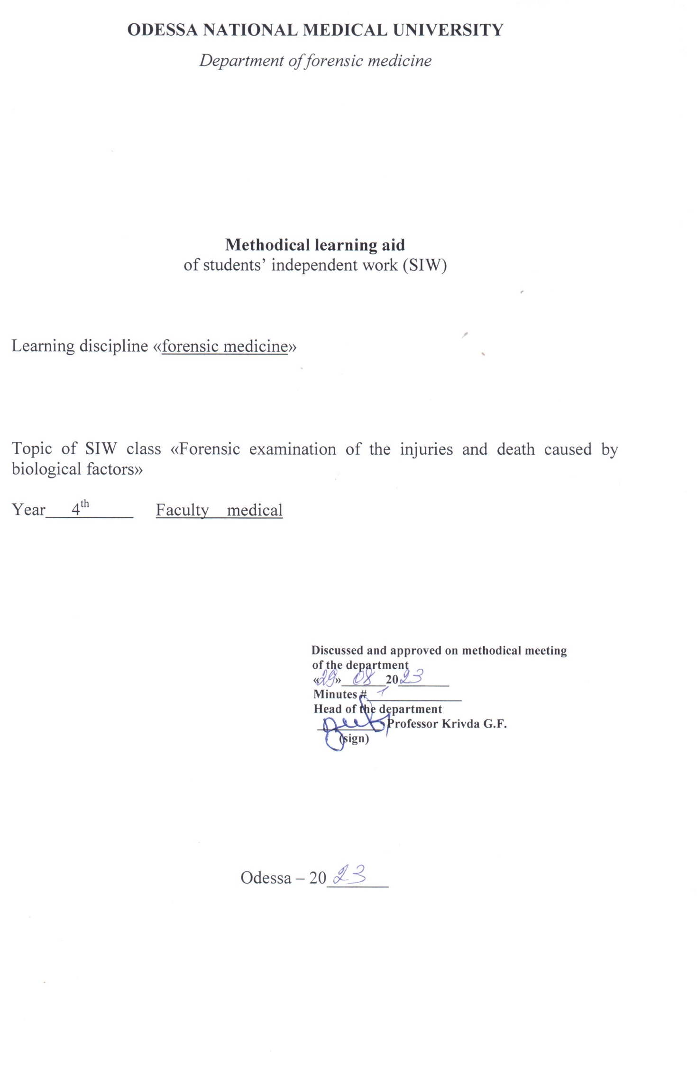
Theme “Forensic examination of the injuries and death caused by biological factors” 4h.

Motivational characteristics
Poisonings, which require the forensic-medical examination, occur often. They can be inflicted by purpose (suicide or homicide) or accidental – in medical practice, at home, on the factory and in other conditions. Suspictions on the poisoning appears if the death was sudden, when completely healthy person dies, often after eating, drinking or taking some drugs. There are many substances, which can result poisoning. Some of them are very dangerous because of their toxicity, some – during usual using do not cause poisoning, and some are even present in food. Some of them are widely spread and can be freely bought, sale and protection of the others, especially those, which are used in medicine and techniques, are controlled by special rules, instructions. That’s why cases of poisonings are thoroughly studied. Bacterial food toxins (food poisons) and non-bacterial food poisons compose the largest part of poisonings resulted by biological factors. Some food can result poisoning with considerable health disturbance or even death.

Educational aims

- Know the poisons classification
- Know the mechanism of the poisons’ effect on human organism
- Know the conditions, when the bacterial and non-bacterial poisons begin to act
- Know the diagnosing of the poisonings, resulted by bacterial and non-bacterial poisons
- Know the biological materials, which should be extracted during the forensic-medical examination of the poisonings, resulted by bacterial and non-bacterial poisons.
- Be able to determine and diagnose the poisonings resulted by bacterial poisons
- Be able to determine death, resulted by bacterial food poisons
- Be able to extract the objects for forensic –toxicologic examination during the poisoning resulted by bacterial food poisons

Materials for the student’s independent work (interdisciplinary integration)

# | Discipline | Student should know | Student should be able to do
1. | Biochemistry | Biochemical reactions, which determine the poisons of biological origin
2. | Pathological anatomy | Tissues, which are extracted for histological examination

Content of the theme (text of theses), graphologic structure of the class

Food poisoning is a vague term. It may be used in a general sense or in a special sense. When the term is used in its general or wider sense, it includes all illnesses resulting from ingestion of foods containing non-bacterial or bacterial products. When the term is used in its special or restricted sense, it means that the poisoning is due to bacterial products only. The non-bacterial products include poisons derived from plants and animals, and inorganic chemicals. Foods containing such products are, by convention, known as poisonous foods. The bacterial products include bacteria and their toxins. The poisoning resulting is known as bacterial food poisoning.
The illness is characterized by (1) simultaneous attack of many persons at the same time (2) history of ingestion of common food by all sufferers, and (3) similarity of signs and symptoms in a majority of cases.
BACTERIAL FOOD POISONING
This is of three types: infection type, toxin-type and botulism. Ptomaine poisoning due to advanced decomposition of food is not common.
Infection type: This type of food poisoning results from ingestion of viable microorganisms that multiply in the gastrointestinal tract producing a true infection, as for example, salmonella group of organisms.
Toxin type: This type of food poisoning results from poisonous substances produced by multiplying organisms that have gained access to the prepared food, as for example, enterotoxin produced by the staphylococcus.
Botulism: This type of food poisoning results from the ingestion of preformed botulinum toxin in the preserved food. The toxin is produced by Clostridium botulinum.
Infection Type
In this type of food poisoning, the organisms multiply in the gut and cause gastroenteritis. The common organisms responsible for the attack are the Salmonella group of organisms. Occasionally, the shighella group of organisms may be responsible.
The natural reservoir of salmonella organisms is in certain birds, mammals and reptiles. Food may be contaminated with infected excreta of mice or rats, or infection may be transferred by flies or by human carriers employed in the handling of food. Shighella infection is the result of contamination of food or water supplies with the faeces of the individuals who either have the disease or, less often, are asymptomatic carriers of the organism.
The types of foods, which are particularly likely to be infected are twice cooked meat dishes, fish dishes, soups, custards, milk, cream, ice-cream, and tinned foods which, though initially sterile, may become infected if not immediately consumed after the tin has been opened. Occasionally, but not usually, there may be visible change in the character of the food. The outbreak of salmonella food poisoning is likely to occur whenever large amounts of food are prepared and the unconsumed food is kept for future meals. Accordingly, such food poisoning is reported far more frequently from canteens, restaurants, hospitals and other institutions than from private houses.
Symptoms and signs: There is a great variation in the susceptibility of individuals to salmonella food poisoning. Some participants may remain free from symptoms, others may be severely affected.
The condition is not merely a toxaemia, but also a gastroenteritis caused by bacterial infection. The incubation period is longer than the staphylococcal food poisoning. The organisms multiply in the intestine and a delay of twelve hours or more is usual before symptoms occur. The onset is sudden and sometimes a chill will be the initial symptom, followed by headache, nausea and vomiting, severe abdominal cramps, and marked prostration. Three characteristics that help to differentiate this from poisoning with staphylococcal enterotoxin are: muscular weakness, fever and persistent, very foul smelling diarrhea. The diagnosis rests on the isolation of the causative organism from the patient and suspected articles of food.
Postmortem appearances: These are those of gastroenteritis and general toxaemia. The mucosa of the stomach and small intestine show varying degree of inflammation and even ulceration. In severe cases, the lesions may extend to the large intestine. The liver, spleen, kidneys and lungs are congested.
Toxin type
This type of food poisoning is caused by toxins formed in the food before ingestion. The majority of cases are due to some strains of staphylococci, viz, Staphylococcus aureus and Staphylococcus albus (coagulase positive strain), which produce enterotoxin. This enterotoxin is an exotoxin, which is fairly stable to heat and will resist boiling. Other toxin-producing organisms, which may give rise to food poisoning are Proteus vulgaris, Streptococcus viridans (milk streptococci). The bacteria may be destroyed in the process of cooking, but the enterotoxic substances produced by them are resistant to heat and may be present in food.
For the production of this type of poisoning food must be contaminated by a strain of organism that produces enterotoxin, the type of food must be suitable for growth of this organism and the infected food must be kept at a temperature suitable for bacterial growth for a sufficiently long time so that an appreciable quantity of enterotoxin is formed. Food such as milk, custard, cream (the filling of cakes), and previously prepared meat dishes are the chief sources of staphylococcal food poisoning.
Symptoms and signs: The toxin is already present in the food and therefore the symptoms develop rapidly within one to four hours. The first symptom is salivation followed by gastroenteritis. The gastroenteritis is sharp and severe, and is usually over in 24 hours. Recovery is the rule.
Unlike salmonella food poisoning, this condition is not an infection. But like botulism, it is the result of ingesting preformed toxins contained in the food. However, staphylococcal food poisoning differs considerably from botulism in that symptoms appear rapidly and are mainly gastrointestinal, they are of short duration, and recovery is usually prompt and complete.
Postmortem appearances: These are the same as those found in salmonella food poisoning.
Botulism
The term botulism is derived from 'botulismus' meaning a sausage, since large outbreaks of the disease were first observed following ingestion of improperly cooked sausage. The causative agent is an anaerobic spore forming bacillus, Clostridium botulinum, which produces an exotoxin. The organism and its spores are heat resistant. The organism is a natural saprophyte and is commonly found in the soil. The toxin is therefore likely to be present in such soil contaminated undercooked or canned foods. When anaerobic decomposition is present, the tin may be 'blown' and such canned foods should be discarded straightaway. The foods that are most often responsible are meat, fish and vegetables. It is important to remember that the toxin is destroyed by heat at 80 C⁰ for 30 minutes and therefore adequate cooking gives protection against it. The toxin paralyses the muscles by blocking nerve impulses at the myoneural junction.
Symptoms and signs: The symptoms are mainly of a nervous nature and there is a little irritation of the gastrointestinal tract. They commence within 12 to 36 hours. The initial symptom is usually diplopia from ocular muscle palsy. Both internal and external ocular muscles may be affected. Involvement of the pharynx with difficulty in swallowing soon follows. Involvement of larynx also ensues and articulation becomes faulty. The picture is thus one of bulbar palsy. Respiratory paralysis with extension to the breathing centre closes the scene. Only in a very few cases, there is nausea, vomiting, abdominal pain and diarrhea. The temperature is normal or subnormal throughout. The unfortunate victim is usually conscious to the end. The fatal dose of contaminated food may be less than 5 grams. Death may occur within 24-48 hours or may be delayed for a week.
Postmortem appearances: The pathological changes consist of congestion and hemorrhages in all the organs and especially in the central nervous system. Degenerative changes occur in the liver and the kidneys.
Medicolegal Aspects
Food poisoning in its epidemic form is properly the concern of the Medical Officer of Health, though in special circumstances, as for example a sporadic case, medicolegal issues may be involved. A number of people are affected at the same time and diagnosis poses no problem. In some instances, however, only one or two persons may be affected, and if food poisoning is not thought of, the diagnosis may be missed and a suspicion of poisoning from other sources may be aroused. Further, in case of attempted poisoning, it may be alleged that the symptoms are due to some article of food or drink, or, in poisoning by alkaloids. A medical practitioner coming across a case of food poisoning from a hotel must report it to public health authorities.
POISONOUS FOODS
By usual implication, this term excludes conventional food poisoning by bacteria and their toxins and is restricted to poisoning by articles of food due to contained toxic principles, metallic contamination, and food allergy.
The articles of food containing toxic principles are poisonous food grains, infected rye, adulterated oil, and poisonous mushrooms.

Rye: The parasitic fungus is known as claviceps purpurea. The symptoms which are associated with the eating of infected rye flour may be local, including vasomotor constriction and even gangrene of the extremities, or generalized in the nervous system with formication and paroxysmal convulsions. The poisoning is known as ergotism and may occur in an epidemic form. The type of ergot poisoning that occurs depends on the amount ingested. If bread contains about 10 per cent ergot or somewhat less the convulsive type of poisoning predominates. Gangrenous type predominates if the concentration of ergot is more than 10 per cent. LSD is synthesized from rye ergot. It is possible that infected rye flour may under some conditions give rise to hallucinatory symptoms, allied to LSD.
Mushrooms: Certain species of mushrooms are non-poisonous and used as articles of food. Others are poisonous and cases of accidental poisoning occasionally occur from one of the poisonous ones being mistaken for an edible variety. Many cases of poisoning are due to the mistaken belief that a poisonous mushroom can be distinguished from the edible one because the skin of the poisonous kind cannot be peeled from the cap.
In Europe, the species mainly met with are amanita phalloides and amanita muscaria. Amanita phalloides, also known as death cap, contains a heat stable polypeptide principle, which damages cells throughout the body. Liver, kidneys, brain and heart are specially affected. The toxic principle is rapidly bound to the tissues. Amanita muscaria is used for killing flies. It contains in variable amounts a heat labile atropine-like alkaloid, a substance that causes narcosis, convulsions and hallucinations, and a heat stable alkaloid, muscarine, which stimulates smooth muscles and those organs supplying the parasympathetic nervous system and thus resembling closely the action of acetylcholine on those structures.
Amanita phalloides, has an incubation period of about ten hours. The symptoms include severe nausea, vomiting, diarrhea, bloody vomitus and stools, enlarged tender liver and jaundice, oliguria or anuria, pulmonary edema, mental confusion, and cerebral injury with convulsions or coma. The mortality is about 50 per cent. Amanita muscaria has a latent period of two to six hours. The symptoms of poisoning consist of excitement, delirium, salivation, vomiting, diarrhea, slowed pulse, and muscular tremors. Death from amanita muscaria is rare.
Ingestion of even a part of one mushroom of a dangerous species may be sufficient to cause death which may take place in three to six days.
The general treatment of mushroom poisoning is symptomatic. Atropine counters the cholinergic effects of toxic mushrooms. Corticosteroids may prove useful and should be given atrial.
The pathologic findings in fatalities from mushroom poisoning are: marked postmortem lividity, diminished rigor mortis, inflammation of the gastrointestinal mucosa, fatty degeneration of the liver, kidneys, heart, and skeletal muscles, and hyperemia of the meninges. Petechial hemorrhages into the serous membranes are common. Mushroom spores can be recovered from the intestinal contents of the victim. Each mushroom has characteristic spores.
Food Allergy
This is due to sensitivity to certain articles of diet, usually proteinaceous in nature. It is followed by an illness characterized by nausea, vomiting, diarrhea, fleeting joint pains, and urticaria. Edema of the glottis and asthmatic seizures may also follow. Many articles of food are implicated. In this, the individual factor plays a very important part. Diagnosis is generally not difficult.

Literature
Main:
        - Parikh’s Textbook of Medical Jurisprudence and Toxicology. Fifth Edition. Bombay, India.
      - Babanin A.A., Belovitskiy O.V., Skrebkova O.Yu. Forensic medicine: Textbook. – Simferopol, 2007. – 464 p.; 24 sh.ill.
Additional:
        - Bernard Knight. Simpson’s Forensic Medicine, Eleventh Edition. London. Sydney. Auckland, 1983
        - Thomas A. Gonzales. Legal Medicine. Second |Edition. New York
        - Journal of Clinical Forensic Medicine ## 1- 6 – 1999

