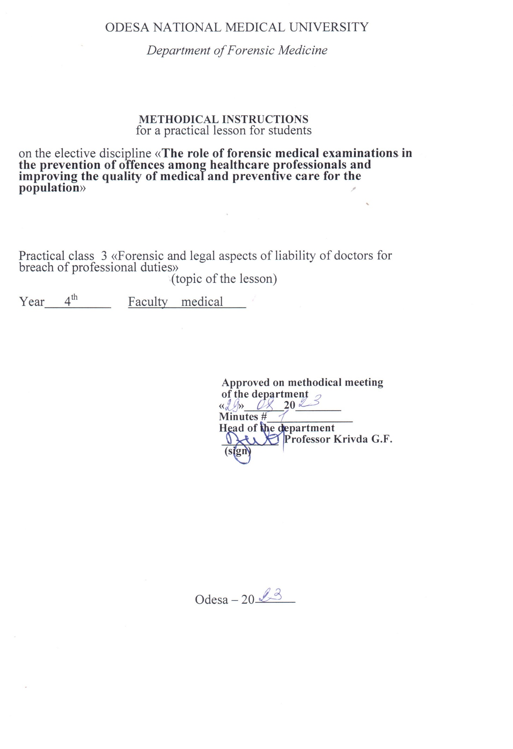

1. topic of the lesson:
"Forensic and legal aspects of liability of doctors for breach of professional duties" - 2 hours.

2. Relevance of the topic:
In the course of investigating cases involving crimes against human health and life, the investigation raises questions that require medical and biological knowledge. The resolution of such issues is entrusted to forensic medical examination and specialists - forensic medical experts. According to the current legislation, if necessary, a doctor of any speciality may be involved in forensic medical actions. Therefore, knowledge of the organisational foundations of forensic medical examination and the procedural rules governing forensic medical expert activity is essential for doctors of any speciality.

3. Objectives of the lesson:
3.1. General objectives: to acquaint students with the organisation of the forensic service in Ukraine, procedural rules and legislative regulations governing its conduct.
3.2. Educational objectives: to acquaint students with historical information about the impact of departmental subordination and the peculiarities of socio-economic formation of society on the objectivity of forensic medical examination on the example of the cases of the Multan Votyaks, Baylis, Sannota Vanzetti, and the Katypi event. To acquaint students with the activities of prominent forensic physicians of Ukraine - Bokarius M.S., Kontsevych I.O., Raiskyi M.I., Rubeshansky A.F., Sapozhnikov Y.S., Fadeev A.M. and their contributions to the development of the theory and practice of forensic medicine.
3.3 Specific goals:
- to know:
1. the concept of codes, their types and the issues they regulate;
2. "The Fundamentals of Ukrainian Healthcare Legislation and in particular Articles 6, 7(e), 69, 71, 72, 73 and be able to interpret them;
3. organisation of the forensic service in Ukraine.
4. the structure of the bureau of forensic medical examination and the functions of its departments;
5. the rights, duties and responsibilities of physicians and be able to use them when performing forensic expert functions.
3.4. Based on theoretical knowledge of the topic:
- be able to:
1. to use and interpret Art. of the Fundamentals of the Legislation of Ukraine on Healthcare";
2. use and interpret the articles of the Criminal Code (CC) and the Code of Criminal Procedure (CCP) of Ukraine;
3. to use the Order of the Ministry of Health of Ukraine No. 6 "On the Development and Improvement of the Forensic Service of Ukraine" (1995);

4. Materials for classroom self-study (interdisciplinary integration).
№ | Disciplines | Know. | Be able to.
n/a
1 | 2 | 3 | 4
1. | Previous  discipline.  1. Social.  medicine, management  and the economics of security  health with a course in the basics of law. | The concept of codes, their  The types and issues that  They regulate;  "Fundamentals of legislation  of Ukraine on protection  Health" | Use.  and  interpret  Art.  legislative  documents.
2. | The following disciplines | - | -
3. | Intersubjective  integration.  Forensic medicine  expertise. | Knowledge of the organisation  of the forensic service in  Ukraine, the rights, duties and responsibilities of a forensic medical expert (expert physician)
 | 1. SMEs - living persons with  determining the degree  severity of bodily harm  damage. | Order of the Ministry of Health No. 6 "On  development and improvement  forensic service  Ukraine" (1995). | Use.  rules  judicial  medical determination of the severity of injuries.
 | 2. Examination of the corpse at the place of discovery | Art. | Art. of the CPC of Ukraine
 | The corpse's medical examiner |  | Use.  rules  holding  forensic  examinations  corpses in the bureau  forensic  expertise.

5. Content of the topic:
The distribution of examinations by medical care profiles is uneven. The largest number of medical cases concerned the activities of surgeons of all specialities, obstetricians and gynaecologists, dentists, anaesthetists and resuscitators, doctors and paramedics of ambulance stations. This is understandable, as these specialists often have to deal with urgent conditions that require urgent decision-making and emergency surgical interventions, i.e. work in conditions where the probability of diagnostic or technical errors is highest, and the pathology itself is characterised by a high risk of complications and adverse outcomes.
The fight against medical offences is aimed at eliminating their sources. Systematic training of doctors, especially in the course of their daily work, helps to reduce the number of defects in the provision of medical care. Medical consultations and systematic analysis of errors at medical clinical and anatomical conferences are of great importance. Clinical and anatomical conferences (clinical and pathological conferences) are held in medical institutions to improve the skills of doctors, find out the causes of death of patients, erroneous or delayed recognition of the disease, incorrect or insufficient treatment, as well as shortcomings in the organisation of the treatment and diagnostic process. The founder of these conferences in the USSR was I.V. Davydovskyi.
Clinical and anatomical conferences are the highest form of activity of the pathological service, with the help of which it controls the quality of medical and diagnostic work not only at the hospital, but also at all stages of the pre-hospital period. The conference covers both casualty diseases or cases in which certain diagnostic and treatment defects were made, as well as pathological diagnostic errors, and observations of scientific interest or that remained unclear after autopsy. The discussion is carried out jointly with clinicians and representatives of laboratory services by analysing all the materials of the patient's clinical examination, including the results of laboratory tests. At the same time, treatment measures are critically reviewed in terms of their adequacy, identification of side effects of drug and intensive care, etc.
The chairman of the clinical and anatomical conference is appointed by the chief physician from among the most experienced and authoritative doctors of the institution. This may be the head of the pathology department or an experienced clinician with the ability to make independent critical judgements. In addition to the attending physician and pathologist, the keynote speakers at the conference may also include doctors from the outpatient network and representatives of the diagnostic services concerned. A reviewer is appointed for each case submitted for discussion, usually an experienced clinician who was not involved in the diagnostic process. The conference materials are drawn up in the form of a protocol, which is a legal document. Based on the protocols of the clinical and anatomical conference, scientific research can be carried out and publications prepared. The deputy chief physician for the medical department and the head of the pathology department of the medical institution are responsible for the preparation of the clinical and anatomical conference.
Meetings of the clinical and anatomical conference are held once a month. In addition to holding conferences, other methods of work may be used: lecturing, speaking at scientific societies, holding seminars, including legal assessment of medical offences in the cycles of thematic improvement and pre-certification cycles for all medical specialties at the postgraduate education faculties of Ukrainian universities.
Forensic medical examination should play a significant role in preventing professional offences among medical personnel. To accomplish this task, the activities of the examination can be divided into two main areas:
1. Active and mandatory use of forensic medical examination materials in improving medical and preventive care for the population. Conduct conferences, seminars, and thematic improvement courses on specific issues of medical care with a legal assessment of possible violations that may result in untimely, poor quality diagnosis, incomplete treatment, incorrect treatment tactics, and prognosis. To inform doctors about possible disciplinary, administrative and criminal penalties for a particular omission.
2. Together with the judicial and investigative authorities, to actively participate in the quality investigation of criminal cases related to medical activities. Comprehensive assistance to healthcare authorities in improving the quality of medical care to the population and carrying out preventive measures is one of the main activities of forensic medicine in our country. The forms and methods of participation of forensic experts in improving the quality of medical care and preventing various kinds of defects in the work of medical personnel are diverse and numerous. One of the areas of this type of activity is an in-depth and systematic analysis of defects in medical treatment.
After all, it is only in the institutions of the bureau of forensic medical examination that all the material of a given region (oblast, republic) is concentrated. All the data obtained should be systematised and summarised annually. It is on their basis that scientifically based conclusions should be drawn about the nature of offences, defects and omissions in medical and preventive work, their frequency and recurrence; about the subjects of these offences, taking into account the medical speciality, length of service, information on professional development, causes and conditions contributing to offences. The generalised information should be regularly sent to the heads of the relevant healthcare authorities and institutions to take measures to prevent such cases.

6.1. Questions to control the acquired knowledge:
1. Appointment, organisation and conduct of commission forensic examination in case of professional and official offences of medical personnel.
2. The importance of the clinical and anatomical conference.
3. Use of examination materials to prevent offences among healthcare professionals and improve the quality of healthcare services

6.2. Information necessary for the formation of knowledge and skills can be found in textbooks:

MAIN : Forensic medicine: textbook / Edited by V.D. Mishalov, - Chernivtsi: "Misto, 2018. - 572 с.

ADDITIONAL: Forensic Medicine: Textbook / Edited by V.F. Moskalenko, B.V. Mykhailychenko. - K.: VSV Medicine, 2011. - 448 с.
Forensic Medicine" Zavalnyuk A.H. Course of lectures, Ternopil 2000, pp. 530-580

