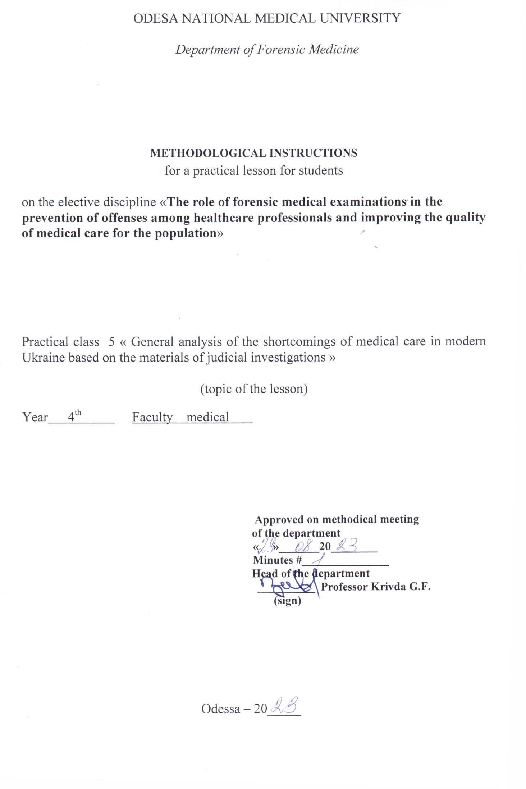

1. topic of the lesson:
"General analysis of the shortcomings of medical care in modern Ukraine based on the materials of judicial investigations"- 6 hours.

2. relevance of the topic:
When investigating cases involving crimes against human health and life, the investigation raises questions that require medical and biological knowledge. The resolution of such issues is entrusted to forensic medical examination and specialists - forensic medical experts. According to the current legislation, if necessary, a doctor of any specialty may be involved in the performance of forensic medical actions. Therefore, knowledge of the organizational foundations of forensic medical examination and the procedural rules governing forensic medical expert activity is essential for doctors of any specialty.

3. Objectives of the lesson:
3.1. General objectives: to familiarize students with the organization of the forensic service in Ukraine, procedural rules and legislative regulations governing its conduct.
3.2. Educational objectives: to familiarize students with historical information about the impact of departmental subordination and the peculiarities of socio-economic formation of society on the objectivity of forensic medical examination on the example of the cases of the Multan Votyaks, Baylis, Sannota Vanzetti, Katypi event. To acquaint students with the activities of prominent forensic physicians of Ukraine - Bokarius M.S., Kontsevych I.O., Raiskyi M.I., Rubeshansky A.F., Sapozhnikov Y.S., Fadeev A.M. and their contributions to the development of the theory and practice of forensic medicine.
3.3 Specific goals:
- to know:
1. the concept of codes, their types and the issues they regulate;
2. "The Fundamentals of Ukrainian Legislation on Health Care and, in particular, Articles 6, 7(e), 69, 71, 72, 73 and be able to interpret them;
3. organization of the forensic service in Ukraine.
4. the structure of the Bureau of Forensic Medical Examination and the functions of its divisions;
5. the rights, duties and responsibilities of physicians and be able to use them when performing forensic expert functions.
3.4. Based on theoretical knowledge of the topic:
- be able to:
1. to use and interpret Art. of the Fundamentals of the Legislation of Ukraine on Health Care";
2. use and interpret the articles of the Criminal Code (CC) and the Code of Criminal Procedure (CCP) of Ukraine;
3. to use the Order of the Ministry of Health of Ukraine No. 6 "On the Development and Improvement of the Forensic Medical Service of Ukraine" (1995);

4. Materials for classroom self-study (interdisciplinary integration).
№ | Disciplines | Know. | Be able to.
n/a
1 | 2 | 3 | 4
1. | Previous  discipline.  1. 1.  medicine, management  and the economics of security  health with a course in the basics of law. | The concept of codes, their  varieties and issues that  They regulate;  "Fundamentals of legislation  of Ukraine on the protection of  Health" | Use.  and  interpret  Art.  legislative  documents.
2. | The following disciplines | - | -
3. | Intersubjective  integration.  Forensic medicine  expertise. | Knowledge of the organization  of the forensic service in  Ukraine, the rights, duties and responsibilities of a forensic expert (expert physician)
 | 1. SMEs - living persons with  determining the degree  severity of bodily injury  damage. | Order of the Ministry of Health №6 "On  development and improvement  forensic medical service  Ukraine" (1995). | Use.  rules  forensic  medical determination of the severity of bodily injury.
 | 2. Examination of the corpse at the place of its discovery | Art. | Art. of the CPC of Ukraine
 | The corpse's medical director |  | Use.  rules  holding  forensic  examinations  corpses in the bureau  forensic  expertise.

5. Content of the topic:
The materials of medical examinations, after mandatory depersonalization (removal of the names of patients and doctors, names of medical institutions), are often used in the educational process by university professors, as many of them are constantly involved in expert commissions. The use of real clinical situations as illustrative examples contributes to a better understanding of not only the issues under study, but also the legal aspects of medical practice.
The distribution of examinations by medical care profiles is uneven. The largest number of medical cases concerned the activities of surgeons of all specialties, obstetricians and gynecologists, dentists, anesthesiologists and resuscitators, doctors and paramedics of ambulance stations. This is understandable, because these specialists often have to deal with emergency conditions that require urgent decision-making and emergency surgical interventions, i.e., work in conditions where the probability of diagnostic or technical errors is highest, and the pathology itself is characterized by a high risk of complications and adverse outcomes.
Less frequently, claims were made against general practitioners, pediatricians, and infectious disease specialists. The appearance of a cosmetologist in this list was initially regarded as a casualty, but in recent years a number of serious claims have been made against doctors of this specialty. The increase in medical dental cases is explained by the lack of uniform standards for the provision of dental care, the absence of institutes of forensic dentistry, and the ignorance of dentists of the regulatory documents governing their professional activities. When these conflict situations arise, a forensic medical examination is ordered. One of the main issues that it resolves when considering in court civil claims of victims and their relatives for compensation for damage caused by the provision of medical dental care is the question of the adequacy and sufficiency of the scope and quality of dental care.
The most frequently raised questions for forensic medical examination regarding poor quality dental care are - the correctness of the therapeutic, surgical, orthopedic dental treatment of adults and children; - the presence of defects in the therapeutic, surgical, orthopedic dental treatment of adults and children; - the causation of harm to health as a result of poor quality medical care; - the existence of a causal relationship between defects in the therapeutic, surgical, orthopedic treatment of adults and children and the result that has occurred. The most frequent errors were made by therapeutic dentists in the process of treating teeth for caries and its complications, as well as in their prosthetics.
Among the most common mistakes, the following were noted: (1) insufficient completeness of the examination of patients, in particular, X-ray examination in only one projection; (2) lack of multifactorial analysis of the clinical picture of the disease; (3) lack of consideration of the patient's health status, previous illnesses and concomitant diseases; (4) lack of special knowledge and experience in the treatment of certain diseases; (5) errors in diagnosis led to the choice of incorrect treatment tactics and the development of complications.
An expert assessment of orthopedic care revealed the following mistakes that are most commonly made when applying various therapeutic techniques and methods of dental prosthetics: (1) incorrect choice of prosthetic method and tactics; (2) incorrect choice of prosthetic design, type of dentition stabilization; (3) insufficient aesthetics of prosthetics; (4) insufficient pre-orthopedic treatment of the patient: tooth extraction, tooth filling, treatment of oral mucosa diseases, surgical preparation of the alveolar bone, palate and soft tissues of the oral cavity for dental prosthetics; (5) violation of the rules for the use of materials for dentures: polymeric, porcelain, base and precious metal alloys.
The following mistakes are typical for dental surgeons: (1) violation of the rules of transportation of victims; (2) failure to recognize complications of the underlying surgical disease; (3) late diagnosis of damage to the dentition; (4) incorrect choice of method and tactics of surgical intervention; (5) inadequate preoperative preparation of the patient; (6) shortcomings in the technical performance of the operation; (7) inadequate anesthetic care and the scope of resuscitation measures; (8) untimely diagnosis of postoperative complications; (9) untimely reoperation.
To summarize, it should be noted that it is extremely difficult to qualify the consequences of unprofessional actions of doctors. Even if these consequences are fatal. The line between a doctor's mistake in trying to save a patient's life and ordinary negligence is too thin.

6.1. Questions to control the acquired knowledge:
1. Appointment, organization and conduct of commission forensic examination in case of professional and official offenses of medical personnel.
2. The importance of the clinical and anatomical conference.
3. Use of examination materials to prevent offenses among healthcare workers and improve the quality of healthcare services

6.2. Information necessary for the formation of knowledge and skills can be found in textbooks:

R MAIN : Forensic medicine: textbook / Edited by V.D. Mishalov, - Chernivtsi: "Misto, 2018. - 572 с.

ADDITIONAL: Forensic medicine: textbook / Edited by V.F. Moskalenko, B.V. Mykhailychenko. - K.: VSV Medicine, 2011. - 448 с.
Forensic Medicine" Zavalnyuk A.H. Course of lectures, Ternopil 2000, pp. 530-580

