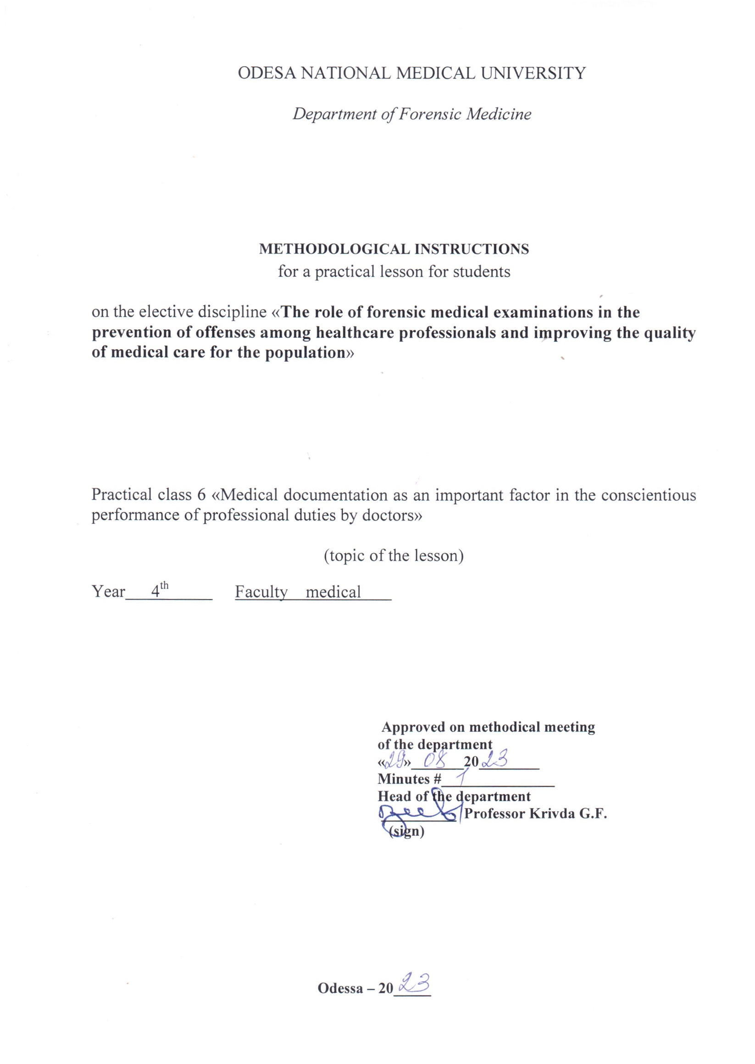

1. topic of the lesson:
"Medical documentation as an important factor in the conscientious performance of professional duties by doctors"- 4 hours.

2. Relevance of the topic:
When investigating cases involving crimes against human health and life, the investigation raises questions that require medical and biological knowledge. The resolution of such issues is entrusted to forensic medical examination and specialists - forensic medical experts. According to the current legislation, if necessary, a doctor of any specialty may be involved in the performance of forensic medical actions. Therefore, knowledge of the organizational foundations of forensic medical examination and the procedural rules governing forensic medical expert activity is essential for doctors of any specialty.

3. Objectives of the lesson:
3.1. General objectives: to familiarize students with the organization of the forensic service in Ukraine, procedural rules and legislative regulations governing its conduct.
3.2. Educational objectives: to familiarize students with historical information about the impact of departmental subordination and the peculiarities of socio-economic formation of society on the objectivity of forensic medical examination on the example of the cases of the Multan Votyaks, Baylis, Sannota Vanzetti, Katypi event. To acquaint students with the activities of prominent forensic physicians of Ukraine - Bokarius M.S., Kontsevych I.O., Raiskyi M.I., Rubeshansky A.F., Sapozhnikov Y.S., Fadeev A.M. and their contributions to the development of the theory and practice of forensic medicine.
3.3 Specific goals:
- to know:
1. the concept of codes, their types and the issues they regulate;
2. "The Fundamentals of Ukrainian Legislation on Health Care and, in particular, Articles 6, 7(e), 69, 71, 72, 73 and be able to interpret them;
3. organization of the forensic service in Ukraine.
4. the structure of the Bureau of Forensic Medical Examination and the functions of its divisions;
5. the rights, duties and responsibilities of physicians and be able to use them when performing forensic expert functions.
3.4. Based on theoretical knowledge of the topic:
- be able to:
1. to use and interpret Art. of the Fundamentals of the Legislation of Ukraine on Health Care";
2. use and interpret the articles of the Criminal Code (CC) and the Code of Criminal Procedure (CCP) of Ukraine;
3. to use the Order of the Ministry of Health of Ukraine No. 6 "On the Development and Improvement of the Forensic Medical Service of Ukraine" (1995);

4. Materials for classroom self-study (interdisciplinary integration).
№ | Disciplines | Know. | Be able to.
n/a
1 | 2 | 3 | 4
1. | Previous  discipline.  1. 1.  medicine, management  and the economics of security  health with a course in the basics of law. | The concept of codes, their  varieties and issues that  They regulate;  "Fundamentals of legislation  of Ukraine on the protection of  Health" | Use.  and  interpret  Art.  legislative  documents.
2. | The following disciplines | - | -
3. | Intersubjective  integration.  Forensic medicine  expertise. | Knowledge of the organization  of the forensic service in  Ukraine, the rights, duties and responsibilities of a forensic expert (expert physician)
 | 1. SMEs - living persons with  determining the degree  severity of bodily injury  damage. | Order of the Ministry of Health №6 "On  development and improvement  forensic medical service  Ukraine" (1995). | Use.  rules  forensic  medical determination of the severity of bodily injury.
 | 2. Examination of the corpse at the place of its discovery | Art. | Art. of the CPC of Ukraine
 | The corpse's medical director |  | Use.  rules  holding  forensic  examinations  corpses in the bureau  forensic  expertise.

5. Content of the topic:
The quality of medical records remains an urgent problem today. Defects in medical record keeping are noted in the vast majority of cases of commission examinations. Experts have to spend a lot of time deciphering entries in medical records, which prolongs the time required for expert examinations, and sometimes does not allow them to form an expert opinion at all.
After reviewing all documents and materials, the forensic medical commission draws conclusions that must be clear, understandable, and at the same time well-grounded and scientifically substantiated. The conclusions must contain answers to the questions posed. As a rule, the commission reaches conclusions unanimously, but if any of its members disagrees with them in general or on certain issues, they have the right to a personal opinion, which they set out in the same document and sign personally.
A forensic medical expert performs all actions by order of the judicial and investigative authorities. They are formalized by appropriate documents. Thus, during the inspection of the scene, the investigator draws up a -Protocol of inspection of the scene,‖ in which the forensic expert provides data related to the corpse and the presence of material evidence of biological origin. Judicial and investigative authorities, when initiating a criminal case, appoint an examination of the relevant object, the results of which are documented in the form of an expert opinion. This document has an introductory, descriptive (research) and final (summary) part.
The introductory part contains information about when, where, by whom, on what basis the expert evaluation is carried out, what object is examined, what materials are available, and who was present during the evaluation. At the end of this part, the expert signs that he or she is aware of his or her rights, duties and responsibilities, which are regulated by applicable law. Next, they provide information about the circumstances of the case, medical records, and write down all the facts relevant to the examination. After that, they indicate the issues that the investigating or judicial authorities have raised for resolution.
The descriptive (research) part describes the results of the examination with the addition of illustrative material, if necessary. The introductory and descriptive parts are called the protocol part. It is signed by the expert and persons who were present during the examination. When conducting a forensic medical examination, there is a need to perform laboratory tests. In such cases, the forensic expert shall issue an appropriate referral to the laboratory, which indicates what should be resolved during the examination of the object. The results of all laboratory and additional studies are included in the expert's conclusion after the research part.
In the final part (conclusion), the expert gives full and substantiated answers to all questions of the resolution. -The expert's conclusion is signed by his or her personal signature and then affixed with the seal of the institution.
Quite often, when a criminal case is not initiated, the judicial and investigative authorities give a written order (instruction) on the basis of which a forensic medical examination (or examination of the victim, accused) of the required object is carried out, rather than an examination. The results of this study are drawn up in the form of a document called the Forensic Medical Examination Report (the Examination Report). This document is drawn up according to the same scheme. Unlike the Expert Opinion, it does not provide for the expert's signature under the articles of the Criminal Code and the Code of Criminal Procedure. However, this does not mean that such a forensic examination can be performed on a different basis than a forensic medical examination. In the final part of this document, the forensic expert answers the questions determined by the purpose of the study.
After conducting a forensic medical examination of the corpse, the expert issues a -Medical Certificate of Death. It indicates the institution issuing the certificate, its number and nature (preliminary, final or instead of the previous one), date of issue, passport data of the deceased, date and place of death, possible cause of death and which doctor stated the cause of death. Then there is information about the name, the doctor, his position and the basis for issuing the certificate: examination of the corpse, records in medical records about the treatment of the deceased, preliminary observation or autopsy.
When formulating the cause of death, the primary cause of death is first indicated - the primary disease or injury that led to death as a result of successive disease processes, and then the diseases that contributed to the onset of death. The latter are not related to the underlying disease or its complications, but negatively affect the course of the underlying disease.
The main cause of death needs to be deciphered. To do this, the immediate cause of death is indicated sequentially, i.e., the disease that led to death, complications of the underlying disease, or injury, and then a list of morphological manifestations of the underlying disease or injury that allow for a diagnosis, and only then, according to the -International Statistical Classification of Diseases, Injuries and Causes of Death, the underlying disease that led to death is indicated.

6.1. Questions to control the acquired knowledge:
1. Appointment, organization and conduct of commission forensic examination in case of professional and official offenses of medical personnel.
2. The importance of the clinical and anatomical conference.
3. Use of examination materials to prevent offenses among healthcare workers and improve the quality of medical and preventive care for the population

6.2. Information necessary for the formation of knowledge and skills can be found in textbooks:

MAIN : Forensic medicine: textbook / Edited by V.D. Mishalov, - Chernivtsi: "Misto, 2018. - 572

ADDITIONAL: Forensic Medicine: Textbook / Edited by V.F. Moskalenko, B.V. Mykhailychenko. - K.: VSV Medicine, 2011. - 448 с.
Forensic Medicine" Zavalnyuk A.H. Course of lectures, Ternopil 2000, pp. 530-580

