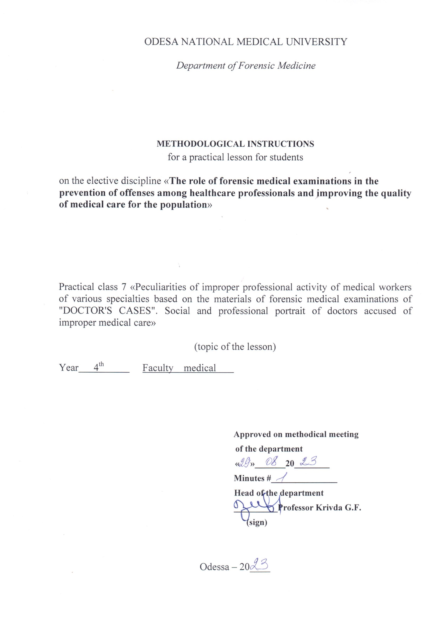

1. Topic of the lesson:
"Peculiarities of improper professional activity of medical workers of various specialties based on the materials of forensic medical examinations of "Doctors' Cases". Social and professional portrait of doctors accused of improper medical care"- 6 hours.

2. Relevance of the topic:
When investigating cases involving crimes against human health and life, the investigation raises questions that require medical and biological knowledge. The resolution of such issues is entrusted to forensic medical examination and specialists - forensic medical experts. According to the current legislation, if necessary, a doctor of any specialty may be involved in the performance of forensic medical actions. Therefore, knowledge of the organizational foundations of forensic medical examination and the procedural rules governing forensic medical expert activity is essential for doctors of any specialty.

3. Objectives of the lesson:
3.1. General objectives: to familiarize students with the organization of the forensic service in Ukraine, procedural rules and legislative regulations governing its conduct.
3.2. Educational objectives: to familiarize students with historical information about the impact of departmental subordination and the peculiarities of socio-economic formation of society on the objectivity of forensic medical examination on the example of the cases of the Multan Votyaks, Baylis, Sannota Vanzetti, Katypi event. To acquaint students with the activities of prominent forensic physicians of Ukraine - Bokarius M.S., Kontsevych I.O., Raiskyi M.I., Rubeshansky A.F., Sapozhnikov Y.S., Fadeev A.M. and their contributions to the development of the theory and practice of forensic medicine.
3.3 Specific goals:
- to know:
1. the concept of codes, their types and the issues they regulate;
2. "The Fundamentals of Ukrainian Legislation on Health Care and, in particular, Articles 6, 7(e), 69, 71, 72, 73 and be able to interpret them;
3. organization of the forensic service in Ukraine.
4. the structure of the Bureau of Forensic Medical Examination and the functions of its divisions;
5. the rights, duties and responsibilities of physicians and be able to use them when performing forensic expert functions.
3.4. Based on theoretical knowledge of the topic:
- be able to:
1. to use and interpret Art. of the Fundamentals of the Legislation of Ukraine on Health Care";
2. use and interpret the articles of the Criminal Code (CC) and the Code of Criminal Procedure (CCP) of Ukraine;
  - to use the Order of the Ministry of Health of Ukraine No. 6 "On the Development and Improvement of the Forensic Medical Service of Ukraine" (1995);

4. Materials for classroom self-study (interdisciplinary integration).
№ | Disciplines | Know. | Be able to.
n/a
1 | 2 | 3 | 4
1. | Previous  discipline.  1. 1.  medicine, management  and the economics of security  health with a course in the basics of law. | The concept of codes, their  varieties and issues that  They regulate;  "Fundamentals of legislation  of Ukraine on the protection of  Health" | Use.  and  interpret  Art.  legislative  documents.
2. | The following disciplines | - | -
3. | Intersubjective  integration.  Forensic medicine  expertise. | Knowledge of the organization  of the forensic service in  Ukraine, the rights, duties and responsibilities of a forensic expert (expert physician)
 | 1. SMEs - living persons with  determining the degree  severity of bodily injury  damage. | Order of the Ministry of Health №6 "On  development and improvement  forensic medical service  Ukraine" (1995). | Use.  rules  forensic  medical determination of the severity of bodily injury.
 | 2. Examination of the corpse at the place of its discovery | Art. | Art. of the CPC of Ukraine
 | The corpse's medical director |  | Use.  rules  holding  forensic  examinations  corpses in the bureau  forensic  expertise.

5. Content of the topic:
Expert examinations in cases of professional misconduct of healthcare professionals are considered to be among the most difficult in forensic expert practice. And there are good reasons for this.
First, before a forensic medical examination is ordered in cases of fatalities, the body is usually already buried, and the commission must be satisfied with the autopsy report, which may not contain all the data necessary for qualified conclusions. Therefore, sometimes it is necessary to conduct an exhumation.
Secondly, even when a person is still alive, it is a case of an illness that occurred some time before the examination, and therefore, the state of health of the expert during the illness and the completeness of his or her examination, as well as the effectiveness (or ineffectiveness) of the treatment applied, can only be concluded on the basis of records in medical records, laboratory results, X-ray examinations, etc. Commission forensic medical examinations in the departments of commission examinations of the bureau of forensic medical examination of the health departments of the regional executive committees, the republican bureau and in the forensic medical department of the Main Bureau of Forensic Medical Examination of the Ministry of Health of Ukraine, as well as on an entrepreneurial basis, are carried out in accordance with the Law of Ukraine "On Forensic Examination", procedural legislation, the Instruction on Conducting Forensic Medical Examination, the Rules for Conducting Commission Forensic Medical Examinations in the Bureau of Forensic Medical Examination (1995) and regulatory documents of the Ministry of Health of Ukraine.
The expert commission must consist of at least three persons: the chairman, member(s) of the commission and the case reporter. The rights and obligations of the members of expert commissions are similar to those of expert physicians performing other types of examinations. According to the current regulations, medical examinations are conducted only on the basis of regional (republican) Bureau of Forensic Medical Examination, which makes it possible to fully utilize the scientific and technical potential of universities, research institutes of the Ministry of Health, and specialized departments of large clinics. In addition, this procedure for conducting an expert examination reduces the possibility of subjective influence on expert opinions, since the expert commission is more likely to include specialists who are in one way or another interested in the outcome of the case.
The purpose of commission examinations is to: - Eliminate contradictions between the previously conducted examination and other case materials in case of unreasonable conclusions or doubts of the person conducting the inquiry, investigator, prosecutor, judge or court about the correctness of the said examination. - Establish the term of conception, fertility, percentage of loss of professional capacity. - Establish the correctness of medical care in cases of criminal prosecution of medical professionals for professional offenses. Investigators and judicial authorities usually need answers to the following questions: - whether the patient was examined in full; - whether the diagnosis was made correctly and in a timely manner; - whether the prescribed treatment corresponds to the diagnosis and severity of the disease; - what caused the severe course and unfavorable outcome of the disease; - whether there were violations by medical professionals, at what stage, and how this affected the course of the disease; - whether there is a direct causal link between the actions of healthcare professionals and the onset of an unfavorable outcome of the disease, the death of the patient; - whether there was a real opportunity to prevent an unfavorable outcome; - whether there was a violation of industry standards or regulations.
In almost all medical examinations, law enforcement officials ask experts the following questions: - What instructions, guidelines, rules, orders should doctors and nurses be guided by in their work. In each particular criminal case, other questions may be raised related to the specifics of the case. The list of questions can be significantly expanded.
Depending on the nature of the examination, the commission may include both specialists in the field of forensic medicine and specialists in other medical (including specialists of medical and social expert commissions of the Ministry of Health) and non-medical specialties. By their procedural position, all of them are experts in the course of the examination. The expert commission must consist of at least three people: the chairman, member(s) of the commission and the case rapporteur. The rights and obligations of the members of expert commissions are similar to the rights and obligations of expert physicians performing other types of examinations.
According to the current regulations, medical examinations are conducted only on the basis of regional (republican) Bureau of Forensic Medicine, which makes it possible to fully utilize the scientific and technical potential of universities, research institutes of the Ministry of Health, and specialized departments of large clinics. In addition, this procedure for conducting an expert examination reduces the possibility of subjective influence on expert opinions, since the expert commission is more likely to include specialists who are in one way or another interested in the outcome of the case.
The examination can be conducted only if the person who appointed the examination provides all the necessary materials on the case. They must necessarily include criminal or civil cases and the originals of medical, including primary expert documentation. In addition, depending on the type of expertise, these materials must be accompanied by physical evidence (histological specimens, clothing, footwear, etc.) and other necessary documents.
After examining all documents and materials, the forensic medical commission draws conclusions that must be clear, understandable, and at the same time substantiated and scientifically reasoned. The conclusions must contain answers to the questions posed. As a rule, the commission reaches conclusions unanimously, but if any of its members disagrees with them in general or on certain issues, they have the right to a personal opinion, which they set out in the same document and sign personally. Unfortunately, there are cases when expert commissions are unclear about the limits of their competence. As a result, when answering some questions, they either go beyond their specialized knowledge and invade the scope of authority of the investigating authorities, or unreasonably refuse to answer the questions they are supposed to resolve.
A forensic medical expert does not give a legal assessment of the actions of medical professionals, which is the prerogative of the court, but rather states the presence or absence of errors in the actions of medical professionals in treating a patient. Upon completion of the expert research, the "Expert Opinion" is returned either to the prosecutor's office or to the court. The prosecutor's office, having reviewed all the case materials on a particular complaint, either refuses to initiate a case or initiates a case and submits it to the court for consideration. The court, on its own, after receiving the "Expert Opinion", conducts a trial. In doing so, the court may or may not take into account the expert's conclusions. The outcome of the court proceedings is a decision that is communicated to the applicant.
Medical examinations are a complex type of expert research, not so much in technical terms (although this is important) as in moral and ethical terms. After all, actions that were supposed to bring relief and recovery to the patient, but caused suffering and death for one reason or another, are subject to evaluation. The expert commission must explain to the investigator or court the meaning of certain actions of the attending physician, evaluate the results of the studies and manipulations performed, identify the objective and subjective causes of shortcomings in the course of the medical and diagnostic process, and help to properly qualify what happened.
In each case, it is necessary to find out what caused the unfavorable outcome of the disease or injury: an objectively determined medical error, an accident, or a negligent attitude to their duties. Although the legal assessment of a doctor's actions is made by the forensic authorities, it is based on a reasoned conclusion of a forensic medical examination. This conclusion is formed as a result of a thorough analysis of all materials, study of a large volume of specialized literature, a number of studies using the most modern methods and equipment, and participation in the work of expert commissions of leading experts in the relevant fields of medicine.
To date, most examinations are conducted as part of a prosecutor's or police investigation into the validity of complaints from patients or their relatives about the quality of medical care. However, practice shows that the claims of patients or their relatives against medical professionals are not always substantiated.
The reasons for the increase in the number of medical examinations are as follows: - the growth of legal literacy of the population; - the active work of insurance companies; - the emergence of the institute of independent forensic medical experts; - the intensification of the work of lawyers. In recent years, there have been more cases where the defense tactics of a defendant who has caused bodily harm to another person that resulted in death are based on accusing the medical staff of the hospital where the victim was taken of improper treatment. Lawyers try to prove that the victim's death was not caused by the injury itself, but as a result of improper or incomplete treatment, and thus to ease the punishment or acquit the client. The materials of medical examinations after mandatory depersonalization (removal of the names of patients and doctors, names of medical institutions) are often used in the educational process by university professors, as many of them are constantly involved in expert commissions. The use of real clinical situations as illustrative examples contributes to a better understanding of not only the issues under study, but also the legal aspects of medical practice.

6.1. Questions to control the acquired knowledge:
1. Appointment, organization and conduct of commission forensic examination in case of professional and official offenses of medical personnel.
2. The importance of the clinical and anatomical conference.
3. Use of examination materials to prevent offenses among healthcare workers and improve the quality of medical and preventive care for the population

6.2. Information necessary for the formation of knowledge and skills can be found in textbooks:

MAIN : Forensic medicine: textbook / Edited by V.D. Mishalov, - Chernivtsi: "Misto, 2018. - 572 с.

ADDITIONAL: Forensic Medicine: Textbook / Edited by V.F. Moskalenko, B.V. Mykhailychenko. - K.: VSV Medicine, 2011. - 448 с.
Forensic Medicine" Zavalnyuk A.H. Course of lectures, Ternopil 2000, pp. 530-580

