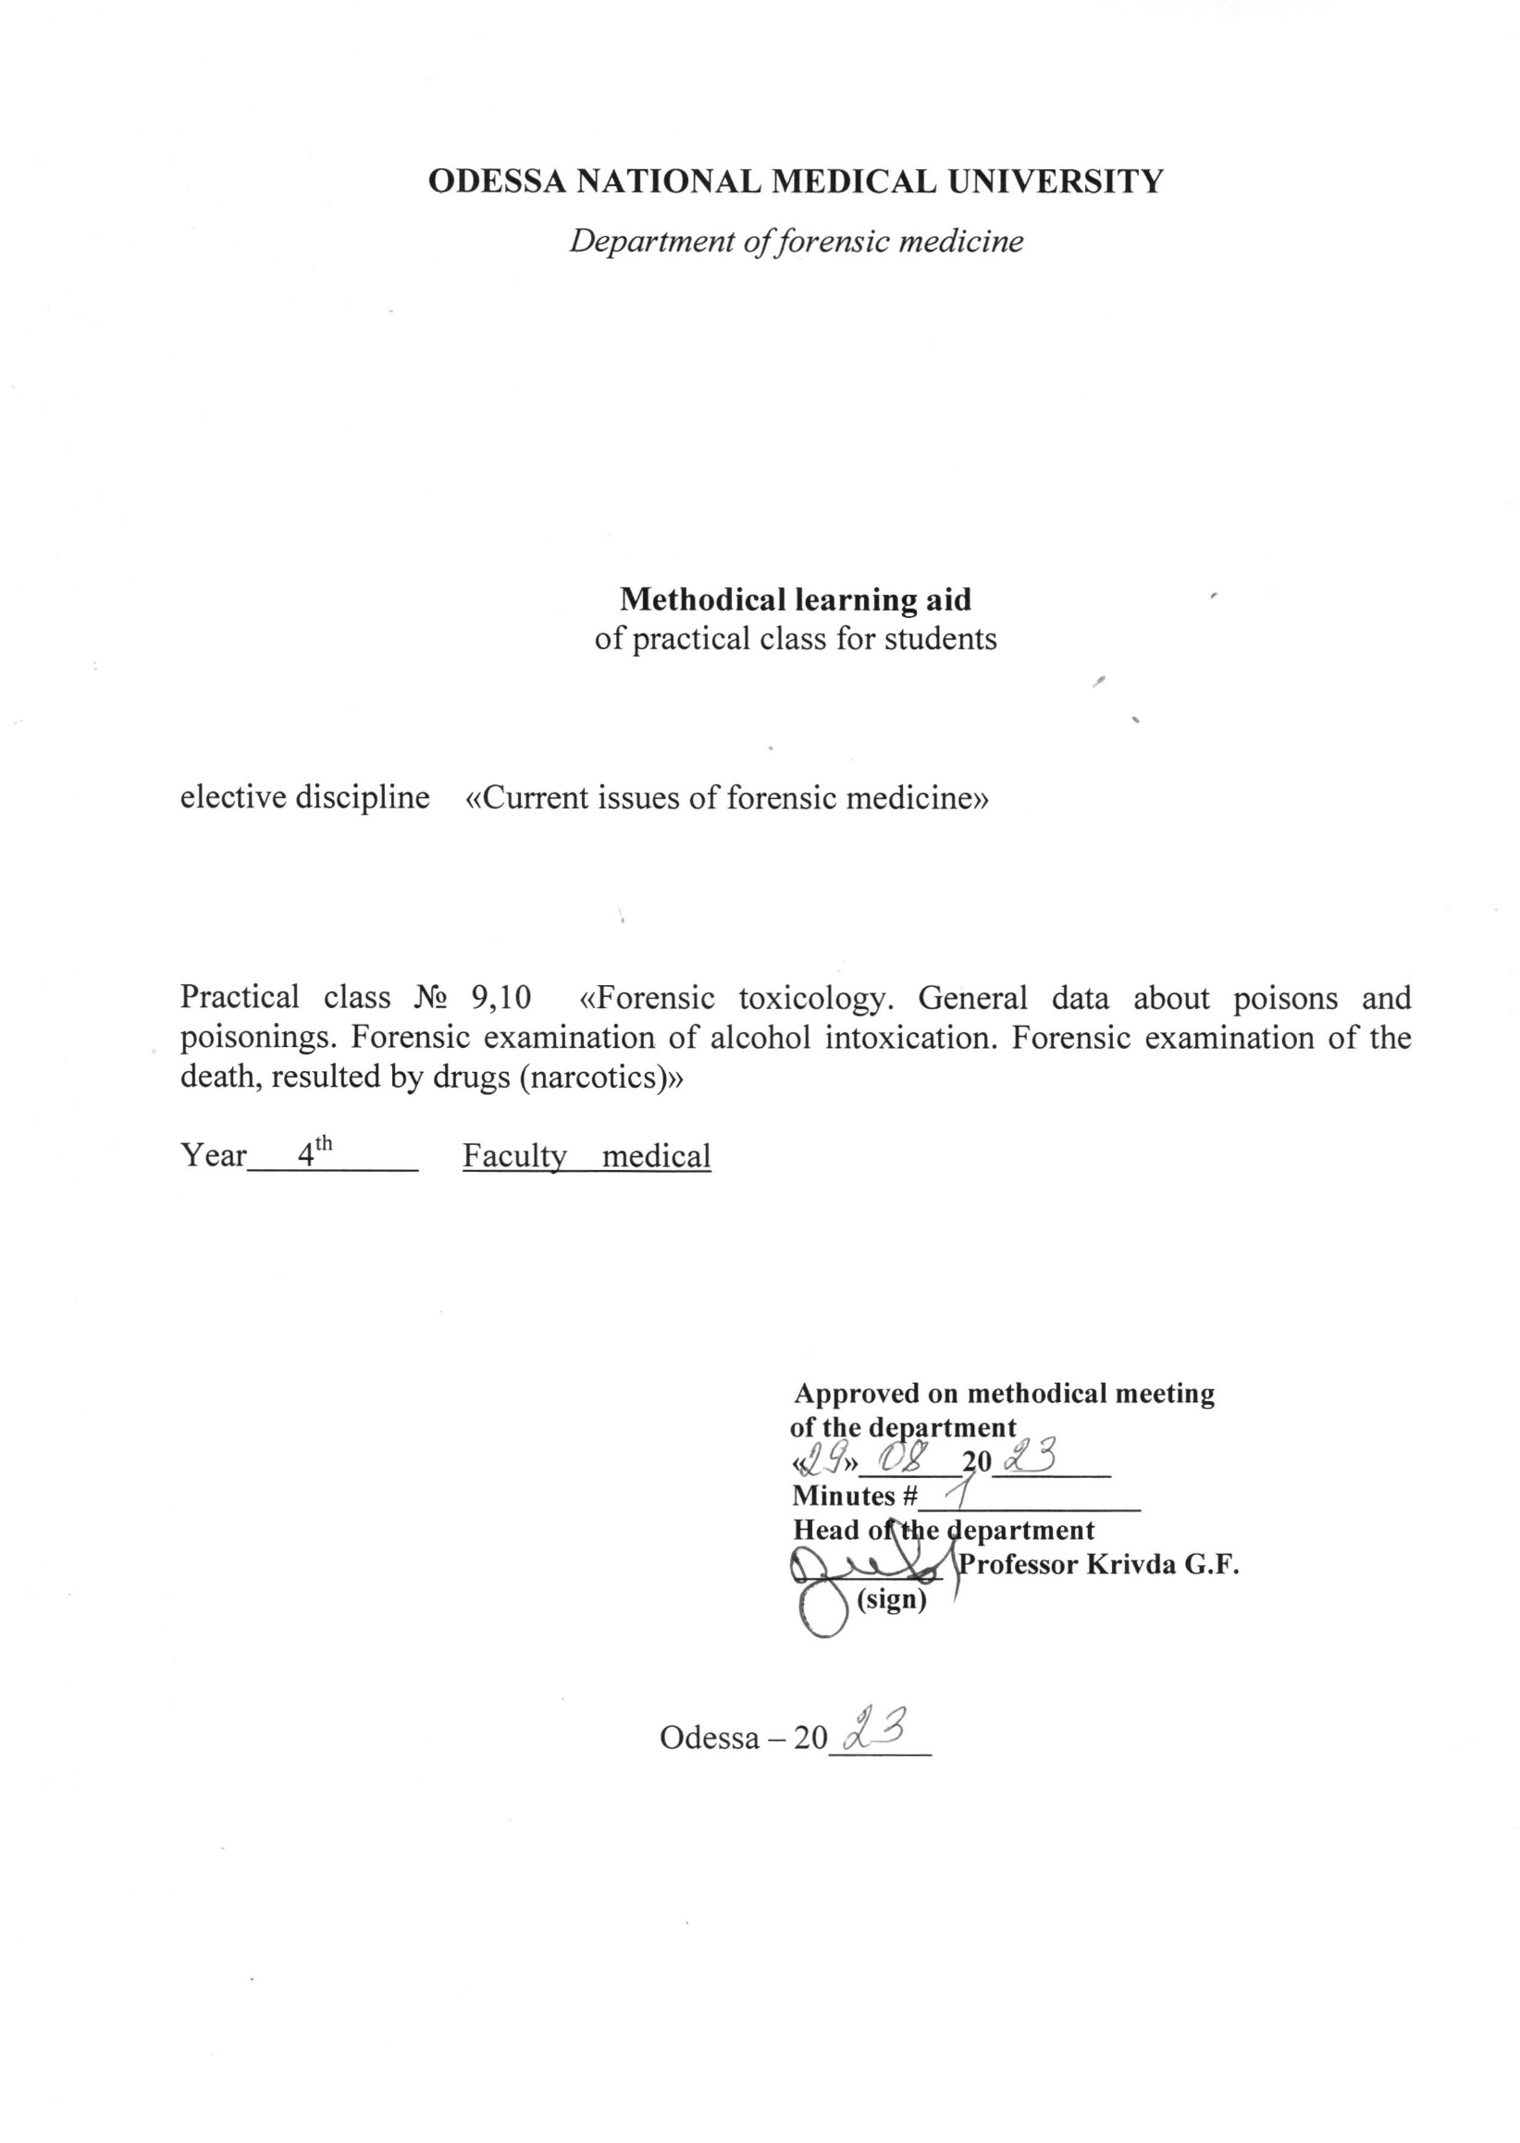

Theme: “Forensic toxicology. General data about poisons and poisonings. Forensic examination of alcohol intoxication. Forensic examination of the death, resulted by drugs (narcotics)” -4 h.

Motivational characteristics
The sample program stipulates the subject. The urgency of a subject is conditioned by large abundance of venenatings now and, first of all, such, as household, medicament, alimentary, professional, customary venenatings with agricultural chemicals. An exceptional value has for the forensic medicine such venenatings, as alcoholic and narcotics. The given subject has direct attitude to ecology. The toxicological expertises fall into difficult and most accountable kinds of expert activity. From here the key of value of this subject in opening-up of the doctor.

Educational aims:
To acquaint the students with a general arrangement and technique of expertise of venenatings, with features of expertise of a corpse, alive face at venenatings, with features of inspection of an occurrence location at suspicion on a venenating, with features of chemical method of testing. To learn the students to development of a general arrangement and technique of realization of expertise of venenatings, to form for the students clinical and professional intellection, skills of a deontology and medical ethics. Preventive maintenance of venenatings and ecology. Preventive maintenance of alcohol and drug addiction.
4. Organization of the contents of a subject, inside subject and intersubject federating.
The contents of the given subject of the lecture are constructed ground sample programs under the forensic medicine and follows from object in views. The given subject is integrated inside a subject with expertise of a corpse, alive face, stuffs of business and material evidences outside of a subject - with venenatings studied on stand of communicable diseases and profpathology.

Content of the theme
The toxicology is a doctrine about poisons and venenatings. There is a general and private toxicology. Now excrete industrial, municipal, military, alimentary, veterinary, medicinal, radiation and judicial toxicology. Many medicinal preparations simultaneously are also poisons - their medical effect depends on a dose. That is why one of emblems of medicine is the cup with the snake.
In FORENSIC-medical attitude the poison is a chemical agent, which is introduced into an organism from the outside, in small doses in certain conditions invoke distress of health or death. A venenating - morbid condition described different functional or by organic destructions resulting in to distress of health or death.
The venenatings on a parentage can be household, medicament, alimentary, professional, customary (toxicomania), from operating agricultural chemicals. On flow - acute, under acute, chronic. On outcomes - satisfactory, with disablement and with fatal outcome.
The operating of poisons are primary (lead-acid, alkaline), series (sublimate kidney),metatoxic).

Conditions of operating of poisons:
1. Dose (inert, therapeutic, toxic, lethal).
2. Dissolubility
3. Form of the introducing (physical condition). A modular condition (firm, fluid, gaseous material) - dusts, the solutions, fatty, alcohol, gaseous poisons - act faster then all other.
4. Concentration (hydrochloric acid mixture for appetites for children and concentrated - strongest poison).
5. The path of the introducing (curare - is only parenteral).
6. Quality of a poison.
7. Combination of a poison to other materials
Synergy, anthogonism, antidotes, alcohol + soporific, Atropinum.
8. Specific feature of an organism (age, sex, disease, specially of excretory system, condition of a stomach, liver, personal sensitivity (idiosyncrasy), physiological terms).

The forensic pathology at venenatings has some stages (phases):
1. Familiarization with stuffs of business.
2. Inspection of a corpse in place. Incidents.
3. Analysis of a clinical picture of a venenating.
4. Expertise of a corpse, exhumated corpse, alive face.
5.Chemical, botanic, histological, spectral and other kinds (views) of researches.

The forensic medical diagnostic of a venenating often invokes handicappings, as the clinical picture of a venenating before research of a corpse remains obscure. The stuffs of business, preliminary items of information should be therefore carefully studied.
The inspection of a corpse in place can spawn incidents the supposition about a capability of a venenating, sometimes death without the manifestation cause can provoke in one or several people suspicion on a venenating. In place of incidents are relevant aged rules:
- Not to trust labels, but to pay attention to drugs, to search for the prescriptions, oddments of a poison, packaging of drugs, adaptation, syringes, to examine of allocation, washing waters.
The analysis of a clinical picture of a venenating can be helped with the witnesses, relatives, and also diaries, premortal slip, oddments of poisons. The information of the medical workers is invaluable. At killings will be used the poison inodorous and taste, at suicides the large doses are characteristic.
The major evidence of a venenating is the expertise of a corpse. The order of research of a corpse is relevant. First of all investigate heart and blood both chemical, and spectral methods. Then the stomach with content is taken on examination. It is impossible to use water at forensic - medical research of a corpse in general and at suspicion on a venenating in particular. At expertise of a corpse take the assays of a soil for chemical research. If the poison is known, for it search precisely, if is unknown - use forensic-medical classification of poisons, it is constructed on principle about definition of poisons. All poisons are divided into two large groups - corrosion and resorbtion (earlier local and general). Corrosion is inorganic acids, organic acetic acid, alkali, and also some pyretics - fluorine hydride, silver nitrate, zinc chloride etc.
If the robust inorganic acid was received there are chemical edemas with dense necrotic peel - black, dense (coal) surface - for hydrogen nitrate (xanthoproteic reaction), dark grey, dry, dense surface - for a hydrochloric acid (dehydrational effect) is characteristic for sulfuric acid, yellow. For operating alkalis the formation of a friable necrotic surface, soap to the touch is characteristic. The formation of a red friable necrotic surface, but not soap to the touch is an operating of a representative ladies' poison (venom) - acetic essence accompanying with a representative odor of Acetum.
For operating alkalis the formation of a friable necrotic surface, soap to the touch is characteristic. The formation of a red friable necrotic surface, but not soap to the touch is an operating of a representative ladies' poison - acetic essence accompanying with a representative odor of Acetum. Phenol (Acidum carbolicum - the aged incorrect title) gives a bright red burnt surface in a stomach and esophagus. It is an artful poison, Invokes an anesthesia and the pain passes in due course, but Phenol does the business. A hydrochloric acid, acetic, and also Phenol also invoke the pneumonic locuses in lungs/
There are no combustions; it is necessary to think of operating resorbtive poisons (venom), which are operational after suction. If at inspection the colour of livores mortis is unusual - brown, chocolate, grey, bright - pink and same colour the fluid blood (can be customary colour of a blood, but, being teemed on desktop, it becomes brown) - it is necessary to think of operating bloody poisons (venom) in group of resorbtive. The greatest value in bloody poisons has those, which connect with hemoglobin -met hemoglobin and carbohemoglobin. At formation of a methemoglobin the oxygen strongly incorporates with a haemoglobin because of transition 2-valence ferrum in 3 in a molecule of a hemoglobin. This connection so strongly, that of ditty bags of rocks to tissues does not act. To methemoglobinforming poisons related Berthollet salt, aniline, diazotizing salts, nitrobenzol. The diazotizing salts were used in a defend industry, in time and after war at a deficit of salt gave in the markets for sodium chloride. Children have found aniline, have accepted it for powder and powdering - the girl has died, the boy managed to be salvaged.
The Berthollet salt will be used in ordnance. A lethal dose 10-20. The clinical picture of a venenating - vomiting, diarrhea, urine darkens because of a methemoglobin, there is a protein, can arise anuria. The death is accompanied by a collapse.
The nitrobenzol - oleaginous fluid with an odor of a bitter almond, will be used in perfumery. A lethal dose - 1-2 g, badly dissolved, therefore venenating shows in some hours. In clinic - vomiting with an odor of a bitter almond, the propulsion disturbance, inexpressive speech, condition are resembled a high-gravity degree of alcoholic drunkenness, then coma and death.
The aniline - colorless material, pleasant odor, will be used as a stain. A lethal dose 10-20. The venenating can arise not only at a reception per os, but also through respiratory tract and skin. The clinical picture resembles a venenating with a nitrobenzol.
The diagnostic of a venenating methemoglobinforming poisons is substantiated by forensic-toxicological researches, including spectral methods. As a rule, the venenating is on a kind of death casualty. The tags of an intoxication occur at the contents in a blood 30 % of a methemoglobin, and lethal outcome - at the contents 70-80 %. If livores mortis are pink, and the blood is red, it is necessary to think of a venenating with monoxide of Carboneum (CO). A carbon monoxide will be derivated at a furnace of faulty boards, gas of the automobile, at fires, especially in the selfcontained spaces (airplanes, ships, submersibles, modern hotels with an air conditioning).
The nature of a venenating is, that CO has strong affinity with a haemoglobin (approximately in 200 times it is stronger, than to oxygen). The haemoglobin, being bound with CO, loses capacity to accept oxygen, owing to what there comes an oxygen deficiency of tissues, which results asphyxia. In a blood the carboxyhemoglobin is stored. In air kills the person instantaneously, as the bullet, 0,57. - 2,3-5 minutes, 0,2 % - is lethally dangerous. Clinic of a venenating: a headache, vertigo, sonitus, nausea, vomiting, acceleration of palpitation, muscle delicacy, depressing of consciousness, comatose condition, cramps and death from a paralysis of breathing. For stayed in alive - violation of mental activity, amnesia, focal hemorrhages in a brain, pneumonia.
For diagnostic of a venenating on dissecting always resort to spectral analysis. The availability СОН is characterized by two black bands of absorption in a yellow-green part of an absorbing spectrum, the same bands are characteristic and for an oxyhemoglobin. But at attachment of any reducing agent (ammonium polysulphide, salt cake) in the tube with blood the oxyhemoglobin transforms to a recovered haemoglobin, and two black bands drain in one. At availability СОН in the tube with a blood all reducing agents are powerless also two bands remain without change.
It is possible to apply one of 16 chemical changes to installation СОН. Most accessible - from 40 % by alkali КОН or NаOH. On a plate put two drops of a blood - one from a corpse with suspicion on a venenating, other neutral (from the donor, from animal, from other corpse). In each is added on 1 drip of alkali. Monitoring becomes dark-red, experimental - without changes. Any alkali cannot tear off from Нв, therefore alkaline hematin in an experimental drip do not derivate
For veracity of diagnostic the quantitative determination СОНв in a blood is necessary.
The hemocatheretic poisons - large scarcity now, hemolytic can call fluorine hydride, death angel. Arises hemoglobinemia, a hemoglobinuria and also the cells of RES system store a lot of hemosiderin. There is a hemosiderosis with reference livores mortis - chocolate or brown colour.
Flank to bloody poisons connecting histic breathing and respiratory enzymes - cytochrome and cytochrome oxydase. It HCN and Cyanides. Thus of livores mortis of pink colour, strong odor of a bitter almond.
Cyanides are contained in cores of a bitter almond, sometimes in bonelets an apricot, peaches, and cherries. A lethal doses of senil an acid - 0,05-0,1.
On dissecting a picture of acute death from asphyxia. The relevant value has forensic-chemical research.
If chemical edemas no, blood and livores mortis customary kinds, it is necessary to think of a venenating with destructive poisons. In this group the salts of heavy metals and metalloids concern and show the operating after suction at abjections from an organism. A representative poison of group of heavy metals is the corrosive sublimate - mercury bichloride. It is a white fine-crystalline dust will be used in medicine as an antiseptic, disinfectant. It is a strong protoplasmatic poison, incorporating with proteins, coagulates them and gives mercury albuminates. A lethal dose - 0,1-0,3. A clinical picture of a venenating: metallically smack in a mouth, pain in an esophagus, stomach, and nausea, vomiting of bloody weights. After suction the consciousness is shaded, temperature is reduced, development of a stomatitis and formation of ulcers, morbid with a rising impurity of a blood a chair, at first polyuria, then oliguria, anuria and uremia. If the dose is great, there can set in a paralysis of a central nervous system and death at the maiden o'clock after a venenating. Usually death comes in 5-10 days, lethality - 50-60 %.
At research of a corpse the main changes in pathes of allocation of a poison a stomatitis, ulcerative colitis. Reference is the availability of a fibrinous inflammation in organs of allocation of Hydrargyrum - pleuritis, pericarditis, and peritonitis, in parenchymatous organs - dystrophia. The kidneys at a venenating is white, increased in the sizes, bast layer imbibed, dwarfed, penetrated by red points and bands (hemorrhage). The forensic-medical diagnostic is grounded on outcomes of forensic-toxicological research. Mercurium is saved in tissues of a corpse till 1 year. On a kind of death of a venenating with a corrosive sublimate are being by casualties, suicide and killing.
The toxic properties of arsenic are known very much for a long time. Absence of taste and odor, the strong toxic properties have stipulated application of arsenic with the criminal purpose.
The arsenic - metal, water-insoluble, therefore is nontoxic in itself. Toxiferous is the white arsenic - oxyhidrities of an arsenical acid, the anhydrite and arsenic acid is less toxic. Is very toxic FsHз - has hemocatheretic and simultaneously destructive properties. The white arsenic a white dust, sometimes with yellowish tint, without taste and odor, can be easily entered into nutrition, including with the purpose of killing. There are casualties in connection with the use of a grain bitten-into by an arsenic, and also suicide. A lethal dose of 0,1-0,2 g.
There are two forms of a venenating: 1). Gastrointestinal and 2). Paralytic (nervous).
The maiden form resembles a cholera. The vomiting, starts with metallically smack in a mouth, thirst, and acute abdominal pain - then, the skin covers cold then, cramp, then the diarrhea such as rice water, as follows at a cholera. Quantity of a urine decreases, collapse and further death for 1-2 day. The venenating with an arsenic starts with a vomiting, while the cholera starts with diarrhea.
The gear of toxic operating of arsenic - linkage of sulfidrilnal groups of enzymes of a cage, that results in formation of toxic arsenides and results in a collapse and destructive changes. The connections of arsenic are toxic poisons resulting in to a collapse and to destruction.
The paralytic (nervous) form is connected with large doses of arsenic and flows past usually without changes in a gastrointestinal channel. There are a mild headache, pain in all parts of a body, sleepiness, darkening of consciousness, cramps and coma. The death comes fast - at the maiden o'clock after a reception of a poison.
On necropsy - picture of toxic gastroenteritis. Closed loops of intestines flasque, mild, in a lumen - rice water, slimy bloodshot, in tucks its small-sized grayish sites of a necrosis, solitary folicules are increased, imbibed, quite often with hemorrhages. The mucosa of a stomach imbibed, bloodshots, with necrotic sites coated with tenacious slime. The blood is condensed, under an endocardium of a left ventricle striate hemorrhages such as maculae of Minacov (because of a decrease of a blood pressure). In a liver, kidneyses - parenchymatous dystrophia. In a stomach find white arsenic - that characteristically for suicide at a reception of large doses. The arsenic is long saved in bones and hair (down to 150 years - " Killing of a celebrity " - Napoleon). The arsenic cans inpour with microorganisms from a soil into remnants of a corpse. If damaged has remained alive, for it arise! Icterus, the emptyings also occur strias a Mass on nails.
At a chronic venenating - there can be a nausea, loss of appetite, snap alternating to diarrhea, lesion of the upper respiratorytracts and skin - rhinitis, bronchitis, distresses a CNS - headache, easing of mental functions, anesthesia, parasthesias, paralyses.
The venenatings with an arsenic can be and through agricultural chemicals. The venenatings with a metalloid - phosphorum are very rare. A lethal dose -is about, 05-0,1г. The finding of phosphorum in a stomach invokes a vomiting. The vomitive weights glow in darkness. Air in this case has garlic odor. On dissecting - futty a degeneration of parenchymatous organs, especially of liver, down to a necrosis with numerous punctulate hemorrhages recalling a picture of a dystrophia of a liver.
Thus, if on expertise of a corpse the destructive changes are detected, the expert can suspect a venenating with destructive poisons. The forensic-toxicological research gives a final solution of the question. If corrosive burns is not detected, operating of bloody poisons on colour of livores mortis it is not supposed, the destructive changes able to speak about operating of destructive poisons no, and the cause of death is not established - it is necessary to think of operating nervous - functional poisons.
The functional poisons act on chimism of a cell, not invoking morphological changes, bloods, abjections therefore are troubleshot or on a clinical picture of a venenating, or by results of forensic-toxicological laboratory researches of an internals. To them concern:
1. Oppressing.
2. Paralytic.
3. Exciting and convulsive,
4. With prevailing operating at a periphery nervous system. To poisons, oppressing a nervous system, concern -
а). Acyclic number of material: alcohol, Aether, chloroform, technical liquids (methanol, ethylen glycol, dichlorethane, lead tetraethyl).
б). Nonvolatile narcotics and soporific.
в). Narcotics oppressing a central nervous system (Morphinum, heroin).

Literature
Main:
- Forensic medicine: textbook / Edited by V.D. Mishalov, - Chernivtsi: "Misto, 2018. - 572 с.
Additional:
        - Bernard Knight. Simpson’s Forensic Medicine, Eleventh Edition. London. Sydney. Auckland, 1983
        - Parikh’s Textbook of Medical Jurisprudence and Toxicology. Fifth Edition. Bombay, India.
        - Thomas A. Gonzales. Legal Medicine. Second |Edition. New York
        - Journal of Clinical Forensic Medicine ## 1- 6 – 1999

Tests for self control

1. Which of the mentioned below poisons is not included in the group of blood poisons?
1. Bertolete salt
2. Aniline
3. Sodium nitrate
4. Carbon monoxide
5. Amygdaline

2. What amount of hemoglobin, conjugated with carbon monoxide, cases death?
1. 10 %
2. 20 %
3. 30 %
4. 40 %
5. 50 %

3. What compound forms during the poisoning by carbon dioxide?
1. Carboxyhemoglobin
2. Sulfhemoglobin
3. Methemoglobin
4. Oxyhemoglobin
5. Hemochromogen

4. What color is blood during the poisoning by carbon monoxide?
1. Strawberry
2. Pink-red
3. Aspid-grey
4. Violet
5. Green

5. Coagulation necrosis of the tissues occurs during the poisoning by:
1. Acid
2. Phenol
3. Sulema
4. Methyl alcohol

6. Coliquation necrosis of the tissues occurs during the poisoning by:
1. Formalin
2. Acid
3. Dichlorine ethane
4. Alkaline
5. Ethylenglycol

7. What color is blood during the poisoning by cyanic substances compounds?
1. Dark-blue
2. Red-pink
3. Pink
4. Brown
5. Green

8. What is the main component of hashish?
1. Methylformin
2. Cannabinol
3. Diethylamide of lysergic acid
4. Tetraethylplumbum
5. Ethylemglycol

9. What is the toxicoinfection?
1. Food poisonings by products of plant origin
2. Food poisonings by products of animal origin
3. Food poisonings, which were caused by effect of bacterial toxins, which accumulated in food product in the result of vital activity of microorganisms
4. Food poisonings, which were caused by the effect of pathogenic microorganisms in the result of pollution of the food
5. Food poisonings by poisonous admixtures to food products

10. What is food intoxication?
1. Food poisonings, which were caused by the effect of pathogenic microorganisms in the result of pollution of the food
2. Food poisonings, which were caused by effect of bacterial toxins, which accumulated in food product in the result of vital activity of microorganisms
3. Food poisonings by products of animal origin
4. Food poisonings by products of plant origin
5. Food poisonings by poisonous admixtures to food products

