ODESSA NATIONAL MEDICAL UNIVERSITY

Department of Biophysics, Informatics and Medical Devices

Information
for
First year students

Taking the course of

Biological physics with physical methods of analysis

Specialty: 226 «Pharmacy, industrial pharmacy»

IWS 02 2h

Oscillations

Composed by:

As. Prof. P.G. Zhumatii

Approved
at the methodical meeting of the Department

"29" _August_ 2023, Protocol No. _1_

Head of Department, Prof. Godlevsky L.S.

ODESSA – 2023
IWS 02 2h Oscillations
Periodic motion is motion of an object that regularly repeats—the object returns to a given position after a fixed time interval T (period).
A special kind of periodic motion occurs in mechanical systems when the force acting on an object is proportional to the position of the object relative to some equilibrium position. If this force is always directed toward the equilibrium position, the motion is called simple harmonic motion.
Simple Harmonic Motion
As a model for simple harmonic motion, consider a block of mass m attached to the end of a spring, with the block free to move on a frictionless, horizontal surface.
When the spring is neither stretched nor compressed, the block is at rest at the position called the equilibrium position of the system, which we identify as x = 0. Such a system oscillates back and forth if disturbed from its equilibrium position.
When the block is displaced to a position x, the spring exerts on the block a force that is proportional to the position and given by Hooke’s law:
F_{s} = ‒ kx.
F_{s} is a restoring force because it is always directed toward the equilibrium position and therefore opposite the displacement x of the block from equilibrium.
That is, when the block is displaced to the right of x = 0, the position is positive and the restoring force is directed to the left. When the block is displaced to the left of x = 0, the position is negative and the restoring force is directed to the right.
When the block is displaced from the equilibrium point and released, it is under a net force and consequently undergoes an acceleration. Applying Newton’s second law
to the motion of the block, providing the net force in the x direction, we obtain
‒ kx = ma or a = ‒ (k/m)x. (1)
That is, the acceleration a of the block is proportional to its displacement x, and the direction of the acceleration is opposite the direction of the displacement of the block from equilibrium.
Systems that behave in this way are said to exhibit simple harmonic motion. An object moves with simple harmonic motion whenever its acceleration is proportional to its position and is oppositely directed to the displacement from equilibrium.
If the block is displaced to a position x = A and released from rest, its initial acceleration is ‒ kA/m. When the block passes through the equilibrium position x = 0, its acceleration is zero. At this instant, its speed is a maximum because the acceleration changes sign.
The block then continues to travel to the left of equilibrium with a positive acceleration and finally reaches x = ‒ A, at which time its acceleration is +kA/m and its speed is again zero. The block completes a full cycle of its motion by returning to the original position, again passing through x = 0 with maximum speed. Therefore, the block oscillates between the turning points x = ±A.
In the absence of friction, this idealized motion will continue forever. Real systems are generally subject to friction, so they do not oscillate forever.
To represent such situations we use the particle in simple harmonic motion model. To develop a mathematical representation for this model, we recall that, by definition,
a = dv/dt = d²x/dt ².
If we denote the ratio k/m with the symbol ω₀² , then we can write equation (1) as
d²x/dt ² + ω₀²x = 0. (2)
A solution to this differential equation:
x(t) = A cos (ω₀t + ), (3)
where A, ω₀, and  are constants of the motion.
A, called the amplitude of the motion, is simply the maximum value of the displacement of the particle from equilibrium in either the positive or negative x direction.
The constant ω₀ is called the angular frequency, and it has units of radians per second. It is a measure of how rapidly the oscillations are occurring.
The constant angle  is called the phase constant and, along with the amplitude A, is determined uniquely by the position x₀ and velocity v₀ of the particle at t = 0.
The quantity (ω₀t + ) is called the phase of the motion.
The function x(t) is periodic and its value is the same each time ω₀t increases by 2π rad.
- If you find that the force on an object is of the mathematical form of (1), you know the
motion is that of a simple harmonic oscillator and the position of the particle is described by (3).
- If you find that it is described by a differential equation of the form of (2), the motion is that
of a simple harmonic oscillator.
- If you analyze a situation and find that the position of a particle is described by (3), you
know the particle undergoes simple harmonic motion.
The period T of the motion is the time interval required for the particle to go through one full cycle of its motion.
That is, the values of x and v for the particle at time t equal the values of x and v at time t + T. Because the phase increases by 2π radians in a time interval of T,
(ω₀(t + T) + ) ‒ (ω₀t + ) = 2π.
Simplifying this expression gives ω₀T = 2π, or
T = 2π/ω_{0,} ω₀ = 2π/T (4)
The inverse of the period T is called the frequency f of the motion.
Whereas the period is the time interval per oscillation, the frequency represents the number of oscillations the particle undergoes per unit time interval:
f = 1/T. (5)
The units of f are cycles per second, or hertz (Hz).
The period and frequency depend only on the mass of the particle m and the force constant k of the spring and not on the parameters of the motion, such as A or . The frequency is larger for a stiffer spring (larger value of k) and decreases with increasing mass of the particle.
The velocity and acceleration of a particle undergoing simple harmonic motion are:
v = dx/dt = ‒ ω₀A sin (ω₀t + ) (6)
a = d ²x/dt ² = ‒ ω₀²A cos (ω₀t + ) (7)
The kinetic energy of a particle undergoing simple harmonic motion is given by
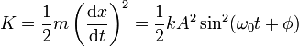 (8)
The elastic potential energy stored in the spring for any elongation x is given by ½ kx².
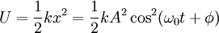 (9)
We see that K and U are always positive quantities or zero. We can express the total mechanical energy of the simple harmonic oscillator as
E = K + U
Because ω₀² = k/m, from the identity sin²α + cos²α = 1, we see this equation reduces to
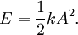. (10)
That is, the total mechanical energy of a simple harmonic oscillator is a constant of the motion and is proportional to the square of the amplitude A.
The total mechanical energy is equal to the maximum potential energy stored in the spring when x = ±A, because v = 0 at these points and there is no kinetic energy.
At the equilibrium position, where U = 0 because x = 0, the total energy, all in the form of kinetic energy, is again ½ kA².
We are spending so much time studying simple harmonic oscillators because they are good models of a wide variety of physical phenomena.
Damped Oscillations
In many real systems, nonconservative forces such as friction or air resistance retard the motion. Consequently, the mechanical energy of the system diminishes in time, and the motion is described as a damped oscillation.
Consider an object moving through a medium such as a liquid or a gas. A spring force, F, which depends linearly on position, does not accomplish damping. However, a force that depends on velocity does. For speeds that are not too large, the damping is given by a drag force of the form
R = –bv, (11)
where b is the damping constant, and v = dx/dt is the velocity.
With damping force R, the differential equation describing damped harmonic motion is:
ma = ‒ kx ‒ bv
(12)
The solution of this differential equation is
. (13)
where the angular frequency of the oscillation is
(14)
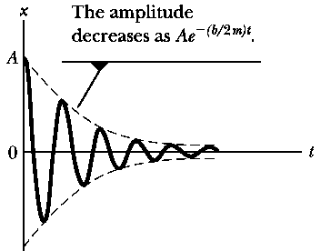
where ω₀² is the angular frequency in the absence of a retarding force and is called the natural frequency of the system.
When the retarding force is small, the oscillatory character of the motion is preserved but the amplitude decreases exponentially in time, with the result that the motion ultimately becomes undetectable.
Any system that behaves in this way is known as a damped oscillator.
The dashed black lines, which define the envelope of the oscillatory curve, represent the exponential factor in (13). This envelope shows that the amplitude decays exponentially with time.
For motion with a given spring constant and object mass, the oscillations dampen more rapidly for larger values of the retarding force.
As the value of b increases, the amplitude of the oscillations decreases more and more rapidly. When b reaches a critical value b_{c} such that
b_{c}/2m = ω₀ and b_{c} = 2mω₀ (15)
the system does not oscillate and is said to be critically damped.

Graphs of position versus time for (a) an
underdamped oscillator, (b) a critically damped oscillator, and (c) an overdamped oscillator.
In this case, the system, once released from rest at some nonequilibrium position, approaches but does not pass through the equilibrium position.
If the medium is so viscous that the retarding force is large compared with the restoring force that is, if
b/2m > ω₀ (16)
the system is overdamped.
Again, the displaced system, when free to move, does not oscillate but rather simply returns to its equilibrium position.

As the damping increases, the time interval required for the system to approach equilibrium also increases.
For critically damped and overdamped systems, there is no angular frequency ω and the solution in (13) is not valid.
Damping is quite frequently introduced to systems that would otherwise oscillate in undesirable ways. Automobile shock absorbers are present for just this.
The quantity b/2m, which appears multiplying t in the exponential factor in (13), has dimensions of inverse time because the argument of an exponential must be dimensionless. We therefore define the lifetime (or the mean life), τ, of the damped oscillator by
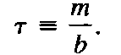 (17)
In terms of τ, the exponential envelope has the form exp(‒t/2τ). The larger the value of τ, the slower the exponential falloff.
Forced Oscillations
The mechanical energy of a damped oscillator decreases in time as a result of the resistive force. It is possible to compensate for this energy decrease by applying an external force that does positive work on the system. Such an oscillator then undergoes forced oscillations.
At any instant, energy can be transferred into the system by an applied force that acts in the direction of motion of the oscillator.
The amplitude of motion remains constant if the energy input per cycle of motion exactly equals the decrease in mechanical energy in each cycle that results from resistive forces.
A forced oscillator is a damped oscillator driven by an external force F(t)
F(t) = F₀ sin ωt,
where ω is the angular frequency of the driving force and F₀ is a constant.
In general, the frequency ω of the driving force is different from the natural frequency ω₀ of the oscillator. Newton’s second law in this situation gives
‒ kx ‒ bv + F₀ sin ωt = ma or
After the driving force on an initially stationary object begins to act, the amplitude of the oscillation will increase.
After a sufficiently long time interval, when the energy input per cycle from the driving force equals the amount of mechanical energy transformed to internal energy for each cycle, a steady-state condition is reached in which the oscillations proceed with constant amplitude:
x(t) = A cos (ωt + )
where
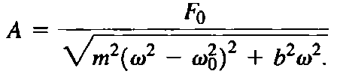
Equation shows that the amplitude of the forced oscillator is constant for a given driving force because it is being driven in steady state by an external force.
For small damping the amplitude becomes large when the frequency of the driving force is near the natural frequency of oscillation, or when ω ≈ ω₀.
The dramatic increase in amplitude near the natural frequency is called resonance, and the resonance frequency ω_{max} of the system is
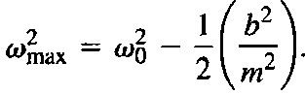

Note that the amplitude increases with decreasing damping (b → 0) and that the resonance curve flattens as the damping increases.

In the absence of a damping (b = 0), we see that the steady state amplitude approaches infinity as ω_{max} → ω₀.
In other words, if there are no resistive forces in the system and we continue to drive an oscillator with a sinusoidal force at the resonance frequency, the amplitude of motion will build up without limit.
That the peak is less sharp for larger b is sometimes expressed as the fact that the width of the peak is a measure of b.

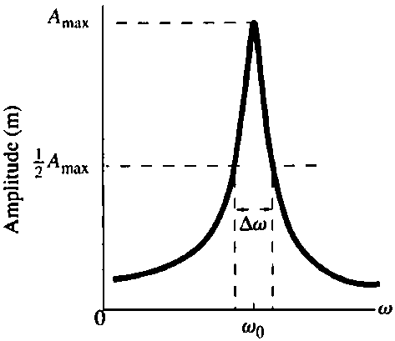
It is possible to compute the total width at half-maximum Δω of the peak by evaluating the amplitude where it is one half its peak value and measuring the spread of frequencies Δω to which this corresponds.
For small b, this width is
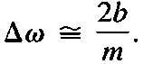
Thus the sharpness Δω of the resonance peak is a direct measure of the damping coefficient, b, divided by m:
The smaller the damping, the sharper the resonance peak.
Resonance appears in many areas of physics. For example, certain electric circuits have resonance frequencies. This fact is exploited in radio tuners, which allow you to select the station you wish to hear.
Vibrating strings and columns of air also have resonance frequencies, which allow them to be used for musical instruments.
Any structure is the oscillator. It has a set of natural frequencies, determined by its stiffness, its mass, and the details of its construction. During an earthquake the periodic driving force is supplied by the shaking of the ground.
A disastrous result can occur if a natural frequency of the building matches a frequency contained in the ground shaking. In this case, the resonance vibrations of the building can build to a very large amplitude, large enough to damage or destroy the building.
This result can be avoided in two ways:
- The first involves designing the structure so that natural frequencies of the building lie
outside the range of earthquake frequencies. (A typical range of earthquake frequencies is 0–15 Hz.) Such a building can be designed by varying its size or mass structure.
- The second method involves incorporating sufficient damping in the building. This method
may not change the resonance frequency significantly, but it will lower the response to the natural frequency. It will also flatten the resonance curve, so the building will respond to a wide range of frequencies but with small amplitude at any given frequency.

