ODESSA NATIONAL MEDICAL UNIVERSITY

Department of Biophysics, Informatics and Medical Devices

Information
for
First year students

Taking the course of

Biological physics with physical methods of analysis

Specialty: 226 «Pharmacy, industrial pharmacy»

IWS 11 3h

Wave optics

Composed by:

As. Prof. P.G. Zhumatii

Approved
at the methodical meeting of the Department
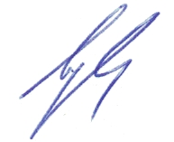
"29" _August_ 2023, Protocol No. _1_

Head of Department, Prof. Godlevsky L.S.

ODESSA – 2023
IWS 11 3h Wave optics.

From a classical optics perspective, interference is the mechanism by which light interacts with light. Interference can occur when two waves overlap each other in space.
The superposition principle for electromagnetic waves implies that two overlapping fields E₁ and E₂ add to give E₁ + E₂. This is the basis for interference.
In order to observe interference in light waves, the following conditions must be met:
- The sources must be coherent (maintain a constant phase with respect to each other).
- The sources should be monochromatic — that is, of a single wavelength.
The observable quantity is the intensity, which becomes
I = I₁ + I₂ + 2 √ I₁ I₂ cos Δφ,
where Δφ is the phase difference. This is the basic equation describing interference.
The detected intensity varies cosinusoidally with the phase difference between the two waves. These alternating bright and dark bands in the intensity pattern are referred to as interference fringes. Along a particular fringe, the phase difference is constant.
The phase difference is related to the difference in the optical path lengths L = nx between the source and the observation point for the two waves. This is the optical path difference δ = L₁ - L₂:
or .
The phase difference changes by 2π every time the δ increases by a wavelength λ.
Constructive interference occurs when the two waves are in phase, and maximum in the intensity pattern results. This corresponds to a phase difference of an integer number m of 2π’s or δ is a multiple of the wavelength λ:
Δφ = 2πm, δ = mλ, m = 0, 1, 2, 3, … .
In constructive interference, the intensity of the resultant wave at a given position or time is:
I = I₁ + I₂ + 2 √ I₁ I₂ .
A dark fringe or minimum in the intensity pattern results from destructive interference when the two waves are out of phase by π or the δ is an odd number of half wavelengths:
Δφ = (2m +1)π, δ = (2m +1)λ/2, m = 0, 1, 2, 3, … .
In destructive interference, the resultant intensity is less than that of either individual wave:
I = I₁ + I₂ - 2 √ I₁ I₂ .
The absolute value of m is called the order of interference.
As we move from one bright fringe to an adjacent bright fringe, the δ changes by λ.
It is this inherent precision that makes interferometry such a valuable metrology tool.
Interference in Thin Films
Consider a film of uniform thickness d and index of refraction n, as shown in figure.
Starting at A, ray 2 has the path AFB in the film and ray 1 the path AD in air. The difference in these optical paths is given by
δ = n(AFB) – AD.
It is equal to to
δ = 2nd cos φ'.
If this path difference is a whole number of wavelengths, we might expect rays 1 and
2 to arrive at the focus of the lens in phase with each other and produce a maximum of intensity.
A field E undergoes a λ/2 change when the wave reflected from a boundary leading to
an optically denser medium (a medium with a higher index of refraction), but no change occurs when the wave is reflected from a boundary leading to a less dense medium.
So ray 1 undergoes a λ/2 change at reflection, while ray 2 does not, since it is internally reflected. Thus condition
2d n cos φ' = mλ m = 0, 1, 2, 3, … Minima
becomes a condition for destructive interference.
2d n cos φ' = (2m +1)λ/2 m = 0, 1, 2, 3, … Maxima
becomes a condition for constructive interference.
If the film is placed between two different media, one with n₁ < n_{film} and the other with n₂ > n_{film} , then the conditions for constructive and destructive interference are reversed.
Principles of interference in thin films are used for the production of coated surfaces.
If a transparent film of index n' is deposited on glass of a larger index n to a thickness d = λ/4 the light reflected at normal incidence is almost completely suppressed by interference.
This corresponds to the conditions cos φ' = 1, m = 0 in
2d n' cos φ' = (2m +1)λ/2,
which here becomes a condition for minima because n' < n .
For the destruction to be complete, however, the fraction of the amplitude reflected at each of the two surfaces must be exactly the same. It will be true for a film in contact with a medium of higher index n only if the index of the film n' obeys the relation
.
Such a film will give zero reflection. No light is destroyed by a nonreflecting film; there is a redistribution such that a decrease of reflection carries with it a increase of transmission.
Almost all optical parts of high quality are now coated to reduce the loss of light by reflection at the various surfaces of a system of lenses or prisms.
Interference phenomena can be observed in interferometers. Light waves can interfere only if they are emitted by the same source. Most interferometers therefore consist of
- light source;
- element for splitting the light into two (or more) partial waves;
- different propagation paths where the partial waves undergo different phase contributions;
- element for superposing the partial waves;
- detector for observation of the interference.
Interferometers are used to measure small variations in distance, index, wavelength.

Diffraction
When light passes an edge, it will deviate from rectilinear propagation. This phenomenon is known as diffraction. The term diffraction has been conveniently defined by Sommerfeld as any deviation from rectilinear paths which can’t be interpreted as reflection or refraction.
Waves are characterized by constant-phase surfaces, called wavefronts. If the initial shape at time t of such a wavefront is known in a vacuum or in any medium, Huygens proposed a geometrical construction to obtain its shape at a later time, t + Δt:
He regarded each point of the initial wavefront as the origin of a secondary wave that propagates in all directions with the speed v of propagation of the initial wave in the medium.
These secondary waves of radii vΔt are constructed at each point of the initial wavefront. A surface tangential to all these secondary waves, called the envelope of all these waves, is then the shape and position of the wavefront at time t + Δt.
With this construct Huygens explained the phenomena of reflection and refraction.
To explain the phenomenon of diffraction, Fresnel modified Huygens’ construction by attributing the property of mutual interference to the secondary waves. The modified Huygens construction is called the Huygens-Fresnel construction.
The diffraction grating
The diffraction grating, a useful device for analyzing light sources, consists of a large number of equally spaced parallel slits.
A transmission grating can be made by cutting parallel grooves on a glass plate with a precision ruling machine. The spaces between the grooves are transparent to the light and hence act as separate slits.
A reflection grating can be made by cutting parallel grooves on the surface of a reflective material. The reflection of light from the spaces between the grooves is specular, and the reflection from the grooves cut into the material is diffuse. Thus, the spaces between the grooves act as parallel sources of reflected light, like the slits in a transmission grating.
Current technology can produce gratings that have very small grating spacing. A typical grating ruled with 1000 grooves/mm has a grating spacing d = 10⁻³ mm.
A section of a diffraction grating is illustrated in figure.
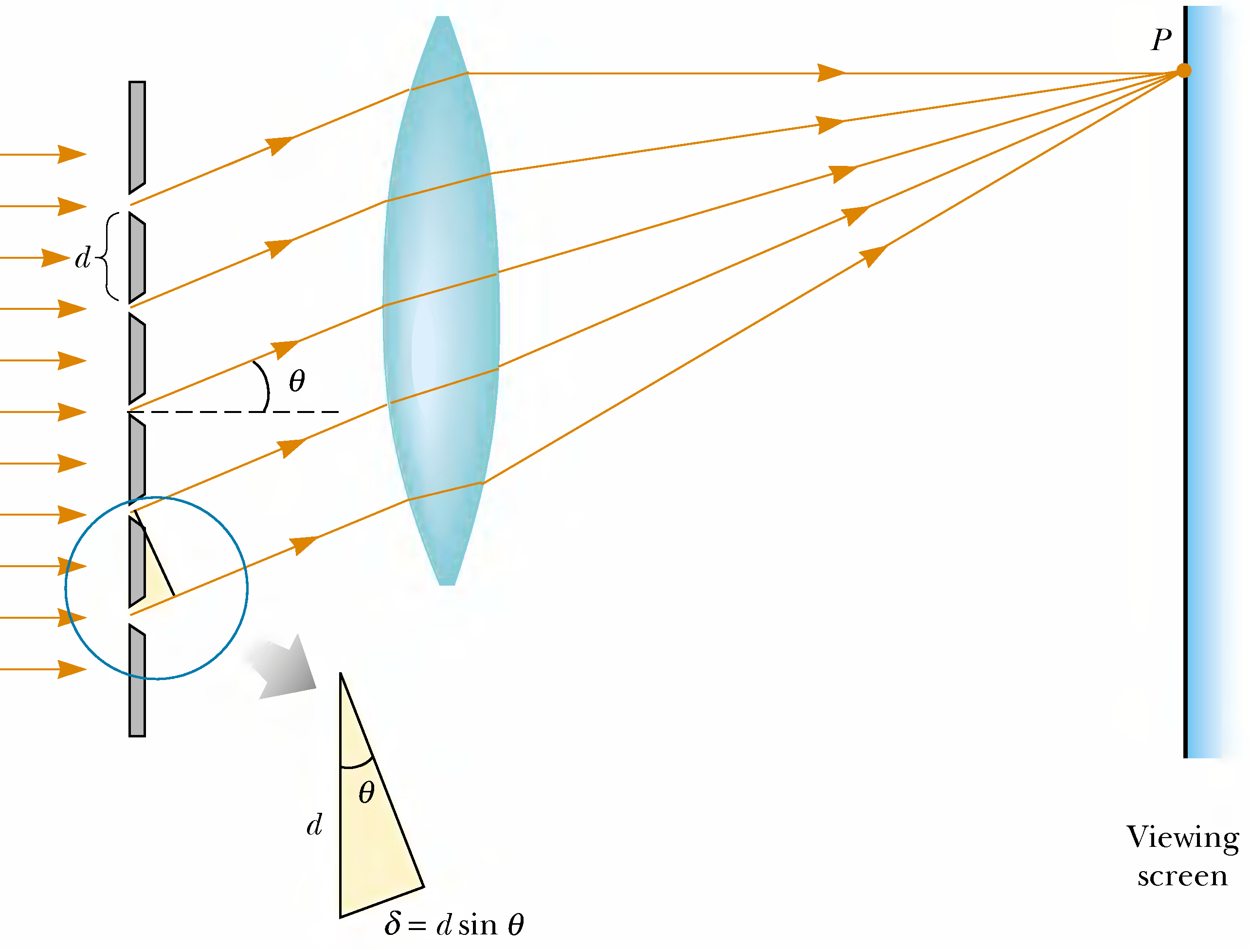
A plane wave is incident from the left, normal to the plane of the grating.
The waves from all slits are in phase as they leave the slits. But, for some direction θ the waves must travel different path lengths before reaching the screen.
The path difference δ between rays from any two adjacent slits is d sinθ.
The condition for principal maxima in the interference pattern at the angle θ_{bright} is
d sinθ = mλ m = 0, ±1, ±2, ±3, … .
If the incident radiation contains several wavelengths, the mth-order maximum for each wavelength λ occurs at a specific angle θ.
Between two adjacent principal maxima there will be N - 1 points of zero intensity:
Between the minima the intensity rises again, but the secondary maxima thus produced are of much smaller intensity than the principal maxima.
Angular dispersion
The separation of any two wavelengths λ₁ and λ₂ increases with the order number m.
To express this separation the quantity frequently used is called the angular dispersion, which is defined as the rate of change of angle θ with change of wavelength λ.
An expression for this quantity is obtained by differentiating d sinθ = mλ with respect to λ. Substituting the ratio of finite increments for the derivative, one has
.
The equation shows that for a given small wavelength difference Δλ, the angular separation Δθ is directly proportional to the order m and is inversely proportional to the grating spacing d.
The occurrence of cos θ in the denominator means that if θ does not become large, cosθ will not differ much from 1, and this factor will be of little importance. If we neglect its influence, the different spectral lines in one order will differ in angle by amounts which are directly proportional to their difference in wavelength Δλ.
Such a spectrum is called a normal spectrum, and one of the chief advantages of gratings over prism instruments is this simple linear scale for wavelengths in their spectra.
Resolving power of the diffraction grating
Of the two diffraction grating, a grating with very small slit separation is more precise if one wants to distinguish two closely spaced wavelengths.
For two nearly equal wavelengths λ₁ and λ₂ between which a diffraction grating can just barely distinguish, the resolving power R of the grating is defined as
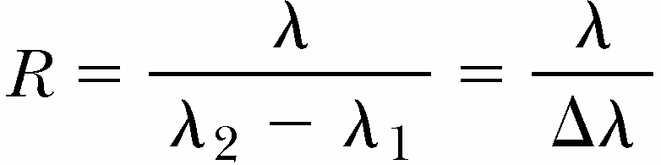,
Thus, a grating that has a high resolving power can distinguish small differences in wavelength.
If N slits of the grating are illuminated, resolving power in the mth-order diffraction is
R = mN.
Holography
One interesting application of diffraction gratings is holography, the production of three-dimensional images of objects. How a hologram is made.
Light from the laser is split into two parts by a half-silvered mirror:
- One part of the beam reflects off the object to be photographed and strikes an ordinary
photographic film.
- The other half of the beam strikes the film.
The two beams overlap to form an extremely complicated interference pattern on the film.
The hologram records not only the intensity of the light scattered from the object (as in a
conventional photograph), but also the phase difference between the reference beam and the
beam scattered from the object.
An interference produces an image in which all three-dimensional information available from the perspective of any point on the hologram is preserved.
In a photographic image, a lens is used to focus the image so that each point on the object corresponds to a single point on the film. There is no lens used to focus the light onto the film. Thus, light from each point on the object reaches all points on the film.
As a result, each region of the photographic film on which the hologram is recorded contains information about all illuminated points on the object.
A hologram is best viewed by allowing coherent light to pass through the developed film as one looks back along the direction from which the beam comes.
This is a special type of hologram called a rainbow hologram, designed to be viewed in reflected white light.
Diffraction of X-rays by crystals
X-rays are electromagnetic waves of very short wavelength (on the order of 0.1 nm).
In 1913, Max von Laue suggested that the regular array of atoms in a crystal could act as a grating for X -rays. Subsequent experiments confirmed this prediction.
Suppose that an incident x-ray beam makes an angle θ with one of the planes. The beam can be reflected from both the upper plane and the lower one (d distance between them).
However, the beam reflected from the lower plane travels farther than the beam reflected from the upper plane. The effective path difference is 2d sinθ.
The two beams reinforce each other (constructive interference) when this path difference equals some integer multiple of λ. The same is true for reflection from the entire family of parallel planes. Hence, the condition for constructive interference (maxima in the reflected beam) is
This is known as Bragg’s law.
If the wavelength and diffraction angle are measured, this equation can be used to calculate the spacing between atomic planes. One can deduce the crystalline structure by analyzing the positions and intensities of the various spots in the pattern.
Polarized light
An ordinary beam of light consists of a large number of waves emitted by the atoms
of the light source. Each atom produces a wave having some particular orientation of the electric field vector E, corresponding to the direction of atomic vibration.
All directions of vibration from a wave source are possible. At any point and at some instant of time, all these electric field vectors add to give one electric field vector.
A wave is said to be polarized if at a particular point the resultant electric field E vibrates in the same direction at all times.
The plane formed by E and the direction of propagation is called the plane of polarization of the wave.
To obtain a linearly polarized beam all waves from the beam must be removed except those whose electric field vectors oscillate in a single plane.
If an unpolarized light beam is incident on a first polarizing sheet, called the polarizer, light with E₀ parallel to the transmission axis is transmitted.
All light with E perpendicular to the transmission axis is absorbed.
A second polarizing sheet, called the analyzer, intercepts the polarized beam. The analyzer transmission axis is set at an angle θ to the polarizer axis.
The component of E₀ perpendicular to the analyzer axis is completely absorbed. The component of E₀ parallel to the analyzer axis, which is transmitted, is E₀ cos θ.
The intensity I of the polarized beam transmitted through the analyzer varies as
,
I_{max} is the intensity of the polarized beam incident on the analyzer. This is Malus’s law.
The intensity of the transmitted beam is maximum when the transmission axes are parallel and that it is zero when the transmission axes are perpendicular to each other.
When an unpolarized light beam is reflected from a surface,the reflected beam is unpolarized, if the angle of incidence is 0°. For other angles of incidence, this results in a partially polarized reflected beam. The refracted beam is also partially polarized.
If the angle between the reflected and refracted beams is 90°, the reflected beam is completely polarized, and the refracted beam is still only partially polarized. This occurs, if the angle of incidence, so called Brewster’s angle θ_{p}, obeys Brewster’s law
Sunlight reflected from water, glass, and snow is partially polarized. If the surface is horizontal, the electric field vector of the reflected light has a strong horizontal component.
Sunglasses made of polarizing material reduce the glare of reflected light. The transmission axes of the lenses are oriented vertically so that they absorb the strong horizontal component of the reflected light.
A number of minerals exhibited dichroism. The dichroic crystals selectivly absorb one of the two rectangular components of ordinary light. One of such crystals is tourmaline.
For polarizing uses are very suitable polaroids. These films consist of thin sheets of nitrocellulose packed with ultramicroscopic polarizing crystals of herapathite with their optic axes all parallel.
Herapathite absorbs one component of polarization and transmits the other with little loss.
Polarizing films are usually mounted between two thin plates of optical glass. They have found uses in different kinds of optical instruments.

Polarization by double refraction
The production of polarized light use the phenomenon of double refraction in crystals of calcite (calcium carbonate CaCO₃), and quartz (SiO₂) .
Calcite and quartz are anisotropic crystals, in which the speed of light is not the same in all directions. They have two indices of refraction. Such crystals are called doublerefracting or birefringent materials.
If a beam of unpolarized light is incident on a doublerefracting crystal, there will be two refracted beams. This phenomenon is called birefringence.
Snell's law of refraction holds only for ordinary or O ray. The other one is called the extraordinary or E ray.
The ordinary ray, is characterized by an index of refraction n_{O} that is constant in all directions.The ordinary waves would spread out from the source as spheres.
The extraordinary ray, is characterized by an index of refraction n_{E} that varies with the direction of propagation. The extraordinary waves have wave fronts that are elliptical in cross section.
There is one direction, called the optic axis, along which both waves have the same speed, corresponding to the direction for which n_{O} = n_{E} . The difference in speed for the two waves is a maximum in the direction perpendicular to the optic axis.
Uniaxial crystals may be divided into two classes, negative and positive:
- in a negative crystal like calcite, the extraordinary index of refraction is less than the ordinary index: n_{E} < n_{O,} (v_{E} > v_{O}).
- in a positive crystal like quartz, the extraordinary index of refraction is greater than the ordinary index: n_{E} > n_{O,} (v_{E} < v_{O}).
For example, in calcite, n_{O} = 1.66 at a wavelength of 589.3 nm, and n_{E} varies from 1.66 along the optic axis to 1.49 perpendicular to the optic axis.
When the light enters the crystal so that it travels along the optic axis, there is no separation of the O and E rays, the double refraction disappears in this case.
The optic axis is not a particular line through the crystal but a direction. For any given point in the crystal an optic axis may be drawn which will be parallel to that for any other point.
The two rays are polarized in two mutually perpendicular directions, as indicated by the dots and arrows.
Dots represent the end-on view of linear vibrations, and doublepointed arrows represent vibrations confined to the plane of the paper.
Since the two opposite faces of a calcite crystal are always parallel, the two refracted rays emerge parallel to the incident beam and therefore parallel to each other.
Inside the crystal the ordinary ray is always to be found in the plane of incidence.
Only for special directions through the crystal is this true for the extraordinary ray.
If the incident light is normal to the surface, the extraordinary ray will be refracted at some angle that is not zero and will come out parallel to, but displaced from, the incident beam; the ordinary ray will pass straight through without deviation.
A rotation of the crystal about the O ray will in this case cause the E ray to rotate
around the fixed O ray.
Some materials, such as glass and plastic, become birefringent when stressed.
Suppose that an unstressed piece of plastic is placed between a polarizer and an analyzer so that light passes from polarizer to plastic to analyzer.
When the analyzer axis is perpendicular to the polarizer axis, none of the polarized light passes through the analyzer. The unstressed plastic has no effect on the light passing through it.
When the analyzer axis is perpendicular to the polarizer axis and the plastic is stressed and become birefringent, the polarization of the light passing through the plastic changes.
Hence, a series of bright and dark bands is observed in the transmitted light, with the bright bands corresponding to regions of greatest stress.
Engineers often use this technique, called optical stress analysis, in designing structures
ranging from bridges to small tools. They build a plastic model and analyze it under different load conditions to determine regions of potential weakness and failure under stress.
Nicol prism, a very useful polarizing device is made from a calcite crystal.
In specifying the directions of rays and vibrations in crystals, it is convenient to use the principal section, made by a plane containing the optic axis and normal to any crystal face.
First a crystal about 3 times as long as it is wide is taken and the ends cut down from 71° in the principal section to a more acute angle of 68°.
The crystal is then cut apart along the plane A'D' perpendicular to both the principal section and the end faces. The two cut surfaces are ground and polished optically flat and then cemented together with canada balsam.
Canada balsam is used because it is a clear transparent substance with an index of refraction about midway between the index of the O and E rays:
n_{O} = 1.66, n_{B} = 1.55, n_{E} = 1.49.
Optically the balsam is denser than the calcite for the E ray and less dense for the O ray. The E ray therefore will be refracted into the balsam and on through the calcite crystal, whereas the O ray for large angles of incidence will be totally reflected.
Many applications of polarized light involve materials that display optical activity. A material is optically active if it rotates the plane of polarization of transmitted light.
Right-handed rotation means that upon looking against the oncoming light the plane of vibration is rotated in a clockwise direction. Substances which rotate to the right are called right-handed. Left-handed substances rotate the light counterclockwise.
This rotation for a 1-mm plate is called the specific rotation.
The angle through which the light is rotated by a specific material depends on the length of the path through the material and on concentration if the material is in solution.
Liquids made up of an optically active substance and an inactive solvent are found to produce a rotation very nearly proportional to the amount of the active substance present.
This has led to the wide use of polarized light as an accurate means of determining the amounts of an optically active substance, in the presence of nonactive impurities (polarimetry).
A standard method for determining the concentration of sugar solutions is to measure the rotation produced by a fixed length of the solution by polarimeter.
The specific rotation or rotatory power is defined as the rotation produced by a 10-cm column of liquid containing 1 g of active substance for every cubic centimeter of solution:
,
where [ρ] is the specific rotation, d the number of grams of active substance per cubic centimeter, l the length of the light path in centimeters, and θ the angle of rotation.
In general the rotation in liquids is considerably less than in crystals.
It is for this reason that the specific rotation for crystals is taken as the angle for a 1-mm path.
Different colors are rotated by very different amounts. Biot found that the rotation is proportional to the inverse square of the wavelength (Biot's law). It may be measured by spectropolarimeter.
The liquid crystal displays have their optical activity changed by the application of electric potential across different parts of the display. The optical activity may be changed by the application of magnetic field.

