ODESSA NATIONAL MEDICAL UNIVERSITY

Department of Biophysics, Informatics and Medical Devices

Information
for
First year students

Taking the course of

Biological physics with physical methods of analysis

Specialty: 226 «Pharmacy, industrial pharmacy»

Lecture 8

Optics

Composed by:

As. Prof. P.G. Zhumatii

Approved
at the methodical meeting of the Department

"29" _August_ 2023, Protocol No. _1_

Head of Department, Prof. Godlevsky L.S.

ODESSA – 2023
Optics
Developments during the nineteenth century led to the general acceptance of the wave theory of light, the most important resulting from the work of Maxwell, who in 1873 asserted that light was a form of high-frequency electromagnetic wave. Hertz provided experimental confirmation of Maxwell’s theory in 1887 by producing and detecting electromagnetic waves.
We now learn how treating light as waves leads to a satisfying description of interference, diffraction, and polarization of light — the objects of study in the field of wave optics.

Conditions for interference
From a classical optics perspective, interference is the mechanism by which light interacts with light. Interference can occur when two or more waves overlap each other in space.
The superposition principle for electromagnetic waves implies that two overlapping fields E₁ and E₂ add to give E₁ + E₂. This is the basis for interference.
In order to observe interference in light waves, the following conditions must be met:
- The sources must be coherent — that is, they must maintain a constant phase with respect to
each other.
- The sources should be monochromatic — that is, of a single wavelength.
We will now add the additional restrictions that the two linear polarizations are parallel.
The observable quantity is the intensity, which becomes
I ( x, y, z ) = I₁ + I₂ + 2 √ I₁ I₂ cos [ Δφ ( x, y, z )],
where Δφ ( x, y, z ) is the phase difference. This is the basic equation describing interference.
The detected intensity varies cosinusoidally with the phase difference between the two waves. These alternating bright and dark bands in the intensity pattern are referred to as interference fringes, and along a particular fringe, the phase difference is constant.
The phase difference is related to the difference in the optical path lengths L = nx between the source and the observation point for the two waves. This is the optical path difference δ = L₁ - L₂:
or .
The phase difference changes by 2π every time the δ increases by a wavelength λ.
The δ is therefore constant along a fringe.
The superposition of two waves can be constructive or destructive.
Constructive interference occurs when the two waves are in phase, and a bright fringe or maximum in the intensity pattern results. This corresponds to a phase difference of an integral number m of 2π’s or δ that is a multiple of the wavelength λ:
Δφ = 2πm, δ = mλ, m = 0, 1, 2, 3, … .
In constructive interference, the intensity of the resultant wave at a given position or time is greater than that of either individual wave:
I ( x, y, z ) = I₁ + I₂ + 2 √ I₁ I₂ .
A dark fringe or minimum in the intensity pattern results from destructive interference when the two waves are out of phase by π or the δ is an odd number of half wavelengths:
Δφ = (2m +1)π, δ = (2m +1)λ/2, m = 0, 1, 2, 3, … .
In destructive interference, the resultant intensity is less than that of either individual wave:
I ( x, y, z ) = I₁ + I₂ - 2 √ I₁ I₂ .
For conditions between these values, an intermediate value of the intensity results.
Since both the δ and the Δφ increase with the integer m, the absolute value of m is called the order of interference.
As we move from one bright fringe to an adjacent bright fringe, the phase difference changes by 2π. Each fringe period corresponds to a change in the δ of a single wavelength.
It is this inherent precision that makes interferometry such a valuable metrology tool. The wavelength of light is used as the unit of measurement. Interferometers can be configured to measure small variations in distance, index, or wavelength.
In general, an electromagnetic wave undergoes a π phase change when reflected from a boundary leading to an optically denser medium (defined as a medium with a higher index of refraction), but no phase change occurs when the wave is reflected from a boundary leading to a less dense medium.
These rules can be deduced from Maxwell’s equations, but the treatment is beyond the scope of this text.
Interference in Thin Films
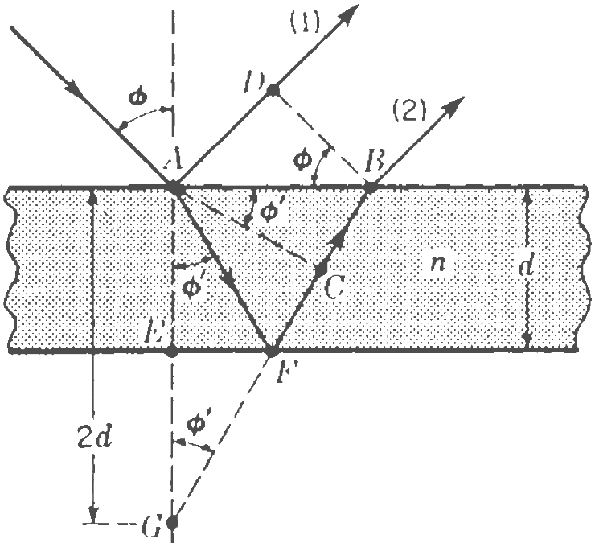
Interference effects are commonly observed in thin films, such as thin layers of oil on water or the thin surface of a soap bubble. The varied colors observed when white light is incident on such films result from the interference of waves reflected from the two surfaces of the film. Consider a film of uniform thickness d and index of refraction n, as shown in figure.
In order to find the phase difference between these rays, we must first evaluate
the difference in the optical path traversed by a pair of successive rays, such as rays 1
and 2.
In figure let φ and φ' the angles of incidence and refraction.
If BD is perpendicular to ray 1, the optical paths from D and B to the focus of the lens will be equal.
Starting at A, ray 2 has the path AFB in the film and ray 1 the path AD in air. The difference in these optical paths is given by
δ = n(AFB) – AD.
If BF is extended to intersect the perpendicular line AE at G, AF = GF because of the equality of the angles of incidence and reflection at the lower surface.
Thus we have
δ = n(GB) – AD = n(GC + CB) – AD.
Now AC is drawn perpendicular to FB; so the broken lines AC and DB represent two successive positions of a wave front reflected from the lower surface. The optical paths must be the same by any ray drawn between two wave fronts; so we may write
n(CB) = AD.
The path difference then reduces to
δ = n(GC) = n(2d cos φ').
If this path difference is a whole number of wavelengths, we might expect rays 1 and
2 to arrive at the focus of the lens in phase with each other and produce a maximum of intensity.
However, we must take account of the fact that ray 1 undergoes a phase change of π at reflection, while ray 2 does not, since it is internally reflected. The condition
2d n cos φ' = mλ m = 0, 1, 2, 3, … Minima
then becomes a condition for destructive interference.
2d n cos φ' = (2m +1)λ/2 m = 0, 1, 2, 3, … Maxima
then becomes a condition for constructive interference.
The foregoing conditions for interference are valid when the medium above the top surface of the film is the same as the medium below the bottom surface or, if there are different
media above and below the film, the index of refraction of both is less than n.
If the film is placed between two different media, one with n₁ < n_{film} and the other with n₂ > n_{film} , then the conditions for constructive and destructive interference are reversed. In this case, either there is a phase change of π for both ray 1 reflecting from surface A and ray 2 reflecting from surface B, or there is no phase change for either ray; hence, the net change in relative phase due to the reflections is zero.
Nonreflecting films
A simple and very important application of the principles of interference in thin films has been the production of coated surfaces.
If a film of a transparent substance of refractive index n' is deposited on glass of a larger index n to a thickness d = λ/4 the light reflected at normal incidence is almost completely suppressed by interference.
This corresponds to the conditions cos φ' = 1, m = 0 in
2d n' cos φ' = (2m +1)λ/2,
which here becomes a condition for minima because n' < n and there is no phase change for either ray due to the reflections.
The waves reflected from the lower surface have an extra path of λ/2 over those from the upper surface, and the two, therefore interfere destructively.
For the destruction to be complete, however, the fraction of the amplitude reflected at each of the two surfaces must be exactly the same. It will be true for a film in contact with a medium of higher index n only if the index of the film n' obeys the relation
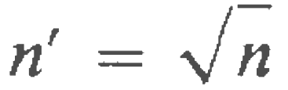.
Such a film will give zero reflection. Of course no light is destroyed by a nonreflecting film; there is merely a redistribution such that a decrease of reflection carries with it a increase of transmission.
The practical importance of these films is that by their use one can greatly reduce the loss of light by reflection at the various surfaces of a system of lenses or prisms. Stray light reaching the image as a result of these reflections is also largely eliminated, with a resulting increase in contrast. Almost all optical parts of high quality are now coated to reduce reflection.

Diffraction
When light passes an edge, it will deviate from rectilinear propagation. This phenomenon (which is a natural consequence of the wave nature of light) is known as diffraction and plays an important role in optics. The term diffraction has been conveniently defined by Sommerfeld as ‘any deviation from rectilinear paths which cannot be interpreted as reflection or refraction’.
A rigorous theory of diffraction is quite complicated. Here we develop expressions for the diffracted field based on Huygens-Fresnel principle of secondary spherical wavelets.
Huygens-Fresnel principle
Waves are characterized by constant-phase surfaces, called wavefronts. If the initial shape at time t of such a wavefront is known in a vacuum or in any medium, Huygens proposed a geometrical construction to obtain its shape at a later time, t + Δt:
He regarded each point of the initial wavefront as the origin of a new disturbance that propagates in the form of secondary wave in all directions with the same speed as the speed v of propagation of the initial wave in the medium.
These secondary wavelets of radii vΔt are constructed at each point of the initial wavefront. A surface tangential to all these secondary wavelets, called the envelope of all these wavelets, is then the shape and position of the wavefront at time t + Δt.
With this construct Huygens explained the phenomena of reflection and refraction.
To explain the phenomenon of diffraction, Fresnel modified Huygens’ construction by attributing the property of mutual interference to the secondary wavelets. The modified Huygens construction is called the Huygens-Fresnel construction. It helps explain the phenomenon of diffraction.
The diffraction grating
The diffraction grating, a useful device for analyzing light sources, consists of a large number of equally spaced parallel slits.
A transmission grating can be made by cutting parallel grooves on a glass plate with a precision ruling machine. The spaces between the grooves are transparent to the light and hence act as separate slits.
A reflection grating can be made by cutting parallel grooves on the surface of a reflective material. The reflection of light from the spaces between the grooves is specular, and the reflection from the grooves cut into the material is diffuse. Thus, the spaces between the grooves act as parallel sources of reflected light, like the slits in a transmission grating.
Current technology can produce gratings that have very small grating spacing. A typical grating ruled with 1000 grooves/mm has a grating spacing d = 10⁻³ mm.
A section of a diffraction grating is illustrated in figure.
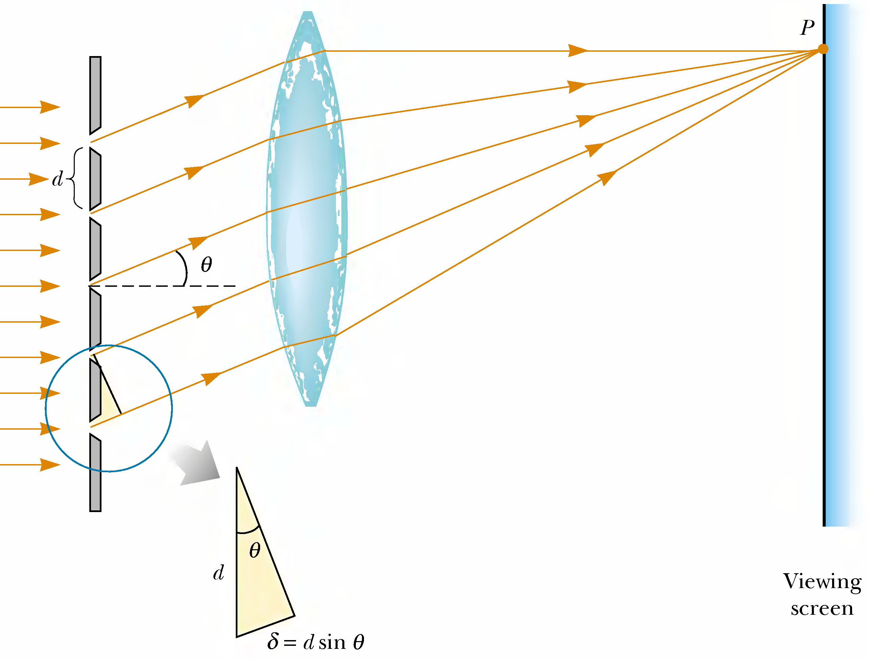
A plane wave is incident from the left, normal to the plane of the grating.
The waves from all slits are in phase as they leave the slits. However, for some arbitrary direction θ measured from the horizontal, the waves must travel different path lengths before reaching the screen.
The path difference δ between rays from any two adjacent slits is d sinθ.
If this path difference equals one wavelength or some integral multiple of a wavelength, then waves from all slits are in phase at the screen and a bright fringe is observed.
So, the condition for principal maxima in the interference pattern at the angle θ_{bright} is
d sinθ_{bright} = mλ m = 0, ±1, ±2, ±3, … .
We can calculate the wavelength λ if we know the grating spacing d and the angle θ_{bright}.
If the incident radiation contains several wavelengths, the mth-order maximum for each wavelength λ occurs at a specific angle θ_{bright}.
A more general equation includes the possibility of light incident on the grating at any angle i. The equation then becomes
d(sin i + sin θ_{bright}) = mλ m = 0, ±1, ±2, ±3, … .
Between two adjacent principal maxima there will be N - 1 points of zero intensity:
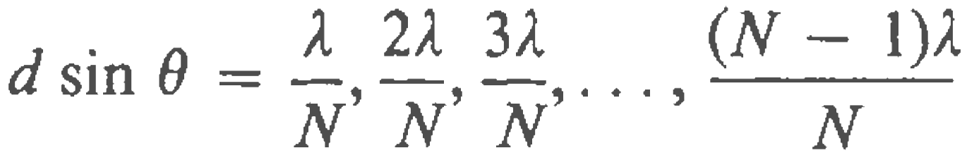
Between the minima the intensity rises again, but the secondary maxima thus produced are of much smaller intensity than the principal maxima.
Angular dispersion
The separation of any two wavelengths λ₁ and λ₂ increases with the order number m.
To express this separation the quantity frequently used is called the angular dispersion, which is defined as the rate of change of angle θ with change of wavelength λ.
An expression for this quantity is obtained by differentiating d sinθ = mλ
with respect to λ. Substituting the ratio of finite increments for the derivative, one has
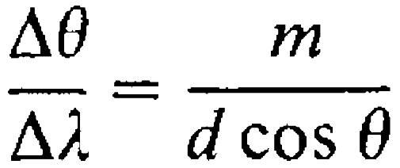.
If θ does not become large, cosθ will not differ much from 1, and this factor will
be of little importance. If we neglect its influence, the different spectral lines in one order will differ in angle by amounts which are directly proportional to their difference in wavelength Δλ.
Such a spectrum is called a normal spectrum, and one of the chief advantages of gratings over prism instruments is this simple linear scale for wavelengths in their spectra.
Resolving power of the diffraction grating
The diffraction grating is useful for measuring wavelengths accurately.
Of the two devices, a grating with very small slit separation is more precise if one wants to distinguish two closely spaced wavelengths.
For two nearly equal wavelengths λ₁ and λ₂ between which a diffraction grating can just barely distinguish, the resolving power R of the grating is defined as
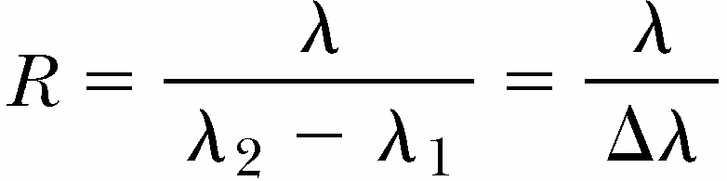,
where λ = (λ₁ + λ₂)/2 and Δλ = λ₂ - λ₁. Thus, a grating that has a high resolving power can distinguish small differences in wavelength.
If N slits of the grating are illuminated, it can be shown that the resolving power in the mth-order diffraction is
R = mN.
Thus, resolving power increases with increasing order number m and with increasing number of illuminated slits N.
Holography
One interesting application of diffraction gratings is holography, the production of three-dimensional images of objects. The physics of holography was developed by Dennis Gabor in 1948, and resulted in the Nobel Prize in physics for Gabor in 1971.
The requirement of coherent light for holography, however, delayed the realization of holographic images from Gabor’s work until the development of lasers in the 1960s.
How a hologram is made.
Light from the laser is split into two parts by a half-silvered mirror:
- One part of the beam reflects off the object to be photographed and strikes an ordinary
photographic film.
- The other half of the beam strikes the film.
The two beams overlap to form an extremely complicated interference pattern on the film.
Such an interference pattern can be produced only if the phase relationship of the two waves is constant throughout the exposure of the film. This condition is met by illuminating the scene with coherent laser radiation.
The hologram records not only the intensity of the light scattered from the object (as in a
conventional photograph), but also the phase difference between the reference beam and the
beam scattered from the object.
Because of this phase difference, an interference pattern is formed that produces an image in which all three-dimensional information available from the perspective of any point on the hologram is preserved.
In a normal photographic image, a lens is used to focus the image so that each point on the object corresponds to a single point on the film. Notice that there is no lens used to focus the light onto the film. Thus, light from each point on the object reaches all points on the film. As a result, each region of the photographic film on which the hologram is recorded contains information about all illuminated points on the object.
This leads to a remarkable result—if a small section of the hologram is cut from the film, the complete image can be formed from the small piece! (The quality of the image is reduced, but the entire image is present.)
A hologram is best viewed by allowing coherent light to pass through the developed film as one looks back along the direction from which the beam comes.
Holograms are finding a number of applications. You may have a hologram on your credit card. This is a special type of hologram called a rainbow hologram, designed to be viewed in reflected white light.
Polarization of light waves
An ordinary beam of light consists of a large number of waves emitted by the atoms
of the light source. Each atom produces a wave having some particular orientation of the electric field vector E, corresponding to the direction of atomic vibration.
The direction of polarization of each individual wave is defined to be the direction in which the electric field is vibrating.
Because all directions of vibration from a wave source are possible, the resultant electromagnetic wave is a superposition of waves vibrating in many different directions.
At any given point and at some instant of time, all these individual electric field vectors add to give one resultant electric field vector. The result is an unpolarized light beam.
A wave is said to be linearly polarized if the resultant electric field E vibrates in the same direction at all times at a particular point. Sometimes, such a wave is described as plane-polarized, or simply polarized.
The plane formed by E and the direction of propagation is called the plane of polarization of the wave.
It is possible to obtain a linearly polarized beam from an unpolarized beam by removing all waves from the beam except those whose electric field vectors oscillate in a single plane. We now discuss processes for producing polarized light from unpolarized light.
Polarization by selective absorption
The most common technique for producing polarized light is to use a material that
transmits waves whose electric fields vibrate in a plane parallel to a certain direction and that absorbs waves whose electric fields vibrate in all other directions.
Figure represents an unpolarized light beam incident on a first polarizing sheet, called the polarizer.
In an ideal polarizer, all light with E parallel to the transmission axis is transmitted, and all light with E perpendicular to the transmission axis is absorbed.
Because the transmission axis is oriented vertically in the figure, the light transmitted through this sheet is polarized vertically.
A second polarizing sheet, called the analyzer, intercepts the beam. In figure, the
analyzer transmission axis is set at an angle θ to the polarizer axis.
We call the electric field vector of the first transmitted beam E₀. The component of E₀ perpendicular to the analyzer axis is completely absorbed. The component of E₀ parallel to
the analyzer axis, which is allowed through by the analyzer, is E₀ cos θ.
Because the intensity I of the transmitted beam varies as the square of its magnitude E₀, we conclude that the intensity of the polarized beam transmitted through the analyzer varies as
,
where I_{max} is the intensity of the polarized beam incident on the analyzer.
This expression, known as Malus’s law, applies to any two polarizing materials whose transmission axes are at an angle θ to each other.
We see that the intensity of the transmitted beam is maximum when the transmission axes are parallel (θ = 0°) and that it is zero (complete absorption by the analyzer) when the transmission axes are perpendicular to each other.
Polarization by Reflection
When an unpolarized light beam is reflected from a surface, the reflected light may be
completely polarized, partially polarized, or unpolarized, depending on the angle of incidence.
If the angle of incidence is 0°, the reflected beam is unpolarized. For other angles of incidence, the reflected light is polarized to some extent, and for one particular angle of incidence, the reflected light is completely polarized.
At this particular angle of incidence, the reflected beam is completely polarized, and the refracted beam is still only partially polarized.
The angle of incidence at which this polarization occurs is called the polarizing angle θ_{p}.
We can obtain an expression relating the polarizing angle to the index of refraction n of the reflecting substance. From figure, we see that
θ_{p} + 90° + θ₂ = 180°; thus θ₂ = 90° - θ_{p} .
Using Snell’s law of refraction and taking n₁ = 1.00 for air and n₂ = n, we have
.
Because sinθ₂ = sin(90° - θ_{p}) = cosθ_{p}, we can write this expression for n as
This expression is called Brewster’s law, and the polarizing angle θ_{p} is sometimes called Brewster’s angle.
Polarization by reflection is a common phenomenon. Sunlight reflected from water, glass, and snow is partially polarized. If the surface is horizontal, the electric field vector of the reflected light has a strong horizontal component.
Polarization by dichroic crystals
The dichroic crystals have the property of selectivity absorbing one of the two rectangular components of ordinary light.
Dichroism is exhibited by a number of minerals and by some organic compounds. Perhaps the best known of the mineral crystals is tourmaline.
The observed effect is due to a selective absorption of all light rays vibrating in one particular plane but not those vibrating in a plane at right angles (called the E vibrations). Thus only the E vibrations are transmitted. Since tourmaline crystals are somewhat colored, they are not used in optical instruments as polarizing or analyzing devices.
Attempts to produce polarizing crystals of large aperture were made by Herapath in 1852. He was successful in producing good but small crystals of the organic compound quinine iodosulfate (now known as herapathite), which completely absorbs one component of polarization and transmits the other with little loss.
One variety of polaroid contains crystals of this substance. Polaroid was invented in 1932 by Land, and has found uses in many different kinds of optical instruments.
These films consist of thin sheets of nitrocellulose packed with ultramicroscopic polarizing crystals with their optic axes all parallel.
Polaroid is very suitable for polarizing uses such as automobile headlights and visors. Polarizing films are usually mounted between two thin plates of optical glass.
Polarization by double refraction
The production and study of polarized light over a wider range of wavelengths than is afforded by polaroid use the phenomenon of double refraction in crystals of calcite (calcium carbonate CaCO₃), and quartz (SiO₂) .
Both these crystals are transparent to visible as well as ultraviolet light.
Calcite and quartz are examples of anisotropic crystals, or ones in which the physical
properties vary with direction and the speed of light is not the same in all directions.
Such materials are characterized by two indices of refraction. Hence, they are often referred to as doublerefracting or birefringent materials.
When a beam of ordinary unpolarized light is incident on a calcite or quartz crystal, there will be, in addition to the reflected beam, two refracted beams in place of the usual single one observed, for example, in glass. This phenomenon is called double refraction, or birefringence.
Snell's law of refraction holds for one ray but not for the other. The ray for which the law holds is called the ordinary or O ray, and the other is called the extraordinary or E ray.
The ordinary ray, is characterized by an index of refraction n_{O} that is the same in all directions.
This means that if one could place a point source S of light inside the crystal, the ordinary waves would spread out from the source as spheres.
The extraordinary ray, travels with different speeds in different directions and hence is characterized by an index of refraction n_{E} that varies with the direction of propagation.
Consider again the point source within a birefringent material. The source sends out an extraordinary wave having wave fronts that are elliptical in cross section.
Note from that there is one direction, called the optic axis, along which the ordinary and
extraordinary rays have the same speed, corresponding to the direction for which n_{E} = n_{E} .
The difference in speed for the two rays is a maximum in the direction perpendicular to the optic axis.
Uniaxial crystals may be divided into two classes, negative and positive:
- in a negative crystal like calcite, the extraordinary index of refraction is less than the ordinary index: n_{E} < n_{O,} (v_{E} > v_{O}).
- in a positive crystal like quartz, the extraordinary index of refraction is greater than the ordinary index: n_{E} > n_{O,} (v_{E} < v_{O}).
For example, in calcite, n_{O} = 1.66 at a wavelength of 589.3 nm, and n_{E} varies from 1.66 along the optic axis to 1.49 perpendicular to the optic axis.
The double refraction disappears when the light is made to enter the crystal so that it travels along the optic axis. That is, there is no separation of the O and E rays in this case.
This is also true in directions at right angles to the axis, but here the O and E rays behave differently in a less obvious respect, namely they differ in velocity.
It should be emphasized that the optic axis is not a particular line through the crystal
but a direction. That is, for any given point in the crystal an optic axis may be drawn which will be parallel to that for any other point.
The two rays are polarized in two mutually perpendicular directions, as indicated by the dots and arrows.
Dots represent the end-on view of linear vibrations, and doublepointed arrows represent vibrations confined to the plane of the paper.
Since the two opposite faces of a calcite crystal are always parallel, the two refracted rays emerge parallel to the incident beam and therefore parallel to each other.
Inside the crystal the ordinary ray is always to be found in the plane of incidence.
Only for special directions through the crystal is this true for the extraordinary ray. If the incident light is normal to the surface, the extraordinary ray will be refracted at some angle that is not zero and will come out parallel to, but displaced from, the incident beam; the ordinary ray will pass straight through without deviation.
A rotation of the crystal about the O ray will in this case cause the E ray to rotate
around the fixed O ray.
Some materials, such as glass and plastic, become birefringent when stressed.
Engineers often use this technique, called optical stress analysis, in designing structures
ranging from bridges to small tools. They build a plastic model and analyze it under different load conditions to determine regions of potential weakness and failure under stress.

Nicol prism
Nicol prism, a very useful polarizing device is made from a calcite crystal.
In specifying the directions of rays and vibrations in crystals, it is convenient to use the principal section, made by a plane containing the optic axis and normal to any crystal face.
A principal section always cuts the surfaces of a calcite crystal in a parallelogram with angles of 71° and 109°, as shown in figure.
First a crystal about 3 times as long as it is wide is taken and the ends cut down from 71° in the principal section to a more acute angle of 68°.
The crystal is then cut apart along the plane A'D' perpendicular to both the principal section and the end faces. The two cut surfaces are ground and polished optically flat and then cemented together with canada balsam.
Canada balsam is used because it is a clear transparent substance with an index of refraction about midway between the index of the O and E rays:
for sodium light wavelength of 589.3 nm, n_{O} = 1.66, n_{B} = 1.55, n_{E} = 1.49.
Optically the balsam is denser than the calcite for the E ray and less dense for the O ray. The E ray therefore will be refracted into the balsam and on through the calcite crystal, whereas the O ray for large angles of incidence will be totally reflected.
The critical angle for total reflection of the O ray at the first calcite to balsam surface is about 69° and corresponds to a limiting angle SMS_{o} of about 14°.
At greater angles than this, some of the O ray will be transmitted. This means that a nicol should not be used in light which is highly convergent or divergent.
The E ray in a nicol also has an angular limit, beyond which it will be totally reflected by the balsam. This is due to the fact that the index of refraction of calcite is different for different directions through the crystal. The index n_{E} = 1.49, as it is usually given, applies only in the special case of light traveling at right angles to the optic axis.
Along the optic axis the E ray travels with the same speed as the O ray, and it therefore has the same index of 1.66. For intermediate angles the effective index lies between these two limits 1.49 and 1.66.
There will therefore be a maximum angle SMS_{E} beyond which the balsam will be optically less dense than the calcite, and there will be total reflection of the E vibrations.
The prism is so cut that this angle likewise is in the neighborhood of 14°. The direction of the incident light on a nicol therefore is limited on the one side to avoid having the O ray transmitted and on the other side to avoid having the E ray totally reflected. In practice, it is important to keep this limitation in mind.

Optical Activity
Many important applications of polarized light involve materials that display optical
activity. A material is said to be optically active if it rotates the plane of polarization of any light transmitted through the material.
A striking feature of optical activity is that different colors are rotated by very different amounts. The first accurate measurements of this effect were made by Biot, who found that the rotation is very nearly proportional to the inverse square of the wavelength.
This rotation for a 1-mm plate is called the specific rotation. Careful measurements on quartz and other substances as well show that Biot's inverse-square law is only approximately true. In fact, optical activity is closely enough connected with ordinary dispersion theory for the regular dispersion formulas for refractive index to be applied to rotation. Cauchy's equation can be used to represent the specific rotation for quartz in the visible region. Thus we have
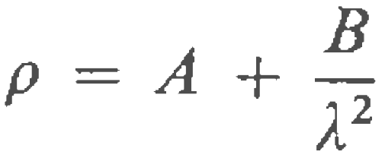,
where A and B are constants to be determined.
The angle through which the light is rotated by a specific material depends on the length of the path through the material and on concentration if the material is in solution.
Liquids made up of an optically active substance and an inactive solvent are found to produce a rotation very nearly proportional to the amount of the active substance present.
This has led to the very wide use of polarized light as an accurate means of determining the amounts of sugar, an optically active substance, in the presence of nonactive impurities.
A standard method for determining the concentration of sugar solutions is to measure the rotation produced by a fixed length of the solution.
The specific rotation or rotatory power is defined as the rotation produced by a 10-cm column of liquid containing 1 g of active substance for every cubic centimeter of solution:
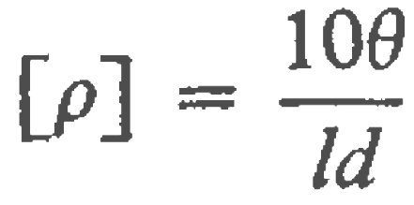,
where [ρ] is the specific rotation, d the number of grams of active substance per cubic centimeter, l the length of the light path in centimeters, and θ the angle of rotation.
In general the rotation in liquids is considerably less than in crystals. For example,
10.0 cm of turpentine rotates sodium light -37°. (The minus sign indicates left-handed or counterclockwise rotation, looking against the direction of propagation.)
An equal thickness of quartz, on the other hand, rotates sodium light 2172°.
It is for this reason that the specific rotation for crystals is taken as the angle for a 1-mm path.
Molecular asymmetry determines whether a material is optically active. For example,
some proteins are optically active because of their spiral shape.

Optical lenses and devices
Perhaps the most important of optical devices are lenses. For a glass lens, only about 4% of the incident light at near normal incidence (in the paraxial approximation, with light traveling nearly along the optic axis) will be reflected at each boundary with air. So most of the light will be transmitted after being refracted by the curved surfaces. Special optical antireflection coatings can even increase the transmitted light closer to 100%.
Lenses are usually made either of glass or clear plastic and are ground and polished to have spherical surfaces. Several varieties of two basic forms of lenses exist: converging lenses and diverging lenses. Occasionally lenses are made with cylindrical or even other surface contours for special purposes.
Many common lenses, especially those in cameras, are not simple single pieces of glass, but are compound lenses made by cementing many individual lenses together with a transparent glue that has a similar index of refraction to that of the glass.
Simple lenses, those that have negligible thickness compared to their diameter are known as thin lenses. The straight line passing through the lens center and traveling perpendicular to both surfaces is the optic axis.
For a thin lens there is a common point, the focal point F at which all incident rays parallel to the optic axis will cross the optic axis. The distance f from this point to the center of the lens is called the focal length of the lens.
The focal length of a thin lens is related to its radii of curvature R₁ and R₂ on each of its sides and its index of refraction n by the lens-maker’s equation
In this equation the radii are taken as positive if the surface is convex and negative if concave. Note that a plane surface has an infinite radius of curvature.
To find the image location as well as its lateral magnification allows the lens equation
Here s is the object distance and s′ is the image distance.
The reciprocal of the focal length for a lens is called lens power P, where
Lens power is measured in reciprocal meters which are called diopters (D). Thus, the shorter the focal length is, the stronger the lens power. The diopter unit is mainly used in coding eyeglass lenses.The two lenses with focal lengths f and f ′ in contact with each other may be treated as a single lens with a combined focal length f given by
Most lenses in optical devices are, in fact, compound lenses designed to compensate for aberrations and so this equation tells how to find the net focal length of the compound lens.
Thick lens
When the thickness of a lens cannot be considered small compared with its focal
length, the thin-lens formulas are no longer applicable. The lens must be treated as a thick lens.
This term is used not only for a single homogeneous lens with two spherical surfaces separated by an appreciable distance but also for any system of coaxial spherical surfaces which is treated as a unit. The thick lens may therefore include several component lenses, which may or may not be in contact.
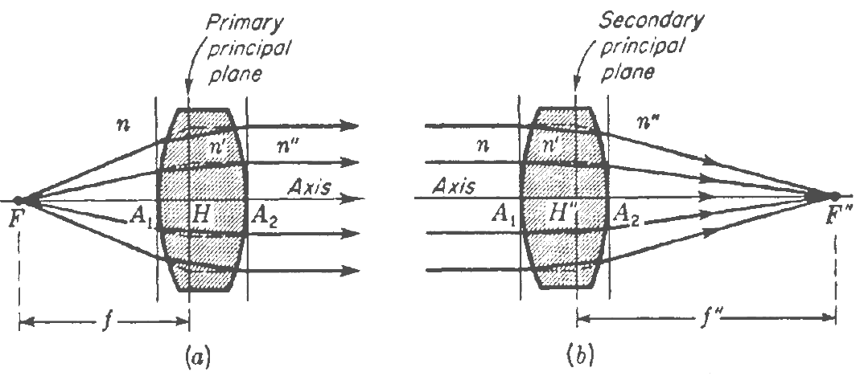
Let n, n', and n" represent the refractive indices of three media separated by two spherical surfaces.
Diagrams showing the characteristics of the two focal points of a thick lens are given in figure.
In the first diagram diverging rays from the primary focal point F emerge parallel to the axis, while in the second diagram parallel incident rays are brought to a focus at the secondary focal point F".
Transverse planes through these intersections constitute primary and secondary focal planes.
In each case the incident and refracted rays have been extended to their point of intersection between the surfaces. Transverse planes through these intersections constitute primary and secondary principal planes.
These planes cross the axis at points H and H", called the principal points.
It will be noticed that there is a point-for-point correspondence between the two principal planes, so that each is an erect image of the other and both are the same size. For this reason
they have sometimes been called unit planes. They are best defined by saying that
the principal planes are two planes having unit positive lateral magnification.
The focal lengths, as shown in the figure, are measured from the focal points F and F" to their respective principal points H and H". If the medium is the same on both sides of the lens, n" = n, the primary focal length f is exactly equal to the secondary focal length f".
If the media on the two sides of the lens are different so that n" is not equal to n, the two focal lengths are different and have the ratio of their corresponding refractive indices:
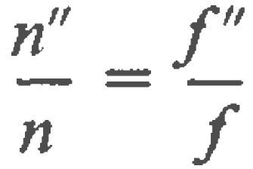.
In general the focal points and principal points are not symmetrically located with respect to the lens but are at different distances from the vertices. This is true even when the media on both sides are the same and the focal lengths are equal.
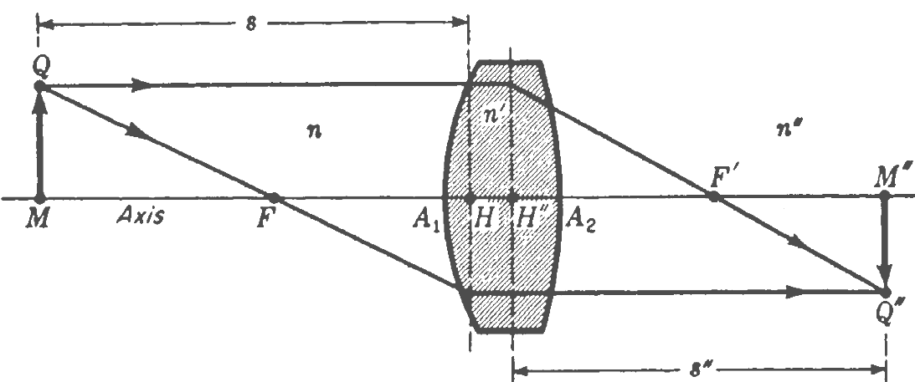
In order to trace any ray through a thick lens, the positions of the focal points and principal points must first be determined. Once this has been done, either graphically or by computation, the parallel-ray construction can be used to locate the image as shown in figure.
The construction procedure follows that given for a thin lens, except that here all rays in the region between the two principal planes are drawn parallel to the axis.
Provided the object and image distances are measured to or from the principal points, we can apply the gaussian lens formula
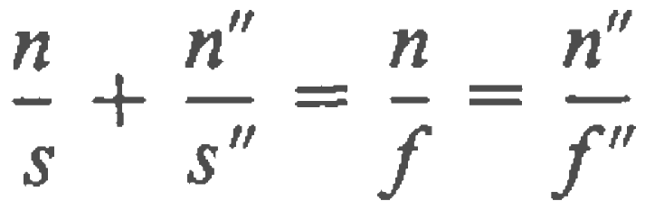.
For the purposes of graphical construction the lens may be regarded as replaced by its two principal planes.
Of all the rays that pass through a lens from an off-axis object point to its corresponding
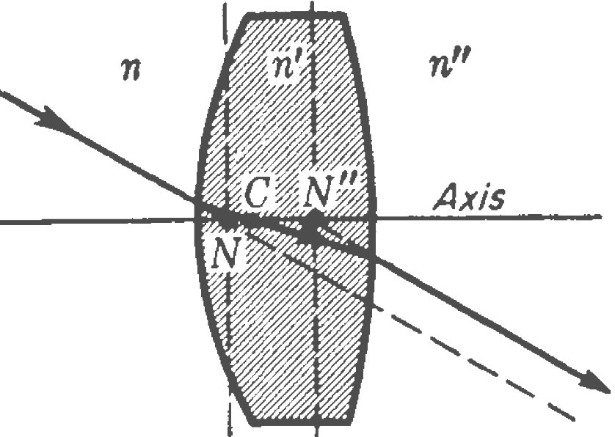
image point, there will always be one for which the direction of the ray in the image space is the same as that in the object space; i.e., the segments of the ray before reaching the lens, and after leaving it, are parallel.
The two points at which these segments, if projected, intersect the axis are called the nodal points, and the transverse planes through them are called the nodal planes.
This third pair of points and their associated planes are shown in figure, which also shows the optical center of the lens at C.
It is readily shown that if the medium on both sides is the same, the nodal points N and N" coincide with the principal points H and H" but if the two media have different indices, the principal points and the nodal points will be separate.
Since the incident and emergent rays make equal angles with the axis, the nodal points are called conjugate points of unit positive angular magnification.
If the ray is to emerge parallel to its original direction, the two surface elements of the lens where it enters and leaves must be parallel to each other so that the effect is like that of a plane-parallel plate. A line between these two points crosses the axis at the optical center C.
It is therefore through the optical center that the undeviated ray must be drawn in all cases. It has the interesting property that its position, depending as it does only on the radii of curvature and thickness of the lens, does not vary with color of the light. All the six cardinal points will in general have a slightly different position for each color.
Figure will help to clarify the different significance of the nodal points and the principal points. This figure is drawn for n" ≠ n, so that the two sets of points are separate.
Ray 11 through the secondary nodal point is parallel to ray 10, the latter being incident in the direction of the primary nodal point N.
On the other hand both these segments intersect the principal planes at the same distance above the principal points H and H". From the small parallelogram at the center of the diagram,
it is observed that the distance between nodal planes is exactly equal to the distance between principal planes. In general, therefore,
NN" = HH".
Furthermore in this case, where the initial and final values of the refractive index differ, the focal lengths, which are measured from the principal points, are no longer equal.
The primary focal length FH is equal to the distance N" F", while the secondary focal length H" F" is equal to FN:
f = FH = N"F" and f" = H"F" = FN.
In thick-lens problems a knowledge of the six cardinal points, comprising the focal points, principal points, and nodal points, is always adequate to obtain solutions.

The simple magnifier
The simple magnifier consists of a single converging lens. As the name implies, this
device increases the apparent size of an object.
Suppose an object is viewed at some distance from the eye. The size of the image formed at the retina depends on the angle θ subtended by the object at the eye. As the object moves closer to the eye, θ increases and a larger image is observed.
However, an average normal eye cannot focus on an object closer than about 25 cm, the near point. Therefore, θ is maximum at the near point.
To further increase the apparent angular size of an object, a converging lens can be placed in front of the eye, with the object located at point O, just inside the focal point of the lens.
At this location, the lens forms a virtual, upright, enlarged image.
.
With a single lens, it is possible to obtain angular magnifications up to about 4 without
serious aberrations. Magnifications up to about 20 can be achieved by using one or two additional lenses to correct for aberrations.
The microscope
A simple magnifier provides only limited assistance in inspecting minute details of
an object. Greater magnification can be achieved by combining two lenses in a device called a compound microscope.
It consists of one lens, the objective, that has a very short focal length f_{o} ≈ 1 cm and a
second lens, the eyepiece or ocular, that has a focal length f_{e} of a few centimeters. The two lenses are separated by a distance L that is much greater than either f_{o} or f_{e} .
The object, which is placed just outside the focal point of the objective, forms a real, inverted image at I₁, and this image is located at or close to the focal point of the eyepiece.
The eyepiece, which serves as a simple magnifier, produces at I₂ a virtual, enlarged image of I₁. The lateral magnification M₁ of the first image is -q₁/p₁. Note that q₁ is approximately equal to L and that the object is very close to the focal point of the objective: p₁ ≈ f_{o}. Thus, the lateral magnification by the objective is
The angular magnification by the eyepiece for an object (corresponding to the image at I₁) placed at the focal point of the eyepiece is
The overall magnification of the image formed by a compound microscope is defined
as the product of the lateral and angular magnifications:
The negative sign indicates that the image is inverted.
Fiber optics
When light in an optically dense medium approaches the boundary of a less dense medium at an angle, greater than the critical angle, it is totally reflected.
Bundles of tiny fibers of clear glass or plastic provide the basis for the sizable industry of fiber optics. Tests on individual fibers over 50 m long show that there are essentially no losses due to reflection on the sides. All attenuation of an incident beam is attributable to reflection from the two ends and absorption by the fiber material.
An ordered array or bundle of tiny transparent fibers can be used to transmit light images around corners and over long distances. A bundle of thousands of fibers is frequently made to follow a path with many turns and ends up at a distant or nearby point.
If the individual fibers in a bundle are not arranged in an orderly array but are randomly interwoven, the emerging image will be scrambled and meaningless.
Fibers are usually coated with a thin transparent layer of glass or other material of lower refractive index. Total reflection will still take place between the two. This separates the fibers of a bundle from one another, thereby preventing light leakage between touching fibers and at the same time protecting the fire-polished reflecting surfaces.
One method for producing coated fibers is to insert a thick, high-refractiveindex glass rod in tubing of lower index. In a special furnace the two are then drawn down to 1/1000 initial diameter, and the thickness is controlled within narrow limits.
A bundle of these fibers can then be fused together to form a solid mass and drawn down a second time so that individual fibers are about 2 μm in diameter. This is about two wavelengths of visible light. Such bundles can resolve approximately 250 lines per millimeter.
If fibers are drawn down until their diameters are close to the wavelength of light, they cease to act like pipes and behave more like waveguides used in conducting microwaves. Two wavelengths of light is an approximate limit for image transmission.
The most important is in the field of medicine. A cystoscope, or catheter-type instrument, enables the surgeon to observe and operate by remote control on tiny areas deep within the body.

