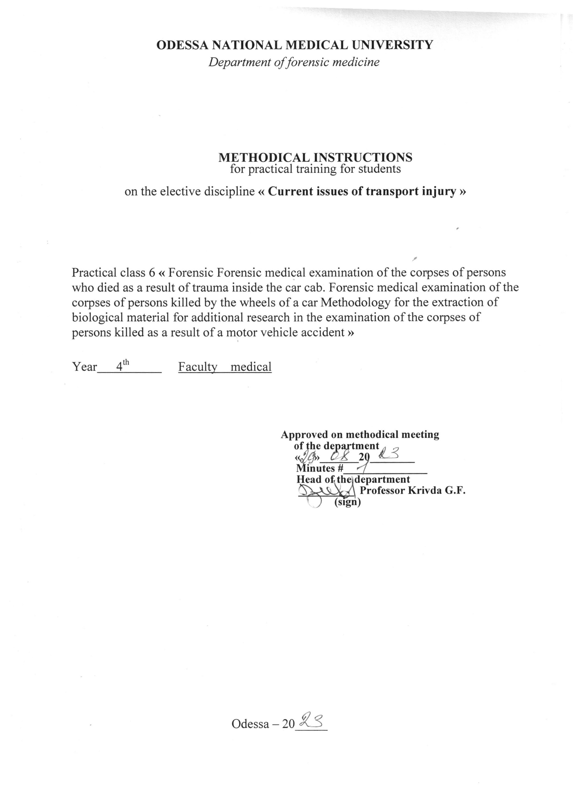
1.Topic of the class " Forensic medical examination of the corpses of persons who died as a result of trauma inside the car cab. Forensic medical examination of the corpses of persons killed by the wheels of a car Methodology for the extraction of biological material for additional research in the examination of the corpses of persons killed as a result of a motor vehicle accident " - 6 hours.

2. Relevance of the topic: forensic traumatology is the most important section of forensic medicine. This is explained by the fact that injuries by blunt and sharp objects, traffic injuries are the most common among all other injuries. As a result of the action of blunt and sharp objects, and transport trauma, the injured person often dies. Traffic injuries in Ukraine are quite high and increase by an average of 12-15% per year. Traffic trauma consistently holds the first place among the causes of violent death. Injuries from blunt and sharp objects are a fairly common cause of disability, long-term health disorders, and death.

3. Whole classes:
3.1. General goals:
a) provide students with information about injuries caused by blunt objects and teach them the specifics of conducting a forensic medical examination in cases of injuries caused by blunt objects;
b) to study the specifics of injuries from different groups of vehicles and their type during forensic autopsies of corpses with the development of a morphological diagnosis in typical cases of automobile, motorcycle, and railway injuries;
c) acquaint students with the features and methods of researching injuries by sharp objects depending on their type, provide skills in describing such injuries and determining the cause of death due to the action of sharp objects.
3.2. Educational goals: to get acquainted with the contribution of domestic scientists A.M. Hamburg, M.I. Raiskyi, Y.S. Sapozhnikov, A.I. Mukhanov in the study of the problems of forensic traumatology.
3.3. Specific goals:
Know:
1. Peculiarities of forensic medical examination of injuries by blunt objects;
2. Peculiarities of forensic medical examination of car, motorcycle and railway injuries;
3. Peculiarities of conducting a forensic medical examination of injuries by sharp objects, including identification means of establishing a specific instance of a cold weapon.
3.4. On the basis of theoretical knowledge on the topic:
Master the techniques /be able to:
1. Determine the types of bodily injuries.
2. Investigate injuries caused by blunt objects.
3. On the basis of a scientific assessment of traces and damage, be able to establish certain facts that relate to the mechanism of transport trauma in general and its individual stages.
4. To be able to describe injuries caused by sharp objects and to identify a specific instance by the characteristics of injuries.
5. To be able to argue the causes of death from the action of blunt, sharp objects and in case of a transport injury.
4. Materials for pre-audit self-study (interdisciplinary integration)

№ p/p | Disciplines | To know | To be able to
1 | 2 | 3 | 4
1. | Prerequisite courses:  1. Pathological anatomy.  2.General surgery.  3.Normal anatomy. | Pathomorphology of tissue inflammation.  Stages of wound healing.  Osteology. | Interpret the duration of inflammation.  Establish  the duration of wound healing.  Interpret anomalies of the human skeleton.
2. | The following disciplines:  1.Military and extreme medicine.  2. Traumatology, orthopedics and naval surgery. | Pathomorphology of combat trauma.  Injuries on road, rail and water transport. | Identify symptoms of traumatic toxicosis.  Distinguish between types of trauma.
3. | Intersubject integration | Forensic medical examination of a corpse and peculiarities of autopsy of corpses in case of road accidents, railway trauma, injuries with blunt and sharp objects. | Draw up a forensic medical examination report describing the injuries.

5.Content of the topic.
Injury inside the car
Inside the car, the passengers in the front seat or cabin are often injured, rarely the drivers and passengers in the back seat of a passenger car. The question of who was driving at the time of the injury is resolved on the basis of a detailed analysis of injuries, their characteristics and localization in each of the victims. There are 4 options:
1. direct (frontal) collision from the front;
2. lateral;
3. rear-end collision;
4. overturning (overturning) of the car, which occurs as a result of a collision from the front, side, rear, or as a result of the car "sliding".
Frontal collision
When the car suddenly brakes, the people sitting in it continue to move at the previous speed due to inertia. The muscular efforts of the limbs that hold the body are small compared to inertial loads and cannot prevent the movement of the body when hitting the interior elements. The driver first hits the instrument panel with the area of the knee joints, after which the body is separated from the seat and the chest hits the steering wheel; at high speed, this is followed by a head impact on the windshield. The next stage is the displacement of the body downwards and backwards, the driver's head is injured against the upper part of the steering wheel, after which his body is thrown back on the car seat. A shift of the head leads to the occurrence of TBI and damage to the cervico-occipital joint. All victims in the car may have a "whiplash injury" with rupture of the spinal cord or the development of diffuse axonal damage to the brain. When shock overload increases, there is a danger of hydrodynamic shock in areas of the heart cavities and large vessels (primarily the aorta) with their subsequent rupture.
As a rule, the investigator is interested in the placement of people in the cabin (who was behind the wheel), their posture and actions, which can be judged by the nature of injuries and marks on clothing based on a medical-traceological approach, since at the moment of impact there are traces formation ratios: - the driver's hand and chest - with the steering wheel, his hands - with the panel located in front, the passenger's right hand - with the interior details located in front, the elbow of the driver's left hand - with the edging of the window of the front two doors, etc.
It is also recommended to apply the principle of biomechanical routes, based on the fact that individual parts of the body of people in the cabin are in different conditions in relation to the interior of the cabin. So, the front seat passenger's feet are in a different position than the driver's (located on the pedals). If the position of the driver's legs determines the increased load on the area of the ankle joints, then the biomechanics of replacing the legs of the passenger in the front seat is slightly different (and, accordingly, the direction of the impact of the loads): his legs slide forward with further emphasis on the front-lower part of the cabin. At the same time, the toe part of the shoes and the feet are exposed.
The biomechanics of the displacement of the human body also affects the nature of clothing damage, which should also be investigated. Thus, when the hands are moved forward, the fabric of the jacket on the side of the seam connecting the sleeve to the back is subjected to tension, and tears and even tears of the fabric are possible. In the case of a frontal collision, damage to clothing at the level of the knee joints (pants, stockings) is observed. In the case of a side impact, the tissue are localized mainly on the side corresponding to the impact of the car.
Injuries specific to the driver
The following injuries are very typical, depending on the force of the impact and the age of the victim:
- localization of injuries on the front and left surfaces of the body;
- torn and bruised wounds in the area of the first interdigital space, wounds and abrasions on the back of the hand, sometimes combined with fracture-dislocation of the main phalanx of the first finger
- bruises of the left elbow (bruises on the elbow edge of the forearms);
- transverse fractures of the middle third of the humerus and femur;
- damage and marks on clothing (footwear) caused by the driver's professional actions (vigorous braking, gear shifting, moving the steering wheel to extreme positions, etc;)
- fracture-dislocation of the ankle joint;
- arcuate bruise on the chest from the steering wheel; - direct fractures of the sternum and ribs (when hitting the steering wheel);
- fractures of the patella and bruises of the knee area (when hitting the edge of the dashboard);
- possible central dislocation of the hip (fracture of the acetabulum);
- rupture of the chest cavity, liver tears from the steering column;
- fracture of the left clavicle from the seat belt;
- when examining items of clothing, traces of sliding on the sole, tearing off the sole in the front sections, and tearing off the heel may be noted. In particular, the sole of the right shoe has a brake pedal mark (as a result of the driver's active actions at the time of impact).
If the driver or front-seat passenger hits his head on the front window, a vertical abrasion and superficial cuts will remain on the face. Fine glass fragments may become lodged in the wounds or found on clothing. In addition to superficial injuries, hitting the head on the frame above the front window can result in a skull base fracture, closed head injuries, and neck fractures.
Fractures of the skull base mainly run along the rocky ridges, passing through the Turkish saddle ("articular fractures"). Less common are ring fractures and multiple fractures of the skull base. The driver's chest may hit the steering wheel, and the front seat passenger may hit the dashboard. External injuries from such impacts range from abrasions to complete absence of external injuries.
In case of neck fractures, the most dangerous are injuries to the upper cervical vertebrae or dislocation of the atlanto-occipital joint. This can lead to either a complete separation or compression of the spinal cord. In other cases, the spinal cord is severely displaced downward, with partial or complete avulsion of the brain stem ventrally.
One of the most fatal chest injuries is aortic rupture. Most often it occurs distal to the origin of the left subclavian artery. Although thoracic aortic ruptures are classically associated with sudden deceleration, studies by some authors have shown that they are caused by chest compression.
Injuries typical for a front seat passenger:
- wounds and abrasions on the base of the palm and in the lower part of the forearm, right hand (formed when the hand is thrown forward reflexively and rests on the front panel of the car)
- wounds and abrasions on the lower part of the chin;
- rupture of the cervical-occipital joint;
- damage to the toe of the shoe and foot;
- bruises and cut wounds on the forehead and face, fractures of the skull in the frontal area and facial bones from impacts with the windshield rim and the glass itself;
- brain damage with predominant damage to the frontal and temporal areas;
- fracture of the right clavicle caused by the seat belt;
- possible injuries to the lower extremities and abdominal organs from impacts with the dashboard panel.
6.1. Questions to control the acquired knowledge:
1. Definition of the concept of "traffic injury" and its classification.
2. The main mechanisms of injuries in a pedestrian car accident.
3. Peculiarities of bone fractures in various mechanisms of autotrauma.
4. Damage in the event of an automobile injury to passengers.
5. Damage in the event of an automobile injury to the driver.
6. Tasks of a doctor when examining a corpse and the scene of an accident.
7. Peculiarities of the examination of a corpse in case of a car injury.
8. Examination of injuries in the event of a motorcycle injury.
9. The main mechanisms of damage formation in railway trauma.
10. Damage caused by water transport.
11. Forensic medical examination in case of aviation injury.

6.2.The information necessary for the formation of knowledge and skills can be found in textbooks:

MAIN: Forensic medicine: a textbook / Ed. V.D. Mishalova, - Chernivtsi: "City" 2018. - 572 p.

ADDITIONAL: Forensic medicine: a textbook / Ed. V.F. Moskalenko, B.V. Mykhailichenka. - K.: VSV Medicine, 2011. - 448 p. Forensic Medicine" Zavalniuk A.Kh. Course of lectures, Ternopil, 2000, p. 530-580

