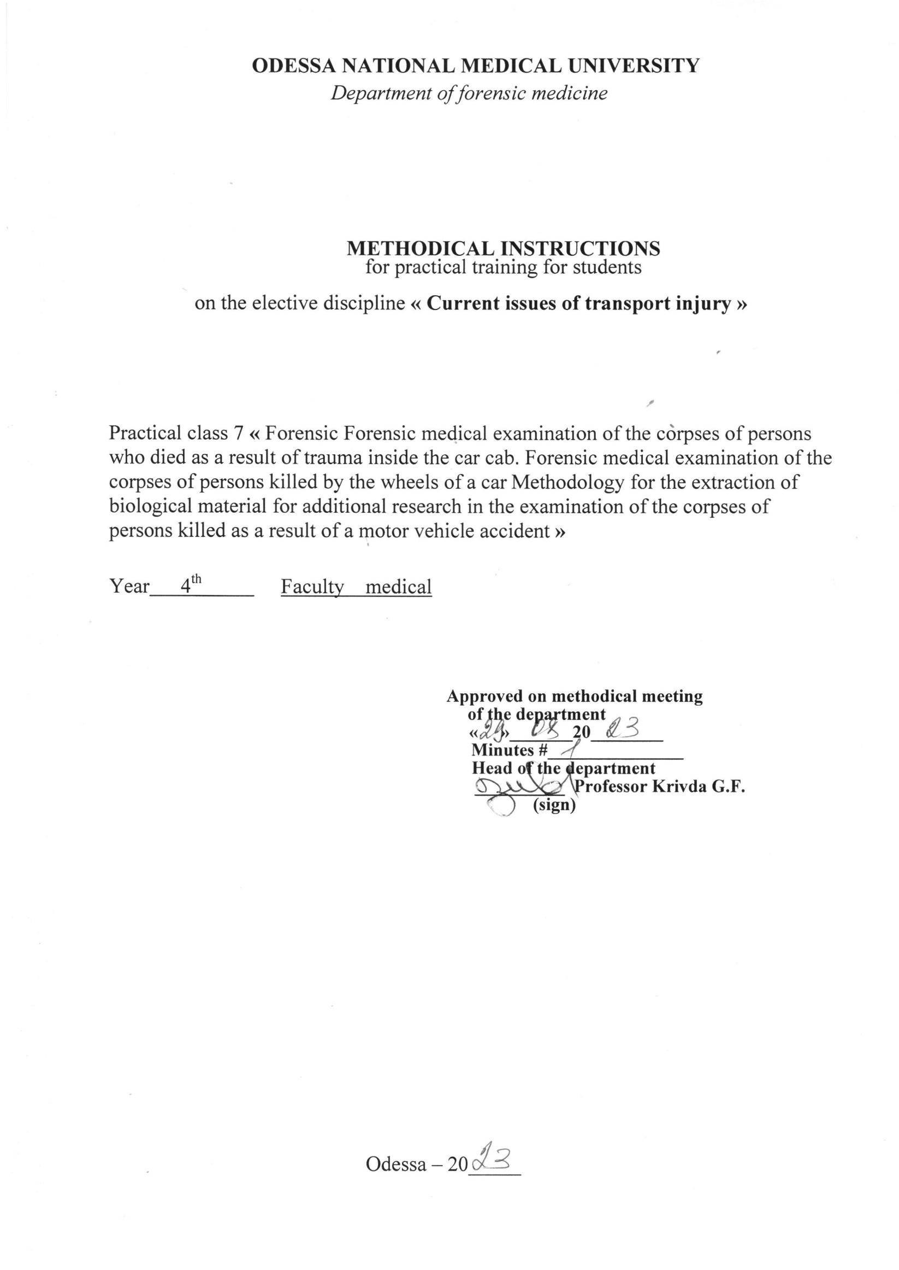

1.Topic of the class " Forensic medical examination of the corpses of persons who died as a result of other types of road traffic injuries (falling out of the car body, being pressed by a car against a fixed obstacle, combined types of road traffic injuries) " - 2 hours.

2. Relevance of the topic: forensic traumatology is the most important section of forensic medicine. This is explained by the fact that injuries by blunt and sharp objects, traffic injuries are the most common among all other injuries. As a result of the action of blunt and sharp objects, and transport trauma, the injured person often dies. Traffic injuries in Ukraine are quite high and increase by an average of 12-15% per year. Traffic trauma consistently holds the first place among the causes of violent death. Injuries from blunt and sharp objects are a fairly common cause of disability, long-term health disorders, and death.

3. Whole classes:
3.1. General goals:
a) provide students with information about injuries caused by blunt objects and teach them the specifics of conducting a forensic medical examination in cases of injuries caused by blunt objects;
b) to study the specifics of injuries from different groups of vehicles and their type during forensic autopsies of corpses with the development of a morphological diagnosis in typical cases of automobile, motorcycle, and railway injuries;
c) acquaint students with the features and methods of researching injuries by sharp objects depending on their type, provide skills in describing such injuries and determining the cause of death due to the action of sharp objects.
3.2. Educational goals: to get acquainted with the contribution of domestic scientists A.M. Hamburg, M.I. Raiskyi, Y.S. Sapozhnikov, A.I. Mukhanov in the study of the problems of forensic traumatology.
3.3. Specific goals:
Know:
1. Peculiarities of forensic medical examination of injuries by blunt objects;
2. Peculiarities of forensic medical examination of car, motorcycle and railway injuries;
3. Peculiarities of conducting a forensic medical examination of injuries by sharp objects, including identification means of establishing a specific instance of a cold weapon.
3.4. On the basis of theoretical knowledge on the topic:
Master the techniques /be able to:
1. Determine the types of bodily injuries.
2. Investigate injuries caused by blunt objects.
3. On the basis of a scientific assessment of traces and damage, be able to establish certain facts that relate to the mechanism of transport trauma in general and its individual stages.
4. To be able to describe injuries caused by sharp objects and to identify a specific instance by the characteristics of injuries.
5. To be able to argue the causes of death from the action of blunt, sharp objects and in case of a transport injury.
4. Materials for pre-audit self-study (interdisciplinary integration)

№ p/p | Disciplines | To know | To be able to
1 | 2 | 3 | 4
1. | Prerequisite courses:  1. Pathological anatomy.  2.General surgery.  3.Normal anatomy. | Pathomorphology of tissue inflammation.  Stages of wound healing.  Osteology. | Interpret the duration of inflammation.  Establish  the duration of wound healing.  Interpret anomalies of the human skeleton.
2. | The following disciplines:  1.Military and extreme medicine.  2. Traumatology, orthopedics and naval surgery. | Pathomorphology of combat trauma.  Injuries on road, rail and water transport. | Identify symptoms of traumatic toxicosis.  Distinguish between types of trauma.
3. | Intersubject integration | Forensic medical examination of a corpse and peculiarities of autopsy of corpses in case of road accidents, railway trauma, injuries with blunt and sharp objects. | Draw up a forensic medical examination report describing the injuries.

5.Content of the topic.
Injury from falling out of a moving car
Injury from falling out of a moving vehicle occurs in rural areas when the rules for transporting people are violated. Damage in the first phase occurs from hitting a part of the car body with the front, rear or side surfaces of the body. These are local injuries in the form of cuts and bruises, sometimes lacerated wounds. The main injuries occur in the second phase - falling to the ground.
Depending on the position of the victim at the moment of "landing", their localization and degree of severity will be different. In essence, these are injuries that occur during a free direct fall from a height, however, when falling from a car, isolated injuries and mainly heads prevail: • when falling on the head, there are direct injuries to the bones of the skull and brain from hitting the head on the ground and indirect injuries to the internal organs from general shock of the body; • when falling on the trunk, direct fractures of the ribs, spine, bones of the upper limbs, sometimes the skull from hitting the ground occur;
• when falling on the area of the buttocks, there are direct fractures of the pelvic bones from hitting the ground and indirect fractures of the spine, skull bones, brain damage;
• if you fall on your feet, there are direct injuries to the bones of the feet from hitting the ground and indirect fractures of the bones of the lower leg or hips, indirect injuries to the bones of the skull and the substance of the brain. Usually, when falling from a car, damage to internal organs from the shock is observed.
When falling from the body of a moving car, a third phase is observed — the movement of the body along the ground, with corresponding injuries at the same time, which do not occur during a normal fall from a height.Thus, injuries to persons who fell out of the cab or body of a moving car can occur: 1) from a body impact on a part of the car (rarely); 2) from impacting the body on the road surface; 3) from general body shock; 4) from sliding of the body on the road surface.
Side impact type of collision
In fatalities involving passenger cars, this type is the second most common. Typically, a car travelling at right angles to another car strikes the middle of the latter. In such cases, the driver suffers fragmented injuries on either one or both sides, depending on whether the driver hit the side window or the window broke off and hit the driver, or both. A side impact occurs when the car is driven sideways and strikes a fixed object, such as a tree or a pole. In a two-vehicle collision, the driver's side impact causes the force to act from shoulder level downwards. The head may be bent sideways towards the side window, and the occupant may hit the risers of the crashed car. If the crashed vehicle is a truck, the force acts from the roof level to the floor, and a direct head impact against the crashed vehicle is possible. In this case, the seat belt is practically useless. External injuries, lacerations and fractures - usually on the left side of the body, with possible fractures of the left arm and leg.
Rib fractures mainly on the left side. There may be ruptures of the aorta, heart, liver and, to a lesser extent, spleen, as well as ruptures of the left kidney. Neck fractures are possible. In general, injuries to the left side of the body are more severe than to the right. In the case of passengers, injuries are also common on the left side. For an unbelted passenger next to the driver, the impact is cushioned by the driver's body, which somewhat reduces the severity of the passenger's injuries.
In an impact from the right (passenger side), the injury is often more severe on the right side of the body. Aortic rupture is possible, although less frequently than in frontal or left-hand side collisions. Heart, liver and spleen ruptures, neck fractures and basal fractures are also possible.

6.1. Questions to control the acquired knowledge:
1. Definition of the concept of "traffic injury" and its classification.
2. The main mechanisms of injuries in a pedestrian car accident.
3. Peculiarities of bone fractures in various mechanisms of autotrauma.
4. Damage in the event of an automobile injury to passengers.
5. Damage in the event of an automobile injury to the driver.
6. Tasks of a doctor when examining a corpse and the scene of an accident.
7. Peculiarities of the examination of a corpse in case of a car injury.
8. Examination of injuries in the event of a motorcycle injury.
9. The main mechanisms of damage formation in railway trauma.
10. Damage caused by water transport.
11. Forensic medical examination in case of aviation injury.

6.2.The information necessary for the formation of knowledge and skills can be found in textbooks:

MAIN: Forensic medicine: a textbook / Ed. V.D. Mishalova, - Chernivtsi: "City" 2018. - 572 p.

ADDITIONAL: Forensic medicine: a textbook / Ed. V.F. Moskalenko, B.V. Mykhailichenka. - K.: VSV Medicine, 2011. - 448 p. Forensic Medicine" Zavalniuk A.Kh. Course of lectures, Ternopil, 2000, p. 530-580

