Ministry of Health of Ukraine
Odessa National Medical University
International Faculty

Department of Organization and Economics of Pharmacy
with post-diploma specialization

Discipline "The labor protection in industry"
Year of study 4 Term 8

GUIDELINES FOR INDEPENDENT WORK OF STUDENTS #2

The topic № 2 «Sanitary and hygienic standardization of air pollution at work»

Discussed and approved
at the meeting of the
Department of Organization and
Economics of Pharmacy
Minutes №1 “04/09 2023
Head of the Department,
As. Prof. Oksana BIELIAIEVA


2023
1. Topic. «Sanitary and hygienic standardization of air pollution at work».

2. Relevance of the topic.One of the specific forms of human activity is labor activity, which means not only work in its classical sense, but any activity (scientific, creative, artistic, service provision, etc.), if it is carried out under labor law. The difficulty and intensity of work are one of the main characteristics of the labor process. The set of factors of the labor process and the production environment that affect a person's health and ability to work during the performance of his / her labor duties constitute working conditions. Real production is accompanied by harmful and dangerous factors (factors) and has a certain production risk.

3. Objectives of the lesson:
3.1 General objectives:
- students must master the knowledge of sanitary and hygienic standardization of air pollution at work;
- students must master skills of working with documents governing the air environment in the workplace.

3.2 Educational goals: to direct the development of a professionally significant substructure of personality; education of students of modern pharmaceutical thinking on health and safety; responsible attitude to compliance with safety requirements during work.
3.3. Specific goals:
- know:
- to direct the development of a professionally significant substructure of personality;
- education of students of modern pharmaceutical thinking;
- assimilation by students knowledge about sanitary and hygienic standardization of air pollution at work.
3.4. Based on theoretical knowledge on the topic:
- master the techniques / be able /:
- to evaluate the parameters of sanitary and hygienic standardization of air pollution at work

4. Materials of the pre-classroom cobridge training (interdisciplinary integration).
№№  p.p. | Disciplines | Know | Be able
1. | Previous disciplines  Jurisprudence | General theory of constitutional law. Fundamentals of the legal status of the individual. Civil law in Ukraine. | Legal basis of labor protection in pharmacy. The main legislative acts on labor protection, their legal field and the range of issues to which they apply. Means of protection of personnel from dangerous and harmful substances.
 | Organization and economics of pharmacy | Pharmacy as an independent business enterprise. Forms of ownership, management, specialization of pharmacies. Types of liability. Pharmacy staff. Location of the pharmacy network. Organization of pharmacy work with inventories. Premises and their equipment. Drawing up of orders-requirements in departments of a drugstore, registration of requirements-invoices. | Safety precautions when receiving drugs. Means of protection of production personnel from possible consequences of dangerous cases. Action of personnel in emergency situations. Ensuring fire safety when working with flammable substances.
2. | The following disciplines  1. Pharmaceutical legislation  2. Good pharmaceutical practice | The importance of the basics of labor protection in the industry in the system of training pharmacists at the present stage of development of pharmacy | - to develop and systematize various legislative acts on labor protection;  - to study the tasks of labor protection in the quality assurance system of medicines.
3. | Intra-subject integration | Requirements for labor protection in the receipt and analysis of drugs. State and industry standards on labor protection. General requirements for clean production facilities. Occupational safety in production and laboratories for the production and analysis of medicines. | Occupational hygiene in the manufacture of drugs.
5. Tasks for independent work in preparation for the lesson
5.1 List of basic terms, parameters, characteristics that a student must learn in preparation for the lesson:
Plan
- Maximum permissible concentrations and approximately safe levels of exposure to harmful substances in the air of the working area.
- General measures and means of air pollution.
- Protection of workers.

Sanitary and hygienic standardization of air pollution at work
Hygienic rationing of harmful substances is carried out at the maximum allowable concentrations (MPC, mg / m3) in accordance with regulations: for workplaces is determined by the maximum allowable concentration in the work area - MPC (GOST 12.1.005-88, CH 245-71); in the atmosphere of the settlement - the maximum one-time MPCmr (highest, registered for 30 minutes of observation), the average daily - MPCsd (average for 24 h with continuous measurement) and approximate safe levels of exposure - a list of MPC pollutants № 3086-84 with additions, DSP 201-97. Hygienic rationing requires that the actual concentration of the contaminant does not exceed the MPC.
A concentration that during daily (except weekends) work for 8 hours or other duration, but not more than 41 hours per week, during the entire experience (25 years) can not cause diseases or health disorders that are modern research methods in the process of work or in the remote period of life of modern and future generations.
Values ​​of maximum permissible concentrations for some ingredients in the industrial air and in the atmosphere of settlements:
Substance  (formula) | concentration,  mg / m3 | MPCmr,  mg / m3 | MPC,  mg / m3 | Danger class | Action on the person
Carbon monoxide (CO) | 20.0 | 3.0 | 1.0 | 4 | Suffocating action, disorders of the central nervous system
Nitrogen dioxide (NO2) | 2.0 | 0.085 | 0.085 | 3 | Respiratory disorders, pulmonary edema, heart failure.
Sulfur dioxide (SO2) | 10.0 | 0.5 | 0.05 | 3 | Irritation of mucous membranes, upper respiratory tract, immune system, gastritis.
Suspended matter (inorganic dust) |  | 0.15 | 0.05 |  | Diseases of the respiratory system
Cadmium (Cd) | 0.05 |  |  | 1 | Carcinogenic
Lead (Pb) | 0.01 |  | 0.003 | 1 | Affected gastrointestinal tract, liver, kidneys; changes in the composition of blood and bone marrow; the brain is affected; causes muscle weakness and possible atrophy.
Gasoline | 100.0 | 5.0 | 1.5 | 4 | Narcotic effect (lesions of the central nervous system)
Benzpyrene (C20H12) | 0.00015 |  | 0.1 mcg // 100 m3 | 1 | Carcinogenic
Manganese (Mn, Mn2) | 0.05 |  |  | 1 | Affects the central nervous system, liver, stomach
Phenol (C6H6) | 0.3 | 0.01 | 0.01 | 2 | Need skin, eye protection; allergic actions
The main criterion for establishing MPC standards for assessing air quality is the impact of harmful impurities contained in the air on the human body.
The degree of influence of dust (aerosol with a particle size of 0.1-200 μm) on the human body depends not only on the chemical composition but also on the particle size (dispersed composition), the shape of the powders and their electrical properties. The greatest danger is the size of 1-2 μm, because these fractions are largely deposited in the lungs during respiration. Studies also show that electrically charged dust is 2-3 times more intensely deposited in the body compared to charge-neutral dust.
Hygienists by the nature of the action on the body distinguish a specific group of dust - dust of fibrogenic substances. The peculiarity of the action of such dust on the body is that when it enters the lungs, such abrasive insoluble dust causes the formation of fibrous nodules in the lung tissue - areas of hardened lung tissue, as a result of which the lungs lose the ability to perform their functions. Such diseases are practically incurable and with their timely detection it is possible to stop the development of the disease by changing working conditions. A number of types of dust (talc, starch, chromium and chlorine compounds) can cause allergic reactions and lung diseases - bronchial asthma.

Classification of harmful substances
The main sources of air pollution in industrial premises with harmful substances can be raw materials, components and finished products.
According to the degree of impact on the human body, harmful substances are divided into four classes of danger:
- extremely dangerous, having MPC - less than 0.1 mg / m3 in air (lethal concentration in air less than 500 mg / m3) - nickel, mercury;
- 1.0 mg / m3 (lethal concentration in the air 500-5000 mg / m3) - hydrogen sulfide, nitrogen dioxide;÷highly dangerous - MPC - 0.1
- 50,000 mg / m3) - soot, cement;÷10.0 mg / m3 (lethal concentration in the air 5000÷moderately dangerous - MPC - 0.1
- low-risk MPCs> 10.0 mg / m3 (lethal concentration in the air> 50,000 mg / m3) - gasoline, phenol.
Toxic substances enter the human body through the respiratory tract, gastrointestinal tract and skin. The degree of poisoning depends on their physical state (gaseous and vaporous substances, liquid and solid aerosols) and the nature of the technological process (heating of the substance, grinding, etc.).

Protection against exposure to harmful substances in production
The main reasons for the selection or falling into environment toxic substances are:
- Violation of technological process or insufficiently thought out organization productionprocesses (combination of works).
- Deficiencies in the equipment (leaks).
- Lack of installations for removal and capture of toxic substances from places of allocation.
- Wrong labor organization (in the production of earthworks, in deep wells, pits can happen poisoning people).
- Failure to comply with the rules and requirements for working with toxic and harmful substances.
- The use in the manufacture of works of substances prohibited for use due to increased toxicity.
Measures to ensure the safety of work in contact with harmful substances are divided into general and individual.
To general measures and means of prevention pollution air environment in production include: architectural design and planning solutions; appointment of sanitary protection zones in the design and construction of facilities, improvement of technological equipment and technological processes;
Technical and organizational activities include:
- Removal of harmful and especially toxic substances from technological processes, replacement of harmful substances with less harmful ones (replacement of dyes, solvents, pigments, etc. with less dangerous ones);
- Compliance with the rules of storage, transportation and use of toxic substances. Toxic substances must be stored in separate closed, well-ventilated warehouses, away from houses, canteens, ponds, wells, as well as from workplaces. It is necessary to hang warning inscriptions in folds. Admission tostorage storage of toxic substances by unauthorized persons is prohibited;
- An effective measure to reduce emissions in the work area are: improvement of process equipment, the use of closed process cycles, continuous transport flows, the use of wet methods of processing raw materials materialssawing (use of pneumatic feeders, gutters, augers, etc.);
- Sealing of the equipment is an obligatory requirement. However, complete sealing is not always possible due to the presence of working holes. The most effective is, in this case, the aspiration of units fromimplementation suction from the shelter. Designs of such extractors are various: fume cupboards, exhaust umbrellas, onboard suctions with artificial or mechanical draft;
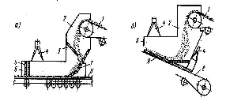
-Application of remote control of technological processes with sealing of the operator's workplace, application of mechanization and automation of production processes (excluding the presence of people in the work area);
- Systematic cleaning of premises;
- Ventilation production facilities and the use of special aspiration systems;
- Permanent control over the content of harmful substances in the air of the working area;
- Carrying out of medical examinations of workers, preventive food, compliance with the rules of industrial sanitation and occupational health.
Scheme of sealing of reloading conveyors:
and - with chops;
b - with a suction funnel, 1 - feeding conveyor; 2 - upper shelter; 3,7 - baffle plate; 4 - suction funnels; 5 - sealing apron; 6 - lower shelter; 8 - accepts the conveyor; 9 - sealing strip.
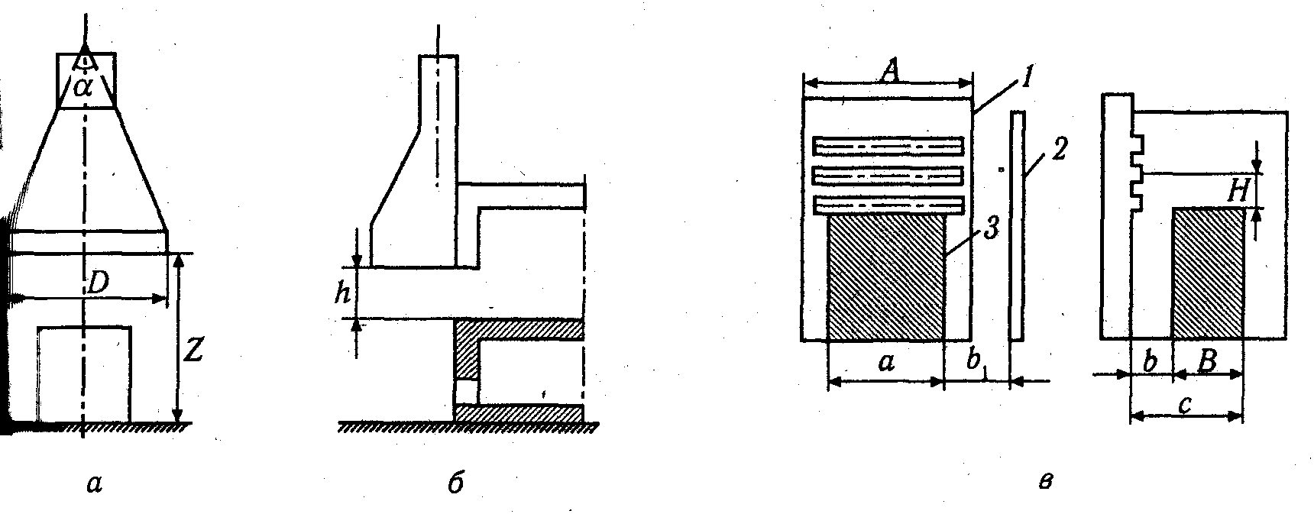

Exhaust umbrella: a - hood from above, b - from the side, c - suction device: 1-suction panel; 2-screen; 3-source of harm.
a-with the upper hood;
b - with a lower hood;
in - combined; p-umbrella hood
Personal protective equipment
Personal protective equipment (PPE) is used when safe conditions are not reached work at the expense of general architecturallydesign and planning decisions, as well as insufficient efficiency of joint collective means of protection.
PPE are divided on insulating suits, means of protection of bodies breath; special clothes; special shoes, means of protection of hands, head, face, eyes, hearing organs; safety devices; protective dermatological means (GOST 12.4.011-89 "Means of protection of workers. General requirements and classification).
On works with harmful and dangerous working conditions, as well as on work related to pollution or unsatisfactory weather conditions, workers are provided free of charge according to the established norms of overalls, footwear and other personal protective equipment, as well as detergents and disinfectants.
The procedure for issuing, storing and using PPE is determined by the "Regulations on the procedure for providing employees with overalls, footwear and other personal protective equipment" (order State Labor Inspectorate of May 7, 2004).
Respiratory personal protective equipment (PPE OD) is designed to protect against the effects of harmful gases, vapors, smoke, fog and dust contained in the air of the work area, as well as to provide oxygen in the absence of it in the surrounding atmosphere. PPE OD are divided into gas masks, respirators, helmets, air masks. According to the principle of PPE OD are filtering and insulating.
In filtering gas masks, the air is cleaned of harmful substances by filtration when passing through the protective element. Filtering PPE OD can not be used in the presence of unknown substances in the air, with a high content of harmful substances (more than 0.5% by volume), as well as with a reduced oxygen content (less than 18% at a rate of 21%). In these cases it is necessary to apply isolating PPE OD. Anti-aerosol filter respirators are used in industry. They are divided into two types: cartridge, in which the front part and the filter element are allocated in separate independent units, and filter masks, in which the filter element simultaneously serves as a front mask. According to the method of ventilation of the submask space, anti-aerosol respirators are valveless and valve. According to the operating conditions, there are disposable and reusable respirators. Respirators provide an easy way to protect the respiratory system from harmful substances.
Respirators ShB-1 "Petal" (domestic analogue "Rostock"), Astra-2 F-S2SI, U-k, RPA, etc .; gas masks - RPG-67 (various modifications); universal - RU-60 MU (domestic analogue of "Poplar"), DP-5, GP-5M, GP-7, GP-7V.
Good protective and operational properties have a filtering anti-aerosol valveless respirator SHB-1 "Petal", which has three modifications: "Petal-200", "Petal-40", "Petal-5", having the color of the outer circle in accordance white, orange and blue (domestic analogue of "Rostok"). The numbers 200, 40 and 5 mean thatappropriate modification of the respirator is intended to protect against fine and medium aerosols at concentrations in the air, in accordance exceed the MPC by 200, 40 and 5 times.
To protect against coarse dust (particle size more than 1 μm) used respirators (regardless of the designation of the name and number) is possible when dust exceeds the MPC not more than 200 times. Each of the respirators has a specific purpose and is used at a certain oxygen content in the air, to protect against certain substances or groups of substances at certain concentrations. The term of its work is also limited. Thus, the RPG-67 respirator is used when O 2 in the air is not less than 16%, RPG-67 is available in four brands (RPG-67A; RPG-67V; RPG-67KD; RPG067G) depending on the brand of filter cartridges. The RPG-67A brand is calculated on vapors of organic substances (gasoline, kerosene, acetone, alcohols, benzene and its homologues, ethers, etc., vaporschlorine - and organophosphorus pesticides). When the benzene content is 10 mg / m 3 the protective action time is at least 60 minutes. The main data and purpose of respirators and gas masks are given in the passport. With a significant content of harmful substances and lack of oxygen in the air IP-46M; IP-4; IP-5.
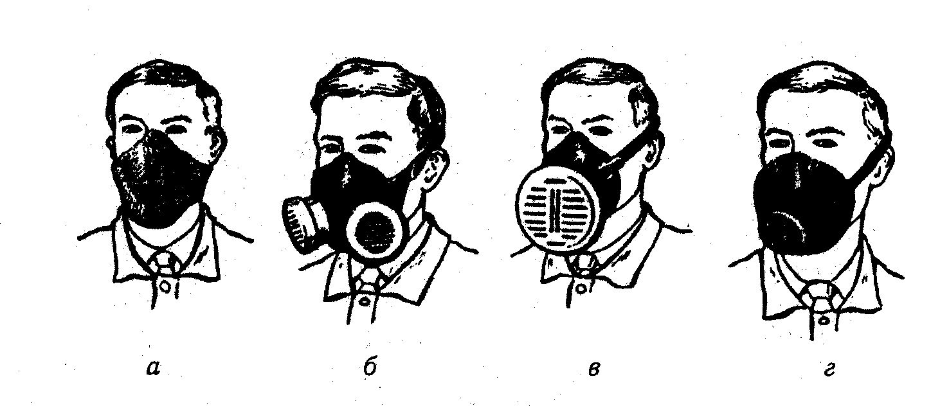
Respirators: a - "Petal", b-RU-60, on-62Sh, r-U-2k
The principle of their work is based on the release of oxygen from chemicals during the absorption of CO 2 and CO released by man.
When performing work in conditions where local and industrial ventilation does not provide removal of dust and gas to the level of MPC the most suitable means of respiratory protection are gas masks PSH-1 and PSH-2 self-reproducing or forced combustible air.
The overalls include: jackets, trousers, overalls, overalls, raincoats, coats, aprons, boot covers, oversleeves.
New types of materials (from synthetics, mixed fibers, oil-acid-resistant artificial fibers) are used for their production, which have special protective properties. According to GOST 12.4.103-80 special clothing depending on protective features is divided into groups (subgroups) which have such designations: M - for protection against mechanical damages; C - from general industrial pollution; T - from high or low temperature, P - from radioactive substances; And - from X-rayradiation; E - from electric fields; P - from non-toxic substances (dust); I - from toxic substances; In - from water; K - from acids; Shch - from meadows; O - from organic solvents; H - from oil, petroleum products, oils and fats; B - from harmful biological factors:
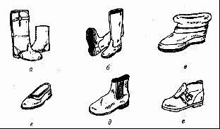
Special shoes subdivided depending on the purpose and protective ability. It includes: boots,galoshes, boots, boots, felt boots.
Head protection designed to protect the head from injury when working at height, as well as the potential for falling objects from a height: helmets, helmets. Helmets are divided according to purpose: helmets of the builder - assembler, miner's helmets, special purpose.
To protect against toxic substances use special hats in the form of hats, caps, caps.
To protect the face apply protective masks (S-40), manual and universal brushes, protective nets-masks (S-39).
To protect your hands use different types of gloves, mittens, fingertips, dermatological products.
Special footwear: a - boots combined, to protect against mechanical damage and exposure to high and low temperatures; b - rubber boots or withpolymers; in - dielectric bots; g - galoshes; d - leather boots for workers with high dust and explosion hazard of shops; e - shoes, to protect against contact with heated surfaces.
In accordance with GOST 12.4.103-80 hand protection is classified similarly to overalls and footwear. They are designed to protect hands from exposure to high temperatures, mechanical damage, vibration, exposure to electric current from acids, alkalis, salts, etc. They are made of cotton, polymers, tarpaulin, rubber, asbestos, depending on the purpose.
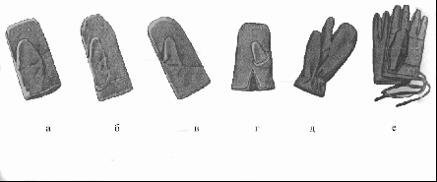
a, b, c - special gloves (type A, B, C); g - fur gloves (type B); d - winter mittens two-fingerfabric; e - fabric gloves
To protect the eyes from the ingress of solid, liquid particles of harmful substances (acids, alkalis, etc.), as well as from various types of radiation, mechanical damage, use special goggles. The type of goggles is accepted according to GOST 12.4.013-85 depending on the danger and type of work.
GOST 12.4.011-89 and GOST 12.4.103-83 contain a classification of means of protection, which indicates the scope and labeling of their groups and subgroups. The supervisor, knowing what substances the workers work with, is obliged according to GOSTto install means of protection of workers.
With to the head works required:
1. To study the atmosphere of the site or shop, workplaces.
2. If toxic fumes and gases are detected, evaluate the MPC and VAT.
3. Taking into account toxicity and explosive limits, develop preventive measures.
Develop instructions that should reflect the physical and chemical agents of harmful gases and vapors, symptoms of poisoning, measures first aid, enumeration of drugs and their dosage for each harmful substance.
Based on the composition of harmful gases, complete the first aid kits in the shops.

List of recommended reading

Basic literature:
- Unguryan L. M., Bieliaieva A. I., Vishnitskaya I. V., Aleksandrova A. A. Texts of lectures on the discipline "Labor protection in the industry." Odessa: ONMedU, 2020. 111 p.
- Unguryan L. M., Bieliaieva A. I., Aleksandrova A. A., Vishnitskaya I. V. et al. Labor protection in the industry: workshop. Odessa: ONMedU, 2019. 48 p.
- Unguryan LM, Bieliaieva AI, Vishnitskaya IV, Aleksandrova AA and others. Labor protection in the industry: teaching aid. Odessa: ONMedU, 2019. 60 p.
- Voinalovych O. V., Golopura S. M. Occupational Safety and Health. Practical. Kyiv: Center of Educational Literature, 2018. 448 p.
- Reese, Charles D. Occupational Safety and Health: fundamental principles and philosophies. Crc Press, 2017. 403 p.
- Phil Hughes, Ed Ferrett. Introduction to Health and Safety at Work: for the NEBOSH National General Certificate in Occupational Health and Safety. Routledge, 2015. 676 p.
- Pedro M. Arezes, João S. Baptista, Mónica P. Barroso. Occupational and Environmental Safety and Health. Springer International Publishing, 2019. 765 p.
- Thomas P Fuller. Global Occupational Safety and Health Management Handbook. CRC Press, 2019. 359 p.

Additional literature:
- Law of Ukraine "On labor protection" No. 2694-XII. dated 14.10.1992 (as amended)
- Law of Ukraine "Fundamentals of Ukrainian legislation on healthcare" No. 2801-XII of 19.11.1992. (As amended)
- Law of Ukraine "On ensuring sanitary and epidemic well-being of the population" No. 4004-XII dated February 24, 1994 (As amended)
- Law of Ukraine "On Compulsory State Social Insurance" No. 1105-XIV of 23.09.1999 (As amended)
- Law of Ukraine "On the basic principles of state supervision of business entities" No. 877-V dated 05.04.2007. (As amended)
- Code of Civil Protection of Ukraine No. 5403-VI dated 02.10.2012 (As amended)
- Resolution of the Cabinet of Ministers of Ukraine "On the procedure for certification of workplaces for working conditions" No. 442 dated 1.08.92r. (With changes)
- Resolution of the Cabinet of Ministers of Ukraine "On Approval of the Procedure for Investigation and Recording of Accidents, Occupational Diseases and Industrial Accidents" No. 337 dated April 17, 2019
- Resolution of the Cabinet of Ministers of Ukraine No. 431 of 23.06.94r. "On the procedure for conducting state examination (verification) of technological, design, technical documentation for the manufacture of means of production for compliance with their regulations on labor protection"
- Regulations on the Ministry of Health of Ukraine Approved by the Decree of the President of Ukraine dated March 25, 2015 No. 267.
- Regulations on the State Drug Control Service of Ukraine. Approved by the Decree of the President of Ukraine dated April 13, 2011 N 457/2011.
- Regulations on the State Service of Ukraine for Medicines. Approved by the Decree of the President of Ukraine dated April 8, 2011 No. 440/2011
- Order of the Ministry of Health of Ukraine No. 275 dated 15.05.2006. "On the approval of the instructions for the sanitary and anti-epidemic regime of pharmacies."
- CMU No. 843 dated 10.09.2001r. "On the approval of the criterion by which the degree of risk from the implementation of activities in the field of public health protection is assessed and the determination of the frequency of implementation of planned measures of state supervision (control)."
- Resolution of the Cabinet of Ministers of Ukraine "On approval of the licensing conditions for the implementation of economic activities for the production of medicines, wholesale and retail trade in medicines, import of medicines (except for active pharmaceutical ingredients)" No. 929 dated November 30, 2016
- NPAOP 0.00-4.35-04 "Standard regulation on the labor protection service".
- DNAP 0.00-6.23-92 "Procedure for certification of workplaces for working conditions".
- NAPB A.01.001-2004. Fire safety rules in Ukraine.
- Aslan, I., & Morsunbul, D. Preferences for job life qualyty and motivation in healthcare. Marketing and Management of Innovations. №2. P. 79-93.
- Saifullah Hakro, Li Jinshan. Workplace Employees' Annual Physical Checkup and During Hire on the Job to Increase Health-care Awareness Perception to Prevent Disease Risk: A Work for Policy-Implementable Option Globally. Safety and Health at Work. №10. 2018. P. 132-140.

Electronic resources:
https://zakon.rada.gov.ua/ - Database "Legislation of Ukraine"
http://ohoronapraci.kiev.ua/ - Site of the scientific and production monthly magazine "Labor Protection"
http://oppb.com.ua/ - Site of the monthly magazine "Labor protection and fire safety"
https://www.sop.com.ua/ - Site of the magazine "Labor Protection Service"
https://esop.mcfr.ua/ - Site of the magazine "Handbook of labor protection specialist"
https://www.dsns.gov.ua/ - Site of the State Emergency Service of Ukraine

Methodical recommendations amounted to Art. off Vyshnytska IV

