MINISTRY OF HEALTH OF UKRAINE

ODESSA NATIONAL MEDICAL UNIVERSITY

International Faculty

Department of Organization and Economics of Pharmacy
with post-diploma specialization

APPROVED
Head of the Department,
As. Prof. Oksana BIELIAIEVA
Minutes №1 “04/09 2023
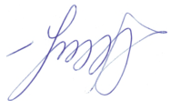

GUIDELINES FOR THE LECTURES

Year of study 4 Faculty of Pharmacy

Discipline «Pharmaceutical and Medical Commodity Science»

Lecture № 7. Topic: «Ophthalmic optics. Product analysis of ophthalmic instruments and devices for vision examination, correction and protection»

Odesa 2023
Lecture №7. Ophthalmic optics. Product analysis of ophthalmic instruments and devices for vision examination, correction and protection.
1) Anatomy of the eye
2) Refraction in the Eye
3) Refractive Errors
4) Types of Lenses for Vision Correction
5) Eye-glasses Prescription
6) Eyeglasses for Vision Correction
7) Types of Contact Lenses

8) The Contact Lens Prescription
9) Contact Lens Care Systems & Solutions
10) Ophthalmic Diagnostic Instruments and Devices
Human eye anatomy
Light passes through transparent tissue cornea first element in the eye's focusing system. Then iris controls the amount of light entering the eye. The adjustable crystalline lens – a biconvex body helping to focus the light on retina a layer of light-sensitive tissue at the back of the eye. The retina contains light-sensitive cells called photoreceptors, which translate the light energy into electrical signals fed into optic nerve for delivery to the brain.
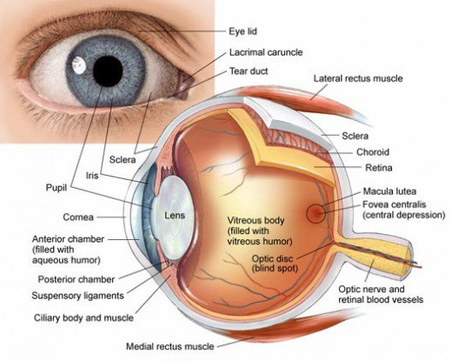
The eye sits in a protective bony socket called the orbit. Six extraocular muscles in the orbit are attached to the eye. These muscles move the eye up and down and side to side, and rotate the eye.
The extraocular muscles are attached to the white part of the eye called the sclera. This is a strong layer of tissue that covers nearly the entire surface of the eyeball.
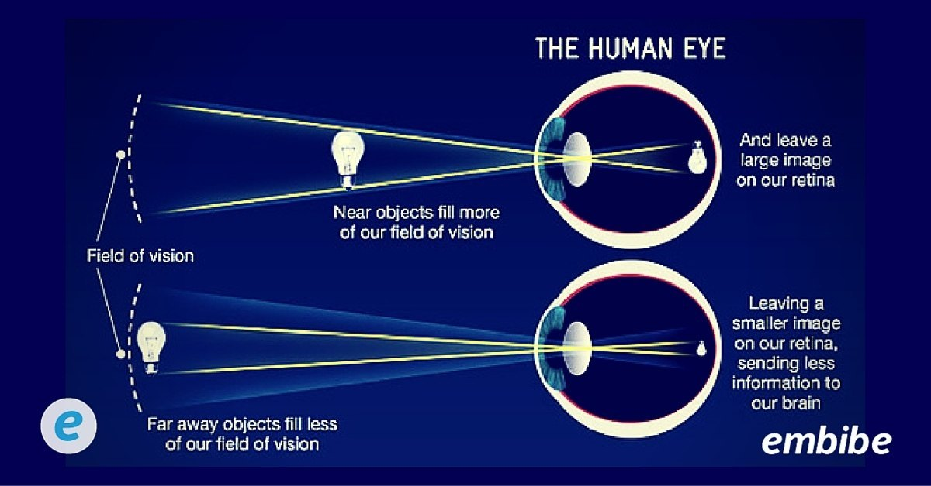
The surface of the eye and the inner surface of the eyelids are covered with a clear membrane called the conjunctiva.
Light is focused into the eye through the clear, dome-shaped front portion of the eye called the cornea.
Behind the cornea is a fluid-filled space called the anterior chamber. The fluid is called aqueous humor. The eye is always producing aqueous humor.
Behind the anterior chamber is the eye’s iris (the colored part of the eye) and the dark hole in the middle called the pupil. Muscles in the iris dilate (widen) or constrict (narrow) the pupil to control the amount of light reaching the back of the eye.
Directly behind the pupil sits the lens. The lens focuses light toward the back of the eye. The lens changes shape to help the eye focus on objects up close. The lens is surrounded by the lens capsule, which is left in place when the lens is removed during cataract surgery. A replacement intraocular lens goes inside the capsule, where the natural lens was.
The vitreous cavity lies between the lens and the back of the eye. A jellylike substance called vitreous humor fills the cavity, nourishing the inside of the eye and helping the eye hold its shape.
Light that is focused into the eye by the cornea and lens passes through the vitreous onto the retina — the light-sensitive tissue lining the back of the eye.
A tiny but very specialized area of the retina called the macula is responsible for giving us our detailed, central vision. The other part of the retina, the peripheral retina, provides us with our peripheral (side) vision.
The retina has special cells called photoreceptors. These cells change light into energy that is transmitted to the brain. There are two types of photoreceptors: rods and cones. Rods perceive black and white, and enable night vision. Cones perceive color, and provide central (detail) vision.
Photoreceptors in the retina: cones and rods
Rods ~120 million on the retina, fast and sensitive “black & white” light detectors, responsible for vision in reduced light levels.
Cones ~6 million on the retina, slow and less sensitive “colour sensitive” light detectors.
Rods ~ 100 – 1000 times more sensitive to light than cones.
Optical power of a lens
The lens power is defined as the reciprocal of the focal length:
D = = (n-1)[ - ] ,
The unit of optical power (refraction) is the inverse metre or the Diopter symbolised by D
$R=\frac{1}{F}$,
R - optical power (refraction),
F - focal length
Each surface bends the incoming rays: the more the bending the “stronger” the surface.
The retina sends light as electrical impulses through the optic nerve to the brain. The optic nerve is made up of millions of nerve fibers that transmit these impulses to the visual cortex — the part of the brain responsible for our sight.

Refraction in the Eye
The vision process relies heavily on the ability of the eye to refract light. The main parts of the optical system of the eye includes the cornea and the lens of the eye.
Cornea
The process of vision first starts with the light passing through the cornea. Since the cornea has a spherical surface it acts like a converging lens.
Pupil and Iris
Once the light passes through the cornea it goes through the pupil which is essentially a hole that regulates light intensity by changing its diameter. So when its dark, the pupils dilate , up to about 8mm, so that more light can enter the eye. And when it is bright the pupil shrinks, to an average of 3mm, to restrict the amount of light. The pupil's size is controlled by the iris. Muscles in the the iris cause the pupil to shrink or dilate.
The Lens and Accommodation
After light rays travel through the pupil they hit the lens where refraction also takes place.
The eye focuses an image through the process of accommodation, where the ciliary muscles can change the curvature of the lens. When the eye is looking at a distance little accommodation is needed, so the ciliary muscles are relaxed, and the lens has the longest focal length. To see a nearer object, the focal length of the lens needs to decrease to produce the image on the retina, to do this the ciliary muscles contract.
Refractive Errors
Emmetropia is the term used to describe an eye without any refractive errors.
Nearsightedness (myopia, shortsightedness) is a condition in which an image of a distant object becomes focused in front of the retina, making distant objects appear out of focus. The condition is usually caused by an elongation of the eyeball that occurs over time.
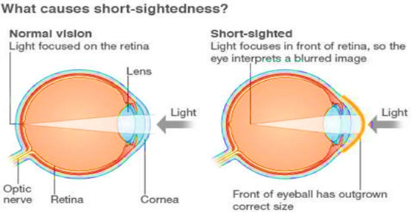
Farsightedness (hyperopia) is a condition in which an image of a distant object becomes focused behind the retina making objects up close appear out of focus. It is opposite of myopia, and is usually caused by shortening of the eyeball.
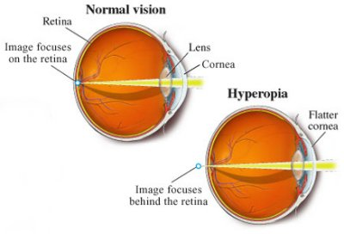

Astigmatism is a condition in which an abnormal curvature of the cornea can cause two focal points to fall in two different locations, making objects up close and at a distance appear blurry. This problem may occur along with either myopia or hyperopia. These frequent conditions are termed "refractive errors."
Presbyopia is a condition associated with the aging of the eye that results in progressively worsening ability to focus clearly on close objects. Presbyopia is a natural part of the aging process. 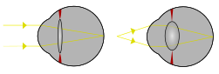

Diagnosis
The visual acuity test is used to determine the smallest letters you can read on a standardized chart (Snellen chart) or a card held 20 feet (6 meters) away. Special charts are used when testing at distances shorter than 20 feet (6 meters). Some Snellen charts are actually video monitors showing letters or images.
Ophthalmologists also diagnose a decline in vision using refraction and retinoscopy and, when necessary, automated computerized devices.

Treatment
Optometrists and ophthalmologists prescribe eyeglasses and contact lenses to compensate for most refractive errors. In addition, newer techniques actually change the curved shape of the cornea, causing it to focus light directly onto the retina, thus producing a clear image.

Types of Lenses for Vision Correction
A corrective lens is a lens worn on (contact lens) or before the eye (eyeglass lenses). They are used to treat short-sightedness, long-sightedness, presbyopia, and astigmatism. Biconcave or diverging lenses are required for near-sightedness and biconvex or converging lenses are required for far-sightedness.
Optometrist usually prescribes corrective lenses. The prescription will involve the necessary corrections for refraction errors in each eye, individually for distance vision and near vision, for a total of four possible correction specifications.
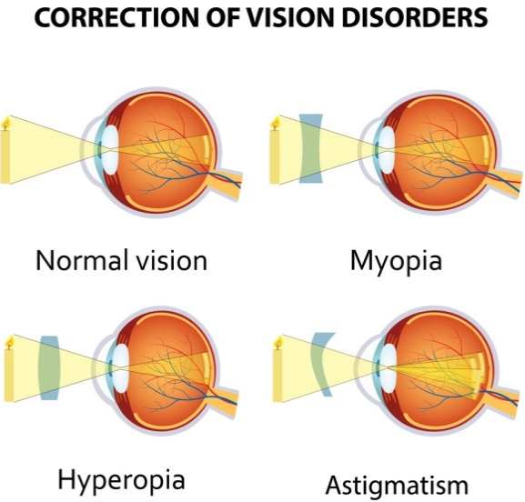
Eye-glasses Prescription Abbreviations
The first step to understanding an eyeglass prescription is knowing what "OD" and “OS" mean. They are abbreviations for oculus dexter and oculus sinister, which are Latin terms for "right eye" and "left eye."
Your eyeglass prescription also may have a column labeled "OU." This is the abbreviation for the Latin term oculus uterque, which means "both eyes."
Though use of these abbreviated Latin terms is common on prescriptions for glasses, contact lenses and eye medicines, some doctors and clinics have opted to modernize their eyeglass prescriptions and use RE (right eye) and LE (left eye) instead of OD and OS.
On your eyeglasses prescription, the information for your right eye (OD) comes before the information for your left eye (OS).
The eyeglass prescription contains other terms and abbreviations as well. These include:
Sphere (SPH). This indicates the amount of lens power, measured in diopters
(D), prescribed to correct nearsightedness or farsightedness. If the number appearing under this heading has a minus sign (–), you are nearsighted; if it has a plus sign (+), you are farsighted.
The term "sphere" means that the correction for nearsightedness or farsightedness is "spherical," or equal in all meridians of the eye.
Cylinder (CYL). This indicates the amount of lens power for astigmatism. If nothing appears in this column, you have little or no astigmatism that requires correction.
The number in the cylinder column may be preceded with a minus sign (for correction of nearsighted astigmatism) or a plus sign (for farsighted astigmatism). Cylinder power always follows the sphere power in an eyeglass prescription.
Axis. This describes the lens meridian that contains no cylinder power to correct astigmatism. The axis is defined with a number from 1 to 180. The number 90 corresponds to the vertical meridian of the eye, and the number 180 corresponds to the horizontal meridian.
If an eyeglass prescription includes cylinder power, it also must include an axis value, which follows the cyl power and is preceded by an "x" when written freehand.
PD (Pupillary Distance). It’s a measurement in millimeters between your eyes from the center of one pupil to the center of the other. Typically, adult’s PD falls in a range between 54 and 74 mm, and kids’ is somewhere between 43 and 54 mm. In Ukraine, PD is an obligatory part of the eyeglasses prescription. In some countries PD is not actually a part of your prescription. The optometrist or ophthalmologist rarely determines physical measurements, because that is the job of the optician.
Add. This is the added magnifying power applied to the bottom part of multifocal lenses to correct presbyopia. The number appearing in this section of the prescription is always a "plus" power, even if it is not preceded by a plus sign
Prism. This is the amount of prismatic power, measured in prism diopters ("p.d.")), prescribed to compensate for eye alignment problems. Only a small percentage of eyeglass prescriptions include prism.
When present, the amount of prism is indicated in either metric or fractional English units (0.5 or ½, for example). Four abbreviations are used for prism direction: BU = base up; BD = base down; BI = base in (toward the wearer's nose); BO = base out (toward the wearer's ear).
Sphere power, cylinder power and add power always appear in diopters. They are in decimal form and generally are written in quarter-diopter (0.25 D) increments.
Axis values are whole numbers from 1 to 180 and signify only a meridional location, not a power. When prism diopters are indicated in decimal form (e.g., 0.5).
Additional Information. Your eye doctor also might write specific lens recommendations on your eyeglass prescription — such as anti-reflective coating, photochromic lenses and/or progressive lenses — to give you the most comfortable vision correction possible.

An example of an eyeglass prescription
OD -2.00 SPH +2.00 add 0.5 p.d. BD
OS -1.00 -0.50 x 180 +2.00 add 0.5 p.d. BU
In this case, the eye doctor has prescribed -2.00 D sphere for the correction of myopia in the right eye (OD). There is no astigmatism correction for this eye, so no cylinder power or axis is noted. This doctor has elected to add "SPH," to confirm the right eye is being prescribed only spherical power. (Some doctors will add "DS" for "diopters sphere;" others will leave this area blank.)
The left eye (OS) is being prescribed -1.00 D sphere for myopia and -0.50 D cylinder for the correction of astigmatism. The cyl power has its axis at the 180 meridian, meaning the horizontal (180-degree) meridian of the eye has no added power for astigmatism and the vertical (90-degree) meridian gets the added -0.50 D.
Both eyes are being prescribed an "add power" of +2.00 D for the correction of presbyopia.
This eyeglass prescription also includes prismatic correction of 0.5 prism diopter in each eye. In the right eye, the prism is base down (BD); in the left eye, it's base up (BU).

Eyeglasses for Vision Correction
Wearing eyeglasses is an easy way to correct refractive errors.
There are two different types of eyeglass lens designs:
- single vision, an all-purpose lens designed to correct distance vision
- multifocal, designed to correct both distance vision and near vision (the upper portion is focused for distance vision, while the bottom portion is used for up close activities such as reading).
Multifocal lenses are eyeglasses used to correct presbyopia, the eye's natural diminished ability to focus on near objects that comes with age.
Bifocals have a correction for reading on the bottom half of the lens and another for seeing at a distance on the top.
Trifocals are lenses with three different lens corrections — distance vision, intermediate vision, and near vision — in one set of eyeglasses.
Progressive lenses function generally the same way as bifocals or trifocals; however, they have a smooth transition between distance and near focal areas instead visible dividing lines.
Prism correction is used in eyeglasses for some people who have diplopia, or double vision and strabismus (cross-vision).

Types of Eyeglass Lens Materials
Eyeglass lenses used to be made only of glass, but today most lenses are plastic. Plastic lenses are lighter, more flexible, and safer because they are less likely to shatter. They also have inherent UV light-blocking ability.
For people who wear eyeglasses during sports or other activities that can result in eye injuries, eye doctors often recommend polycarbonate lenses, a safety lens material that is highly resistant.
Another type of lens is a thin, light, plastic lens called a "high index" lens. These are recommended for people who need high visual correction.

Prescription Glasses - Optical Coatings
The most common types of coatings include anti-reflective coatings which reduce the reflections of the white of the eye as well as bright objects behind the spectacles wearer; UV coatings which reduce the light transmission in the UV or ultraviolet spectrum and; scratch resistant coatings which increase the abrasive properties of plastic lens.
Another option for vision correction with UV protection is prescription sunglasses. Also, for people who prefer one set of eyeglasses for both inside and outdoors, photochromatic lenses are a good option. Photochromatic lenses have a tint that varies based on their light exposure, with a darker tint in sunlight and lighter indoors.

Types of Contact Lenses
There are two general categories of contact lenses – soft and rigid gas permeable (RGP). All contact lenses require a valid prescription.

Soft Contact Lenses
Soft contact lenses are made of soft, flexible plastics that allow oxygen to pass through to the cornea. Soft contact lenses may be easier to adjust to and are more comfortable than rigid gas permeable lenses. Newer soft lens materials include silicone-hydrogels to provide more oxygen to your eye while you wear your lenses.

Rigid Gas Permeable (RGP) Contact Lenses
Rigid gas permeable contact lenses (RGPs) are more durable and resistant to deposit buildup, and generally give a clearer vision. They are less expensive over the life of the lens since they last longer than soft contact lenses. They are easier to handle and less likely to tear.

Extended Wear Contact Lenses
Extended wear contact lenses are available for overnight or continuous wear ranging from one to six nights or up to 30 days. Extended wear contact lenses are usually soft contact lenses. They are made of flexible plastics that allow oxygen to pass through to the cornea.

Disposable (Replacement Schedule) Contact Lenses
The majority of soft contact lens wearers are prescribed some type of frequent replacement schedule. “Disposable” means used once and discarded, i.e., a new pair of lenses is used each day.

Specialized Uses of Contact lenses
Conventional contact lenses correct vision in the same way that glasses do, only they are in contact with the eye. Two types of lenses that serve a different purpose are orthokeratology lenses and decorative (plano) lenses.

Orthokeratology (Ortho-K)
Orthokeratology, or Ortho-K, is a procedure that uses specially designed rigid gas permeable (RGP) contact lenses to change the curvature of the cornea to temporarily improve vision. This procedure is primarily used for the correction of myopia (nearsightedness).
Overnight Ortho-K lenses are the most common type of Ortho-K. There are some Ortho-K lenses that are prescribed only for daytime wear. Overnight Ortho-K lenses are commonly prescribed to be worn while sleeping for at least eight hours each night. The vision correction effect is temporary. If Ortho-K is discontinued, the corneas will return to their original curvature and the eye to its original amount of nearsightedness.

The Contact Lens Prescription

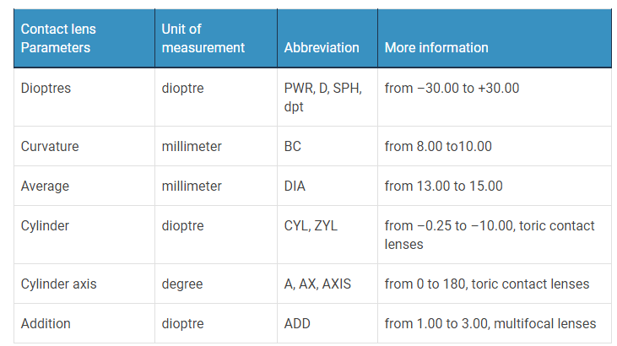
Curvature (BC). The base curve of a contact lens describes the curvature of the lens in millimeters, to provide the highest comfort while wearing lenses, i.e. how well the lens attaches to the eye. Normally these parameters are between 8–10 mm.
Dioptres / Sphere (D/dpt./S/SPH/PWR)
Sphere is the power of the contact lens. The unit of measure for sphere power is a diopter, or D. In general the spherical power of a lens is indicated with a plus sign (+) for hyperopia and a minus sign (-) for myopia.
Average (DIA)
This value is the diameter (or size) of the lens. Soft contact lenses have a larger diameter from 13.00 to 15.00 mm than hard contact lenses from 9 to 10 mm.
Cylinder (CYL)
The cylinder value is needed for the manufacture of contact lenses for astigmatism. It is a negative value, which makes any correction for the curvature of the cornea.
Axis (A/ACH/AXIS/AX)
The axis is required for astigmatism as a supplement to the contact lens with cylinder. It describes the exact position of the curvature on the cornea and is given in a range of 0° – 180°. Note that a degree of zero is also written as 180. The number 90 means the vertical position of the eye, and the number 180 corresponds to the horizontal meridian.
Addition (ADD)
ADD is the difference between the dioptric value of the far vision and the dioptric value of the near vision. Values up to 1.25 are regarded as low, up to 2.00 as average and up to 3.00 as high

The difference between contact lens and eyeglasses prescription
They are completely different because eyeglass lenses are placed roughly 12 millimeters from your eyes, whereas contact lenses are applied directly to the eyes' surface. However it is necessary to determine both values so that a perfect view is possible.
Furthermore, the measurement method between glasses and contact lenses is slightly different, as eyeglasses prescription needs to measure the distance between the eyes.

Additional information on a contact lens package
The oxygen permeability is given with the value “Dk/t”. The longer the lenses remain on the eyes, the more oxygen permeable they should be. If the value is too low, redness, or itching and burning may occur in sensitive eyes.

Contact Lens Care Systems & Solutions
Lens care systems and solutions are products you use to clean, disinfect, and store contact lenses.
Multipurpose solution is an all-in-one care system used to clean, rinse, disinfect, and store soft contact lenses. This solution is the most commonly used care system among soft contact lens wearers.
Saline solution does not disinfect contact lenses. Only use saline for rinsing contact lenses after cleaning and disinfecting with another care system.
Daily cleaner is intended for cleaning—not disinfecting—contact lenses. The cleaner loosens and removes deposits and debris from the contact lens. You must use additional products, such as multipurpose solution, for rinsing the daily cleaner off, disinfecting, and storing the contact lenses.
Ophthalmic Diagnostic Instruments and Devices
To establish the diagnosis ophthalmologists use the range of instruments and devices.
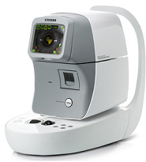
Tonometers are used to measure the Intraocular Pressure, or IOP, of the eye. IOP is often measured in millimeters of Mercury (mmHg).

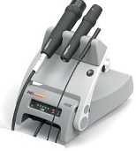
A-scan Ultrasound biometry utilizes an ultrasound device. This device can determine the length of the eye and can be useful in diagnosing common sight disorders. A-scans are also extremely beneficial in cataract surgeries.
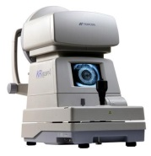
An automatic objective refractor is used to determine a patient's refractive error. Some refractors on the market today also provide visual acuity capabilities.
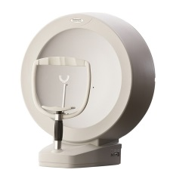
A visual field test checks the extent and intensity of what you are able to see including your entire peripheral (side) vision. By measuring the extent and the intensity of one’s visual field, many visual and general health conditions can be detected.
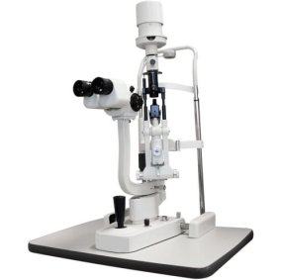
The Slit Camera The slit lamp gives us a magnified, three-dimensional view of your eye. We can use the slit lamp to look at the front parts of the eye (cornea and sclera), the lens, the colored part (iris), and the front section of the gel-like fluid that fills the large space in the middle of the eye.

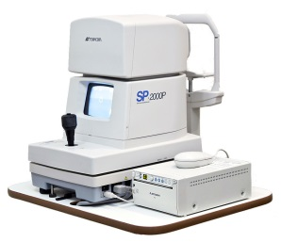
Unique and special Specular Microscope that evaluates the health of the cells lining the inner most layer of your cornea. Being the only cells in the body that do not regenerate, depending on the corneal health, these cells change size and shape to fill in the loss of the other cells.
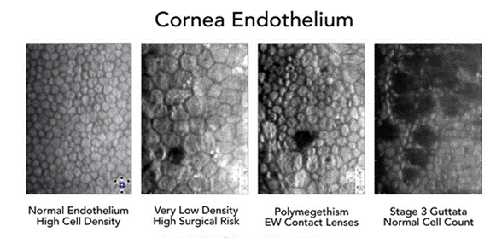

References:
1 .https://www.iso.org/obp/ui/#iso:std:iso:15253:dis:ed-2:v1:en
2.http://www.frankshospitalworkshop.com/equipment/documents/ophthalmology/equipment/Overview_of_ophthalmic_equipment.pdf
3. http://www.vision-research.eu/index.php?id=923

4. Optical Devices in Ophthalmology and Optometry: Technology, Design Principles, and Clinical Application. Dr. Michael Kaschke, Dr. Karl‐Heinz Donnerhacke, Dr. Michael Stefan Rill 2014
5. tps://www.iso.org/ics/11.040.70/x/
6.U.S. Food and Drug Administration. https://www.fda.gov/
7.World Health Organization (WHO) i https://www.who.int/
8.European Medicines Agency (EMA) https://www.ema.europa.eu/en

Guidelines are developed by PharmD, prof. _______ Unhurian L.M.
senior teacher _______ Stepanova O.A

